Supplementary Materials

Improving Antibiotic Utilization in West Africa: Enhancing Interventions through Systematic Review and Evidence Synthesis

Eric S. Donkor¹* Abdul-Halim Osman¹ Bill Clinton Aglomasa¹ Aaron Awere-Duodu¹ Alex Odoom¹ Bismark Opoku-Asare² Gilbert Lazarus^{3,4}

¹Department of Medical Microbiology, University of Ghana Medical School, Accra
²Department of Medicine and Therapeutics, University of Ghana Medical School, Accra
³Oxford University Clinical Research Unit (OUCRU) Indonesia, Jakarta, Indonesia
⁴Faculty of Medicine, Universitas Indonesia, Jakarta, Indonesia

*Author to whom correspondence should be addressed; esampane-donkor@ug.edu.gh

Table of Contents
Table S1: A table containing search terms used on each Database (February 14, 2024)
Table S2: Quality assessment criteria for study inclusion
Antibiotic Appropriateness Meta-Analysis Results
Antibiotic Consumption Meta-Analysis Results
Supplementary Figure 1: Sensitivity analysis on antibiotic consumption
Supplementary Figure 2: Antibiotic consumption subgroup analysis on duration of study
Supplementary Figure 3: Antibiotic consumption subgroup analysis on healthcare level
Supplementary Figure 4: Antibiotic consumption subgroup analysis on location of study
Supplementary Figure 5: Antibiotic consumption sensitivity analysis without outliers
Supplementary Figure 6: Antibiotic consumption sensitivity analysis with outliers
Supplementary Figure 7: Antibiotic appropriateness sensitivity analysis
Supplementary Figure 8: Antibiotic appropriateness subgroup analysis on country/location
Supplementary Figure 9: Antibiotic appropriateness subgroup analysis on guidelines used in Ghana
Supplementary Figure 10: Antibiotic appropriateness subgroup analysis on healthcare level
Supplementary Figure 11: Antibiotic appropriateness subgroup analysis on year of study
Table S3: Summary of findings of the knowledge, attitudes, and practice surveys
Table S4: List of the studies excluded at full-text screening stage

Table S1. A table containing search terms used on each Database (February 14, 2024)
Data Base | Search Terms | Comment | Date Searched
PubMed | ("Anti-Bacterial Agents"[Mesh] OR "Antibiotic Prophylaxis"[Mesh]) OR (("anti-bacterial"[tiab] OR "antibiotic"[tiab] OR "antimicrobial"[tiab]) AND ("use"[tiab] OR "usage"[tiab] OR "prescription*"[tiab] OR "prescribing"[tiab] OR "consumption"[tiab] OR "dispensing"[tiab] OR "stewardship"[tiab])) AND ("Benin"[tiab] OR "Benin"[MeSH]) NOT Review [Publication Type] | All the remaining 15 West African Countries were replaced at “Benin”, one after the other | February 14, 2024
Scopus | ("Anti-Bacterial Agents" OR "Antibiotic Prophylaxis") OR (("anti-bacterial" OR "antibiotic" OR "antimicrobial") AND ("use" OR "usage" OR "prescription*" OR "prescribing" OR "consumption" OR "dispensing" OR "stewardship")) AND ("Benin" OR "Burkina Faso" OR "Cape Verde" OR "Côte D'Ivoire" OR "Gambia" OR "Ghana" OR "Guinea" OR "Guinea-Bissau" OR "Liberia" OR "Mali" OR "Mauritania" OR "Niger" OR "Nigeria" OR "Senegal" OR "Sierra Leone" OR "Togo") | All the West African countries were selected | February 14, 2024

Table S2. Quality assessment criteria for study inclusion
No | Items | Antibiotic consumption | Antibiotic appropriateness | Indicators of antibiotic use | Antimicrobial stewardship | Knowledge, attitudes, practices
STROBE checklist core items
1 | State specific objectives, including any prespecified hypotheses (item 3) | ● | ● | ● | ● | ●
2 | Presents key elements of study design early in the paper (item 4) | ● | ● | ● | ● | ●
3 | Describe the setting, locations, and relevant dates, including periods of recruitment, exposure, follow-up, and data collection (item 5) | ● | ● | ● | ● | ●
4 | Give the eligibility criteria, and the sources and methods of selection of participants (item 6) | ● | ● | ● | ● | ●
5 | For each variable of interest, give sources of data and details of methods of assessment (measurement) (item 8) | ● | ● | ● | ● | ●
6 | Report numbers of individuals at each stage of study—e.g., numbers potentially eligible, examined for eligibility, confirmed eligible, included in the study, completing follow-up, and analysed (item 13) | ● | ● | ● | ● | ●
7 | Give characteristics of study participants (e.g., demographic, clinical, social) and information on exposures and potential confounders (item 14) | ● | ● | ● | ● | ●
Themes specific to this manuscript
8 | Consumption reported in DDD/100 | ●
9 | Gyssens method applied |  | ●
10 | Indicated the use of reference prescribing guidelines |  | ●
11 | Over 35 study participants responding to questionnaire |  |  |  |  | ●
12 | Overall quality of paper and results interpretation | ● | ● | ● | ● | ●
13 | Indicators or drivers of antibiotic use |  |  | ●
Abbreviations: DDD, defined daily dose
● signify ‘item’ applied on the ‘theme’

Antibiotic Appropriateness Meta-Analysis Results
Table 1: Antibiotic appropriateness random-effects model for pooled estimate
Study | Events | 95%-CI | tau^2 | tau | I^2
Enriquez et al. | 20.2797 | [14.0222; 27.8090] | 3.8602 | 1.9647 | 99.5%
Ankrah et al. | 89.0383 | [86.8974; 90.9378] | 3.5081 | 1.8730 | 99.3%
Sefah, Sneddon et al. | 87.4704 | [85.5225; 89.2429] | 3.5960 | 1.8963 | 99.3%
Sefah, Denoo et al. | 2.5126 | [ 1.4129; 4.1103] | 2.2390 | 1.4963 | 99.4%
Hope et al. | 71.1712 | [61.8043; 79.3738] | 4.0168 | 2.0042 | 99.5%
Aboderin et al. | 39.2523 | [33.8758; 44.8291] | 4.1076 | 2.0267 | 99.5%
Agyare et al. | 24.3902 | [15.5791; 35.1249] | 3.9435 | 1.9858 | 99.5%
Kamara et al. | 28.9921 | [26.0170; 32.1080] | 4.0193 | 2.0048 | 99.3%
Afriyie et al. | 92.8287 | [88.9029; 95.6947] | 3.2059 | 1.7905 | 99.5%
Pooled estimate | 50.0921 | [22.2112; 77.9159] | 3.6673 | 1.9150 | 99.4%
Random effects model | 50.0921 | [22.2112; 77.9159]

Heterogeneity Statistics
Statistic | Value
tau^2 | 3.6673
tau | 1.9150
I^2 | 99.4% [99.3%; 99.5%]
H | 13.20 [11.90; 14.64]
Test | Q | d.f. | p-value
Wald-type | 1393.50 | 8 | < 0.0001
Likelihood-Ratio | 2501.00 | 8 | 0

Table 3: Antibiotic appropriateness sensitivity analysis
Omission Study | Events | 95%-CI | tau^2 | tau | I^2
Omitting Enriquez et al. | 54.3927 | [23.3030; 82.3988] | 3.8602 | 1.9647 | 99.5%
Omitting Ankrah et al. | 43.5366 | [17.2944; 73.9799] | 3.5081 | 1.8730 | 99.3%
Omitting Sefah, Sneddon et al. | 44.0019 | [17.3336; 74.6493] | 3.5960 | 1.8963 | 99.3%
Omitting Sefah, Denoo et al. | 61.3382 | [35.8370; 81.8400] | 2.2390 | 1.4963 | 99.4%
Omitting Hope et al. | 47.2490 | [18.1708; 78.3218] | 4.0168 | 2.0042 | 99.5%
Omitting Aboderin et al. | 51.4660 | [20.5504; 81.2990] | 4.1076 | 2.0267 | 99.5%
Omitting Agyare et al. | 53.6436 | [22.5219; 82.1641] | 3.9435 | 1.9858 | 99.5%
Omitting Kamara et al. | 52.9148 | [21.7683; 81.9456] | 4.0193 | 2.0048 | 99.3%
Omitting Afriyie et al. | 42.1761 | [17.3291; 71.7356] | 3.2059 | 1.7905 | 99.5%
Pooled estimate | 50.0921 | [22.2112; 77.9159] | 3.6673 | 1.9150 | 99.4%

Table 4: Antibiotic appropriateness subgroup analysis results
Year of study summary statistics
Number of studies combined | k = 2
Number of observations: | o = 4624
Number of events: | e = 2729
Q | d.f | p-value | Test
192.29 | 1 | < 0.0001 | Wald-type
201.46 | 1 | < 0.0001 | Likelihood-Ratio
Healthcare Level summary statistics
Number of studies combined | k = 4
Number of observations: | o = 4624
Number of events: | e = 2729
Q | d.f | p-value | Test
695.93 | 3 | < 0.0001 | Wald-type
891.18 | 3 | < 0.0001 | Likelihood-Ratio
Country of study summary statistics
Number of studies combined | k = 4
Number of observations: | o = 4624
Number of events: | e = 2729
Q | d.f | p-value | Test
584.66 | 1 | < 0.0001 | Wald-type
639.87 | 1 | < 0.0001 | Likelihood-Ratio
Guidelines used in Ghana summary statistics
Number of studies combined | k = 2
Number of observations: | o = 3277
Number of events: | e = 2318
Q | d.f | p-value | Test
124.21 | 1 | < 0.0001 | Wald-type
140.32 | 1 | < 0.0001 | Likelihood-Ratio

Antibiotic Consumption Meta-Analysis Results

Table 5: Antibiotic consumption random-effects model for pooled estimate
Study | Rate | 95%-CI | %W(random)
Abubakar et al. | 1675.3000 | [1675.2921; 1675.3079] | 33.3
Lakoh et al. | 117.9000 | [117.8974; 117.9026] | 33.3
Lakoh, Williams et al. | 66.9000 | [66.8958; 66.9042] | 33.3
Parameter | Rate | 95%-CI | z | p-value
Random effects model | 620.0333 | [0.0000; 1286.6655] | 1.82 | 0.0683
Parameter | Value
tau^2 | 347054.3985
tau | 589.1132
I^2 | 100.0%
H | 265800.15
95%-CI for H | [265787.91; 265812.39]
Q | d.f. | p-value
141299437685.11 | 2 | 0

Table 5: Antibiotic consumption sensitivity analysis results
Omitting Study | Rate | tau^2 | tau | I^2 | 95%-CI | p-value
Omitting Abubakar et al. | 92.4000 | 1300.5000 | 36.0624 | 100.0% | [42.4209; 142.3791] | 0.0003
Omitting Lakoh et al. | 871.1000 | 1293475.2800 | 1137.3105 | 100.0% | [0.0000; 2447.3030] | 0.2787
Omitting Lakoh, Williams et al. | 896.6000 | 1212747.3800 | 1101.2481 | 100.0% | [0.0000; 2422.8240] | 0.2496
Parameter | Rate | tau^2 | tau | I^2 | 95%-CI | p-value
Pooled estimate | 620.0333 | 347054.3985 | 589.1132 | 100.0% | [-46.5988; 1286.6655] | 0.0683

Table 6: Antibiotic consumption subgroup analysis results

Duration of study | Rate | 95%-CI | %W(random)
Less_than_one | 1469.0000 | [1468.9989; 1469.0011] | 50.0
More_than_one | 2629786.0000 | [2629786.0000; 2629786.0000] | 50.0
Number of studies combined: | k = 2
Parameter | Value
tau^2 | 3454025126211.5425
tau | 1858500.7738
I^2 | 100.0%
H | 4888924448.67
95%-CI for H | [4888924417.75; 4888924479.59]
Parameter | Rate | 95%-CI | z | p-value
Random effects model | 1315627.5000 | [0.0000; 3891330.8300] | 1.00 | 0.3168
Q | d.f. | p-value
23901582264784953344.00 | 1 | 0
Location of study | Rate | 95%-CI | %W(random)
Nigeria | 248.0000 | [247.9988; 248.0012] | 50.0
Sierra Leone | 1221.0000 | [1220.9894; 1221.0106] | 50.0
Number of studies combined: | k = 2
Parameter | Value
tau^2 | 473364.5000
tau | 688.0149
I^2 | 100.0%
H | 178726.32
95%-CI for H | [178709.56; 178743.08]
Parameter | Rate | 95%-CI | z | p-value
Random effects model | 734.5000 | [0.0000; 1688.0225] | 1.51 | 0.1311
Q | d.f. | p-value
31943096744.8 | 1 | 0
Healthcare level | Rate | 95%-CI | %W(random)
Tertiary | 716.0000 | [715.9989; 716.0011] | 50.0
Mixed | 753.0000 | [752.9834; 753.0166] | 50.0
Number of studies combined: | k = 2
Parameter | Value
tau^2 | 684.5000
tau | 26.1630
I^2 | 100.0%
H | 4352.35
95%-CI for H | [4340.75; 4363.97]
Parameter | Rate | 95%-CI | z | p-value
Random effects model | 734.5000 | [698.2407; 770.7593] | 39.70 | 0
Q | d.f. | p-value
18942909.53 | 1 | 0

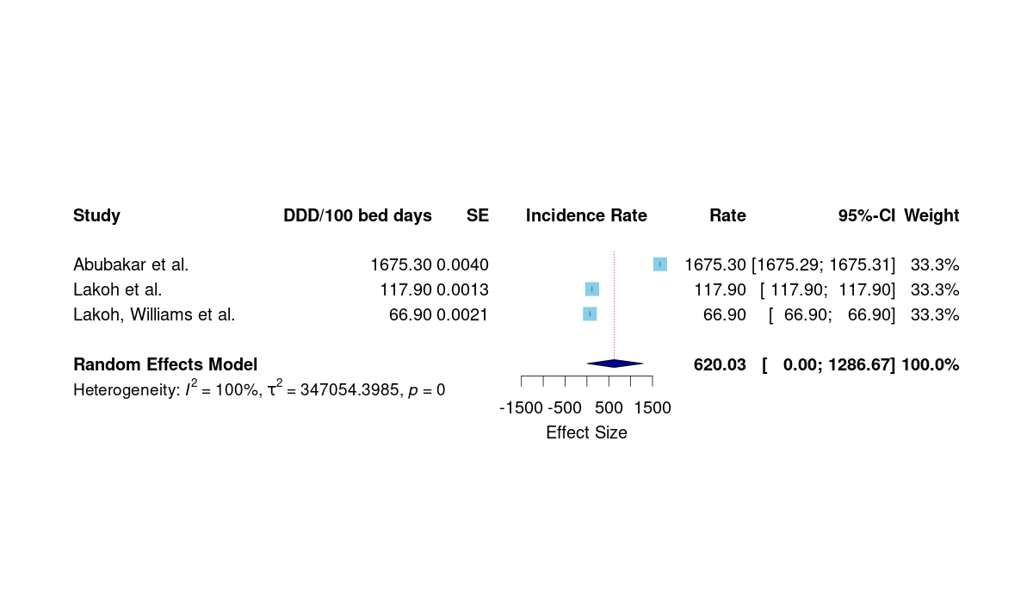
Supplementary Figure 1: Sensitivity analysis on antibiotic consumption

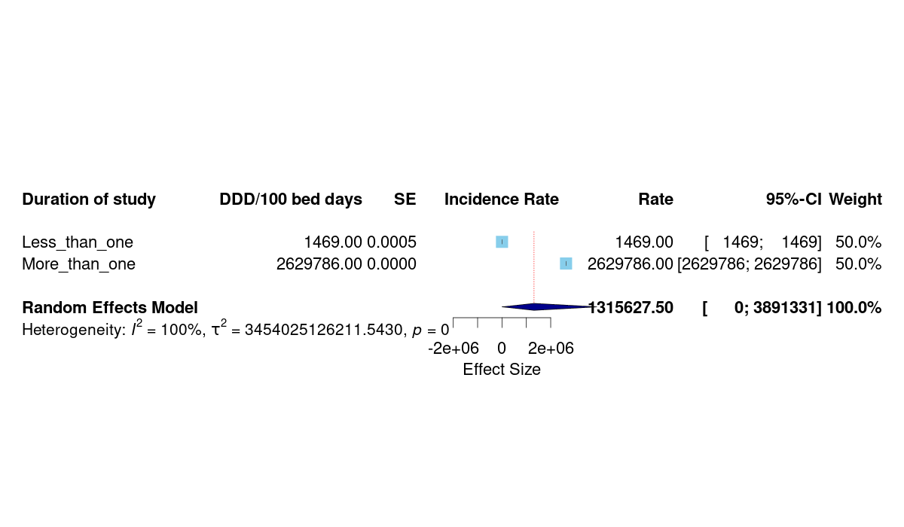
Supplementary Figure 2: Antibiotic consumption subgroup analysis on duration of study

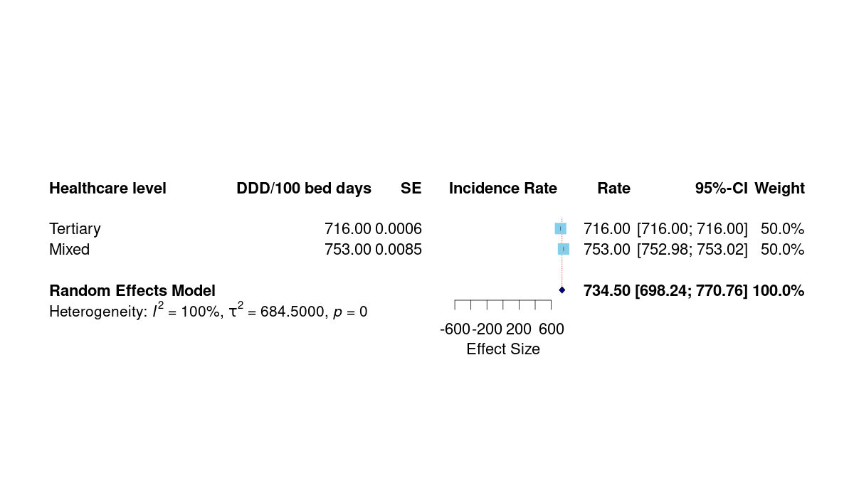

Supplementary Figure 3: Antibiotic consumption subgroup analysis on healthcare level

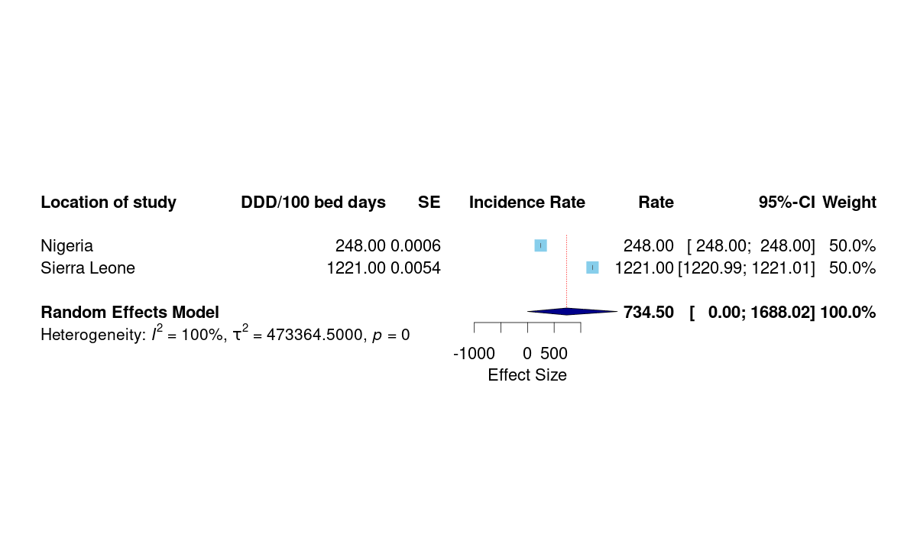
Supplementary Figure 4: Antibiotic consumption subgroup analysis on location of study

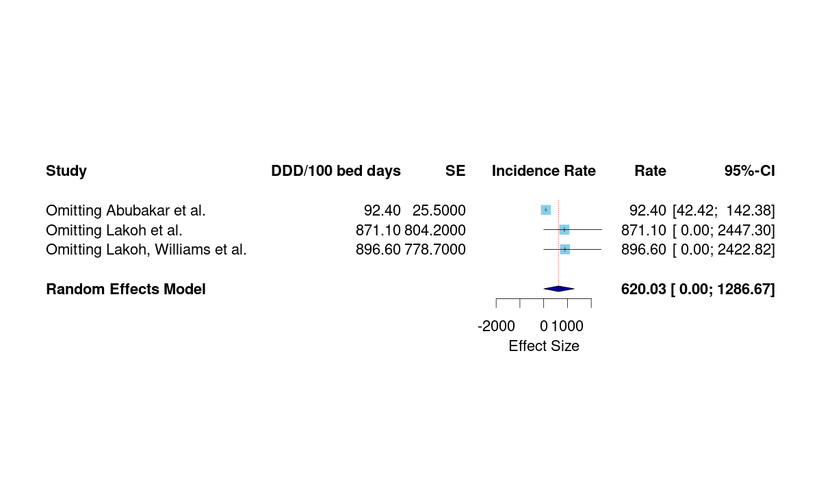
Supplementary Figure 5: Antibiotic consumption sensitivity analysis without outliers

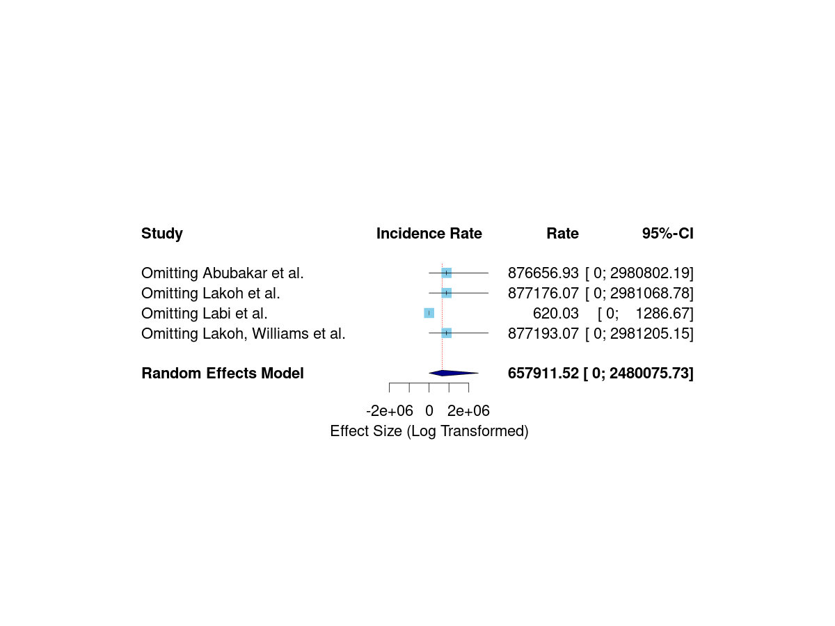
Supplementary Figure 6: Antibiotic consumption sensitivity analysis with outliers

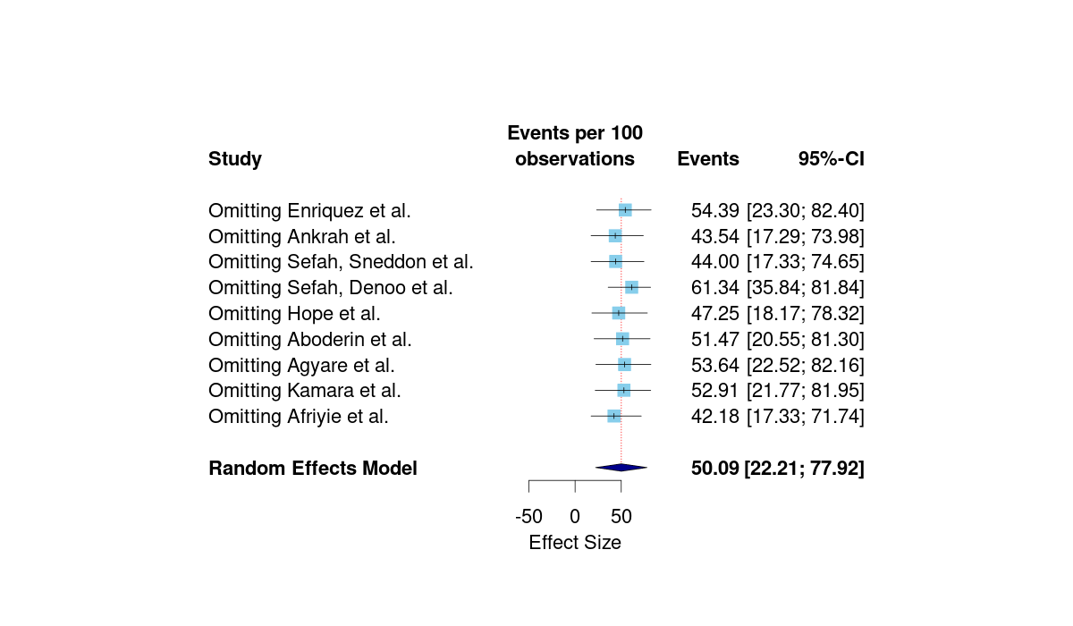
Supplementary Figure 7: Antibiotic appropriateness sensitivity analysis

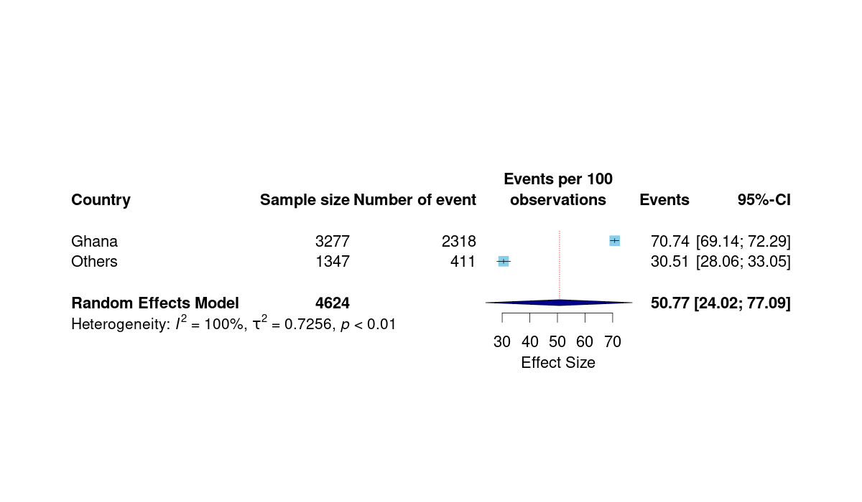
Supplementary Figure 8: Antibiotic appropriateness subgroup analysis on country/location

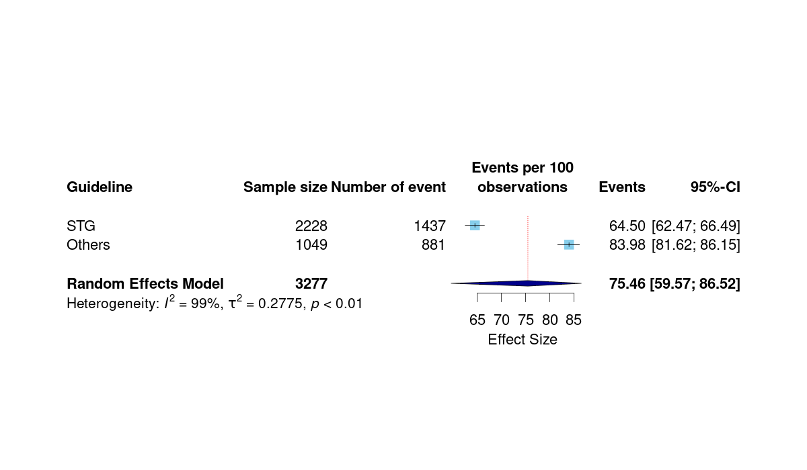
Supplementary Figure 9: Antibiotic appropriateness subgroup analysis on guidelines used in Ghana

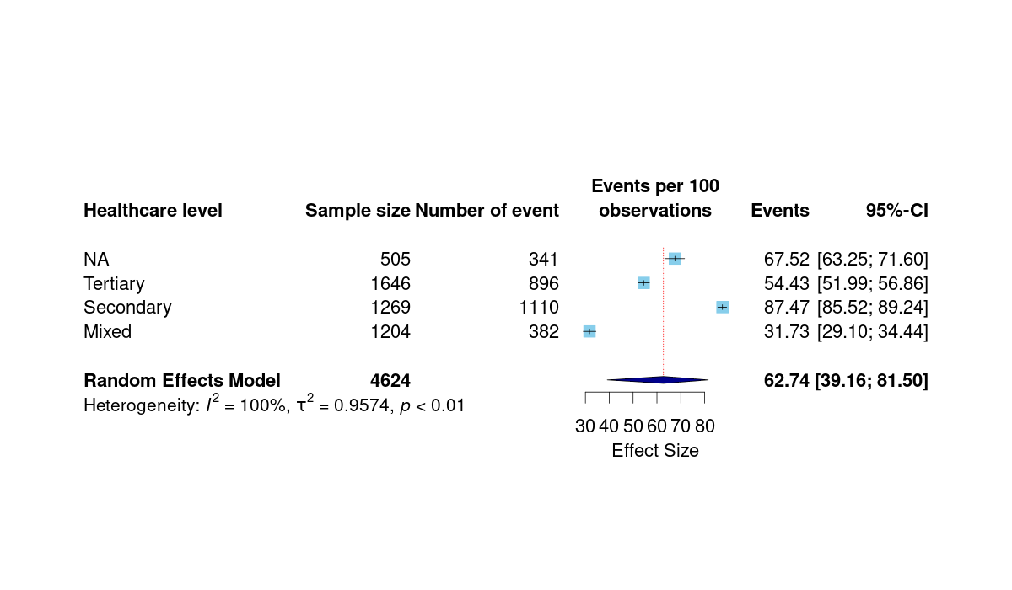
Supplementary Figure 10: Antibiotic appropriateness subgroup analysis on healthcare level

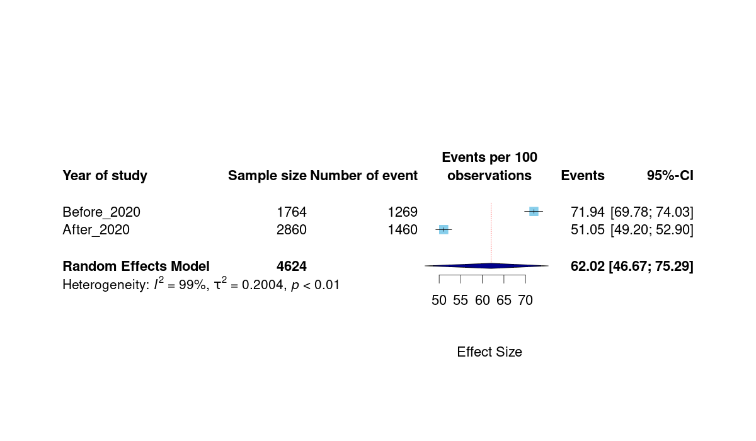
Supplementary Figure 11: Antibiotic appropriateness subgroup analysis on year of study

Table 5. Summary of findings of the knowledge, attitudes, and practice surveys
Publication | Duration/ period of study | Location | Population type | Population Size | Theme of Assessing Survey | Summary of findings
Afari-Asiedu, Hulscher, et al.,. (98) | January-March, 2019 | Ghana | Health professionals, community members | 70 | Antibiotic use | Antibiotics were mostly misused through self-medication for several diseases
 |  |  |  |  | Sources of knowledge on antibiotics | The major sources of knowledge were doctors, pharmacies, OTC sellers, drug peddlers, family, friends, radio, and television.
 |  |  |  |  | Knowledge of antibiotics | There was poor knowledge of what antibiotics were and they were mostly confused with painkillers.
Afari-Asiedu et al. et al. (38) | January-June, 2017 | Ghana | Antibiotic suppliers, community members | 72 | Knowledge of the regulations on the sale of antibiotics | Antibiotic suppliers were aware that regulations prevented them from selling antibiotics except Cotrimoxazole.
 |  |  |  |  | Community demand for antibiotics | There was high community demand for antibiotics owing to factors like knowledge of the effectiveness of some antibiotics, financial constraints, delays in assessing care at health facilities, and distance to health facilities.
 |  |  |  |  | Resolving the differences in regulatory and community demands of antibiotics | Antibiotic sellers suggested that they should be trained to sell all types of antibiotics instead of being largely restricted.
Afari-Asiedu, Oppong, et al., et al. (40) | July, 2016- September, 2018 | Ghana | Community members | 1100 households | Antibiotic use | A total of 585 (53.2%) households with 3193 members used antibiotics. Of these 676 (21.2%) used antibiotics, with 489 (64.3%) using them without prescription, 345 (45.34%) not completing their antibiotic courses and 336 (44.15%) not following instructions for the antibiotics.
 |  |  |  |  | Factors associated with choice of drug suppliers | The major factors were distance to the facility, trust in the medicine supplier and disease severity.
 |  |  |  |  | Determinants of inappropriate use of antibiotics | The major determinants were the high cost of medicines including antibiotics and low socioeconomic status.
Akande-Sholabi & Ajamu et al. (43) | August-November, 2019 | Nigeria | University students | 866 | Knowledge of antimicrobial resistance | There was good knowledge of antimicrobial resistance (58.6%) with 88.3% of the students being aware of antimicrobial resistance and its implications.
 |  |  |  |  | Antibiotic use | 95.2% of the respondents had used antibiotics in the past 12 months
 |  |  |  |  | Sources of antibiotics | Community pharmacies (52.4%), hospitals (23.3%), patent medicine vendors (18.2%), and family and friends (6.1%)
Akande-Sholabi & Oyesiji et al. (81) | - | Nigeria | Community members | 509 | Knowledge of antibiotics | 95.9% of respondents agreed to the ability of antibiotics to eliminate bacterial infections, 60.7% claimed that antibiotics could cure all types of infections, 67.2% understood what antibiotic resistance was and 57.4% were not aware of antibiotic resistance.
 |  |  |  |  | Perception on antibiotics | 74.5% held a positive perception, 85.1% concurred that it was not appropriate to purchase antibiotics without a doctor’s prescription, and 49.3% believed that antibiotic resistance could not spread to other individuals or cause death.
 |  |  |  |  | Antibiotic use and misuse | 72.5% had used antibiotics in the last 12 months, with amoxicillin (42.4%) being the most frequently used. 38.9% reported to use antibiotics in treating malaria.
 |  |  |  |  | Factors associated with antibiotic misuse | The major ones were the belief that antibiotics could relieve symptoms faster (75.8%), relying on past prescriptions from health professionals (77.4%), and perceived comfort in using antibiotics prescribed by pharmacists (73.7%).
Asante et al. (99) | January-March, 2014 | Ghana | Prescribers | 379 | Knowledge of antibiotic resistance | Prescribers had high knowledge of antibiotic resistance with 81.8% of the opinion that current antibiotics could be ineffective shortly.
 |  |  |  |  | Perception of antibiotic resistance | Prescribers were aware of the significant threat posed by antibiotic resistance and attributed its cause to irrational antibiotic prescription and overprescription, patient non-compliance, and poor regulations on antibiotic availability.
 |  |  |  |  | Practices of antibiotic use | Antibiotic prescription practices were largely poor. Laboratory investigations were less frequently employed.
Asekun-Olarinmoye et al. (100) | - | Nigeria | University staff | 450 | Knowledge of antimicrobial use | Only 40.7% had good knowledge while the majority (59.3%) had poor knowledge
 |  |  |  |  | Attitude towards antimicrobial use | Only 38.9% had a positive attitude while the majority (61.1%) had a poor attitude.
 |  |  |  |  | Antibiotic use | 62% were rightly informed about antibiotic use, 88.4% had used antibiotics in the past year with Ampicillin+Cloxacillin (19.6%) being the most frequently used, and 51.8% self-medicating at times.
Auta et al. (101) | November, 2011 | Nigeria | Community members | 430 | Knowledge of antibiotic use | 56.5% of respondents had used antibiotics before the study. 40.9% had high knowledge with 28.6% and 22.3% having intermediate and low knowledge respectively.
 |  |  |  |  | Attitude toward antibiotic use | The majority of the respondents demonstrated negative attitudes with less than 50% demonstrating positive attitudes.
Babatola et al. (102) | April1-June 30, 2019 | Nigeria | Physicians | 323 | Knowledge of AMR | 82.7%, 14.6%, and 2.7% of the respondents had good, average, and poor knowledge respectively.
 |  |  |  |  | Self-reported prescribing of antibiotics | 55.5% routinely requested for laboratory investigations. Fluoroquinolones (74%) and 3rd generation cephalosporins (72.1) were the most frequently prescribed.
 |  |  |  |  | Knowledge and attitude towards Antimicrobial Stewardship Programs (ASP) | 36.5%, 57.6%, and 5.9% had good, average, and poor knowledge of ASP respectively.
Bedekelabou et al. (103) | August 1-October 1, 2020 and January 1-July 1, 2021 | Ivory Coast and Togo | Human and animal health professionals | 221 | Knowledge of antibiotic resistance | 88% and 50% of respondents had good knowledge in Togo and Ivory Coast respectively.
 |  |  |  |  | Attitude towards antibiotic resistance | More than 75% of respondents in both countries had good perceptions of the antibiotic resistance problem.
 |  |  |  |  | Practices regarding antibiotic use | 39% and 69% of the respondents, respectively, did not systematically use the antibiogram, and 69% and 61% of pharmacists, also respectively, admitted to occasionally selling antibiotics without a prescription.
Chen et al. (104) | July-August, 2019 | Mali | Medical students | 446 | Knowledge of antibiotic use | The average knowledge score was 4.2 out of 10. 61.7% believed that overuse of antibiotics could result in the development of antibiotic resistance and 57.6% agreed that misuse of antibiotics could result in increased antibiotic resistance
 |  |  |  |  | Antibiotic use | 80.1% of 151 students self-medicated antibiotics and 71.1% bought the antibiotics without prescriptions
Chukwu et al. (51) | June-November, 2019 | Nigeria | Household members | 482 | Antibiotic use | 70.3%, 14.5%, and 2.1% bought antibiotics from pharmacies, chemists, and hawkers respectively. The most consumed antibiotics were Ampicillin/Cloxacillin (54.4%) and Ampicillin (41.7%) with the least consumed being Clindamycin (3.7%)
 |  |  |  |  | Knowledge of antibiotics and antibiotic resistance | Only 8.3% of respondents had good knowledge with 58.7% and 33% having fair and poor knowledge respectively. The major sources of knowledge were doctors/nurses (50%), pharmacists (31.3%), and family/friends (15.1%).
Chukwu et al. (52) | June-November, 2019 | Nigeria | Health workers | 358 | Awareness of AMR | 85.2% believed that AMR was relevant to their work.
 |  |  |  |  | Knowledge of AMR | 49.2%, 47.2%, and 3.6% had good, fair, and poor knowledge respectively.
 |  |  |  |  | Prescribing behaviour | Antibiotics were prescribed for common viral infections such as sore throats (75.7%), measles (37.7%), common cold and flu (21.2%). 70.9% frequently or moderately used practice guidelines while 25.7% adopted the delayed antibiotic prescription (DAP) strategy to reduce antimicrobial prescription.
Donkor et al. (78) | September, 2007-April, 2008 | Ghana | Tertiary students | 600 | Self-medication | 70% of respondents self-medicated with antibiotics with the majority (30%) doing it at 1month interval frequency. The major reasons were cost-effectiveness compared to hospital care (40.5%), and long delays in assessing hospital care (40.5%).
Effah et al. (54) | August-November, 2019 | Ghana | General public | 632 | Knowledge of antibiotic use and resistance | 25%, 40%, and 35% had low, moderate, and high knowledge. 75.9% were aware of the development of resistance against antibiotics by bacteria, and 34.8% and 33.7% knew that antibiotic-resistant bacteria could be transferred among persons and between animals and humans respectively.
 |  |  |  |  | Attitude towards antibiotic use and resistance | 39.7% waited to see if their infections would go away without medication, 62.2% relied on hand hygiene to reduce the spread of common infections and 73.1% used a doctor’s prescription to buy antibiotics from pharmacies.
Kretchy et al. (83) | - | Ghana | Adult residents | 350 | Antibiotic self-medication | There was a 36% prevalence within the past year. The commonly used antibiotics were amoxicillin (53%), ampicillin (23%), and tetracycline (21%). Among the reasons for self-medicating were past successful experience (47%), ease of antibiotic purchase (36%), and infection being minor to require medical attention (36%).
 |  |  |  |  | Where antibiotics were purchased | Community pharmacies (39%), chemical shops (29%), herbal shops (0.6%), and drug peddlers (0.6%).
Kukula et al. (60) | November-December, 2019 | Ghana | Health workers and community members | 105 | Antibiotic adherence | Several factors including the patient’s educational level, the economic status workload of health workers, the language barrier, and medication availability affect antibiotic adherence.
Manga et al. (84) | - | Nigeria | Primary health workers | 442 | Antibiotic prescribing | The prescription rate was 98.2%. The most commonly prescribed were Amoxycillin (71.7%), Ampicillin/Cloxacillin (70.1%), and Metronidazole (69.7%) while Meropenem (4.1%) was the least prescribed.
 |  |  |  |  | Antibiotic misuse | Major indicators include unconfirmed typhoid fever (96.1%), non-specific vaginal discharge (95.4%), fresh trauma wound (91.3%), non-specific diarrhea (87.1%), and common cold (85.9%). 85.8% of respondents concurred that overprescribing was a cause of antibiotic resistance.
Ogoina et al. (69) | October, 2018-February, 2019 | Nigeria | Physicians | 1778 | Knowledge of antibiotic use and AMR | More than 80% had heard of rational antibiotic prescription, 49% to 83% were aware of antibiotic-resistant organisms, 85.4% knew that antibiotics should only be stopped after completion of the course, and 90% knew that frequent use of antibiotics could result in the development of antibiotic resistance.
 |  |  |  |  | Attitude towards antibiotic prescription and AMR | The majority of the respondents agreed that AMR is a serious public health concern globally and in Nigeria, 62% and 29.5% sometimes prescribed antibiotics based on mistrust of laboratory results and recommendations of pharmaceutical companies respectively.
 |  |  |  |  | Antibiotic prescriptions | The most frequently prescribed antibiotics were Amoxicillin-Clavulanate (98%), Ciprofloxacin/Ofoxacin (97%), Ceftriaxone (69.8%), and Metronidazole (69.5%)
Ogunleye et al. (85) | - | Nigeria | Physicians | 98 | Antibiotics prescription | The major influencing factors were drug promotional and marketing influences (97.9%), clinical judgment without laboratory results (93.9%), experience (87.8%), cost to patients (80.6%), and drug availability (80.6%)
Okedo-Alex et al. (70) | April 2018 | Nigeria | Medical students | 184 | Knowledge of AMR | 96.2% attributed AMR to the misuse of antimicrobial drugs, 98.4% knew that AMR was a public health issue, and 64.7% had good knowledge of AMR and antibiotic usage.
 |  |  |  |  | Antibiotic use | 56% practiced good antibiotic usage while 44% had bad practice.
Opoku et al. (72) | October-December, 2015 | Ghana | Febrile outpatients | 2519 | Antibiotic prescription | 70.11% of the participants were prescribed antibiotics, and amongst these, 74.6% of those for whom no laboratory investigation was requested were prescribed antibiotics.
 |  |  |  |  | Factors associated with antibiotic prescription | Prescriber’s years of experience, age of the patient, presenting symptoms like cough and difficulty in swallowing, laboratory tests, and diagnoses like skin disease, UTI, and typhoid fever.
Osemene & Lamikanra. (86) | - | Nigeria | University students | 2000 | Self-medication | 53.8% of respondents self-medicated with antibiotics.
 |  |  |  |  | Reasons for self-medication | UTI (43.5%), typhoid fever (4.9%), dysentery (10%), cough and catarrh (6.8 %), diarrhea (10.2%), malaria (5.5 %), sore throat (15.3 %), otitis media (2.0 %) and pneumonia (1.8 %)
 |  |  |  |  | Sources of antibiotics | Patent medicine stores (49.3 %), community pharmacies (29.1 %), friends (11.5 %), relatives (7.1 %), and left-over drugs from previous prescriptions 55 (3.0 %).
Otieku et al. (73) | July-September, 2021 | Ghana | Outpatients | 800 | Knowledge of antibiotic use and AMR | 87.3% of participants knew about antibiotics while less than 40% knew about antibiotic resistance or AMR
 |  |  |  |  | Reasons for antibiotic use | Past effective antibiotics (70%), a recommendation from a known person (69%), prescribed by a health professional (73%), media advertisement (77%), and bacterial infections such as UTIs (76%)
Owusu-Ofori et al. (74) | January, 2018-August, 2019 | Ghana | University students | 280 | Self-medication | The most commonly used antibiotics were Amoxicillin (72.4%), Metronidazole (6.8%), Ciprofloxacin (6%) and Erythromycin (3.2%)
 |  |  |  |  | Reasons for self-medication | Major reasons include convenience (55.2%), cost saving (27.9%), and not trusting doctor (2.2%)
 |  |  |  |  | Sources of antibiotics | Pharmacies (83%), leftover antibiotics from family and friends (4.6%), leftover antibiotics from previous prescriptions (7.6%)
 |  |  |  |  | Knowledge of antibiotic use and AMR | 94.1% knew that antibiotics were used to treat bacterial infections, 73% knew of AMR
 |  |  |  |  | Attitude toward antibiotic use | 90.7% had previously misused antibiotics, and 77% agreed that antibiotic resistance was a problem in Ghana
Popoola et al. (87) | - | Nigeria | Tertiary graduates | 537 | Self-medication | 47.7% admitted to buying antibiotics without prescriptions. Inappropriate antibiotic use for viral infections like sore throat, cold and flu, and diarrhoea was reported in 50.2, 42.6, and 40.2 % of respondents, respectively.
 |  |  |  |  | Reasons for self-medication | Convenience (41.2%), limited access to health professionals (23.4%), and financial constraints (23.1%)
 |  |  |  |  | Antibiotic use | The most commonly used were Amoxicillin (54.2 %), Metronidazole (48.2 %), and Ciprofloxacin (45.6 %).
 |  |  |  |  | Where antibiotics are purchased | Pharmacies (85.6%), hospitals (7.8%), and roadside medicine vendors (4.3%)
Salihu Dadari et al. (88) | - | Nigeria | Breastfeeding mothers | 321 | Knowledge of antibiotic use and resistance | 50.55% believed that antibiotics were used to treat bacterial infections, 72.35% believed that it was wrong to use left-over antibiotics, 43.65% had not heard of antibiotic resistance before
 |  |  |  |  | Attitude toward antibiotic use | 39.79% took their drugs before breastfeeding, 22.89% took their drugs after breastfeeding, and 16.90% took their antibiotics during breastfeeding.
 |  |  |  |  | Where antibiotics are purchased | 64.07% bought their antibiotics from pharmacies
 |  |  |  |  | Antibiotic use | Penicillins (65.53%), Nitro-imidazoles (14.04%), Quinolones (7.23%), and Cotrimoxazole (4.68%) were the most used
Sanya et al. (79) | February-June, 2012 | Nigeria | Non-medical students | 400 | Sources of antibiotics | Doctor’s prescription (68.3%), pharmacist’s recommendation (11.0%), nurse’s recommendation (6.0%), trade-medical practitioner’s recommendation (1.3%), self-medication (7.3%), and from friends and relatives (6.3%).
 |  |  |  |  | Reasons for antibiotic use | Most frequent amongst them were carbuncles (20.74%), unspecified infection (18.52%), and malaria (17.03%)
 |  |  |  |  | Reasons for antibiotic non-adherence | Financial constraints (18.3%), long duration of treatment (7.5%), side effects experienced (15.0%), polypharmacy (14.0%), tablet size (11.3%), and perceived low level of confidence in the prescriber (2.8%)
Sefah et al. (89) | - | Ghana | University students | 160 | Knowledge of antibiotic use and AMR | 80% and 57.5% had good knowledge of antibiotic use and AMR respectively.
Sefah et al. (90) | - | Ghana | Healthcare professionals | 339 | Knowledge, attitude, and practice of antimicrobial stewardship (AMS) | The majority of participants had poor knowledge (91.2%) and poor practice (64.6%) but a good attitude (78.8%) toward AMS
Vicar et al. (94) | - | Ghana | Community members | 660 households | Antibiotic use | 44.1% of the households reported taking at least one type of antibiotic within the last month before the study, 30.9% had used antibiotics without a prescription, and Amoxicillin (26.0%) was the most frequently used antibiotic.
 |  |  |  |  | Sources of antibiotics | Pharmacies (41.2%), previously used antibiotics (22.5%), friends/family (18.6%), and drug hawkers (14.7%)
 |  |  |  |  | Knowledge of antibiotic use and resistance | 53.6% had good knowledge of both antibiotic use and resistance, 74.4% knew that AMR referred to the inability of antibiotics to kill bacteria, and 82.4% were aware that misuse of antibiotics was a major cause of AMR.

Table S4. List of the studies excluded at full-text screening stage
Number | First Author, Year | Article Title | Reason for Exclusion
1 | (Abubakar et al., 2021) | Knowledge and self-reported confidence in antimicrobial stewardship programme among final year pharmacy undergraduate students in Malaysia and Nigeria | Conducted in Africa and Nigeria and Malaysia. But difficult to take the results for only Nigeria
2 | (Abubakar & Tangiisuran, 2020) | Nationwide survey of pharmacists’ involvement in antimicrobial stewardship programs in Nigerian tertiary hospitals | Not really in line with the scope of our study
3 | (Adebayo & Hussain, 2010) | Pattern of prescription drug use in Nigerian army hospitals | Antibiotics not reported in DDD. Prescription in accordance with Standard guidelines was unavailable
4 | (Adisa et al., 2018) | Evaluation of antibiotic prescriptions and use in under-five children in Ibadan, South Western Nigeria | Prescription in accordance with Standard guidelines was unavailable
5 | (Afari-Asiedu et al., 2021) | Stakeholders’ perspectives on training over the counter medicine sellers and Community‑based Health Planning and Services facilities to dispense antibiotics in Ghana | Theme does not align with our manuscript
6 | (Aika & Enato, 2022) | Health care systems administrators perspectives on antimicrobial stewardship and infection prevention and control programs across three healthcare levels: a qualitative study | Did not report on any outcome such as improvement after application of AMS
7 | (Amponsah et al., 2021) | Point prevalence survey of antibiotic consumption across three hospitals in Ghana | Consumption not in DDD
8 | (Amponsah, Owusu-Ofori, et al., 2022) | Antimicrobial stewardship capacity and infection prevention and control assessment of three health facilities in the Ashanti Region of Ghana | It assessed AMS intervention but effect of AMS intervention was unavailable.
9 | (Amponsah, Ayisi-Boateng, et al., 2022) | Adherence to Prescribing Indicators at a District Hospital in Ghana: Do We Match WHO Standards? | Not on only antibiotics
10 | (Amponsah, Nagaraja, et al., 2022) | High Levels of Outpatient Antibiotic Prescription at a District Hospital in Ghana: Results of a Cross Sectional Study | Consumption not in DDD
11 | (Asaolu et al., 2021) | “Antibiotics Can Work as a Contraceptive:” Contraceptive Knowledge and Use Among University Students in Calabar, Nigeria | Did not report on any of the key themes of this manuscript
12 | (Ashiru-Oredope et al., 2022) | Development and Implementation of an Antimicrobial Stewardship Checklist in Sub-Saharan Africa: A Co-Creation Consensus Approach | Antimicrobial Stewardship intervention but wrong country
13 | (Awuor et al., 2023) | Antibiotic-Prescribing Practices for Management of Childhood Diarrhea in 3 Sub-Saharan African Countries: Findings From the Vaccine Impact on Diarrhea in Africa (VIDA) Study, 2015–2018 | Not on only antibiotics
14 | (Balayssac et al., 2023) | Targeted Pharmaceutical Analysis of Antibiotic Use by Risk Criteria in Patients Hospitalized in the Infectious and Tropical Diseases Department at Treichville Teaching Hospital (Abidjan, Côte d'Ivoire) | Antibiotic use not reported in DDD
15 | (Bediako-Bowan et al., 2019) | Antibiotic use in surgical units of selected hospitals in Ghana: a multi-centre point prevalence survey | Not in line with the theme of our manuscript
16 | (Bekoe et al., 2020) | Exposure of consumers to substandard antibiotics from selected authorised and unauthorised medicine sales outlets in Ghana | Not in line with the theme of our manuscript
17 | (Bessat et al., 2019) | Large-scale implementation of electronic Integrated Management of Childhood Illness (eIMCI) at the primary care level in Burkina Faso: a qualitative study on health worker perception of its medical content, usability and impact on antibiotic prescription and resistance | Not in line with the theme of our manuscript
18 | (Chah et al., 2022) | Knowledge and practices regarding antibiotic use among small-scale poultry farmers in Enugu State, Nigeria | Not for human antibiotic. Or not human centered but poultry
19 | (Charani et al., 2019) | Investigating the cultural and contextual determinants of antimicrobial stewardship programmes across low-, middle- and highincome countries—A qualitative study | Different countries
20 | (Chukwu et al., 2021) | Antimicrobial stewardship programmes in healthcare facilities in Lagos State, Nigeria: a needs assessment | Sample less than 30
21 | (Chukwu et al., 2024) | Implementation of antimicrobial stewardship programs: A study of prescribers’ perspective of facilitators and barriers | Did not report on any outcome such as improvement after application of AMS
22 | (Compaore et al., 2023) | Viewpoint: Antimicrobial Resistance Diagnostics Use Accelerator: Qualitative Research on Adherence to Prescriptions | It is a view point and not a research work
23 | (D’Arcy et al., 2014) | Antibiotic Prescribing Patterns in Ghana, Uganda, Zambia and Tanzania Hospitals: Results from the Global Point Prevalence Survey (G-PPS) on Antimicrobial Use and Stewardship Interventions Implemented | On multiple African countries including Ghana. But information on Ghana was difficult to take
24 | (Daniel et al., 2021) | A survey of the usage (frequency and pattern) of antibiotics at the University of Maiduguri Veterinary Teaching Hospital, Maiduguri, Borno State, Nigeria | On animal/ vertinary
25 | (Dodoo et al., 2021) | Antimicrobial Prescription Pattern in Ho Teaching Hospital, Ghana: Seasonal Determination Using a Point Prevalence Survey | In DDD
26 | (Dohou et al., 2022) | Healthcare Professionals’ Knowledge and Beliefs on Antibiotic Prophylaxis in Cesarean Section: A Mixed-Methods Study in Benin | Few samples size
27 | (Dougnon et al., 2020) | Prescription of antibiotics as a source of emerging antibiotic resistance: Knowledge, attitudes, and practices of medical staff in the Dassa-Glazoué and Savalou-Bantè’s health zones (Benin, West Africa) | Does not directly state the knowledge of antibiotic use as in the context of this manuscript.
28 | (Efunshile et al., 2019) | Apparent overuse of antibiotics in the management of watery diarrhoea in children in Abakaliki, Nigeria | Not in line with the theme of our manuscript. Antibiotic consumption not in DDD
29 | (Ekwochi et al., 2014) | The Use of Unprescribed Antibiotics in Management of Upper Respiratory Tract Infection in Children in Enugu, South East Nigeria | It is a report
30 | (Esan et al., 2018) | Assessment of Self-Medication Practices and Its Associated Factors among Undergraduates of a Private University in Nigeria | Not on only antibiotics
31 | (Ezeonu et al., 2017) | Intestinal candidiasis and antibiotic usage in children: case study of Nsukka, South Eastern Nigeria. | On candidiasis
32 | (J. Fadare et al., 2015) | Drug prescribing pattern for under-fives in a paediatric clinic in south-western Nigeria | Its on appropriate antibiotic prescription but overall prescribing appropriateness is unavailable
33 | (J. O. Fadare et al., 2019) | Status of antimicrobial stewardship programs in Nigerian tertiary healthcare facilities; findings and implications | Did not report on any outcome such as improvement after application of AMS
34 | (Fredua-Agyeman et al., 2020) | Antibiotic prescribing and the risk of antibiotic–associated diarrhoea in Korle Bu Teaching Hospital, Ghana: a pilot study | Value for the antibiotic prescription appropriateness not stated. Antibiotic consumption not reported in DDD.
35 | (Garcia-Vello et al., 2020) | A cross-sectional study on antibiotic prescription in a teaching hospital in Ghana | Its on Prescribing Appropriateness but did id not meet many of the quality assessment in our previous table
36 | (Goff et al., 2022) | Global resilience and new strategies needed for antimicrobial stewardship during the COVID-19 pandemic and beyond | Wrong country
37 | (Gyedu et al., 2019) | Antibiotics for Groin Hernia Repair According to Evidence-Based Guidelines: Time for Action in Ghana | -
38 | (Isanaka et al., 2022) | Cost-effectiveness of routine versus indicated antibiotic therapy in the management of severe wasting in children | On Cost-effectiveness
39 | (Janssen et al., 2022) | Exploring the economic impact of inappropriate antibiotic use: the case of upper respiratory tract infections in Ghana | On economic impact
40 | (G. S. Joseph & Salaudeen, 2021) | Assessment of Antibiotic Prescription Pattern as a Predisposing Factor to Growing Antibiotics Resistance in Kwara South Senatorial District of Nigeria | Not in DDD AND Prescription appropriateness was unavailable
41 | (Kamara et al., 2022) | Antibiotic Use in Suspected and Confirmed COVID-19 Patients Admitted to Health Facilities in Sierra Leone in 2020–2021: Practice Does Not Follow Policy | Not in DDD AND Prescription appropriateness was unavailable
42 | (Kamere et al., 2023) | Supply-chain factors and antimicrobial stewardship | Not in line with our themes and it’s not a research work as well
43 | (Kpagoi et al., 2023) | Assessing Changes in Surgical Site Infections and Antibiotic Use among Caesarean Section and Herniorrhaphy Patients at a Regional Hospital in Sierra Leone Following Operational Research in 2021 | Not in DDD AND Prescription appropriateness was unavailable
44 | (Kubasari et al., 2023) | Quality of Data Recording and Antimicrobial Use in a Municipal Veterinary Clinic in Ghana | Not on human
45 | (Labbé et al., 2012) | Periodical Antibiotic Treatment for the Control of Gonococcal and Chlamydial Infections Among Sex Workers in Benin and Ghana: A ClusterRandomized Placebo-Controlled Trial | Not in DDD AND Prescription appropriateness was unavailable
46 | (Labi et al., 2016) | Neonatal bloodstream infections in a Ghanaian Tertiary Hospital: Are the current antibiotic recommendations adequate? | Not in line with our themes
47 | (Lakoh et al., 2020) | Antibiotic use among hospitalized adult patients in a setting with limited laboratory infrastructure in Freetown Sierra Leone, 2017–2018 | Not in line with our inclusion criteria
48 | (Makanjuola et al., 2021) | Comparative analysis of the unregulated sale of antimicrobial prescription medication by drug retailers before and during the COVID-19 pandemic in Abuja, Nigeria | Unrelated with our themes of inclusion
49 | (Mambula et al., 2023) | Practices and challenges related to antibiotic use in paediatric treatment in hospitals and health centres in Niger and Uganda: a mixed methods study | Not in line with our inclusion themes. Additionally, wrong geographical location
50 | (Mensah et al., 2017) | Antibiotic use during pregnancy: A retrospective study of prescription patterns and birth outcomes at an antenatal clinic in rural Ghana | Not in line with our inclusion criteria. Antibiotic consumption is not in DDD.
51 | (Moon et al., 2023) | Antibiotic prescribing practices for acute respiratory illness in children less than 24 months of age in Kenema, Sierra Leone: is it time to move beyond algorithm driven decision making? | Does not report the DDD consumed. Does not report on guidelines either.
52 | (Nduka et al., 2017) | Prescribing practices for pediatric out-patients: A case study of two teaching hospitals in Nigeria | Does not cover prescribing appropriateness or any other theme under our consideration
53 | (Nelson et al., 2022) | Improving Antibiotic Stewardship for Diarrheal Disease With Probability-Based Electronic Clinical Decision Support A Randomized Crossover Trial | Did not report on any outcome such as improvement after application of AMS
54 | (Nyarko et al., 2023) | Perceived antimicrobial dispensing practices in medicine outlets in Ghana: Amaximum difference experiment design | Slightly not in line with our themes
55 | (Obasanya et al., 2022) | An appraisal of the contextual drivers of successful antimicrobial stewardship implementation in Nigerian health care facilities | Did not report on any outcome such as improvement after application of AMS
56 | (Ogunnigbo et al., 2022) | Exploring the Antimicrobial Stewardship Educational Needs of Healthcare Students and the Potential of an Antimicrobial Prescribing App as an Educational Tool in Selected African Countries | Did not report on any outcome such as improvement after application of AMS. Additionally, wrong geographical locations
57 | (Ogunrinde et al., 2012) | Knowledge, attitude and practice of home management of childhood diarrhoea among caregivers of under-5 children with diarrhoeal disease in northwestern Nigeria | It’s a report
58 | (Okoro et al., 2019) | Antibiotics prescription pattern and determinants of utilization in the national health insurance scheme at a Tertiary Hospital in Nigeria | Not reported in DDD
59 | (Oli et al., 2021) | Evaluating antimicrobial prescribing in a Tertiary Healthcare Institution in Nigeria | Fall short of the themes under consideration
60 | (Olliaro et al., 2023) | Synthesis and Meta-analysis of 3 Randomized Trials Conducted in Burkina Faso, Ghana, and Uganda Comparing the Effects of Point-of-Care Tests and Diagnostic Algorithms Versus Routine Care on Antibiotic Prescriptions and Clinical Outcomes in Ambulatory Patients <18 Years of Age With Acute Febrile Illness | Does not meet our inclusion criteria
61 | (Oloso et al., 2022) | Knowledge, Attitudes, and Risk Perception of Broiler Grow-Out Farmers on Antimicrobial Use and Resistance in Oyo State, Nigeria | Not on human antibiotic use
62 | (Opintan, 2018) | Leveraging donor support to develop a national antimicrobial resistance policy and action plan: Ghana’s success story | Did not report on the situation before the implementation of AMS or any outcome such as improvement after application of AMS.
63 | (Oppong et al., 2022) | Antibiotic stewardship and its impact on antibiotic use at the child health directorate of a teaching hospital in Ghana | Did not report on the situation before the implementation of AMS or any outcome such as improvement after application of AMS.
64 | (Osifo & Aghahowa, 2011) | Audit of antibiotic therapy in surgical neonates in a tertiary hospital in Benin City, Nigeria | Fall short of the themes under consideration
65 | (Prah et al., 2017) | Antibiotic prescription pattern in a Ghanaian primary health care facility | Value for the antibiotic prescription appropriateness not stated. Antibiotic consumption not reported in DDD.
66 | (Roberts et al., 2020) | Feasibility Study of Prospective Audit, Intervention and Feedback as an Antimicrobial Stewardship Strategy at the Lagos University Teaching Hospital | Did not report on the situation before the implementation of AMS or any outcome such as improvement after application of AMS.
67 | (Saleem et al., 2022) | Ongoing Efforts to Improve Antimicrobial Utilization in Hospitals among African Countries and Implications for the Future | Not in line with our inclusion criteria
68 | (Sawadogo et al., 2023) | Knowledge, Attitudes, and Practices Related to Antibiotic Use and Antibiotic Resistance among Poultry Farmers in Urban and Peri-Urban Areas of Ouagadougou, Burkina Faso | Among Poultry Farmers
69 | (Senn et al., 2014) | Use of Antibiotics within the IMCI Guidelines in Outpatient Settings in Papua New Guinean Children: An Observational and Effectiveness Study | Wrong geographical location
70 | (Sié et al., 2019) | Antibiotic Prescription Patterns among Children Younger than 5 Years in Nouna District, Burkina Faso | Value for the antibiotic prescription appropriateness not stated. Antibiotic consumption not reported in DDD.
71 | (Sié et al., 2021) | Indication for Antibiotic Prescription among Children Attending Primary Healthcare Services in Rural Burkina Faso | Its a report
72 | (Umar et al., 2018) | Prescribing pattern and antibiotic use for hospitalized children in a Northern Nigerian Teaching Hospital | Not in line with our inclusion criteria
73 | (Valia et al., 2022) | Use of WATCH antibiotics prior to presentation to the hospital in rural Burkina Faso | Not in DDD
74 | (Valia et al., 2023) | Healthcare seeking outside healthcare facilities and antibiotic dispensing patterns in rural Burkina Faso: A mixed methods study | Not in line with our inclusion criteria
75 | (Vialle-Valentin et al., 2012) | Predictors of antibiotic use in African communities: evidence from medicines household surveys in five countries | Wrong geographical location
76 | (Wieters et al., 2024) | Reported antibiotic use among patients in the multicenter ANDEMIA infectious diseases surveillance study in sub-saharan Africa | Antibiotic use not reported in DDD
77 | (Wood et al., 2022) | Exploring barriers to guideline implementation for prescription of surgical antibiotic prophylaxis in Nigeria | Not related to the themes under our consideration
78 | (Yevutsey et al., 2017) | Situational analysis of antibiotic use and resistance in Ghana: Policy and regulation | Not in line with our inclusion criteria
79 | (Yi et al., 2022) | Emergency department antimicrobial use in a low-resource setting: Results from a retrospective observational study at a referral hospital in Liberia | Antibiotic use not reported in DDD
80 | (Yusuf et al., 2021) | Cross-sectional survey of knowledge and attitudes of healthcare workers and community members toward the Ebola virus disease and antimicrobial resistance pathogens outbreaks in Nigeria | Not in line with our inclusion criteria
81 | (The CDI Study Group, 2010) | Community-directed interventions for priority health problems in Africa: results of a multicountry study | Not related to the themes under our consideration
82 | (Lakoh et al., 2023) | Establishing an Antimicrobial Stewardship Program in Sierra Leone: A Report of the Experience of a Low-Income Country in West Africa | Antibiotic use not reported in DDD
83 | (Aulakh et al., 2018) | Caesarean section wound infections and antibiotic use: a retrospective case-series in a tertiary referral hospital in The Gambia | The full article is not freely accessible to us
84 | (Risk et al., 2013) | Rational prescribing in paediatrics in a resource-limited setting | The full article is not freely accessible to us.
85 | (Okomo et al., 2015) | Neonatal admissions, quality of care and outcome: 4 years of inpatient audit data from The Gambia's teaching hospital | Not related to the themes under our consideration
86 | (F. Joseph et al., 2015) | Drug prescribing pattern for under-fives in a paediatric clinic in south-western Nigeria | Not solely on antibiotics
87 | (Ayele & Taye, 2018) | Antibiotic utilization pattern for surgical site infection prophylaxis at Dil Chora Referral Hospital Surgical Ward, Dire Dawa, Eastern Ethiopia | Not related to the themes under our consideration

Reference of excluded papers
Abubakar, U., Sha’aban, A., Mohammed, M., Muhammad, H. T., Sulaiman, S. A. S., & Amir, O. (2021). Knowledge and self-reported confidence in antimicrobial stewardship programme among final year pharmacy undergraduate students in Malaysia and Nigeria. Pharmacy Education, 21, 298–305. Scopus. https://doi.org/10.46542/PE.2021.211.298305
Abubakar, U., & Tangiisuran, B. (2020). Nationwide survey of pharmacists’ involvement in antimicrobial stewardship programs in Nigerian tertiary hospitals. Journal of Global Antimicrobial Resistance, 21, 148–153. Scopus. https://doi.org/10.1016/j.jgar.2019.10.007
Adebayo, E. T., & Hussain, N. A. (2010). Pattern of prescription drug use in Nigerian army hospitals. Annals of African Medicine, 9(3), Article 3. https://www.ajol.info/index.php/aam/article/view/67103
Adisa, R., Orherhe, O. M., & Fakeye, T. O. (2018). Evaluation of antibiotic prescriptions and use in under-five children in ibadan, southwestern nigeria. African Health Sciences, 18(4), 1189–1201. Scopus. https://doi.org/10.4314/AHS.V18I4.40
Afari-Asiedu, S., Hulscher, M., Abdulai, M. A., Boamah-Kaali, E., Wertheim, H. F. L., & Asante, K. P. (2021). Stakeholders’ perspectives on training over the counter medicine sellers and Community-based Health Planning and Services facilities to dispense antibiotics in Ghana. Journal of Pharmaceutical Policy and Practice, 14(1). Scopus. https://doi.org/10.1186/s40545-021-00349-0
Aika, I. N., & Enato, E. (2022). Health care systems administrators perspectives on antimicrobial stewardship and infection prevention and control programs across three healthcare levels: A qualitative study. Antimicrobial Resistance & Infection Control, 11(1), 157. https://doi.org/10.1186/s13756-022-01196-7
Amponsah, O. K. O., Ayisi-Boateng, N. K., Nagaraja, S. B., Nair, D., Muradyan, K., Hedidor, G. K., Labi, A.-K., Opare-Addo, M. N. A., Sarkodie, E., & Buabeng, K. O. (2022). Adherence to Prescribing Indicators at a District Hospital in Ghana: Do We Match WHO Standards? International Journal of Environmental Research and Public Health, 19(19), Article 19. https://doi.org/10.3390/ijerph191912260
Amponsah, O. K. O., Buabeng, K. O., Owusu-Ofori, A., Ayisi-Boateng, N. K., Hämeen-Anttila, K., & Enlund, H. (2021). Point prevalence survey of antibiotic consumption across three hospitals in Ghana. JAC-Antimicrobial Resistance, 3(1). Scopus. https://doi.org/10.1093/jacamr/dlab008
Amponsah, O. K. O., Nagaraja, S. B., Ayisi-Boateng, N. K., Nair, D., Muradyan, K., Asense, P. S., Wusu-Ansah, O. K., Terry, R. F., Khogali, M., & Buabeng, K. O. (2022). High Levels of Outpatient Antibiotic Prescription at a District Hospital in Ghana: Results of a Cross Sectional Study. International Journal of Environmental Research and Public Health, 19(16), Article 16. https://doi.org/10.3390/ijerph191610286
Amponsah, O. K. O., Owusu-Ofori, A., Ayisi-Boateng, N. K., Attakorah, J., Opare-Addo, M. N. A., & Buabeng, K. O. (2022). Antimicrobial stewardship capacity and infection prevention and control assessment of three health facilities in the Ashanti Region of Ghana. JAC-Antimicrobial Resistance, 4(2). Scopus. https://doi.org/10.1093/jacamr/dlac034
Asaolu, I., Kram, N., Ajala, C., Aquaisua, E., Asaolu, A., Kato-Lagumbay, K., Abuh, A., Bernand, M., & Ehiri, J. (2021). “Antibiotics Can Work as a Contraceptive:” Contraceptive Knowledge and Use Among University Students in Calabar, Nigeria. Frontiers in Reproductive Health, 3. Scopus. https://doi.org/10.3389/frph.2021.665653
Ashiru-Oredope, D., Garraghan, F., Olaoye, O., Krockow, E. M., Matuluko, A., Nambatya, W., Babigumira, P. A., Tuck, C., Amofah, G., Ankrah, D., Barrett, S., Benedict, P., Boaitey, K. P., Buabeng, K. O., Cavanagh, S., Charani, E., Chikatula, E., Ghebrehewet, S., Islam, J., … Skone-James, R. (2022). Development and Implementation of an Antimicrobial Stewardship Checklist in Sub-Saharan Africa: A Co-Creation Consensus Approach. Healthcare (Switzerland), 10(9). Scopus. https://doi.org/10.3390/healthcare10091706
Aulakh, A., Idoko, P., Anderson, S. T., & Graham, W. (2018). Caesarean section wound infections and antibiotic use: A retrospective case-series in a tertiary referral hospital in The Gambia. Tropical Doctor, 48(3), 192–199. https://doi.org/10.1177/0049475517739539
Awuor, A. O., Ogwel, B., Powell, H., Verani, J. R., Sow, S. O., Hossain, M. J., Ochieng, J. B., Juma, J., Jamka, L. P., Roose, A., Doh, S., Deichsel, E. L., Onwuchekwa, U., Keita, A. M., Antonio, M., Jones, J. C. M., Zaman, S. M. A., Badji, H., Kasumba, I. N., … Kotloff, K. L. (2023). Antibiotic-Prescribing Practices for Management of Childhood Diarrhea in 3 Sub-Saharan African Countries: Findings From the Vaccine Impact on Diarrhea in Africa (VIDA) Study, 2015–2018. Clinical Infectious Diseases, 76(Supplement_1), S32–S40. https://doi.org/10.1093/cid/ciac980
Ayele, Y., & Taye, H. (2018). Antibiotic utilization pattern for surgical site infection prophylaxis at Dil Chora Referral Hospital Surgical Ward, Dire Dawa, Eastern Ethiopia. BMC Research Notes, 11(1), 537. https://doi.org/10.1186/s13104-018-3629-6
Balayssac, J. E., Djadji, L. T. A., Aimé, B. N., Silue, A. N. G., Tia, E. G., & Eholié, S. P. (2023). Targeted Pharmaceutical Analysis of Antibiotic Use by Risk Criteria in Patients Hospitalized in the Infectious and Tropical Diseases Department at Treichville Teaching Hospital (Abidjan, Côte d’Ivoire). Biomedical and Pharmacology Journal, 16(3), 1491–1504. Scopus. https://doi.org/10.13005/bpj/2727
Bediako-Bowan, A. A. A., Owusu, E., Labi, A.-K., Obeng-Nkrumah, N., Sunkwa-Mills, G., Bjerrum, S., Opintan, J. A., Bannerman, C., Mølbak, K., Kurtzhals, Jø. A. L., & Newman, M. J. (2019). Antibiotic use in surgical units of selected hospitals in Ghana: A multi-centre point prevalence survey. BMC Public Health, 19(1). Scopus. https://doi.org/10.1186/s12889-019-7162-x
Bekoe, S. O., Ahiabu, M.-A., Orman, E., Tersbøl, B. P., Adosraku, R. K., Hansen, M., Frimodt-Moller, N., & Styrishave, B. (2020). Exposure of consumers to substandard antibiotics from selected authorised and unauthorised medicine sales outlets in Ghana. Tropical Medicine and International Health, 25(8), 962–975. Scopus. https://doi.org/10.1111/tmi.13442
Bessat, C., Zonon, N. A., & D’Acremont, V. (2019). Large-scale implementation of electronic Integrated Management of Childhood Illness (eIMCI) at the primary care level in Burkina Faso: A qualitative study on health worker perception of its medical content, usability and impact on antibiotic prescription and resistance. BMC Public Health, 19(1), 449. https://doi.org/10.1186/s12889-019-6692-6
Chah, J. M., Nwankwo, S. C., Uddin, I. O., & Chah, K. F. (2022). Knowledge and practices regarding antibiotic use among small-scale poultry farmers in Enugu State, Nigeria. Heliyon, 8(4). Scopus. https://doi.org/10.1016/j.heliyon.2022.e09342
Charani, E., Smith, I., Skodvin, B., Perozziello, A., Lucet, J.-C., Lescure, F.-X., Birgand, G., Poda, A., Ahmad, R., & Singh, S. (2019). Investigating the cultural and contextual determinants of antimicrobial stewardship programmes across low-, middle-and high-income countries—A qualitative study. PloS One, 14(1), e0209847.
Chukwu, E. E., Abuh, D., Idigbe, I. E., Osuolale, K. A., Chuka-Ebene, V., Awoderu, O., Audu, R. A., & Ogunsola, F. T. (2024). Implementation of antimicrobial stewardship programs: A study of prescribers’ perspective of facilitators and barriers. Plos One, 19(1), e0297472.
Chukwu, E. E., Oshun, P. O., Osuolale, K. A., Chuka-Ebene, V. O., Salako, A., Idigbe, I. E., Oladele, D., Audu, R. A., & Ogunsola, F. T. (2021). Antimicrobial stewardship programmes in healthcare facilities in Lagos State, Nigeria: A needs assessment. Journal of Global Antimicrobial Resistance, 25, 162–170. Scopus. https://doi.org/10.1016/j.jgar.2021.02.034
Compaore, A., Ekusai-Sebatta, D., Kaawa-Mafigiri, D., Kukula, V., Odopey, S., Kapisi, J., Hopkins, H., Kiemde, F., Tinto, H., Baiden, R., Olliaro, P., Nkeramahame, J., Dittrich, S., & Horgan, P. (2023). Viewpoint: Antimicrobial Resistance Diagnostics Use Accelerator: Qualitative Research on Adherence to Prescriptions. Clinical Infectious Diseases, 77, S206–S210. Scopus. https://doi.org/10.1093/cid/ciad323
Daniel, N., Malgwi, K. D., Umaru, B., Omeh, I. J., & Sanya, L. (2021). A survey of the usage (frequency and pattern) of antibiotics at the University of Maiduguri Veterinary Teaching Hospital, Maiduguri, Borno State, Nigeria. Veterinary World, 14(11), 2941–2946. Scopus. https://doi.org/10.14202/vetworld.2021.2941-2946
D’Arcy, N., Cloutman-Green, E., Klein, N., & Spratt, D. A. (2014). Environmental viral contamination in a pediatric hospital outpatient waiting area: Implications for infection control. American Journal of Infection Control, 42(8), 856–860. https://doi.org/10.1016/j.ajic.2014.04.014
Dodoo, C. C., Orman, E., Alalbila, T., Mensah, A., Jato, J., Mfoafo, K. A., Folitse, I., Hutton-Nyameaye, A., Ben, I. O., Mensah-Kane, P., Sarkodie, E., Kpokiri, E., Ladva, M., Awadzi, B., & Jani, Y. (2021). Antimicrobial prescription pattern in ho teaching hospital, ghana: Seasonal determination using a point prevalence survey. Antibiotics, 10(2), 1–11. Scopus. https://doi.org/10.3390/antibiotics10020199
Dohou, A. M., Buda, V. O., Anagonou, S., Bambeke, F. V., Hees, T. V., Dossou, F. M., & Dalleur, O. (2022). Healthcare Professionals’ Knowledge and Beliefs on Antibiotic Prophylaxis in Cesarean Section: A Mixed-Methods Study in Benin. Antibiotics, 11(7). Scopus. https://doi.org/10.3390/antibiotics11070872
Dougnon, V., Chabi, Y., Koudokpon, H., Agbankpe, J., Sefounon, R., Alle, D., Bankole, H., & Baba-Moussa, L. (2020). Prescription of antibiotics as a source of emerging antibiotic resistance: Knowledge, attitudes, and practices of medical staff in the Dassa-Glazoué and Savalou-Bantè’s health zones (Benin, West Africa). International Journal of One Health, 6(1), 34–40. Scopus. https://doi.org/10.14202/IJOH.2020.34-40
Efunshile, A. M., Ezeanosike, O., Nwangwu, C. C., König, B., Jokelainen, P., & Robertson, L. J. (2019). Apparent overuse of antibiotics in the management of watery diarrhoea in children in Abakaliki, Nigeria. BMC Infectious Diseases, 19(1). Scopus. https://doi.org/10.1186/s12879-019-3899-1
Ekwochi, U., Chinawa, J. M., Osuorah, C. D. I., Odetunde, O. I., Obu, H. A., & Agwu, S. (2014). The use of unprescribed antibiotics in management of upper respiratory tract infection in children in Enugu, South East Nigeria. Journal of Tropical Pediatrics, 60(3), 249–252. Scopus. https://doi.org/10.1093/tropej/fmt111
Esan, D. T., Fasoro, A. A., Odesanya, O. E., Esan, T. O., Ojo, E. F., & Faeji, C. O. (2018). Assessment of Self-Medication Practices and Its Associated Factors among Undergraduates of a Private University in Nigeria. Journal of Environmental and Public Health, 2018. Scopus. https://doi.org/10.1155/2018/5439079
Ezeonu, I. M., Ntun, N. W., & Ugwu, K. O. (2017). Intestinal candidiasis and antibiotic usage in children: Case study of Nsukka, South Eastern Nigeria. African Health Sciences, 17(4), 1178–1184. Scopus. https://doi.org/10.4314/ahs.v17i4.27
Fadare, J. O., Ogunleye, O., Iliyasu, G., Adeoti, A., Schellack, N., Engler, D., Massele, A., & Godman, B. (2019). Status of antimicrobial stewardship programmes in Nigerian tertiary healthcare facilities: Findings and implications. Journal of Global Antimicrobial Resistance, 17, 132–136. Scopus. https://doi.org/10.1016/j.jgar.2018.11.025
Fadare, J., Olatunya, O., Oluwayemi, O., & Ogundare, O. (2015). Drug prescribing pattern for under-fives in a paediatric clinic in South-Western Nigeria. Ethiopian Journal of Health Sciences, 25(1), 73–78. Scopus. https://doi.org/10.4314/ejhs.v25i1.10
Fredua-Agyeman, M., Onwukwe, B., & Adu-Aryee, N. A. (2020). Antibiotic prescribing and the risk of antibiotic–associated diarrhoea in Korle Bu Teaching Hospital, Ghana: A pilot study. The Journal of Infection in Developing Countries, 14(08), Article 08. https://doi.org/10.3855/jidc.11259
Garcia-Vello, P., Brobbey, F., Gonzalez-Zorn, B., & Setsoafia Saba, C. K. (2020). A cross-sectional study on antibiotic prescription in a teaching hospital in Ghana. The Pan African Medical Journal, 35, 12. https://doi.org/10.11604/pamj.2020.35.12.18324
Goff, D. A., Gauthier, T. P., Langford, B. J., Prusakov, P., Ubaka Chukwuemka, M., Nwomeh, B. C., Yunis, K. A., Saad, T., van den Bergh, D., Villegas, M. V., Martinez, N., Morris, A., Ashiru-Oredope, D., Howard, P., & Sanchez, P. J. (2022). Global resilience and new strategies needed for antimicrobial stewardship during the COVID-19 pandemic and beyond. JACCP Journal of the American College of Clinical Pharmacy, 5(7), 707–715. Scopus. https://doi.org/10.1002/jac5.1622
Gyedu, A., Katz, M., Agbedinu, K., Donkor, P., & Mock, C. (2019). Antibiotics for Groin Hernia Repair According to Evidence-Based Guidelines: Time for Action in Ghana. Journal of Surgical Research, 238, 90–95. Scopus. https://doi.org/10.1016/j.jss.2019.01.040
Isanaka, S., Tang, K., Berthé, F., Grais, R. F., & Pandya, A. (2022). Cost-effectiveness of routine versus indicated antibiotic therapy in the management of severe wasting in children. Cost Effectiveness and Resource Allocation, 20(1). Scopus. https://doi.org/10.1186/s12962-022-00374-z
Janssen, J., Afari-Asiedu, S., Monnier, A., Abdulai, M. A., Tawiah, T., Wertheim, H., Baltussen, R., & Asante, K. P. (2022). Exploring the economic impact of inappropriate antibiotic use: The case of upper respiratory tract infections in Ghana. Antimicrobial Resistance & Infection Control, 11(1), 53. https://doi.org/10.1186/s13756-022-01096-w
Joseph, F., Oladele, O., Oludare, O., & Olatunde, O. (2015). Drug prescribing pattern for under-fives in a paediatric clinic in south-western Nigeria. Ethiopian Journal of Health Sciences, 25(1), Article 1. https://doi.org/10.4314/ejhs.v25i1.10
Joseph, G. S., & Salaudeen, A. G. (2021). Assessment of Antibiotic Prescription Pattern as a Predisposing Factor to Growing Antibiotics Resistance in Kwara South Senatorial District of Nigeria. Texila International Journal of Public Health, 9(2). Scopus. https://doi.org/10.21522/TIJPH.2013.09.02.Art020
Kamara, I. F., Kumar, A. M. V., Maruta, A., Fofanah, B. D., Njuguna, C. K., Shongwe, S., Moses, F., Tengbe, S. M., Kanu, J. S., Lakoh, S., Mansaray, A. H. D., Selvaraj, K., Khogali, M., & Zachariah, R. (2022). Antibiotic Use in Suspected and Confirmed COVID-19 Patients Admitted to Health Facilities in Sierra Leone in 2020–2021: Practice Does Not Follow Policy. International Journal of Environmental Research and Public Health, 19(7), Article 7. https://doi.org/10.3390/ijerph19074005
Kamere, N., Rutter, V., Munkombwe, D., Aywak, D. A., Muro, E. P., Kaminyoghe, F., Rajab, K., Lawal, M. O., Muriithi, N., Kusu, N., Karimu, O., Barlatt, S. H. A., Nambatya, W., & Ashiru-Oredope, D. (2023). Supply-chain factors and antimicrobial stewardship. Bulletin of the World Health Organization, 101(6), 403–411. Scopus. https://doi.org/10.2471/BLT.22.288650
Kpagoi, S. S. T. K., Kamara, K. N., Carshon-Marsh, R., Delamou, A., Manzi, M., Kamara, R. Z., Moiwo, M. M., Kamara, M., Koroma, Z., Lakoh, S., Fofanah, B. D., Kamara, I. F., Kanu, A. B. J., Kenneh, S., Kanu, J. S., Margao, S., & Kamau, E. M. (2023). Assessing Changes in Surgical Site Infections and Antibiotic Use among Caesarean Section and Herniorrhaphy Patients at a Regional Hospital in Sierra Leone Following Operational Research in 2021. Tropical Medicine and Infectious Disease, 8(8). Scopus. https://doi.org/10.3390/tropicalmed8080385
Kubasari, C., Adeapena, W., Najjemba, R., Hedidor, G. K., Adjei, R. L., Manu, G., Timire, C., Afari-Asiedu, S., & Asante, K. P. (2023). Quality of Data Recording and Antimicrobial Use in a Municipal Veterinary Clinic in Ghana. Tropical Medicine and Infectious Disease, 8(11). Scopus. https://doi.org/10.3390/tropicalmed8110485
Labbé, A.-C., Pépin, J., Khonde, N., Dzokoto, A., Méda, H., Asamoah-Adu, C., Mayaud, P., Mabey, D., Demers, E., & Alary, M. (2012). Periodical antibiotic treatment for the control of gonococcal and chlamydial infections among sex workers in benin and Ghana: A cluster-randomized placebo-controlled trial. Sexually Transmitted Diseases, 39(4), 253–259. Scopus. https://doi.org/10.1097/OLQ.0b013e318244aaa0
Labi, A.-K., Obeng-Nkrumah, N., Bjerrum, S., Enweronu-Laryea, C., & Newman, M. J. (2016). Neonatal bloodstream infections in a Ghanaian Tertiary Hospital: Are the current antibiotic recommendations adequate? BMC Infectious Diseases, 16(1). Scopus. https://doi.org/10.1186/s12879-016-1913-4
Lakoh, S., Adekanmbi, O., Jiba, D. F., Deen, G. F., Gashau, W., Sevalie, S., & Klein, E. Y. (2020). Antibiotic use among hospitalized adult patients in a setting with limited laboratory infrastructure in Freetown Sierra Leone, 2017–2018. International Journal of Infectious Diseases, 90, 71–76. https://doi.org/10.1016/j.ijid.2019.10.022
Lakoh, S., Bawoh, M., Lewis, H., Jalloh, I., Thomas, C., Barlatt, S., Jalloh, A., Deen, G. F., Russell, J. B. W., Kabba, M. S., Batema, M. N. P., Borgstein, C., Sesay, N., Sesay, D., Nagi, N. K., Firima, E., & Thomas, S. (2023). Establishing an Antimicrobial Stewardship Program in Sierra Leone: A Report of the Experience of a Low-Income Country in West Africa. Antibiotics, 12(3). Scopus. https://doi.org/10.3390/antibiotics12030424
Makanjuola, R. O., Bello, A. A., Sadiq, F. U., Ishaleku, D., Oduwole, K. H., & Taylor-Robinson, A. W. (2021). Comparative analysis of the unregulated sale of antimicrobial prescription medication by drug retailers before and during the COVID-19 pandemic in Abuja, Nigeria. Microbes and Infectious Diseases, 2(3), 423–432. Scopus. https://doi.org/10.21608/MID.2021.71677.1142
Mambula, G., Nanjebe, D., Munene, A., Guindo, O., Salifou, A., Mamaty, A.-A., Rattigan, S., Ellis, S., Khavessian, N., van der Pluijm, R. W., Marquer, C., Adehossi, I. A., & Langendorf, C. (2023). Practices and challenges related to antibiotic use in paediatric treatment in hospitals and health centres in Niger and Uganda: A mixed methods study. Antimicrobial Resistance & Infection Control, 12(1), 67. https://doi.org/10.1186/s13756-023-01271-7
Mensah, K. B., Opoku-Agyeman, K., & Ansah, C. (2017). Antibiotic use during pregnancy: A retrospective study of prescription patterns and birth outcomes at an antenatal clinic in rural Ghana. Journal of Pharmaceutical Policy and Practice, 10(1). Scopus. https://doi.org/10.1186/s40545-017-0111-0
Moon, T. D., Sumah, I., Amorim, G., Alhasan, F., Howard, L. M., Myers, H., Green, A. F., Grant, D. S., Schieffelin, J. S., & Samuels, R. J. (2023). Antibiotic prescribing practices for acute respiratory illness in children less than 24 months of age in Kenema, Sierra Leone: Is it time to move beyond algorithm driven decision making? BMC Infectious Diseases, 23(1), 626. https://doi.org/10.1186/s12879-023-08606-0
Nduka, S. O., Edebeatu, C., Isidienu, C. P., & Amorha, K. C. (2017). Prescribing practices for pediatric out-patients: A case study of two teaching hospitals in Nigeria. Tropical Journal of Pharmaceutical Research, 16(3), 705–711. Scopus. https://doi.org/10.4314/tjpr.v16i3.28
Nelson, E. J., Khan, A. I., Keita, A. M., Brintz, B. J., Keita, Y., Sanogo, D., Islam, M. T., Khan, Z. H., Rashid, M. M., Nasrin, D., Watt, M. H., Ahmed, S. M., Haaland, B., Pavia, A. T., Levine, A. C., Chao, D. L., Kotloff, K. L., Qadri, F., & Sow, S. O. (2022). Improving Antibiotic Stewardship for Diarrheal Disease with Probability-Based Electronic Clinical Decision Support: A Randomized Crossover Trial. JAMA Pediatrics, 176(10), 973–979. Scopus. https://doi.org/10.1001/jamapediatrics.2022.2535
Nyarko, E., Akoto, F. M., & Doku-Amponsah, K. (2023). Perceived antimicrobial dispensing practices in medicine outlets in Ghana: A maximum difference experiment design. PLoS ONE, 18(7), 1–15. https://doi.org/10.1371/journal.pone.0288519
Obasanya, J. O., Ogunbode, O., & Landu-Adams, V. (2022). An appraisal of the contextual drivers of successful antimicrobial stewardship implementation in Nigerian health care facilities. Journal of Global Antimicrobial Resistance, 31, 141–148. https://doi.org/10.1016/j.jgar.2022.08.007
Ogunnigbo, O., Nabiryo, M., Atteh, M., Muringu, E., Olaitan, O. J., Rutter, V., & Ashiru-Oredope, D. (2022). Exploring the Antimicrobial Stewardship Educational Needs of Healthcare Students and the Potential of an Antimicrobial Prescribing App as an Educational Tool in Selected African Countries. Antibiotics, 11(5). Scopus. https://doi.org/10.3390/antibiotics11050691
Ogunrinde, O. G., Raji, T., Owolabi, O. A., & Anigo, K. M. (2012). Knowledge, attitude and practice of home management of childhood diarrhoea among caregivers of under-5 children with diarrhoeal disease in northwestern Nigeria. Journal of Tropical Pediatrics, 58(2), 143–146. Scopus. https://doi.org/10.1093/tropej/fmr048
Okomo, U. A., Dibbasey, T., Kassama, K., Lawn, J. E., Zaman, S. M. A., Kampmann, B., Howie, S. R. C., & Bojang, K. (2015). Neonatal admissions, quality of care and outcome: 4 years of inpatient audit data from The Gambia’s teaching hospital. Paediatrics and International Child Health. https://doi.org/10.1179/2046905515Y.0000000036
Okoro, R. N., Nmeka, C., & Erah, P. O. (2019). Antibiotics prescription pattern and determinants of utilization in the national health insurance scheme at a Tertiary Hospital in Nigeria. African Health Sciences, 19(3), Article 3. https://doi.org/10.4314/ahs.v19i3.8
Oli, A. N., Onyeaso, N., Emencheta, S. C., Ofomata, C. M., Kretchy, J.-P., Okhamafe, A., & Ele, G. N. (2021). Evaluating antimicrobial prescribing in a Tertiary Healthcare Institution in Nigeria. Journal of Pharmaceutical Policy and Practice, 14(1). Scopus. https://doi.org/10.1186/s40545-021-00380-1
Olliaro, P., Nkeramahame, J., Horgan, P., Tinto, H., Kiemde, F., Baiden, R., Adjei, A., Kapisi, J., Hopkins, H., Salami, O., Moore, C. E., Dittrich, S., Weber, S., & Ongarello, S. (2023). Synthesis and Meta-analysis of 3 Randomized Trials Conducted in Burkina Faso, Ghana, and Uganda Comparing the Effects of Point-of-Care Tests and Diagnostic Algorithms Versus Routine Care on Antibiotic Prescriptions and Clinical Outcomes in Ambulatory Patients <18 Years of Age with Acute Febrile Illness. Clinical Infectious Diseases, 77, S199–S205. Scopus. https://doi.org/10.1093/cid/ciad324
Oloso, N. O., Odetokun, I. A., Ghali-Mohammed, I., Fasina, F. O., Olatoye, I. O., & Adetunji, V. O. (2022). Knowledge, Attitudes, and Risk Perception of Broiler Grow-Out Farmers on Antimicrobial Use and Resistance in Oyo State, Nigeria. Antibiotics, 11(5). Scopus. https://doi.org/10.3390/antibiotics11050567
Opintan, J. A. (2018). Leveraging donor support to develop a national antimicrobial resistance policy and action plan: Ghana’s success story. African Journal of Laboratory Medicine, 7(2). Scopus. https://doi.org/10.4102/ajlm.v7i2.825
Oppong, K. G., Attakorah, J., Enimil, A., Ansah, C., & Buabeng, K. O. (2022). ANTIBIOTIC STEWARDSHIP AND ITS IMPACT ON ANTIBIOTIC USE AT THE CHILD HEALTH DIRECTORATE OF A TEACHING HOSPITAL IN GHANA. African Journal of Applied Research, 8(2), 322–331. Scopus. https://doi.org/10.26437/ajar.31.10.2022.22
Osifo, O., & Aghahowa, S. (2011). Audit of antibiotic therapy in surgical neonates in a tertiary hospital in Benin City, Nigeria. African Journal of Paediatric Surgery, 8(1), 23–28. Scopus. https://doi.org/10.4103/0189-6725.78664
Prah, J., Kizzie-Hayford, J., Walker, E., & Ampofo-Asiama, A. (2017). Antibiotic prescription pattern in a Ghanaian primary health care facility. Pan African Medical Journal, 28. Scopus. https://doi.org/10.11604/pamj.2017.28.214.13940
Risk, R., Naismith, H., Burnett, A., Moore, S. E., Cham, M., & Unger, S. (2013). Rational prescribing in paediatrics in a resource-limited setting. Archives of Disease in Childhood, 98(7), 503–509. https://doi.org/10.1136/archdischild-2012-302987
Roberts, A. A., Fajolu, I., Oshun, P., Osuagwu, C., Awofeso, O., Temiye, E., & Oduyebo, O. O. (2020). Feasibility Study of Prospective Audit, Intervention and Feedback as an Antimicrobial Stewardship Strategy at the Lagos University Teaching Hospital. Nigerian Postgraduate Medical Journal, 27(1), 54. https://doi.org/10.4103/npmj.npmj_115_19
Saleem, Z., Godman, B., Cook, A., Khan, M. A., Campbell, S. M., Seaton, R. A., Siachalinga, L., Haseeb, A., Amir, A., Kurdi, A., Mwita, J. C., Sefah, I. A., Opanga, S. A., Fadare, J. O., Ogunleye, O. O., Meyer, J. C., Massele, A., Kibuule, D., Kalungia, A. C., … Moore, C. E. (2022). Ongoing Efforts to Improve Antimicrobial Utilization in Hospitals among African Countries and Implications for the Future. Antibiotics, 11(12). Scopus. https://doi.org/10.3390/antibiotics11121824
Sawadogo, A., Kagambèga, A., Moodley, A., Ouedraogo, A. A., Barro, N., & Dione, M. (2023). Knowledge, Attitudes, and Practices Related to Antibiotic Use and Antibiotic Resistance among Poultry Farmers in Urban and Peri-Urban Areas of Ouagadougou, Burkina Faso. Antibiotics, 12(1). Scopus. https://doi.org/10.3390/antibiotics12010133
Senn, N., Rarau, P., Salib, M., Manong, D., Siba, P., Rogerson, S., Mueller, I., & Genton, B. (2014). Use of Antibiotics within the IMCI Guidelines in Outpatient Settings in Papua New Guinean Children: An Observational and Effectiveness Study. PLoS ONE, 9(3), 1–9. https://doi.org/10.1371/journal.pone.0090990
Sié, A., Coulibaly, B., Adama, S., Ouermi, L., Dah, C., Tapsoba, C., Bärnighausen, T., Kelly, J. D., Doan, T., Lietman, T. M., Keenan, J. D., & Oldenburg, C. E. (2019). Antibiotic prescription patterns among children younger than 5 years in Nouna district, Burkina Faso. American Journal of Tropical Medicine and Hygiene, 100(5), 1121–1124. Scopus. https://doi.org/10.4269/ajtmh.18-0791
Sié, A., Ouattara, M., Bountogo, M., Dah, C., Compaoré, G., Boudo, V., Lebas, E., Brogdon, J., Nyatigo, F., Arnold, B. F., Lietman, T. M., & Oldenburg, C. E. (2021). Indication for Antibiotic Prescription among Children Attending Primary Healthcare Services in Rural Burkina Faso. Clinical Infectious Diseases, 73(7), 1288–1291. Scopus. https://doi.org/10.1093/cid/ciab471
The CDI Study Group. (2010). Community-directed interventions for priority health problems in Africa: Results of a multicountry study. Bulletin of the World Health Organization, 88(7), 509–518. https://doi.org/10.2471/BLT.09.069203
Umar, L. W., Isah, A., Musa, S., & Umar, B. (2018). Prescribing pattern and antibiotic use for hospitalized children in a Northern Nigerian Teaching Hospital. Annals of African Medicine, 17(1), 26–32. Scopus. https://doi.org/10.4103/aam.aam_44_17
Valia, D., Ingelbeen, B., Kaboré, B., Karama, I., Peeters, M., Lompo, P., Vlieghe, E., Post, A., Cox, J., de Mast, Q., Robert, A., van der Sande, M. A. B., Villalobos, H. R., van der Ven, A., Tinto, H., & Jacobs, J. (2022). Use of WATCH antibiotics prior to presentation to the hospital in rural Burkina Faso. Antimicrobial Resistance and Infection Control, 11(1). Scopus. https://doi.org/10.1186/s13756-022-01098-8
Valia, D., Kouanda, J. S., Ingelbeen, B., Derra, K., Kaboré, B., Kiemdé, F., Rouamba, T., Rouamba, E., Hien, F. S., Campbell, L., Meudec, M., Robert, A., Tinto, H., van der Sande, M. A. B., & Villalobos, H. R. (2023). Healthcare seeking outside healthcare facilities and antibiotic dispensing patterns in rural Burkina Faso: A mixed methods study. Tropical Medicine and International Health, 28(5), 391–400. Scopus. https://doi.org/10.1111/tmi.13868
Vialle-Valentin, C. E., LeCates, R. F., Zhang, F., Desta, A. T., & Ross-Degnan, D. (2012). Predictors of antibiotic use in African communities: Evidence from medicines household surveys in five countries. Tropical Medicine & International Health, 17(2), 211–222. https://doi.org/10.1111/j.1365-3156.2011.02895.x
Wieters, I., Johnstone, S., Makiala-Mandanda, S., Poda, A., Akoua-Koffi, C., Abu Sin, M., Eckmanns, T., Galeone, V., Kaboré, F. N., Kahwata, F., Leendertz, F. H., Mputu, B., Ouedraogo, A.-S., Page, N., Schink, S. B., Touré, F. S., Traoré, A., Venter, M., Vietor, A. C., … Tomczyk, S. (2024). Reported antibiotic use among patients in the multicenter ANDEMIA infectious diseases surveillance study in sub-saharan Africa. Antimicrobial Resistance & Infection Control, 13(1), 9. https://doi.org/10.1186/s13756-024-01365-w
Wood, C. E., Luedtke, S., Musah, A., Bammeke, F., Mutiu, B., Ojewola, R., Bankole, O., Ademuyiwa, A. O., Ekumankama, C. B., Ogunsola, F., Okonji, P., Kpokiri, E. E., Ayibanoah, T., Aworabhi-Oki, N., Shallcross, L., Molnar, A., Wiseman, S., Hayward, A., Soriano, D., … Kostkova, P. (2022). Exploring barriers to guideline implementation for prescription of surgical antibiotic prophylaxis in Nigeria. JAC-Antimicrobial Resistance, 4(2). Scopus. https://doi.org/10.1093/jacamr/dlac044
Yevutsey, S. K., Buabeng, K. O., Aikins, M., Anto, B. P., Biritwum, R. B., Frimodt-Møller, N., & Gyansa-Lutterodt, M. (2017). Situational analysis of antibiotic use and resistance in Ghana: Policy and regulation. BMC Public Health, 17(1). Scopus. https://doi.org/10.1186/s12889-017-4910-7
Yi, S., Ramachandran, A., Epps, L., Mayah, A., Burkholder, T. W., Jaung, M. S., Haider, A., Whesseh, P., Shakpeh, J., Enriquez, K., & Bills, C. (2022). Emergency department antimicrobial use in a low-resource setting: Results from a retrospective observational study at a referral hospital in Liberia. BMJ Open, 12(4). Scopus. https://doi.org/10.1136/bmjopen-2021-056709
Yusuf, I., Arzai, A. H., Yusha´u, M., Garba, L., Haruna, M., & Getso, M. I. (2021). Cross-sectional survey of knowledge and attitudes of healthcare workers and community members toward the Ebola virus disease and antimicrobial resistance pathogens outbreaks in Nigeria. Pan African Medical Journal, 40(1), Article 1. https://www.ajol.info/index.php/pamj/article/view/231226

