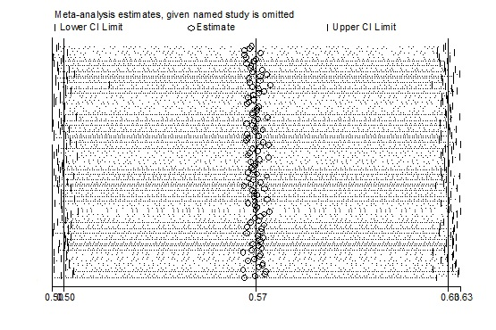
Supplementary Figure 1. A sensitivity analysis of the knowledge base was conducted by removing one study at a time.

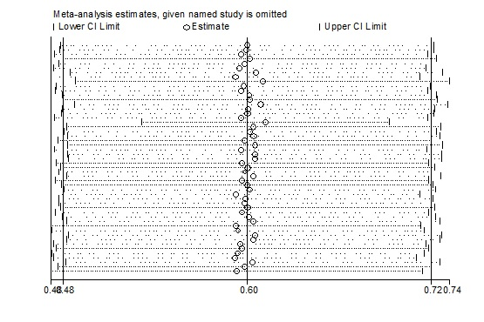
Supplementary Figure 2. A sensitivity analysis of the attitude base was conducted by removing one study at a time.

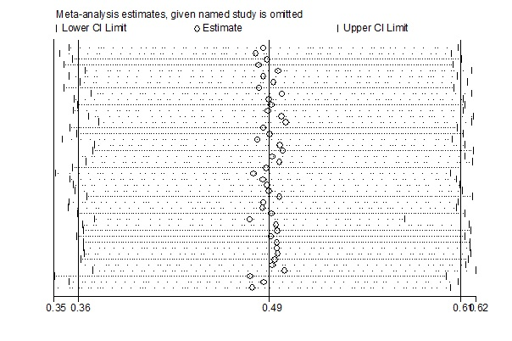
Supplementary Figure 3. A sensitivity analysis of the practice base was conducted by removing one study at a time.

