SUPPLEMENTARY MATERIAL

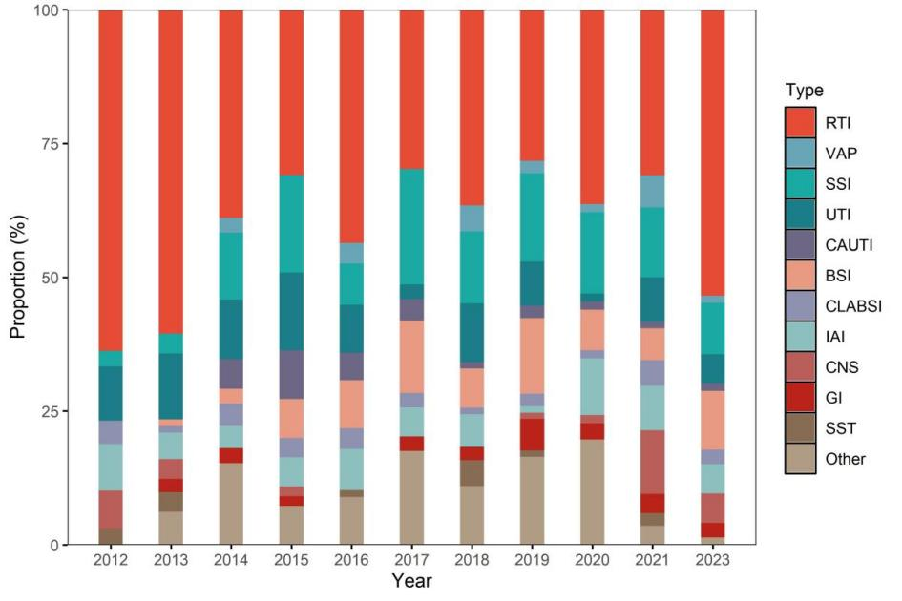
SUPPLEMENTARY Figure S1 Proportions of different HAI subtypes over the study period
Abbreviation: RTI=respiratory tract infection; VAP=ventilator-associated pneumonia; UTI=urinary tract infection; CAUTI=catheter-associated urinary tract infection; BSI=bloodstream infection; CLABSI=central line-associated bloodstream infection; SSI=surgical-site infection; CNS=central nervous system infection; IAI=intra-abdominal infection; GI=gastrointestinal infection; SST=skin and soft tissue infection.

SUPPLEMENTARY Table S1 Results of the linear regression of the yearly trend of HAI subtypes including and excluding the 2023 data
Data | Types of HAIs | β | Standard error | P value
All data | RTI | -0.089 | 0.060 | 0.172
All data | VAP | -0.003 | 0.013 | 0.853
All data | SSI | 0.036 | 0.021 | 0.120
All data | UTI | -0.030 | 0.014 | 0.056
All data | CAUTI | -0.032 | 0.006 | 0.001
All data | BSI | 0.031 | 0.019 | 0.130
All data | CLABSI | -0.002 | 0.006 | 0.691
All data | IAI | -0.002 | 0.012 | 0.892
All data | CNS | 0.006 | 0.020 | 0.771
All data | GI | 0.006 | 0.007 | 0.384
All data | SST | -0.004 | 0.009 | 0.681
All data | Other | 0.007 | 0.028 | 0.805
Excluding2023 | RTI | -0.152 | 0.058 | 0.031
Excluding2023 | VAP | 0.007 | 0.015 | 0.683
Excluding2023 | SSI | 0.054 | 0.022 | 0.040
Excluding2023 | UTI | -0.031 | 0.017 | 0.103
Excluding2023 | CAUTI | -0.036 | 0.007 | 0.003
Excluding2023 | BSI | 0.032 | 0.023 | 0.215
Excluding2023 | CLABSI | -0.002 | 0.007 | 0.734
Excluding2023 | IAI | 0.000 | 0.014 | 0.993
Excluding2023 | CNS | 0.006 | 0.026 | 0.820
Excluding2023 | GI | 0.010 | 0.008 | 0.274
Excluding2023 | SST | -0.004 | 0.009 | 0.681
Excluding2023 | Other | 0.034 | 0.028 | 0.261

SUPPLEMENTARY Table S2 Proportion of HAI subtypes stratified by department, sex, and age group
Variable | Levels | Overall | RTI | VAP | SSI | UTI | CAUTI | BSI | CLABSI | IAI | CNS | GI | SST | Other | P value
Department (%) | ICU | 94 | 37 (39.36) | 8 (8.51) | 10 (10.64) | 9 (9.57) | 6 (6.38) | 7 (7.45) | 6 (6.38) | 1 (1.06) | 0 (0) | 5 (5.32) | 4 (4.26) | 1 (1.06) | <0.001
 | Medicine | 309 | 155 (50.16) | 2 (0.65) | 10 (3.24) | 40 (12.94) | 8 (2.59) | 25 (8.09) | 9 (2.91) | 11 (3.56) | 0 (0) | 15 (4.85) | 6 (1.94) | 28 (9.06)
 | Surgical | 416 | 145 (34.86) | 8 (1.92) | 79 (18.99) | 21 (5.05) | 8 (1.92) | 28 (6.73) | 9 (2.16) | 38 (9.13) | 25 (6.01) | 1 (0.24) | 3 (0.72) | 51 (12.26)
Sex (%) | Female | 306 | 127 (41.5) | 5 (1.63) | 31 (10.13) | 30 (9.8) | 7 (2.29) | 23 (7.52) | 11 (3.59) | 23 (7.52) | 13 (4.25) | 9 (2.94) | 2 (0.65) | 25 (8.17) | 0.339
 | Male | 513 | 210 (40.94) | 13 (2.53) | 68 (13.26) | 40 (7.8) | 15 (2.92) | 37 (7.21) | 13 (2.53) | 27 (5.26) | 12 (2.34) | 12 (2.34) | 11 (2.14) | 55 (10.72)
Age group, years (%) | <15 | 44 | 10 (22.73) | 1 (2.27) | 10 (22.73) | 1 (2.27) | 0 (0) | 7 (15.91) | 3 (6.82) | 1 (2.27) | 1 (2.27) | 0 (0) | 0 (0) | 10 (22.73) | <0.001
 | 15–64 | 300 | 105 (35) | 9 (3) | 43 (14.33) | 18 (6) | 6 (2) | 29 (9.67) | 8 (2.67) | 23 (7.67) | 14 (4.67) | 7 (2.33) | 6 (2) | 32 (10.67)
 | >64 | 475 | 222 (46.74) | 8 (1.68) | 46 (9.68) | 51 (10.74) | 16 (3.37) | 24 (5.05) | 13 (2.74) | 26 (5.47) | 10 (2.11) | 14 (2.95) | 7 (1.47) | 38 (8)

SUPPLEMENTARY Table S3 Indication of antimicrobial use across subgroups
Variable | Levels | Prophylactic  (N=4,032) | Therapeutic  (N=2,911 ) | P value
Department | ICU | 76 (38.38) | 122 (61.62) | <0.001
 | Non-surgical | 1,189 (39.22) | 1,843 (60.78)
 | Surgical | 2,767 (74.52) | 946 (25.48)
Age group, years | <15 | 142 (58.44) | 101 (41.56) | <0.001
 | 15–64 | 2,074 (64.41) | 1,146 (35.59)
 | >64 | 1,816 (52.18) | 1,664 (47.82)
Surgery | No | 707 (25.84) | 2,029 (74.16) | <0.001
 | Yes | 3,325 (79.03) | 882 (20.97)
The proportion of antimicrobial use indications within a particular group was shown in parentheses.

