Supplemental Figure 1. IPC instructional posters drawn by a local Bangladeshi artist.
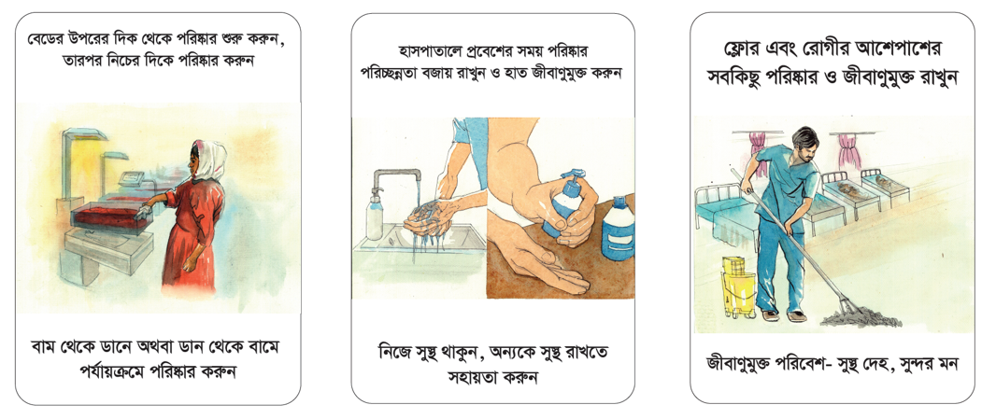
Image credit: xx
Supplemental Table 1. Surfaces and equipment included in environmental cleaning assessments in a neonatal intensive care unit in Bangladesh
Patient zone surfaces | Common surfaces | Shared equipment
Crib rail | Nurses’ charting table or chairs | Portable or wall-mounted suction machines
Crib mattress | Nurses’ station telephone | Nebulizer machine
Crib storage drawers | Nurses’ station microphone | Stethoscopes
Crib shelf | Sink faucet | Thermometers
Radiant warmer stand | Doorknobs | Xray machine
IV pump control or IV stand | Medication and supply carts | Weight scales
Vital signs monitor | Light switches | Ultrasound machine
Phototherapy light
Oxygen facemask
Ventilator panel

Supplemental Table 2. IPC metrics, colonization prevalence, BSIs, and mortality in a NICU in Bangladesh during an IPC intervention, February-September 2024

 | PPS 1 | PPS 2 | PPS 3 | PPS 4 | PPS 5 | PPS 6 | PPS 7 | PPS 8 | PPS 9 | PPS 10 | PPS 11 | PPS 12
PPS date | 2/12 | 2/27-2/28 | 3/13-3/14 | 3/27-3/28 | 4/8 | 4/22-4/23 | 5/8-5/9 | 5/25-5/26 | 6/10-6/11 | 9/1 | 9/15 | 9/29
Dates included (for admissions, BSIs, deaths) | 2/1-2/12 | 2/13-2/28 | 2/29-3/14 | 3/15-3/28 | 3/29-4/8 | 4/9-4/23 | 4/24-5/9 | 5/10-5/26 | 5/27-6/11 | 8/1-8/31 | 9/1-9/14 | 9/15-9/30
HH/EC assessment dates | 2/1, 2/7 | 2/14, 2/20, 2/25 | 3/2, 3/10 | 3/18, 3/27 | 4/2 | 4/18 | 5/2 | 5/14 | 6/1 | 8/1, 8/20 | 9/1 | 9/15
HH compliance | 37% | 48% | 44% | 55% | 57% | 64% | 67% | 65% | 64% | 68% | 71% | 69%
EC compliance | 42% | 46% | 50% | 61% | 67% | 56% | 67% | 73% | 67% | 80% | 80% | 87%
Admissions | 39 | 46 | 57 | 34 | 48 | 54 | 57 | 61 | 69 | 117 | 47 | 77
PPS enrollment | 30 | 33 | 38 | 23 | 28 | 31 | 30 | 28 | 30 | 28 | 32 | 32
BSIs | 11 | 9 | 6 | 1 | 6 | 4 | 4 | 2 | 0 | 1 | 5 | 3
Deaths | 10 | 5 | 7 | 11 | 12 | 12 | 14 | 9 | 10 | 24 | 4 | 3
CRO colonization | 87% | 91% | 74% | 87% | 86% | 87% | 67% | 68% | 80% | 64% | 94% | 81%
CRE colonization | 77% | 58% | 58% | 78% | 54% | 74% | 37% | 39% | 70% | 46% | 66% | 69%
CR-Kp colonization | 63% | 48% | 42% | 78% | 54% | 55% | 27% | 36% | 50% | 46% | 50% | 59%
BSIs/100 admissions | 28.2 | 19.6 | 10.5 | 2.9 | 12.5 | 7.4 | 7.0 | 3.3 | 0.0 | 0.9 | 10.6 | 3.9
Deaths/100 admissions | 25.6 | 10.9 | 12.3 | 32.4 | 25.0 | 22.2 | 24.6 | 14.8 | 14.5 | 20.5 | 8.5 | 3.9
IPC = infection prevention and control, BSI = bloodstream infection, NICU = neonatal intensive care unit, PPS = point prevalence survey, HH = hand hygiene, EC = environmental cleaning, CRO = carbapenem-resistant organisms, CRE = carbapenem resistant Enterobacterales, CR-Kp = carbapenem-resistant K. pneumoniae. The intervention was paused for 2 months during July-August because of political instability (indicated by the double line between PPS 9 and PPS 10).

Supplemental Figure 2. IPC metrics, colonization prevalence, BSIs, and mortality in a NICU in Bangladesh during an IPC intervention, February-September 2024
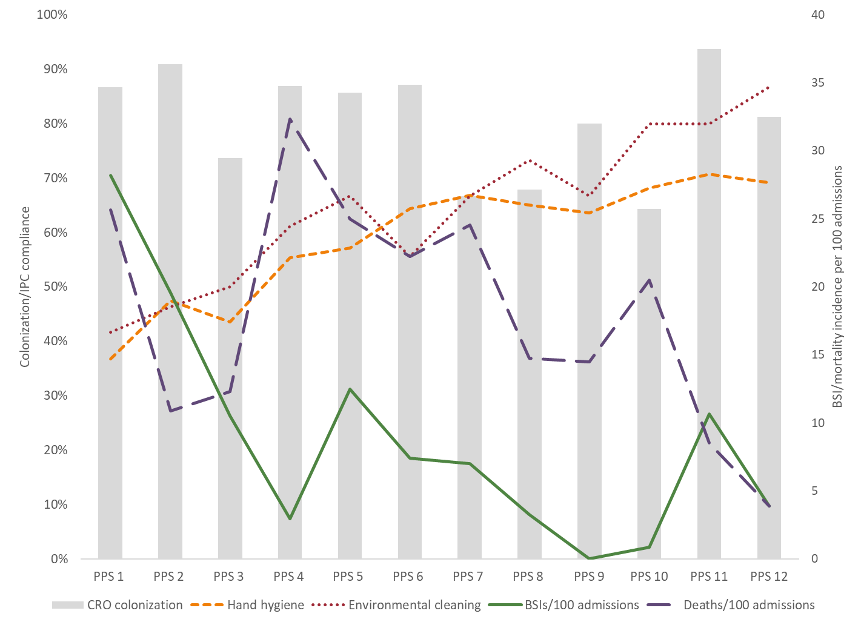
IPC = infection prevention and control, BSI = bloodstream infection, NICU = neonatal intensive care unit, PPS = point prevalence survey, CRO = carbapenem-resistant organism. The intervention was paused for 2 months during July-August between PPS-9 and PPS-10 because of political instability.

Supplemental Table 3. Pathogens recovered from blood cultures among neonates with suspected infections in a Bangladesh NICU, February-September 2024
Organism name | Frequency
A. baumannii | 7
B. cepacia | 7
C. albicans | 3
C. ciferrii | 2
C. pelliculosa | 3
C. indologenes | 1
C. parapsilosis | 1
Candida spp. | 8
Enterococcus spp. | 1
E. coli | 1
K. pneumoniae | 3
K. ohmeri | 1
Pseudomonas spp. | 6
S. fonticola | 6
S. marcescens | 1
Unclassified | 1
Total | 52
List excludes common commensals.

Supplemental Table 4. Proportion of neonates with peripheral IV, central venous line (umbilical catheter), and mechanical ventilation by PPS in a Bangladesh NICU, February-September 2024
PPS | Peripheral IV | Central venous line | Mechanical ventilation
PPS 1 | 23 (76.7%) | 4 (13.3%) | 1 (3.3%)
PPS 2 | 29 (87.9%) | 0 (0%) | 2 (6.1%)
PPS 3 | 33 (86.8%) | 1 (2.6%) | 2 (5.3%)
PPS 4 | 14 (60.9%) | 1 (4.3%) | 0 (0%)
PPS 5 | 26 (92.9%) | 2 (7.1%) | 1 (3.6%)
PPS 6 | 28 (90.3%) | 3 (9.7%) | 1 (3.2%)
PPS 7 | 28 (93.3%) | 2 (6.7%) | 1 (3.3%)
PPS 8 | 21 (75.0%) | 5 (17.9%) | 1 (3.6%)
PPS 9 | 26 (86.7%) | 4 (13.3%) | 2 (6.7%)
PPS 10 | 25 (89.3%) | 1 (3.6%) | 0 (0%)
PPS 11 | 28 (87.5%) | 0 (0%) | 2 (6.3%)
PPS 12 | 27 (84.4%) | 0 (0%) | 3 (9.4%)
IPC = infection prevention and control, PPS = point prevalence survey, NICU = neonatal intensive care unit.

