Supplementary Material

Supplementary Methods
Previous precautions at Geneva University Hospitals: droplet precautions and SARS-CoV-2-specific precautions measures
Droplet precautions were recommended for patients with suspected or confirmed colonization or infection by respiratory pathogens - particularly viral - or diseases transmitted via the respiratory route. Droplet precautions recommended single-room placement or alternatively, cohorting of patients infected with the same pathogen was considered, provided there was no additional indication for specific transmission-based precautions. In all cases, the sharing of rooms with immunosuppressed patients was to be avoided. In addition to standard precautions, healthcare workers (HCWs) were required to wear a surgical mask upon room entry. Droplet precautions were combined with contact precautions for respiratory viruses such as respiratory syncytial virus (RSV). Additionally, the use of an FFP2 respirator and eye protection was recommended for HCW when caring for patients with suspected or confirmed respiratory infection undergoing aerosol-generating procedures.
Prior to the implementation of the ‘Respiratory precautions’, transmission-based precautions or the care of patients with suspected or confirmed SARS-CoV-2 infection included the use of FFP2 respirators, eye protection and gowns, as well as mandatory single-room placement or cohorting.

Screening strategy for respiratory viruses at Geneva University Hospitals between November 1 2023 and March 31 2025
Since November 2023, SARS-CoV-2 screening strategies at hospital admission and during nosocomial outbreaks have been simplified, notably with the discontinuation of asymptomatic screening upon admission. These strategies remained consistent across the 2023–2024 and 2024–2025 seasons. Testing strategies for influenza and RSV were comparable across the 2023-2024 and 2024-2025 seasons.
Respiratory virus testing was performed using (RT-)PCR assays on nasopharyngeal or lower respiratory tract samples, based on clinical and epidemiological criteria. At hospital admission, SARS-CoV-2 testing was systematically conducted year-round for patients presenting signs or symptoms suggestive of respiratory viral infection, and during the winter season for influenza and RSV. Testing for other respiratory viruses (e.g., human metapneumovirus, parainfluenza viruses, adenovirus) was generally reserved for immunocompromised or frail patients.
During a patient’s hospitalization, testing indications for SARS-CoV-2, influenza, and RSV were similar to those applied for community-acquired cases, with additional screening of symptomatic contacts of confirmed cases. For SARS-CoV-2, testing was extended to asymptomatic contacts who were unvaccinated or eligible for antiviral treatment to prevent severe disease (e.g., nirmatrelvir-ritonavir). A positive test triggered contact tracing among hospitalised patients, which was managed by staff within the infection Control Program.

Masking policy during winter seasons
The requirement for all staff and visitors to wear a medical mask in patient care areas was in effect during the periods: December 14 2023 to March 4 2024 and December 18 2024 to March 19 2025. Medical mask use by staff and visitors was monitored through standardized observations conducted at routine times in clinical areas outside patient rooms during these periods.

Structure of the audit questionnaire
Methodology:
Audits were conducted, either using paper forms or a digital tablet-based format, once per week in each unit across all departments, excluding psychiatry and intensive care. The audit cannot be carried out more than once a week per patient and unit. The number of audits performed in each department was proportional to the number of droplet precautions prescribed during the same period in the prior year.
Inclusion: All patients admitted to a care unit with a medical prescription for at least one additional precaution.
The following are excluded:
- any patient with a specific precaution in place without a medical prescription ;
- any patient with > 2 specific precautions prescribed ;
- any patient in the psychiatry department and correctional healthcare unit
Audit procedure:
The audit is carried out by the IPC nursing team in the care units in order to assess the quality of transmission-based precautions implementation according to five variables:
- Quality of medical prescriptions
- Type of accommodation room
- Quality of signage
- Availability of required personal protective equipment (PPE)
- Use of PPE according to the additional precautions in place and according to the situation.
Note: Hand hygiene compliance was not included in the audit, as it is routinely monitored across all departments at HUG.


Audit form
(form number generated automatically during data entry)
If entered via paper form: note the room number and bed number, and Redcap form number

Care unit: | Observer (initials):
Service/Sector:
Department: | Date:
To select the answers(s): if multiple answers possible if only one answer possible

Structure Audit
(Infrastructure, Equipment)
1.  Additional precaution prescribed | 2.  Justification for additional precaution (lab, note…) | 3.  Additional precautions expected | 4.  Type of room occupied | 5.  Type of signage on the patient’s door | 6.  Additional precautions implemented according to expected additional precautions | 7.  Signage |  |  | 8.  PPE availability and suitable placement
- Contact  - Respiratory  - Contact Plus  - Protection  - Air | - Correct  - Incorrect  - Reason not  documented | - Contact  - Respiratory  - Contact PLUS  - Protection  - Air  - None  (stop audit) | - single room/ adjacent bed(s) blocked  - shared room:  - Suitable  - Unsuitable | - Contact  - Respiratory  - Contact Plus  - Protection  - Air  - None | - Correct  - Incorrect  - AP stopped | Door  - NA  - Suitable  - Not suitable | Bed  - NA  - Visible  - Not visible  - Error | Auxiliary equipment  - NA  - Visible  - Not visible  - Erro | - Gloves  - Hydrophobic gown/ Waterproof gown  - Medical mask  - FFP2 mask  - Eye protection

Notes:
Audit of practices
9.  Number of health professionals with the patient | 10.  Health professionals | 11. Type and suitability of PPE worn |  |  |  |  | Comments
- 0  - 1  - 2 | 0
- 0  - 1  - 2 | 1st professional | - Gloves | - Worn | - Suitable  - Unsuitable | - Not worn | - Suitable  - Unsuitable
- 0  - 1  - 2 | 1st professional | - Hydrophobic gown/ Waterproof gown | - Worn | - Suitable  - Unsuitable | - Not worn | - Suitable  - Unsuitable
- 0  - 1  - 2 | 1st professional | - Medical mask | - Worn | - Suitable  - Unsuitable | - Not worn | - Suitable  - Unsuitable
- 0  - 1  - 2 | 1st professional | - FFP2 mask | - Worn | - Suitable  - Unsuitable | - Not worn | - Suitable  - Unsuitable
- 0  - 1  - 2 | 1st professional | - Eye protection | - Worn | - Suitable  - Unsuitable | - Not worn | - Suitable  - Unsuitable
- 0  - 1  - 2 | 2nd professional | - Gloves | - Worn | - Suitable  - Unsuitable | - Not worn | - Suitable  - Unsuitable
- 0  - 1  - 2 | 2nd professional | - Hydrophobic gown/ Waterproof gown | - Worn | - Suitable  - Unsuitable | - Not worn | - Suitable  - Unsuitable
- 0  - 1  - 2 | 2nd professional | - Medical mask | - Worn | - Suitable  - Unsuitable | - Not worn | - Suitable  - Unsuitable
- 0  - 1  - 2 | 2nd professional | - FFP2 mask | - Worn | - Suitable  - Unsuitable | - Not worn | - Suitable  - Unsuitable
- 0  - 1  - 2 | 2nd professional | - Eye protection | - Worn | - Suitable  - Unsuitable | - Not worn | - Suitable  - Unsuitable

PPE required according to type of precaution:
- Contact Precaution: gown
- Respiratory Precaution: gown, medical mask or FFP2 mask, eye protection
- Air Precaution: FFP2
- Contact Plus precaution: gown, gloves
- Protection precaution: gown, medical mask
PPE is then added according to any combination of additional precautions. This means that Any other PPE not specified by these precautions are only assessed if they are worn.

Supplementary Figure
Figure S1: Signage for respiratory precautions placed on patients’ doors. The signage includes a pictogram illustrating the respiratory precautions, along with several icons indicating the required personal protective equipment and the corresponding indications for their use.
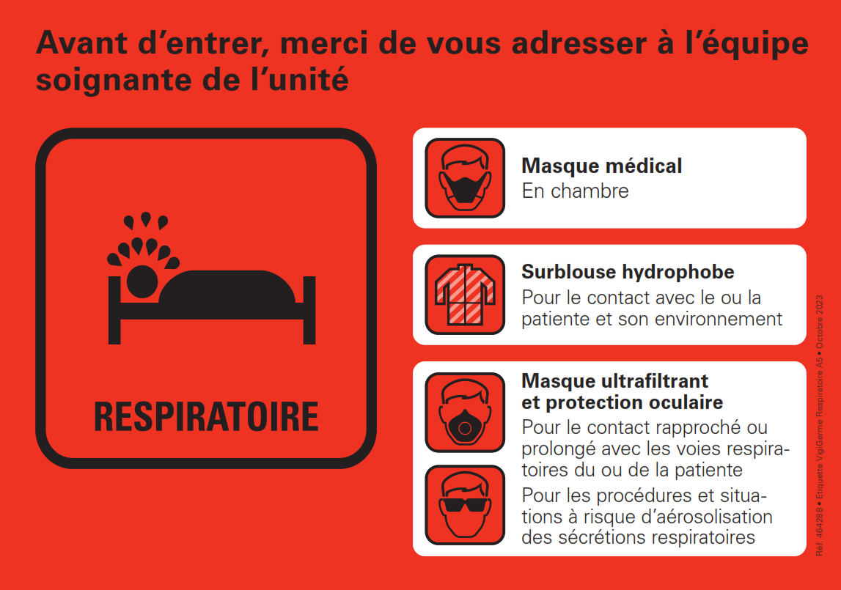

Supplementary results
Masking policy during winter seasons
During the 2023–2024 masking policy period, we conducted 3,545 observations of mask use by staff and visitors in clinical areas outside patient rooms; appropriate mask use was recorded in 2,634 of 3,545 observations (74.3%). During the 2024–2025 masking policy period, 3,214 observations were conducted, with appropriate mask use recorded in 2,722 of 3,214 observations (85.0%).

