Supplementary Information

Supplementary Methods 1. Details about the outpatient department at The University of Tokyo Hospital.
Clinical departments in this study were defined as follows; internal medicine (department of general internal medicine, department of cardiovascular medicine, department of respiratory medicine, department of gastroenterology, department of nephrology and endocrinology, department of diabetes and metabolic diseases, department of hematology and oncology, department of allergy and rheumatology, department of infectious diseases, department of neurology, department of geriatric medicine, department of stress sciences and psychosomatic medicine), surgery (department of general surgery, department of gastrointestinal surgery, department of surgical oncology, hepato-biliary-pancreatic surgery, department of artificial organ and transplantation, department of cardiac surgery, department of thoracic surgery, department of vascular surgery, department of neurosurgery), pediatrics (department of pediatrics, department of pediatric surgery), obstetrics and gynecology (department of obstetrics and gynecology, department of gynecological surgery), psychiatry (department of neuropsychiatry).

Supplementary Methods 2. Setting of IRT.
The IRT we used in the study was Dome AI Thermal Camera (IR-DC-TH20, IRIS OHYAMA Inc., Japan). This IRT device can measure multiple walking subjects simultaneously. According to the manufacturer’s specifications, this device is designed to screen a large volume of moving people efficiently and does not require individuals to remain stationary or undergo a waiting period for thermal equilibration prior to measurement. However, it should be noted that such specifications for moving subjects naturally deviate from international laboratory guidelines, such as ISO/TR 13154 [27], which recommend stationary thermal equilibration. The measurement error was within 0.5°C and the recommended measurement distance was 3 meters according to the packaging insert. We set the measurement point 3 meters in front of the IRT and measured the body surface temperature of the moving patient. An air thermometer was placed at the measurement point, and the air temperature was measured every 30 minutes and input into the IRT operating program for temperature compensation.

Supplementary Methods 3. Announcement of self-reporting.
We announced that symptomatic patients should self-report upon entering the hospital. Patients who self-reported were isolated to an examination room for third step of screening without second screening using IRT. Symptomatic patients were defined as follows; 1) Fever of 37.0°C or higher within 7 days, 2) Cough or shortness of breath within 7 days, 3) Common cold symptoms such as sore throat and nasal discharge within 7 days; 4) COVID-19 concentrated contacts within 7 days. We displayed these screening criteria at the main entrance of hospital building (Figure S1).

Figure S1. Poster displayed at the main entrance of The University of Tokyo Hospital instructing visitors with symptoms suggestive of COVID-19 to self-report upon entering the hospital.
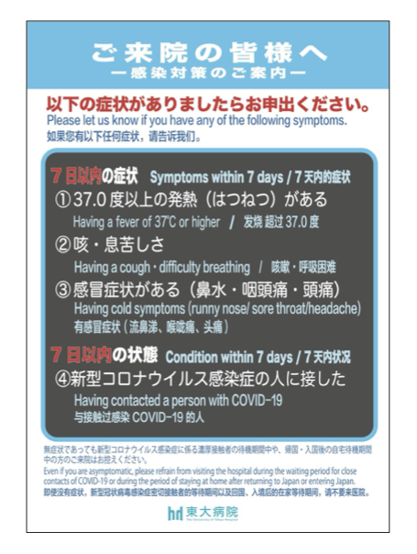

Supplementary Analysis. Estimation of the Pre-Test Probability of IRT Screening.
1. Estimated Number of COVID-19 Cases Among Self-Reporting Visitors
An exploratory estimation was performed to assess how many COVID-19 cases may have been included among the visitors who self-reported symptoms and were directly referred to the fever clinic according to the entrance posters (n = 354 during the study period). The prevalence of COVID-19 in this population was estimated using the PCR positivity rate reported at fever clinics in Tokyo during the same period. Specifically, approximate monthly PCR positivity rates were extracted from publicly available surveillance data provided by the Tokyo Metropolitan Government [S1] and combined with the observed monthly numbers of self-reporting visitors at our hospital. A weighted month-by-month calculation was then performed. Based on this approach, an estimated 108.5 individuals of 354 visitors were estimated to have had COVID-19 among those who self-reported symptoms and were directly referred to the fever clinic.

2. Estimation of the Total Number of Potential COVID-19 Cases Visiting Our Institution
Next, we estimated the total number of potential COVID-19 cases who visited the main entrance of our institution during the study period, including both symptomatic and asymptomatic individuals.
For this estimation, the probability that an individual infected with the Omicron variant would develop fever (≥37.5°C) was assumed to be 30%, based on a previous report [S2]. In addition, the proportion of febrile symptomatic individuals who would voluntarily self-report their symptoms in accordance with the hospital entrance posters (self-reporting rate) was assumed to be 80%. This assumption was based on the characteristics of our outpatient population. Most visitors were returning patients with chronic conditions who received ongoing care at our institution and were therefore likely to follow the hospital guidance regarding referral to the fever clinic. Nevertheless, because the true self-reporting rate was unknown, this assumption should be regarded as illustrative.
Using the estimated number of confirmed COVID-19 cases who met both conditions of being febrile and self-reporting (108.5 individuals; Section 1) as an anchor, we back-calculated the total number of potential COVID-19 cases by applying these assumptions:
Estimated total number of COVID-19 cases = 108.5 / (0.8 × 0.3) = 452
Based on this approach, the total number of potential COVID-19 cases visiting our institution during the study period was estimated to be 452 individuals.

3. Estimation of the Number of COVID-19 Cases Within the IRT-Screened Population and Calculation of the Pre-Test Probability
Finally, we estimated the number of COVID-19 cases included in the population that underwent IRT screening at the main entrance (i.e., individuals who passed through the entrance screening area without being directly diverted to the fever clinic), as well as the corresponding pre-test probability.
Based on the estimated total number of COVID-19 cases visiting our institution during the study period (452 individuals), and subtracting the estimated number of self-reporting visitors who were directly referred to the fever clinic (109 individuals), approximately 343 COVID-19 cases were estimated to have entered the IRT-screened population. However, because IRT screening is based on body temperature detection, individuals without fever would not be expected to be identified. Therefore, the number of COVID-19 cases theoretically detectable by IRT would have been smaller than the estimated 343 cases entering the IRT-screened population.
Estimated number of theoretically detectable COVID-19 cases = 452 × 0.3 × 0.2 = 27
Accordingly, among the 570,076 visitors who underwent IRT screening during the study period, the pre-test probability of encountering a COVID-19 case theoretically detectable by IRT was estimated to be 0.0047% (27/570,076).

Reference
S1. Ministry of Health, Labour and Welfare. Status of positive cases adjusted by treatment type in Tokyo (Jan 2022–Jan 2023). Tokyo: Ministry of Health, Labour and Welfare; 2023. https://www.mhlw.go.jp/content/10900000/001044057.pdf. Accessed June 9, 2026.
S2. Menni C, Valdes AM, Polidori L, Antonelli M, Penamakuri S, Nogal A, et al. Symptom prevalence, duration, and risk of hospital admission in individuals infected with SARS-CoV-2 during periods of omicron and delta variant dominance: a prospective observational study from the ZOE COVID Study. Lancet 2022;399:1618–24. https://doi.org/10.1016/S0140-6736(22)00327-0

