Figure S1. Annual prevalence trends in antibiotic resistance rates among Enterobacterales bloodstream infections in hematological malignancy patients from 2017 to 2023. 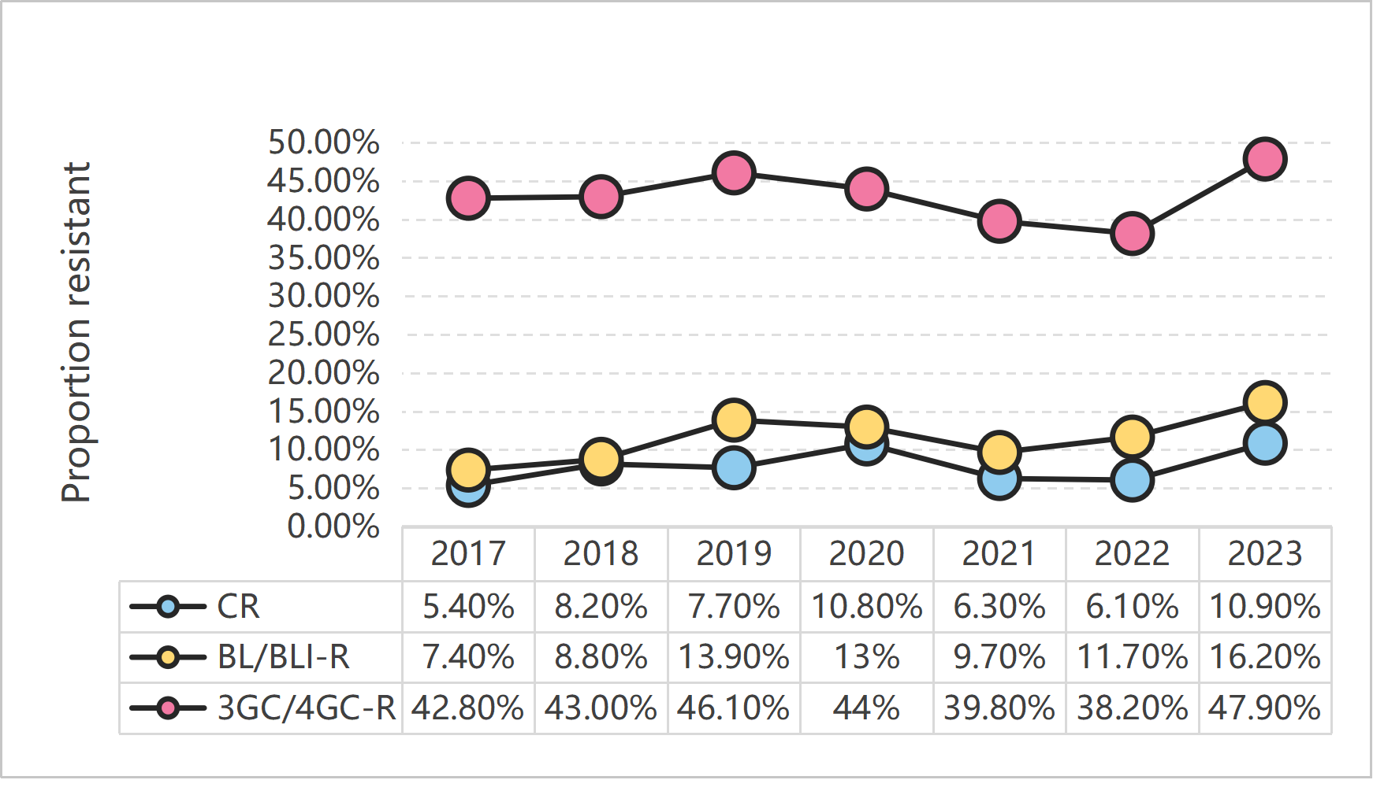
Abbreviations: CR, carbapenem resistance; 3GC/4GC-R, third-/fourth-generation cephalosporin resistance; BL/BLI-R, β-lactam/β-lactamase inhibitor combinations resistance.

Figure S2. Subgroup analysis of receiver operating characteristic (ROC) curves in tumor remission stage patients for predicting antibiotic resistance. (A) carbapenem resistance prediction, (B) β-lactam/β-lactamase inhibitor combinations resistance (BL/BLI-R) prediction, and (C) third-/fourth-generation cephalosporin resistance (3GC/4GC-R) prediction.

Table S1. Performance comparison of machine learning original and optimized threshold-based models in predicting antibiotic resistance in the train cohort from 2017 to 2021 without pathogen information.

 | Target | AUC 95% CI | Sensitivity 95% CI | Specificity 95% CI | PPV 95% CI | NPV 95% CI
Original models | CR | 0.92(0.91-0.94) | 0.17(0.08-0.26) | 0.998(0.99-1.00) | 0.86(0.67-1.00) | 0.93(0.92-0.95)
Original models | BL/BLI-R | 0.82(0.79-0.84) | 0.21(0.13-0.30) | 0.99(0.98-1.00) | 0.70(0.54-0.86) | 0.91(0.89-0.93)
Original models | 3GC/4GC-R | 0.89(0.87-0.91) | 0.65(0.61-0.70) | 0.91(0.89-0.94) | 0.85(0.81-0.89) | 0.78(0.74-0.81)
Optimized threshold-based models | CR | 0.92( 0.91-0.94) | 0.90 (0.83-0.97) | 0.76 (0.73-0.79) | 0.24 (0.19-0.29) | 0.99 (0.98-1.00)
Optimized threshold-based models | BL/BLI-R | 0.82( 0.79-0.84) | 0.94 (0.89-0.99) | 0.36 (0.33-0.40) | 0.15 (0.12-0.18) | 0.98 (0.96-1.00)
Optimized threshold-based models | 3GC/4GC-R | 0.89( 0.87-0.91) | 1.00 (1.00-1.00) | 0.12 (0.09-0.15) | 0.46 (0.43-0.50) | 1.00 (1.00-1.00)
Abbreviations: CR, carbapenem resistance; 3GC/4GC-R, third-/fourth-generation cephalosporin resistance; BL/BLI-R, β-lactam/β-lactamase inhibitor combinations resistance; AUC, area under the curve; PPV, positive predictive value; NPV, negative predictive value.

Table S2. Sensitivity analysis of probability threshold perturbations in the validation cohort without pathogen information.
 | Threshold_3GC/4GC-R | Threshold_BL/BLI-R | Threshold_CR | Mean Sensitivity (%) | Mean NPV (%) | IEAT Rate (%) | Carbapenem Use (%) | Salvage strategies Use (%)
Optimal (Base) | 0.1554 | 0.0443 | 0.072 | 89.67 | 93.82 | 3.39 | 39.14 | 28.51
Perturbed | 0.1554 | 0.0443 | 0.122 | 79.42 | 93.07 | 5.88 | 58.14 | 9.5
Perturbed | 0.2054 | 0.0443 | 0.072 | 88.98 | 93.22 | 4.3 | 37.1 | 28.05
Perturbed | 0.1554 | 0.0943 | 0.072 | 85.44 | 93.28 | 4.75 | 18.78 | 22.4
Perturbed | 0.1554 | 0.0443 | 0.022 | 97.37 | 61.49 | 1.58 | 0 | 67.65
Perturbed | 0.1554 | 0.01 | 0.072 | 91.79 | 94.83 | 2.71 | 62.22 | 32.13
Perturbed | 0.1054 | 0.0443 | 0.072 | 90.19 | 97.99 | 2.71 | 41.4 | 28.51
Abbreviations: CR, carbapenem resistance; 3GC/4GC-R, third-/fourth-generation cephalosporin resistance; BL/BLI-R, β-lactam/β-lactamase inhibitor combinations resistance; AUC, area under the curve; PPV, positive predictive value; NPV, negative predictive value.

Table S3. Performance comparison of machine learning original and optimized threshold-based models in the train cohort from 2017 to 2021 with pathogen species identification.
 | Target | AUC 95% CI | Sensitivity 95% CI | Specificity 95% CI | PPV 95% CI | NPV 95% CI
Original models | CR | 0.93(0.91-0.94) | 0.17(0.08-0.26) | 0.998(0.99-1.00) | 0.86(0.67-1.04) | 0.93(0.92-0.95)
Original models | BL/BLI-R | 0.82(0.79-0.84) | 0.20(0.12-0.28) | 0.99(0.98-1.00) | 0.69(0.52-0.86) | 0.91(0.89-0.93)
Original models | 3GC/4GC-R | 0.87(0.85-0.90) | 0.70(0.66-0.75) | 0.86(0.83-0.89) | 0.80(0.75-0.84) | 0.79(0.76-0.83)
Optimized threshold-based models | CR | 0.93(0.91-0.94) | 0.87 (0.80-0.95) | 0.78 (0.75-0.81) | 0.25 (0.20-0.30) | 0.99 (0.98-1.00)
Optimized threshold-based models | BL/BLI-R | 0.82(0.79-0.84) | 0.92 (0.86-0.97) | 0.54 (0.50-0.57) | 0.19 (0.16-0.23) | 0.98 (0.97-0.99)
Optimized threshold-based models | 3GC/4GC-R | 0.87(0.85-0.90) | 1.00 (1.00-1.00) | 0.14 (0.11-0.17) | 0.47 (0.43-0.50) | 1.00 (1.00-1.00)

Abbreviations:
CR, carbapenem resistance; 3GC/4GC-R, third-/fourth-generation cephalosporin resistance; BL/BLI-R, β-lactam/β-lactamase inhibitor combinations resistance; AUC, area under the curve; PPV, positive predictive value; NPV, negative predictive value.

Table S4. Performance comparison of machine learning original and optimized threshold-based models in predicting antibiotic resistance in the test cohort from 2022 to 2023 with pathogen species identification.

 | Target | AUC 95% CI | Sensitivity 95% CI | Specificity 95% CI | PPV 95% CI | NPV 95% CI
Original models | CR | 0.82(0.78-0.85) | 0.10(0.01-0.20) | 0.998(0.99-1.00) | 0.80(0.45-1.15) | 0.92(0.89-0.95)
Original models | BL/BLI-R | 0.81(0.77-0.84) | 0.19(0.09-0.29) | 0.99(0.98-1.00) | 0.80(0.60-1.00) | 0.88(0.85-0.91)
Original models | 3GC/4GC-R | 0.76(0.72-0.80) | 0.63(0.56-0.70) | 0.80(0.75-0.85) | 0.71(0.64-0.78) | 0.74(0.68-0.79)
Optimized threshold-based models | CR | 0.82(0.78-0.85) | 0.77 (0.64-0.90) | 0.75 (0.70-0.79) | 0.23 (0.16-0.30) | 0.97 (0.95-0.99)
Optimized threshold-based models | BL/BLI-R | 0.81(0.77-0.84) | 0.89 (0.81-0.97) | 0.47 (0.42-0.52) | 0.22 (0.17-0.27) | 0.96 (0.94-0.99)
Optimized threshold-based models | 3GC/4GC-R | 0.76(0.72-0.80) | 0.98 (0.97-1.00) | 0.09 (0.06-0.13) | 0.46 (0.41-0.50) | 0.88 (0.76-1.00)
Abbreviations:
CR, carbapenem resistance; 3GC/4GC-R, third-/fourth-generation cephalosporin resistance; BL/BLI-R, β-lactam/β-lactamase inhibitor combinations resistance; AUC, area under the curve; PPV, positive predictive value; NPV, negative predictive value.

