Supplementary Figures
Prevalence, molecular epidemiology and antibiotic resistance of extended-spectrum β-lactamase-producing Enterobacterales (2020–2024): a systematic review and meta-analysis of regional and between-study variation

Nia Krisniawati, Edwin Widyanto Daniwijaya, Anggia Prasetyoputri, Riris Andono Ahmad, Titik Nuryastuti

Fig. S1 The pooled prevalence of ESBL-E (k=120) 3
Fig. S2 The pooled prevalence of ESBL-E in Middle East and North Africa (k=42). 4
Fig. S3 The pooled prevalence of ESBL-E in Sub-Saharan Africa (k=38). 5
Fig. S4 The pooled prevalence of ESBL-E in South Asia (k=15). 6
Fig. S5 The pooled prevalence of ESBL-E in Europe and Central Asia (k=9). 6
Fig. S6 The pooled prevalence of ESBL-E in East Asia and Pacific (k=13). 7
Fig. S7 The pooled prevalence of ESBL-E in lower middle income (k=57). 8
Fig. S8 The pooled prevalence of ESBL-E in upper middle income (k=27). 9
Fig. S9 The pooled prevalence of ESBL-E in low income (k=22). 10
Fig. S10 The pooled prevalence of ESBL-E in high income (k=14). 10
Fig. S11 The pooled prevalence of ESBL-E in hospital (k=106). 11
Fig. S12 The pooled prevalence of ESBL-E in community (k=14). 12
Fig. S13 Pooled isolate-level prevalence of ESBL-E in diagnostic-specimen studies (k = 93). 13
Fig. S14 Pooled isolate-level prevalence of ESBL-E in colonisation-screening studies (k = 27). 14
Fig. S15 The pooled prevalence of ESBL-E determined by phenotypic methods (k = 35). 15
Fig. S16 The pooled prevalence of ESBL-E determined by genotypic methods (k = 11). 15
Fig. S17 The pooled prevalence of ESBL-E determined by combined methods (k = 74). 16
Fig. S18 The pooled prevalence of bla_{CTX-M} among ESBL-E (k = 71). 17
Fig. S19 The pooled prevalence of bla_{TEM} among ESBL-E (k = 59). 18
Fig. S20 The pooled prevalence of bla_{SHV} among ESBL-E (k = 52). 19
Fig. S21 The pooled prevalence of bla_{CTX-M-15} among ESBL-E (k = 22). 20
Fig. S22 The pooled prevalence of bla_{CTX-M-14} among ESBL-E (k = 9). 20
Fig. S23 The pooled prevalence of bla_{CTX-M-27} among ESBL-E (k = 8). 21
Fig. S24 The pooled prevalence of co-existence bla_{CTX-M} + bla_{SHV} among ESBL-E (k = 24). 21
Fig. S25 The pooled prevalence of co-existence bla_{CTX-M} + bla_{TEM} among ESBL-E (k = 23). 22
Fig. S26 The pooled prevalence of co-existence bla_{CTX-M} + bla_{TEM} + bla_{SHV} among ESBL-E (k = 21). 22
Fig. S27 The pooled prevalence of co-existence bla_{TEM} + bla_{SHV} among ESBL-E (k = 21). 23
Fig. S28 The pooled prevalence of ampicillin resistance among ESBL-E (k = 27). 24
Fig. S29 The pooled prevalence of cefotaxime resistance among ESBL-E (k = 32). 25
Fig. S30 The pooled prevalence of ceftriaxone resistance among ESBL-E (k = 36). 25
Fig. S31 The pooled prevalence of amoxicillin/clavulanic acid resistance among ESBL-E (k = 31). 26
Fig. S32 The pooled prevalence of ampicillin/sulbactam resistance among ESBL-E (k = 10). 26
Fig. S33 The pooled prevalence of piperacillin/tazobactam resistance among ESBL-E (k = 26). 27
Fig. S34 The pooled prevalence of gentamicin resistance among ESBL-E (k = 40). 27
Fig. S35 The pooled prevalence of ciprofloxacin resistance among ESBL-E (k = 43). 28
Fig. S36 The pooled prevalence of levofloxacin resistance among ESBL-E (k = 19). 28
Fig. S37 The pooled prevalence of trimethoprim/sulfamethoxazole resistance among ESBL-E (k = 30). 29
Fig. S38 The pooled prevalence of nitrofurantoin resistance among ESBL-E (k = 20). 29
Fig. S39 The pooled prevalence of cefuroxime resistance among ESBL-E (k = 13). 30
Fig. S40 The pooled prevalence of cefepime resistance among ESBL-E (k = 28). 30
Fig. S41 The pooled prevalence of ertapenem resistance among ESBL-E (k = 16). 31
Fig. S42 The pooled prevalence of imipenem resistance among ESBL-E (k = 33). 31
Fig. S43 The pooled prevalence of meropenem resistance among ESBL-E (k = 32). 32
Fig. S44 The pooled prevalence of amikacin resistance among ESBL-E (k = 26). 33
Fig. S45 The pooled prevalence of cefoxitin resistance among ESBL-E (k = 12). 34
Fig. S46 The pooled prevalence of tetracycline resistance among ESBL-E (k = 19). 34
Fig. S47 The pooled prevalence of aztreonam resistance among ESBL-E (k = 21). 35
Fig. S48 The pooled prevalence of ceftazidime resistance among ESBL-E (k = 34). 35

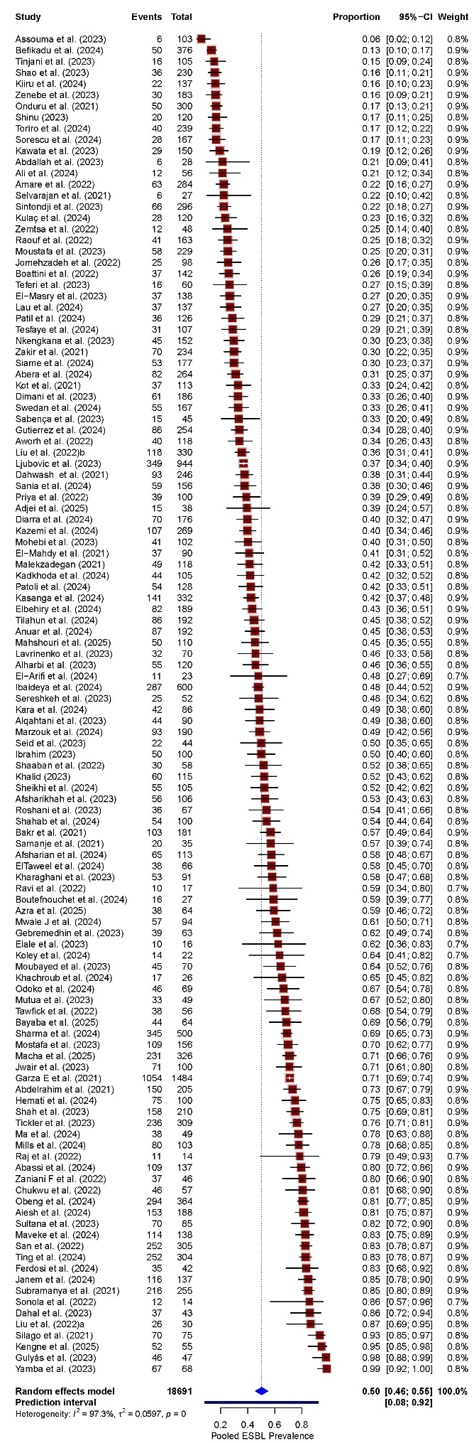
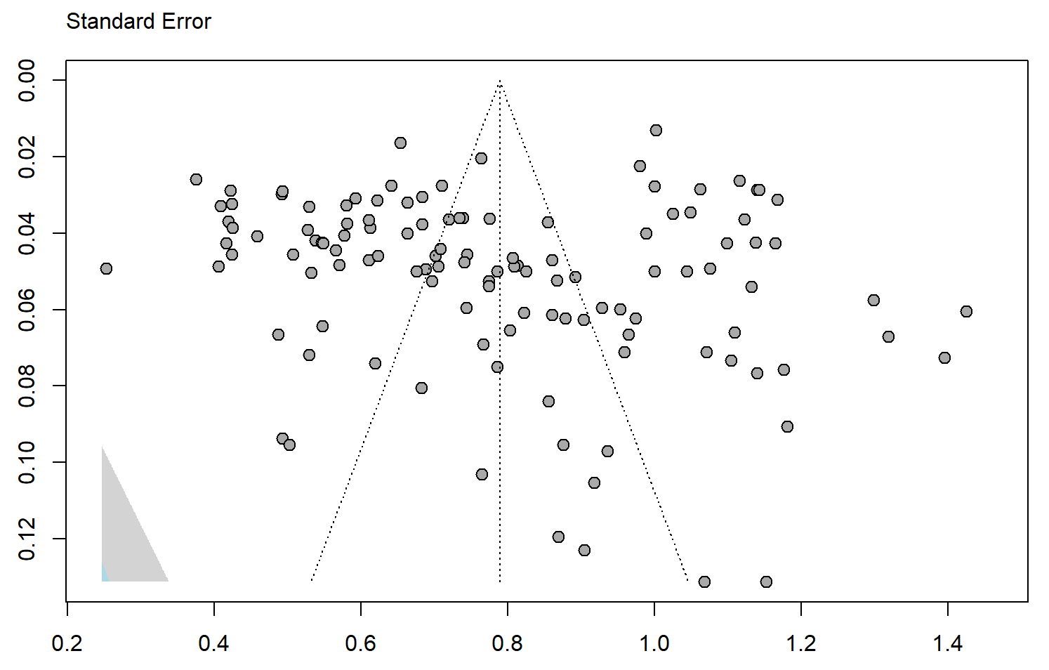
A B

Fig. S1 The pooled prevalence of ESBL-E (k=120)
- Forest plot. The blue horizontal line beneath the pooled estimate denotes the 95% prediction interval; (B) funnel plot

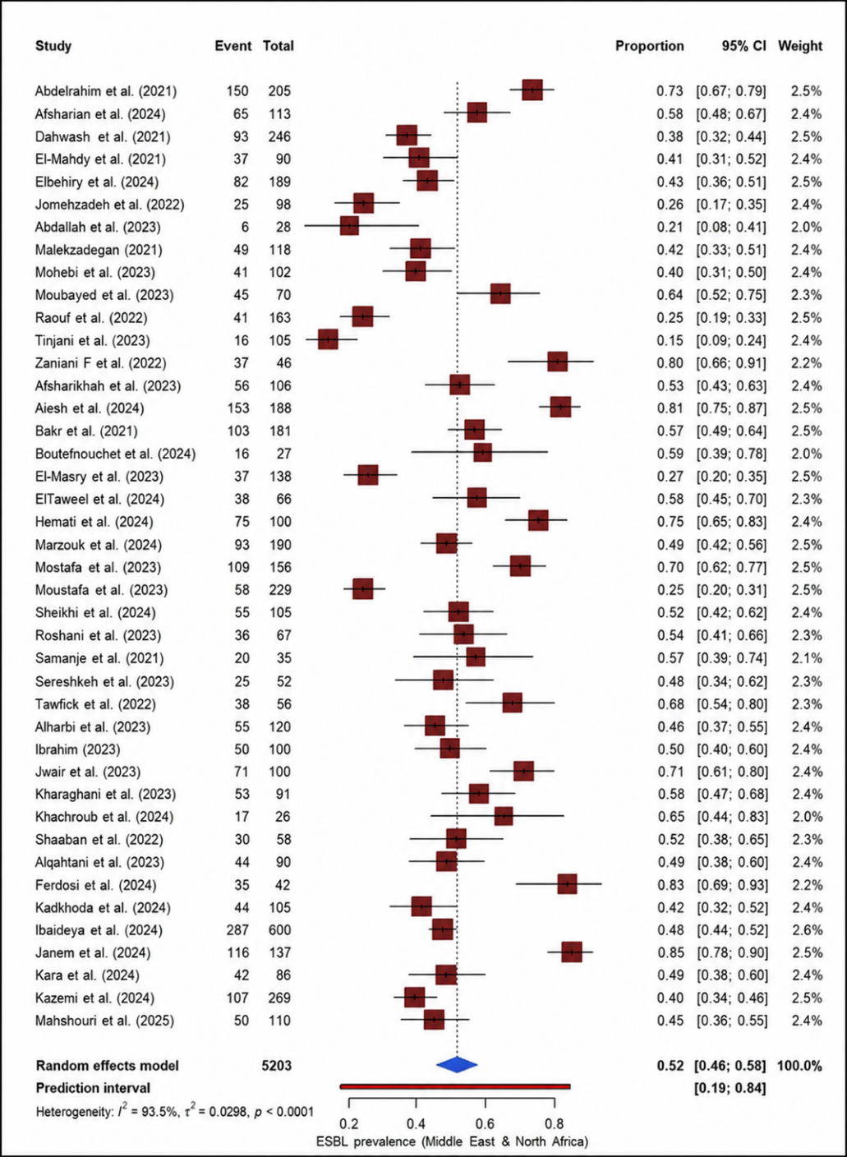
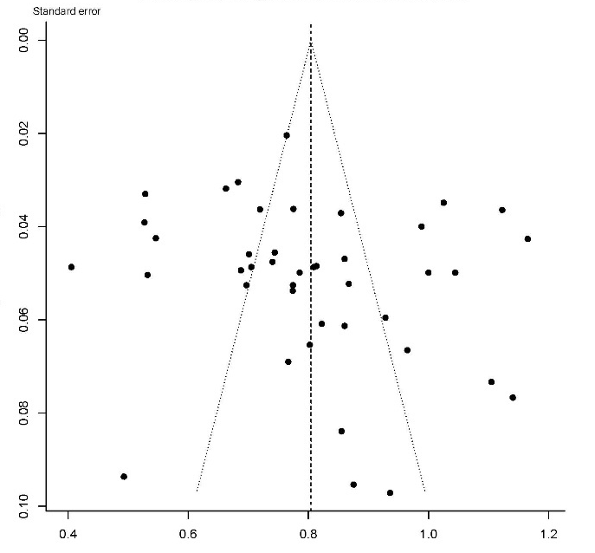
A B

Fig. S2 The pooled prevalence of ESBL-E in Middle East and North Africa (k=42).
(A) Forest plot. The red horizontal line beneath the pooled estimate denotes the 95% prediction interval; (B) funnel plot

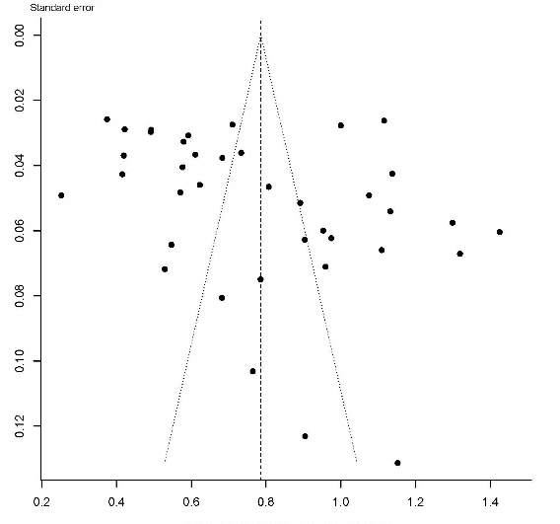
A B
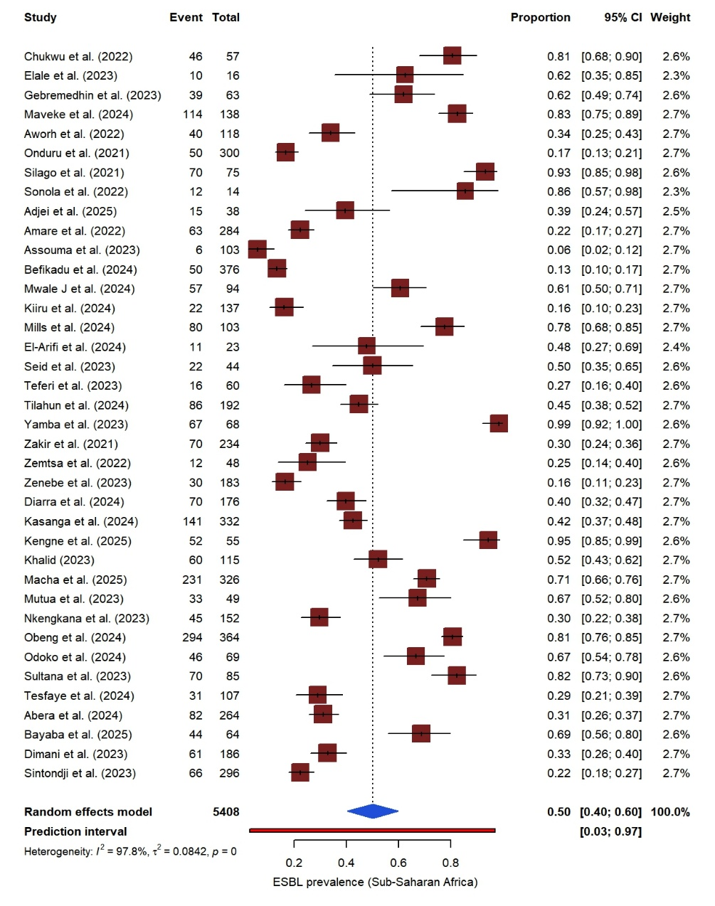

Fig. S3 The pooled prevalence of ESBL-E in Sub-Saharan Africa (k=38).
(A) Forest plot. The red horizontal line beneath the pooled estimate denotes the 95% prediction interval; (B) funnel plot

A B
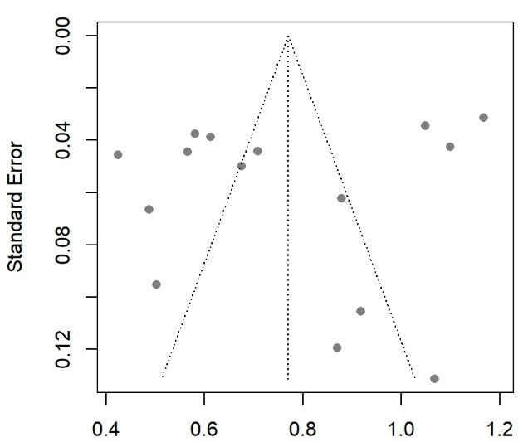
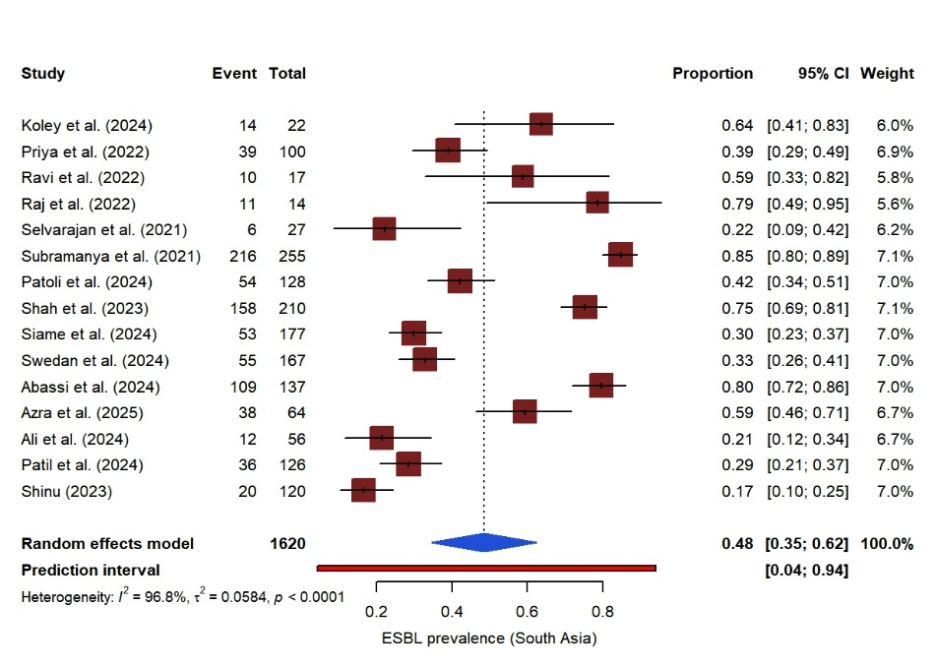

Fig. S4 The pooled prevalence of ESBL-E in South Asia (k=15).
(A) Forest plot. The red horizontal line beneath the pooled estimate denotes the 95% prediction interval; (B) funnel plot
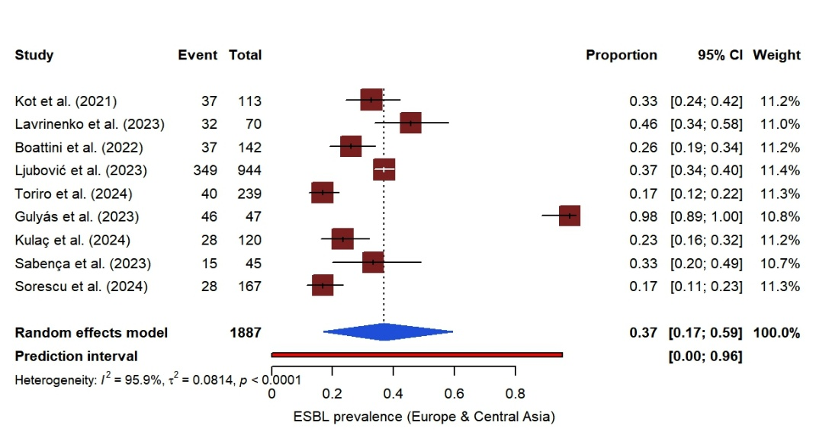
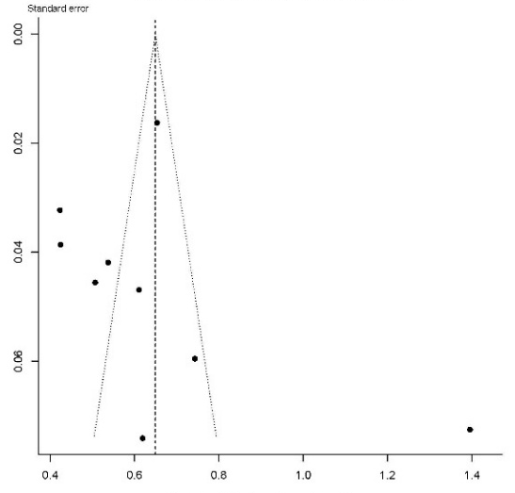
A B

Fig. S5 The pooled prevalence of ESBL-E in Europe and Central Asia (k=9).
(A) Forest plot. The red horizontal line beneath the pooled estimate denotes the 95% prediction interval; (B) funnel plot

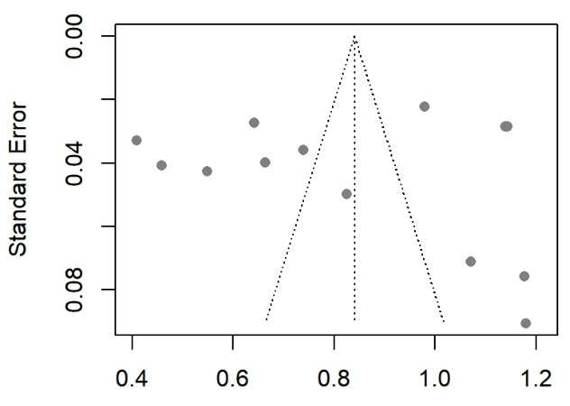
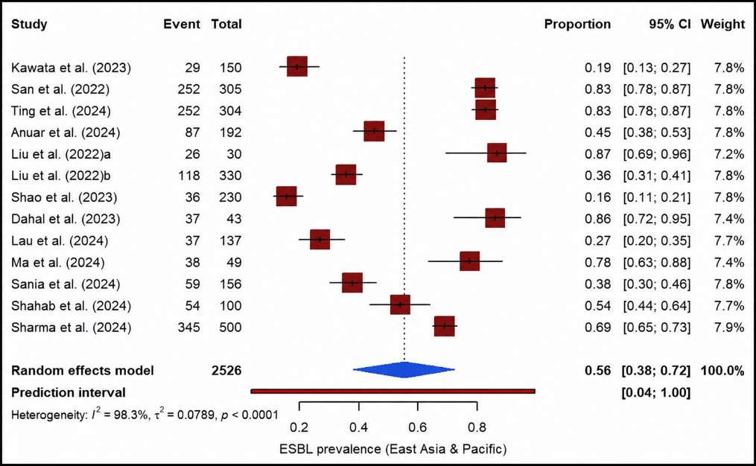
A B

Fig. S6 The pooled prevalence of ESBL-E in East Asia and Pacific (k=13).
(A) Forest plot. The red horizontal line beneath the pooled estimate denotes the 95% prediction interval; (B) funnel plot

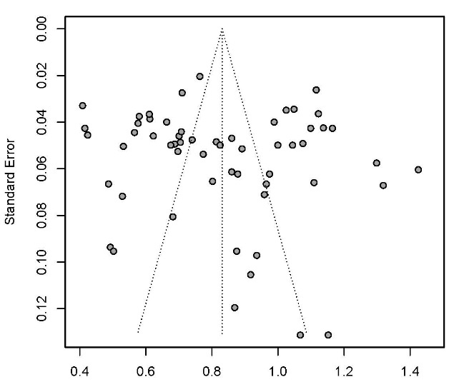
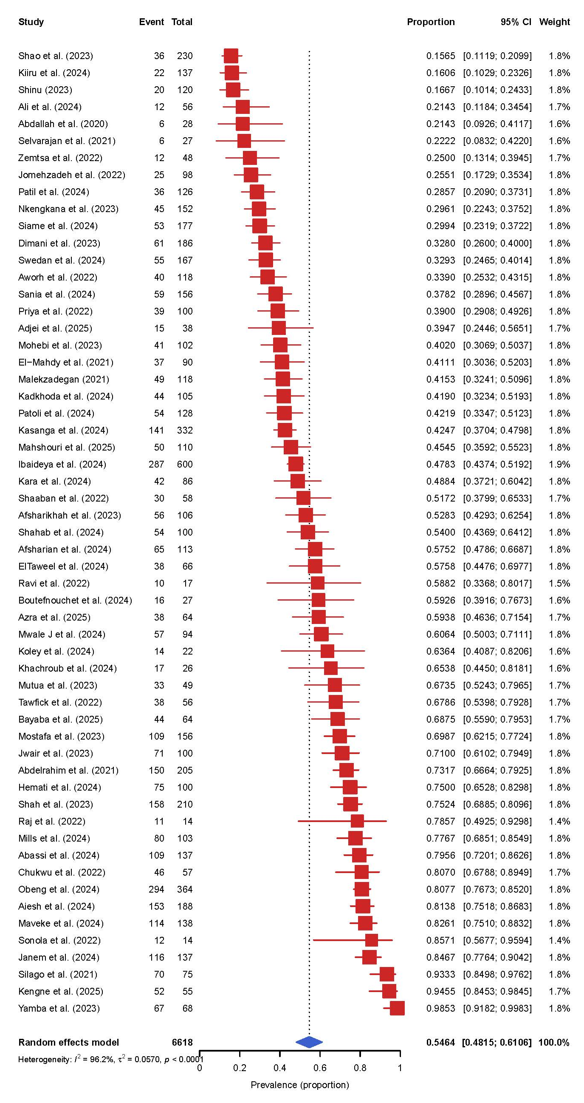
A B

Fig. S7 The pooled prevalence of ESBL-E in lower middle income (k=57).
- Forest plot, (B) funnel plot

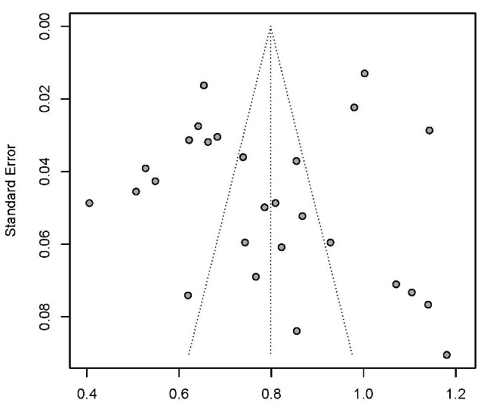
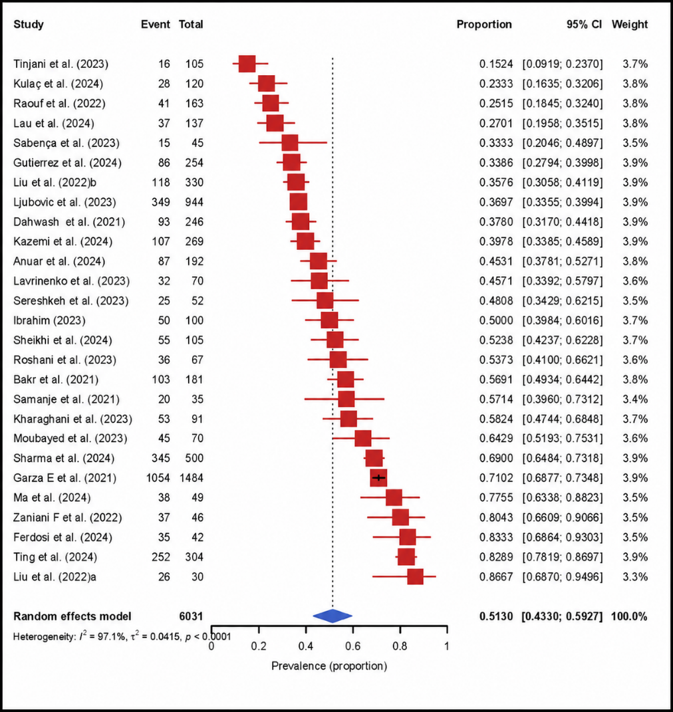
A B

Fig. S8 The pooled prevalence of ESBL-E in upper middle income (k=27).
(A) Forest plot, (B) funnel plot

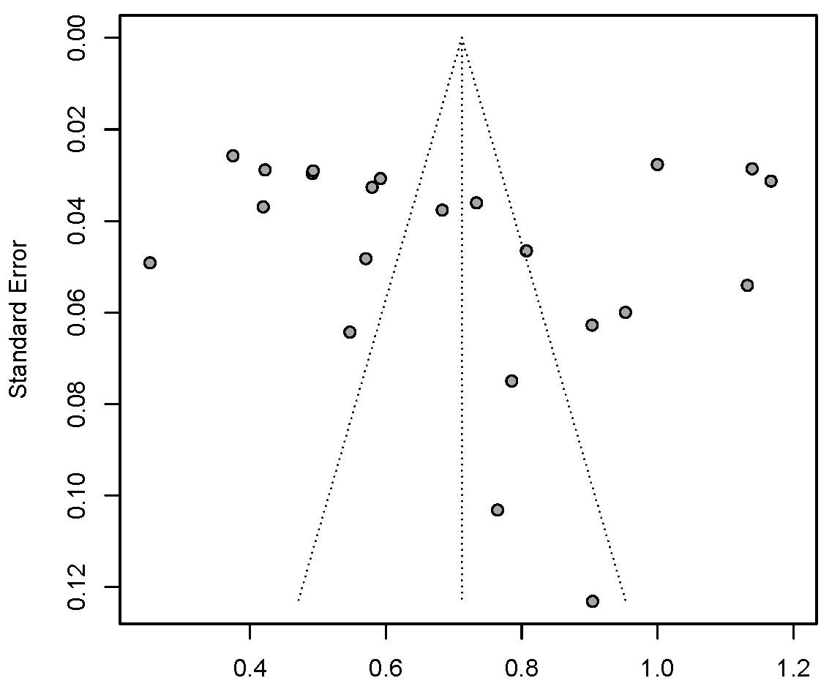
A B
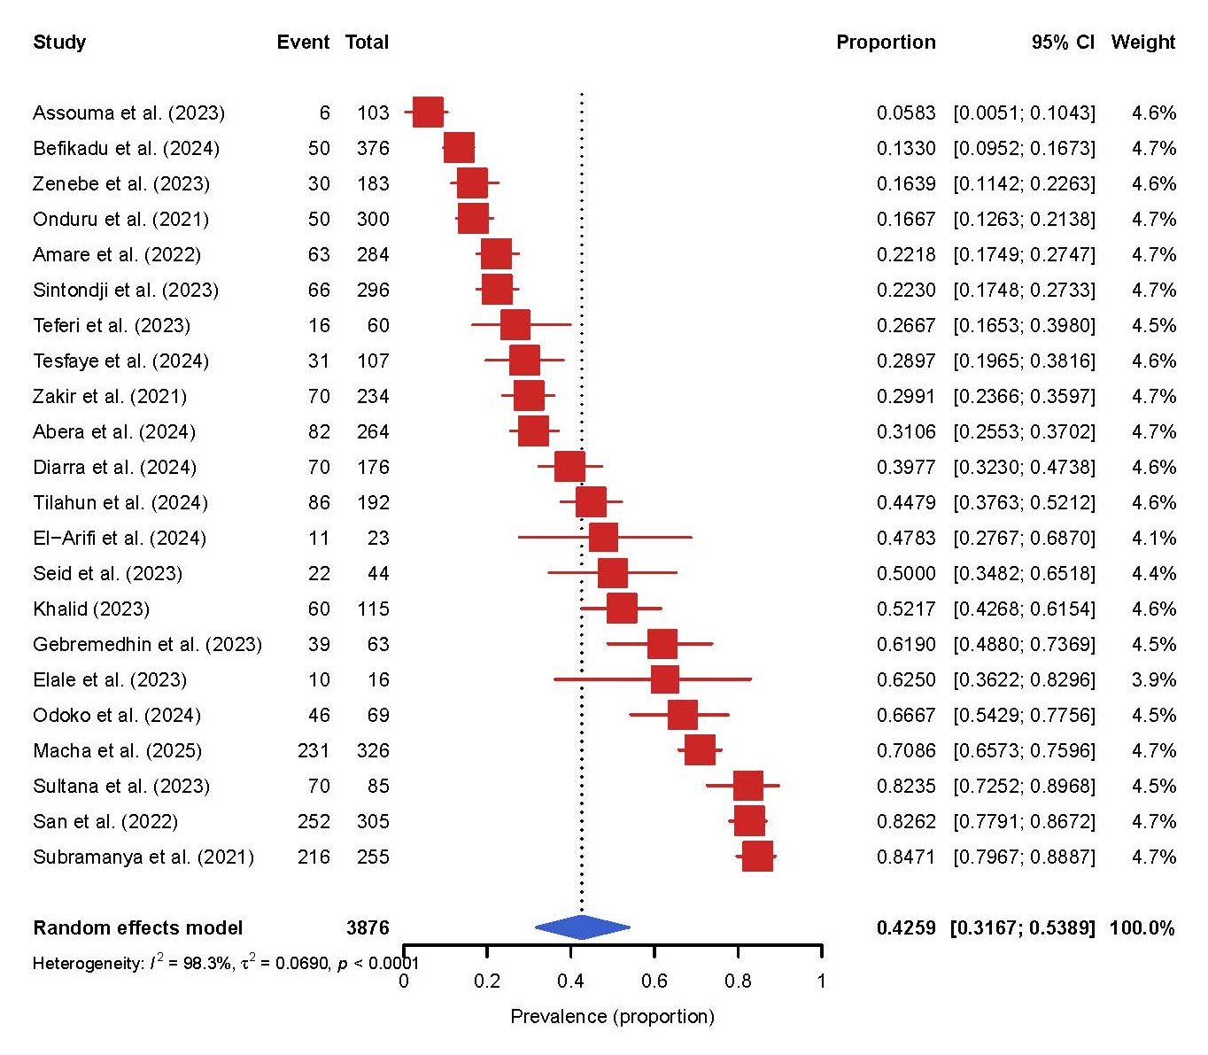

Fig. S9 The pooled prevalence of ESBL-E in low income (k=22).
(A) Forest plot, (B) funnel plot

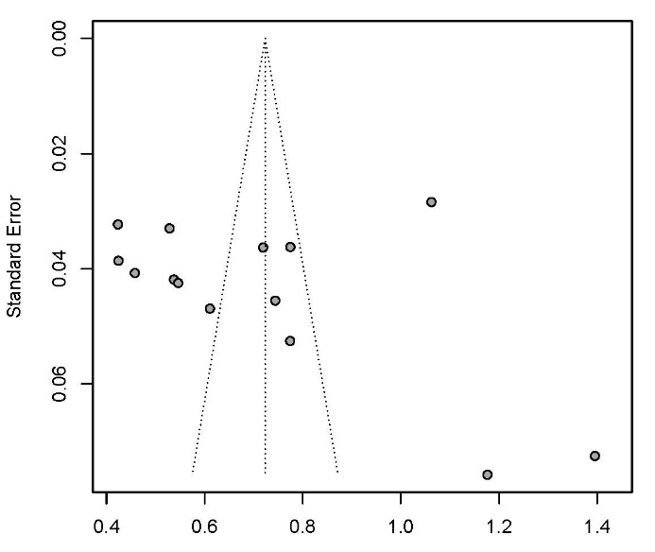
A B
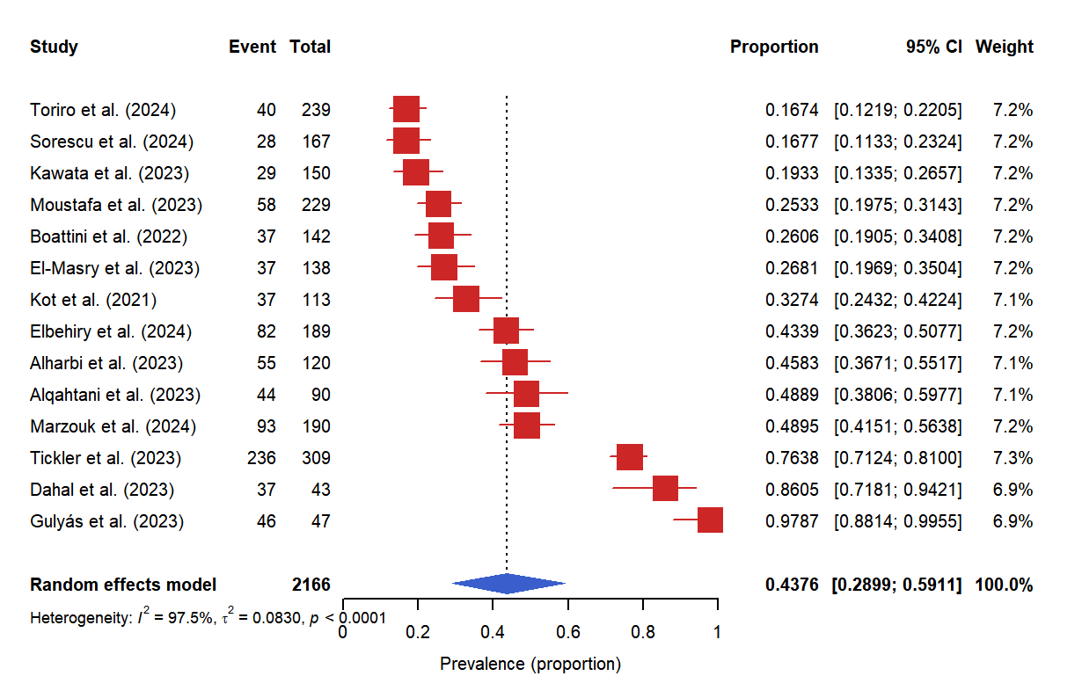
Fig. S10 The pooled prevalence of ESBL-E in high income (k=14).
(A) Forest plot, (B) funnel plot

A B
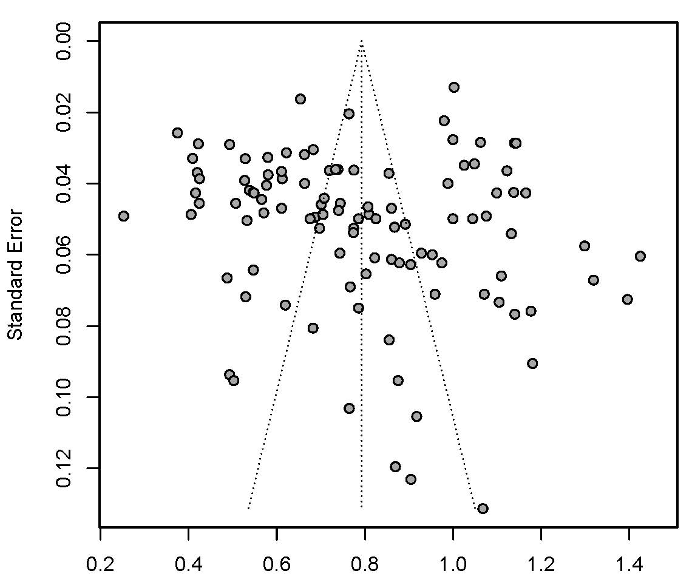
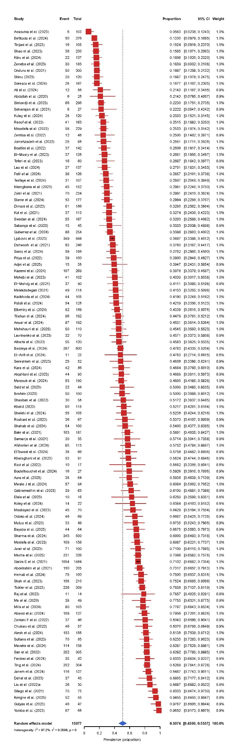

Fig. S11 The pooled prevalence of ESBL-E in hospital (k=106).
(A) Forest plot, (B) funnel plot

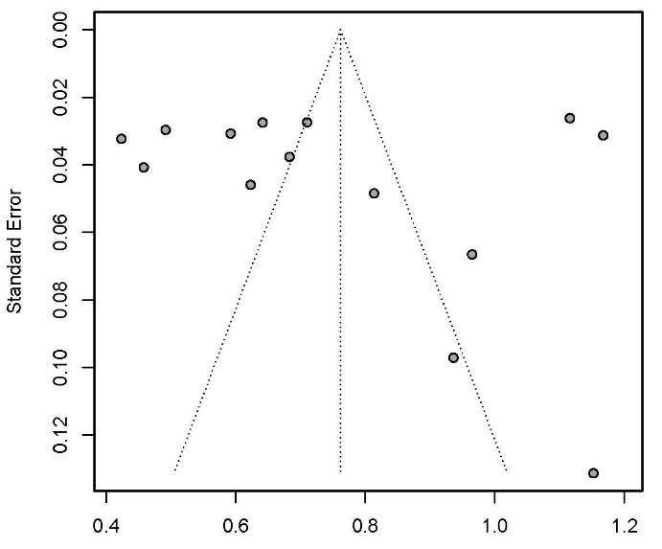
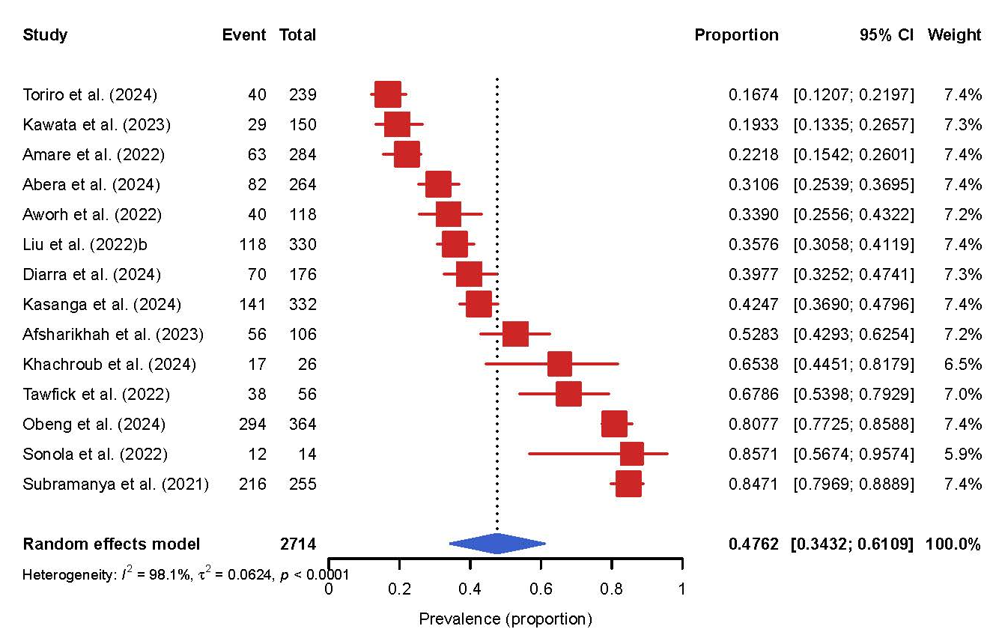
A B

Fig. S12 The pooled prevalence of ESBL-E in community (k=14).
(A) Forest plot, (B) funnel plot

A B
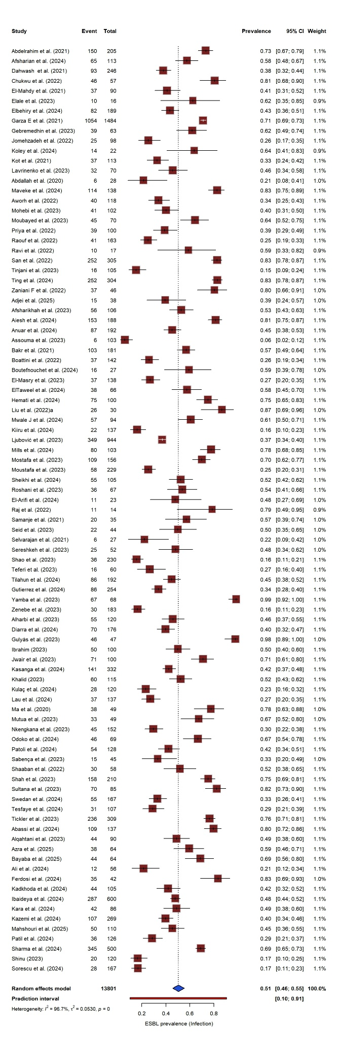
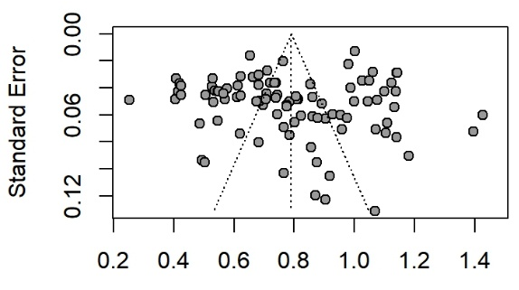

Fig. S13 Pooled isolate-level prevalence of ESBL-E in diagnostic-specimen studies (k = 93).
(A) Forest plot, (B) funnel plot

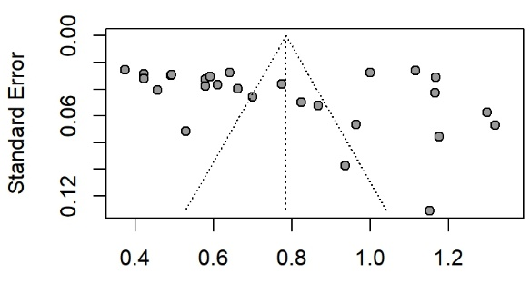
A B
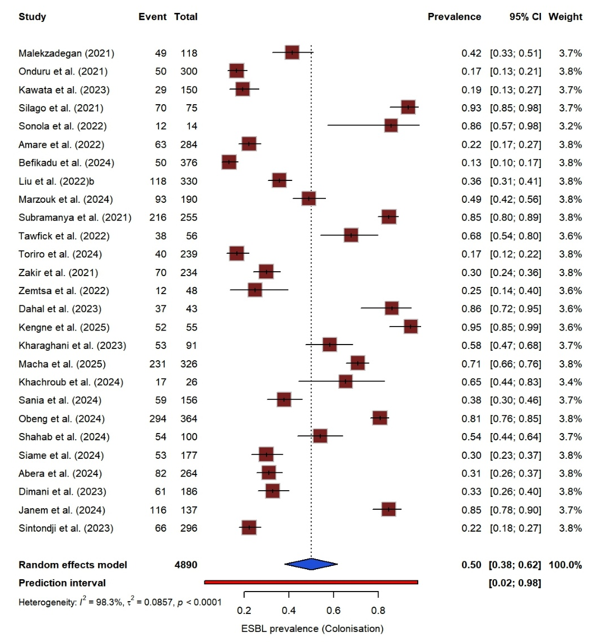

Fig. S14 Pooled isolate-level prevalence of ESBL-E in colonisation-screening studies (k = 27).
- Forest plot, (B) funnel plot

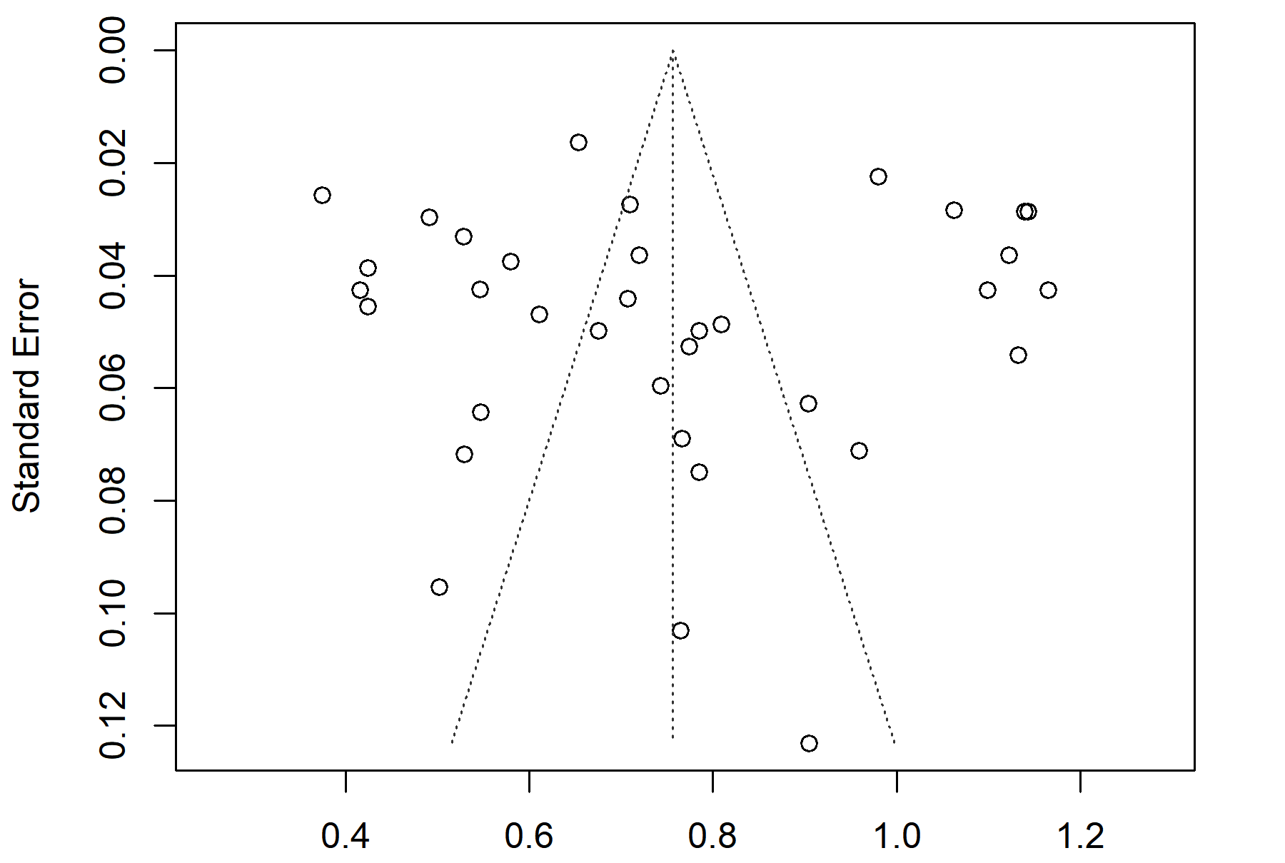
A B
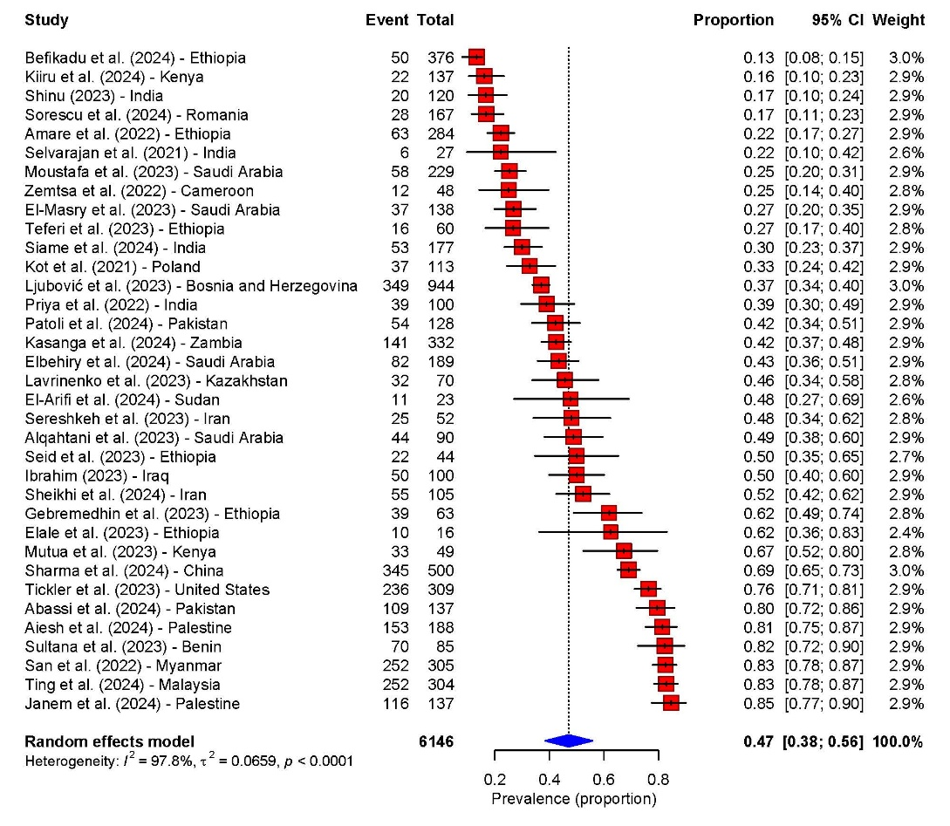

Fig. S15 The pooled prevalence of ESBL-E determined by phenotypic methods (k = 35).
(A) Forest plot, (B) funnel plot

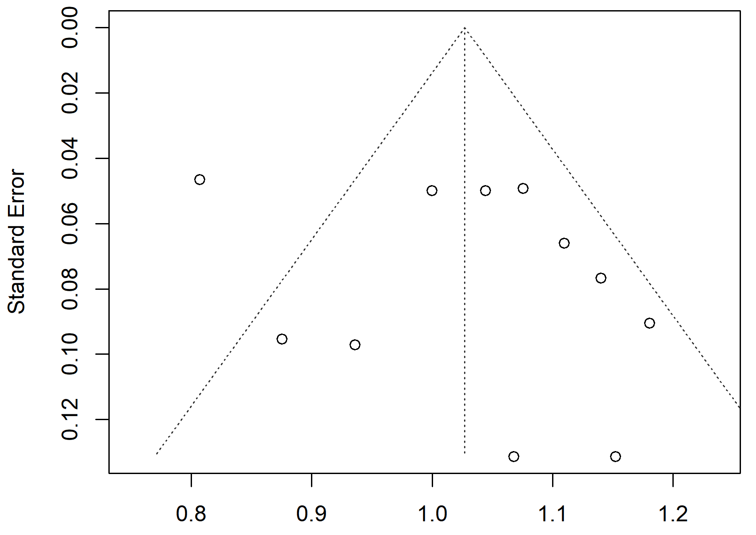
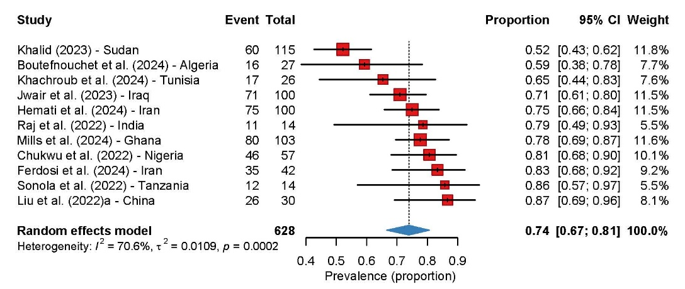
A B

Fig. S16 The pooled prevalence of ESBL-E determined by genotypic methods (k = 11).
(A) Forest plot, (B) funnel plot

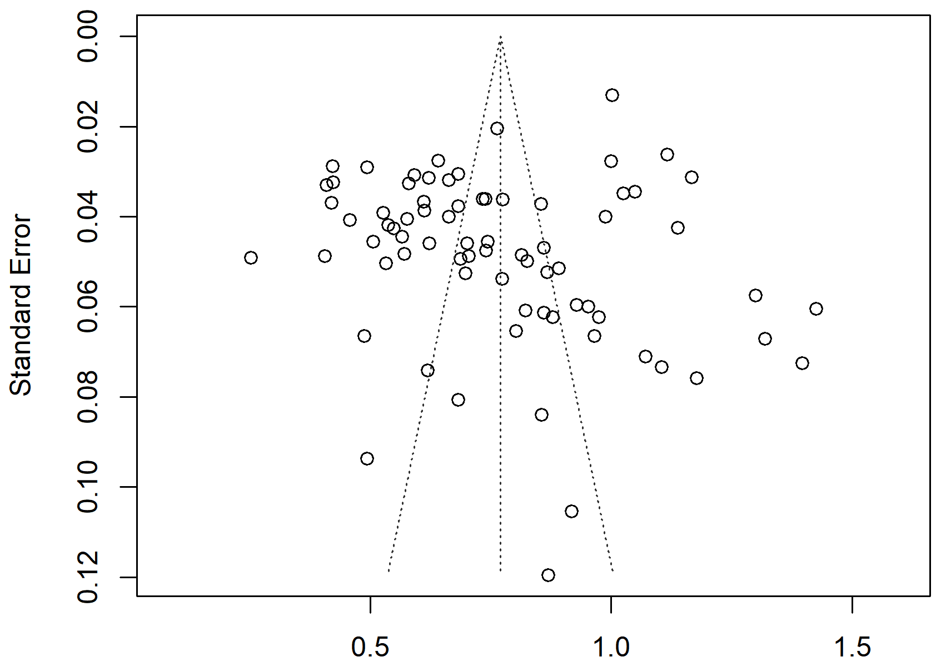
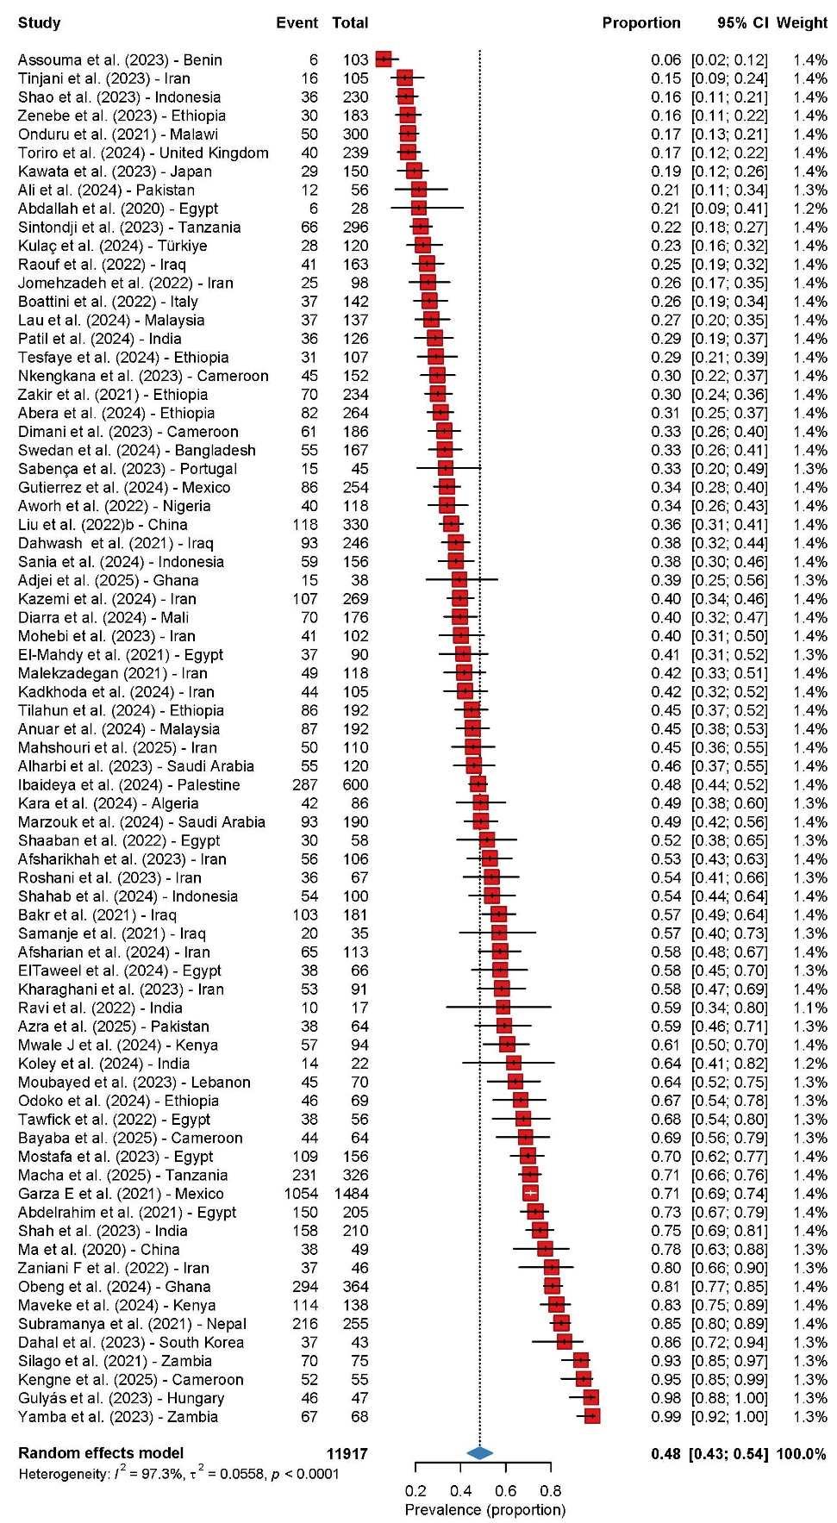
A B

Fig. S17 The pooled prevalence of ESBL-E determined by combined methods (k = 74).
- Forest plot, (B) funnel plot

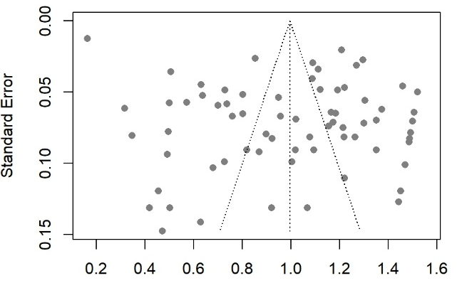
A B

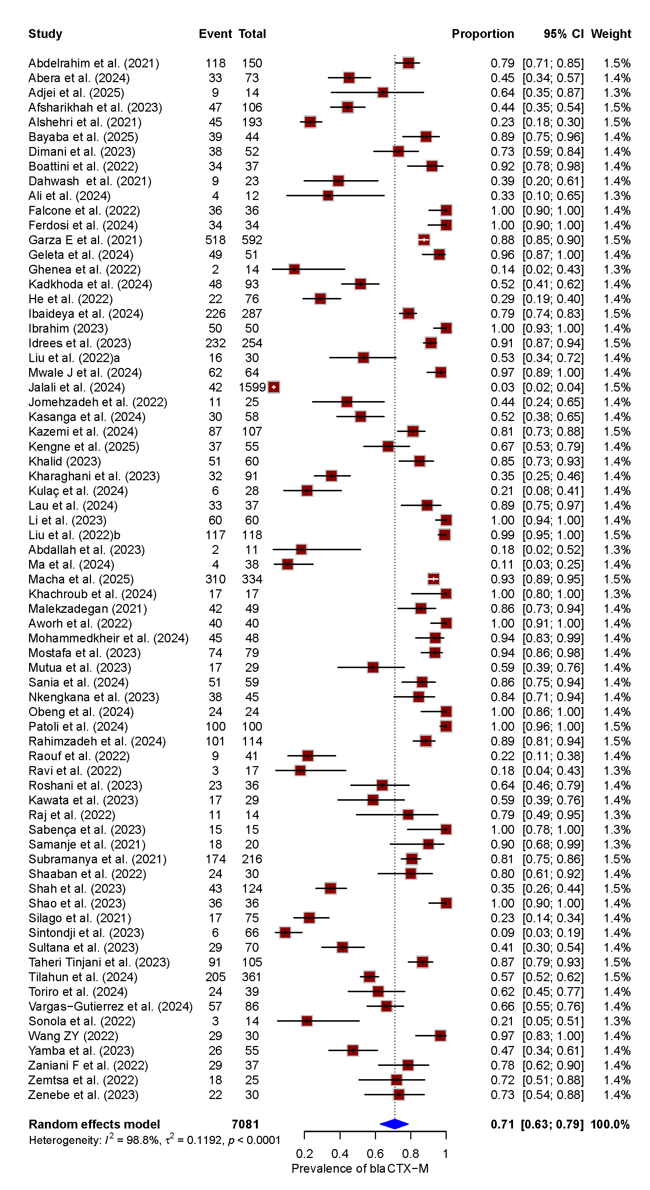

Fig. S18 The pooled prevalence of bla_{CTX-M} among ESBL-E (k = 71).
(A) Forest plot, (B) funnel plot, CI, confidence interval.

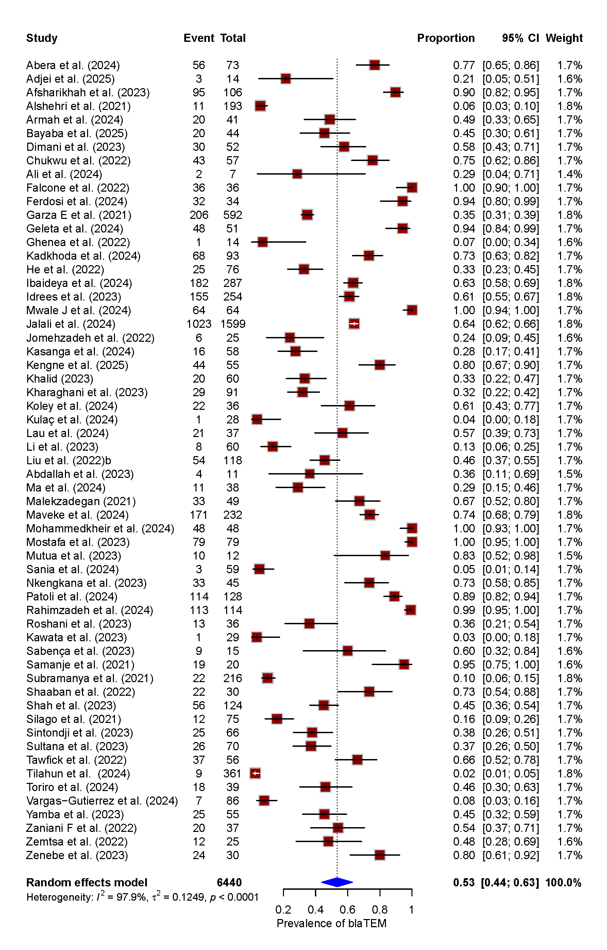
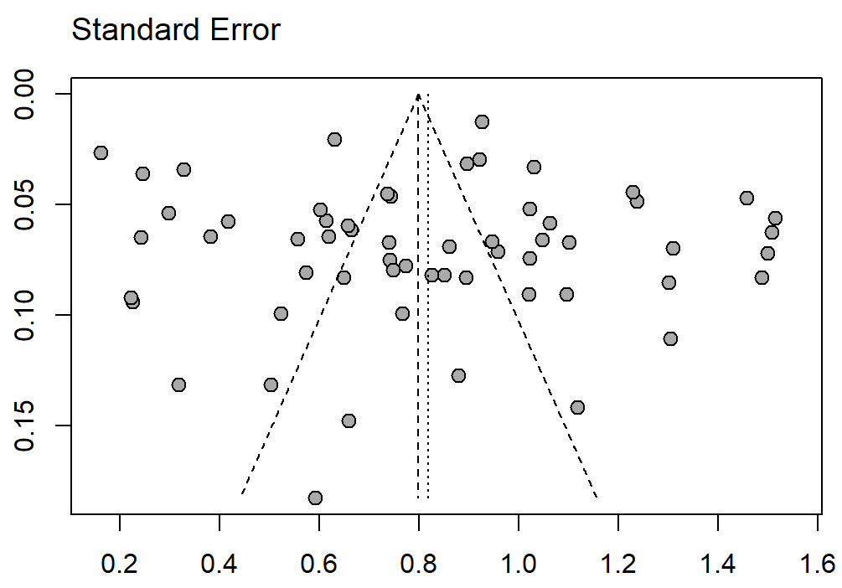
A B

Fig. S19 The pooled prevalence of bla_{TEM} among ESBL-E (k = 59).
- Forest plot, (B) funnel plot, CI, confidence interval.

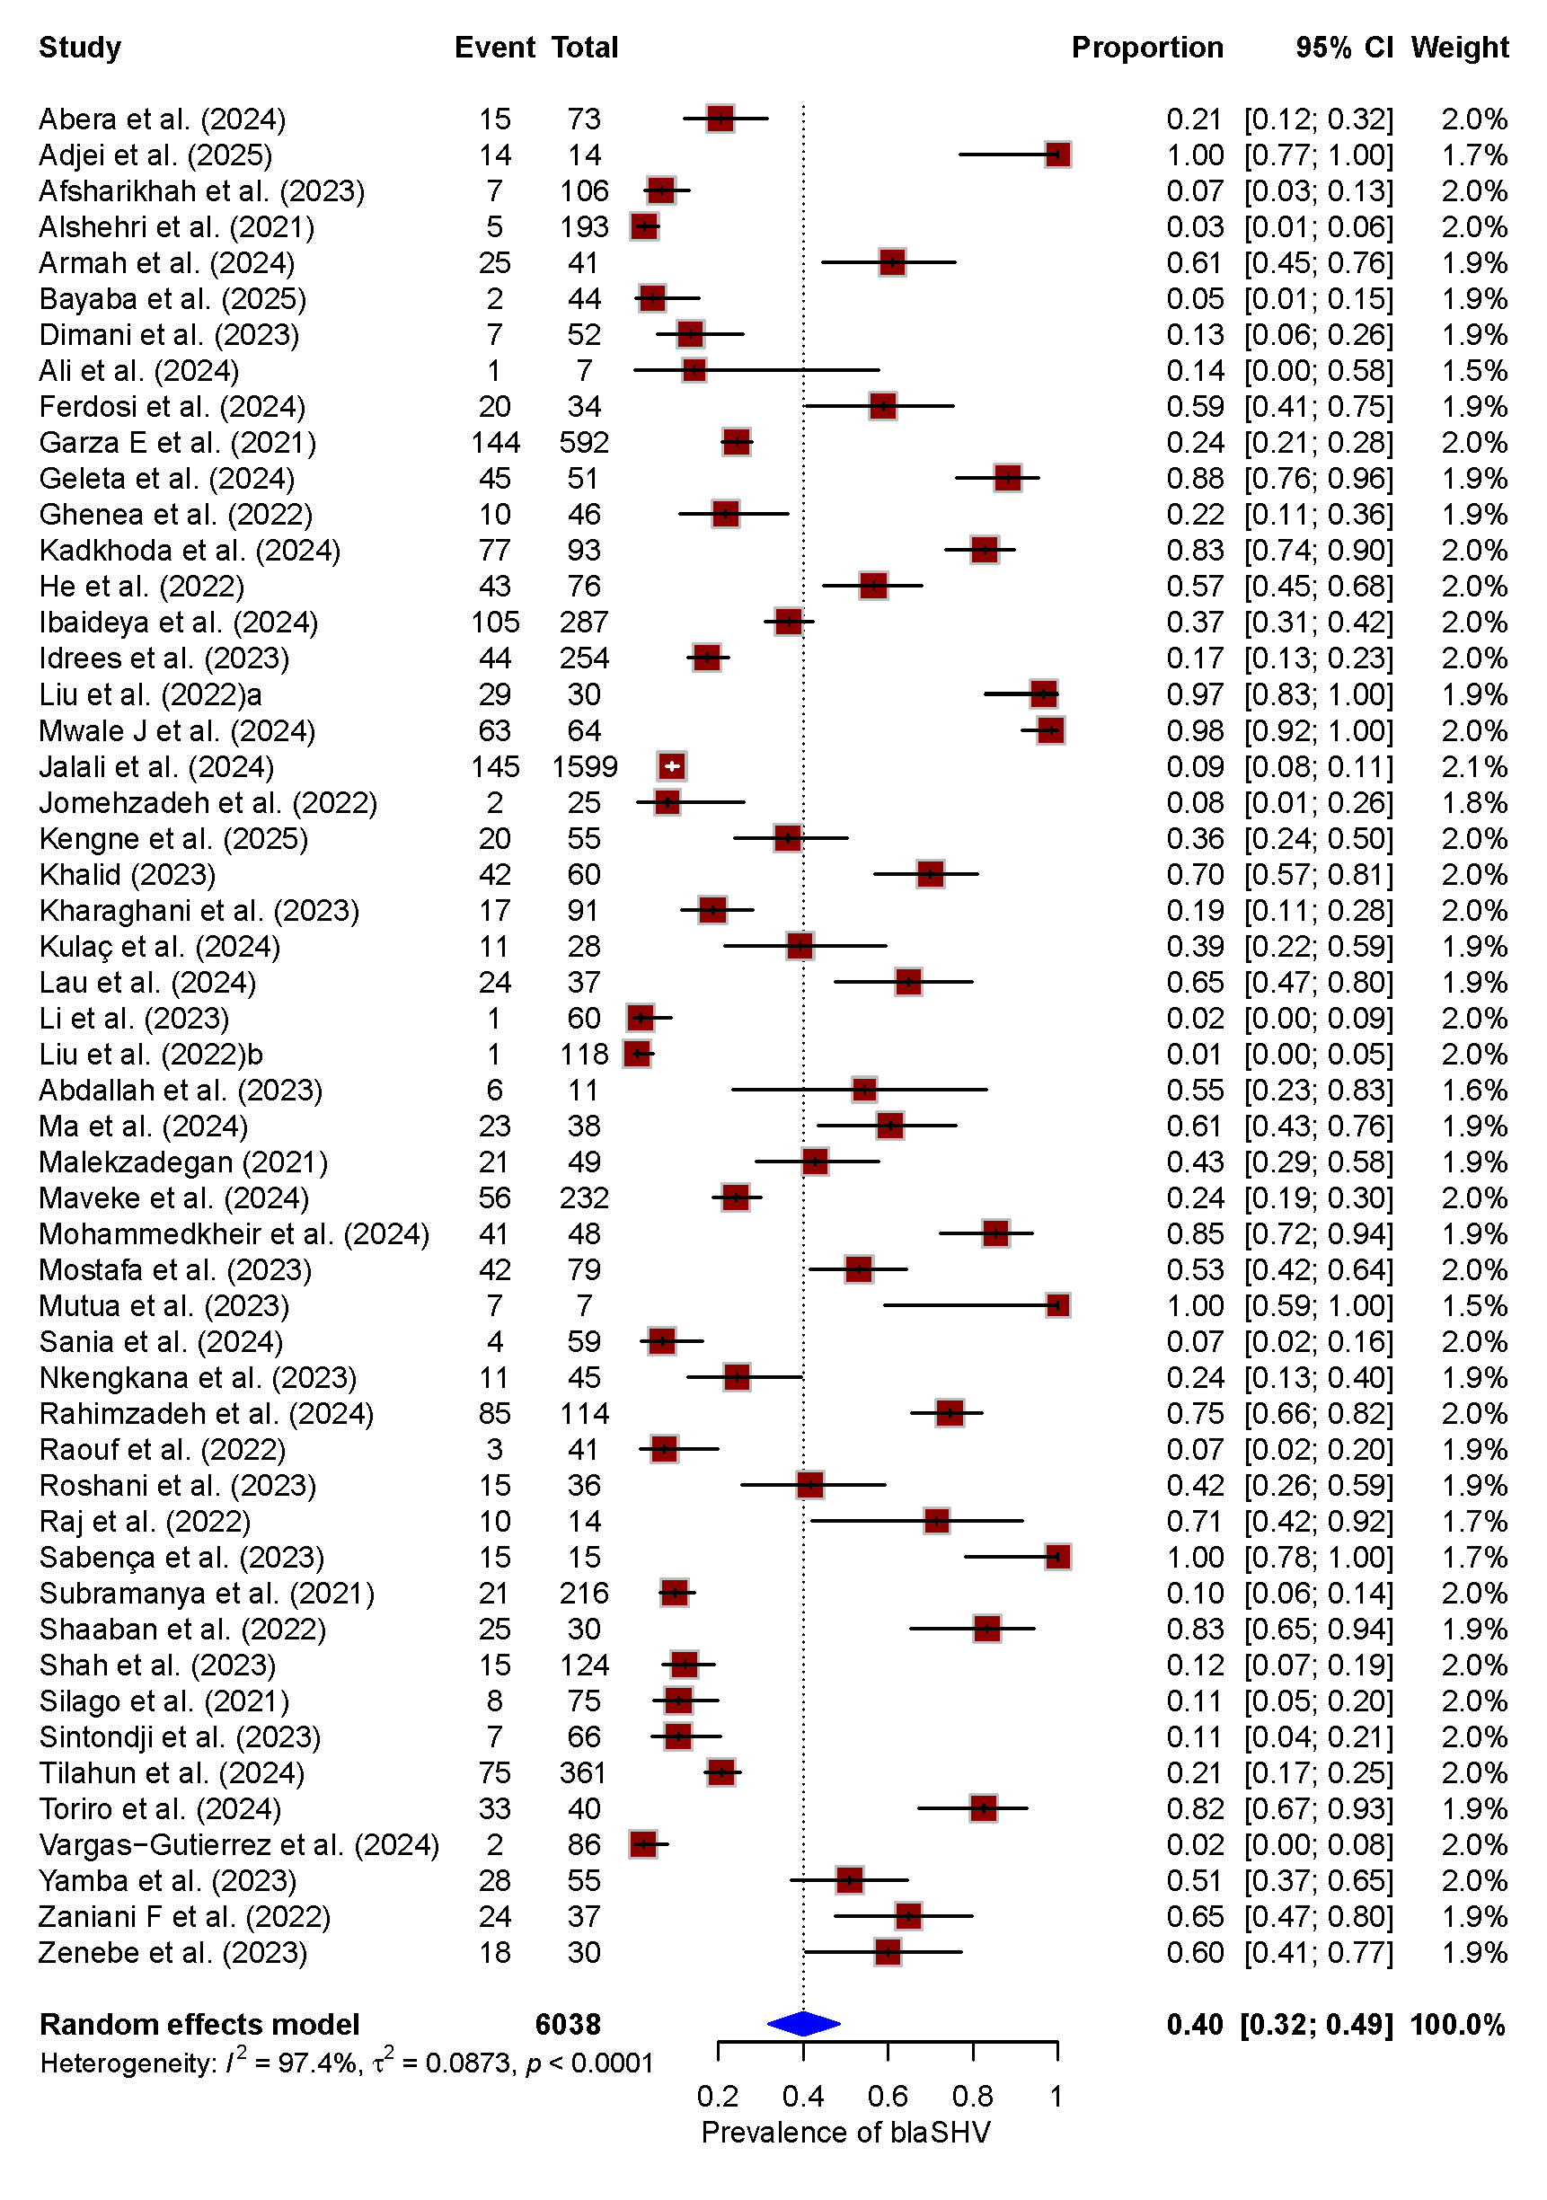
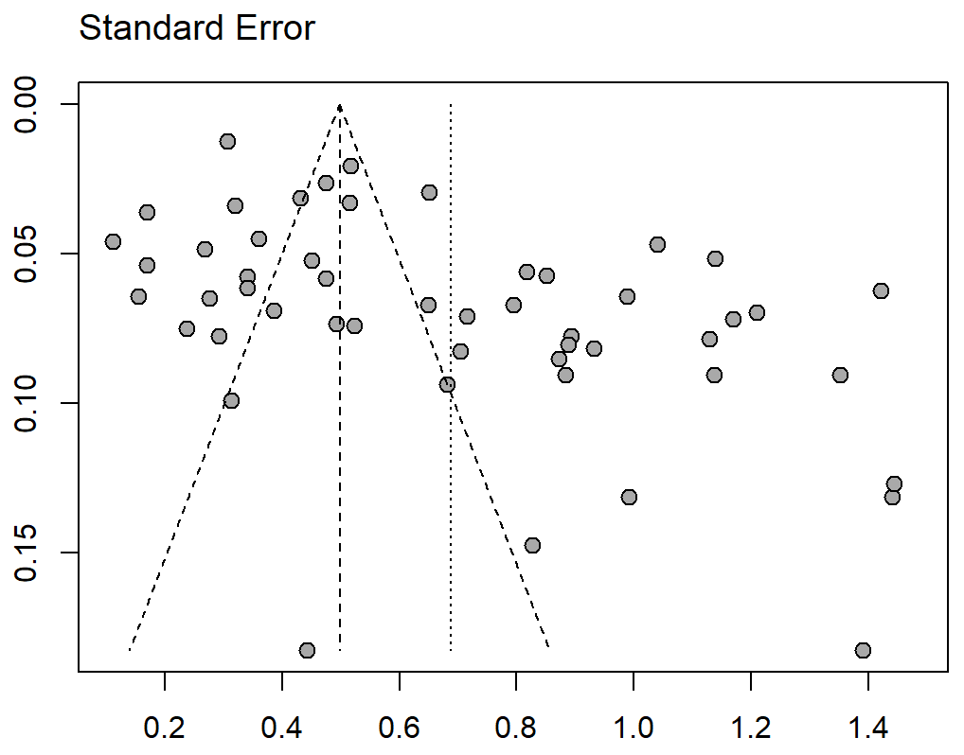
A B

Fig. S20 The pooled prevalence of bla_{SHV} among ESBL-E (k = 52).
(A) Forest plot, (B) funnel plot, CI, confidence interval.

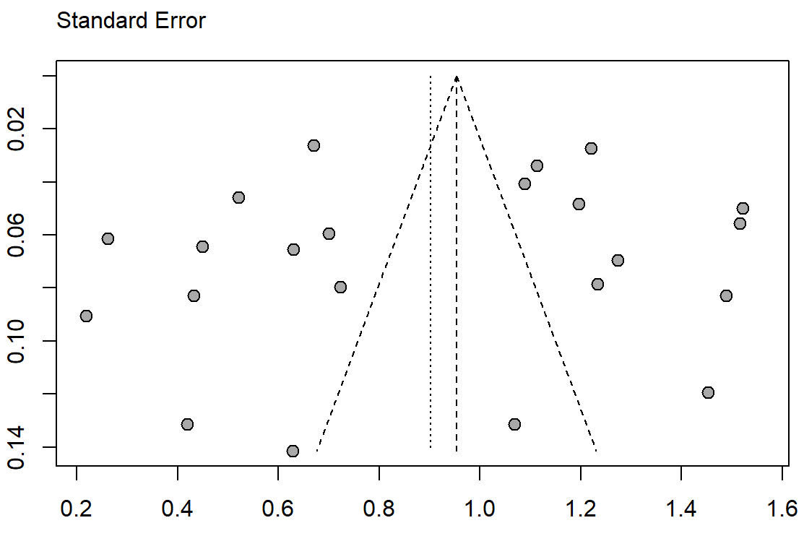
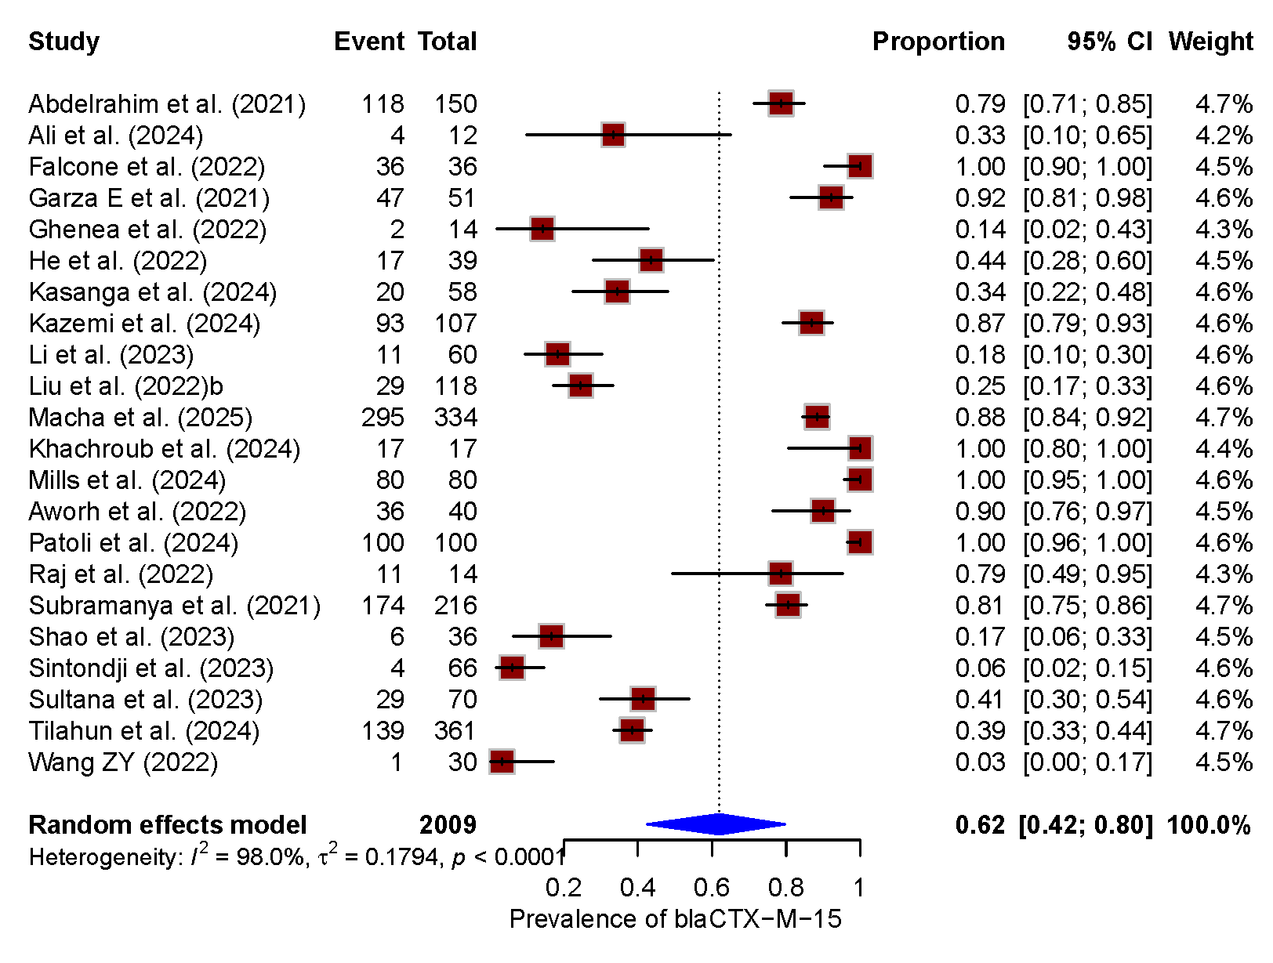
A B

Fig. S21 The pooled prevalence of bla_{CTX-M-15} among ESBL-E (k = 22).
(A) Forest plot, (B) funnel plot, CI, confidence interval.

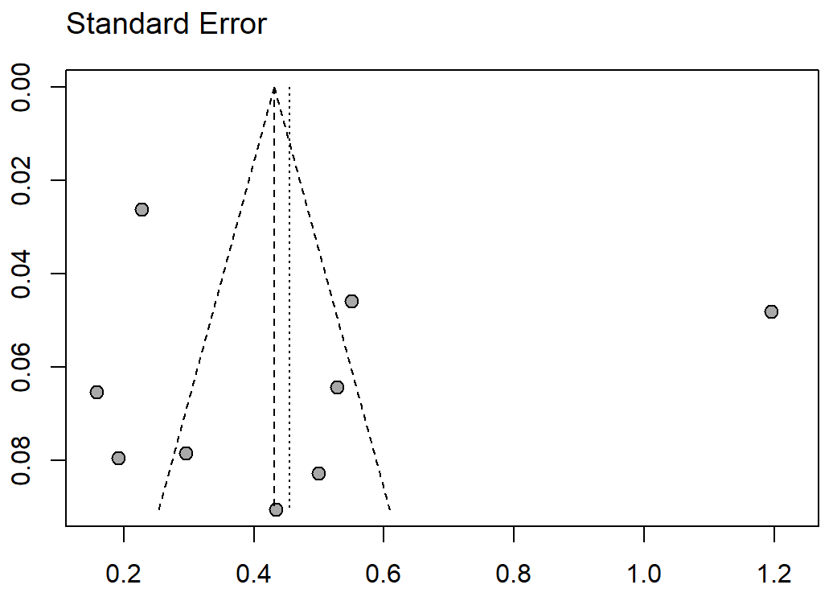
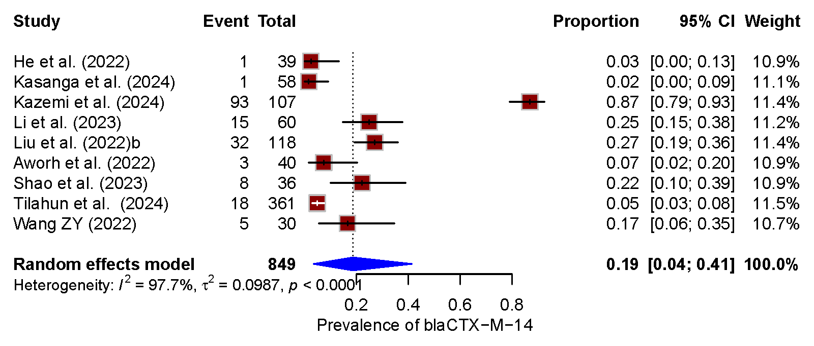
A B

Fig. S22 The pooled prevalence of bla_{CTX-M-14} among ESBL-E (k = 9).
(A) Forest plot, (B) funnel plot, CI, confidence interval.

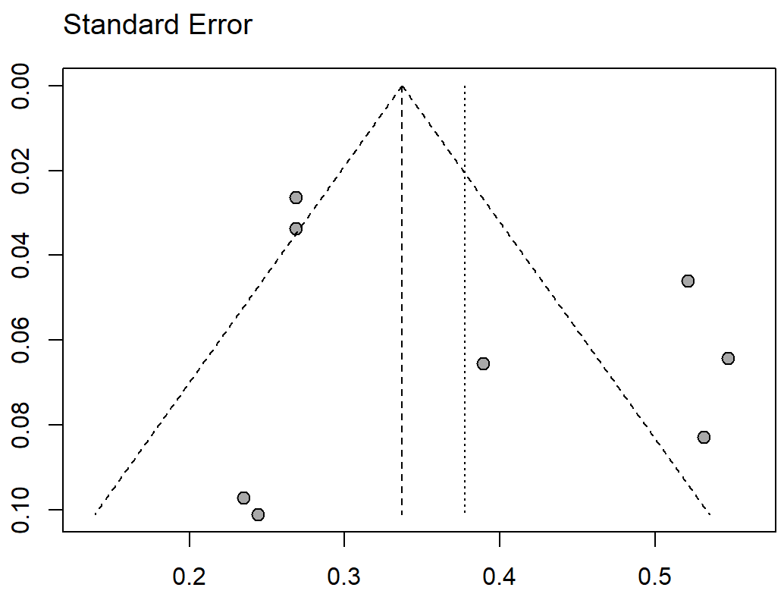
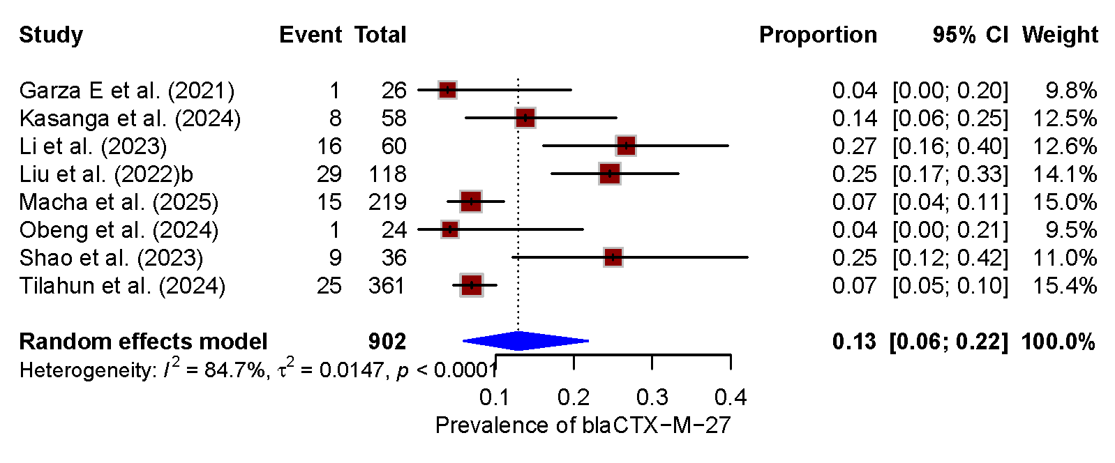
A B

Fig. S23 The pooled prevalence of bla_{CTX-M-27} among ESBL-E (k = 8).
(A) Forest plot, (B) funnel plot, CI, confidence interval.

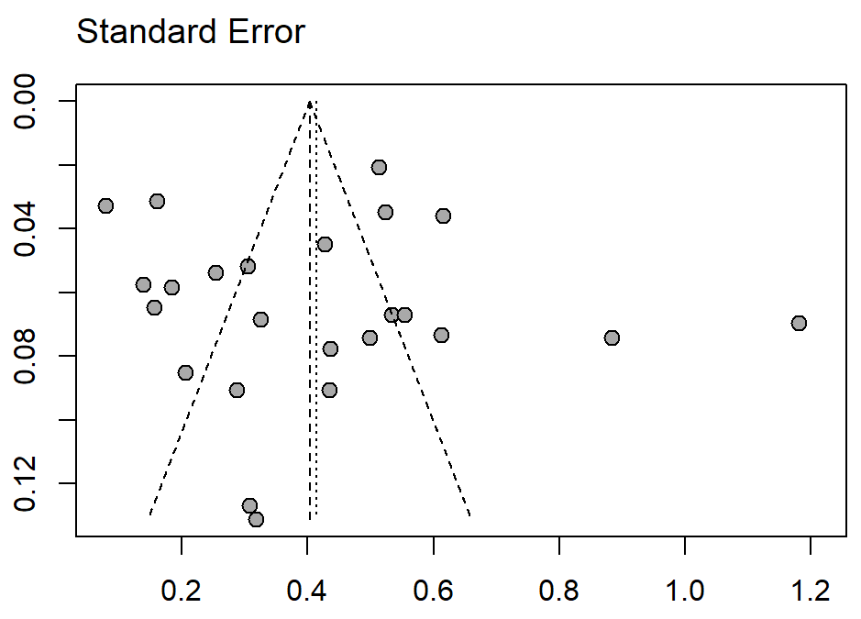
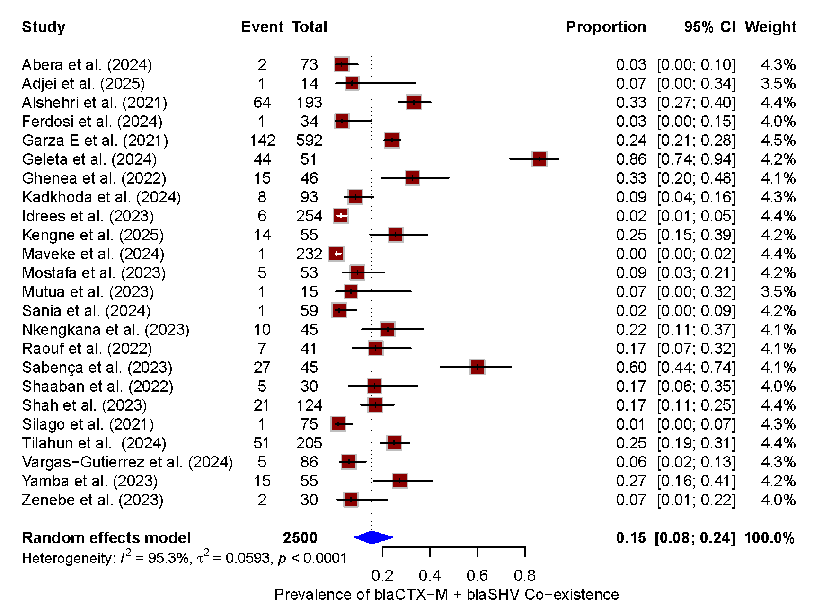
A B

Fig. S24 The pooled prevalence of co-existence bla_{CTX-M} + bla_{SHV} among ESBL-E (k = 24).
(A) Forest plot, (B) funnel plot, CI, confidence interval.

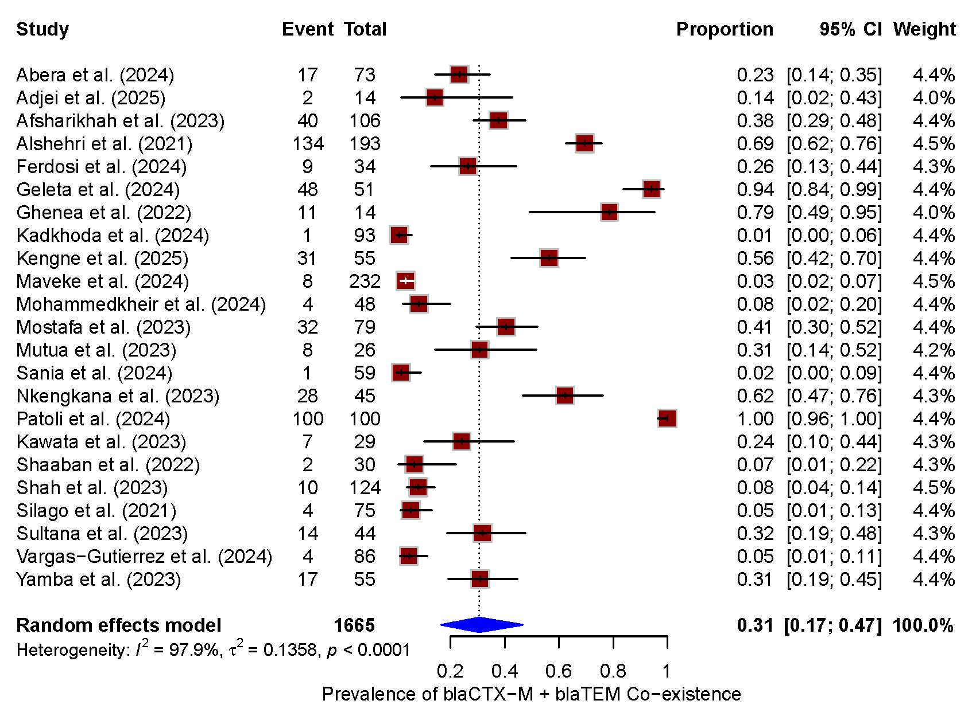
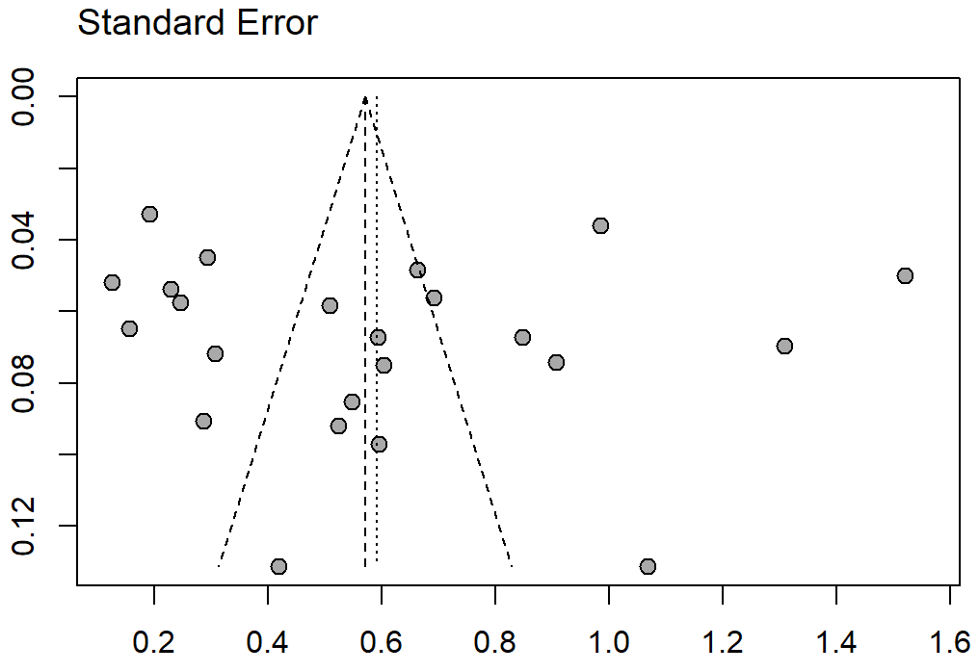
A B

Fig. S25 The pooled prevalence of co-existence bla_{CTX-M} + bla_{TEM} among ESBL-E (k = 23).
(A) Forest plot, (B) funnel plot, CI, confidence interval.
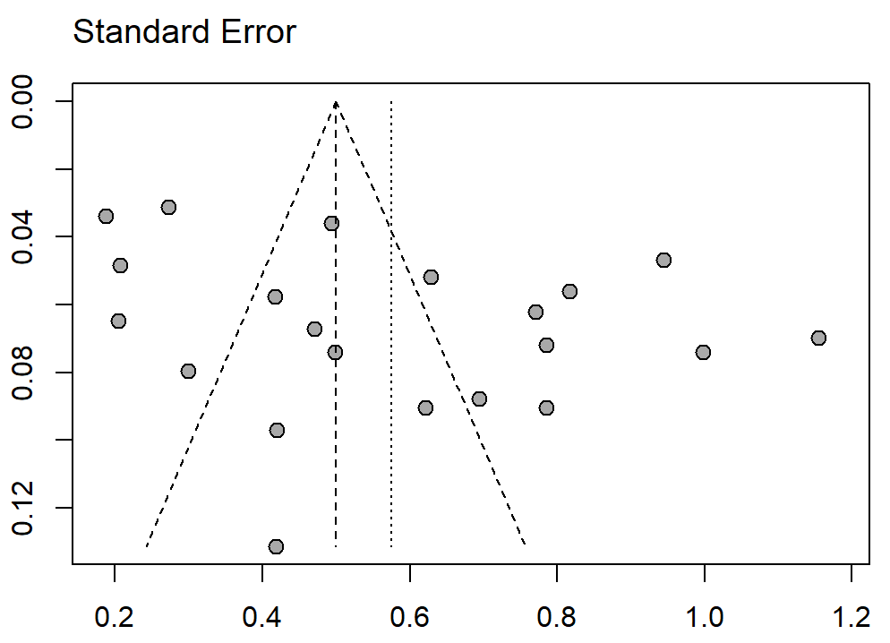
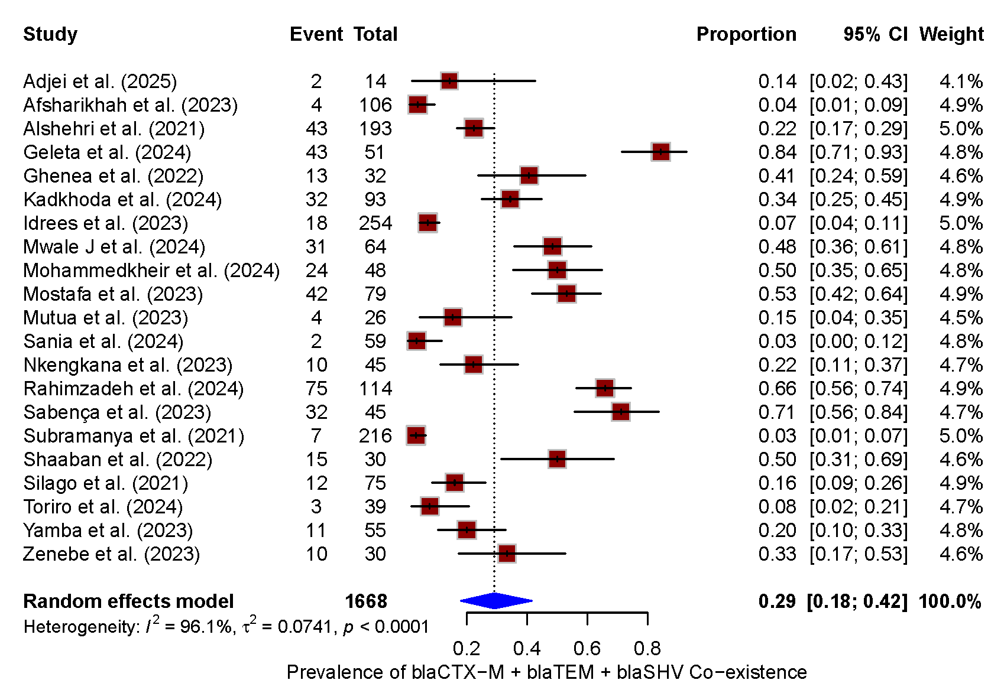
A B

Fig. S26 The pooled prevalence of co-existence bla_{CTX-M} + bla_{TEM} + bla_{SHV} among ESBL-E (k = 21).
(A) Forest plot, (B) funnel plot, CI, confidence interval.

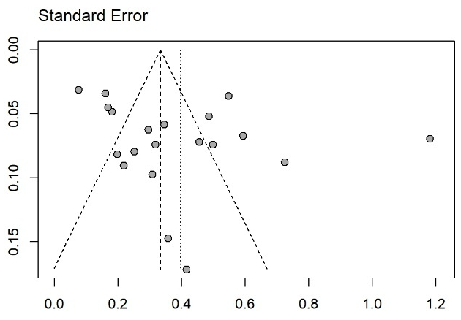
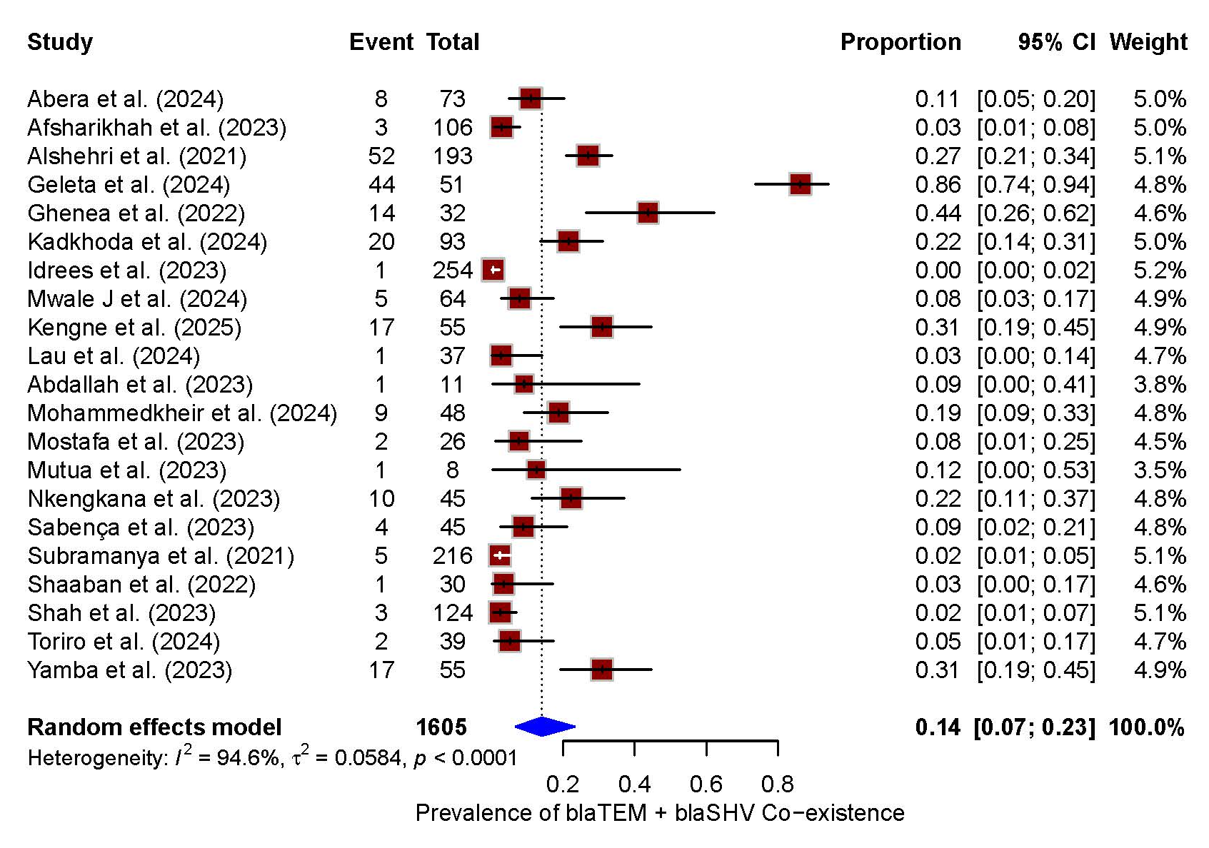
A B

Fig. S27 The pooled prevalence of co-existence bla_{TEM} + bla_{SHV} among ESBL-E (k = 21).
(A) Forest plot, (B) funnel plot, CI, confidence interval.

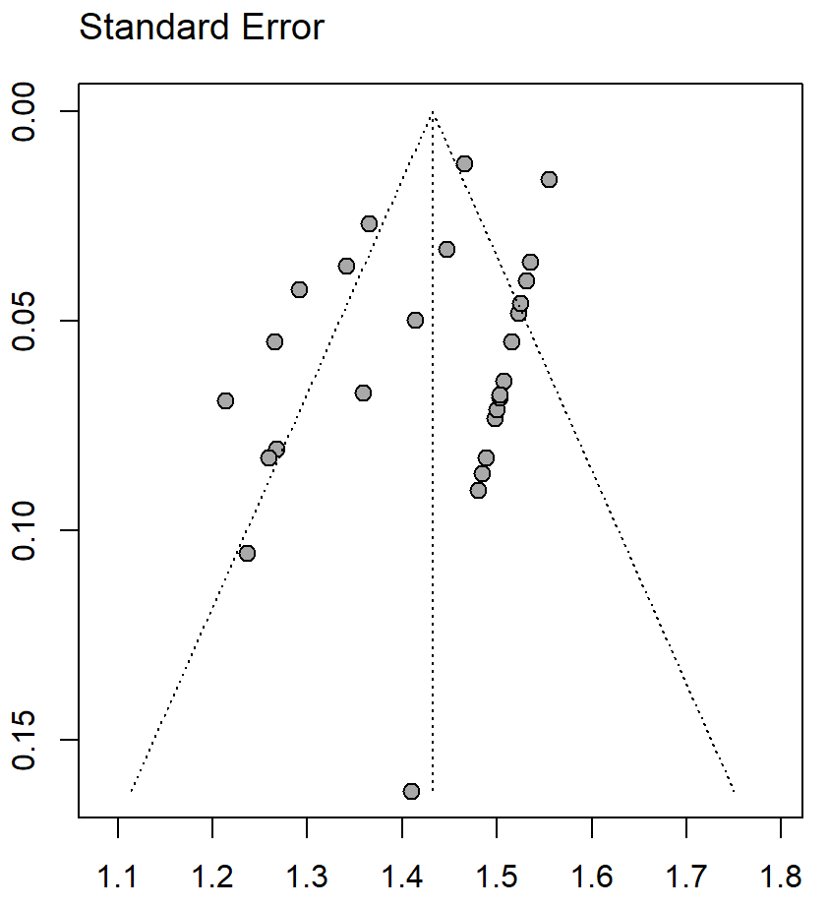
A B
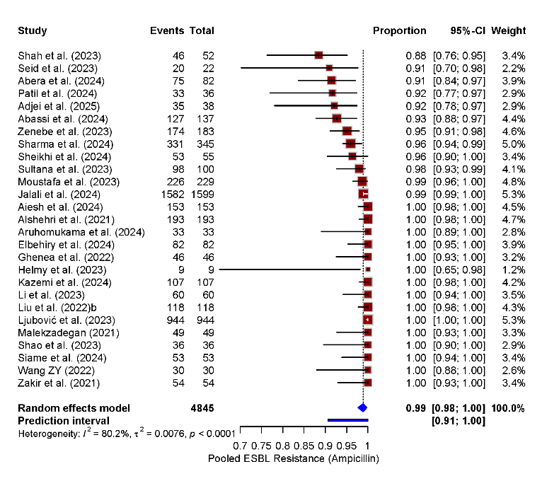
Fig. S28 The pooled prevalence of ampicillin resistance among ESBL-E (k = 27).
(A) Forest plot, (B) funnel plot. CI, confidence interval.

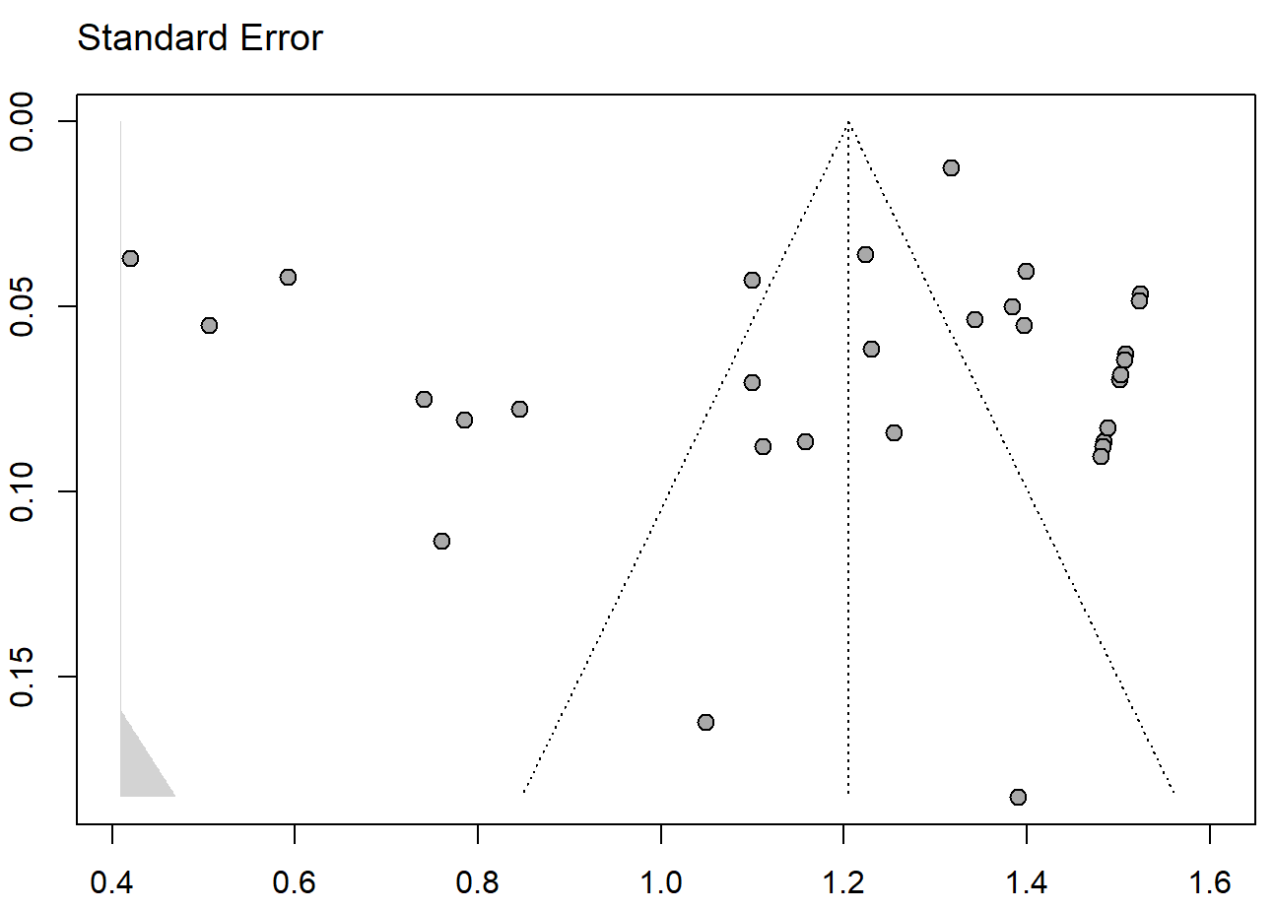
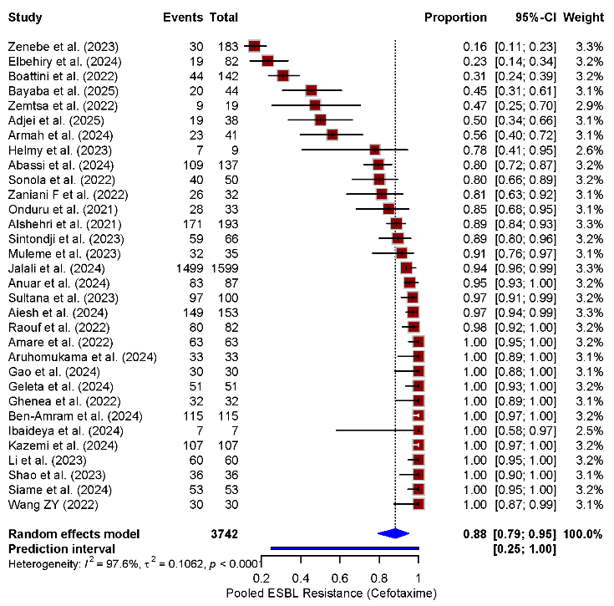
A B

Fig. S29 The pooled prevalence of cefotaxime resistance among ESBL-E (k = 32).
- Forest plot, (B) funnel plot. CI, confidence interval.

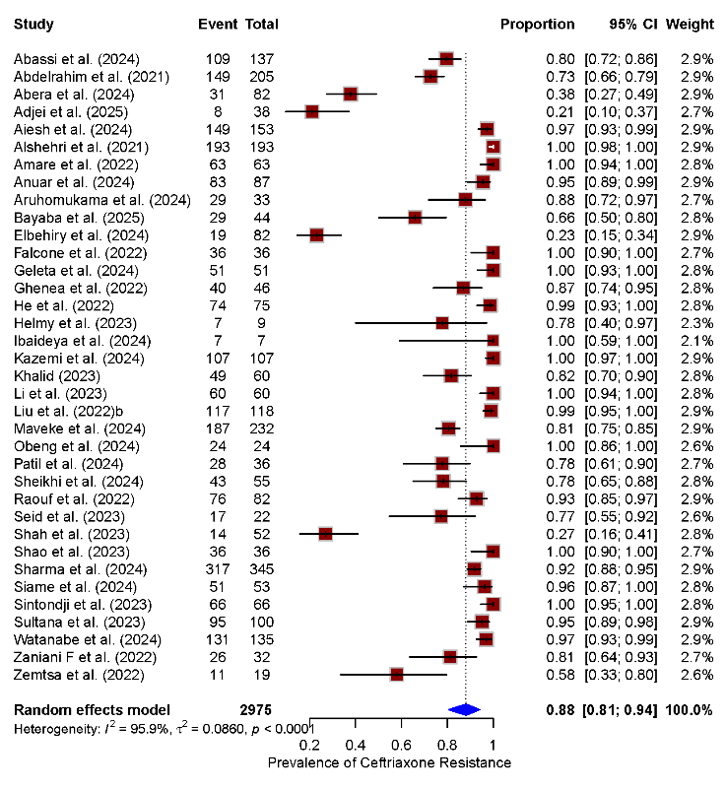
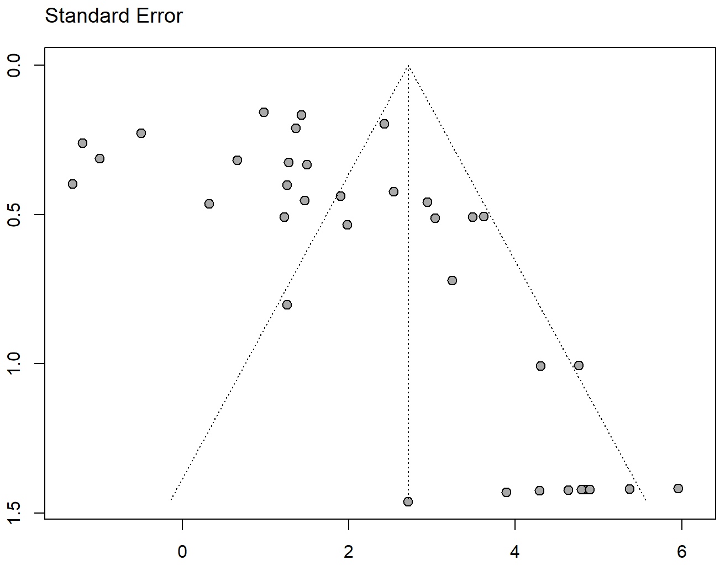
A B

Fig. S30 The pooled prevalence of ceftriaxone resistance among ESBL-E (k = 36).
(A) Forest plot, (B) funnel plot.

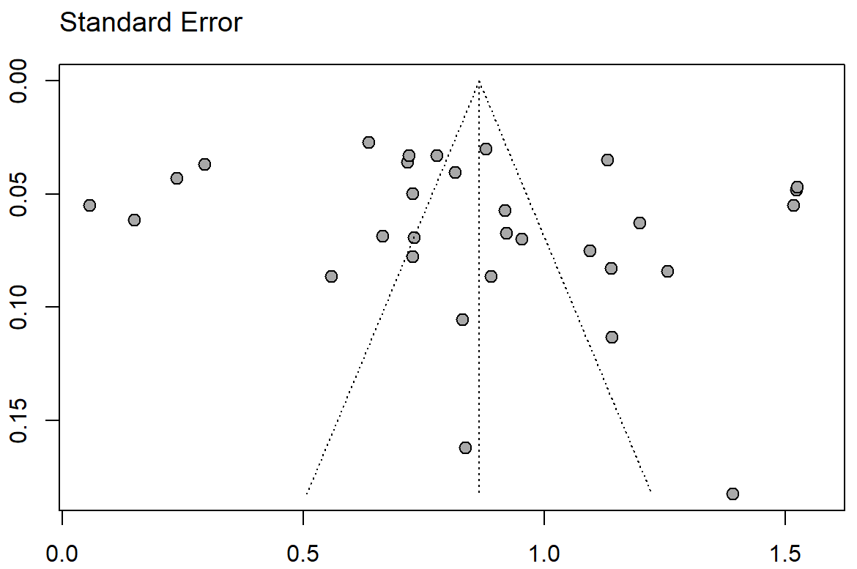
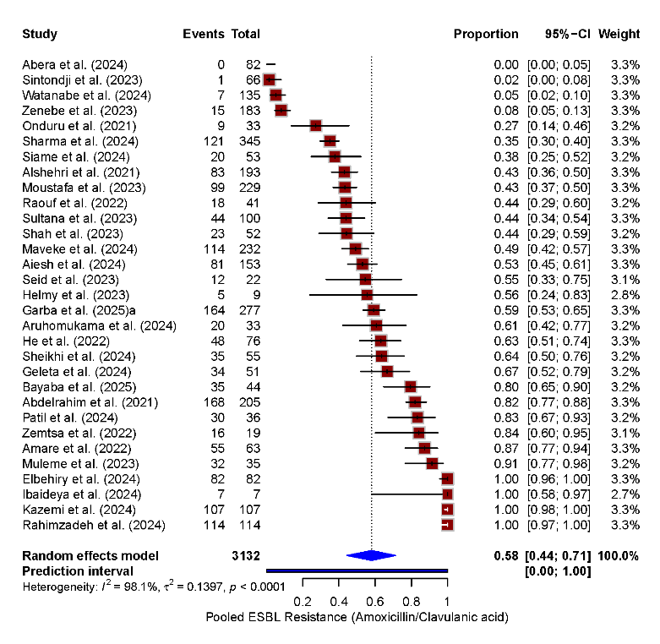
A B

Fig. S31 The pooled prevalence of amoxicillin/clavulanic acid resistance among ESBL-E (k = 31).
(A) Forest plot, (B) funnel plot, CI, confidence interval.

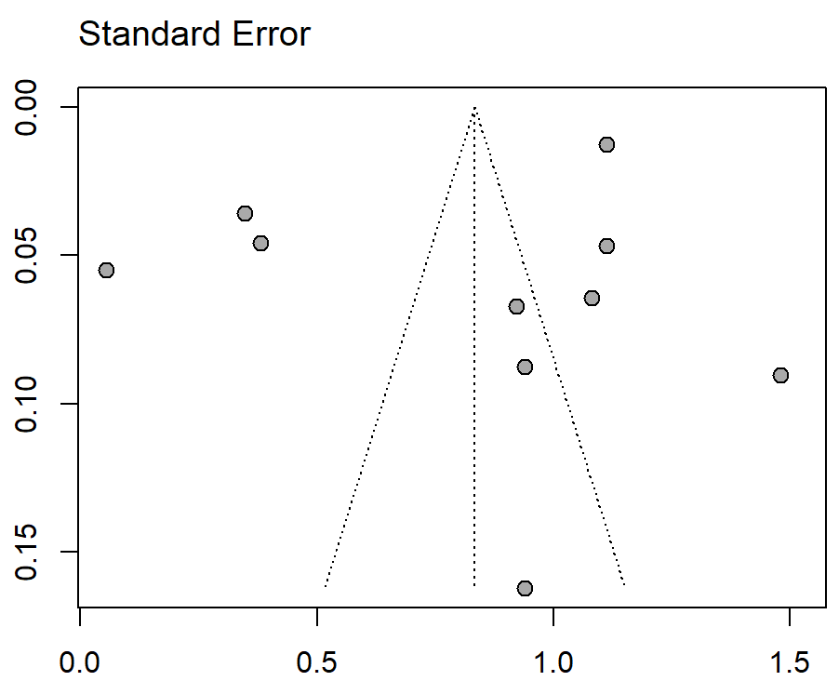
A B
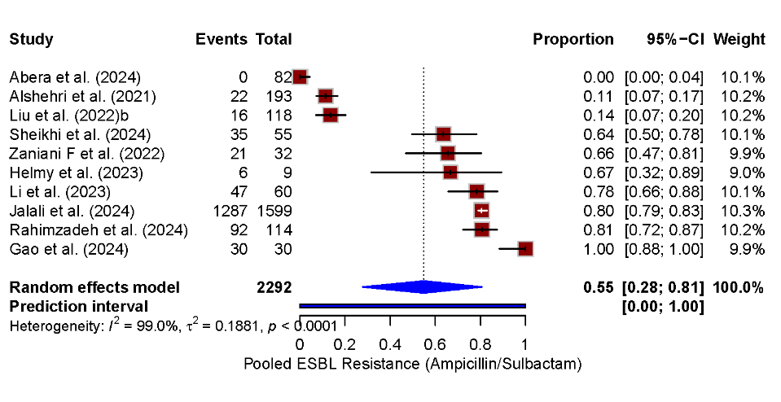
Fig. S32 The pooled prevalence of ampicillin/sulbactam resistance among ESBL-E (k = 10).
(A) Forest plot, (B) funnel plot, CI, confidence interval.

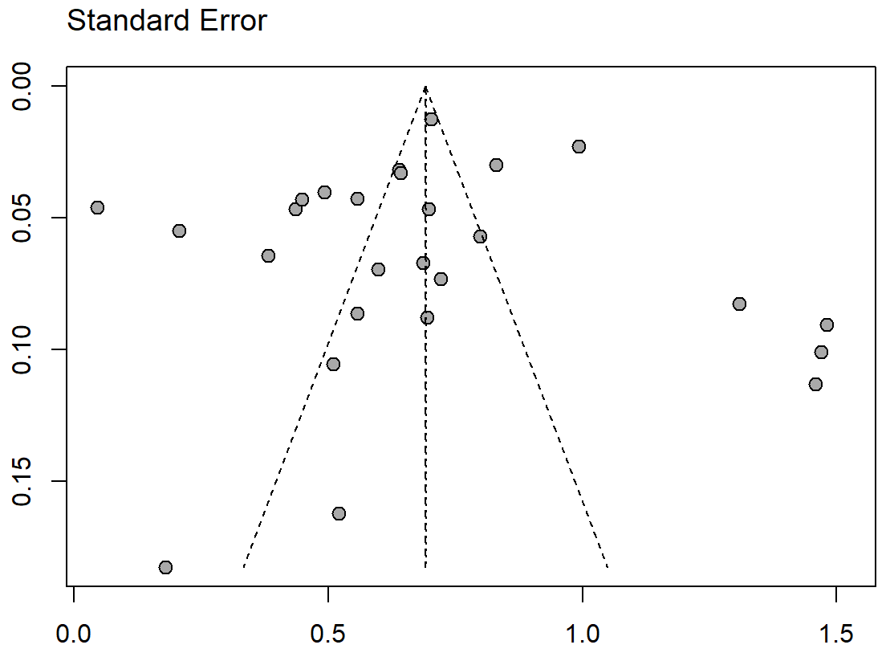
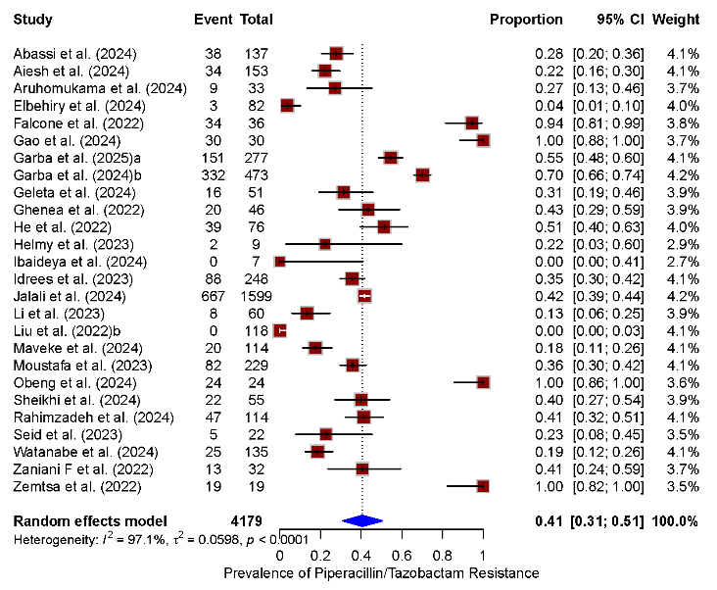
A B

Fig. S33 The pooled prevalence of piperacillin/tazobactam resistance among ESBL-E (k = 26).
(A) Forest plot, (B) funnel plot, CI, confidence interval.

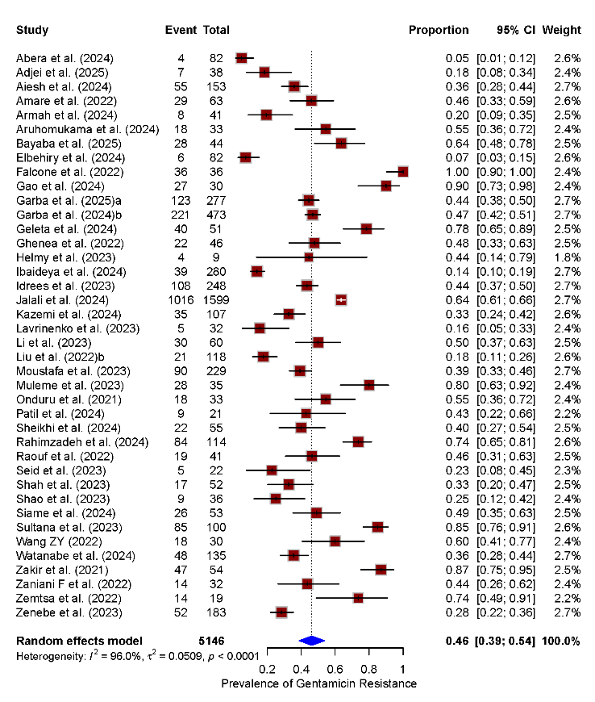
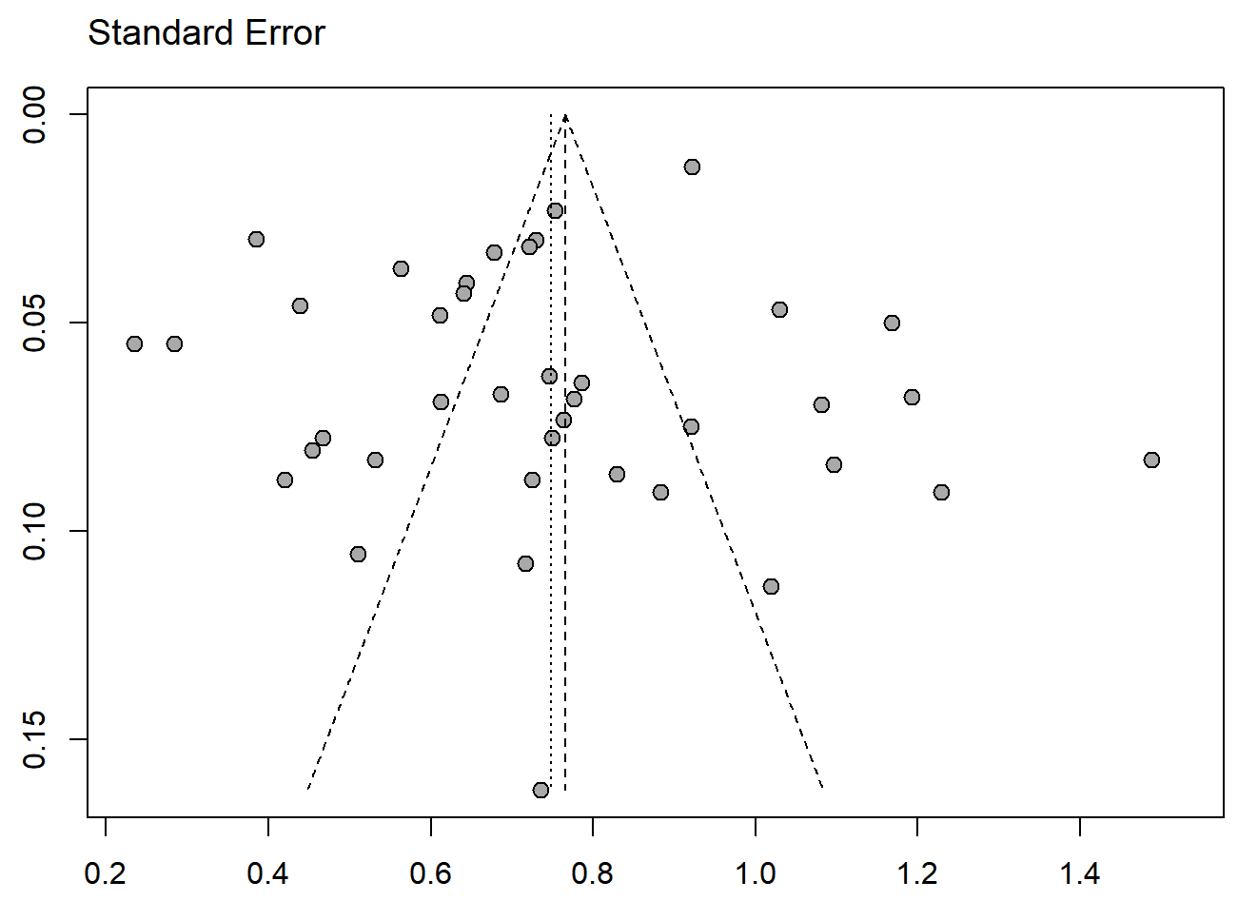
A B

Fig. S34 The pooled prevalence of gentamicin resistance among ESBL-E (k = 40).
(A) Forest plot, (B) funnel plot, CI, confidence interval.

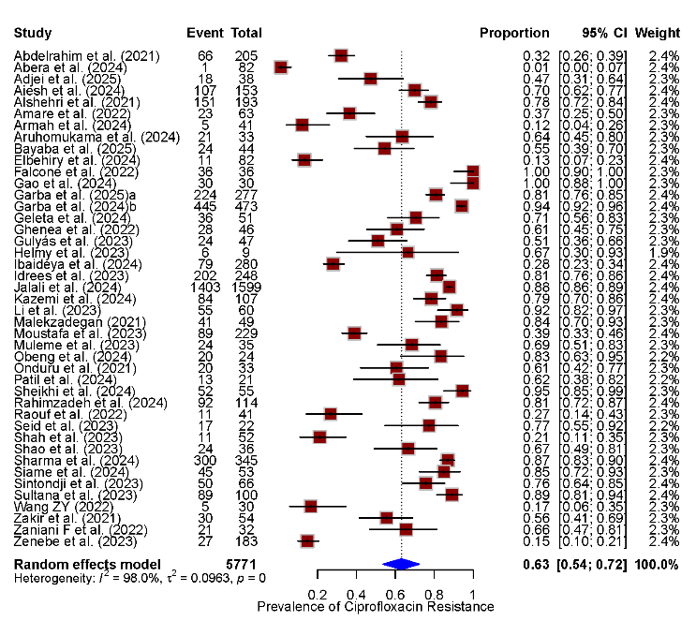
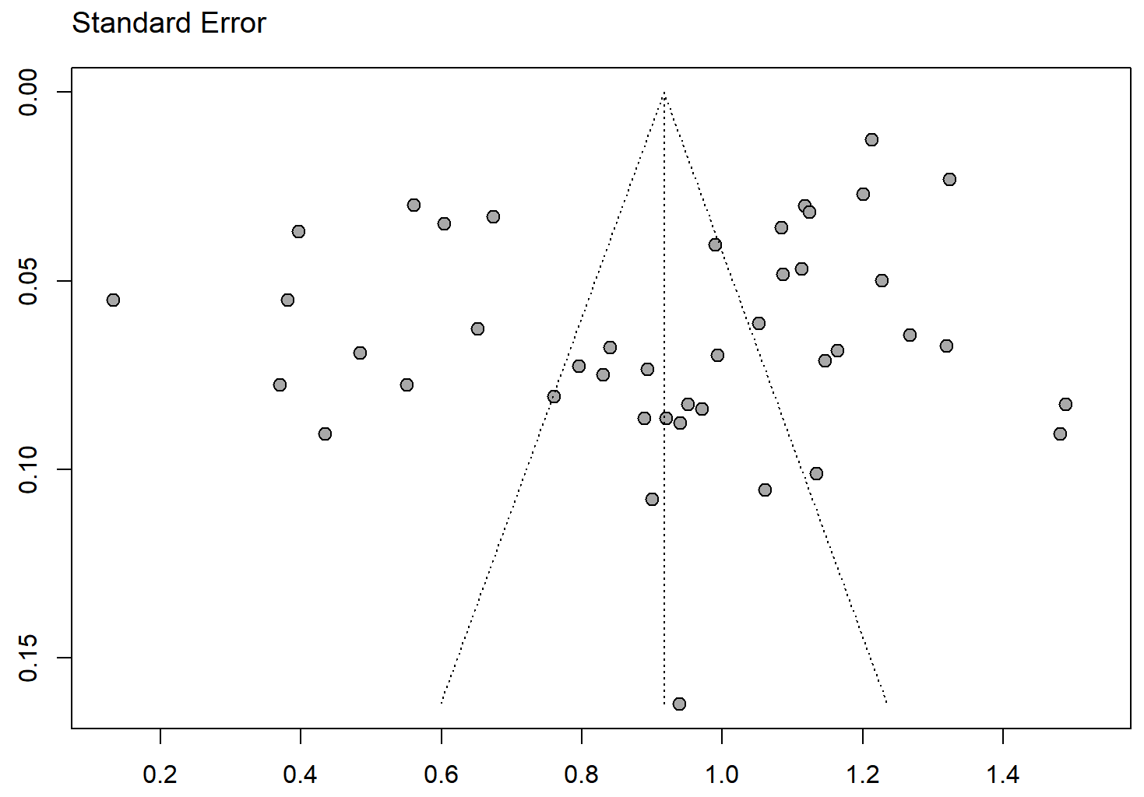
A B

Fig. S35 The pooled prevalence of ciprofloxacin resistance among ESBL-E (k = 43).
(A) Forest plot, (B) funnel plot.

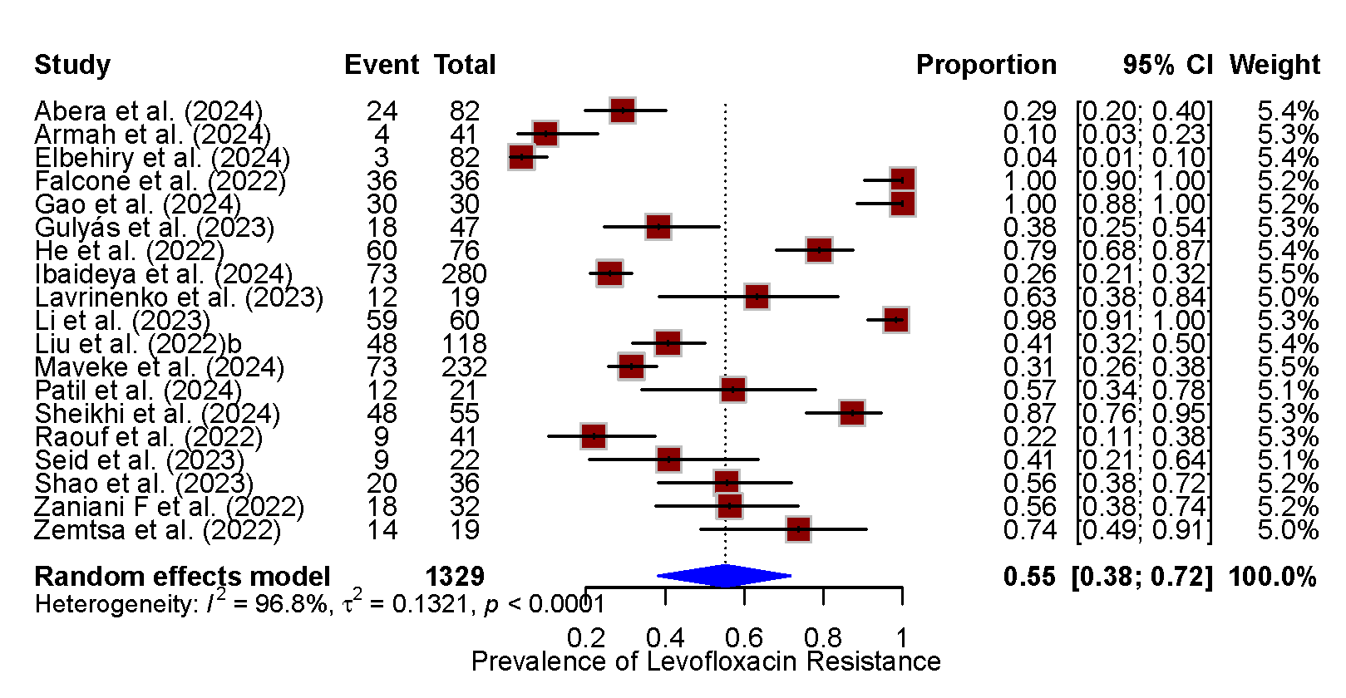
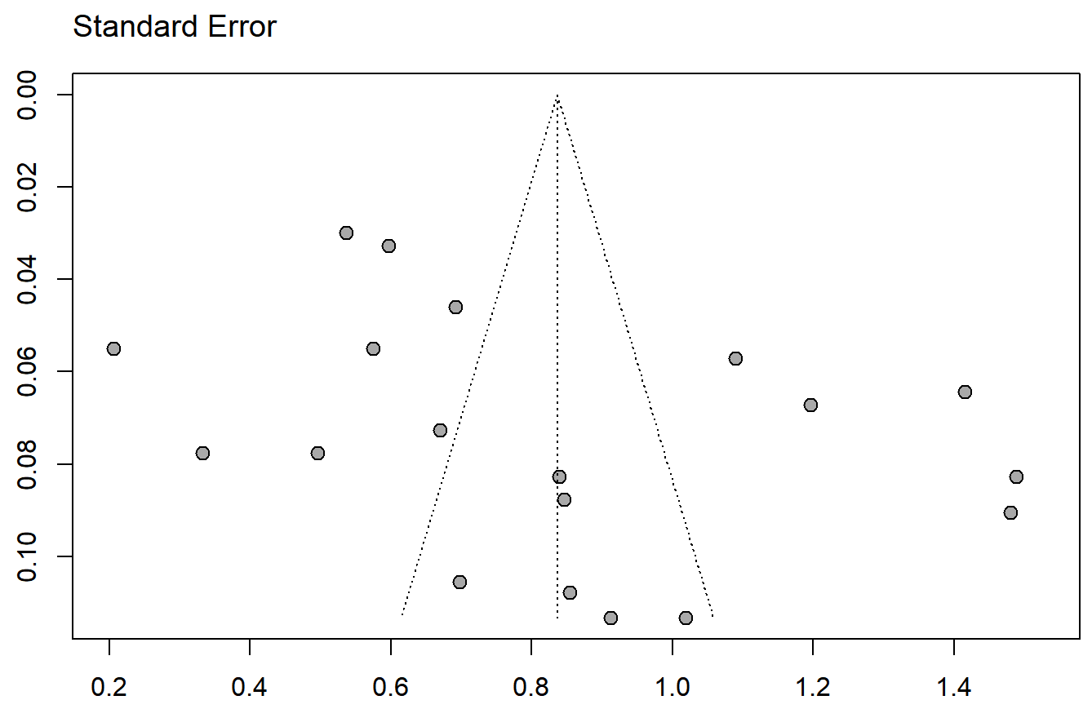
A B

Fig. S36 The pooled prevalence of levofloxacin resistance among ESBL-E (k = 19).
(A) Forest plot, (B) funnel plot, CI, confidence interval.

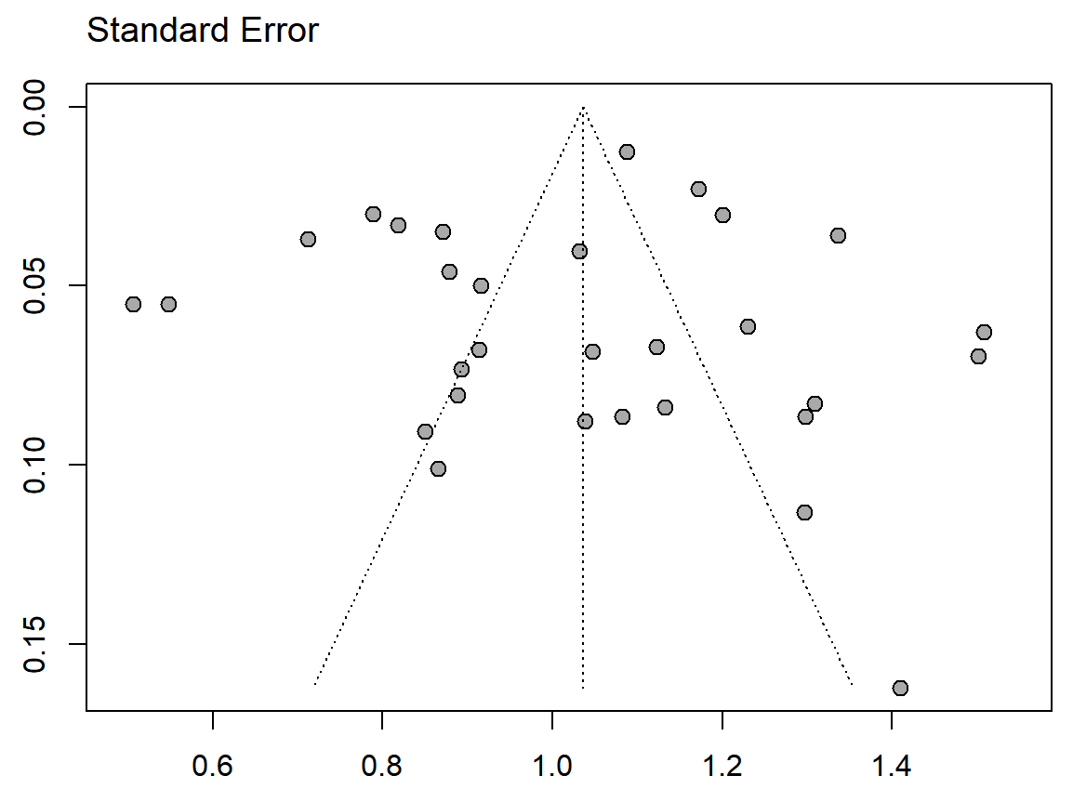
A B

Fig. S37 The pooled prevalence of trimethoprim/sulfamethoxazole resistance among ESBL-E (k = 30).
(A) Forest plot, (B) funnel plot, CI, confidence interval.

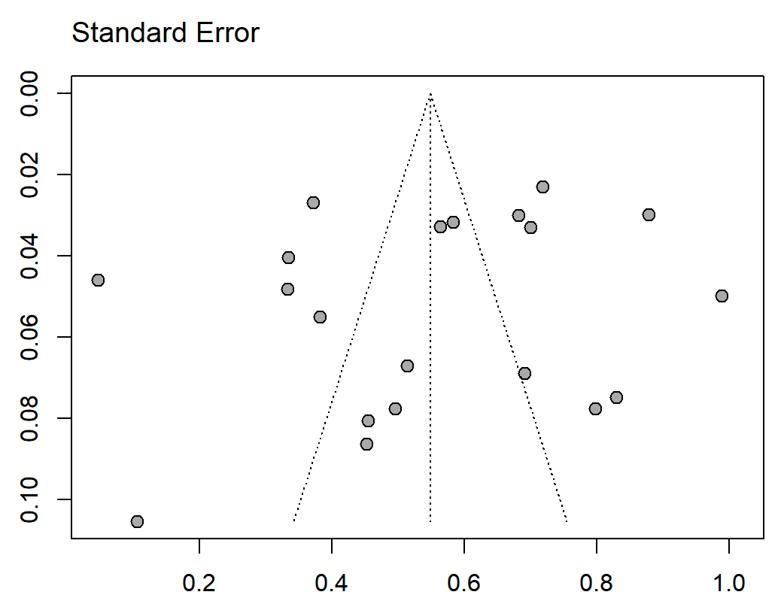
A B

Fig. S38 The pooled prevalence of nitrofurantoin resistance among ESBL-E (k = 20).
(A) Forest plot, (B) funnel plot, CI, confidence interval.

A B

Fig. S39 The pooled prevalence of cefuroxime resistance among ESBL-E (k = 13).
(A) Forest plot, (B) funnel plot, CI, confidence interval.

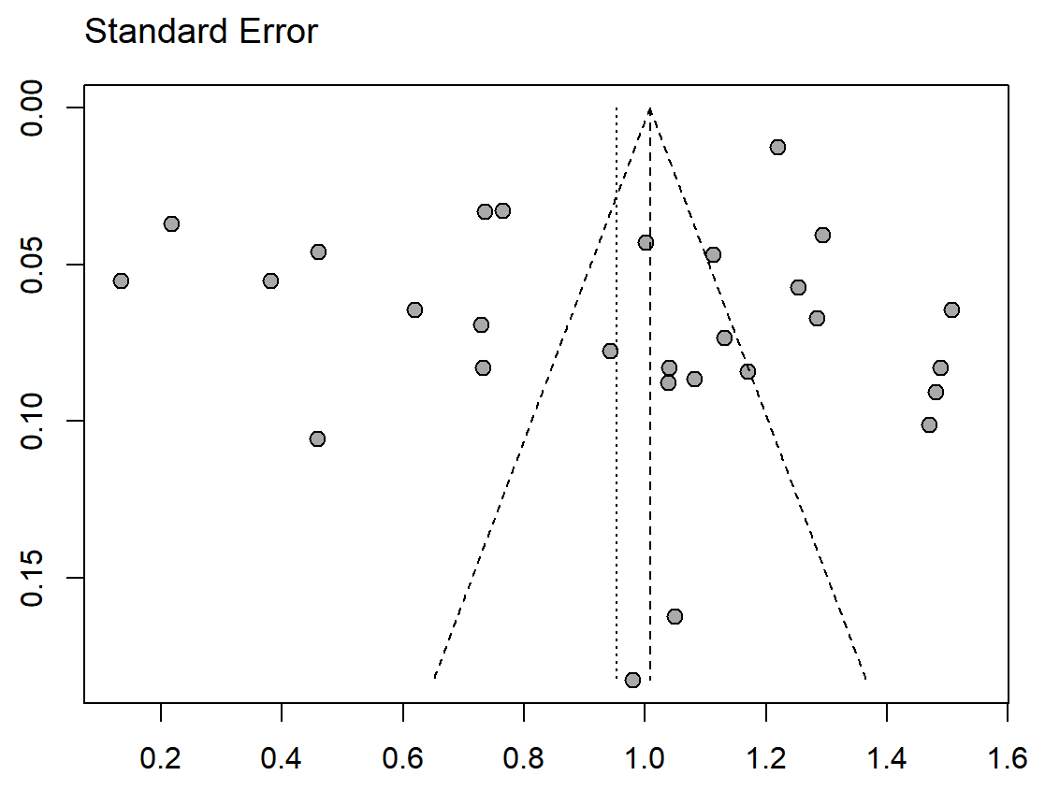
A B

Fig. S40 The pooled prevalence of cefepime resistance among ESBL-E (k = 28).
(A) Forest plot, (B) funnel plot, CI, confidence interval.

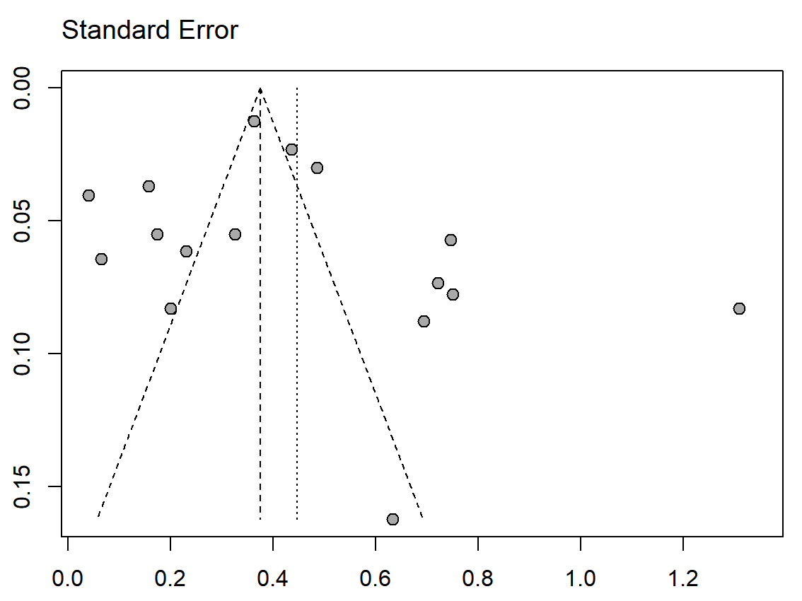
A B

Fig. S41 The pooled prevalence of ertapenem resistance among ESBL-E (k = 16).
(A) Forest plot, (B) funnel plot, CI, confidence interval.

A B

Fig. S42 The pooled prevalence of imipenem resistance among ESBL-E (k = 33).
(A) Forest plot, (B) funnel plot.

A B

Fig. S43 The pooled prevalence of meropenem resistance among ESBL-E (k = 32).
(A) Forest plot, (B) funnel plot, CI, confidence interval.

A B

Fig. S44 The pooled prevalence of amikacin resistance among ESBL-E (k = 26).
(A) Forest plot, (B) funnel plot, CI, confidence interval.

A B

Fig. S45 The pooled prevalence of cefoxitin resistance among ESBL-E (k = 12).
(A) Forest plot, (B) funnel plot, CI, confidence interval.

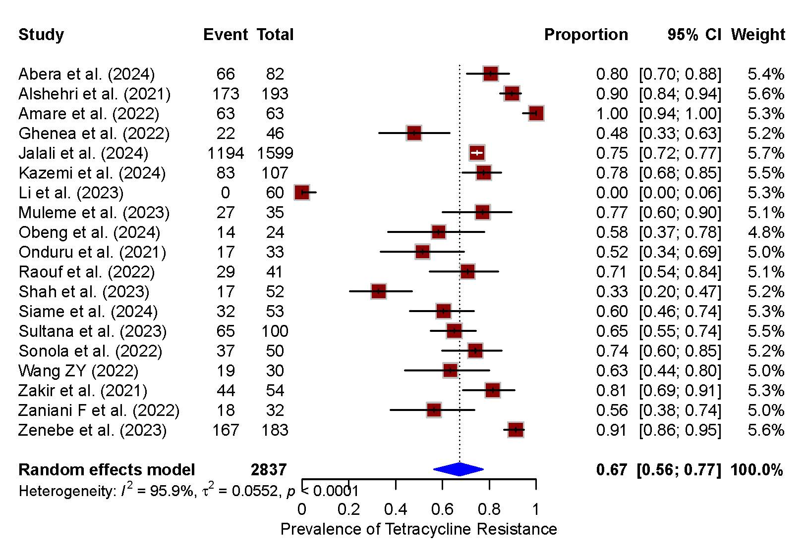
A B

Fig. S46 The pooled prevalence of tetracycline resistance among ESBL-E (k = 19).
(A) Forest plot, (B) funnel plot, CI, confidence interval.

A B

Fig. S47 The pooled prevalence of aztreonam resistance among ESBL-E (k = 21).
(A) Forest plot, (B) funnel plot, CI, confidence interval.

A B

Fig. S48 The pooled prevalence of ceftazidime resistance among ESBL-E (k = 34).
(A) Forest plot, (B) funnel plot, CI, confidence interval.

