Additional data
A trienone analog of cucumin, 1,7-bis(3-hydroxyphenyl)-1,4,6-heptatrien-3-one, possesses ROS- and caspase-mediated apoptosis in human oral squamous cell carcinoma cells in vitro

Tanyarath Utaipan, Piyawan Boonyanuphong, Thipphawan Chuprajob, Apichart Suksamrarn and Warangkana Chunglok

Contents
- General ………………………………………..………………………………….. 2
- Fig. S1.1 ¹H and ¹³C NMR spectra of curcumin (a) recorded in acetone-d₆. …….. 3
- Fig. S1.2 ¹H and ¹³C NMR spectra of trienone 4 (b) recorded in acetone-d₆.. ……. 4
- Fig. S1.3 COSY and COSY expansion spectra of trienone 4 (b) recorded in acetone-d₆.. 5
- Fig. S1.4 HMQC and HMQC expansion spectra of trienone 4 (b) recorded in acetone-d₆.. 6
- Fig. S1.5 HMBC and HMBC expansion spectra of trienone 4 (b) recorded in acetone-d₆.. 7
- Fig. S1.6 ¹H and ¹³C NMR spectra of trienone 11 (c) recorded in acetone-d₆…..…. 8
- Fig. S1.7 COSY and COSY expansion spectra of trienone 11 (c) recorded in acetone-d₆.. 9
- Fig. S1.8 HMQC and HMQC expansion spectra of trienone 11 (c) recorded in acetone-d₆.. 10
- Fig. S1.9 HMBC and HMBC expansion spectra of trienone 11 (c) recorded in acetone-d₆.. 11
- Fig. S2 Cell morphology of CLS-354/DX and CLS/354/WT cells
upon treating with Trienone 11 for 24 h …………………………………………………… 12
- Fig. S3 Intracellular ROS levels in CLS-354/DX cells upon treatment with trienone 4
and trienone 11 at 15 and 30 μM for 12 h. Bars showing the different letter are significantly different (p < 0.05). ……………………………………………………………… …… 13

General
¹H and ¹³C NMR spectra were recorded on a Bruker AVANCE 400 spectrometer operating at 400 and 100 MHz, respectively. The trienones 4 and 11 were synthesized and characterized by the literature method [15]. The ¹H NMR, ¹³C NMR, COSY, HMQC and HMBC spectra are shown in Figs. S1.1−S1.9.

Fig. S1.1 ¹H and ¹³C NMR spectra of curcumin (a) recorded in acetone-d₆.
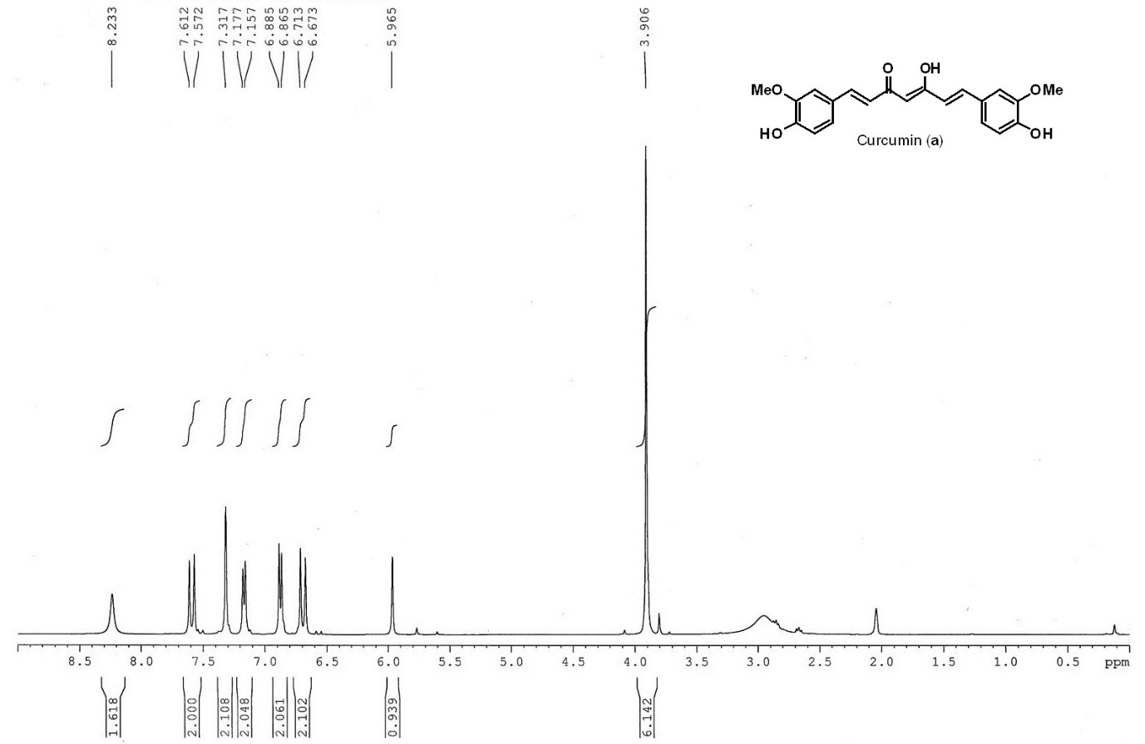

Fig. S1.2 ¹H and ¹³C NMR spectra of trienone 4 (b) recorded in acetone-d₆.

Fig. S1.3 COSY and COSY expansion spectra of trienone 4 (b) recorded in acetone-d₆.

Fig. S1.4 HMQC and HMQC expansion spectra of trienone 4 (b) recorded in acetone-d₆.

Fig. S1.5 HMBC and HMBC expansion spectra of trienone 4 (b) recorded in acetone-d₆.

Fig. S1.6 ¹H and ¹³C NMR spectra of trienone 11 (c) recorded in acetone-d₆.

Fig. S1.7 COSY and COSY expansion spectra of trienone 11 (c) recorded in acetone-d₆.

Fig. S1.8 HMQC and HMQC expansion spectra of trienone 11 (c) recorded in acetone-d₆.

Fig. S1.9 HMBC and HMBC expansion spectra of trienone 11 (c) recorded in acetone-d₆.

