Supplementary Information
Characterization of tea leaf metabolites dependent on tea (Camellia sinensis) plant age through ¹H NMR-based metabolomics

N. H. M. Rubel Mozumder^{1,a}, Yeong-Ran Lee ^{2,a}, Kyeong Hwan Hwang², Min-Seuk Lee³, Eun-Hee Kim⁴, Young-Shick Hong^{1,}*
ªDivision of Food and Nutrition, Chonnam National University, Yongbong-ro, Buk-gu, Gwangju 61186, Republic of Korea
^{b}Basic Research & Innovation Division, R&D Center, AmorePacific Corporation, Yongin-si, Gyeonggi-do 446-729, Republic of Korea
^{c}Osulloc Tea R&D Center, Osulloc Farm Corporation, Jeju 699-820, Republic of Korea
^{d}Center for Research Equipment, Korea Basic Science Institute, Cheongwon-Gu, Cheongju-Si, Chungbuk 363-883, Republic of Korea
ª These authors equally contributed to this work.
* Corresponding author: chtiger@jnu.ac.kr (Y.-S. Hong).

Additional Information
Table S1. Assignments of Metabolites in the Representative ¹H NMR Spectra.
Figure legends
Fig. S1. Representative ¹H 700 MHz NMR spectra of tea leaf extract from 8- and 25-year-old tea plants plucked on May 2015.
Fig. S2. Permutation tests of PLS-DA models.

Table S1: Assignments of Metabolites in the Representative ¹H NMR Spectra.
Metabolites | Abbreviation | Chemical shift (ppm)ª | Multiplicity
Acetate | - | 1.975 | singlet
Alanine | Ala | 1.55 | doublet
2-O-(b-L-Arabinopyranosyl)-myo-inositol | Ara | 5.179 | doublet
Asparagine | Asn | 3.012 | doublet-doublet
Aspartate | Asp | 2.877  2.673 | doublet  doublet-doublet
Caffeine | - | 7.943  4.042  3.601  3.421 | singlet  singlet  singlet  singlet
Catechin | - | 6.932  6.895  6.064  5.986  4.695  4.125 | doublet  doublet  doublet  doublet  doublet  doublet
Choline | - | 3.281 | singlet
Epicatechin | EC | 7.061  6.907  6.077  6.049  4.302  2.963  2.933  2.799 | singlet  singlet  triplet  doublet  multiplet  doublet  doublet  doublet-doublet
Epicatechin gallate | ECG | 7.042  6.925  6.834  6.097  5.572  5.138 | doublet  doublet-doublet  singlet-singlet  singlet  multiplet  singlet
Epigallocatechin | EGC | 6.629  6.075  6.047  4.287  2.934  2.789 | singlet  doublet  doublet  multiplet  multiplet  multiplet
Epigallocatechin gallate | EGCG | 7.027  6.631  6.098  5.558  5.079  3.091  3.066  2.933  2.789 | doublet  doublet  multiplet  multiplet  singlet  doublet  doublet  multiplet  doublet-doublet
Epigallocatechin 3-O-(3-O-methyl) gallate | EGCG3"Me | 7.128  7.073  6.644  6.118  5.109  3.886  2.988 | doublet  doublet  singlet  doublet  singlet  singlet  doublet
γ-aminobutyric acid | GABA | 3.063  2.379  1.958 | triplet  triplet  multiplet
Gallate | - | 7.196 | singlet
Gallocatechin | GC | 6.520  6.063  5.986  4.665 | Singlet  doublet  multiplet  doublet
α-Glucose | - | 5.230 | doublet
β-Glucose | - | 4.615 | doublet
Glutamate | Glu | 3.713  2.383  2.120 | doublet-doublet  multiplet  multiplet
Glutamine | Gln | 3.718  2.464  2.158 | doublet  multiplet  multiplet
Isoleucine | Ile | 1.047  1.104 | triplet  doublet
Leucine | Leu | 1.063 | triplet
Quinate | - | 4.147  3.594  2.047  1.927 | multiplet  multiplet  multiplet  multiplet
Succinate | - | 2.532 | singlet
Sucrose | - | 5.473 | doublet
Theanine | - | 3.715  3.266  2.48  2.187  1.187 | triplet  doublet  multiplet  multiplet  triplet
Theobromine | - | 7.974 | singlet
Theogallin | - | 7.101  4.247  2.249 | singlet  doublet  doublet-doublet
Threonine | Thr | 1.394 | doublet
Valine | Val | 1.129  1.087 | doublet  doublet
ª signals marked as bold were selected for relative integration.
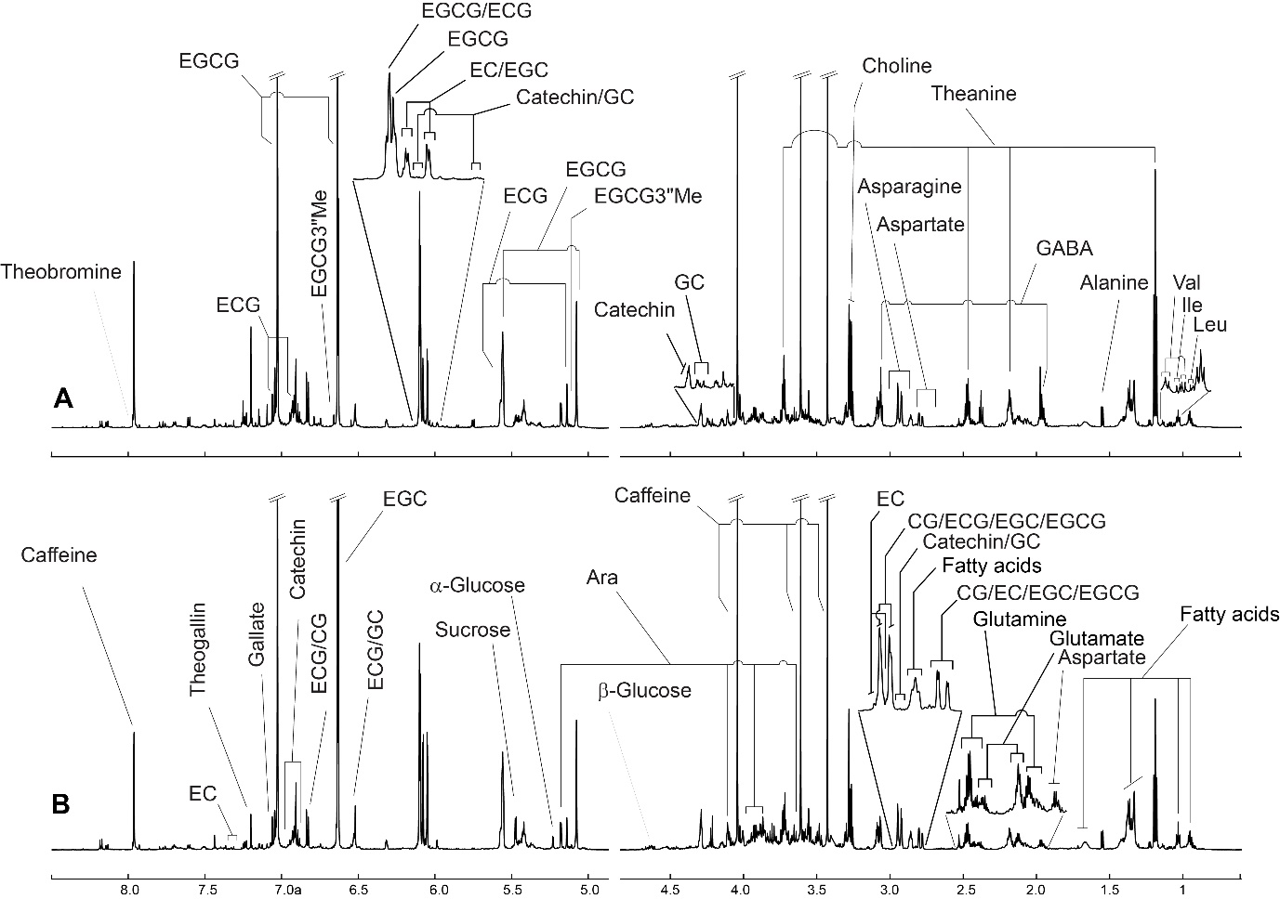
Fig. S1. Representative ¹H 700 MHz NMR spectra of tea leaf extract from 8- (A) and 25-year-old (B) tea plants plucked on May 2015. The tea metabolites identified by ¹H NMR spectroscopy include acetate, alanine, 2-O-(b-L-Arabinopyranosyl)-myo-inositol (Ara), asparagine, aspartate, caffeine, catechin, choline, epicatechin (EC), epicatechin gallate (ECG), epigallocatechin (EGC), epigallocatechin gallate (EGCG), O-methylated EGCG or epigallocatechin- 3-O-(3-O-methyl)-gallate (EGCG3"Me), fatty acids, γ-aminobutyric acid (GABA), gallate, gallocatechin (GC), α-glucose, β-glucose, glutamate, glutamine, isoleucine (Ile), leucine (Leu) quinate, sucrose, succinate, theanine, theobromine, theogallin, threonine, and valine (Val). In particular, the identifications of the EGCG3"Me compound was also confirmed by spiking of its pure chemical.

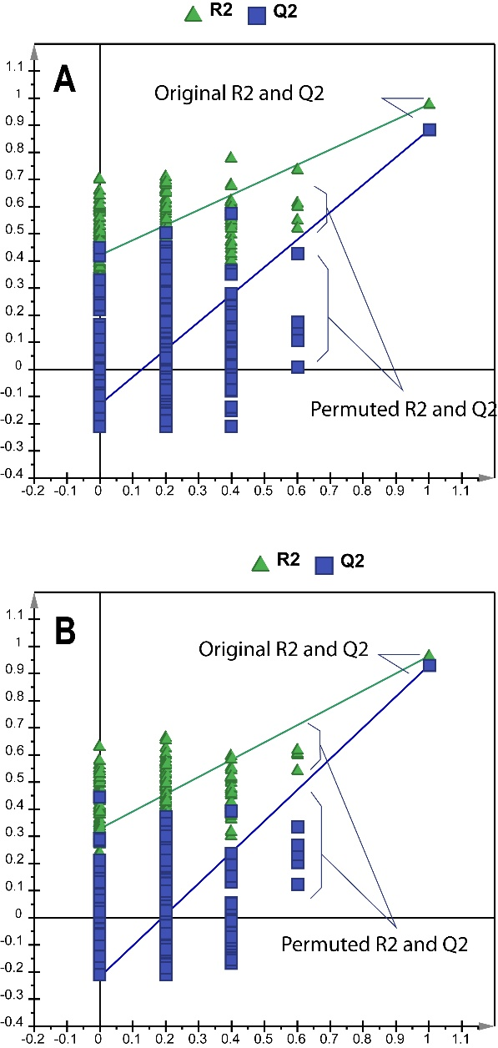
Fig. S2. Permutation tests of PLS-DA models with the same predictive and orthogonal components as the OPLS-DA models for pairwise comparison between the two classes, indicating great predictability (Q²) and goodness of fit (R²) of models between 8-year-old versus 25-year-old tea plants plucked at April 2016 (A) and 8-year-old versus 25-year-old tea plants plucked in May 2015 (B).

