Supplementary Materials

Biochemical characterization of a family IV esterase with R-form enantioselectivity from a compost metagenomic library

Supplementary Table S1. Docking values of Est15L and (R)- or (S)-methyl-3-hydroxy-2-methyl-propionate.
(R)-methyl-3-hydroxy-2-methyl-propionate |  |  |  |  | (S)-methyl-3-hydroxy-2-methyl-propionate
Cluster | Element | Full fitness (kcal/mol) | Estimated ΔG (kcal/mol) |  | Cluster | Element | Full fitness (kcal/mol) | Estimated ΔG (kcal/mol)
8 | 7 | -2294.57 | -6.31 |  | 2 | 3 | -2302.89 | -6.23
0 | 0 | -2304.95 | -6.28 |  | 1 | 0 | -2303.79 | -6.22
0 | 1 | -2303.76 | -6.20 |  | 1 | 1 | -2303.79 | -6.22
20 | 6 | -2288.42 | -6.16 |  | 1 | 2 | -2303.79 | -6.22
2 | 0 | -2301.85 | -6.12 |  | 1 | 3 | -2303.74 | -6.22
2 | 1 | -2301.85 | -6.12 |  | 1 | 4 | -2303.74 | -6.22
1 | 3 | -2303.37 | -6.11 |  | 1 | 5 | -2303.56 | -6.22
1 | 4 | -2301.82 | -6.11 |  | 1 | 6 | -2303.56 | -6.22
1 | 1 | -2303.64 | -6.10 |  | 1 | 7 | -2303.56 | -6.22
20 | 0 | -2299.55 | -6.10 |  | 0 | 0 | -2304.7 | -6.17

Supplementary Table S2. Docking values of Est8L and (R)- or (S)-methyl-3-hydroxy-2-methyl-propionate.
(R)-methyl-3-hydroxy-2-metyhl-propionate |  |  |  |  | (S)-methyl-3-hydroxy-2-metyhl-propionate
Cluster | Element | Full fitness (kcal/mol) | Estimated ΔG (kcal/mol) |  | Cluster | Element | Full fitness (kcal/mol) | Estimated ΔG (kcal/mol)
0 | 0 | -2792.14 | -6.92 |  | 3 | 0 | -2791.77 | -6.87
0 | 1 | -2792.11 | -6.92 |  | 6 | 3 | -2780.28 | -6.78
6 | 0 | -2790.61 | -6.65 |  | 8 | 0 | -2789.88 | -6.68
2 | 0 | -2791.13 | -6.53 |  | 2 | 0 | -2792.16 | -6.64
0 | 3 | -2787.22 | -6.48 |  | 6 | 2 | -2781.41 | -6.64
0 | 4 | -2787.21 | -6.48 |  | 3 | 1 | -2788.11 | -6.63
2 | 1 | -2787.66 | -6.44 |  | 1 | 0 | -2792.19 | -6.61
8 | 0 | -2789.86 | -6.39 |  | 1 | 1 | -2788.37 | -6.56
0 | 2 | -2788.26 | -6.37 |  | 0 | 0 | -2792.97 | -6.53
6 | 1 | -2785.2 | -6.32 |  | 23 | 1 | -2787.83 | -6.47
The docking simulation was conducted using SwissDock (https://www.swissdock.ch/), and the highest estimated ΔG values of 10 bindings were provided.

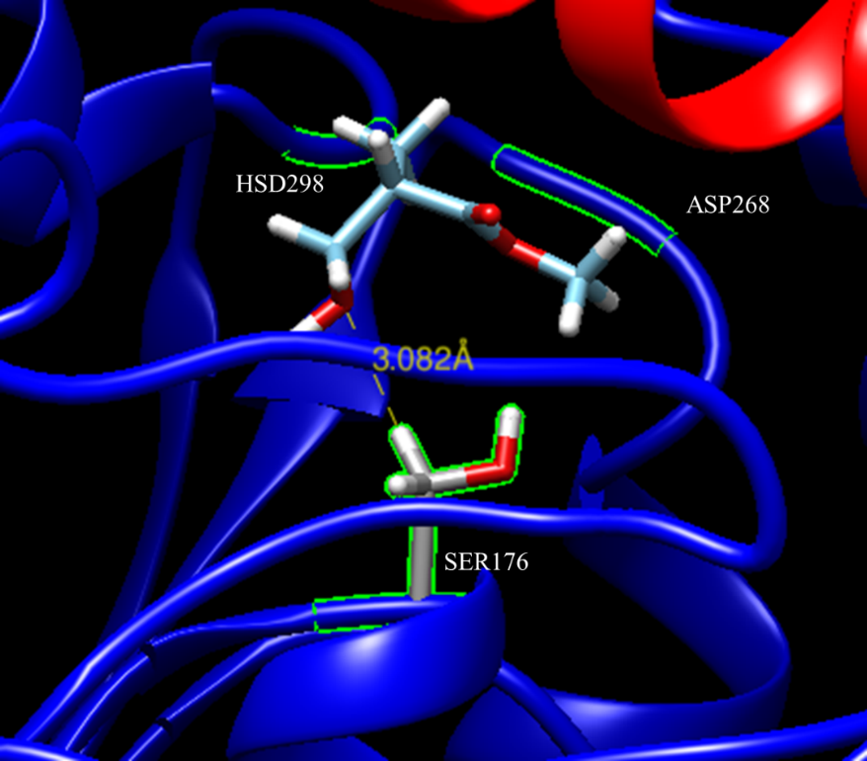
Supplementary Figure S1. Docking simulation of Est15L and (S)-methyl-3-hydroxy-2-methyl-propionate. The docking data were analyzed with Chimera version 1.15, and then interaction between catalytic residues of Est15L and the substrate was predicted at cluster 1.

