Additional file Data

Cherry fruits anthocyanins, cyanidin 3-O-glucoside and cyanidin 3-O -rutinoside protects against blue light-induced cytotoxicity

Effects of cherry fruit extract (CFE) on the viability of HaCaT cells exposed to blue light.

Figure S1. Effects of cherry fruit extract (CFE) on the viability of HaCaT cells exposed to blue light. (A) HaCaT cells were treated with or without the indicated concentrations of CFE for 24 h, and then cell viability was quantified using an MTT assay (n = 3, ±SD). (B) Cells were pre-treated with or without the indicated concentrations of CFE for 24 h prior to blue light exposure for 1 h. After 24 h, cell viability was quantified using an MTT assay (n = 3, ±SD). * p < 0.05, ** p < 0.01, and *** p < 0.001 vs. blue light (20,000 Lux).

Analysis of total anthocyanin contents
C3OG and C3OR were two of the major anthocyanin components. Total anthocyanin contents were measured by below equations using the mole absorption coefficient (ε=26,900 M⁻¹cm⁻¹) of C3OG. Based on the total anthocyanin contents of crude extract and anthocyanin enriched extract from ion exchange column chromatography, 428.6 ± 3.8 mg of anthocyanins contain in 200 g of fresh cherry. After ion exchange column chromatography, the content of total anthocyanins enriched about 3 times to 1185.6 ± 3.4mg/L.

Anthocyanin content (mg/L) = A x MW x 1000/ε x V
A (Absorbance)=(A510-A700)_{pH1.0} – (A510-A700)_{pH4.5}
MW (molecular weight of C3OG)=449.2
ε=26,900 M⁻¹cm⁻¹
V=volume of extract

Figure S2. Total anthocyanine content of the crude extract (1) and the anthocyanine enriched extract (2) from ion exchange chromatography. 1; 428.6 ± 3.8mg/L, 2; 1185.6 ± 3.4mg/L.

NMR of C3OG and C3OR
Experiments using nuclear magnetic resonance (NMR) spectroscopy carried out to obtain additional direct evidence for the identification of two major anthocyanins, C3OG and C3OR.

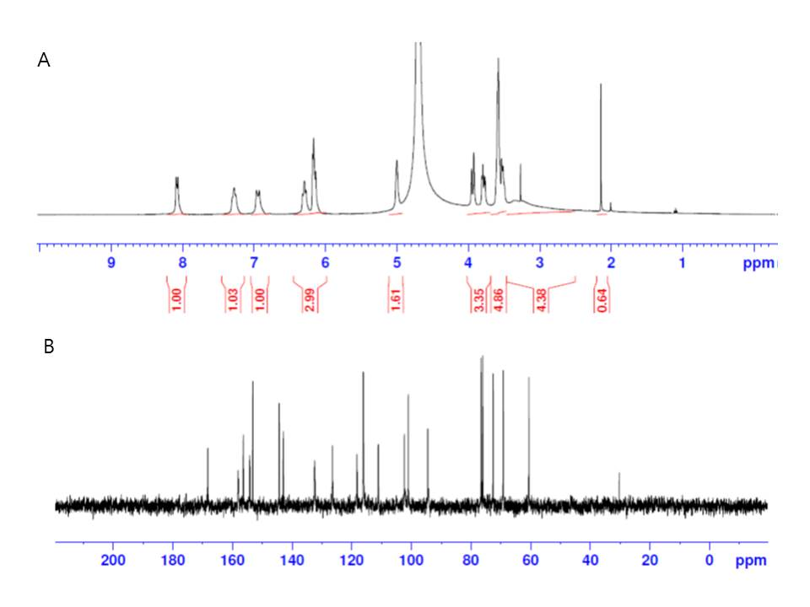
Figure S3. NMR spectra of cyanidin 3-O-glucoside (C3OG). A; ¹H-NMR, B; ¹³C-NMR. ¹H-NMR (400 MHz, D₂O) 8.08 (d, 1H, J=10.4 Hz), 7.28 (s, 1H), 6.94 (d, 1H, J=15.6Hz), 6.29 (t, 1H, J=10.2Hz), 6.16 (t, 2H, J=8.6Hz), 5.0 (s, 1H), 3.93 (d, 1H, J=12.0Hz), 3.79 (m, 1H), 3.58 ~ 3.51 (m, 4H). ¹³C-NMR (100 MHz, D₂O) 168.7, 158.8, 156.5, 154.6, 153.3, 144.6, 142.9, 132.9, 126.3, 118.4, 116.1, 111.2, 102.4, 101.2, 100.3, 94.7, 75.7, 75.5, 72.5, 71.8, 70.3, 69.8, 69.1, 68.5, 66.3, 16.4.

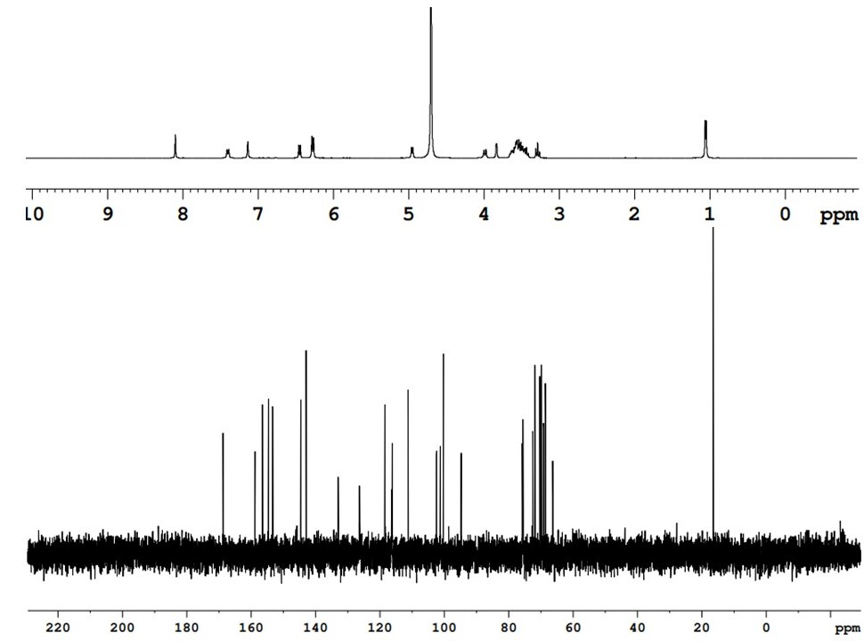

Figure S4. NMR spectra of cyanidin 3-O-rutinoside (C3OR). A; ¹H-NMR, B; ¹³C-NMR. ¹H-NMR (400 MHz, D₂O) 8.10 (s, 1H), 7.40 (d, 1H, J=8.4 Hz), 7.13 (s, 1H), 6.45 (d, 1H, J=8.8Hz), 6.27 (d, 2H, J=8.0Hz), 4.95 (d, 1H, J=7.2Hz), 3.98 (d, 1H, , J=10.8Hz), 3.83 (s, 1H), 3.53 (m, 8H), 3.28 (t, 1H, , J=9.6Hz), 1.05 (d, 3H, , J=6.0Hz). ¹³C-NMR (100 MHz, D₂O) 168.7, 158.8, 156.5, 154.6, 153.3, 144.6, 142.9, 132.9, 126.3, 118.4, 116.1, 111.2, 102.4, 101.2, 100.3, 94.7, 75.7, 75.5, 72.5, 71.8, 70.3, 69.8, 69.1, 68.5, 66.3, 16.4.

