Table S1. Physicochemical properties of 12 antibiotics.
Class  Compound  Abbreviation | Molecular structure | Molecular formula and weight (g mol⁻¹) | Water solubility  (at 25 ℃, mg mL⁻¹) | pK_{a}¹⁾ | Log K_{ow}²⁾
Penicillins  Amoxicillin  AMO | 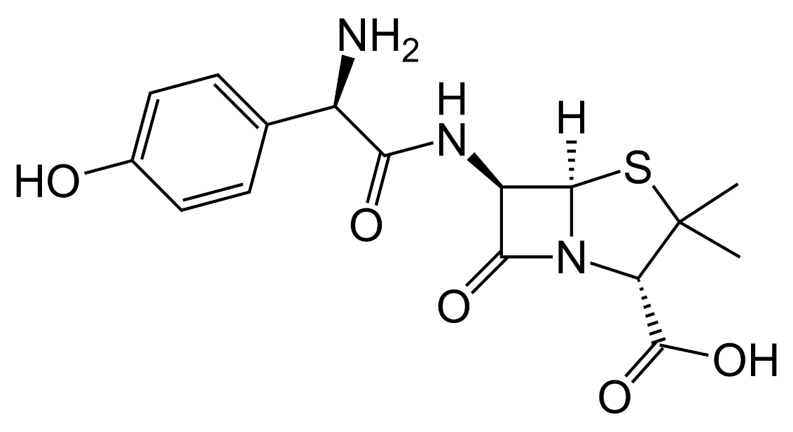 | C₁₆H₁₉N₃O₅S  365.40 | 0.958 | 2.4/  7.4/  9.6 | 0.87
Penicillins  Ampicillin  AMP | 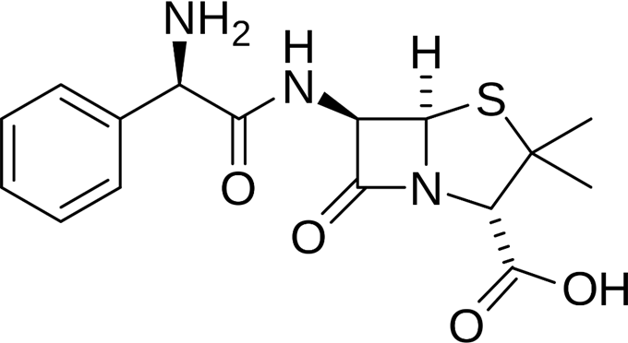 | C₁₆H₁₉N₃O₄S  349.40 | 0.605 | 2.5/  7.1 | -1.13
Penicillins  Penicillin G  PNG | 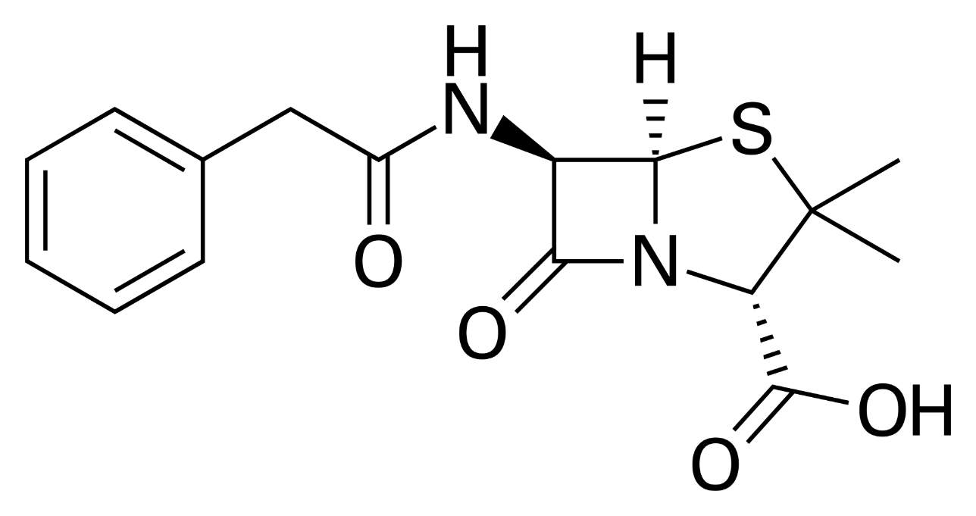 | C₁₆H₁₈N₂O₄S  334.39 | 0.285 | 3.42 | 1.83
Tetracyclines  Chlortetracycline  CTC | 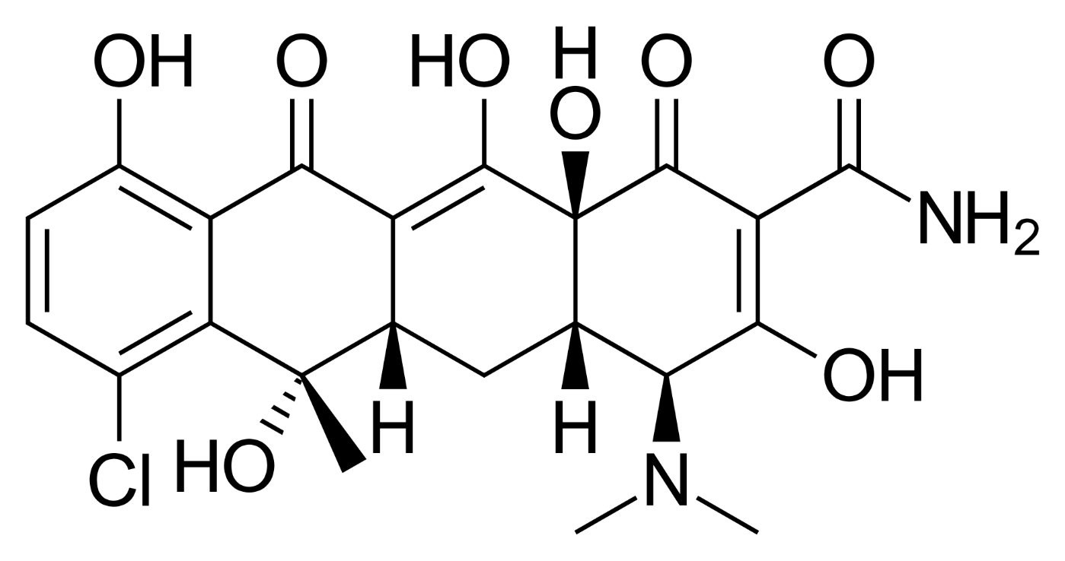 | C₂₂H₂₃ClN₂O₈  478.88 | 0.259 | 3.3/  7.4/  9.3 | -0.62
Tetracyclines  Oxytetracycline  OTC | 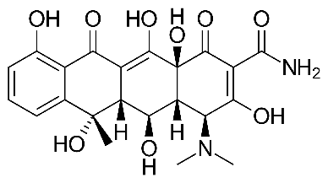 | C₂₂H₂₄N₂O₉  460.43 | 0.313 | 3.3/  7.3/  9.1 | -1.12
Tetracyclines  Tetracycline  TC | 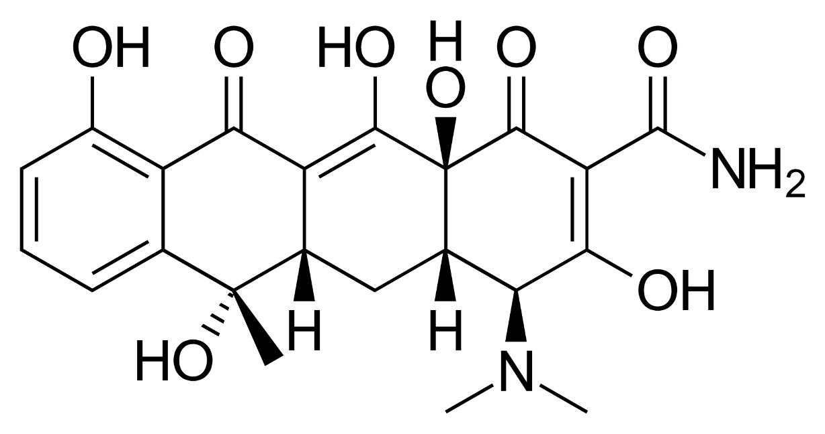 | C₂₂H₂₄N₂O₈  444.43 | 0.231 | 3.3/  7.7/  9.7 | -1.25
Macrolides  Spiramycin  SPM | 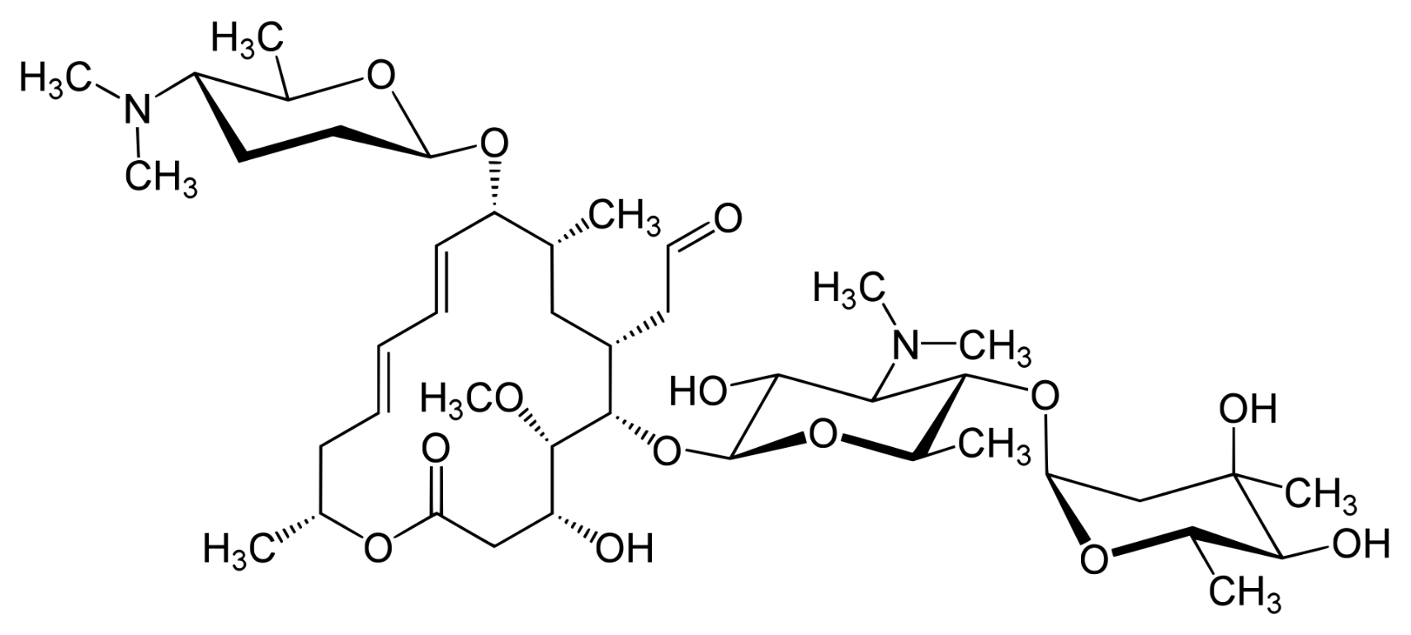 | C₄₃H₇₄N₂O₁₄  843.05 | 0.196 | 7.88/  9.28 | 1.87
Macrolides  Tylosin  TYL | 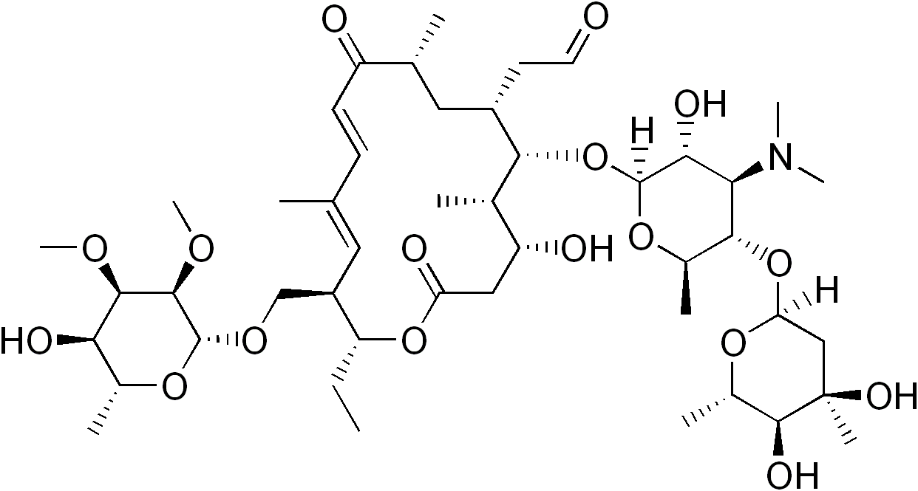 | C₄₆H₇₇NO₁₇  916.10 | 0.211 | 3.31/  7.50 | 2.5
Sulfonamides  Sulfadiazine  SDZ | 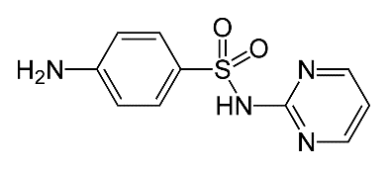 | C₁₀H₁₀N₄O₂S  250.28 | 0.601 | 2.10/  6.28 | -0.09
Sulfonamides  Sulfamethazine  SMZ | 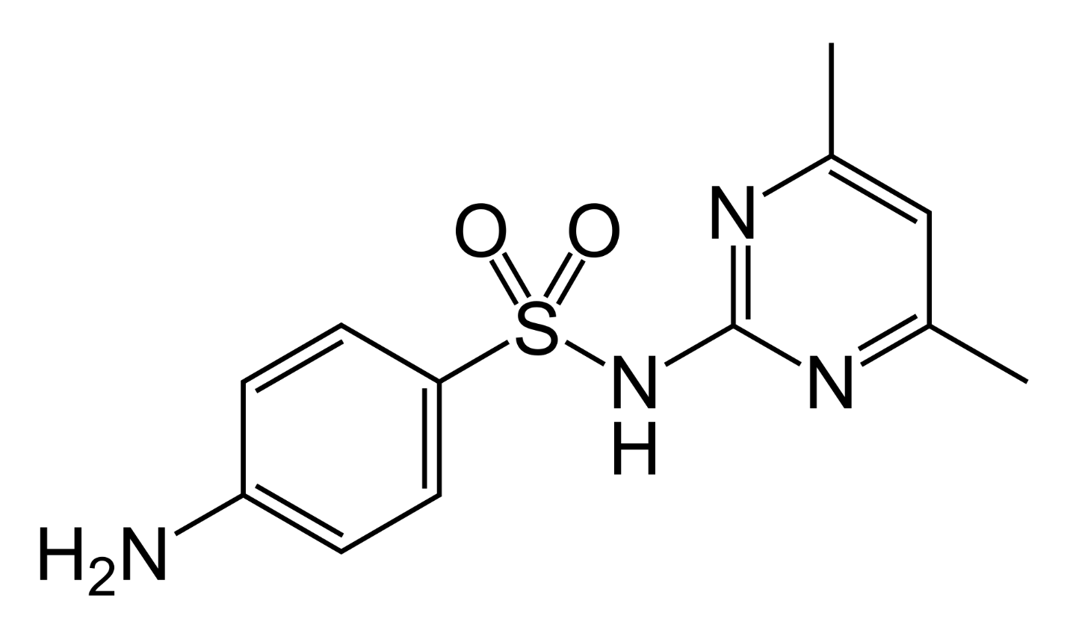 | C₁₂H₁₄N₄O₂S  278.33 | 0.23 | 2.28/  7.42 | 0.79
Sulfonamides  Sulfamethoxazole  SMX | 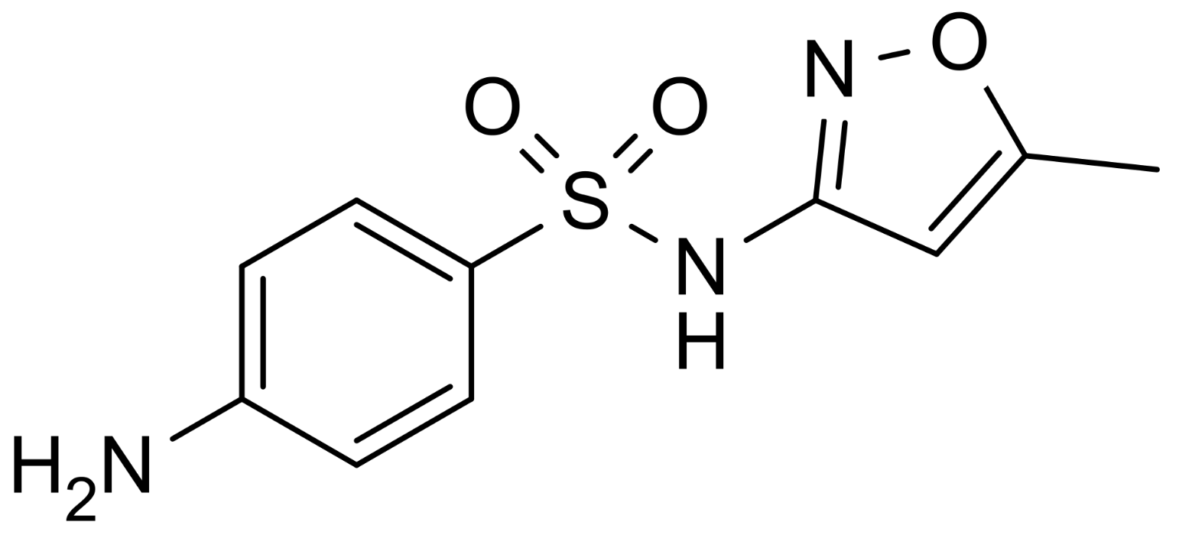 | C₁₀H₁₁N₃O₃S  253.28 | 0.459 | 1.83/  5.57 | 0.89
Sulfonamdies  Sulfathiazole  STZ | 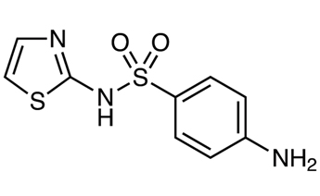 | C₉H₉N₃O₂S₂  255.32 | 0.921 | 2.08/  7.07 | 0.05
References: ¹⁾ [1–3]; ²⁾ [4]

Table S2. LC-MS/MS parameters for the analysis of antibiotics
Instrument | Parameter | Conditions
HPLC | Column | Zorbax Eclipse Plus C18 (3.5 μm, 4.6×150 mm)
HPLC | Guard column | Security Guard Cartridge Kit
HPLC | Column temperature | 25 ℃
HPLC | Mobile phase | A: 0.1% (v/v) formic acid in water  B: 0.1% (v/v) formic acid in acetonitrile
HPLC | Flow rate | 0.7 mL min⁻¹
HPLC | Inject volume | 5 μL
HPLC | Gradient | Time | Mobile phase
HPLC | Gradient | (min) | A (%) | B (%)
HPLC | Gradient | 0  2  8  10  11  11.1  15 | 90  90  50  100  0  90  90 | 10  10  50  0  100  10  10
MS/MS | Mode | Electrospray Ionization (ESI)
MS/MS | Polarity | Positive (+)
MS/MS | Sc.an type | Multiple reaction monitoring (MRM)
MS/MS | Curtain Gas | 30 psi
MS/MS | Collision Gas | High
MS/MS | Ion source-temperature | 500 ℃
MS/MS | Ion spray voltage | 5500 V

Table S3. Standard solution calibration curves equations and coefficient of determination
Compound | Regression line equation  (y = ax + b) | Coefficient of determination (R²) | Retention time  (min)
Amoxicillin | y = 0.1403x − 0.0013 | 0.9991 | 4.09
Ampicillin | y = 4.1677x − 0.0515 | 0.9998 | 6.37
Penicillin G | y = 0.2044x − 0.0034 | 0.9990 | 10.12
Chlortetracycline | y = 4.3201x − 0.0569 | 0.9996 | 7.84
Oxytetracycline | y = 3.5338x − 0.0627 | 0.9992 | 6.69
Tetracycline | y = 6.9437x − 0.0933 | 0.9996 | 6.94
Spiramycin | y = 1.9795x − 0.0257 | 0.9993 | 7.05
Tylosin | y = 5.0753x − 0.4560 | 0.9998 | 8.64
Sulfadiazine | y = 5.2131x – 0.0478 | 0.9995 | 6.70
Sulfamethazine | y = 6.0890x − 0.0887 | 0.9995 | 7.73
Sulfamethoxazole | y = 7.1538x −0.0493 | 0.9994 | 9.21
Sulfathiazole | y = 1.2146x − 0.0084 | 0.9995 | 6.82

Table S4. Linearity of matrix-matched calibration curves for target analytes
Compound | Calibration range  (μg L⁻¹) | Coefficient of determination (R²)
Compound | Calibration range  (μg L⁻¹) | River water | Soil
Amoxicillin | 0.01–1.0 | 0.9995 | 0.9976
Ampicillin | 0.01–1.0 | 0.9956 | 0.9973
Penicillin G | 0.01–1.0 | 0.9938 | 0.9998
Chlortetracycline | 0.01–1.0 | 0.9985 | 0.9955
Oxytetracycline | 0.01–1.0 | 0.9967 | 0.9978
Tetracycline | 0.01–1.0 | 0.9933 | 0.9977
Spiramycin | 0.01–1.0 | 0.9952 | 0.9916
Tylosin | 0.01–1.0 | 0.9988 | 0.9988
Sulfadiazine | 0.01–1.0 | 0.9994 | 0.9998
Sulfamethazine | 0.01–1.0 | 0.9987 | 0.9939
Sulfamethoxazole | 0.01–1.0 | 0.9963 | 0.9989
Sulfathiazole | 0.01–1.0 | 0.9995 | 0.9971

Table S5. Matrix effect of 12 antibiotics in river water and soil sample
Compound | Matrix | Slope | Y-intercept | R² | ME (%)
 | Standard | 3.E+06 | 2.E+04 | 0.9978 | -
Amoxicillin | River Water | 4.E+06 | −1.E+04 | 0.9925 | 26.1
 | Soil | 3.E+06 | 5.E+04 | 0.9979 | 5.8
 | Standard | 4.E+06 | −3.E+04 | 0.9942 | -
Ampicillin | River Water | 4.E+06 | 2.E+05 | 0.9792 | 7.3
 | Soil | 3.E+06 | 1.E+05 | 0.9856 | −11.1
 | Standard | 5.E+06 | −9.E+04 | 0.9992 | -
Penicillin G | River Water | 2.E+06 | −6.E+04 | 0.9933 | −52.4
 | Soil | 3.E+06 | 5.E+03 | 0.9953 | −39.5
 | Standard | 2.E+07 | −1.E+06 | 0.9799 | -
Chlortetracycline | River Water | 4.E+07 | 2.E+05 | 0.9942 | 80.5
 | Soil | 3.E+07 | −7.E+05 | 0.9979 | 24.2
 | Standard | 3.E+06 | −2.E+05 | 0.9454 | -
Oxytetracycline | River Water | 8.E+06 | −3.E+05 | 0.9808 | 124.9
 | Soil | 1.E+07 | −7.E+05 | 0.9519 | 198.9
 | Standard | 2.E+07 | −1.E+06 | 0.9704 | -
Tetracycline | River Water | 4.E+07 | 1.E+06 | 0.9980 | 101.5
 | Soil | 4.E+07 | 3.E+05 | 0.9855 | 81.7

Table S5. Matrix effect of 12 antibiotics in river water and soil sample (continued)
Compound | Matrix | Slope | Y-intercept | R² | ME (%)
 | Standard | 5.E+06 | −6.E+04 | 0.9973 | -
Spiramycin | River Water | 2.E+06 | −1.E+04 | 0.9993 | −54.2
 | Soil | 2.E+06 | −1.E+05 | 0.8262 | −64.2
 | Standard | 5.E+07 | −8.E+05 | 0.9993 | -
Tylosin | River Water | 3.E+07 | 1.E+06 | 0.9747 | −35.8
 | Soil | 3.E+07 | 9.E+05 | 0.9927 | −29.0
 | Standard | 1.E+07 | −1.E+05 | 0.9998 | -
Sulfadiazine | River Water | 7.E+06 | 3.E+05 | 0.9967 | −42.8
 | Soil | 5.E+06 | 1.E+05 | 0.9814 | −63.6
 | Standard | 3.E+07 | −2.E+05 | 0.9919 | -
Sulfamethazine | River Water | 2.E+07 | −8.E+05 | 0.9457 | −35.2
 | Soil | 8.E+06 | 8.E+04 | 0.9422 | −68.1
 | Standard | 2.E+07 | 5.E+05 | 0.9776 | -
Sulfamethoxazole | River Water | 6.E+06 | −1.E+03 | 0.9968 | −62.9
 | Soil | 5.E+06 | 3.E+05 | 0.9300 | −72.7
 | Standard | 1.E+07 | 2.E+05 | 0.9841 | -
Sulfathiazole | River Water | 6.E+06 | −2.E+05 | 0.9826 | −52.7
 | Soil | 4.E+06 | 4.E+04 | 0.9274 | −70.3

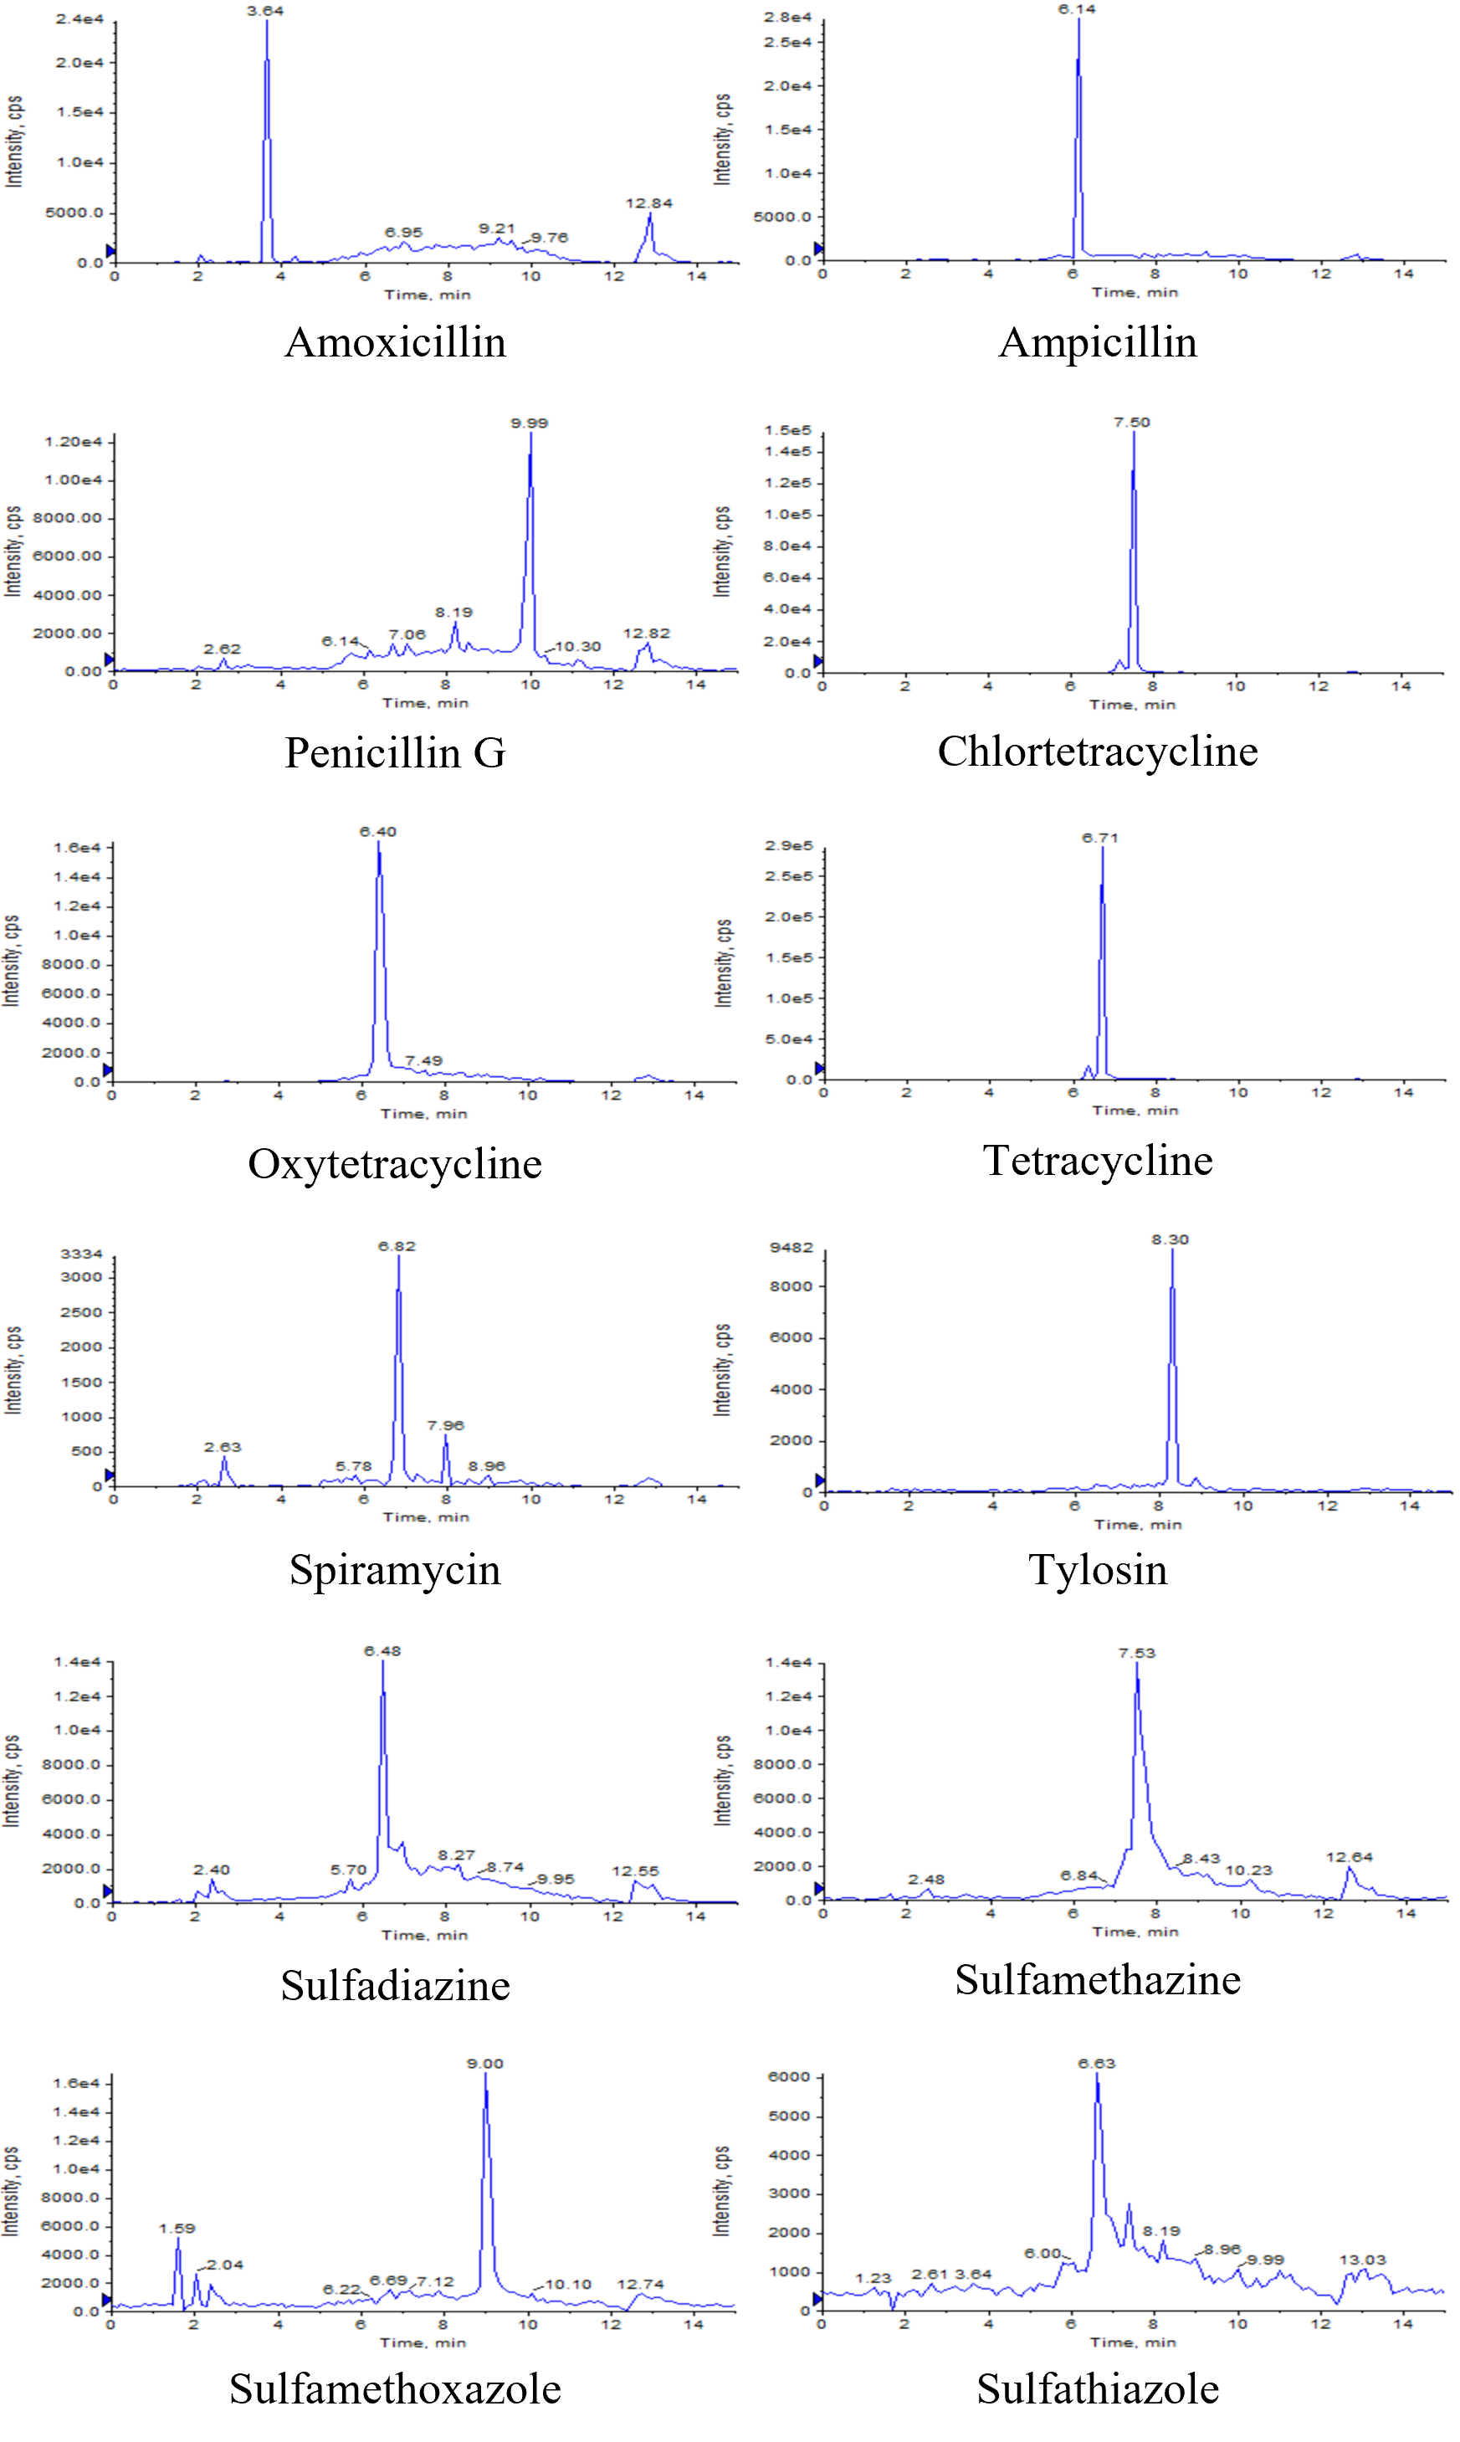
Fig. S1. Extracted ion chromatogram in spiked (0.025 mg L⁻¹) samples.

References
1. Boukhelkhal A, Benkortbi O, Hamadeche M, Hanini S, Amrane A (2015) Removal of amoxicillin antibiotic from aqueous solution using an anionic surfactant. Water Air Soil Pollut 226(10):323
2. Lin CE, Chang CC, Lin WC (1997) Migration behavior and separation of sulfonamides in capillary zone electrophoresis III. Citrate buffer as a background electrolyte. J Chromatogr A 768(1):105–112
3. Qiang Z, Adams C (2004) Potentiometric determination of acid dissociation constants (pKa) for human and veterinary antibiotics. Water Res 38(12):2874–2890
4. Sayers EW, Beck J, Bolton EE, Bourexis D, Brister JR, Canese K, Comeau DC, Funk K, Kim S, Klimke W (2021) Database resources of the national center for biotechnology information. Nucleic Acids Res 49(2021):D1–D10

