Additional Files

Additional Figure

Cytotoxicity Protection and Reactive Oxygen Species Inhibition Effect of Carrot Leaves in H₂O₂-Induced RAW 264.7 Cells
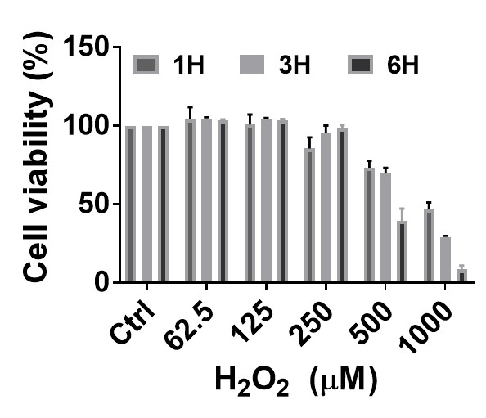
Figure S1. Cytotoxicity of H₂O₂ induced Raw 264.7 cells. Cells were pretreated with carrot leaf extract at each concentration prior to exposure to 500 μM H₂O₂. Cell viability was measured by MTT assay. Values are mean ± SD (n = 3).

Cytotoxicity Protection and Reactive Oxygen Species Inhibition Effect of Carrot Leaves in H₂O₂-Induced RAW 264.7 Cells
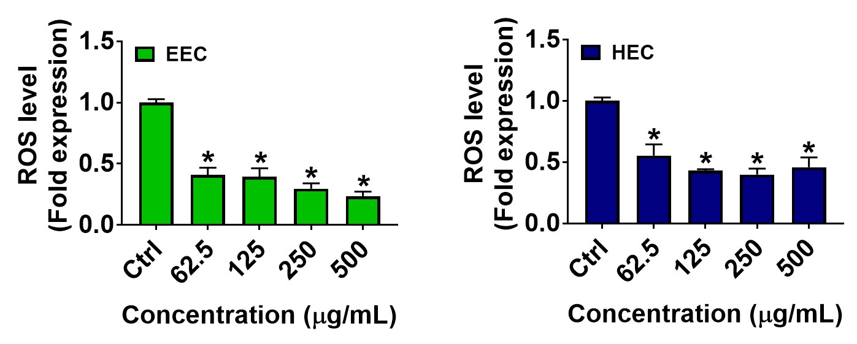
Figure S2. Levels of reactive oxygen species (ROS) production in Raw 264.7 cells. Intracellular ROS levels were measured using FACS. Values are mean ± SD (n = 3). * p < 0.05 vs. untreated control group

Restoration of NRF2 and HO-1 by Extract of Carrot Leaves

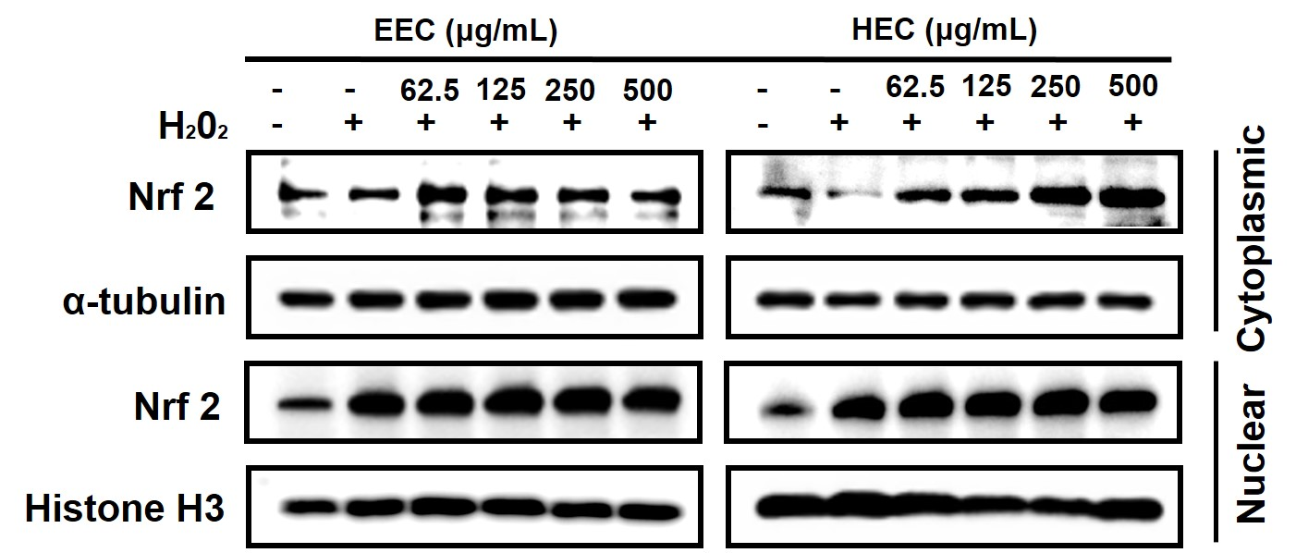
Figure S3. Cell fractionation of Nrf2 in H₂O₂-induced RAW 264.7 cells. The cells were pretreated with extracts of carrot leaves at each concentration prior to exposure to 500 μM H₂O₂. Aα-tubulin and Histone H3 were used as controls for the protein in cytoplasmic and nuclear fractions, respectively. Values are mean ± SD (n = 3).

HPLC Analysis of Extracts from Carrot Leaves
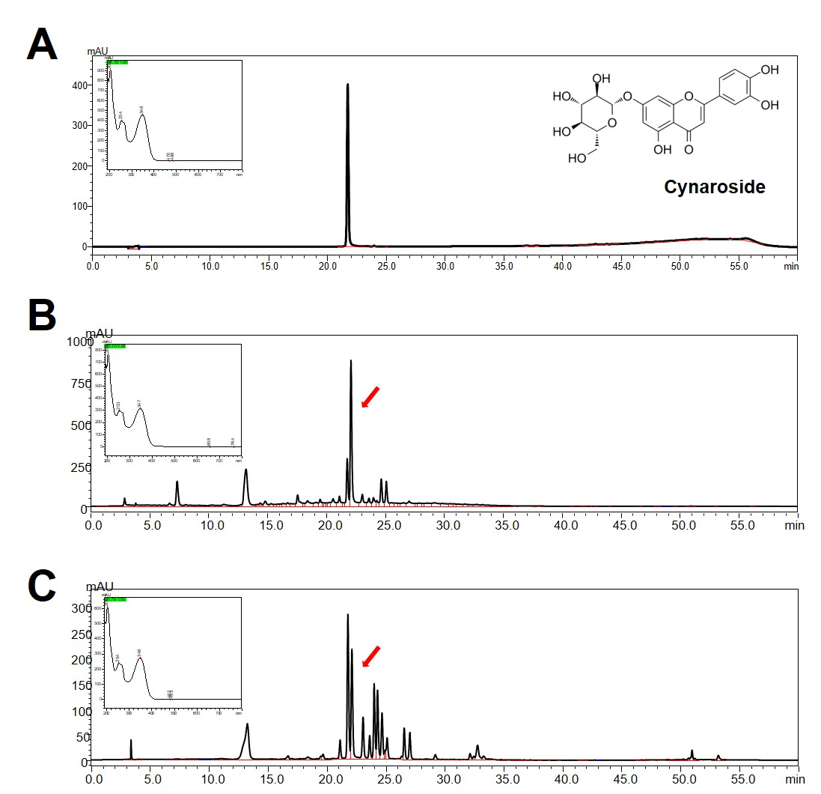
Figure S4. HPLC-UVD chromatogram of cynaroside composition. (A) cynaroside, (B) EEC and (C) HEC.

Table

HPLC Analysis of Extracts from Carrot Leaves
Table S1. Correlations between the compounds and activities of carrot leaf extract.
Compound | TPC | TFC | DPPH | ABTS | Catalase | SOD | GPx | ROS | NO
Catechin | 0.332 | 0.434 | 0.461 | 0.440 | 0.100 | 0.293 | 0.433 | 0.703 | 0.325
Chlorogenic acid | -0.924 | 0.000 | 0.935 | 0.803 | 0.143 | -0.564 | 0.176 | 0.995 | 0.997*
Caffeic acid | 0.254 | -0.989 | 0.553 | 0.757 | -0.993 | -0.346 | 0.390 | 0.432 | 0.244
Rutin | 0.990** | 0.979** | 0.990** | 0.993** | 0.930** | -0.424 | 0.015 | 0.854* | 0.998**
Quercetin | 0.949** | 0.966** | 0.978** | 0.977** | 0.906* | -0.415 | 0.033 | 0.905* | 0.973**
Cynaroside | 0.986** | 0.974** | 0.990** | 0.992** | 0.939** | -0.435 | 0.024 | 0.858* | 0.996**
Correlation significant at the * p < 0.05, ** p < 0.01

