Table S1. Heavy metals content of both dried leaf lettuce and Japanese hogfennel affected by the varying application rates of organic amendments
Crops | Treatments | As | Cd | Ni | Pb
Crops | Treatments | (mg/kg)
Leaf lettuce | Control | N.D | N.D | N.D | N.D
Leaf lettuce | N | N.D | N.D | N.D | N.D
Leaf lettuce | SCGs_{0.5} | N.D | N.D | N.D | N.D
Leaf lettuce | SCGs_{1.0} | N.D | N.D | N.D | N.D
Leaf lettuce | SCGs_{2.0} | N.D | N.D | N.D | N.D
Leaf lettuce | DFWP_{0.5} | N.D | N.D | N.D | N.D
Leaf lettuce | DFWP_{1.0} | N.D | N.D | N.D | N.D
Leaf lettuce | DFWP_{2.0} | N.D | N.D | N.D | N.D
p-value |  | - | - | - | -
Japanese hogfennel | Control | N.D | N.D | 0.41±0.02e | N.D
Japanese hogfennel | N | N.D | N.D | 0.43±0.03de | N.D
Japanese hogfennel | SCGs_{0.5} | N.D | N.D | 0.84±0.11ª | N.D
Japanese hogfennel | SCGs_{1.0} | N.D | N.D | 0.54±0.02^{b} | N.D
Japanese hogfennel | SCGs_{2.0} | N.D | N.D | 0.22±0.04^{f} | N.D
Japanese hogfennel | DFWP_{0.5} | N.D | N.D | 0.45±0.01^{d} | N.D
Japanese hogfennel | DFWP_{1.0} | N.D | N.D | 0.51±0.03^{bc} | N.D
Japanese hogfennel | DFWP_{2.0} | N.D | N.D | 0.04±0.00^{g} | N.D
p-value |  | - | - | ** | -
Control, Untreated treatment; N, Treatment with inorganic fertilizers; SCGs_{x.x}, Treatment applied at half the recommeded rate (0.5), the recommeded rate (1.0), and double the recommeded rate (2.0) of spent coffee grounds; DFWP_{x.x}, Treatment applied at half the recommeded rate (0.5), the recommeded rate (1.0), and double the recommeded rate (2.0) of dehydrated food waste powder; N.D, Not detected (< 0.01 mg/kg).
** is used to indicate statistically significant differences at the p < 0.01.
Within each column, values follwed by the same letters are not significant difference at p <0.05.

Table S2. Changes in physicochemical properties of soil affected by the varying application rates of organic amendments
Crops | Treatments | WC | pH | EC | OM | Avail. P | Exchangeable Na⁺
Crops | Treatments | (%) | (1:5, H₂O) | (dS/m) | (%) | (mg/kg) | (cmol_{c}/kg)
Initial soil |  | 9.40±2.51^{D,c} | 6.21±0.05^{E,c} | 0.14±0.02^{E,f} | 2.92±0.35^{F,f} | 13.45±1.18^{G,g} | 1.45±0.27^{C,bcd}
Leaf lettuce | Control | 16.10±7.92^{C} | 6.67±0.08^{D} | 0.26±0.00^{D} | 4.60±0.28E | 18.08±0.58E | 1.50±0.05^{C}
Leaf lettuce | N | 18.15±11.25^{C} | 6.71±0.11^{D} | 0.40±0.05^{CD} | 4.68±0.32E | 23.15±0.35^{B} | 1.51±0.08^{C}
Leaf lettuce | SCGs_{0.5} | 22.78±8.91^{C} | 6.72±0.05^{D} | 0.30±0.02^{D} | 9.70±0.33^{C} | 19.35±0.21^{D} | 1.45±0.10^{C}
Leaf lettuce | SCGs_{1.0} | 31.28±9.28^{BC} | 6.52±0.13DE | 0.32±0.04^{CD} | 11.47±0.92^{B} | 18.69±0.17E | 1.30±0.03^{D}
Leaf lettuce | SCGs_{2.0} | 52.14±12.18^{A} | 6.20±0.03E | 0.38±0.05^{CD} | 18.10±1.13^{A} | 21.31±0.18^{C} | 1.17±0.09E
Leaf lettuce | DFWP_{0.5} | 16.87±5.56^{C} | 6.98±0.17^{C} | 0.49±0.13^{C} | 7.52±0.58^{D} | 19.06±1.09^{D} | 1.54±0.11^{C}
Leaf lettuce | DFWP_{1.0} | 17.91±4.17^{C} | 7.25±0.22^{B} | 1.03±0.21^{B} | 8.41±1.57^{CD} | 17.67±0.35^{F} | 1.91±0.17^{B}
Leaf lettuce | DFWP_{2.0} | 15.69±6.28^{C} | 8.08±0.15^{A} | 1.42±0.17^{A} | 8.71±0.85^{CD} | 29.61±1.28^{A} | 2.83±0.33^{A}
p-value |  | ** | ** | * | ** | *** | **
Japanese hogfennel | Control | 15.78±1.38^{b} | 6.90±0.09^{b} | 0.28±0.05de | 3.44±0.28e | 16.48±0.98e | 1.48±0.06^{cd}
Japanese hogfennel | N | 15.07±2.51^{b} | 6.93±0.11^{b} | 0.71±0.05^{b} | 3.46±0.31e | 23.67±1.12^{d} | 1.51±0.05^{bcd}
Japanese hogfennel | SCGs_{0.5} | 15.37±3.17^{b} | 6.91±0.08^{b} | 0.21±0.05e | 5.56±0.35^{c} | 14.20±0.37^{g} | 1.49±0.08^{cd}
Japanese hogfennel | SCGs_{1.0} | 18.22±4.25ª | 6.79±0.03^{b} | 0.21±0.03e | 6.95±0.97^{b} | 16.14±1.10^{ef} | 1.45±0.06^{cd}
Japanese hogfennel | SCGs_{2.0} | 16.69±2.27^{ab} | 6.81±0.05^{b} | 0.25±0.02e | 10.92±1.18ª | 15.53±0.58^{f} | 1.48±0.05^{cd}
Japanese hogfennel | DFWP_{0.5} | 19.55±5.28ª | 7.39±0.13ª | 0.39±0.07^{d} | 4.19±0.47^{d} | 29.83±3.25^{c} | 1.54±0.07^{bcd}
Japanese hogfennel | DFWP_{1.0} | 19.14±4.21ª | 7.45±0.05ª | 0.59±0.03^{c} | 3.38±0.33e | 41.86±1.28ª | 1.58±0.11^{ab}
Japanese hogfennel | DFWP_{2.0} | 19.43±7.88ª | 7.40±0.07ª | 1.02±0.11ª | 6.83±0.85^{b} | 35.23±2.17^{b} | 1.62±0.21ª
p-value |  | *** | ** | ** | *** | * | **
Control, Untreated treatment; N, Treatment with inorganic fertilizers; SCGs_{x.x}, Treatment applied at half the recommeded rate (0.5), the recommeded rate (1.0), and double the recommeded rate (2.0) of spent coffee grounds; DFWP_{x.x}, Treatment applied at half the recommeded rate (0.5), the recommeded rate (1.0), and double the recommeded rate (2.0) of dehydrated food waste powder; N.D, Not detected (< 0.01 mg/kg).
*, **, and *** are used to indicate statistically significant differences at the p < 0.05, p < 0.01, and p < 0.001, respectively.
Within each column, values follwed by the same letters are not significant difference at p <0.05.

Table S3. Statistical relationships amongst the different antioxidants and functional components of leaf lettuce
 | Total sugar | Total anthocyanin | Total phenolics compounds | Total flavonoid | DPPH free radical  scavenging activity | ABTS radical  scavenging activity
Total sugar | 1.000 | - | - | - | - | -
Total anthocyanin | -0.009^{NS} | 1.000 | - | - | - | -
Total phenolics compounds | +0.025^{NS} | +0.807** | 1.000 | - | - | -
Total flavonoid | -0.109^{NS} | +0.861** | +0.923** | 1.000 | - | -
DPPH free radical  scavenging activity | +0.332* | +0.850** | +0.828** | +0.900** | 1.000 | -
ABTS radical  scavenging activity | +0.369* | +0.961** | +0.946** | +0.949** | +0.851** | 1.000
ABTS, 2,2'-azino-bis-3-ethylbenzothiazoline-6-sulfonic acid; DPPH, 2,2-Diphenyl-1-picrylhydrazyl; NS, Non-significant.
* and ** are used to indicate statistically significant differences at the p < 0.05 and p < 0.01, respectively.

Table S4. Statistical relationships amongst the different antioxidants of Japanese hogfennel
 | Total phenolics compounds | Total flavonoid | DPPH free radical  scavenging activity | ABTS radical  scavenging activity
Total phenolics compounds | 1.000 | - | - | -
Total flavonoid | +0.840** | 1.000 | - | -
DPPH free radical  scavenging activity | +0.987** | +0.906** | 1.000 | -
ABTS radical  scavenging activity | +0.955** | +0.925** | +0.625* | 1.000
ABTS, 2,2'-azino-bis-3-ethylbenzothiazoline-6-sulfonic acid; DPPH, 2,2-Diphenyl-1-picrylhydrazyl; NS, Non-significant.
* and ** are used to indicate statistically significant differences at the p < 0.05 and p < 0.01, respectively.

Table S5. Statistical relationships amongst the different carotenoids and chlorophyll content of leaf lettuce
 | Violaxanthin | Lutein | All-trans-ß-carotene | Zeaxanthin | 13Z-ß-carotene | 9Z-ß-carotene | Others | Chlorophyll
Violaxanthin | 1.000 | - | - | - | - | - | - | -
Lutein | +0.946** | 1.000 | - | - | - | - | - | -
All-trans-ß-carotene | +0.964** | +0.926** | 1.000 | - | - | - | - | -
Zeaxanthin | +0.753** | +0.849** | +0.798** | 1.000 | - | - | - | -
13Z-ß-carotene | +0.926** | +0.794** | +0.828** | +0.588* | 1.000 | - | - | -
9Z-ß-carotene | +0.043^{NS} | -0.018^{NS} | +0.069^{NS} | -0.256^{NS} | -0.002^{NS} | 1.000 | - | -
Others | +0.603* | +0.527* | +0.629* | +0.255* | +0.509* | +0.814** | 1.000 | -
Chlorophyll | +0.902** | -0.040^{NS} | +0.158^{NS} | -0.311^{NS} | -0.021^{NS} | +0.749** | +0.948** | 1.000
NS, Non-significant.
* and ** are used to indicate statistically significant differences at the p < 0.05 and p < 0.01, respectively.

Table S6. Statistical relationships amongst the different coumarin and growth components of Japanese hogfennel
 | 3,4-disenecioylkhellactone | Hyuganin C | Peucedanol-7-O-D-glucopyranoside | Root length | Root diameter | Fresh weight | Dry weight
3,4-disenecioylkhellactone | 1.000 | - | - | - | - | - | -
Hyuganin C | +0.804** | 1.000 | - | - | - | - | -
Peucedanol-7-O-D-glucopyranoside | +0.688** | +0.956** | 1.000 | - | - | - | -
Root length | +0.821** | +0.888** | +0.835** | 1.000 | - | - | -
Root diameter | -0.010^{NS} | +0.021^{NS} | +0.217* | +0.102* | 1.000 | - | -
Fresh weight | +0.804** | +0.831** | +0.497* | +0.656** | +0.386* | 1.000 | -
Dry weight | +0.796** | +0.825** | +0.302* | +0.588** | +0.363* | +0.982** | 1.000
NS, Non-significant.
* and ** are used to indicate statistically significant differences at the p < 0.05 and p < 0.01, respectively.

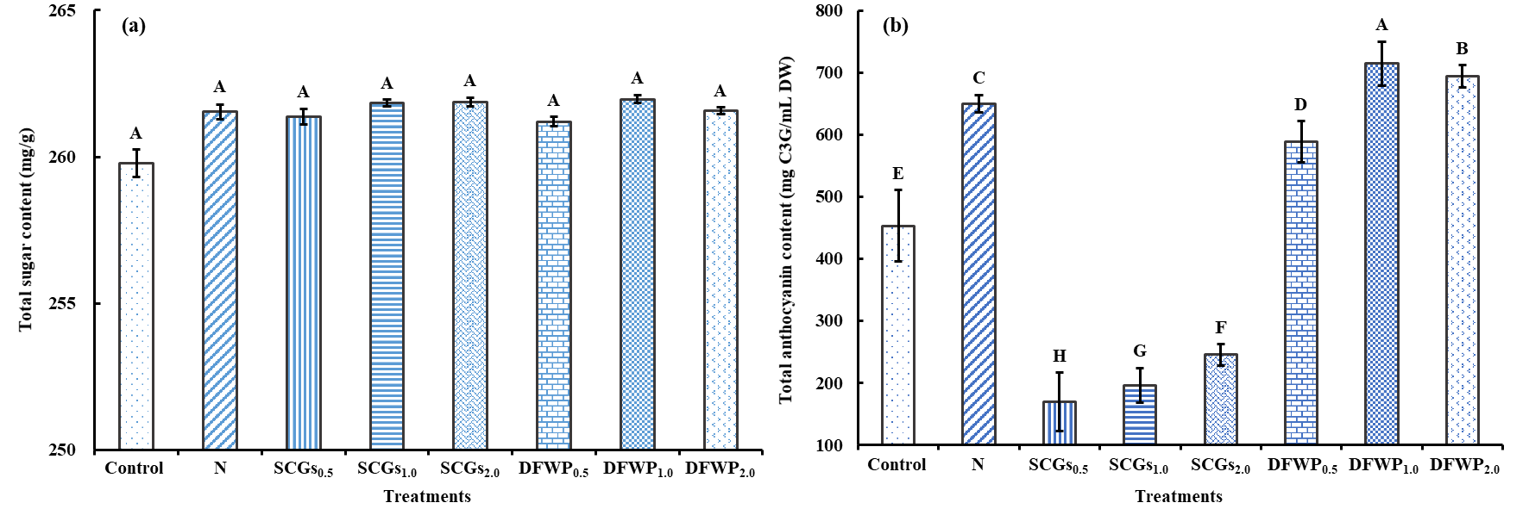
Figure S1. Total sugar (a) and total anthocyanin (b) contents of leaf lettuce affected by the varying rates of spent coffee grounds (SCGs) and dehydrated food waste powder (DFWP). Within the figure, values follwed by the same letters are not statistically significant difference at p <0.05.

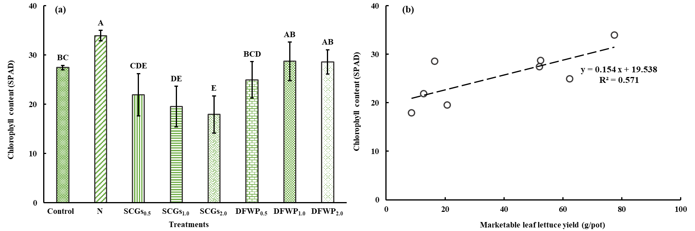
Figure S2. Chlorophyll content of leaf lettuce (a) affected by the varying rates of spent coffee grounds (SCGs) and dehydrated food waste powder (DFWP), and the linear relationship (b) between the chlorophyll content and marketable yield of leaf lettuce. Within the figure, values follwed by the same letters are not statistically significant difference at p <0.05.

