Supplementary Materials
Classification of soybeans from different habitats based on metabolomic-transcriptomic integration
WANG Jinghui¹, ZHENG Qiyou^{1,}*, WANG Chenxu¹, Zhou Ao¹
1 College of information technology, Jilin Agricultural University, Changchun 130118, China.
* Correspondence: zqy@tccu.edu.cn

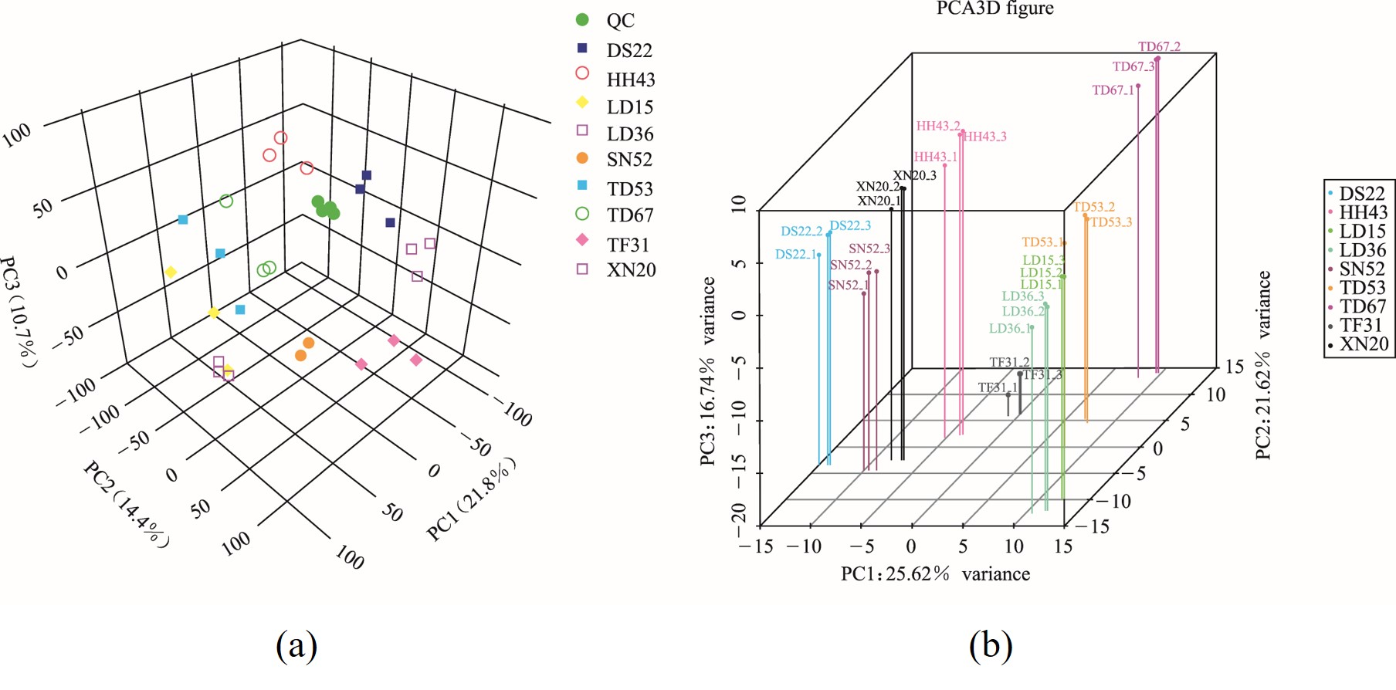
Figure S1. (a) PCA of metabolites in soybeans from different regions; (b) PCA of gene transcripts in soybeans from different regions.

Figure S2. The number of DEMs in each group pair
Figure S3. Number of DEGs of each pairwise comparison
Figure S4. KEGG pathway annotation of DEGs in each pairwise comparison. (A) DS22/SN52, (B) HH43/SN52, (C) XN20/SN52, (D) LD15/TF31, (E) LD36/TF31, (F) TD53/TF31, (G) TD67/TF31.

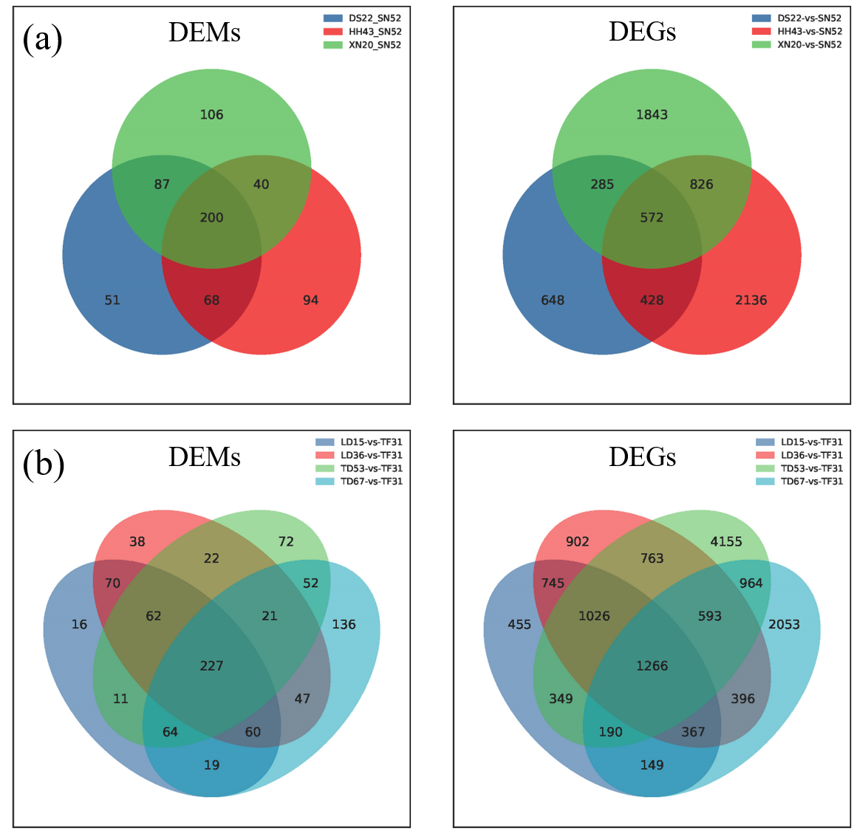
Figure S5. Venn diagram of the common DEMs and DEGs in (a) Heilongjiang provinces and (b) Liaoning provinces.

Figure S6. Connection network between metabolites and genes inferred from metabolomic and transcriptomic analysis. Correlation coefficient |r| ≥ 0.5, p < 0.05. (A) DS22/SN52, (B) XN20/SN52, (C) LD15/TF31, (D) LD36/TF31, (E) TD53/TF31, (F) TD67/TF31.
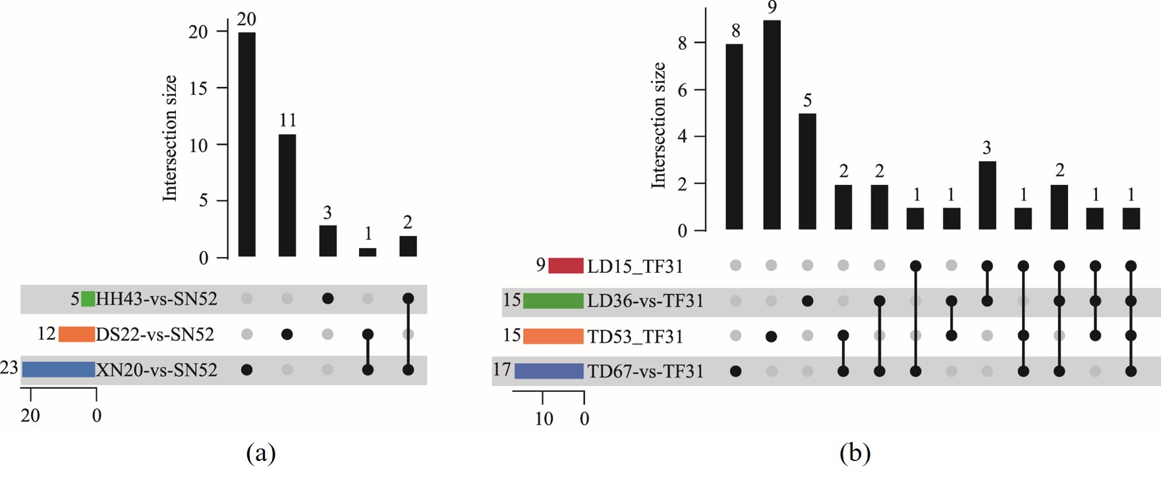
Figure S7. (a) Upset diagram of core DEMs in Heilongjiang; (b) Upset diagram of core DEMs in Liaoning.

Figure S8. Scatterplot of PLS-DA model for soybean samples from different sources

Table S1. The types and quantities of metabolites contained in various soybean samples

Sample | lipids and lipid-like molecules | phenylpropanoic acids and polyketides | organic oxygen compounds | organic acids and derivatives | organic heterocyclic compounds | benzoic acids | nucleosides, nucleotides and analogues | alkaloids and derivatives | lignin, neolignan and related compounds | organic nitrogen compounds | hydrocarbons | organic sulfur compounds | organic halogen compounds | homogeneous non-metallic compounds | homogeneous metal compound | hydrocarbon derivative | organic phosphorus compound, one organic 1,3 dipole compound | unclassified compounds
DS22-1 | 2695 | 915 | 762 | 633 | 608 | 427 | 92 | 37 | 37 | 34 | 21 | 14 | 4 | 2 | 1 | 1 | 1 | 1998
DS22-2 | 2695 | 915 | 762 | 633 | 608 | 427 | 92 | 37 | 37 | 34 | 21 | 14 | 4 | 2 | 1 | 1 | 1 | 1998
DS22-3 | 2695 | 915 | 762 | 633 | 608 | 427 | 92 | 37 | 37 | 34 | 21 | 14 | 4 | 2 | 1 | 1 | 1 | 1998
HH43-1 | 2695 | 915 | 762 | 633 | 608 | 427 | 92 | 37 | 37 | 34 | 21 | 14 | 4 | 2 | 1 | 1 | 1 | 1998
HH43-2 | 2695 | 915 | 762 | 633 | 608 | 427 | 92 | 37 | 37 | 34 | 21 | 14 | 4 | 2 | 1 | 1 | 1 | 1998
HH43-3 | 2695 | 915 | 762 | 633 | 608 | 427 | 92 | 37 | 37 | 34 | 21 | 14 | 4 | 2 | 1 | 1 | 1 | 1998
LD15-1 | 2695 | 915 | 762 | 633 | 608 | 427 | 92 | 37 | 37 | 34 | 21 | 14 | 4 | 2 | 1 | 1 | 1 | 1998
LD15-2 | 2695 | 915 | 762 | 633 | 608 | 427 | 92 | 37 | 37 | 34 | 21 | 14 | 4 | 2 | 1 | 1 | 1 | 1998
LD15-3 | 2695 | 915 | 762 | 633 | 608 | 427 | 92 | 37 | 37 | 34 | 21 | 14 | 4 | 2 | 1 | 1 | 1 | 1998
LD36-1 | 2695 | 915 | 762 | 633 | 608 | 427 | 92 | 37 | 37 | 34 | 21 | 14 | 4 | 2 | 1 | 1 | 1 | 1998
LD36-2 | 2695 | 915 | 762 | 633 | 608 | 427 | 92 | 37 | 37 | 34 | 21 | 14 | 4 | 2 | 1 | 1 | 1 | 1998
LD36-3 | 2695 | 915 | 762 | 633 | 608 | 427 | 92 | 37 | 37 | 34 | 21 | 14 | 4 | 2 | 1 | 1 | 1 | 1998
SN52-1 | 2695 | 915 | 762 | 633 | 608 | 427 | 92 | 37 | 37 | 34 | 21 | 14 | 4 | 2 | 1 | 1 | 1 | 1998
SN52-2 | 2695 | 915 | 762 | 633 | 608 | 427 | 92 | 37 | 37 | 34 | 21 | 14 | 4 | 2 | 1 | 1 | 1 | 1998
SN52-3 | 2695 | 915 | 762 | 633 | 608 | 427 | 92 | 37 | 37 | 34 | 21 | 14 | 4 | 2 | 1 | 1 | 1 | 1998
TD53-1 | 2695 | 915 | 762 | 633 | 608 | 427 | 92 | 37 | 37 | 34 | 21 | 14 | 4 | 2 | 1 | 1 | 1 | 1998
TD53-2 | 2695 | 915 | 762 | 633 | 608 | 427 | 92 | 37 | 37 | 34 | 21 | 14 | 4 | 2 | 1 | 1 | 1 | 1998
TD53-3 | 2695 | 915 | 762 | 633 | 608 | 427 | 92 | 37 | 37 | 34 | 21 | 14 | 4 | 2 | 1 | 1 | 1 | 1998
TD67-1 | 2695 | 915 | 762 | 633 | 608 | 427 | 92 | 37 | 37 | 34 | 21 | 14 | 4 | 2 | 1 | 1 | 1 | 1998
TD67-2 | 2695 | 915 | 762 | 633 | 608 | 427 | 92 | 37 | 37 | 34 | 21 | 14 | 4 | 2 | 1 | 1 | 1 | 1998
TD67-3 | 2695 | 915 | 762 | 633 | 608 | 427 | 92 | 37 | 37 | 34 | 21 | 14 | 4 | 2 | 1 | 1 | 1 | 1998
TF31-1 | 2695 | 915 | 762 | 633 | 608 | 427 | 92 | 37 | 37 | 34 | 21 | 14 | 4 | 2 | 1 | 1 | 1 | 1998
TF31-2 | 2695 | 915 | 762 | 633 | 608 | 427 | 92 | 37 | 37 | 34 | 21 | 14 | 4 | 2 | 1 | 1 | 1 | 1998
TF31-3 | 2695 | 915 | 762 | 633 | 608 | 427 | 92 | 37 | 37 | 34 | 21 | 14 | 4 | 2 | 1 | 1 | 1 | 1998
XN20-1 | 2695 | 915 | 762 | 633 | 608 | 427 | 92 | 37 | 37 | 34 | 21 | 14 | 4 | 2 | 1 | 1 | 1 | 1998
XN20-2 | 2695 | 915 | 762 | 633 | 608 | 427 | 92 | 37 | 37 | 34 | 21 | 14 | 4 | 2 | 1 | 1 | 1 | 1998
XN20-2 | 2695 | 915 | 762 | 633 | 608 | 427 | 92 | 37 | 37 | 34 | 21 | 14 | 4 | 2 | 1 | 1 | 1 | 1998

Table S2. The total number of detectable expressed genes in soybeans in each region

Heilongjiang |  |  | Liaoning
Sample | Sequence | Total Count | Sample | Sequence | Total Count
DS22 | 1 | 31232 | LD15 | 1 | 31935
DS22 | 2 | 30984 | LD15 | 2 | 31356
DS22 | 3 | 30982 | LD15 | 3 | 31449
HH43 | 1 | 31722 | LD36 | 1 | 31766
HH43 | 2 | 31170 | LD36 | 2 | 31712
HH43 | 3 | 31143 | LD36 | 3 | 31633
SN52 | 1 | 31550 | TD53 | 1 | 32135
SN52 | 2 | 31363 | TD53 | 2 | 31430
SN52 | 3 | 31477 | TD53 | 3 | 31403
XN20 | 1 | 31594 | TD67 | 1 | 31858
XN20 | 2 | 31376 | TD67 | 2 | 31609
XN20 | 3 | 31387 | TD67 | 3 | 31643
 |  |  | TF31 | 1 | 31472
 |  |  | TF31 | 2 | 31145

Table S3. Core DEMs among pairwise comparisons in Heilongjiang
Heilongjiang
Comparison | Number | DEM
DS22-vs-SN52 | 2 | APC  L-Isoleucine
DS22-vs-SN52  HH43-vs-SN52 | 1 | L-Phenylalanine
DS22-vs-SN52  XN20-vs-SN52 | 2 | Citric acid  Isocitric acid
XN20-vs-SN52 | 5 | Galactinol  L-Asparagine  Sucrose  Alpha-Lactose  D-Gal alpha 1->6D-Gal alpha 1->6D-Glucose

Table S4. Core DEMs among pairwise comparisons in Liaoning
Liaoning
Comparison | Number | DEM
LD15-vs-TF31  LD36-vs-TF31 | 3 | 5,10-Methylene-THF  Pelargonidin  Kaempferol
LD15-vs-TF31  LD36-vs-TF31  TD53-vs-TF31 | 1 | Argininosuccinic acid
LD15-vs-TF31;  LD36-vs-TF31  TD53-vs-TF31  TD67-vs-TF31 | 1 | D-Gal alpha 1->6D-Gal alpha 1->6D-Glucose
LD15-vs-TF31  LD36-vs-TF31  TD67-vs-TF31 | 2 | (-)-Epigallocatechin  Sulfate
LD57-vs-TF31  TD53-vs-TF31  TD67-vs-TF31 | 1 | Norsanguinarine
LD15-vs-TF31  TD67-vs-TF31 | 1 | Secologanin
LD36-vs-TF31 | 5 | Sucrose  L-Glutamate;  Uridine diphosphate-N-acetylglucosamine  2-Hydroxycinnamic acid  Choline
LD36-vs-TF31  TD53-vs-TF31 | 1 | cis-2-Hydroxycinnamate
LD36-vs-TF31  TD67-vs-TF31 | 2 | Leucopelargonidin  APC
TD53-vs-TF31 | 9 | N-Acetylornithine;beta-Cortol  PC (18:1(11Z)/16:0)  Prunasin  6''-O-Malonylglycitin  PC (16:0/20:4(5Z,8Z,11Z,14Z))  CMP-N-glycoloylneuraminate  6-Hydroxydaidzein  Biochanin A 7-(6-malonylglucoside)
TD53-vs-TF31  TD67-vs-TF31 | 2 | L-Phenylalanine  Daidzin
TD67-vs-TF31 | 8 | 4-Hydroxycinnamic acid  Daidzein; Genistein; Naringin  6''-Malonylgenistin  Coenzyme A  2'-Hydroxydihydrodaidzein  Gamma-Linolenic acid

