Supplementary figure legends
Fig. S1. UPLC-qTOFMS total ion chromatogram (TIC) of untargeted compounds obtained from QC sample. (A) Positive ion mode. (B) Negative ion mode.

Fig. S2. GC-TOFMS analytical ion chromatogram (AIC) of targeted metabolites extracted from QC sample. 1, Pyruvic acid; 2, Lactic acid; 3, Alanine; 4. Oxalic acid; 5, Glycolic acid; 6, Valine; 7, Urea; 8, Serine-1; 9, Ethanolamine; 10, Glycerol; 11, Phosphoric acid; 12, Leucine; 13, Isoleucine; 14, Proline; 15, Glycine; 16, Succinic acid; 17, Glyceric acid; 18, Fumaric acid; 19, Serine-2; 20, Threonine; 21, β-Alanine; 22, Malic acid; 23, Aspartic acid; 24, Methionine; 25, Pyroglutamic acid; 26, 4-Aminobutyric acid (GABA); 27, Threonic acid; 28, Cysteine; 29, Glutamic acid; 30, Phenylalanine; 31, Xylose-1; 32, Xylose-2; 33, Arabinose; 34, Asparagine; 35, Xylitol; 36, Ribitol (internal standard); 37, Glutamine; 38, Shikimic acid; 39, Citric acid; 40, Quinic acid; 41, Fructose-1; 42, Fructose-2; 43, Mannose; 44, Galactose; 45, Glucose-1; 46, Glucose-2; 47, Mannitol; 48, Lysine; 49, Tyrosine; 50, Inositol; 51, Tryptophan; 52, Sucrose; 53, Raffinose.

Fig. S3. Internal validation test and permutation test by orthogonal partial least squares-discriminant analysis (OPLS-DA). The number of permutations for the permutation test was 200. (A) Identified untargeted metabolites, R²X: 0.54, R²Y: 0.965, Q²: 0.912, RMSEP: 0.131, CV-ANOVA p-value: 9.50e⁻⁶; (B) Targeted metabolites, R²X: 0.502, R²Y: 0.963, Q²: 0.848, RMSEP: 0.234, CV-ANOVA p-value: 1.79e⁻⁴;

Fig S4. Receiver operating characteristic (ROC) curves for selecting biomarkers between the two groups. Group A: GM lines and their parental lines. Group B: Commercial cultivars. ROC curves for (A) 2-hydroxycinnamic acid, (B) docosatetraenoyl ethanolamide, (C) 2-hydroxyhexadecanoic acid, (D) platanic acid, (E) 3-hydroxycinnamic acid, (F) N-oleoyl leucine, (G) 2-methylpentadecanoic acid, (H) cis-vaccenic acid, and (I) N-oleoyl phenylalanine.

Fig. S5. UPLC-qTOFMS extracted ion chromatogram (EIC) and mass spectrum of selected biomarkers. Chromatogram and mass spectrum for (A) 2-hydroxyhexadecanoic acid, (B) N-oleoyl leucine, (C) cis-vaccenic acid, and (D) N-oleoyl phenylalanine of authentic standards and QC samples.

Fig. S6. Orthogonal partial least squares (OPLS) biplot of all filtered untargeted metabolites.

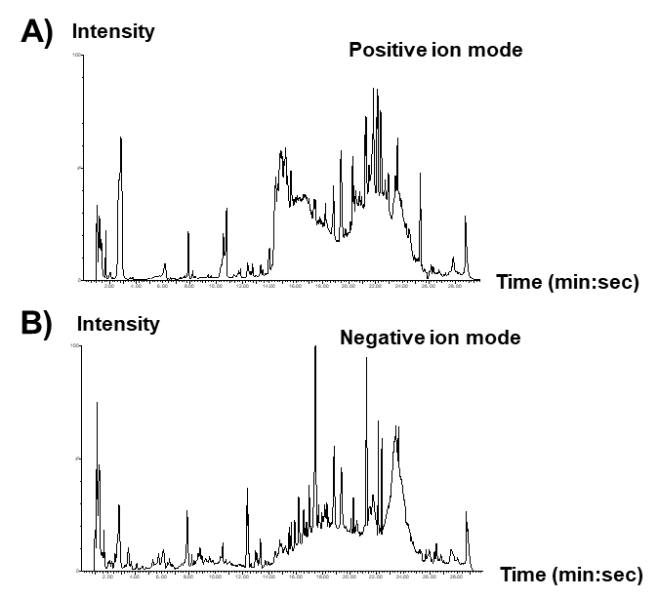Fig. S1.

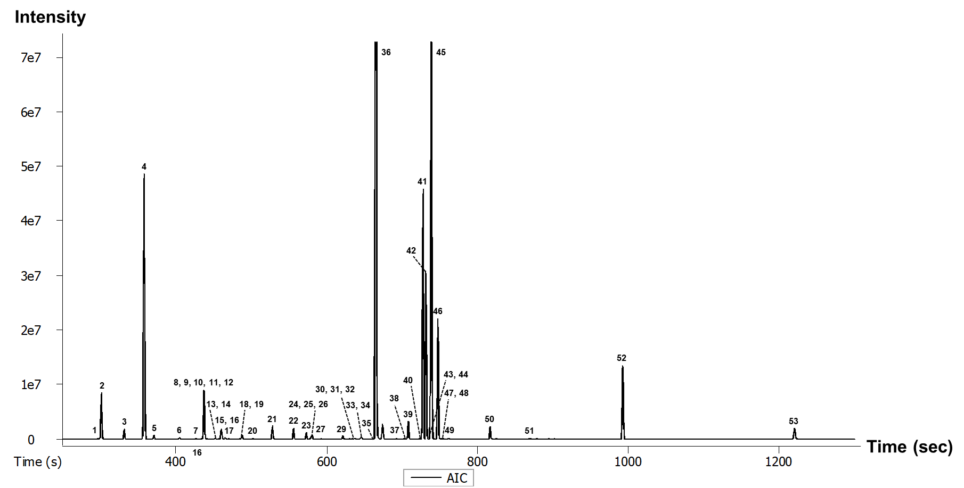
Fig. S2.

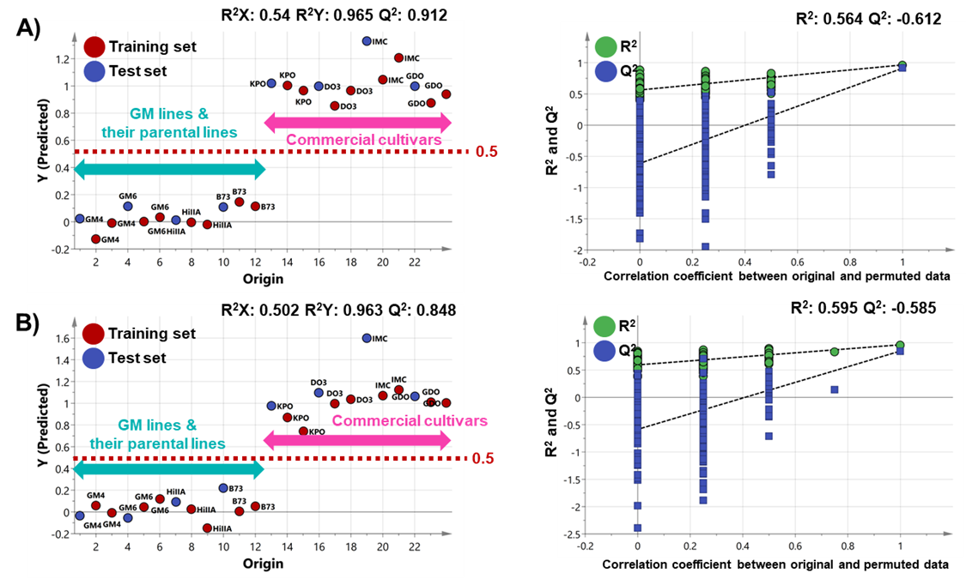
Fig. S3.

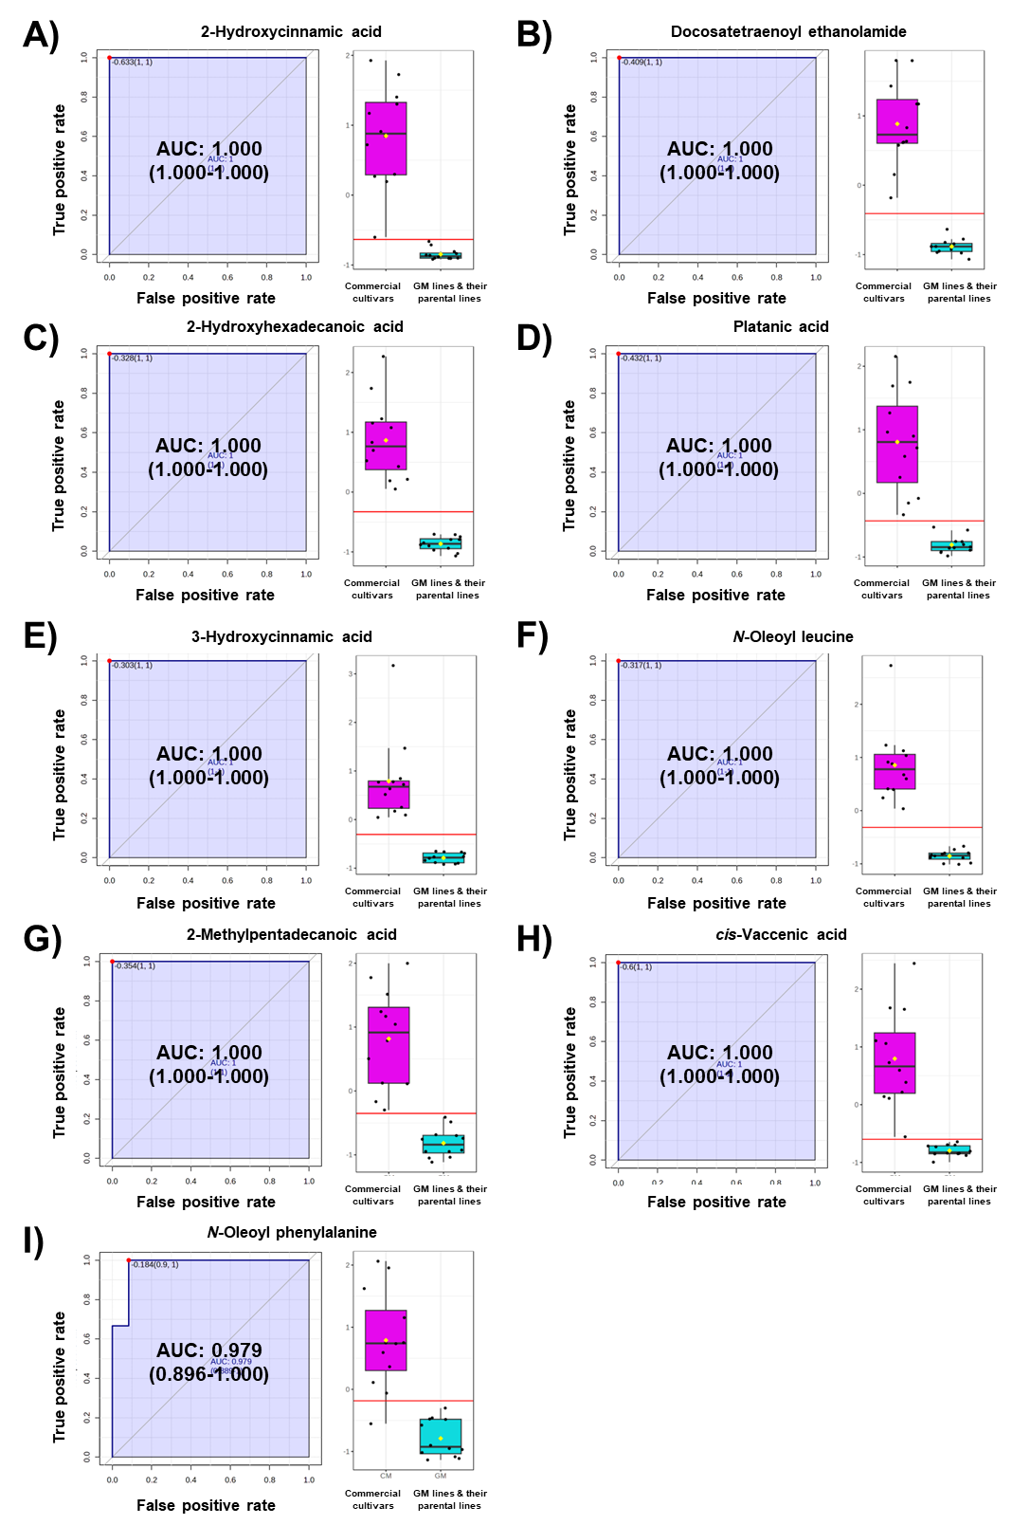
Fig. S4.
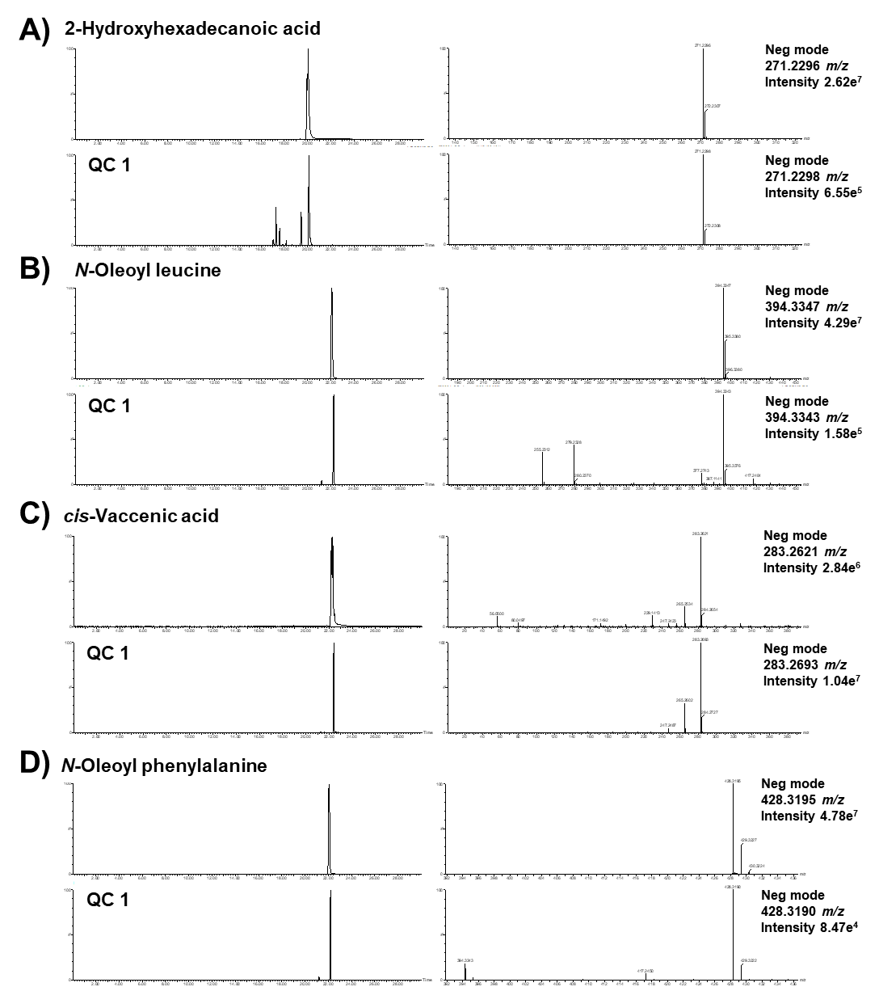
Fig. S5.
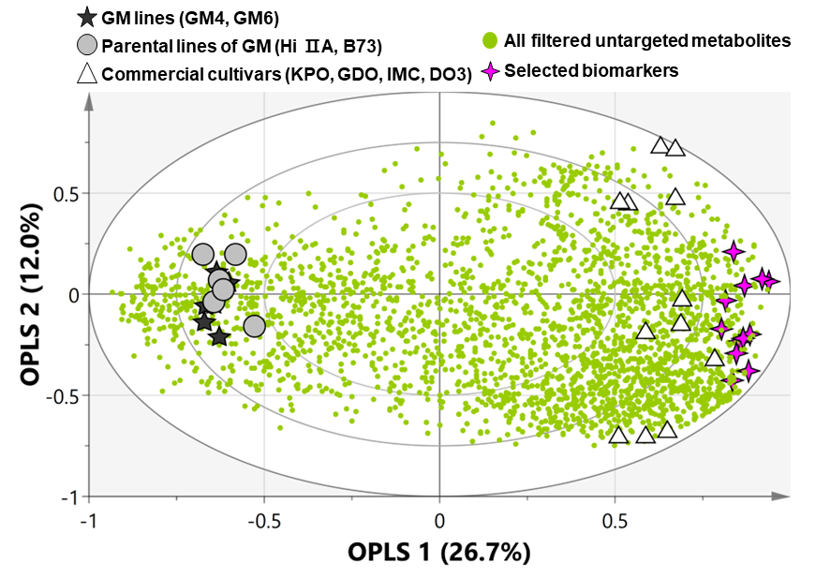
Fig. S6.

