Additional file 1

Table S1. Affymetrix® expression analysis of NHDF treated with HA vs. control showing the 50 most upregulated genes (FC = fold change).

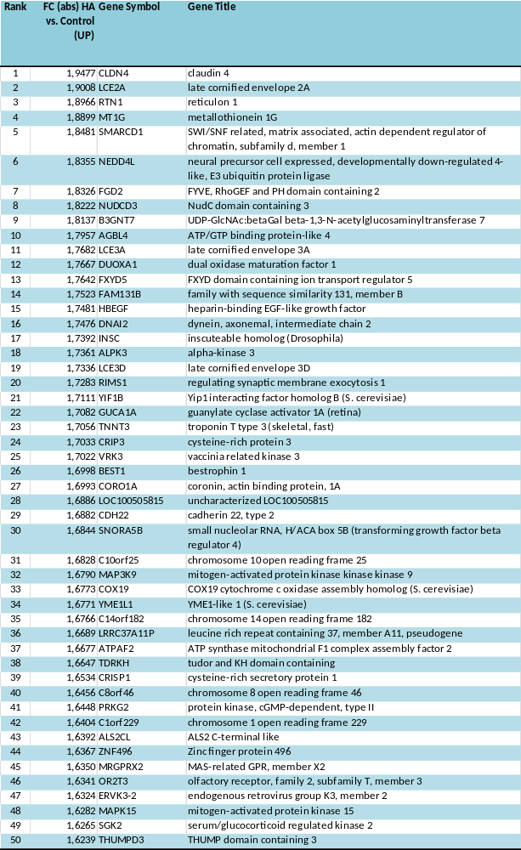

Table S2. Affymetrix® expression analysis of NHDF treated with HA vs. control showing the 50 most downregulated genes (FC = fold change).

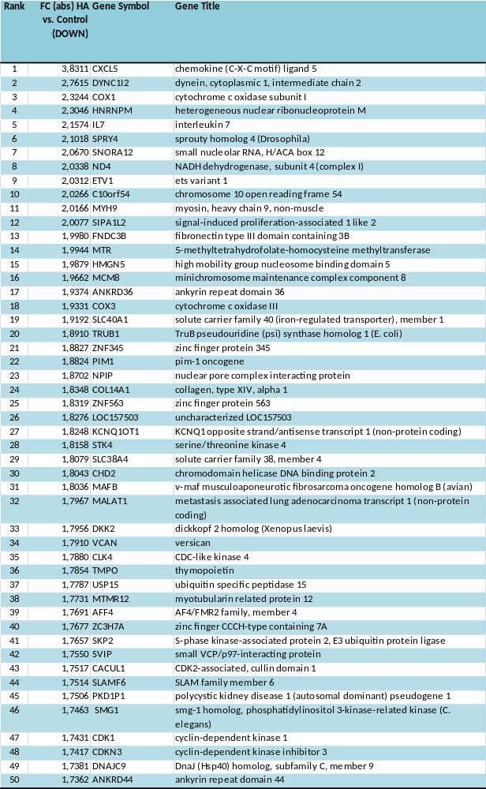

Table S3. Affymetrix® expression analysis of NHDF treated with medium-sized HA vs. control showing the 50 most upregulated genes (FC = fold change).

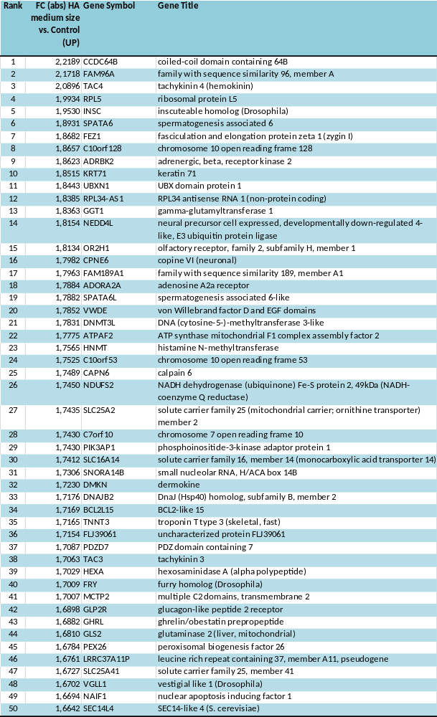

Table S4. Affymetrix® expression analysis of NHDF treated with medium-sized HA vs. control showing the 50 most downregulated genes (FC = fold change).

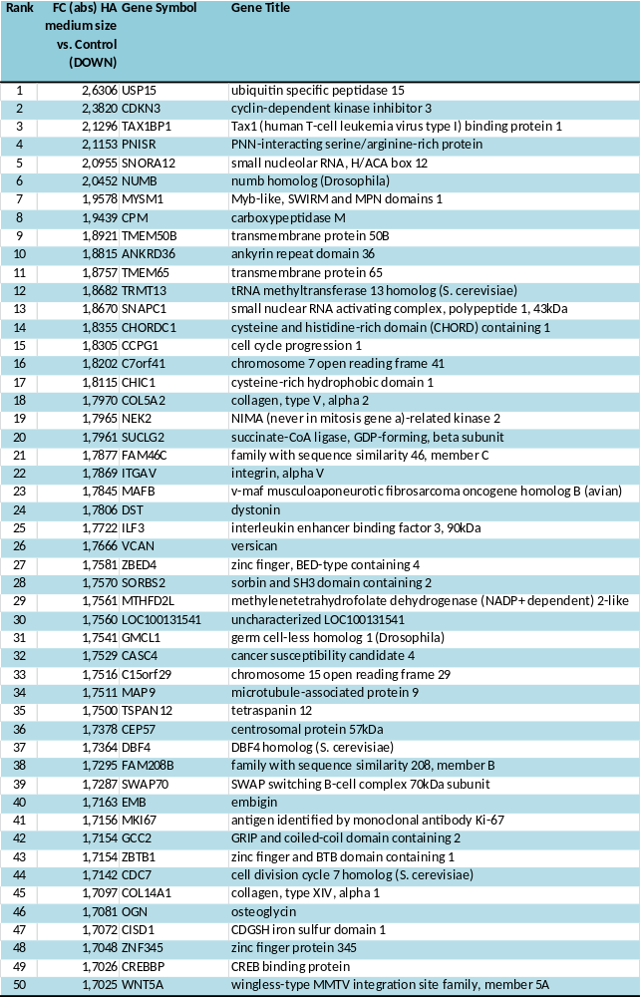

Table S5. Affymetrix® expression analysis of NHDF treated with HYAL vs. control showing the 50 most upregulated genes (FC = fold change).

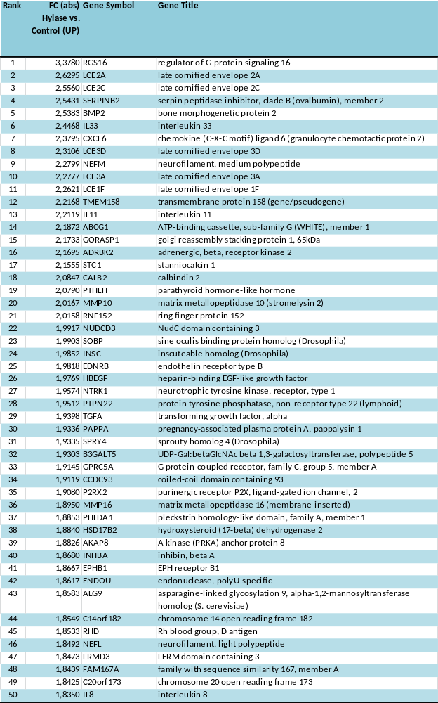

Table S6. Affymetrix® expression analysis of NHDF treated with HYAL vs. control showing the 50 most downregulated genes (FC = fold change).

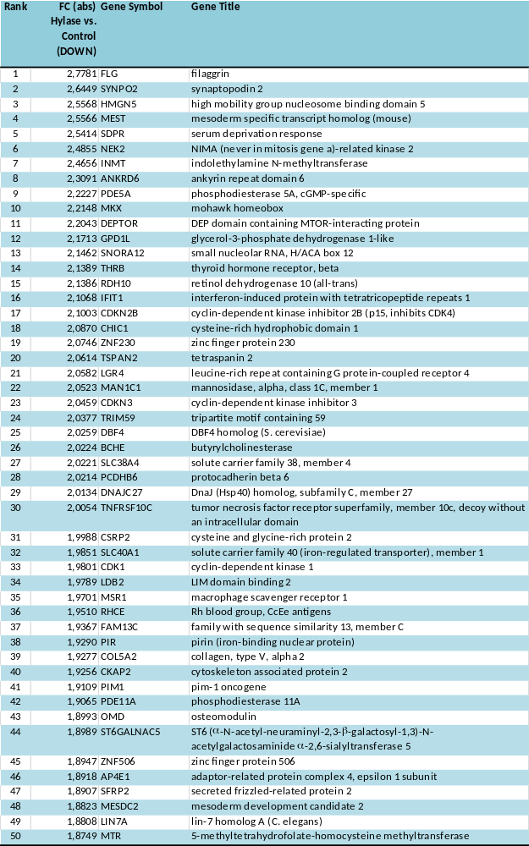
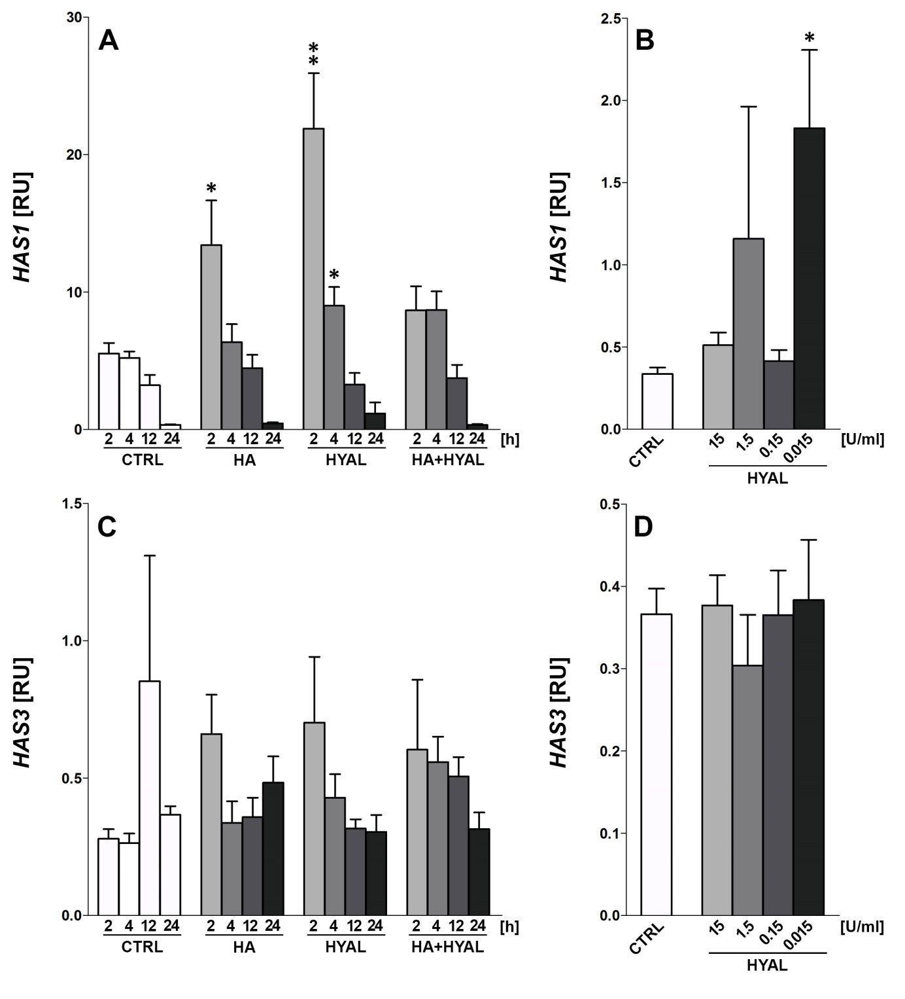Figure S1. (A, C) HAS1, HAS3 gene expression levels in normal human dermal fibroblasts (NHDF) after stimulation with 1 mg/ml HA, 1.5 U/ml HYAL and HA+HYAL co-stimulation for 2 h, 4 h, 12 h and 24 h, (B, D) HAS1, HAS3 gene expression levels of NHDF after stimulation with 15 U/ml, 1.5 U/ml, 0.15 U/ml and 0.015 U/ml HYAL for 24 h. Asterisks above columns indicate statistical significant differences compared to their respective medium controls. *p ≤ 0.05, **p ≤ 0.01, ***p ≤ 0.001 (t-test, two-sided).

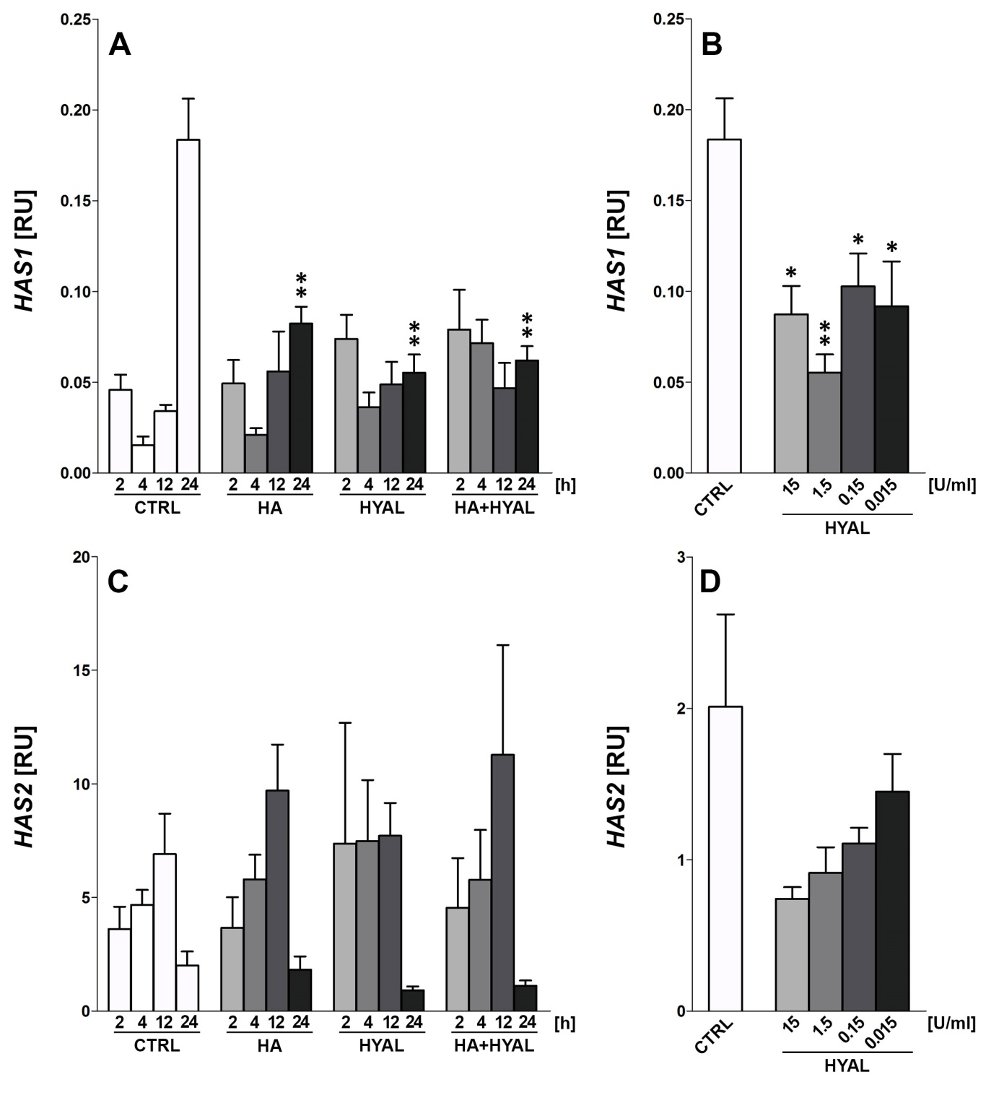
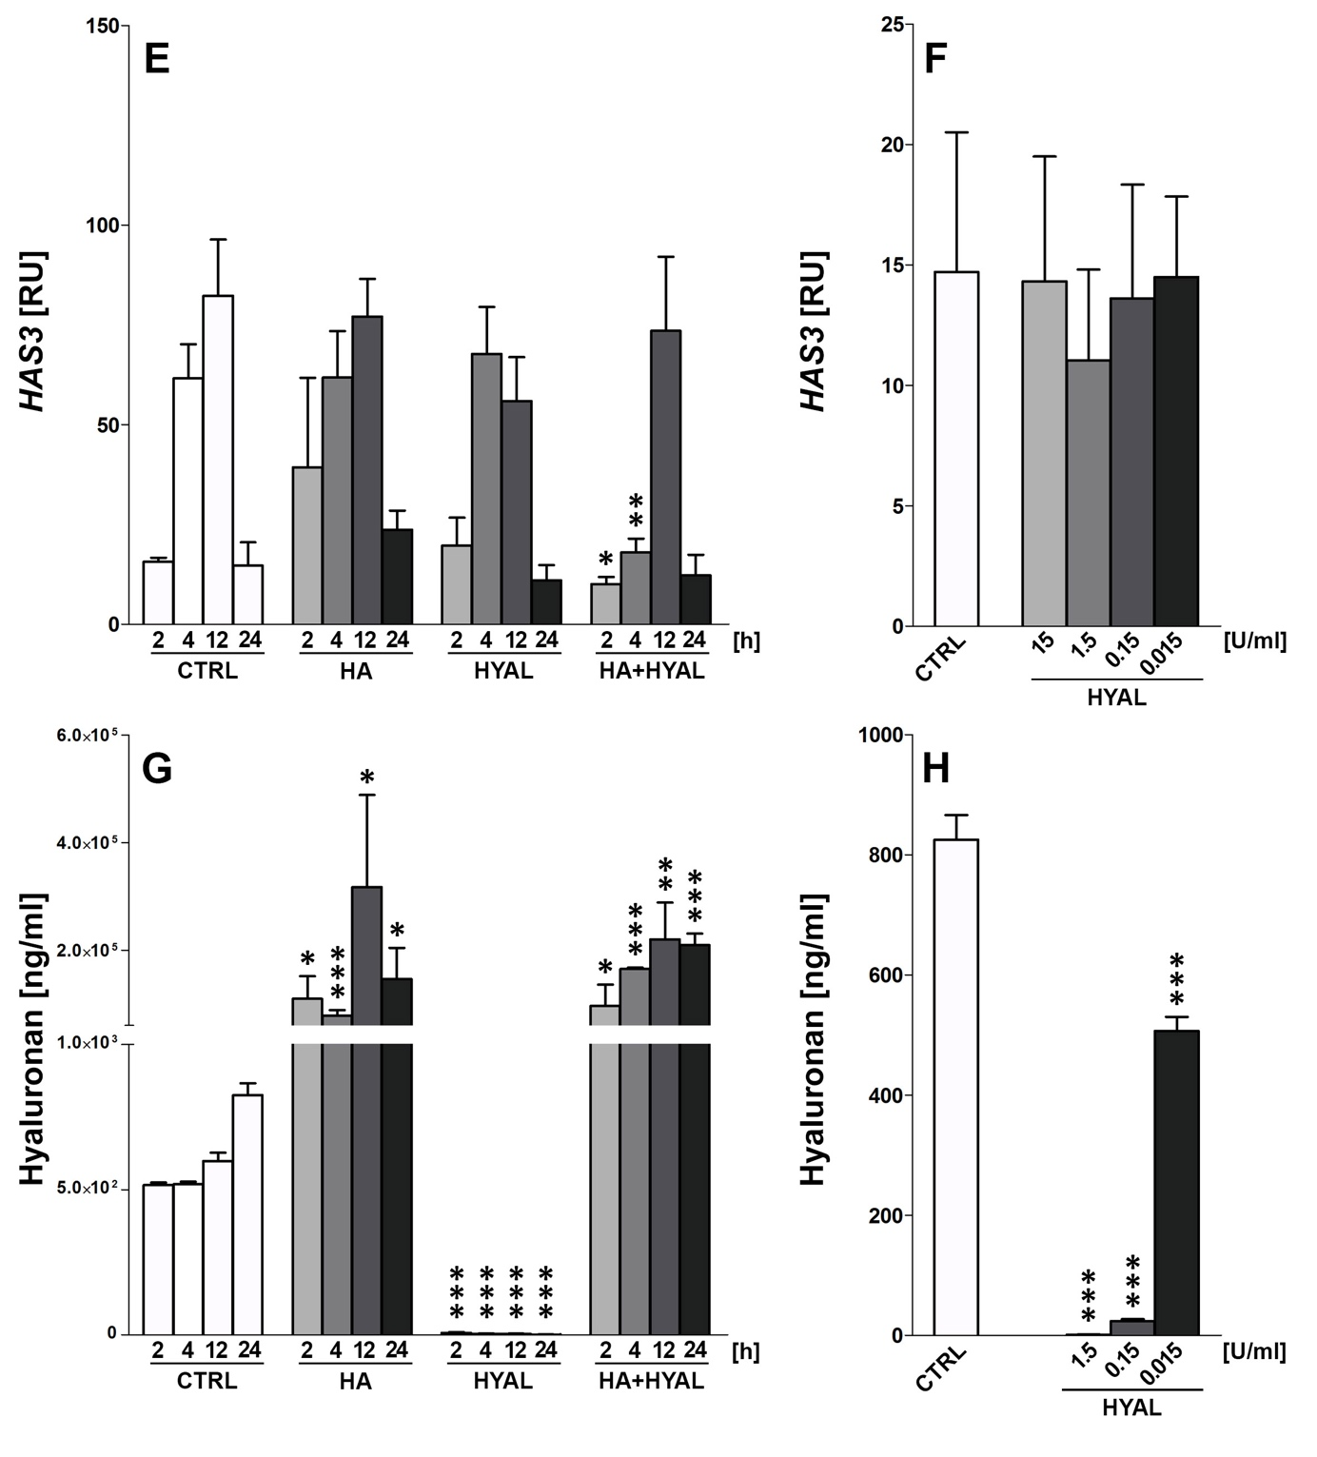
Figure S2. (A, C, E) HAS1, HAS2, HAS3 gene expression levels in primary human keratinocytes after stimulation with 1 mg/ml HA, 1.5 U/ml HYAL and HA+HYAL co-stimulation for 2 h, 4 h, 12 h and 24 h, (B, D, F) HAS1, HAS2, HAS3 gene expression levels in keratinocytes after stimulation with 15 U/ml, 1.5 U/ml, 0.15 U/ml and 0.015 U/ml HYAL for 24 h, (G, H) HA amount (ng/ml) measurement by means of ELISA in supernatants of NHDF treated as described in A-F. Asterisks above columns indicate statistical significant differences compared to their respective medium controls. *p ≤ 0.05, **p ≤ 0.01, ***p ≤ 0.001 (t-test, two-sided).

