Additional data
Figure S1: Leukocyte kinetics in patients who did and did not develop pneumonia during the hospital stay

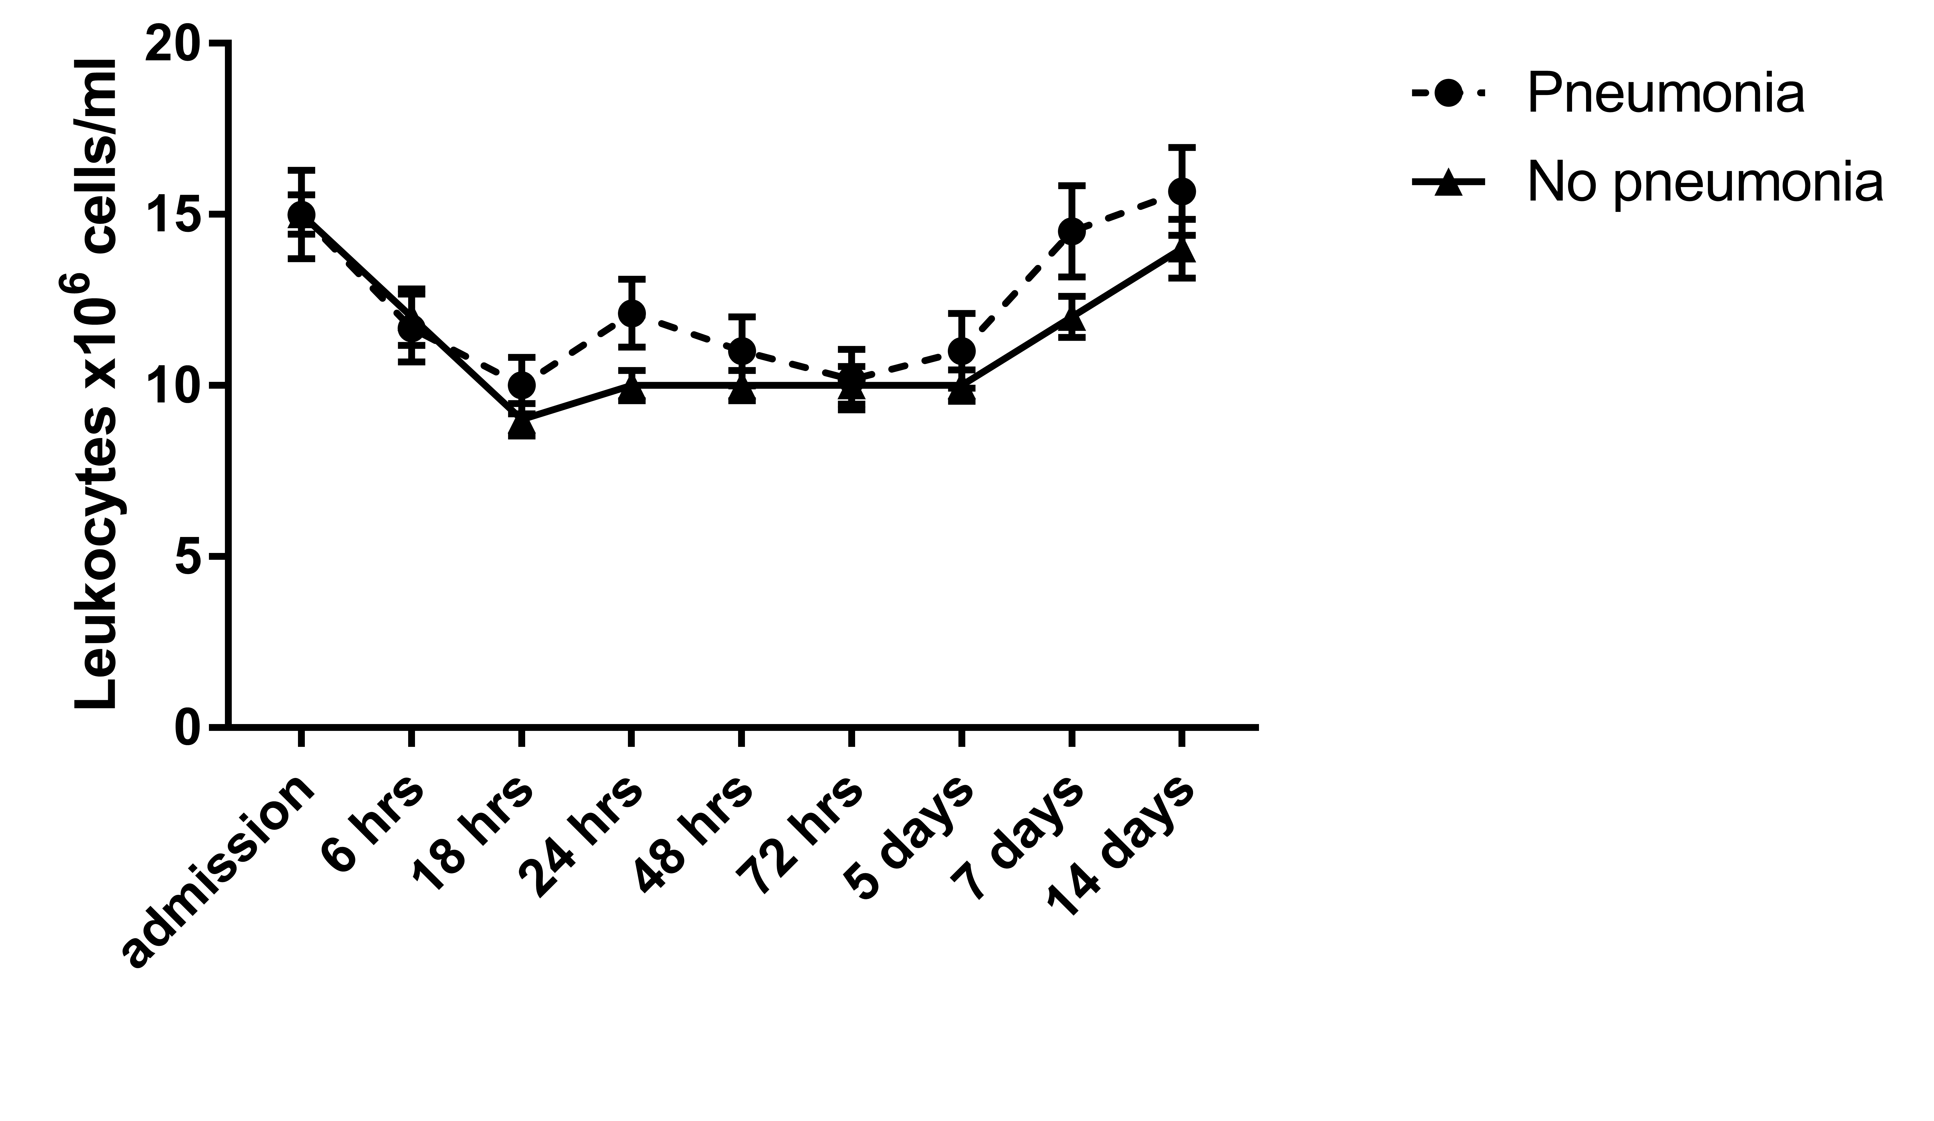

Figure S1: Absolute leukocyte numbers in patients diagnosed with pneumonia and regular patients. Data are expressed as mean +/- SEM (*p<0.05).

Figure S2: Analysis of potential correlation between the no. of transfused PRBCs and early circulatory leukocytosis

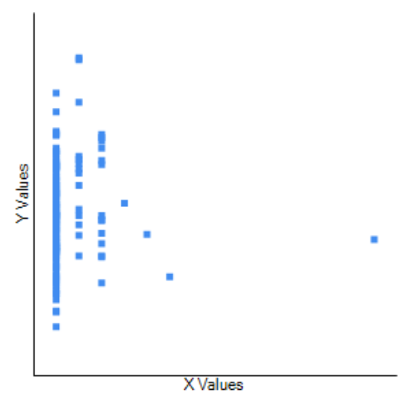

r(127)=-0.0015, p=0.991
Figure S2: x-axis= no. of transfused PRBCs, y-axis= WBC_{max/72hrs} (defined as Peak-WBC-counts within 72 hours).

