Additional file 1. Additional data and statistical analyses

Content | Page
Table S1: Included hospitals | 2
Table S2: Definitions of selected variables and clinical outcomes | 3
Table S3: Distribution of baseline covariates across groups before matching | 4
Table S4: Other baseline characteristics of the total cohort | 5-8
Table S5:. Ventilator and radiology characteristics of the included patients at days 0 and 1 of ICU | 9-10
Table S6: SOFA and APCHE-II scores at baseline | 11-12
Table S7: ICU support and interventions at days 0 of ICU admission after IPTW and matching | 13
Table S8: Distribution of Anakinra and Remdesivir doses | 14
Table S9: When was the patient admitted to ICU with respect to hospital admission day. | 15
Table S10: Clinical outcomes before adjusting for non-time and time-varying covariates | 16
Table S11: Linear regression analysis for ventilation-free days after adjusting for covariates stratified by steroid dose | 17
Table S12: Association between medication use and mortality after adjustment stratified by steroid dose | 18
Table S13: Other documented complication during hospitalization | 19
Table S14: Post-hoc analysis for changes in selected biomarkers values using linear mixed modelling up to 28 days | 20
Table S15: Linear mixed modelling of PF ratio | 21
Table S16: Post-hoc analysis for the ventilator-free days outcome stratified by time of administration | 22
Figure S1: Adjusted survival curves for competing risk models for (A) mortality and (B) discharge | 23
Figure S2:Unweighted and weighted Kaplan–Maier estimates for association between treatment and ICU LOS | 24
Figure S3:Unweighted and weighted Kaplan–Maier estimates for association between treatment hospital LOS | 24
Figure S4: Estimated marginal trend for the change in PF ratio across groups. | 25
Figure S5: Post-hoc analysis for the clinical outcomes ( ventilator-free days and mortality) stratified by age (> 60 vs. ≤ 60) | 26-27

Table S1Included Hospitals
Country | N
- United States | 60
- Japan | 4
- Saudi Arabia | 4
- India | 2
- Belgium | 2
- Colombia | 1
- Mexico | 1
- Bosnia and Herzegovina | 1
- Croatia | 1
- Egypt | 1
- Hungary | 1
- Hondurus | 1
- Russia | 1
- Serbia | 2
- Spain | 1
- Pakistan | 1
Total | 84
These are the included hospital per country in the VIRUS registry

Table S2: Definitions of Selected Variables and Clinical Outcomes
Severity of illness was evaluated using Sequential Organ Failure Assessment (SOFA) and Acute Physiology and Chronic Health Evaluation (APACHEII) scores. | The worst value for baseline laboratory tests was chosen. These data were collected within the first 24 h after admission to the ICU. If that data were not available, then data closest to admission were recorded.
Duration of mechanical ventilation | Recorded as the number of calendar days from intubation to extubation or until ICU discharge, or death whichever occurs first. The median ventilator-free days was calculated as calendar days with no ventilator support to day 28. Participants who die before day 28 are assigned zero free days.
Secondary infections | Identified based on positive blood, urine, and sputum cultures. Only infections occurring after administration of interleukin-6 Receptor Antagonists or steroids were considered. The definition of infection outcomes was following VIRUS Standard operating definitions
28-day mortality | Defined as the time from hospital admission until death within 28 days, with censoring of alive patients at 28 days.
Acute respiratory distress syndrome (ARDS) | Classified according to the Berlin definition [1].  The PF ratio was calculated by dividing the arterial Po2 by the FiO2 at the same time. If the FiO2 was not available, the lowest FiO2 was used followed by the highest FiO2.
Critical COVID-19 | Defined by the WHO criteria for ARDS, sepsis, septic shock or other conditions that would normally require the provision of life-sustaining therapies, such as mechanical ventilation (invasive or non-invasive) or vasopressor therapy [2,3].
Severe covid-19 | Defined by any of the following: oxygen saturation <90% on room air, respiratory rate >30 breaths per minute in adults, signs of severe respiratory distress (accessory muscle use, inability to complete full sentences) [3].
ICU and hospital length of stay | the interval between the ICU or hospital admission date to the ICU or hospital  discharge date was calculated in days

References :
(1) ARDS Definition Task Force, Ranieri VM, Rubenfeld GD, Thompson BT, Ferguson ND, Caldwell E, Fan E, Camporota L, Slutsky AS. Acute respiratory distress syndrome: the Berlin Definition. JAMA. 2012 Jun 20;307(23):2526-33. PMID: 22797452
(2) Alhazzani W, Evans L, Alshamsi F, Møller MH, Ostermann M, Prescott HC, Arabi YM et al A. Surviving Sepsis Campaign Guidelines on the Management of Adults With Coronavirus Disease 2019 (COVID-19) in the ICU: First Update. Crit Care Med. 2021 Mar 1;49(3):e219-e234. doi: 10.1097/CCM.0000000000004899
(3) Rochwerg B, Agarwal A, Siemieniuk R A, Agoritsas T, Lamontagne F, Askie L et al. A living WHO guideline on drugs for covid-19 BMJ 2020; 370 :m3379 doi:10.1136/bmj.m3379

Table S3: Distribution of baseline covariates across groups before adjustment
 | Steroids | IL6-R antagonists | Both | P
 | N=589 | N=170 | N=101
Sex |  |  |  | 0.39
Female | 205 (34.8) | 49 (28.8) | 34 (33.7)
Male | 384 (65.2) | 119 (70) | 70 (66.3)
Age, mean (SD) | 61.1 (14.3) | 57.4 (14.7) | 62.1 (13.2) | 0.01
Therapeutic anticoagulation |  |  |  | 0.24
No | 455 (77.2) | 136 (80) | 75 (74.3)
Yes | 134 (22.8) | 32 (20) | 29 (25.7)
Ethnic group |  |  |  | <0.001
Hispanic | 112 (19) | 48 (28.2) | 22 (21.7)
Non-Hispanic | 263 (44.7) | 80 (47.1) | 55 (54.4)
Weight (kg) at Hospital Admission, mean (SD) | 90.1 (27.7) | 96.9 (28) | 95.3 (28.5) | 0.01
Cardiovascular disease | 130 (22.1) | 16 (9.4) | 23 (22.7) | 0.001
Asthma/COPD | 102 (17.3) | 19 (11.1) | 29 (28.7) | 0.002
Hydroxychloroquine | 87 (14.8) | 87 (51.2) | 41 (40.6) | <0.001
Antiviral | 474 (80.5) | 159 (93.5) | 86 (85.1) | <0.001
Azithromycin | 204 (34.6) | 93 (54.7) | 50 (49.5) | <0.001
ARDS |  |  |  | .
Mild (P:F 200-300) | 15 (2.7) | 4 (2.4) | 6 (5.9)
Moderate (P:F 100-199) | 65 (11.5) | 4 (2.4) | 8 (7.9)
Severe (P:F< 100) | 105 (18.6) | 12 (7.1) | 16 (15.8)
Lowest FiO2, mean (SD) | 0.57 (0.3) | 0.51 (0.3) | 0.55 (0.2) | 0.12
Data presented as n (%) unless otherwise specified
Abbreviation: ARDS: Acute respiratory distress syndrome ; COPD: Chronic obstructive pulmonary disease SD: standard deviation; P:F: ratio of arterial oxygen partial pressure (PaO2 in mmHg) to fractional inspired oxygen (FiO2)
Table S4: Other Baseline characteristics of the total cohort
 | Steroids  N=589 | IL6-R antagonists  N=170 | Both  N=101 | P | N
Hospital Admission Source |  |  |  | <0.001 | 858
Home | 207 (35.3) | 42 (24.7) | 36 (35.6)
Hospital ED | 177 (30.2) | 92 (54.1) | 43 (42.6)
Nursing Home | 25 (4.26) | 2 (1.2) | 2 (1.9)
Other | 5 (0.85) | 1 (0.6) | 0 (0)
Outside ED | 30 (5.11) | 8 (4.7) | 3 (2.9)
Transfer from other Facility | 143 (24.4) | 25 (14.7) | 17 (16.8)
Signs and symptoms |  |  |  | 0.80 | 860
Abdominal pain | 38 (6.5) | 5 (2.9) | 7 (6.9) | 0.20 | 860
Ageusia (loss of taste sense) | 25 (4.24) | 5 (2.9) | 3 (2.9) | 0.82 | 860
Loss of appetite | 51 (8.7) | 25 (14.7) | 13 (12.9) | 0.05 | 860
Anosmia (loss of smell sense) | 19 (3.2) | 4 (2.4) | 6 (5.9) | 0.27 | 860
Arthralgia | 11 (1.9) | 4 (2.4) | 6 (5.9) | 0.05 | 860
Chest pain/tightness | 67 (11.4) | 16 (9.4) | 11 (10.9) | 0.77 | 860
Chills/rigors | 84 (14.3) | 33 (19.4) | 15 (14.9) | 0.26 | 860
Confusion/delirium | 49 (8.3) | 11 (6.5) | 7 (6.9) | 0.69 | 860
Conjunctival congestion | 1 (0.17) | 1 (0.59) | 0 (0) | 0.53 | 860
Dry cough | 283 (48) | 101 (59.4) | 58 (57.4) | 0.01 | 860
Cough with sputum | 69 (11.7) | 25 (14.7) | 16 (15.8) | 0.37 | 860
Diarrhea | 78 (13.2) | 44 (25.9) | 21 (20.8) | <0.001 | 860
Dizziness/lightheadedness | 31 (5.3) | 8 (4.7) | 5 (4.9) | 0.96 | 860
Dyspnea/shortness of breath | 436 (74) | 133 (78.2) | 73 (72.3) | 0.45 | 860
Fever | 370 (62.8) | 125 (73.5) | 72 (71.3) | 0.02 | 860
Headache | 60 (10.2) | 23 (13.5) | 11 (10.9) | 0.47 | 860
Hemoptysis | 7 (1.2) | 0 (0) | 0 (0) | 0.39 | 860
Malaise | 91 (15.4) | 28 (16.5) | 23 (22.8) | 0.19 | 860
Myalgia or fatigue | 439 (74.5) | 101 (59.4) | 62 (61.4) | <0.001 | 860
Nasal congestion/rhinorrhea | 25 (4.2) | 12 (7.06) | 10 (9.9) | 0.04 | 860
Nausea and Vomiting | 81 (13.8) | 22 (12.9) | 15 (14.9) | 0.91 | 860
Night sweat | 9 (1.5) | 1 (0.59) | 2 (1.9) | 0.60 | 860
Seizure | 6 (1.02) | 1 (0.59) | 0 (0) | 0.85 | 860
Sneezing | 1 (0.2) | 1 (0.59) | 0 (0) | 0.53 | 860
Sore throat or throat pain | 33 (5.6) | 15 (8.8) | 11 (10.9) | 0.08 | 860
Swollen neck/glands (lymphadenopathy) | 1 (0.2) | 0 (0) | 0 (0) | 1.00 | 860
Comorbidities
Coronary heart diseases | 492 (83.5) | 161 (94.7) | 85 (84.2) | 0.001 | 860
Hypertension | 251 (42.6) | 67 (39.4) | 45 (44.6) | 0.67 | 860
Cardiac arrhythmias | 50 (8.5) | 5 (2.9) | 4 (3.9) | 0.02 | 860
Congestive heart failure | 72 (12.2) | 10 (5.9) | 9 (8.9) | 0.05 | 860
Valvular heart disease | 17 (2.9) | 1 (0.6) | 1 (0.9) | 0.18 | 860
Chronic pulmonary disease not asthma | 59 (10) | 7 (4.1) | 16 (15.8) | 0.005 | 860
Asthma physician diagnosed | 45 (7.6) | 12 (7.1) | 12 (11.9) | 0.31 | 860
Pulmonary circulation disorder | 7 (1.2) | 1 (0.6) | 2 (1.9) | 0.55 | 860
Chronic kidney disease | 58 (9.9) | 14 (8.24) | 12 (11.9) | 0.62 | 860
Chronic dialysis | 12 (2.04) | 2 (1.18) | 3 (2.9) | 0.59 | 860
Diabetes | 362 (61.5) | 111 (65.3) | 55 (54.5) | 0.21 | 860
Hypothyroidism | 45 (7.6) | 6 (3.5) | 5 (4.9) | 0.13 | 860
Liver disease | 20 (3.4) | 2 (1.2) | 2 (1.9) | 0.32 | 860
Hepatitis B | 2 (0.34) | 1 (0.6) | 0 (0) | 0.68 | 860
Hepatitis C | 11 (1.9) | 3 (1.8) | 2 (1.9) | 1.00 | 860
peptic ulcer disease excluding bleeding | 6 (1.02) | 3 (1.8) | 2 (1.9) | 0.44 | 860
solid tumor without metastasis | 26 (4.4) | 0 (0) | 8 (7.9) | 0.001 | 860
hematologic malignancy | 7 (1.2) | 4 (2.4) | 1 (0.9) | 0.43 | 860
metastatic cancer | 10 (1.7) | 0 (0) | 0 (0) | 0.12 | 860
history of solid organ or bone marrow transplant | 1 (0.17) | 0 (0) | 2 (1.9) | 0.06 | 860
HIV aids or other immunosuppression | 6 (1.02) | 4 (2.4) | 2 (1.9) | 0.24 | 860
stroke or other neurological disorders | 47 (7.9) | 4 (2.4) | 5 (4.9) | 0.03 | 860
Paralysis | 5 (0.9) | 1 (0.6) | 0 (0) | 1.00 | 860
Rheumatoid arthritis collagen vascular disease | 9 (1.5) | 3 (1.8) | 1 (0.9) | 0.91 | 860
Blood loss anemia | 0 (0) | 1 (0.6) | 0 (0) | 0.32 | 860
Iron deficiency anemia | 13 (2.2) | 3 (1.8) | 2 (1.9) | 1.00 | 860
Coagulopathy | 4 (0.68) | 3 (1.8) | 1 (0.9) | 0.32 | 860
Malnutrition | 1 (0.17) | 0 (0) | 1 (0.9) | 0.26 | 860
Obesity | 117 (19.9) | 60 (35.3) | 32 (31.7) | <0.001 | 860
Substance use disorder | 15 (2.6) | 2 (1.2) | 2 (1.9) | 0.63 | 860
Depression | 37 (6.3) | 5 (2.9) | 10 (9.9) | 0.06 | 860
Psychosis | 5 (0.9) | 1 (0.6) | 0 (0) | 1.00 | 860
Dementia | 18 (3.1) | 3 (1.8) | 2 (1.9) | 0.76 | 860
Obstructive sleep apnea | 33 (5.6) | 19 (11.2) | 11 (10.9) | 0.02 | 860
Venous thromboembolism | 15 (2.6) | 4 (2.4) | 6 (5.9) | 0.19 | 860
Dyslipidemia hyperlipidemia | 59 (10) | 6 (3.5) | 10 (9.9) | 0.03 | 860
Admission Diagnosis/Complications
Acute Liver Injury | 22 (3.7) | 5 (2.9) | 6 (5.9) | 0.42 | 860
Acute Myocardial Infarction | 9 (1.5) | 1 (0.6) | 0 (0) | 0.41 | 860
Acute Renal Failure Requiring Hemofiltration | 23 (3.9) | 5 (2.9) | 8 (7.9) | 0.12 | 860
Acute Renal Injury | 89 (15.1) | 31 (18.2) | 14 (13.9) | 0.54 | 860
Bacteremia | 16 (2.7) | 4 (2.4) | 0 (0) | 0.29 | 860
Bacterial Pneumonia | 59 (10) | 23 (13.5) | 8 (7.9) | 0.28 | 860
Cardiac Arrest | 19 (3.2) | 1 (0.6) | 1 (0.9) | 0.09 | 860
Cardiac Arrhythmia: Atrial Fibrillation | 10 (1.7) | 3 (1.8) | 4 (3.9) | 0.35 | 860
Cardiac Arrhythmia: Heart Block | 2 (0.3) | 0 (0) | 1 (0.9) | 0.40 | 860
Cardiac Arrhythmia: Ventricular Tachycardia | 8 (1.4) | 0 (0) | 2 (1.9) | 0.19 | 860
Congestive Heart Failure / Cardiomyopathy | 13 (2.2) | 1 (0.6) | 3 (2.9) | 0.31 | 860
Diabetic Ketoacidosis (DKA) | 2 (0.34) | 0 (0) | 0 (0) | 1.00 | 860
Delirium / Encephalopathy | 48 (8.2) | 4 (2.4) | 3 (2.9) | 0.008 | 860
Gastrointestinal Hemorrhage | 2 (0.3) | 1 (0.6) | 1 (0.9) | 0.38 | 860
Hyperglycemia | 67 (11.4) | 22 (12.9) | 14 (13.9) | 0.71 | 860
Hypoglycemia | 5 (0.9) | 0 (0) | 0 (0) | 0.63 | 860
Meningitis/Encephalitis | 3 (0.5) | 0 (0) | 0 (0) | 1.00 | 860
Myocarditis | 3 (0.5) | 0 (0) | 1 (0.9) | 0.53 | 860
Pneumothorax | 3 (0.5) | 0 (0) | 2 (1.9) | 0.16 | 860
Pleural Effusion | 6 (1.02) | 0 (0) | 1 (0.9) | 0.48 | 860
Rhabdomyolysis / Myositis | 8 (1.4) | 0 (0) | 2 (1.9) | 0.19 | 860
Seizure | 5 (0.9) | 0 (0) | 0 (0) | 0.63 | 860
Shock | 72 (12.2) | 9 (5.3) | 9 (8.9) | 0.03 | 860
Stroke | 8 (1.4) | 0 (0) | 0 (0) | 0.22 | 860
Pre-Hospital (Home) Medication
Angiotensin-converting-enzyme Inhibitor | 97 (16.5) | 31 (18.2) | 20 (19.8) | 0.66 | 860
Angiotensin receptor blocker | 68 (11.5) | 22 (12.9) | 13 (12.9) | 0.85 | 860
Antiretroviral | 2 (0.3) | 2 (1.2) | 1 (0.9) | 0.23 | 860
Antibiotics | 54 (9.2) | 11 (6.5) | 7 (6.9) | 0.46 | 860
Anti-Diabetic | 44 (7.5) | 5 (2.9) | 13 (12.9) | 0.009 | 860
Aspirin | 122 (20.7) | 31 (18.2) | 29 (28.7) | 0.11 | 860
Chemotherapy currently or in the last 3 Months: | 12 (2.04) | 1 (0.6) | 2 (1.9) | 0.51 | 860
Immunotherapy | 9 (1.5) | 0 (0) | 3 (2.9) | 0.11 | 860
Inhaled corticosteroids | 54 (9.2) | 13 (7.7) | 13 (12.9) | 0.35 | 860
NSAID/Ibuprofen | 49 (8.3) | 18 (10.6) | 10 (9.9) | 0.62 | 860
Other anti-hypertensive agent (eg., beta blocker, calcium channel blocker, diuretic) | 211 (35.8) | 57 (33.5) | 37 (36.6) | 0.83 | 860
Paracetamol/Acetaminophen | 81 (13.8) | 25 (14.7) | 22 (21.8) | 0.11 | 860
Proton Pump Inhibitors | 76 (12.9) | 27 (15.9) | 20 (19.8) | 0.15 | 860
Statins | 166 (28.2) | 58 (34.1) | 31 (30.7) | 0.32 | 860
Anticoagulants | 46 (7.8) | 9 (5.3) | 10 (9.9) | 0.35 | 860
Hydroxychloroquine (Plaquenil) | 5 (0.9) | 2 (1.2) | 1 (0.9) | 0.87 | 860
Social History
Social history (current smoker) | 29 (4.9) | 7 (4.12) | 6 (5.94) | 0.80 | 860
Social history (former smoker) | 119 (20.2) | 29 (17.1) | 25 (24.8) | 0.31 | 860
Social history (vaping) | 0 (0) | 1 (0.59) | 0 (0.00) | 0.32 | 860
Social history (alcohol use disorder) | 26 (4.4) | 6 (3.53) | 5 (4.95) | 0.81 | 860
Social history (substance use disorder) | 14 (2.4) | 3 (1.76) | 1 (0.99) | 0.81 | 860
Social history (unknown/not available) | 37 (6.3) | 5 (2.94) | 4 (3.96) | 0.19 | 860
Packs per day (PPD) patient smokes |  |  |  | 0.09 | 49
< ½ PPD (0.5 PPD) | 8 (21.1) | 0 (0) | 2 (33.3)
1 PPD | 6 (15.8) | 0 (0) | 2 (33.3)
1½ PPD (1.5 PPD) | 1 (2.6) | 0 (0) | 0 (0)
2 PPD | 4 (10.5) | 1 (20) | 2 (33.3)
Unknown/Not Available | 19 (50) | 4 (80) | 0 (0)
Does/Did patient uses other tobacco products regularly? (Cigars) | 6 (1.02) | 0 (0) | 1 (0.9) | 0.48 | 860
Does/Did patient uses other tobacco products regularly? (Pipes) | 1 (0.2) | 0 (0) | 1 (0.9) | 0.26 | 860
Does/Did patient uses other tobacco products regularly? (Chewing tobacco) | 2 (0.3) | 0 (0) | 0 (0) | 1.00 | 860
Does/Did patient uses other tobacco products regularly? (No other tobacco) | 9 (1.5) | 1 (0.6) | 3 (2.9) | 0.27 | 860
Does/Did patient uses other tobacco products regularly? (Unknown/ Not available) | 19 (3.2) | 4 (2.4) | 2 (1.9) | 0.86 | 860
Type of Shock |  |  |  | 0.49 | 80
Cardiogenic shock | 5 (7.6) | 0 (0) | 0 (0)
Distributive shock | 59 (89.4) | 5 (83.3) | 8 (100)
Hypovolemic shock | 2 (3.03) | 1 (16.7) | 0 (0)
Data presented as n (%) unless otherwise specified
Abbreviation: ARDS: Acute respiratory distress syndrome ; P:F: ratio of arterial oxygen partial pressure (PaO2 in mmHg) to fractional inspired oxygen (FiO2)
Table S5: Ventilator and Radiology Characteristics of the included patients at days 0 and 1 of ICU stay
 | Day 0 |  |  |  | Day 1
 | Steroids | IL6-R antagonists | combination | P | Steroids | IL6-R antagonists | combination | P
 | N=589 | N=170 | N=101 |  | N=568 | N=170 | N=94
Performed diagnostics
None | 31 (5.3) | 7 (4.1) | 7 (6.9) | 0.60 | 232 (40.8) | 49 (28.8) | 33 (35.1) | 0.02
Chest X-ray | 467 (79.3) | 149 (87.6) | 89 (88.1) | 0.01 | 256 (45.1) | 108 (63.5) | 53 (56.4) | <0.001
CT Chest | 153 (26) | 25 (14.7) | 13 (12.9) | <0.001 | 27 (4.75) | 6 (3.5) | 5 (5.3) | 0.73
Lung US | 8 (1.4) | 0 (0) | 1 (0.9) | 0.31 | 2 (0.4) | 1 (0.6) | 0 (0) | 0.68
Cardiac Echo | 26 (4.4) | 3 (1.8) | 2 (1.9) | 0.22 | 30 (5.3) | 4 (2.4) | 3 (3.2) | 0.27
infiltrates present in CXR | 424 (91.4) | 136 (91.3) | 84 (94.4) | 0.62 | 244 (97.2) | 105 (97.2) | 53 (100) | 0.72
Interstitial pattern | 108 (18.3) | 26 (15.3) | 24 (23.8) | 0.22 | 58 (10.2) | 18 (10.6) | 12 (12.8) | 0.76
Opacities | 320 (54.3) | 103 (60.6) | 62 (61.4) | 0.20 | 194 (34.2) | 80 (47.1) | 37 (39.4) | 0.01
Multifocal | 155 (26.3) | 50 (29.4) | 30 (29.7) | 0.62 | 79 (13.9) | 48 (28.2) | 23 (24.5) | <0.001
Bilateral | 336 (57) | 102 (60) | 63 (62.4) | 0.53 | 203 (35.7) | 90 (52.9) | 39 (41.5) | <0.001
Pleural effusion | 26 (4.4) | 6 (3.5) | 8 (7.9) | 0.22 | 15 (2.6) | 6 (3.5) | 4 (4.3) | 0.48
CT chest pattern¶
Ground Glass Opacity (GGO) | 104 (17.7) | 17 (10) | 13 (12.9) | 0.04 | 19 (3.4) | 6 (3.5) | 5 (5.3) | 0.57
Crazy paving | 10 (1.7) | 1 (0.6) | 2 (1.9) | 0.57 | 2 (0.4) | 0 (0) | 1 (1.1) | 0.40
Multifocal | 88 (14.9) | 14 (8.2) | 8 (7.9) | 0.02 | 11 (1.9) | 3 (1.8) | 2 (2.1) | 1
Bilateral | 134 (22.8) | 18 (10.6) | 12 (11.9) | <0.001 | 18 (3.2) | 6 (3.5) | 4 (4.3) | 0.76
Lymphadenopathy (LAP) | 13 (2.2) | 1 (0.6) | 1 (0.9) | 0.40 | 3 (0.5) | 0 (0) | 0 (0) | 1
Pleural effusion | 17 (2.9) | 2 (1.2) | 0 (0) | 0.12 | 7 (1.2) | 1 (0.6) | 0 (0) | 0.63
Opacity | 49 (8.3) | 7 (4.1) | 5 (4.9) | 0.11 | 6 (1.1) | 0 (0) | 0 (0) | 0.43
Consolidation | 27 (4.6) | 1 (0.6) | 0 (0) | 0.003 | 3 (0.5) | 1 (0.6) | 1 (1.1) | 0.78
Pulmonary nodules | 2 (0.34) | 0 (0) | 0 (0) | 1.00 | 0 (0) | 0 (0) | 0 (0) | 1
Respiratory Rate- mean (SD) | 21.0 (24.2) | 29.8 (61.5) | 17.9 (4.9) | 0.12 | 23.9 (36.2) | 34.2 (75.1) | 18.3 (5.6) | 0.07
Tidal volume (ml) mean (SD) | 432 (121) | 439 (114) | 444 (97.8) | 0.83 | 432 (113) | 419 (108) | 442 (93.6) | 0.46
PEEP (cm H2O) mean (SD) | 11.2 (3.6) | 12 (3.9) | 11.1 (4.3) | 0.36 | 11.8 (6.4) | 12.0 (3.8) | 11.5 (3.1) | 0.88
Ventilator mode |  |  |  | <0.001 |  |  |  | <0.005
Airway pressure release ventilation (APRV) | 6 (1.9) | 1 (2) | 6 (16.7) |  | 9 (2.5) | 1 (0.9) | 2 (3.7)
Pressure control (PC) | 49 (15.5) | 4 (8) | 8 (22.2) |  | 42 (11.5) | 5 (4.9) | 12 (22.2)
Pressure Support (PS) | 4 (1.3) | 1 (2) | 1 (2.8) |  | 4 (1.1) | 1 (0.9) | 1 (1.9)
Volume control (VC) | 206 (65) | 22 (44) | 16 (44.4) |  | 243 (66.8) | 63 (62.4) | 32 (59.3)
Documented ventilator associated pneumonia (VAP) | 15 (5.2) | 0 (0) | 4 (10.5) | 0.05 | 13 (3.9) | 3 (2.9) | 2 (3.7) | 1
Documented assessment of spontaneous breathing trial |  |  |  | 0.32 |  |  |  | 0.46
No | 145 (50.7) | 28 (54.9) | 18 (48.6) |  | 180 (54.9) | 55 (55) | 26 (48.1)
not indicated | 131 (45.8) | 22 (43.1) | 15 (40.5) |  | 118 (36) | 39 (39) | 26 (48.1)
Yes | 10 (3.5) | 1 (1.9) | 4 (10.8) |  | 30 (9.2) | 6 (6) | 2 (3.7)

Data presented as n (%) unless otherwise specified
¶ percentage calculated based on available data for patients with computerized tomography (CT) chest scan

Table S6: SOFA and APCHE-II scores at baseline
 | Steroids | IL-6 antagonists | Both | P | N
 | N=446 | N=105 | N=73
SOFA Respiration: |  |  |  | . | 622
0. >400 | 19 (4.3) | 10 (9.5) | 2 (2.8)
1. < 400 (S:F 221-301), +/- Respiratory support | 25 (5.6) | 9 (8.6) | 6 (8.5)
2. < 300 (S:F 142-220), +/- Respiratory support | 73 (16.4) | 19 (18.1) | 19 (26.8)
3. < 200 (S:F 67-141) and Respiratory support | 165 (37) | 46 (43.8) | 26 (36.6)
4. < 100 (S:F <67) and Respiratory support | 164 (36.8) | 21 (20) | 18 (25.4)
SOFA coagulation (platelet): |  |  |  | 0.41 | 582
0. >150 | 338 (83.5) | 86 (82.7) | 60 (82.2)
1. < 150 | 47 (11.6) | 11 (10.6) | 13 (17.8)
2. < 100 | 14 (3.5) | 6 (5.8) | 0 (0)
3. < 50 | 5 (1.2) | 1 (0.9) | 0 (0)
4. < 20 | 1 (0.3) | 0 (0) | 0 (0)
SOFA cardiovascular (vasopressors): |  |  |  | . | 583
0. No Hypotension | 233 (57.5) | 60 (57.1) | 40 (54.8)
1. MAP < 70 mm Hg | 25 (6.2) | 21 (20) | 11 (15.1)
2. Dopamine ≤ 5 or Dobutamine (any dose) | 1 (0.3) | 0 (0) | 1 (1.4)
3. Dopamine > 5 or Epi/Norepi ≤0.1 | 70 (17.3) | 11 (10.5) | 11 (15.1)
4. Dopamine > 15 or Epi/Norepi > 0.1 | 76 (18.8) | 13 (12.4) | 10 (13.7)
SOFA GCS: |  |  |  | 0.01 | 582
0. 15 | 176 (43.5) | 62 (59) | 38 (52.8)
1. 13-14 | 37 (9.1) | 9 (8.6) | 4 (5.6)
2. 10-12 | 30 (7.4) | 9 (8.6) | 6 (8.3)
3. 6-9 | 73 (18) | 18 (17.1) | 16 (22.2)
4. <6 | 89 (22) | 7 (6.7) | 8 (11.1)
SOFA Liver (bilirubin): |  |  |  | 0.16 | 569
0. < 1.2 | 335 (84.8) | 92 (89.3) | 64 (90.1)
1. 1.2 -1.9 mg/dl .......... 20-32 micromole/L | 41 (10.4) | 7 (6.8) | 2 (2.8)
2. 2.0 - 5.9 mg/dl ......... 33-101 micromole /L | 18 (4.6) | 3 (2.9) | 4 (5.6)
3. 6.0-11.9 mg/dl ......... 102-204 micromole /L | 1 (0.3) | 1 (0.9) | 1 (1.4)
SOFA Renal (creatinine or urine output): |  |  |  | . | 583
0. < 1.2 mg/dl (110μmol/L) | 254 (62.7) | 73 (69.5) | 46 (63)
1. 1.2 -1.9 mg/dl (110-170μmol/L) | 77 (19) | 21 (20) | 15 (20.5)
2. 2.0 - 2.4 mg/dl (171-299μmol/L) | 28 (6.9) | 5 (4.8) | 6 (8.2)
3. 2.5-4.9 mg/dl (300-440μmol/L) or urine output < 500 mL/day | 30 (7.4) | 5 (4.8) | 4 (5.5)
4. > 5.0 mg/dl (>440μmol/L) or urine output < 200 mL/day | 16 (3.9) | 1 (0.9) | 2 (2.7)
Calculated APACHE II (First 24 hours in ICU that is Day 1 ICU) |  |  |  | <0.001 | 117
No | 23 (46.9) | 4 (9.1) | 6 (25)
Yes | 26 (53.1) | 40 (90.9) | 18 (75)
APACHE II (First 24 hours) score, mean (SD) | 18.1 (7.1) | 18.2 (6.9) | 18.8 (7.9) | 0.94 | 83

Data presented as n (%) unless otherwise specified

Table S7: ICU support and therapeutic interventions at days 0 of ICU admission after IPTW and matching
 | Steroids | IL6-R antagonists | Both | P | SMD
n¶ | 804.1 | 582.4 | 689.6
Code status change |  |  |  | 0.62 | 0.137
N/A | 17 ( 2.4) | 23 (4.0) | 11 (1.7)
No | 690 ( 94.9) | 531 (94.7) | 624 (94.8)
Yes | 20 ( 2.8) | 7 ( 1.3) | 23 ( 3.5)
Code change |  |  |  | 0.14 | 1.284
Changed to 'no chest compression' (no CPR) -DNR | 12 ( 58.6) | 3 ( 40.1) | 0 ( 0)
Changed to both- DNI-DNR | 3 ( 12.8) | 0 ( 0) | 4 ( 18.0)
Changed to full support (full code) | 6 ( 28.6) | 4 ( 59.9) | 19 ( 82.0)
Neuromuscular blocker |  |  |  | 0.08 | 0.423
Atracurium | 10 (1.6) | 6 (1.6) | 30 (6.4)
Cisatracurium | 75 (12.4) | 24 (6.2) | 26 (5.4)
Pancuronium | 4 ( 0.6) | 0 (0) | 0 (0)
Rocuronium | 117 ( 19.3) | 125 (32.6) | 125 (26.3)
Succinylcholine | 4 ( 0.6) | 5 ( 1.2) | 12 (2.5)
Vecuronium | 16 ( 2.7) | 12 ( 3.1) | 0 (0)
None | 370 ( 60.8) | 207 (54.0) | 277 (58.5)
Stress ulcer prophylaxis | 609 ( 77.6) | 367 (66.9) | 462 (70.2) | 0.14 | 0.159
Esomeprazole | 22 ( 3.0) | 0 (0) | 0 (0)
Famotidine | 141 (19.4) | 110 (19.6) | 122 (18.7)
Lansoprazole | 20 ( 2.7) | 25 ( 4.5) | 39 (5.9)
Omeprazole | 92 (12.6) | 63 ( 11.2) | 98 (14.9)
Pantoprazole | 163 (22.4) | 58 (10.3) | 175 (26.7)
Ranitidine | 46 ( 6.3) | 0 ( 0.0) | 4 (0.6)
None | 210 (28.9) | 223 ( 39.8) | 176 (26.9)
Not Indicated | 30 ( 4.1) | 78 ( 14.0) | 41 (6.2)
Stress ulcer prophylaxis route (IV) | 325 (66.7) | 162 ( 62.4) | 287 (65.7) | 0.86 | 0.06
Anticoagulant | 687 ( 85.4) | 494 ( 84.7) | 549 (79.6) | 0.36 | 0.102
Data presented as n (%) unless otherwise specified. N (%) may differ due to approximation
¶ Each individual gets its own weight that is used for further analysis. Multiplication by these weights can usually results in decimals
Abbreviation: CPR: Cardiopulmonary resuscitation; DNR: Do-not-resuscitate order; DNI: Do Not Intubate; IV: intravenous

Table S8: Distribution of Anakinra and Remdesivir doses
Anakinra doses | N (%)
0 | 851 (99)
1 | 1 (0.1)
2 | 3 (0.4)
3 | 2 (0.2)
4 | 2 (0.2)
5 | 1 (0.1)
Remdesivir doses
0 | 737 (85.7)
1 | 24 (2.8)
2 | 22 (2.6)
3 | 21 (2.4)
4 | 27 (3.1)
5 | 14 (1.6)
6 | 2 (0.2)
7 | 2 (0.2)
8 | 3 (0.4)
9 | 1 (0.1)
10 | 6 (0.7)
11 | 1 (0.1)

Data presented as n (%) unless otherwise specified

Table S9: When was the patient admitted to ICU with respect to hospital admission day.

 | N (% of patients admitted to ICU)
Hospital day | Steroid (n=589) | IL6-R antagonists (n= 170) | Both (n=101)
Day 0 | 437 (74.2)ª | 96 (56.5) ª | 59 (58.4) ª
Day 1 | 71 (12.1) | 49 (28.8) | 31 (30.7)
Day 2 | 21 (3.57) | 9 (5.29) | 2 (1.98)
Day 3 | 27 (4.58) | 7 (4.12) | 5 (4.95)
Day 4 | 12 (2.04) | 1 (0.60) | 3 (2.97)
Day 5 | 2 (0.34) | 4 (2.35) | 0 (0.00)
Day 6 | 1 (0.17) | 1 (0.60) | 0 (0.00)
Day 7 | 13 (2.21) | 1 (0.60) | 2 (1.98)
Day 8 | 3 (0.51) | 0 (0.00) | 1 (0.99)
ª For many patients, the progression to critical illness occurs in a short period of time and this percentage also included patients who transferred from other hospitals

Table S10: Clinical outcomes before matching
 | Steroids | IL6-R antagonists | Both | P overall
 | N=589 | N=170 | N=101
ICU discharge status |  |  |  | <0.001
Alive | 296 (50.3) | 118 (69.4) | 51 (50.4)
Deceased | 287 (48.7) | 50 (30.6) | 53 (49.5)
Hospital discharge status |  |  |  | <0.001
Alive | 294 (49.9) | 119 (70) | 47 (46.5)
Deceased | 295 (50.1) | 51 (30) | 54 (53.5)
Ventilation free days, median IQR | 18 [10;22] | 16.2 [7.50;21.4] | 14 [6.4;21] | 0.03
Duration of mechanical ventilation  (Survivors only) | 10.42 [6; 20.5] | 13.75 [7.8; 22.1] | 14.2 [9.6; 20.8] | 0.16
Total ICU length of Stay, median IQR | 13.8 [8.00;22.0] | 13.4 [8.14;23.8] | 17.0 [9.38;24.3] | 0.08
Total ICU length of Stay in survivor, median IQR  (Survivors only) | 15.2 [9.00;25.0] | 14.0 [8.89;24.0] | 18.0 [13.1;25.6] | 0.22
Total hospital length of Stay, median IQR | 18 [10.6;28.4] | 19 [11.0;31] | 23.9 [13.1;33] | 0.05
Statistical analysis was performed using Chi-square test of independent for ICU discharge and Kruskal-Wallis test for continuous variables
Data presented as n (%) unless otherwise specified

Table S11: Linear regression analysis for ventilation-free days after adjusting for covariates stratified by steroid dose
Predictors | ß | 95% CI | P
Group
IL-6 antagonist | Reference
Steroid Low-dose | 0.62 | -1.54 – 2.78 | 0.57
Steroid High-dose | -1.19 | -3.85 – 1.47 | 0.38
Age | -0.01 | -0.07 – 0.04 | 0.59
Weight | -0.02 | -0.05 – 0.00 | 0.07
Lowest FiO2 | 3.20 | 1.26 – 8.27 | 0.02
Gender
Female | Reference
Male | -1.09 | -2.58 – 0.40 | 0.15
Neuromuscular blocker
Yes | Reference
No | 2.87 | 0.18 – 5.55 | 0.04
Vasopressors
Yes | Reference
No | -1.69 | -4.17 – 0.79 | 0.18
Therapeutic anticoagulation
No | Reference
Yes | 2.02 | 0.26 – 3.78 | 0.03
Any anticoagulation
Yes | Reference
No | -1.36 | -3.45 – 0.73 | 0.20
Ethnicity
Hispanic | Reference
Non-Hispanic | 0.67 | -1.20 – 2.54 | 0.48
Hydroxychloroquine
Yes | Reference
No | 1.36 | -0.57 – 3.30 | 0.17
Antivirals
Yes | Reference
No | 0.04 | -1.87 – 1.95 | 0.97
Azithromycin
Yes | Reference
No | -0.28 | -1.85 – 1.30 | 0.73
ARDS grade
No | Reference
Mild (P:F 200-300) | -3.47 | -7.78 – 0.84 | 0.11
Moderate (P:F 100-199) | -1.27 | -3.96 – 1.41 | 0.35
Severe (P:F< 100) | -1.63 | -3.88 – 0.62 | 0.16
CVD
No | Reference
Yes | -0.97 | -2.79 – 0.85 | 0.29
Asthma/COPD
No | Reference
Yes | 0.40 | -1.45 – 2.25 | 0.67
The normality of residuals was inspected to ensure good model fit for the linear regression model.
ARDS = Acute respiratory distress syndrome; CI= confidence interval; CVD = cardiovascular diseases; COPD = Chronic obstructive pulmonary disease; P:F = ratio of arterial oxygen partial pressure (PaO2 in mmHg) to fractional inspired oxygen (FiO2); ß= the log of incident rate ratio. If 0, then it is not significant

Table S12: Association between medication use and mortality after adjustment stratified by steroid dose
The model was adjusted for the same variables used for IPTW.
Abbreviation: OR: odds ratio; CI: confidence interval; IPTW: Inverse probability weighting

Predictors | Adj Odds Ratio | 95% CI | p
IL-6R antagonist | Reference
Steroid Low-dose | 1.28 | 0.66 – 2.51 | 0.46
Steroid High-dose | 1.73 | 0.75 – 4.04 | 0.20
Age (1 year increase) | 1.05 | 1.03 – 1.07 | <0.001
Weight (1 Kg increase) | 1.00 | 0.99 – 1.01 | 0.90
Lowest FiO2 | 3.20 | 1.26 – 8.27 | 0.02
Gender
Female | Reference
Male | 1.32 | 0.82 – 2.15 | 0.26
Neuromuscular blocker
Yes | Reference
No | 0.87 | 0.40 – 1.92 | 0.73
Vasopressors
Yes | Reference
No | 0.88 | 0.42 – 1.82 | 0.72
Therapeutic anticoagulation
No | Reference
Yes | 1.41 | 0.80 – 2.46 | 0.23
Any anticoagulation
Yes | Reference
No | 0.60 | 0.31 – 1.16 | 0.13
Ethnicity
Hispanic | Reference
Non-Hispanic | 1.41 | 0.79 – 2.55 | 0.25
Hydroxychloroquine
Yes | Reference
No | 1.16 | 0.62 – 2.16 | 0.64
Antivirals
Yes | Reference
No | 0.82 | 0.44 – 1.54 | 0.53
Azithromycin
Yes | Reference
No | 1.32 | 0.78 – 2.22 | 0.30
ARDS grade
No | Reference
Mild (P:F 200-300) | 0.42 | 0.07 – 2.20 | 0.32
Moderate (P:F 100-199) | 0.61 | 0.25 – 1.46 | 0.27
Severe (P:F< 100) | 0.98 | 0.48 – 1.97 | 0.95
Cardiovascular diseases
No | Reference
Yes | 2.27 | 1.29 – 4.08 | 0.01
Asthma/COPD
No | Reference
Yes | 0.94 | 0.51 – 1.72 | 0.84

Table S13: Other documented complication during hospitalization after adjusting for baseline covariates
 | Steroids | IL6-R antagonists | Both | p
N¶ | 804.1 | 582.4 | 689.6
Anemia | 155 (19.2) | 145 (24.9) | 154 (22.3) | 0.50
Bed ulcers | 40 ( 4.9) | 23 ( 3.9) | 28 ( 4.1) | 0.88
Cardiomyopathy | 27 ( 3.4) | 13 ( 2.3) | 27 ( 3.9) | 0.73
Secondary infection | 125 (15.5) | 82 (14.1) | 93 (13.5) | 0.88
Congestive heart failure | 34 ( 4.3) | 15 ( 2.6) | 12 ( 1.8) | 0.40
Endocarditis | 0 ( 0) | 6 ( 1.1) | 0 (0) | 0.24
Gastrointestinal hemorrhage | 29 ( 3.6) | 17 ( 2.9) | 24 (3.5) | 0.92
Hepatomegaly | 4 ( 0.5) | 0 ( 0) | 0 (0) | 0.41
High bnp nt pro bnp | 34 ( 4.2) | 29 ( 4.9) | 34 (4.9) | 0.91
Hyperglycemia | 200 (24.9) | 161 (27.7) | 206 (29.8) | 0.62
Hypoglycemia | 31 ( 3.9) | 6 ( 1.0) | 27 ( 3.9) | 0.25
Meningitis encephalitis | 15 ( 1.8) | 3 ( 0.5) | 0 (0) | 0.07
Pancreatitis | 2 ( 0.2) | 0 ( 0) | 0 (0) | 0.67
Pleural effusions | 54 ( 6.7) | 63 (10.7) | 24 ( 3.5) | 0.07
Pleurisy | 2 ( 0.2) | 3 ( 0.4) | 0 (0) | 0.47
Respiratory failure (ARDS) | 520 (64.7) | 315 (54.1) | 460 (66.7) | 0.11
Rhabdomyolysis myositis | 20 ( 2.5) | 20 ( 3.3) | 11 ( 1.6) | 0.57
Seizure | 17 ( 2.2) | 11 ( 1.9) | 7 ( 1.0) | 0.69
Septic shock | 300 (37.3) | 279 (48.0) | 307 (44.4) | 0.19
Splenomegaly | 3 ( 0.4) | 4 ( 0.7) | 0 (0) | 0.30
St elevations in ECG | 8 ( 1.0) | 9 ( 1.6) | 0 (0) | 0.09
Stroke or cerebrovascular accident | 25 ( 3.1) | 16 ( 2.8) | 10 ( 1.4) | 0.71

Data presented as n (%) unless otherwise specified. N (%) may differ due to approximation
¶ Each individual gets its own weight that is used for further analysis. Multiplication by these weights can usually results in decimals

Table S14:: Post-hoc analysis for changes in selected biomarkers values using linear mixed modelling up to 28 days
Linear mixed modelling was used to assess whether the change in lab values across time was significantly different between groups. The interaction between time and medication was included in the model. The same variables used for IPTW were used for the analysis. Only results for the interaction are shown.
These results represent the change in CRP units based on the change of covariates. In CRP for example, the coefficients for IL-6 antagonist represent the expected change in CRP units with each day in the IL-6 group relative to steroid group. Thus, the -0.98 means that the reduction in CRP per day is higher by 0.98 units in the IL-6 antagonist compared to the steroid group.

 | ß | SE | t | p
CRP (n = 247)
IL-6R antagonist | -0.98 | 1.8 | -0.55 | 0.58
Both | -3.39 | 1.64 | -2.07 | 0.04
LDH (n = 205)
IL-6R antagonist | 0.01 | 0.12 | 0.12 | 0.91
Both | 0.02 | 0.12 | 0.19 | 0.85
Ferritin (n = 220)
IL-6R antagonist | -51.65 | 24.67 | -2.09 | 0.04
Both | -32.19 | 19.77 | -1.63 | 0.10
N represents the number of available patients for the analysis
Steroids alone group was a reference group

Abbreviation: CRP= C-reactive protein; IL6-R antagonists= Interleukin-6 receptor antagonists; IPTW= Inverse Probability Treatment Weighting, LDH= Lactate Dehydrogenase

Table S15: Linear mixed modelling of PF ratio
Linear mixed model and linear marginal trends were used to assess changes in the PF ratio after adjusting for the same covariates and showed that the use of IL-6RA or combination therapy was not associated with significantly different changes in the PF ratio compared with the use of steroids alone.
Predictors | ß | 95 %CI | P
Steroids | Reference
IL-6R antagonists | 8.68 | -6.67 – 24.02 | 0.27
Both | -1.51 | -18.30 – 15.28 | 0.86
ICU day | 1.30 | 0.42 – 2.18 | 0.004
sex: Male | -7.64 | -17.67 – 2.38 | 0.14
Age (1 year increase) | -0.30 | -0.67 – 0.07 | 0.11
Weight(kg)at Hospital  Admission (1 Kg increase) | -0.31 | -0.48 – -0.13 | 0.001
therapeutic anticoagulation: Yes | -6.12 | -15.92 – 3.67 | 0.22
Any anticoagulation: Yes vs. No | -0.56 | -14.92 – 13.80 | 0.94
ethnic group: Non-Hispanic | -2.46 | -15.04 – 10.12 | 0.70
med hydroxychloroquine: No | -6.73 | -17.76 – 4.29 | 0.23
med antiviral: No | 5.57 | -5.01 – 16.15 | 0.30
med azithromycin: No | 10.74 | 1.44 – 20.04 | 0.02
ARDS: Mild(P:F 200-300) | 15.11 | -14.74 – 44.97 | 0.32
ARDS: Moderate(P:F 100-199) | 3.82 | -14.70 – 22.34 | 0.69
ARDS: Severe(P:F<100)¶ | -33.64 | -47.96 – -19.32 | <0.001
CVD: Yes | 6.32 | -6.09 – 18.72 | 0.32
Asthma/COPD: Yes | -5.93 | -19.29 – 7.43 | 0.38
Respiratory failure: No | 0.99 | -11.34 – 13.31 | 0.88
IL-6 antagonists x ICU day | 1.12 | -1.30 – 3.55 | 0.36
Both meds x ICU day * | 0.96 | -1.06 – 2.97 | 0.35

ß: estimate represents average change in PFO2 for each 1 unit change in the predictor i.e. the increase in the PF ratio for each 1 unit increase in the predictor for IL-6R antagonists, steroids, and combination group.
Linear mixed modelling is similar to linear regression. The coefficients represent the change in the outcome for each 1 unit change if the predictor is continuous. If the predictor is categorical, it represents the average change between the specified level and the reference category
¶The -33.64 means that the average PF ratio is lower by 33.64 in patients with severe ARDS compared to patients with no ARDS
* This represents the average change in PF ratio per day in each of these groups for each 1 day increase in the ICU stay. for example, the 1.12 means that the average increase in the PF ration (per day) in patients who received both meds is higher by 1.12 units compared to patients who received steroids
Linear mixed modeling considers clustering within patients. Time was included as the main effect of the model. The same covariates used for MSM were used in the mixed model to ensure consistency. PF ratio data were available for 482 patients. Estimated marginal trends were used to visualize the change in the ratio after adjusting for baseline factors (e.g., age and sex) and time-varying covariates, such as the use of anticoagulation. Missing values were not imputed. The interaction between time and medication use was also included in the model to assess whether the change in the PF ratio was significantly different between the groups.
Table S16: Post-hoc analysis for the ventilator-free days outcome stratified by time of administration

Steroids
Outcome | Early | Late | P
VFD | Ref | 0.92 (0.74 – 1.13) | 0.418
IL-6 antagonists
VFD | Ref | 0.73 (0.53 – 1.01) | 0.06
Results for VFD represent aIRR < 1 is favorable for control/reference group (early)
Abbreviation: aIRR= adjusted incident rate ratio, aOR= adjusted odds ratio, IL6-R antagonists= Interleukin-6 receptor antagonists; VFDs = ventilation free days

This analysis compared early administration (which was defined as receiving IL-6RA or steroids at days 0 or 1) versus late otherwise. The results were more favorable with early administration of steroids and IL-6RA as compared with late administration. VFD (<1 is favorable for reference group which is early group).

Figure S1:. Adjusted survival curves for competing risk models for (A) mortality (B) discharge

Risk regression models for survival endpoints in the presence of competing risks were fitted using binomial regression based on a time sequence of binary event status variables. The same predictors used for marginal structured model were used in the cause-specific Cox regression analysis.

Figure S2: Unweighted and weighted Kaplan–Maier estimates for association between treatment ICU LOS
Figure S3: Unweighted and weighted Kaplan–Maier estimates for association between treatment and hospital LOS
Figure S4: Estimated marginal trend for the change in PF ratio across groups.

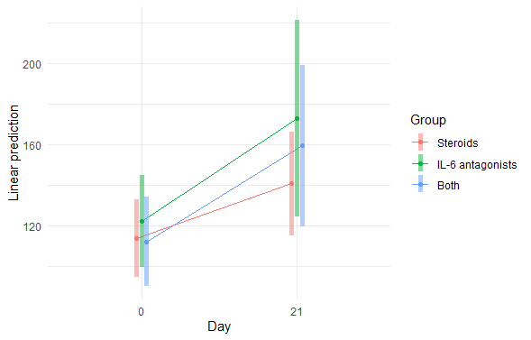

Figure S5: Post-hoc analysis for the clinical outcomes ( ventilator-free days and mortality) stratified by age (> 60 vs. ≤ 60)
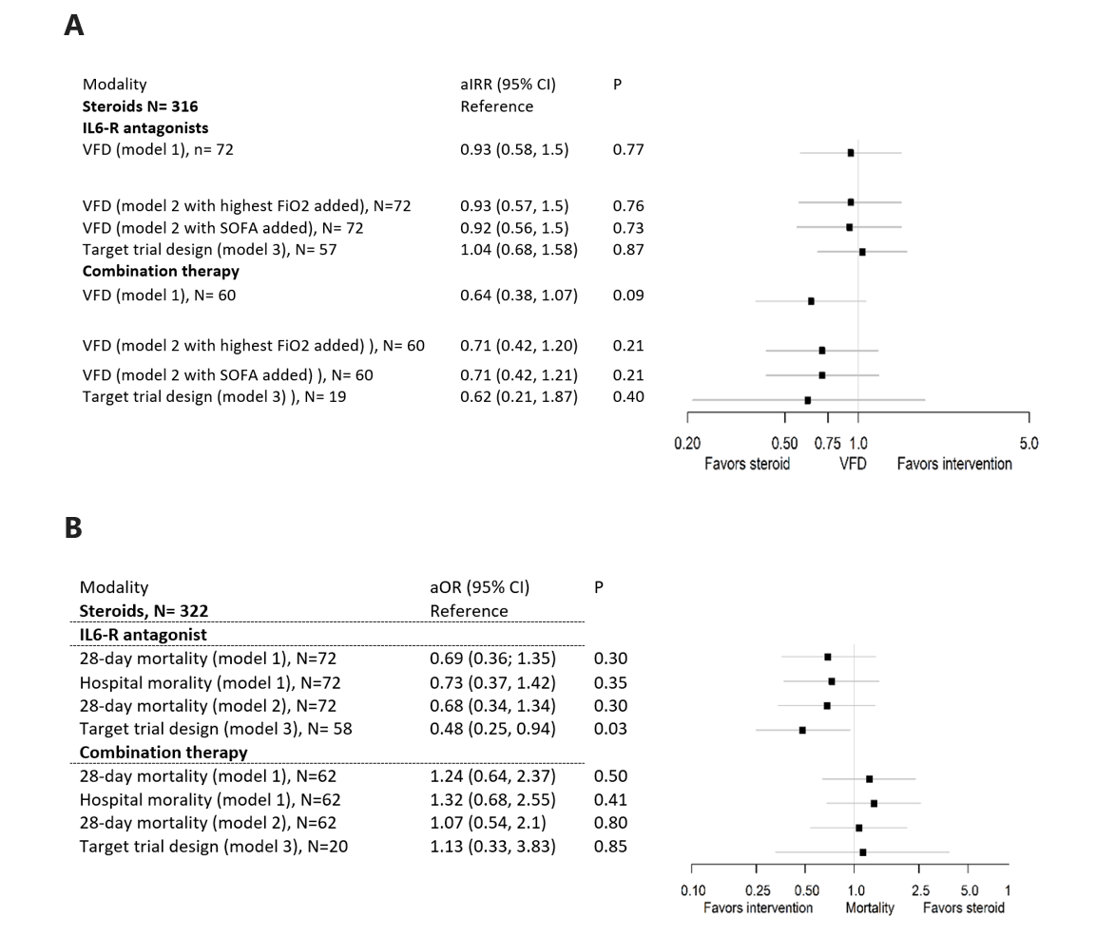

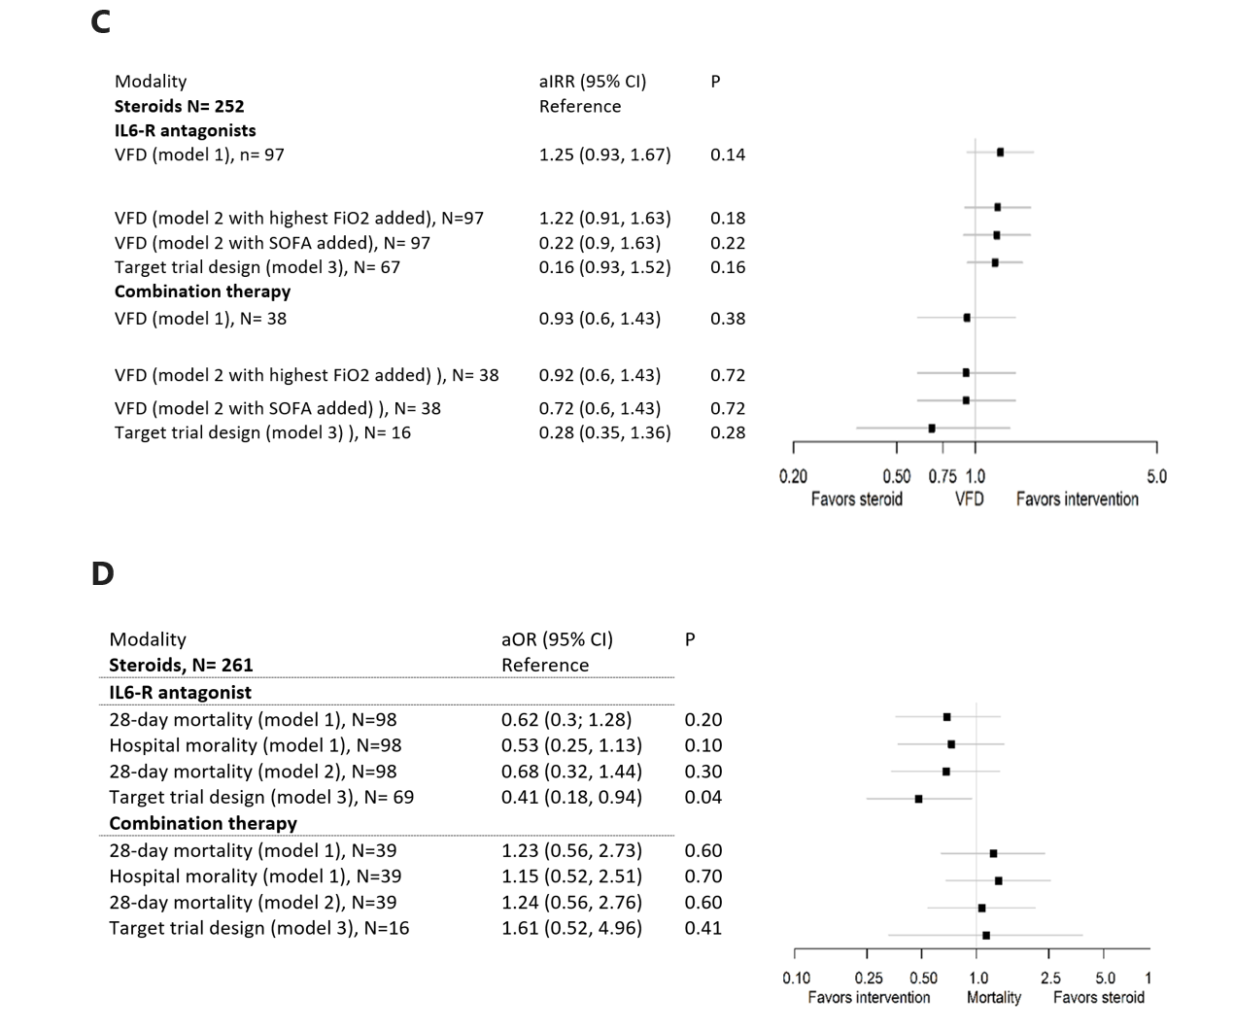

Figure legend. Association between treatment modality, ventilator-free days, and 28-day mortality stratified by age . (A-B) ventilator-free days and 28-day mortality for patients > 60 years. (C-D) ventilator-free days and 28-day mortality for patients ≤ 60 years. Adjusted incident rate ratio (aIRR) was used for VFD (>1 is favorable for intervention), Adjusted odds ratio (aOR) was used for 28-day mortality (< 1 is favorable for intervention)
Abbreviation: aIRR= adjusted incident rate ratio, aOR= adjusted odds ratio, FiO2 = fractional inspired oxygen concentration, IL6-R antagonists= Interleukin-6 receptor antagonists, SOFA= Sequential Organ Failure Assessment; VFDs = ventilation free days.
As shown by the point estimates, younger patients perhaps had more favorable outcomes with IL-6RA in VFDs and mortality compared with older population.

