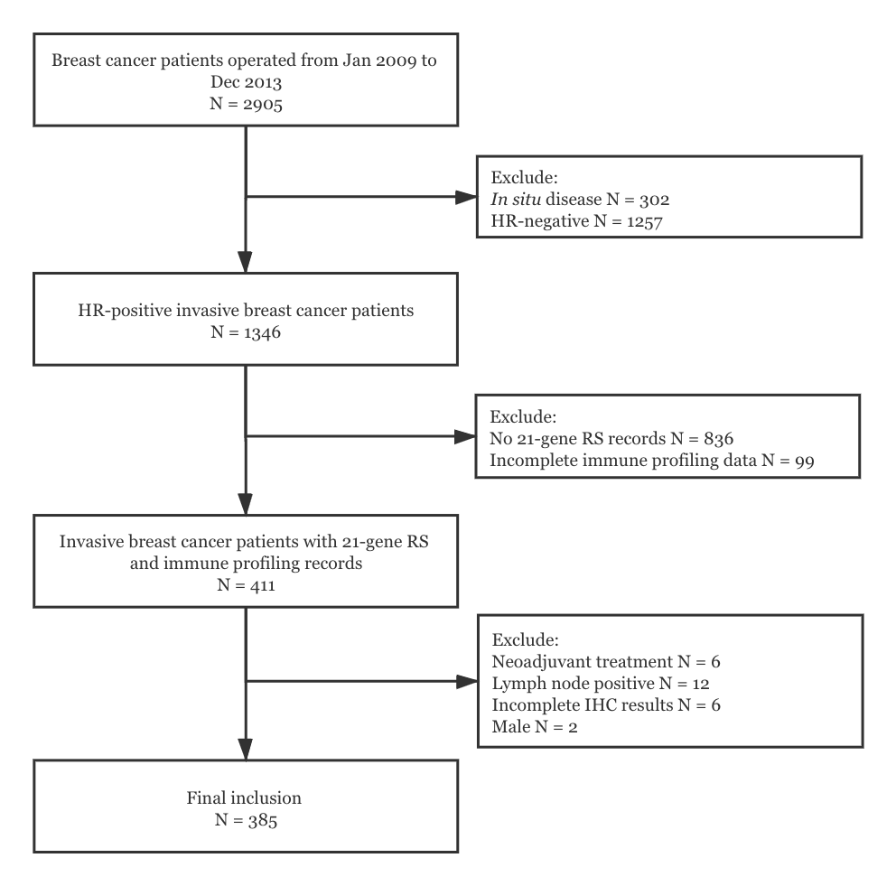
Supplementary Figure S1. Study population flowchart.
Abbreviations: HR, hormone receptor; RS, recurrence score; IHC, immunohistochemistry.

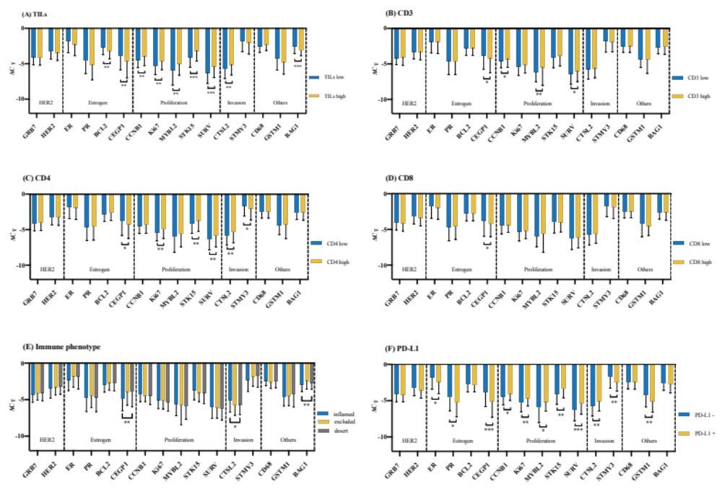

Supplementary Figure S2. Single gene expression from 21-gene RS panel according to TIME markers. The mRNA expression of genes in RS panel were tested by qRT-PCR assay, measured by cycle threshold, adjusted by endogenous genes β-actin, GAPDH, GUS, RPLPO, and TFRC, and recorded as ΔC_{T}= C_{T} _{Gene} – C_{T} _{Reference}. ΔC_{T} was compared using Kruskal-Wallis test to compare ΔC_{T} by different TIME markers. *P <0.05, ** P <0.01, **** P <0.001, **** P <0.0001.
Abbreviations: TIL, tumor-infiltrating lymphocyte; C_{T}, cycle threshold; HER2, human epidermal growth factor receptor-2; PD-L1, programmed cell death-ligand 1; RS, recurrence score; TIME, tumor immune microenvironment.

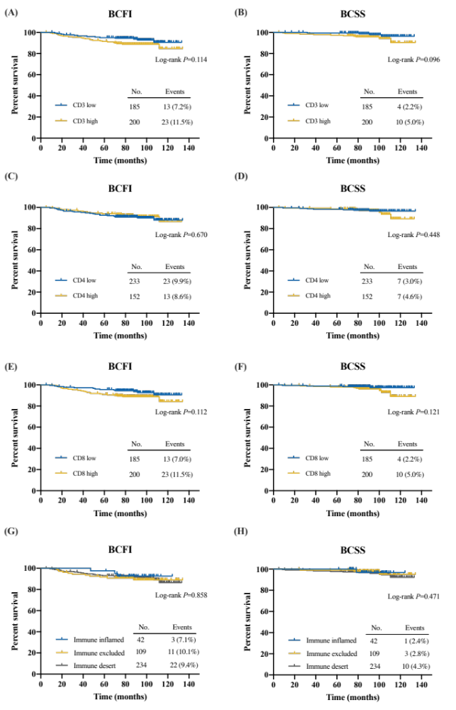
Supplementary Figure S3. Clinical outcomes of Luminal-like patients according to TIME markers. BCFI and BCSS were compared by TIME markers using Kaplan–Meier curves.
Abbreviations: BCFI, breast cancer-free interval; BCSS, breast cancer-specific survival.

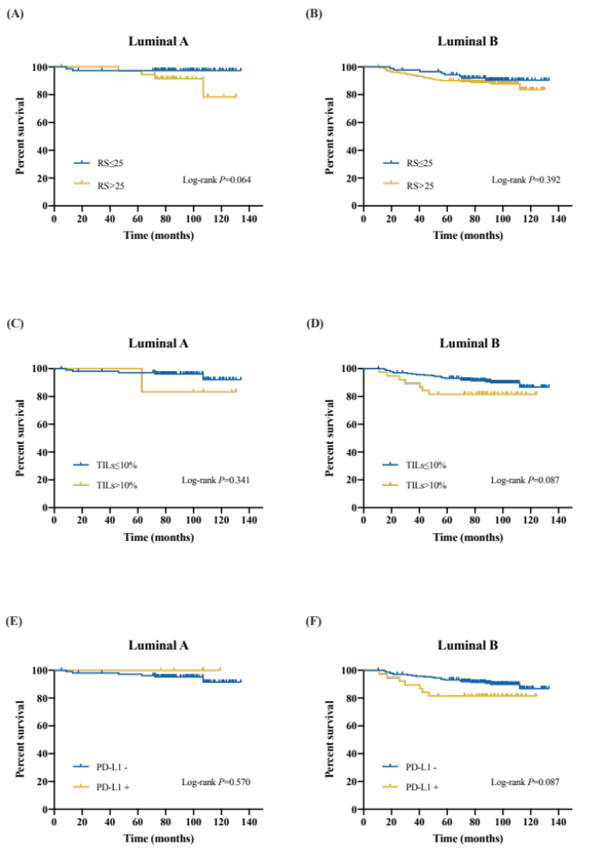
Supplementary Figure S4. BCFI according to RS, TILs, and PD-L1 level by luminal subtypes.
Abbreviations: BCFI, breast cancer-free interval; RS, recurrence score; TIL, tumor infiltrating lymphocyte; PD-L1, programmed cell death-ligand 1.

