Additional material

Tracking Longitudinal Biomarkers in Burn Patients with Sepsis and Acute Kidney Injury: An Unsupervised Clustering Approach

Myongjin Kim1, Dohern Kym1,2*+, Jongsoo Park1, Jun Hur1+ , Jaechul Yoon1, Yong-Suk Cho1, Wook Chun1,2, Dogeon Yoon2

1Department of Surgery and Critical Care, Burn Center, Hangang Sacred Heart Hospital, Hallym University Medical Center, 12, Beodeunaru-ro 7-gil, Youngdeungpo-gu, Seoul, Korea, 07247
2Burn Institutes, Hangang Sacred Heart Hospital, Hallym University Medical Center, 12, Beodeunaru-ro 7-gil, Youngdeungpo-gu, Seoul, Korea, 07247

+Dohern Kym and Jun Hur contributed equally in this work as corresponding author.
*Corresponding authors
Department of Surgery and Critical Care, Burn Center, Hangang Sacred Heart Hospital, College of Medicine, Hallym University 12, Beodeunaru-ro 7-gil, Youngdeungpo-gu, Seoul, Korea, 07247
Tel. 82-2-2639-5446, Fax. 82-2-2678-4386, E-mail: dohern@hallym.or.kr
Contents
STROBE Statement—Checklist of items that should be included in reports of cohort studies 4
Figure S1. Plot of Missingness for Longitudinal Data in Acute Kidney Injury with Sepsis. 8
Figures. The kmlShape package Generated Longitudinal Plots for Each Cluster 9
Fig S2. For pH 9
Fig S3. For LD 9
Fig S4. For Creatinine 10
Fig S5. For Lactate 10
Fig S6. For Platelet Values 11
Fig S7. For Bicarbonate 11
Fig S8. For Albumin Values 12
Fig S9. For Glucose Values 12
Fig S10. For BUN 13
Figures. The longitudinal Profile base on Actual Data. (A. Blood culture positive group, B. Blood culture negative group) 14
Fig S11. For pH 14
Fig. S12 For LD 14
Fig. S13 for Creatinine 15
Fig S14. For lactate 15
Fig S15. For platelet 16
Fig S16. For Bicarbonate 16
Fig S17. For Albumin 17
Fig S18. For Glucose 17
Fig S19. For BUN 18
Tables. The Characteristics and levels Change over time in Positive/Negative Group 19
Table S1. For pH Levels 19
Table S2. For LD Levels 20
Table S3. For Creatinine levels 21
Table S4. For Lactate levels 22
Table S5. For Platelet Levels 23
Table S6. For Bicarbonate Levels 24
Table S7. For Albumin levels 25
Table S8. For Glucose levels 26
Table S9. For BUN levels 27

STROBE Statement—Checklist of items that should be included in reports of cohort studies
 |  |  | Item No | Recommendation | Checked
Title and abstract |  |  | 1 | (a) Indicate the study’s design with a commonly used term in the title or the abstract | Yes
 |  |  | 1 | (b) Provide in the abstract an informative and balanced summary of what was done and what was found | Yes
Introduction
Background/rationale |  |  | 2 | Explain the scientific background and rationale for the investigation being reported | Yes
Objectives |  |  | 3 | State specific objectives, including any prespecified hypotheses | Yes
Methods
Study design |  |  | 4 | Present key elements of study design early in the paper | Yes
Setting |  |  | 5 | Describe the setting, locations, and relevant dates, including periods of recruitment, exposure, follow-up, and data collection | Yes
Participants |  |  | 6 | (a) Give the eligibility criteria, and the sources and methods of selection of participants. Describe methods of follow-up | Yes
 |  |  | 6 | (b) For matched studies, give matching criteria and number of exposed and unexposed | Yes
Variables |  |  | 7 | Clearly define all outcomes, exposures, predictors, potential confounders, and effect modifiers. Give diagnostic criteria, if applicable | Yes
Data sources/ measurement |  |  | 8* | For each variable of interest, give sources of data and details of methods of assessment (measurement). Describe comparability of assessment methods if there is more than one group | Yes
Bias |  |  | 9 | Describe any efforts to address potential sources of bias | Yes
Study size |  |  | 10 | Explain how the study size was arrived at | No
Quantitative variables |  |  | 11 | Explain how quantitative variables were handled in the analyses. If applicable, describe which groupings were chosen and why | Yes
Statistical methods |  |  | 12 | (a) Describe all statistical methods, including those used to control for confounding | Yes
 |  |  | 12 | (b) Describe any methods used to examine subgroups and interactions | Yes
 |  |  | 12 | (c) Explain how missing data were addressed | Yes
 |  |  | 12 | (d) If applicable, explain how loss to follow-up was addressed | NA
 |  |  | 12 | (e) Describe any sensitivity analyses | NA
Results
Participants |  |  | 13* | (a) Report numbers of individuals at each stage of study—eg numbers potentially eligible, examined for eligibility, confirmed eligible, included in the study, completing follow-up, and analysed | Yes
 |  |  | 13* | (b) Give reasons for non-participation at each stage | NA
 |  |  | 13* | (c) Consider use of a flow diagram | Yes
Descriptive data |  |  | 14* | (a) Give characteristics of study participants (eg demographic, clinical, social) and information on exposures and potential confounders | Yes
 |  |  | 14* | (b) Indicate number of participants with missing data for each variable of interest | Yes
 |  |  | 14* | (c) Summarise follow-up time (eg, average and total amount) | NA
Outcome data |  |  | 15* | Report numbers of outcome events or summary measures over time | Yes
Main results | 16 | (a) Give unadjusted estimates and, if applicable, confounder-adjusted estimates and their precision (eg, 95% confidence interval). Make clear which confounders were adjusted for and why they were included |  |  |  | Yes
Main results | 16 | (b) Report category boundaries when continuous variables were categorized |  |  |  | Yes
Main results | 16 | (c) If relevant, consider translating estimates of relative risk into absolute risk for a meaningful time period |  |  |  | Yes
Other analyses | 17 | Report other analyses done—eg analyses of subgroups and interactions, and sensitivity analyses |  |  |  | Yes
Discussion
Key results | 18 | Summarise key results with reference to study objectives |  |  |  | Yes
Limitations | 19 | Discuss limitations of the study, taking into account sources of potential bias or imprecision. Discuss both direction and magnitude of any potential bias |  |  |  | Yes
Interpretation | 20 | Give a cautious overall interpretation of results considering objectives, limitations, multiplicity of analyses, results from similar studies, and other relevant evidence |  |  |  | Yes
Generalisability | 21 | Discuss the generalisability (external validity) of the study results |  |  |  | Yes
Other information
Funding | 22 | Give the source of funding and the role of the funders for the present study and, if applicable, for the original study on which the present article is based |  |  |  | Yes

*Give information separately for exposed and unexposed groups.

Note: An Explanation and Elaboration article discusses each checklist item and gives methodological background and published examples of transparent reporting. The STROBE checklist is best used in conjunction with this article (freely available on the Web sites of PLoS Medicine at http://www.plosmedicine.org/, Annals of Internal Medicine at http://www.annals.org/, and Epidemiology at http://www.epidem.com/). Information on the STROBE Initiative is available at http://www.strobe-statement.org.

Figure S1. Plot of Missingness for Longitudinal Data in Acute Kidney Injury with Sepsis.

Figures. The kmlShape package Generated Longitudinal Plots for Each Cluster

Fig S2. For pH
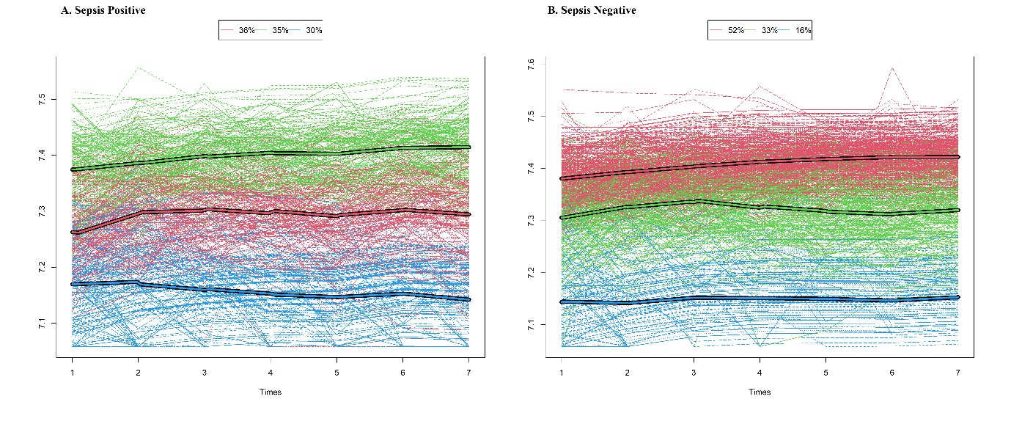

Fig S3. For LD

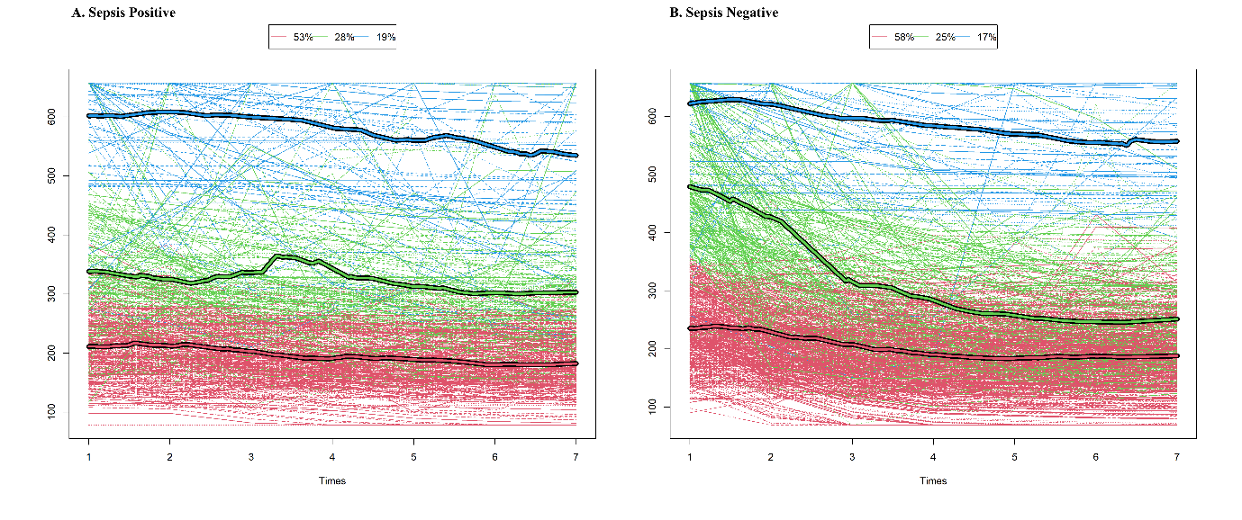

Fig S4. For Creatinine

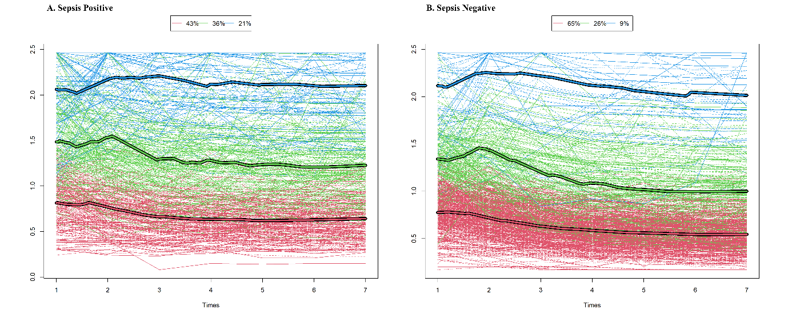

Fig S5. For Lactate
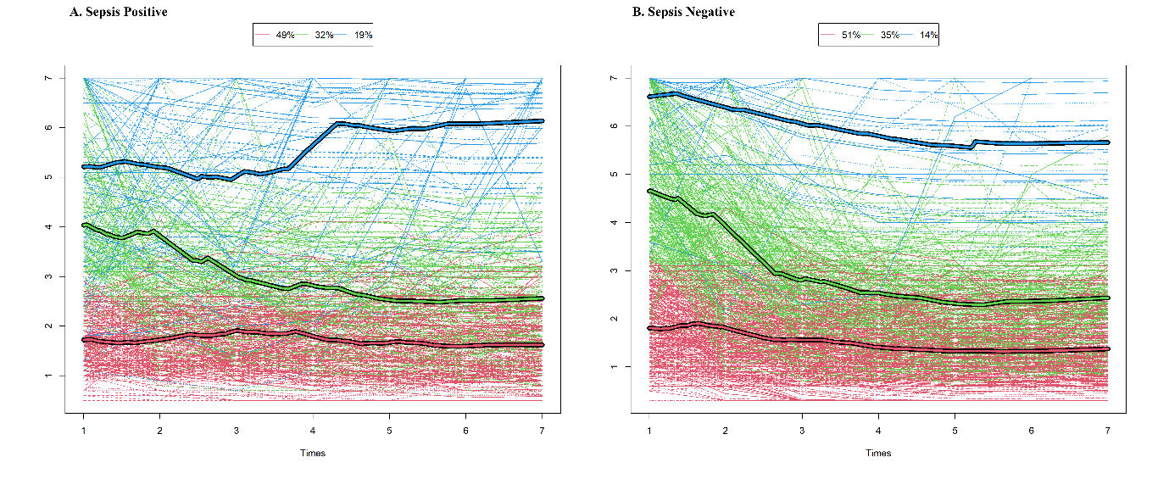

Fig S6. For Platelet Values
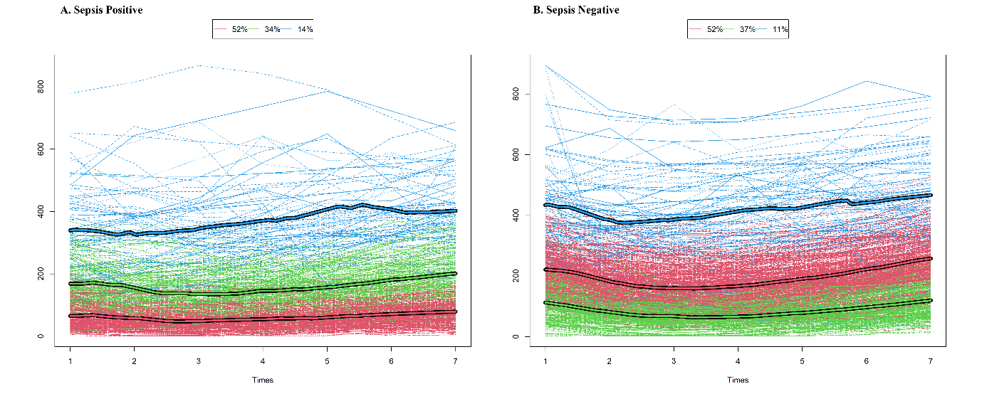

Fig S7. For Bicarbonate
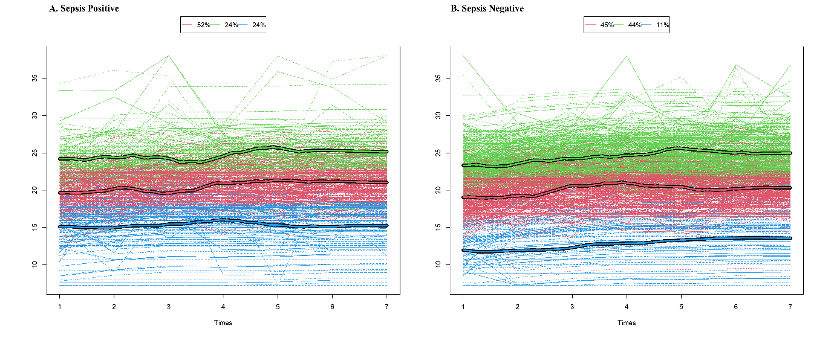

Fig S8. For Albumin Values

Fig S9. For Glucose Values

Fig S10. For BUN
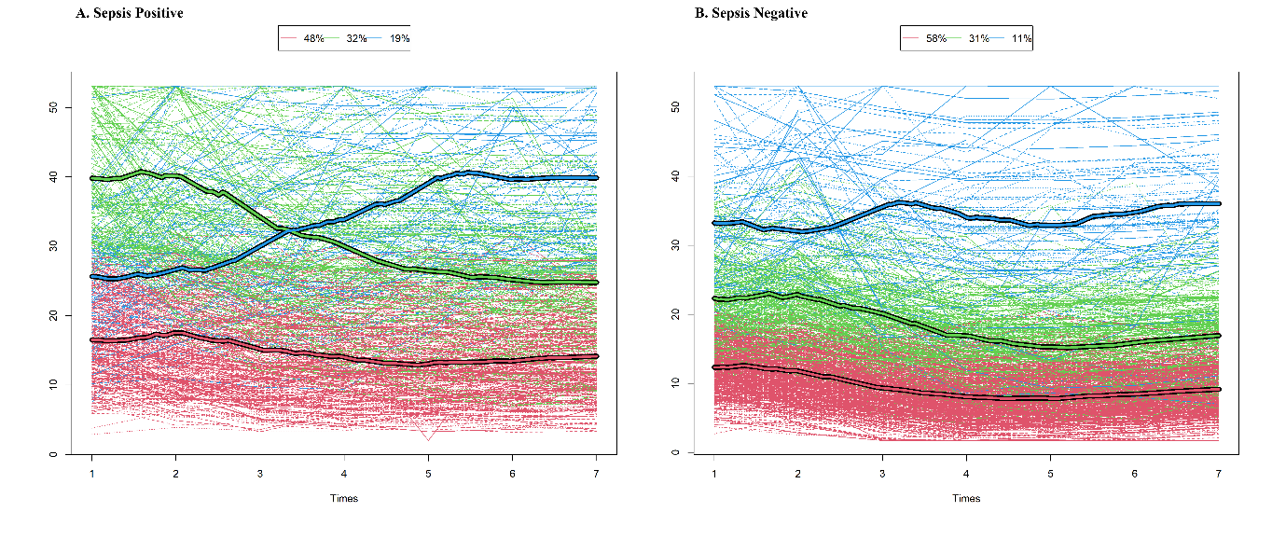

Figures. The Raincloud Plot base on Actual Data. (A. Blood culture positive group, B. Blood culture negative group)

Fig S11. For pH
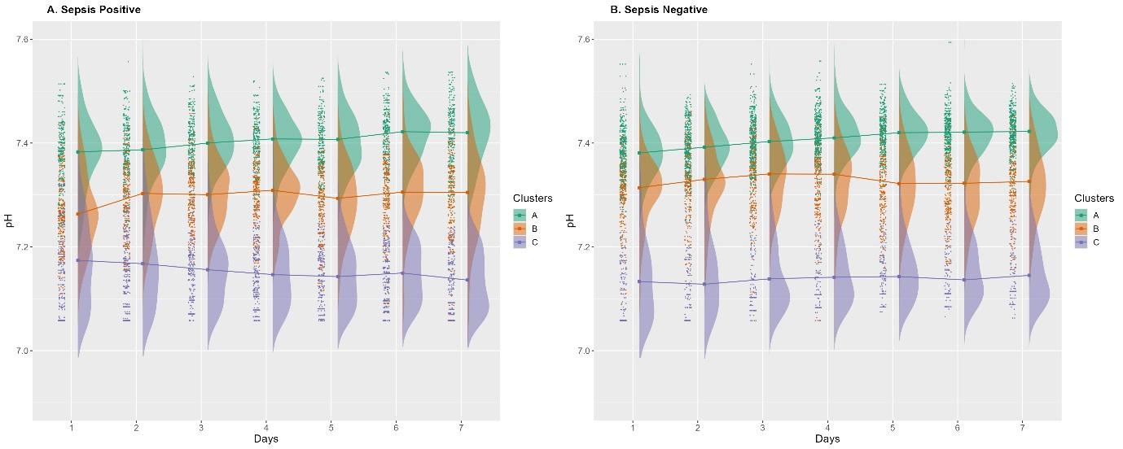

Fig. S12 For LD
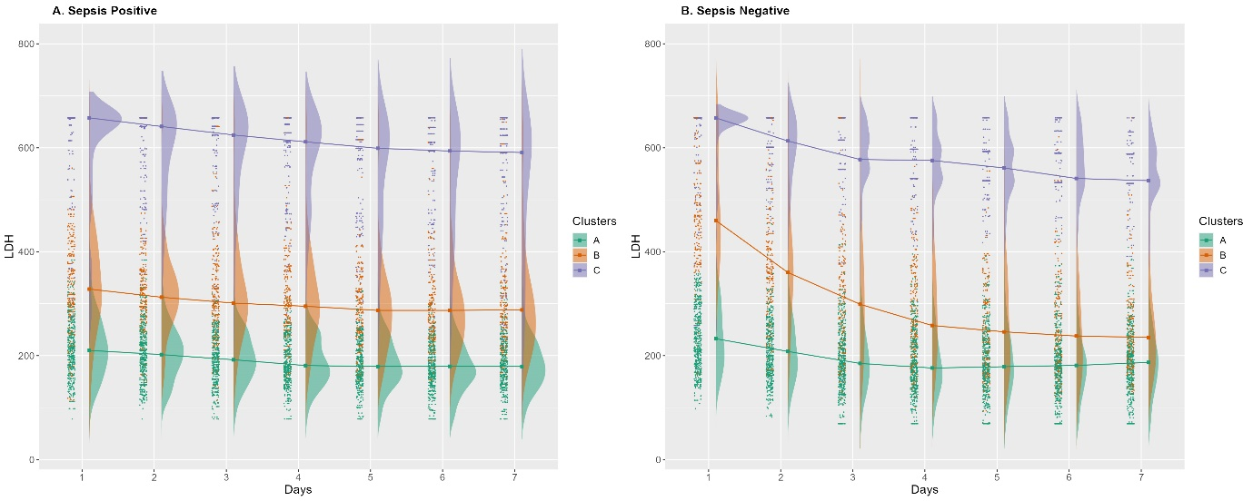

Fig. S13 for Creatinine
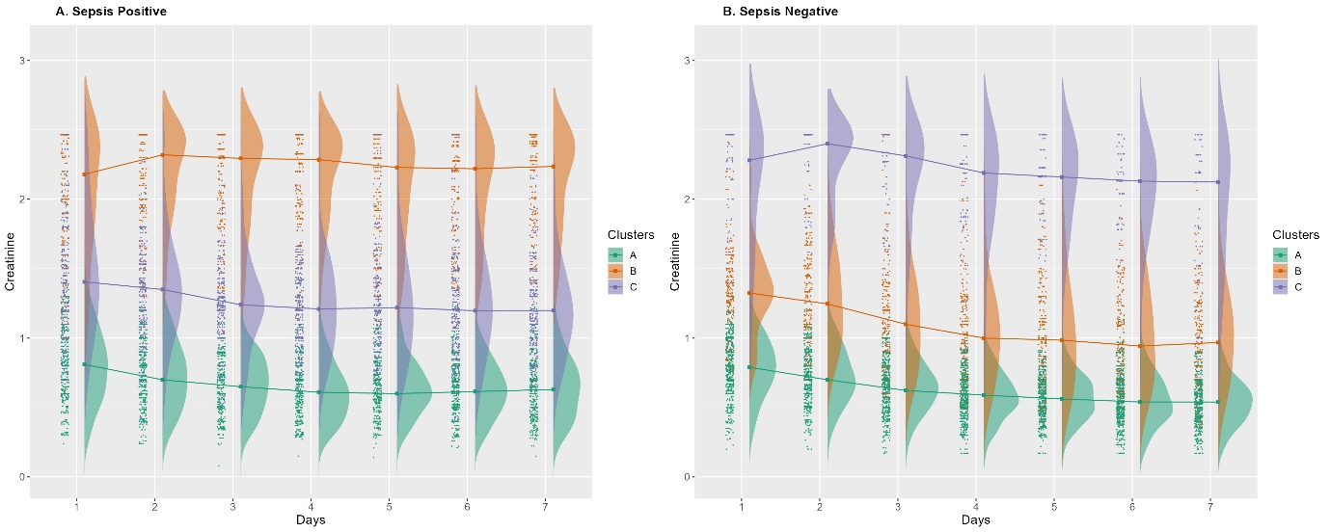

Fig S14. For platelet

Fig S15. For lactate

Fig S16. For Bicarbonate

Fig S17. For Albumin

Fig S18. For Glucose

Fig S19. For BUN

Tables. The Characteristics and levels Change over time in Positive/Negative Group

Table S1. For pH Levels
 |  | Sepsis Positive |  |  |  | Sepsis Negative
Group | Variables | A, N = 186 (34.6%) | B, N = 192 (35.8%) | C, N = 159 (29.6%) | p-value | A, N = 420 (51.4%) | B, N = 268 (32.8%) | C, N = 129 (15.8%) | p-value
Demographics | Mortality | 33 (17.7%) | 115 (59.9%) | 156 (98.1%) | <0.001 | 25 (6.0%) | 117 (43.7%) | 126 (97.7%) | <0.001
 | Patient Age |  |  |  | 0.575 |  |  |  | <0.001
 | Median [IQR] | 54 [44, 66] | 53 [43, 64] | 54 [46, 64] |  | 49 [40, 59] | 51 [41, 62] | 56 [45, 71]
 | Sex |  |  |  | 0.513 |  |  |  | 0.094
 | Male | 158 (84.9%) | 162 (84.4%) | 128 (80.5%) |  | 331 (78.8%) | 226 (84.3%) | 99 (76.7%)
 | Female | 28 (15.1%) | 30 (15.6%) | 31 (19.5%) |  | 89 (21.2%) | 42 (15.7%) | 30 (23.3%)
 | TBSA |  |  |  | <0.001 |  |  |  | <0.001
 | Median [IQR] | 30 [20, 45] | 52 [32, 70] | 63 [46, 83] |  | 24 [15, 34] | 46 [26, 70] | 75 [47, 88]
 | Inhalation | 73 (39.2%) | 111 (57.8%) | 97 (61.0%) | <0.001 | 138 (32.9%) | 146 (54.5%) | 102 (79.1%) | <0.001
 | LOICU |  |  |  | <0.001 |  |  |  | <0.001
 | Median [IQR] | 29 [19, 46] | 27 [17, 42] | 11 [6, 17] |  | 17 [6, 31] | 23 [10, 38] | 3 [2, 8]
pH value | Day 1 |  |  |  | <0.001 |  |  |  | <0.001
 | Median [IQR] | 7.38 [7.33, 7.42] | 7.26 [7.22, 7.31] | 7.17 [7.10, 7.22] |  | 7.38 [7.35, 7.41] | 7.31 [7.26, 7.35] | 7.13 [7.06, 7.20]
 | Day 2 |  |  |  | <0.001 |  |  |  | <0.001
 | Median [IQR] | 7.39 [7.35, 7.43] | 7.30 [7.24, 7.34] | 7.17 [7.11, 7.23] |  | 7.39 [7.36, 7.43] | 7.33 [7.29, 7.37] | 7.13 [7.08, 7.18]
 | Day 3 |  |  |  | <0.001 |  |  |  | <0.001
 | Median [IQR] | 7.40 [7.37, 7.44] | 7.30 [7.26, 7.34] | 7.16 [7.10, 7.20] |  | 7.40 [7.37, 7.43] | 7.34 [7.29, 7.37] | 7.14 [7.10, 7.20]
 | Day 4 |  |  |  | <0.001 |  |  |  | <0.001
 | Median [IQR] | 7.41 [7.37, 7.44] | 7.31 [7.26, 7.34] | 7.15 [7.10, 7.19] |  | 7.41 [7.38, 7.44] | 7.34 [7.28, 7.37] | 7.14 [7.11, 7.19]
 | Day 5 |  |  |  | <0.001 |  |  |  | <0.001
 | Median [IQR] | 7.41 [7.36, 7.44] | 7.29 [7.24, 7.34] | 7.14 [7.10, 7.19] |  | 7.42 [7.39, 7.44] | 7.32 [7.28, 7.37] | 7.14 [7.11, 7.19]
 | Day 6 |  |  |  | <0.001 |  |  |  | <0.001
 | Median [IQR] | 7.42 [7.38, 7.45] | 7.31 [7.27, 7.35] | 7.15 [7.10, 7.20] |  | 7.42 [7.39, 7.45] | 7.32 [7.27, 7.36] | 7.14 [7.11, 7.19]
 | Day 7 |  |  |  | <0.001 |  |  |  | <0.001
 | Median [IQR] | 7.42 [7.37, 7.45] | 7.30 [7.25, 7.35] | 7.14 [7.09, 7.19] |  | 7.42 [7.40, 7.45] | 7.33 [7.27, 7.36] | 7.15 [7.11, 7.19]
Mean of overall median value | pH |  |  |  | <0.001 |  |  |  | <0.001
 | Median [IQR] | 7.40 [7.36, 7.43] | 7.29 [7.24, 7.34] | 7.18 [7.12, 7.22] |  | 7.41 [7.38, 7.44] | 7.33 [7.28, 7.36] | 7.17 [7.11, 7.22]

Table S2. For LD Levels
 |  | Sepsis Positive |  |  |  | Sepsis Negative
Group | Variables | A, N = 285 (53.0%) | B, N = 153 (28.4%) | C, N = 100 (18.6%) | p-value | A, N = 473 (57.7%) | B, N = 205 (25.0%) | C, N = 142 (17.3%) | p-value
Demographics | Mortality | 146 (51.2%) | 80 (52.3%) | 79 (79.0%) | <0.001 | 71 (15.0%) | 79 (38.5%) | 116 (81.7%) | <0.001
 | Patient Age |  |  |  | 0.075 |  |  |  | 0.528
 | Median [IQR] | 55 [46, 65] | 53 [41, 66] | 51 [41, 60] |  | 51 [41, 61] | 51 [39, 63] | 53 [42, 67]
 | Sex |  |  |  | 0.221 |  |  |  | 0.382
 | Male | 245 (86.0%) | 122 (79.7%) | 82 (82.0%) |  | 384 (81.2%) | 166 (81.0%) | 108 (76.1%)
 | Female | 40 (14.0%) | 31 (20.3%) | 18 (18.0%) |  | 89 (18.8%) | 39 (19.0%) | 34 (23.9%)
 | TBSA |  |  |  | 0.227 |  |  |  | <0.001
 | Median [IQR] | 45 [28, 67] | 43 [29, 63] | 58 [31, 73] |  | 26 [17, 42] | 40 [25, 61] | 69 [33, 90]
 | Inhalation | 149 (52.3%) | 70 (45.8%) | 62 (62.0%) | 0.039 | 189 (40.0%) | 92 (44.9%) | 103 (72.5%) | <0.001
 | LOICU |  |  |  | <0.001 |  |  |  | <0.001
 | Median [IQR] | 25 [14, 41] | 24 [13, 38] | 10 [4, 23] |  | 18 [7, 32] | 22 [9, 38] | 3 [2, 7]
LDH value | Day 1 |  |  |  | <0.001 |  |  |  | <0.001
 | Median [IQR] | 210 [174, 250] | 328 [276, 403] | 658 [570, 658] |  | 232 [190, 282] | 460 [402, 570] | 658 [656, 658]
 | Day 2 |  |  |  | <0.001 |  |  |  | <0.001
 | Median [IQR] | 202 [169, 238] | 312 [269, 363] | 641 [514, 658] |  | 208 [169, 247] | 360 [285, 434] | 613 [601, 658]
 | Day 3 |  |  |  | <0.001 |  |  |  | <0.001
 | Median [IQR] | 192 [162, 231] | 301 [260, 364] | 625 [508, 658] |  | 185 [152, 229] | 299 [214, 380] | 577 [558, 615]
 | Day 4 |  |  |  | <0.001 |  |  |  | <0.001
 | Median [IQR] | 181 [156, 222] | 295 [243, 352] | 611 [482, 645] |  | 176 [141, 223] | 258 [196, 343] | 576 [541, 597]
 | Day 5 |  |  |  | <0.001 |  |  |  | <0.001
 | Median [IQR] | 179 [153, 214] | 287 [235, 338] | 599 [459, 632] |  | 179 [142, 221] | 246 [185, 325] | 561 [537, 593]
 | Day 6 |  |  |  | <0.001 |  |  |  | <0.001
 | Median [IQR] | 179 [151, 213] | 287 [239, 341] | 594 [450, 627] |  | 181 [144, 224] | 238 [182, 311] | 541 [533, 589]
 | Day 7 |  |  |  | <0.001 |  |  |  | <0.001
 | Median [IQR] | 179 [150, 216] | 288 [230, 341] | 591 [451, 624] |  | 187 [148, 227] | 235 [187, 300] | 537 [531, 588]
Mean of overall median value | LDH |  |  |  | <0.001 |  |  |  | <0.001
 | Median [IQR] | 188 [160, 225] | 295 [245, 349] | 592 [461, 658] |  | 202 [162, 245] | 286 [206, 385] | 593 [531, 658]

Table S3. For Creatinine levels
 |  | Sepsis Positive |  |  |  | Sepsis Negative
Group | Variables | A, N = 229 (42.6%) | B, N = 113 (21.0%) | C, N = 196 (36.4%) | p-value | A, N = 535 (65.2%) | B, N = 212 (25.9%) | C, N = 73 (8.90%) | p-value
Demographics | Mortality | 79 (34.5%) | 79 (69.9%) | 147 (75.0%) | <0.001 | 87 (16.3%) | 119 (56.1%) | 60 (82.2%) | <0.001
 | Patient Age |  |  |  | 0.120 |  |  |  | <0.001
 | Median [IQR] | 53 [43, 62] | 52 [43, 61] | 55 [47, 66] |  | 49 [39, 59] | 56 [47, 68] | 51 [41, 72]
 | Sex |  |  |  | <0.001 |  |  |  | 0.002
 | Male | 175 (76.4%) | 102 (90.3%) | 172 (87.8%) |  | 411 (76.8%) | 182 (85.8%) | 65 (89.0%)
 | Female | 54 (23.6%) | 11 (9.7%) | 24 (12.2%) |  | 124 (23.2%) | 30 (14.2%) | 8 (11.0%)
 | TBSA |  |  |  | <0.001 |  |  |  | <0.001
 | Median [IQR] | 40 [24, 60] | 52 [37, 70] | 56 [33, 75] |  | 28 [17, 45] | 45 [25, 76] | 61 [30, 88]
 | Inhalation | 116 (50.7%) | 70 (61.9%) | 95 (48.5%) | 0.061 | 223 (41.7%) | 116 (54.7%) | 46 (63.0%) | <0.001
 | LOICU |  |  |  | <0.001 |  |  |  | <0.001
 | Median [IQR] | 25 [16, 40] | 14 [8, 35] | 19 [10, 34] |  | 17 [6, 34] | 13 [5, 30] | 5 [3, 13]
Creatinine value | Day 1 |  |  |  | <0.001 |  |  |  | <0.001
 | Median [IQR] | 0.81 [0.60, 1.00] | 2.18 [1.77, 2.46] | 1.41 [1.17, 1.79] |  | 0.79 [0.64, 0.91] | 1.33 [1.18, 1.50] | 2.28 [1.72, 2.46]
 | Day 2 |  |  |  | <0.001 |  |  |  | <0.001
 | Median [IQR] | 0.70 [0.57, 0.88] | 2.32 [1.95, 2.46] | 1.35 [1.10, 1.54] |  | 0.70 [0.58, 0.86] | 1.25 [1.00, 1.50] | 2.40 [2.08, 2.46]
 | Day 3 |  |  |  | <0.001 |  |  |  | <0.001
 | Median [IQR] | 0.65 [0.50, 0.80] | 2.29 [1.89, 2.46] | 1.24 [1.04, 1.46] |  | 0.62 [0.50, 0.75] | 1.10 [0.84, 1.38] | 2.31 [1.95, 2.46]
 | Day 4 |  |  |  | <0.001 |  |  |  | <0.001
 | Median [IQR] | 0.61 [0.48, 0.77] | 2.29 [1.88, 2.46] | 1.21 [1.00, 1.47] |  | 0.59 [0.48, 0.70] | 1.00 [0.75, 1.27] | 2.19 [1.87, 2.38]
 | Day 5 |  |  |  | <0.001 |  |  |  | <0.001
 | Median [IQR] | 0.60 [0.48, 0.76] | 2.23 [1.86, 2.45] | 1.22 [0.96, 1.44] |  | 0.56 [0.45, 0.68] | 0.99 [0.70, 1.24] | 2.16 [1.85, 2.36]
 | Day 6 |  |  |  | <0.001 |  |  |  | <0.001
 | Median [IQR] | 0.61 [0.49, 0.78] | 2.22 [1.83, 2.42] | 1.20 [0.96, 1.42] |  | 0.54 [0.43, 0.66] | 0.94 [0.70, 1.21] | 2.13 [1.82, 2.33]
 | Day 7 |  |  |  | <0.001 |  |  |  | <0.001
 | Median [IQR] | 0.63 [0.47, 0.80] | 2.24 [1.86, 2.42] | 1.20 [0.98, 1.45] |  | 0.54 [0.42, 0.66] | 0.97 [0.73, 1.20] | 2.12 [1.81, 2.32]
Mean of overall median value | Creatinine |  |  |  | <0.001 |  |  |  | <0.001
 | Median [IQR] | 0.64 [0.48, 0.80] | 2.29 [1.84, 2.46] | 1.21 [0.99, 1.51] |  | 0.60 [0.50, 0.74] | 1.00 [0.77, 1.31] | 2.25 [1.83, 2.46]

Table S4. For Platelet Levels
 |  | Sepsis Positive |  |  |  | Sepsis Negative
Group | Variables | A, N = 77 (14.3%) | B, N = 181 (33.6%) | C, N = 280 (52.0%) | p-value | A, N = 431 (52.4%) | B, N = 88 (10.7%) | C, N = 303 (36.9%) | p-value
Demographics | Mortality | 12 (15.6%) | 64 (35.4%) | 229 (81.8%) | <0.001 | 68 (15.8%) | 20 (22.7%) | 179 (59.1%) | <0.001
 | Patient Age |  |  |  | 0.744 |  |  |  | 0.055
 | Median [IQR] | 54 [45, 62] | 54 [45, 65] | 54 [42, 64] |  | 49 [40, 61] | 52 [41, 61] | 53 [43, 64]
 | Sex |  |  |  | 0.784 |  |  |  | 0.891
 | Male | 64 (83.1%) | 154 (85.1%) | 231 (82.5%) |  | 343 (79.6%) | 72 (81.8%) | 245 (80.9%)
 | Female | 13 (16.9%) | 27 (14.9%) | 49 (17.5%) |  | 88 (20.4%) | 16 (18.2%) | 58 (19.1%)
 | TBSA |  |  |  | <0.001 |  |  |  | <0.001
 | Median [IQR] | 33 [16, 45] | 37 [22, 55] | 60 [40, 80] |  | 25 [16, 40] | 32 [17, 52] | 51 [30, 78]
 | Inhalation | 31 (40.3%) | 91 (50.3%) | 159 (56.8%) | 0.032 | 160 (37.1%) | 44 (50.0%) | 181 (59.7%) | <0.001
 | LOICU |  |  |  | <0.001 |  |  |  | 0.100
 | Median [IQR] | 30 [20, 42] | 28 [17, 44] | 15 [10, 27] |  | 13 [5, 28] | 25 [6, 35] | 13 [5, 32]
Platelet value | Day 1 |  |  |  | <0.001 |  |  |  | <0.001
 | Median [IQR] | 322 [222, 425] | 155 [115, 212] | 54 [35, 90] |  | 216 [166, 262] | 419 [328, 507] | 111 [62, 147]
 | Day 2 |  |  |  | <0.001 |  |  |  | <0.001
 | Median [IQR] | 333 [234, 393] | 137 [104, 180] | 48 [31, 72] |  | 172 [132, 213] | 362 [292, 484] | 74 [48, 104]
 | Day 3 |  |  |  | <0.001 |  |  |  | <0.001
 | Median [IQR] | 324 [248, 409] | 132 [101, 178] | 46 [28, 67] |  | 151 [116, 200] | 366 [303, 478] | 62 [41, 89]
 | Day 4 |  |  |  | <0.001 |  |  |  | <0.001
 | Median [IQR] | 331 [273, 424] | 142 [106, 187] | 51 [32, 69] |  | 161 [123, 211] | 393 [315, 488] | 69 [44, 91]
 | Day 5 |  |  |  | <0.001 |  |  |  | <0.001
 | Median [IQR] | 351 [291, 436] | 156 [122, 201] | 56 [37, 79] |  | 178 [143, 228] | 428 [333, 518] | 76 [54, 105]
 | Day 6 |  |  |  | <0.001 |  |  |  | <0.001
 | Median [IQR] | 384 [321, 477] | 177 [136, 222] | 65 [45, 95] |  | 213 [176, 258] | 437 [356, 540] | 89 [63, 129]
 | Day 7 |  |  |  | <0.001 |  |  |  | <0.001
 | Median [IQR] | 391 [322, 486] | 197 [150, 245] | 76 [50, 105] |  | 250 [211, 301] | 453 [372, 560] | 112 [76, 156]
Mean of overall median value | Platelet |  |  |  | <0.001 |  |  |  | <0.001
 | Median [IQR] | 341 [270, 425] | 155 [114, 209] | 57 [37, 90] |  | 189 [141, 242] | 415 [325, 509] | 83 [58, 118]

Table S5. For Lactate levels
 |  | Sepsis Positive |  |  |  | Sepsis Negative
Group | Variables | A, N = 263 (48.9%) | B, N = 173 (32.2%) | C, N = 102 (19.0%) | p-value | A, N = 409 (50.6%) | B, N = 283 (35.0%) | C, N = 117 (14.5%) | p-value
Demographics | Mortality | 102 (38.8%) | 106 (61.3%) | 97 (95.1%) | <0.001 | 55 (13.4%) | 100 (35.3%) | 111 (94.9%) | <0.001
 | Patient Age |  |  |  | 0.008 |  |  |  | <0.001
 | Median [IQR] | 56 [47, 66] | 51 [38, 62] | 54 [46, 63] |  | 51 [41, 62] | 49 [39, 60] | 56 [47, 72]
 | Sex |  |  |  | 0.053 |  |  |  | 0.128
 | Male | 226 (85.9%) | 146 (84.4%) | 77 (75.5%) |  | 331 (80.9%) | 233 (82.3%) | 86 (73.5%)
 | Female | 37 (14.1%) | 27 (15.6%) | 25 (24.5%) |  | 78 (19.1%) | 50 (17.7%) | 31 (26.5%)
 | TBSA |  |  |  | <0.001 |  |  |  | <0.001
 | Median [IQR] | 39 [22, 60] | 55 [31, 70] | 60 [43, 80] |  | 24 [15, 38] | 40 [26, 62] | 76 [50, 92]
 | Inhalation | 126 (47.9%) | 103 (59.5%) | 52 (51.0%) | 0.055 | 148 (36.2%) | 138 (48.8%) | 97 (82.9%) | <0.001
 | LOICU |  |  |  | <0.001 |  |  |  | <0.001
 | Median [IQR] | 27 [18, 43] | 22 [12, 38] | 10 [5, 18] |  | 18 [7, 31] | 21 [9, 36] | 2 [2, 5]
Lactate value | Day 1 |  |  |  | <0.001 |  |  |  | <0.001
 | Median [IQR] | 1.70 [1.30, 2.20] | 3.90 [3.20, 4.70] | 5.35 [3.60, 7.00] |  | 1.75 [1.20, 2.40] | 4.30 [3.68, 5.50] | 7.00 [6.60, 7.00]
 | Day 2 |  |  |  | <0.001 |  |  |  | <0.001
 | Median [IQR] | 1.60 [1.20, 2.20] | 3.10 [2.43, 3.90] | 5.60 [4.03, 6.60] |  | 1.54 [1.10, 2.20] | 3.33 [2.60, 4.30] | 6.34 [6.34, 7.00]
 | Day 3 |  |  |  | <0.001 |  |  |  | <0.001
 | Median [IQR] | 1.54 [1.20, 2.20] | 2.90 [2.08, 3.50] | 5.99 [3.83, 6.79] |  | 1.40 [0.92, 1.90] | 2.70 [2.00, 3.46] | 5.76 [5.76, 6.42]
 | Day 4 |  |  |  | <0.001 |  |  |  | <0.001
 | Median [IQR] | 1.56 [1.10, 2.10] | 2.58 [1.80, 3.40] | 6.20 [4.90, 6.68] |  | 1.26 [0.87, 1.88] | 2.30 [1.70, 3.01] | 5.52 [5.52, 6.18]
 | Day 5 |  |  |  | <0.001 |  |  |  | <0.001
 | Median [IQR] | 1.60 [1.07, 2.15] | 2.60 [1.82, 3.50] | 6.18 [5.05, 6.79] |  | 1.23 [0.80, 1.72] | 2.20 [1.60, 2.91] | 5.44 [5.44, 6.10]
 | Day 6 |  |  |  | <0.001 |  |  |  | <0.001
 | Median [IQR] | 1.56 [1.10, 2.07] | 2.50 [1.70, 3.33] | 6.18 [5.27, 6.67] |  | 1.21 [0.80, 1.80] | 2.20 [1.50, 2.91] | 5.43 [5.43, 6.09]
 | Day 7 |  |  |  | <0.001 |  |  |  | <0.001
 | Median [IQR] | 1.53 [1.10, 2.10] | 2.50 [1.70, 3.30] | 6.48 [5.84, 6.86] |  | 1.23 [0.82, 1.88] | 2.33 [1.70, 3.02] | 5.46 [5.46, 6.12]
Mean of overall median value | Lactate |  |  |  | <0.001 |  |  |  | <0.001
 | Median [IQR] | 1.66 [1.20, 2.19] | 2.80 [1.90, 3.60] | 5.50 [3.90, 6.70] |  | 1.47 [1.01, 2.00] | 2.60 [1.90, 3.60] | 5.92 [5.10, 6.76]

Table S6. For Bicarbonate Levels
 |  | Sepsis Positive |  |  |  | Sepsis Negative
Group | Variables | A, N = 128 (24.4%) | B, N = 270 (51.5%) | C, N = 126 (24.0%) | p-value | A, N = 356 (44.0%) | B, N = 366 (45.2%) | C, N = 87 (10.8%) | p-value
Demographics | Mortality | 50 (39.1%) | 151 (55.9%) | 95 (75.4%) | <0.001 | 44 (12.4%) | 142 (38.8%) | 78 (89.7%) | <0.001
 | Patient Age |  |  |  | 0.168 |  |  |  | <0.001
 | Median [IQR] | 54 [43, 65] | 52 [42, 63] | 56 [48, 64] |  | 49 [39, 58] | 51 [42, 64] | 57 [46, 70]
 | Sex |  |  |  | 0.537 |  |  |  | 0.027
 | Male | 111 (86.7%) | 222 (82.2%) | 105 (83.3%) |  | 300 (84.3%) | 287 (78.4%) | 64 (73.6%)
 | Female | 17 (13.3%) | 48 (17.8%) | 21 (16.7%) |  | 56 (15.7%) | 79 (21.6%) | 23 (26.4%)
 | TBSA |  |  |  | <0.001 |  |  |  | <0.001
 | Median [IQR] | 38 [22, 60] | 50 [30, 65] | 56 [33, 77] |  | 24 [15, 40] | 40 [24, 63] | 70 [36, 86]
 | Inhalation | 68 (53.1%) | 147 (54.4%) | 61 (48.4%) | 0.542 | 143 (40.2%) | 173 (47.3%) | 67 (77.0%) | <0.001
 | LOICU |  |  |  | <0.001 |  |  |  | <0.001
 | Median [IQR] | 24 [13, 37] | 25 [13, 40] | 14 [6, 27] |  | 15 [6, 31] | 19 [8, 35] | 2 [2, 6]
Bicarbonate value | Day 1 |  |  |  | <0.001 |  |  |  | <0.001
 | Median [IQR] | 24.0 [22.4, 25.5] | 19.8 [18.1, 21.4] | 15.6 [13.4, 17.1] |  | 23.1 [21.7, 24.8] | 18.9 [17.4, 20.6] | 12.4 [10.1, 14.1]
 | Day 2 |  |  |  | <0.001 |  |  |  | <0.001
 | Median [IQR] | 24.0 [23.0, 26.0] | 20.7 [19.0, 22.0] | 16.1 [13.7, 17.6] |  | 23.9 [22.6, 25.5] | 20.0 [18.3, 21.5] | 13.6 [11.0, 14.9]
 | Day 3 |  |  |  | <0.001 |  |  |  | <0.001
 | Median [IQR] | 24.3 [23.0, 26.2] | 20.9 [19.4, 22.2] | 16.4 [14.2, 17.7] |  | 24.4 [22.7, 26.0] | 20.4 [18.6, 21.6] | 13.9 [11.4, 15.6]
 | Day 4 |  |  |  | <0.001 |  |  |  | <0.001
 | Median [IQR] | 24.6 [23.4, 26.6] | 20.9 [19.4, 22.4] | 16.2 [14.1, 17.5] |  | 24.7 [22.9, 26.4] | 20.4 [18.8, 21.8] | 13.9 [11.5, 15.7]
 | Day 5 |  |  |  | <0.001 |  |  |  | <0.001
 | Median [IQR] | 24.6 [23.5, 26.1] | 21.0 [19.5, 22.4] | 15.9 [13.6, 17.5] |  | 24.6 [22.8, 26.6] | 20.4 [18.7, 21.8] | 14.1 [11.5, 15.7]
 | Day 6 |  |  |  | <0.001 |  |  |  | <0.001
 | Median [IQR] | 24.6 [23.5, 26.4] | 21.1 [19.7, 22.5] | 16.0 [13.6, 17.6] |  | 24.8 [23.0, 26.8] | 20.2 [18.7, 21.7] | 14.3 [11.6, 15.7]
 | Day 7 |  |  |  | <0.001 |  |  |  | <0.001
 | Median [IQR] | 24.7 [23.5, 26.5] | 20.9 [19.5, 22.4] | 15.9 [13.4, 17.4] |  | 24.8 [23.0, 26.5] | 20.4 [19.0, 21.8] | 14.2 [11.5, 15.7]
Mean of overall median value | Bicarbonate |  |  |  | <0.001 |  |  |  | <0.001
 | Median [IQR] | 24.4 [23.1, 26.1] | 20.9 [19.2, 22.3] | 16.3 [13.8, 17.7] |  | 24.0 [22.3, 26.0] | 20.2 [18.3, 21.7] | 14.5 [11.7, 16.0]

Table S7. For Albumin levels
 |  | Sepsis Positive |  |  |  | Sepsis Negative
Group | Variables | A, N = 177 (32.9%) | B, N = 269 (50.0%) | C, N = 92 (17.1%) | p-value | A, N = 191 (23.3%) | B, N = 460 (56.1%) | C, N = 169 (20.6%) | p-value
Demographics | Mortality | 61 (34.5%) | 165 (61.3%) | 79 (85.9%) | <0.001 | 11 (5.8%) | 115 (25.0%) | 139 (82.2%) | <0.001
 | Patient Age |  |  |  | 0.004 |  |  |  | 0.082
 | Median [IQR] | 55 [44, 68] | 55 [46, 64] | 50 [38, 59] |  | 48 [41, 56] | 52 [41, 63] | 52 [41, 64]
 | Sex |  |  |  | 0.797 |  |  |  | 0.611
 | Male | 145 (81.9%) | 226 (84.0%) | 78 (84.8%) |  | 158 (82.7%) | 365 (79.3%) | 135 (79.9%)
 | Female | 32 (18.1%) | 43 (16.0%) | 14 (15.2%) |  | 33 (17.3%) | 95 (20.7%) | 34 (20.1%)
 | TBSA |  |  |  | <0.001 |  |  |  | <0.001
 | Median [IQR] | 33 [16, 50] | 53 [33, 70] | 63 [47, 83] |  | 19 [10, 25] | 32 [21, 50] | 70 [47, 85]
 | Inhalation | 81 (45.8%) | 140 (52.0%) | 60 (65.2%) | 0.009 | 60 (31.4%) | 201 (43.7%) | 122 (72.2%) | <0.001
 | LOICU |  |  |  | <0.001 |  |  |  | <0.001
 | Median [IQR] | 25 [13, 37] | 23 [13, 41] | 12 [5, 26] |  | 8 [4, 23] | 22 [9, 36] | 6 [2, 19]
Albumin value | Day 1 |  |  |  | <0.001 |  |  |  | <0.001
 | Median [IQR] | 2.60 [2.50, 2.90] | 2.20 [2.00, 2.40] | 1.40 [1.10, 1.60] |  | 3.70 [3.40, 4.10] | 2.50 [2.30, 2.80] | 1.30 [1.03, 1.70]
 | Day 2 |  |  |  | <0.001 |  |  |  | <0.001
 | Median [IQR] | 2.60 [2.40, 2.90] | 2.30 [2.10, 2.50] | 1.70 [1.39, 2.03] |  | 3.00 [2.60, 3.37] | 2.40 [2.10, 2.60] | 1.50 [1.00, 1.90]
 | Day 3 |  |  |  | <0.001 |  |  |  | <0.001
 | Median [IQR] | 2.65 [2.40, 2.82] | 2.30 [2.10, 2.50] | 1.80 [1.40, 2.10] |  | 2.90 [2.50, 3.30] | 2.44 [2.14, 2.64] | 1.60 [1.04, 2.10]
 | Day 4 |  |  |  | <0.001 |  |  |  | <0.001
 | Median [IQR] | 2.60 [2.40, 2.83] | 2.40 [2.20, 2.60] | 2.08 [1.60, 2.30] |  | 2.90 [2.50, 3.32] | 2.50 [2.28, 2.73] | 1.79 [1.14, 2.20]
 | Day 5 |  |  |  | <0.001 |  |  |  | <0.001
 | Median [IQR] | 2.70 [2.50, 2.90] | 2.33 [2.20, 2.50] | 2.10 [1.71, 2.40] |  | 2.90 [2.60, 3.35] | 2.57 [2.30, 2.74] | 1.87 [1.17, 2.40]
 | Day 6 |  |  |  | <0.001 |  |  |  | <0.001
 | Median [IQR] | 2.70 [2.50, 2.87] | 2.40 [2.20, 2.60] | 2.15 [1.79, 2.42] |  | 2.90 [2.60, 3.45] | 2.60 [2.36, 2.76] | 1.89 [1.26, 2.30]
 | Day 7 |  |  |  | <0.001 |  |  |  | <0.001
 | Median [IQR] | 2.70 [2.60, 2.90] | 2.40 [2.20, 2.60] | 2.10 [1.76, 2.40] |  | 2.92 [2.60, 3.41] | 2.60 [2.38, 2.78] | 1.91 [1.28, 2.32]
Mean of overall median value | Albumin |  |  |  | <0.001 |  |  |  | <0.001
 | Median [IQR] | 2.63 [2.43, 2.85] | 2.40 [2.20, 2.50] | 2.10 [1.60, 2.30] |  | 2.80 [2.50, 3.40] | 2.50 [2.21, 2.70] | 1.97 [1.40, 2.30]

Table S8. For Glucose levels
 |  | Sepsis Positive |  |  |  | Sepsis Negative
Group | Variables | A, N = 212 (39.8%) | B, N = 219 (41.2%) | C, N = 101 (19.0%) | p-value | A, N = 420 (52.0%) | B, N = 253 (31.3%) | C, N = 135 (16.7%) | p-value
Demographics | Mortality | 101 (47.6%) | 131 (59.8%) | 70 (69.3%) | 0.002 | 65 (15.5%) | 111 (43.9%) | 88 (65.2%) | <0.001
 | Patient Age |  |  |  | 0.039 |  |  |  | <0.001
 | Median [IQR] | 53 [40, 63] | 54 [46, 64] | 56 [48, 68] |  | 48 [38, 58] | 53 [44, 65] | 56 [47, 71]
 | Sex |  |  |  | 0.201 |  |  |  | 0.437
 | Male | 183 (86.3%) | 182 (83.1%) | 79 (78.2%) |  | 344 (81.9%) | 198 (78.3%) | 106 (78.5%)
 | Female | 29 (13.7%) | 37 (16.9%) | 22 (21.8%) |  | 76 (18.1%) | 55 (21.7%) | 29 (21.5%)
 | TBSA |  |  |  | 0.004 |  |  |  | <0.001
 | Median [IQR] | 41 [25, 61] | 50 [32, 70] | 58 [32, 74] |  | 26 [16, 40] | 40 [23, 72] | 52 [26, 80]
 | Inhalation | 101 (47.6%) | 123 (56.2%) | 57 (56.4%) | 0.151 | 157 (37.4%) | 140 (55.3%) | 84 (62.2%) | <0.001
 | LOICU |  |  |  | 0.235 |  |  |  | <0.001
 | Median [IQR] | 23 [12, 36] | 21 [13, 40] | 19 [10, 35] |  | 13 [5, 28] | 19 [8, 36] | 12 [4, 32]
Glucose value | Day 1 |  |  |  | <0.001 |  |  |  | <0.001
 | Median [IQR] | 130 [106, 156] | 220 [190, 265] | 323 [273, 373] |  | 132 [112, 154] | 195 [164, 235] | 299 [238, 340]
 | Day 2 |  |  |  | <0.001 |  |  |  | <0.001
 | Median [IQR] | 133 [110, 157] | 211 [175, 246] | 313 [253, 362] |  | 130 [111, 153] | 194 [168, 227] | 305 [272, 362]
 | Day 3 |  |  |  | <0.001 |  |  |  | <0.001
 | Median [IQR] | 130 [107, 153] | 204 [160, 242] | 289 [243, 348] |  | 128 [109, 148] | 193 [163, 225] | 311 [266, 361]
 | Day 4 |  |  |  | <0.001 |  |  |  | <0.001
 | Median [IQR] | 123 [101, 147] | 188 [154, 232] | 305 [252, 354] |  | 124 [106, 145] | 195 [167, 226] | 314 [269, 358]
 | Day 5 |  |  |  | <0.001 |  |  |  | <0.001
 | Median [IQR] | 120 [101, 146] | 196 [162, 242] | 298 [240, 346] |  | 119 [104, 141] | 193 [164, 229] | 316 [263, 367]
 | Day 6 |  |  |  | <0.001 |  |  |  | <0.001
 | Median [IQR] | 119 [99, 143] | 191 [150, 229] | 303 [252, 349] |  | 118 [101, 140] | 192 [163, 227] | 314 [273, 360]
 | Day 7 |  |  |  | <0.001 |  |  |  | <0.001
 | Median [IQR] | 116 [96, 145] | 179 [144, 219] | 295 [244, 342] |  | 117 [101, 137] | 193 [162, 232] | 324 [275, 368]
Mean of overall median value | Glucose |  |  |  | <0.001 |  |  |  | <0.001
 | Median [IQR] | 130 [106, 152] | 202 [164, 245] | 290 [233, 342] |  | 128 [110, 150] | 193 [163, 226] | 301 [244, 357]

Table S9. For BUN levels
 |  | Sepsis Positive |  |  |  | Sepsis Negative
Group | Variables | A, N = 260 (48.3%) | B, N = 174 (32.3%) | C, N = 104 (19.3%) | p-value | A, N = 472 (57.6%) | B, N = 255 (31.1%) | C, N = 92 (11.2%) | p-value
Demographics | Mortality | 107 (41.2%) | 123 (70.7%) | 75 (72.1%) | <0.001 | 91 (19.3%) | 107 (42.0%) | 68 (73.9%) | <0.001
 | Patient Age |  |  |  | 0.042 |  |  |  | <0.001
 | Median [IQR] | 52 [42, 62] | 55 [48, 66] | 56 [44, 68] |  | 46 [38, 56] | 56 [47, 68] | 62 [50, 77]
 | Sex |  |  |  | 0.094 |  |  |  | 0.709
 | Male | 209 (80.4%) | 147 (84.5%) | 93 (89.4%) |  | 375 (79.4%) | 209 (82.0%) | 73 (79.3%)
 | Female | 51 (19.6%) | 27 (15.5%) | 11 (10.6%) |  | 97 (20.6%) | 46 (18.0%) | 19 (20.7%)
 | TBSA |  |  |  | <0.001 |  |  |  | <0.001
 | Median [IQR] | 40 [25, 61] | 56 [32, 75] | 54 [33, 71] |  | 28 [17, 43] | 42 [25, 72] | 50 [24, 80]
 | Inhalation | 141 (54.2%) | 82 (47.1%) | 58 (55.8%) | 0.247 | 215 (45.6%) | 120 (47.1%) | 49 (53.3%) | 0.404
 | LOICU |  |  |  | 0.548 |  |  |  | <0.001
 | Median [IQR] | 22 [11, 39] | 23 [12, 36] | 19 [11, 35] |  | 12 [5, 27] | 24 [6, 40] | 13 [6, 25]
BUN value | Day 1 |  |  |  | <0.001 |  |  |  | <0.001
 | Median [IQR] | 16 [12, 21] | 39 [33, 48] | 24 [19, 29] |  | 12 [10, 15] | 22 [18, 25] | 32 [25, 42]
 | Day 2 |  |  |  | <0.001 |  |  |  | <0.001
 | Median [IQR] | 15 [10, 20] | 34 [29, 43] | 29 [21, 36] |  | 11 [8, 14] | 21 [18, 25] | 35 [30, 44]
 | Day 3 |  |  |  | <0.001 |  |  |  | <0.001
 | Median [IQR] | 13 [10, 19] | 28 [23, 38] | 31 [24, 39] |  | 9 [7, 11] | 18 [14, 22] | 34 [28, 41]
 | Day 4 |  |  |  | <0.001 |  |  |  | <0.001
 | Median [IQR] | 13 [9, 18] | 27 [20, 35] | 32 [24, 43] |  | 8 [6, 10] | 16 [12, 20] | 32 [26, 40]
 | Day 5 |  |  |  | <0.001 |  |  |  | <0.001
 | Median [IQR] | 13 [9, 18] | 27 [20, 35] | 34 [27, 46] |  | 8 [6, 10] | 16 [12, 19] | 33 [26, 41]
 | Day 6 |  |  |  | <0.001 |  |  |  | <0.001
 | Median [IQR] | 13 [9, 17] | 25 [19, 31] | 35 [29, 47] |  | 8 [6, 11] | 16 [12, 20] | 33 [28, 42]
 | Day 7 |  |  |  | <0.001 |  |  |  | <0.001
 | Median [IQR] | 13 [10, 18] | 25 [18, 30] | 38 [30, 48] |  | 9 [7, 12] | 18 [13, 20] | 35 [29, 42]
Mean of overall median value | BUN |  |  |  | <0.001 |  |  |  | <0.001
 | Median [IQR] | 14 [10, 19] | 28 [21, 38] | 31 [24, 41] |  | 9 [7, 12] | 18 [14, 22] | 33 [26, 42]

