Additional file
The impact of SLC10A3 on prognosis and immune microenvironment in colorectal adenocarcinoma

Additional file
Figure S1. Correlation between somatic copy number alterations (SCNA) and immune infiltration abundance in relation to SLC10A3 expression.

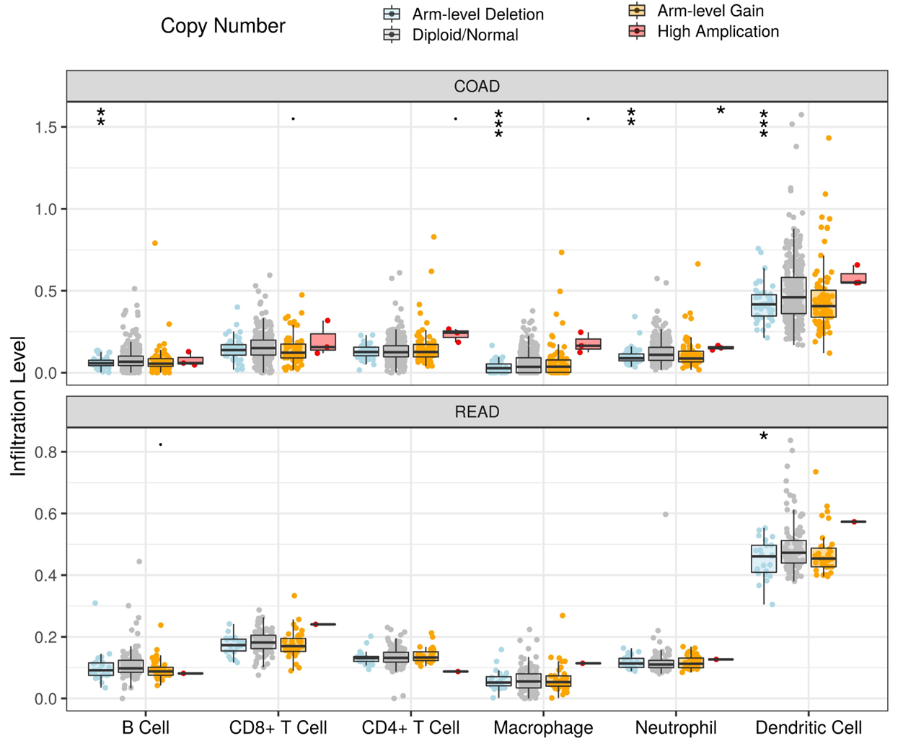
Figure S2. Impact of age, gender, and SLC10A3 expression on the overall and disease-free survival of CRC patients. (A-B) Female and older patients had shorter lifespans. (C-D) The OS, DFS of CRC patients between low and high-expressional groups. CRC, colorectal cancer; OS, overall Survival; DFS, disease-free survival.

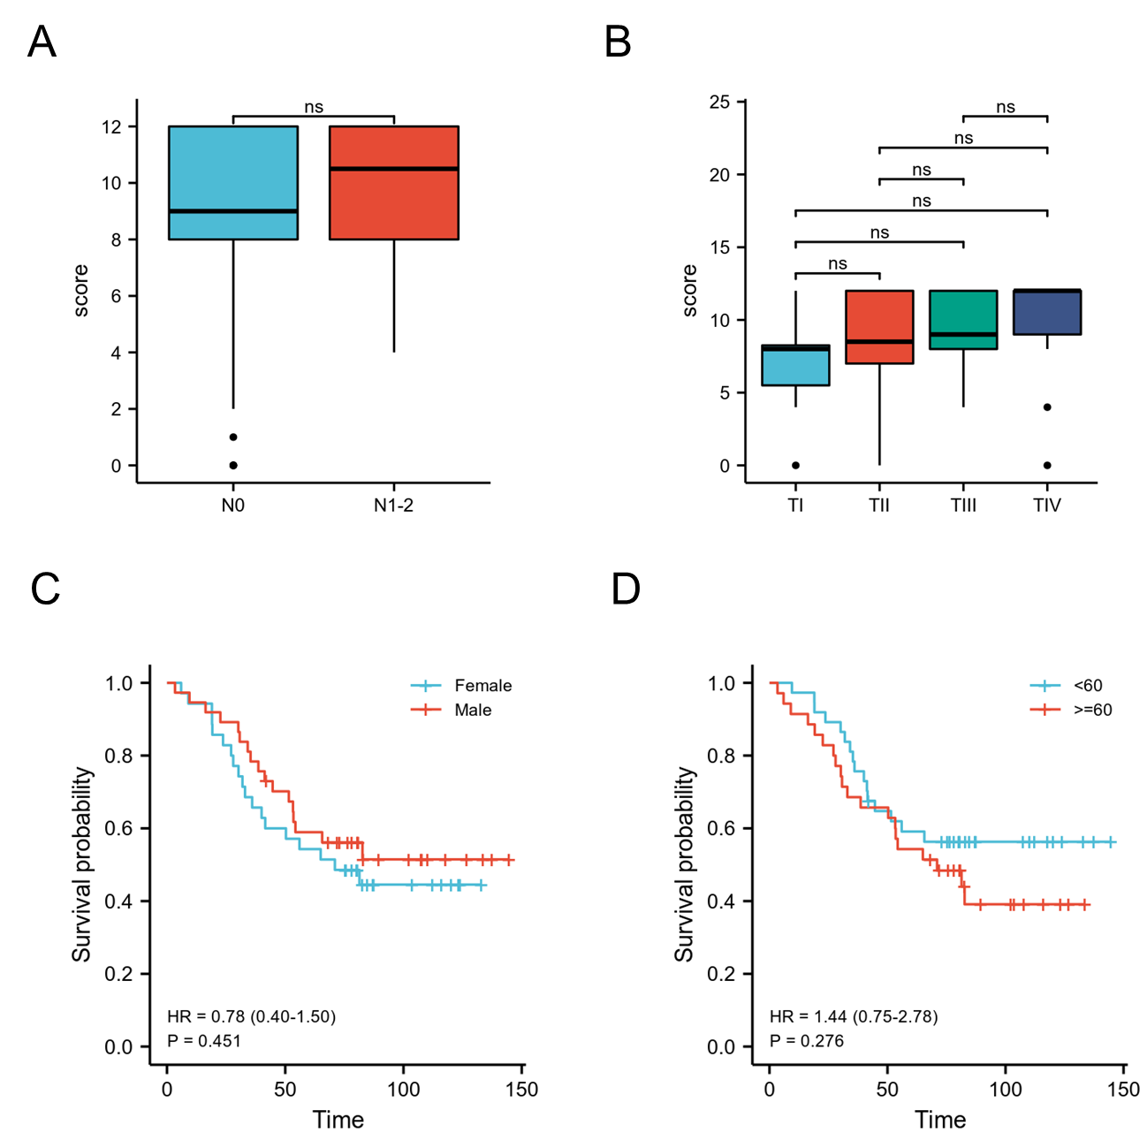

Table S1. The relationship between SLC10A3 and immune infiltration based on TIMER2.
cells | cancer | CIBERSORT | MCPCOUNTER | XCELL | EPIC | QUANTISEQ
B cell | COAD | NA | 0.116037447 | -0.134340234 | 0.067802244 | 0.125860934
B cell | READ | NA | -0.120133639 | -0.205546867 | -0.151622861 | -0.025159541
T cell CD4+ | COAD | NA | NA | NA | -0.051902884 | NA
T cell CD4+ | READ | NA | NA | NA | -0.067155024 | NA
T cell CD4+ Th1 | COAD | NA | NA | -0.166997721 | NA | NA
T cell CD4+ Th1 | READ | NA | NA | -0.233949822 | NA | NA
T cell CD4+ Th2 | COAD | NA | NA | -0.357168546 | NA | NA
T cell CD4+ Th2 | READ | NA | NA | -0.091131431 | NA | NA
Endothelial cell | COAD | NA | 0.250330584 | 0.146631564 | 0.214756558 | NA
Endothelial cell | READ | NA | 0.096627109 | 0.017024299 | -0.022488518 | NA
T cell CD8+ | COAD | -0.061082013 | 0.014110805 | -0.064769103 | -0.105166106 | -0.00932946
T cell CD8+ | READ | -0.125408872 | -0.062486392 | -0.100179717 | -0.102499466 | -0.144052309
Tregs | COAD | 0.113206373 | NA | 0.046410556 | NA | 0.00669494
Tregs | READ | -0.286205977 | NA | -0.00249584 | NA | -0.026556309
DC | COAD | NA | 0.101842353 | -0.03216371 | NA | -0.006096826
DC | READ | NA | 0.126061717 | -0.003041335 | NA | 0.074144998
NK cell | COAD | NA | -0.179271029 | -0.101465105 | -0.022414074 | 0.175067733
NK cell | READ | NA | -0.139687185 | 0.203479813 | 0.140074475 | 0.144038468
Mast cell | COAD | NA | NA | 0.026209618 | NA | NA
Mast cell | READ | NA | NA | -0.084602555 | NA | NA
Macrophage0 | COAD | 0.1506273 | NA | NA | NA | NA
Macrophage0 | READ | -0.015773217 | NA | NA | NA | NA
Macrophage 1 | COAD | -0.03403432 | NA | 0.037985599 | NA | -0.222356313
Macrophage 1 | READ | 0.043471015 | NA | 0.238944569 | NA | 0.112419528
Macrophage 2 | COAD | 0.051201597 | NA | 0.034437049 | NA | 0.239840824
Macrophage 2 | READ | 0.267123867 | NA | 0.149843875 | NA | 0.160963442
Eosinophils | COAD | 0.080361799 | NA | 0.02564887 | NA | NA
Eosinophils | READ | -0.04347 | NA | -0.063736959 | NA | NA
Neutrophil | COAD | -0.044647445 | 0.198156317 | 0.083288176 | NA | 0.146302967
Neutrophil | READ | 0.091712254 | 0.037301222 | -0.172140634 | NA | 0.179593922
Cancer Associated Fibroblast | COAD | NA | 0.261849663 | 0.222652377 | 0.232172663 | NA
Cancer Associated Fibroblast | READ | NA | 0.293539062 | 0.186404694 | 0.2929987 | NA
Blue negative relation, p-value<0.05; Red positive relation, p-value<0.05.

