Table S1. Source of S. aureus clinical isolates

Types of specimens | No.(%) isolates
Types of specimens | MSSA (n=68) | MRSA  (n=54) | Overall (n=122)
Blood | 18 (26.5) | 20 (37) | 38 (31.1)
Sterile tissues | 22 (32.4) | 14 (25.9) | 36 (29.5)
Pus | 11 (16.2) | 4 (7.4) | 15 (12.3)
Wound swab | 6 (8.8) | 5 (9.3) | 11 (9)
Lower respiratory tract specimen | 9 (13.2) | 9 (16.7) | 18 (14.8)
Others | 2 (2.9) | 2 (3.7) | 4 (3.3)

Table S2. Nucleotide sequences of primers and thermal cycling conditions used in this study

Genes | Primers |  | Nucleotide sequence (5’ – 3’) |  | Fragment size (bp) |  | Annealing temperature (ºC)
16SrRNA | 27F  1492R |  | AGAGTTTGATCCTGGCTCAG TACGGTTACCTTGTTACGACTT |  | 1500 |  | 54
sarA | sarAF  sarAR |  | CCCAGAAATACA ATCACTGTG  AGTGCCATTAGTGCAAAACC |  | 720 |  | 53
agr I | pan-agr  agr I |  | ATGCACATGGTGCACATGC  GTCACAAGTACTATAAGCTGCGAT |  | 440 |  | 55
agr II | pan-agr  agr II |  | ATGCACATGGTGCACATGC  GTATTACTAATTGAAAAGTGCCATAGC |  | 572 |  | 55
agr III | pan-agr  agr III |  | ATGCACATGGTGCACATGC  CTGTTGAAAAAGTCAACTAAAAGCTC |  | 406 |  | 55
agr IV | pan-agr  agr IV |  | ATGCACATGGTGCACATGC  CGATAATGCCGTAATAC CCG |  | 588 |  | 55
bap | Forward  Reverse |  | CCCTATATCGAAGGTGTAGAATTG  GCTGTTGAAGTTAATACTGTACCTGC |  | 971 |  | 62
ebpS | EBP-1  EBP-2 |  | CATCCAGAACCAATCGAAGAC  CTTAACAGTTACATCATCATGTTTATCTTTG |  | 652 |  | 55
eno | ENO-1  ENO-2 |  | ACGTGCAGCAGCTGACT  CAACAGCATYCTTCAGTACCTTC |  | 302 |  | 55
fib | FIB-1  FIB-2 |  | CTACAACTACAATTGCCGTCAACAG  GCTCTTGTAAGACCATTTTCTTCAC |  | 404 |  | 55
fnbA | FNBA-1  FNBA-1 |  | GTGAAGTTTTAGAAGGTGGAAAGATTAG  GCTCTTGTAAGACCATTTTTCTTCAC |  | 127 |  | 55
fnbB | FNBB-1  FNBB-2 |  | GTAACAGCTAATGGTCGAATTGATACT  CAAGTTCGATAGGAGTACTATGTTC |  | 524 |  | 55
clfA | CLFA-1  CLFA-2 |  | ATTGGCGTGGCTTCAGTGCT  CGTTTCTTCCGTAGTTGCATTTG |  | 292 |  | 55
clfB | CLFB-1  CLFB-2 |  | ACATCAGTAATAGTAGGGGGCAAC  TTCGCACTGTTTGTGTTTGCAC |  | 205 |  | 55
cna |  | CNA-2  CNA-1 |  | GTCAAGCAGTTATTAACACCAGAC  AATCAGTAATTGCACTTTGTCCACTG |  | 423 |  | 55
icaD | icaDF  icaDR |  | ATG GTC AAG CCC AGA CAG AG  CGT GTT TTC AAC ATT TAA TGC AA |  | 188 |  | 55
icaA | icaAF  icaAR |  | ACA CTT GCT GGC GCA GTC AA  TCTGGAACCAACATCCAACA |  | 198 |  | 55

Table S3. MIC range, MIC₅₀ and MIC₉₀ values of 112 S. aureus isolates against various classes of antibiotics

Antibiotic | Antibiotic classes | MIC range (µg/mL) |  | MIC₅₀ (µg/mL) |  | MIC₉₀ (µg/mL)
Antibiotic | Antibiotic classes | MSSA | MRSA | MSSA | MRSA | MSSA | MRSA
Clindamycin | Lincosamides | 0.25 - 8 | 0.25 – 8 | 0.25 | 0.25 | 0.25 | 8
Erythromycin | Macrolides | 0.25 - 8 | 0.25 – 8 | 0.25 | 0.5 | 0.25 | 8
Gentamicin | Aminoglycosides | 0.5 - 8 | 0.5 – 16 | 0.5 | 0.5 | 0.5 | 8
Linezolid | Oxazolidinones | 1 - 2 | 1 - 4 | 2 | 2 | 2 | 2
Oxacillin | Penicillinase-stabile penicillins | 0.25 - 1 | 4 - 4 | 0.5 | 4 | 0.5 | 4
Penicillin | Penicillinase-labile penicillins | 0.03 - 0.5 | 0.5 - 0.5 | 0.5 | 0.5 | 0.5 | 0.5
Rifampicin | Ansamycins | 0.25 – 0.5 | 0.5 – 32 | 0.5 | 0.5 | 0.5 | 0.5
Cotrimoxazole | Sulfonamides | 10 - 320 | 10 - 320 | 10 | 10 | 10 | 10
Tetracycline | Tetracyclines | 1-16 | 1-16 | 1 | 1 | 16 | 16
Vancomycin | Glycopeptides | 0.5 - 2 | 0.5 - 1 | 1 | 0.5 | 1 | 1
Ciprofloxacin | Fluoroquinolones | 0.5 - 8 | 0.5 – 8 | 0.5 | 8 | 0.5 | 8
Levofloxacin | Fluoroquinolones | 0.12 - 4 | 0.12 – 8 | 0.25 | 8 | 0.25 | 8
Moxifloxacin* | Fluoroquinolones | 0.25 - 1 | 0.25 – 4 | 0.25 | 2 | 0.25 | 2
*Data for 10 isolates was not available

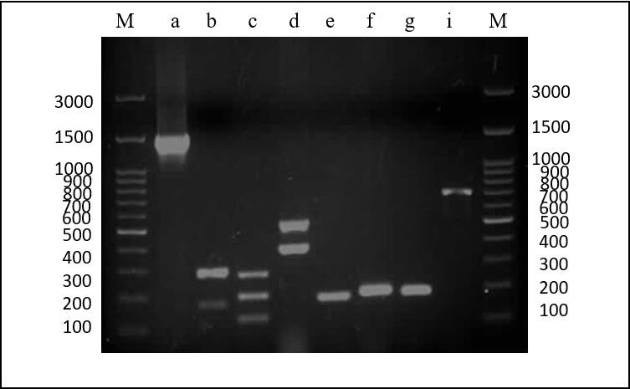
Figure S1. Agarose gel electrophoresis results for amplified biofilm associated gene fragments of S. aureus.
(M) 100 bp DNA molecular marker (Simply, Taiwan); (a) 16S rRNA (1500 bp); (b) Multiplex 1 – eno (302bp), ebpS (186 bp); (c) Multiplex 2 – clfA (292bp), clfB (205 bp), fnbA (128 bp); (d) Multiplex 3 – fnbB (524bp), fib (404 bp); (e) icaA (188 bp); (f) icaD (198 bp); (g) cna (192 bp); (i) sarA (720bp).

