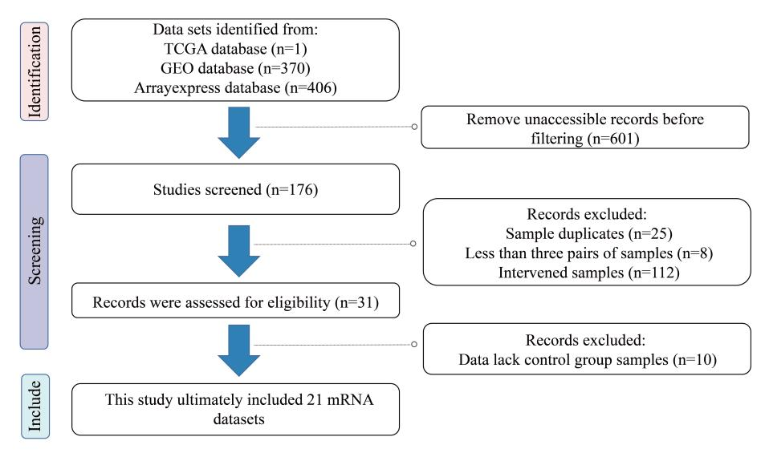
Figure S1 Flow of bladder cancer related dataset screening in this study.
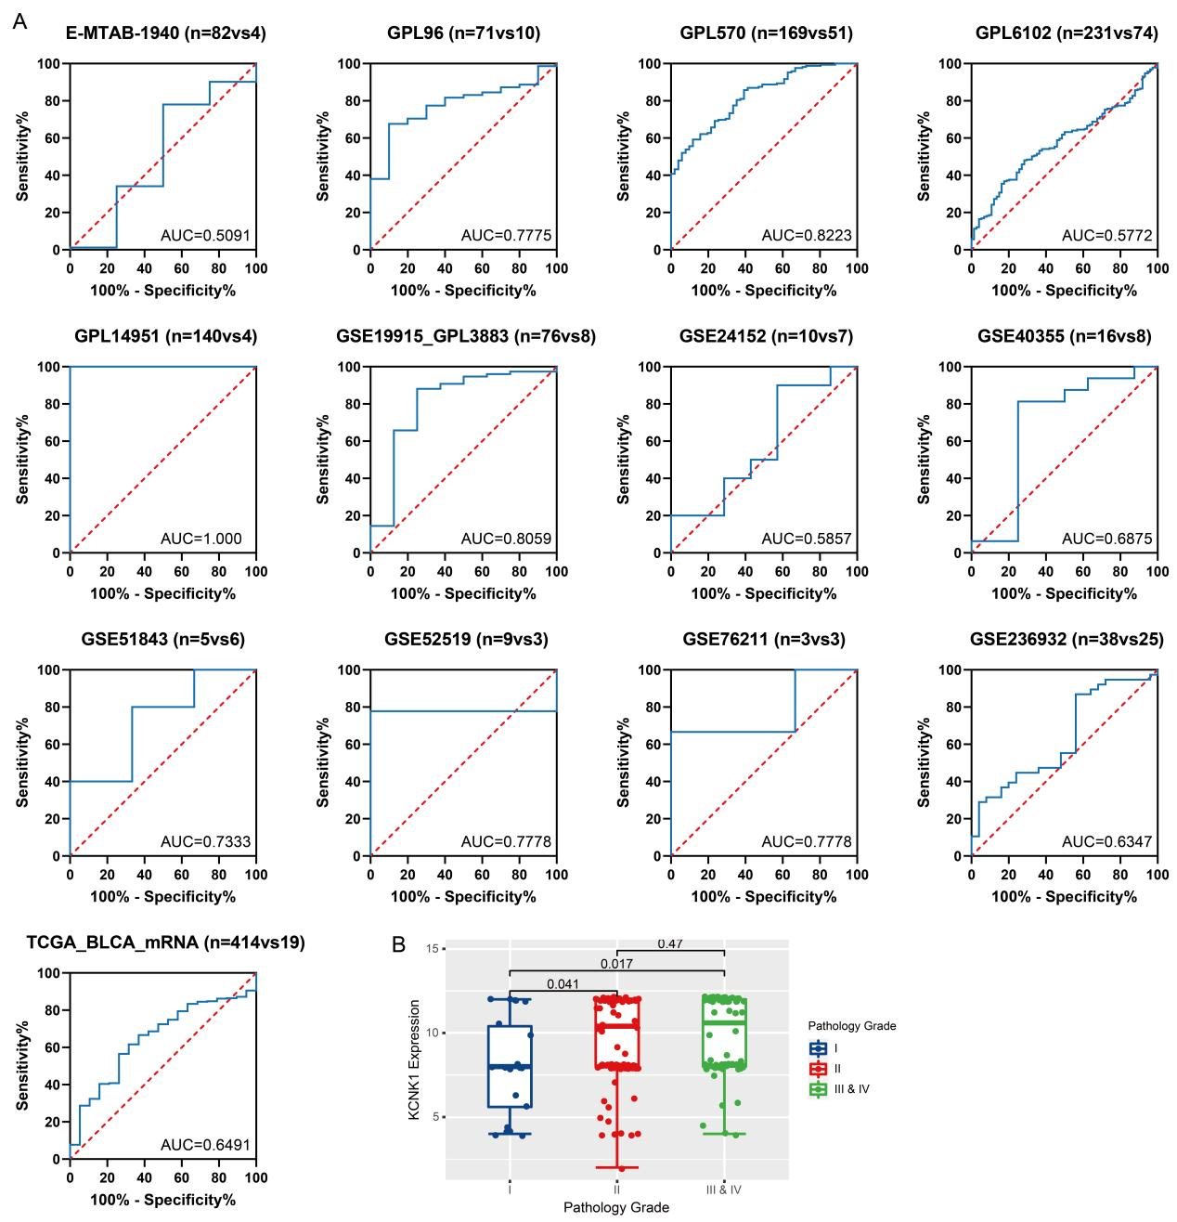
Figure S2 The ability of KCNK1 to distinguish BC samples and control samples, and the correlation between KCNK1 expression and pathology grade. (A) Receiver operator characteristic curve. (B) Box plot.
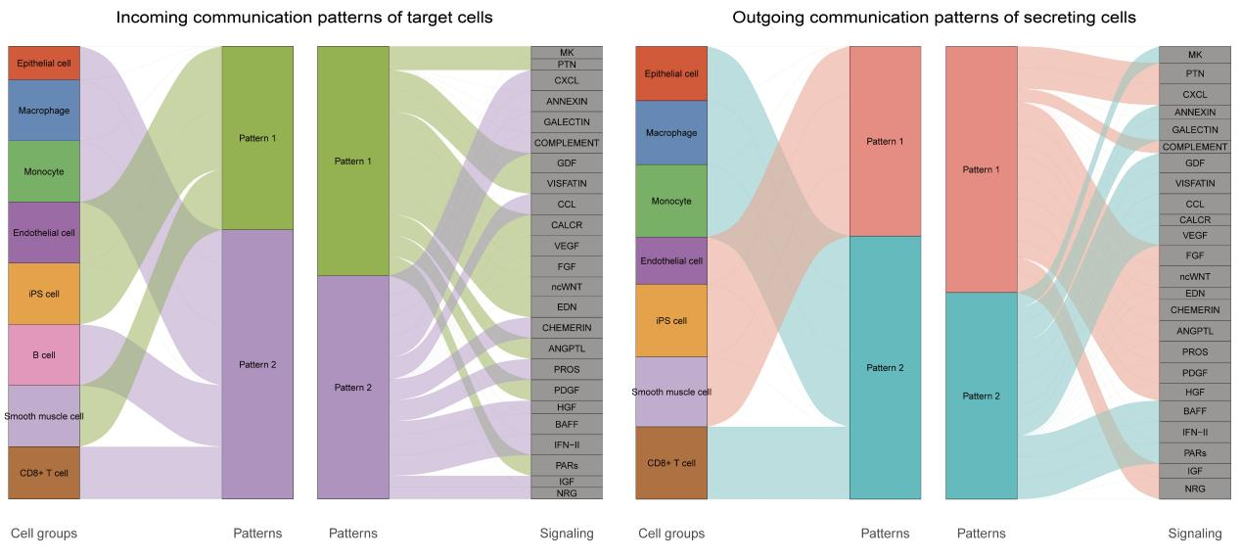
Figure S3 Afferent/efferent global communication patterns of multiple bladder cancer cell clusters.
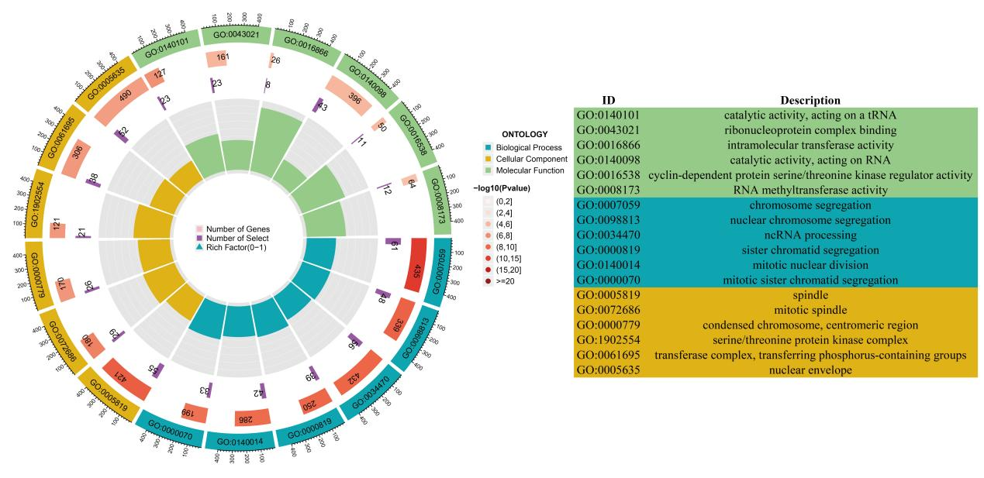
Figure S4 GO enrichment analysis of highly expressed co-expressed genes of KCNK1.
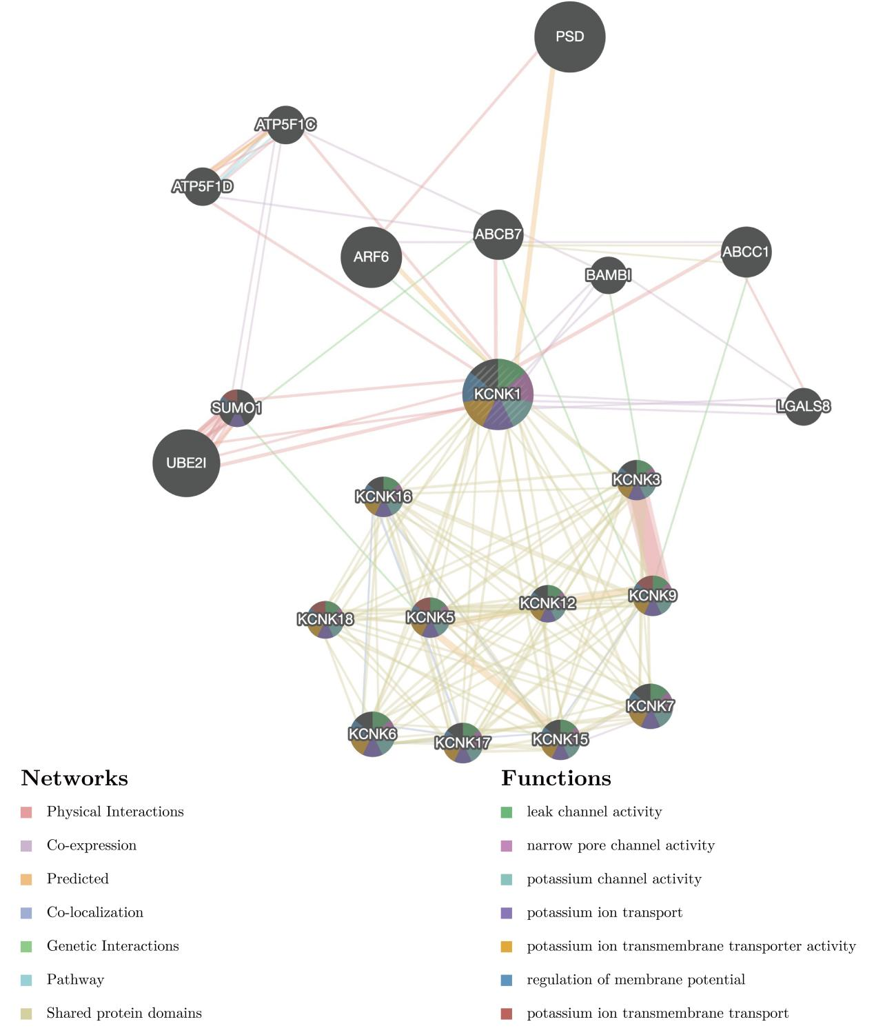
Figure S5 KCNK1-based protein-protein interaction networks as well as functional pathways.

