Supplementary Table 1. Assessing the performance of various machine learning models under 7 classifiers on the test data.
Model | Classifier |  | AUC ROC |  |  |  | Accuracy |  |  | Precision |  |  | Recall |  |  | F1 Score
Model | Classifier |  | Mean | 95% CI | STD |  | Mean | STD |  | Mean | STD |  | Mean | STD |  | Mean | STD
DOS | SVM |  | 0.49 | 0.26-0.75 | 0.16 |  | 0.55 | 0.08 |  | 0.34 | 0.19 |  | 0.52 | 0.06 |  | 0.23 | 0.29
DOS | KNN |  | 0.70 | 0.54-0.83 | 0.07 |  | 0.67 | 0.08 |  | 0.69 | 0.08 |  | 0.68 | 0.07 |  | 0.67 | 0.07
DOS | LR |  | 0.69 | 0.57-0.82 | 0.06 |  | 0.61 | 0.06 |  | 0.66 | 0.08 |  | 0.63 | 0.06 |  | 0.65 | 0.06
DOS | ET |  | 0.78 | 0.65-0.88 | 0.05 |  | 0.67 | 0.07 |  | 0.71 | 0.07 |  | 0.69 | 0.06 |  | 0.68 | 0.07
DOS | GTB |  | 0.75 | 0.59-0.90 | 0.08 |  | 0.66 | 0.08 |  | 0.70 | 0.08 |  | 0.68 | 0.08 |  | 0.68 | 0.08
DOS | RF |  | 0.75 | 0.61-0.85 | 0.06 |  | 0.64 | 0.07 |  | 0.69 | 0.07 |  | 0.66 | 0.06 |  | 0.67 | 0.06
DOS | NB |  | 0.69 | 0.60-0.77 | 0.04 |  | 0.59 | 0.05 |  | 0.63 | 0.06 |  | 0.60 | 0.05 |  | 0.60 | 0.08
DVH | SVM |  | 0.46 | 0.22-0.75 | 0.19 |  | 0.54 | 0.07 |  | 0.30 | 0.13 |  | 0.51 | 0.05 |  | 0.20 | 0.29
DVH | KNN |  | 0.66 | 0.48-0.81 | 0.09 |  | 0.62 | 0.08 |  | 0.62 | 0.15 |  | 0.60 | 0.09 |  | 0.46 | 0.23
DVH | LR |  | 0.71 | 0.56-0.78 | 0.06 |  | 0.66 | 0.08 |  | 0.68 | 0.08 |  | 0.67 | 0.09 |  | 0.63 | 0.13
DVH | ET |  | 0.66 | 0.45-0.76 | 0.08 |  | 0.61 | 0.08 |  | 0.53 | 0.20 |  | 0.59 | 0.09 |  | 0.39 | 0.30
DVH | GTB |  | 0.66 | 0.46-0.76 | 0.08 |  | 0.62 | 0.09 |  | 0.63 | 0.10 |  | 0.62 | 0.09 |  | 0.59 | 0.13
DVH | RF |  | 0.67 | 0.45-0.81 | 0.09 |  | 0.65 | 0.09 |  | 0.67 | 0.10 |  | 0.66 | 0.10 |  | 0.62 | 0.15
DVH | NB |  | 0.68 | 0.51-0.75 | 0.07 |  | 0.66 | 0.08 |  | 0.66 | 0.09 |  | 0.65 | 0.09 |  | 0.58 | 0.16
RTP | SVM |  | 0.49 | 0.17-0.83 | 0.16 |  | 0.52 | 0.06 |  | 0.30 | 0.11 |  | 0.50 | 0.04 |  | 0.23 | 0.28
RTP | KNN |  | 0.53 | 0.34-0.8 | 0.12 |  | 0.51 | 0.09 |  | 0.51 | 0.13 |  | 0.51 | 0.09 |  | 0.47 | 0.17
RTP | LR |  | 0.68 | 0.41-0.87 | 0.13 |  | 0.64 | 0.11 |  | 0.66 | 0.11 |  | 0.65 | 0.11 |  | 0.62 | 0.15
RTP | ET |  | 0.74 | 0.45-0.94 | 0.13 |  | 0.68 | 0.10 |  | 0.70 | 0.11 |  | 0.69 | 0.11 |  | 0.66 | 0.15
RTP | GTB |  | 0.66 | 0.46-0.84 | 0.12 |  | 0.62 | 0.12 |  | 0.63 | 0.13 |  | 0.62 | 0.12 |  | 0.58 | 0.14
RTP | RF |  | 0.61 | 0.38-0.86 | 0.15 |  | 0.57 | 0.13 |  | 0.58 | 0.15 |  | 0.58 | 0.13 |  | 0.55 | 0.16
RTP | NB |  | 0.63 | 0.29-0.88 | 0.17 |  | 0.59 | 0.14 |  | 0.60 | 0.16 |  | 0.60 | 0.15 |  | 0.55 | 0.20
DVH+RTP | SVM |  | 0.68 | 0.43-0.86 | 0.13 |  | 0.63 | 0.09 |  | 0.65 | 0.11 |  | 0.63 | 0.10 |  | 0.59 | 0.15
DVH+RTP | KNN |  | 0.70 | 0.48-0.87 | 0.11 |  | 0.62 | 0.09 |  | 0.66 | 0.12 |  | 0.62 | 0.09 |  | 0.54 | 0.17
DVH+RTP | LR |  | 0.69 | 0.46-0.83 | 0.10 |  | 0.61 | 0.09 |  | 0.63 | 0.09 |  | 0.62 | 0.09 |  | 0.60 | 0.11
DVH+RTP | ET |  | 0.69 | 0.42-0.86 | 0.12 |  | 0.61 | 0.09 |  | 0.59 | 0.18 |  | 0.60 | 0.10 |  | 0.47 | 0.27
DVH+RTP | GTB |  | 0.65 | 0.40-0.87 | 0.13 |  | 0.59 | 0.11 |  | 0.60 | 0.13 |  | 0.60 | 0.12 |  | 0.56 | 0.15
DVH+RTP | RF |  | 0.65 | 0.37-0.85 | 0.14 |  | 0.60 | 0.11 |  | 0.62 | 0.13 |  | 0.60 | 0.11 |  | 0.54 | 0.16
DVH+RTP | NB |  | 0.68 | 0.48-0.82 | 0.08 |  | 0.62 | 0.08 |  | 0.63 | 0.09 |  | 0.63 | 0.08 |  | 0.58 | 0.12
DOS+DVH | SVM |  | 0.76 | 0.64-0.84 | 0.05 |  | 0.63 | 0.08 |  | 0.68 | 0.10 |  | 0.64 | 0.07 |  | 0.61 | 0.09
DOS+DVH | KNN |  | 0.72 | 0.61-0.81 | 0.05 |  | 0.66 | 0.06 |  | 0.67 | 0.07 |  | 0.66 | 0.06 |  | 0.62 | 0.10
DOS+DVH | LR |  | 0.78 | 0.69-0.84 | 0.04 |  | 0.63 | 0.07 |  | 0.66 | 0.07 |  | 0.65 | 0.07 |  | 0.65 | 0.05
DOS+DVH | ET |  | 0.69 | 0.51-0.79 | 0.07 |  | 0.62 | 0.08 |  | 0.61 | 0.14 |  | 0.62 | 0.08 |  | 0.57 | 0.19
DOS+DVH | GTB |  | 0.68 | 0.56-0.83 | 0.07 |  | 0.64 | 0.08 |  | 0.67 | 0.08 |  | 0.66 | 0.08 |  | 0.66 | 0.07
DOS+DVH | RF |  | 0.71 | 0.56-0.83 | 0.07 |  | 0.65 | 0.07 |  | 0.69 | 0.08 |  | 0.67 | 0.07 |  | 0.67 | 0.07
DOS+DVH | NB |  | 0.74 | 0.66-0.80 | 0.04 |  | 0.68 | 0.05 |  | 0.69 | 0.05 |  | 0.69 | 0.06 |  | 0.66 | 0.07
DOS+RTP | SVM |  | 0.69 | 0.54-0.81 | 0.06 |  | 0.60 | 0.05 |  | 0.64 | 0.07 |  | 0.61 | 0.05 |  | 0.59 | 0.10
DOS+RTP | KNN |  | 0.75 | 0.60-0.89 | 0.08 |  | 0.66 | 0.07 |  | 0.70 | 0.07 |  | 0.67 | 0.07 |  | 0.67 | 0.08
DOS+RTP | LR |  | 0.55 | 0.33-0.78 | 0.13 |  | 0.51 | 0.11 |  | 0.53 | 0.13 |  | 0.52 | 0.12 |  | 0.52 | 0.13
DOS+RTP | ET |  | 0.75 | 0.58-0.82 | 0.06 |  | 0.66 | 0.07 |  | 0.71 | 0.09 |  | 0.68 | 0.07 |  | 0.67 | 0.10
DOS+RTP | GTB |  | 0.70 | 0.52-0.85 | 0.09 |  | 0.63 | 0.09 |  | 0.68 | 0.10 |  | 0.65 | 0.09 |  | 0.65 | 0.09
DOS+RTP | RF |  | 0.69 | 0.52-0.81 | 0.08 |  | 0.62 | 0.08 |  | 0.66 | 0.09 |  | 0.64 | 0.08 |  | 0.64 | 0.09
DOS+RTP | NB |  | 0.69 | 0.57-0.77 | 0.05 |  | 0.59 | 0.05 |  | 0.64 | 0.08 |  | 0.61 | 0.06 |  | 0.61 | 0.09
DOS+DVH+RTP | SVM |  | 0.75 | 0.64-0.83 | 0.05 |  | 0.64 | 0.08 |  | 0.70 | 0.11 |  | 0.64 | 0.06 |  | 0.59 | 0.12
DOS+DVH+RTP | KNN |  | 0.66 | 0.51-0.81 | 0.08 |  | 0.60 | 0.08 |  | 0.63 | 0.12 |  | 0.61 | 0.08 |  | 0.55 | 0.14
DOS+DVH+RTP | LR |  | 0.82 | 0.74-0.89 | 0.05 |  | 0.65 | 0.06 |  | 0.69 | 0.05 |  | 0.67 | 0.06 |  | 0.68 | 0.05
DOS+DVH+RTP | ET |  | 0.83 | 0.71-0.90 | 0.05 |  | 0.70 | 0.07 |  | 0.74 | 0.06 |  | 0.72 | 0.06 |  | 0.72 | 0.06
DOS+DVH+RTP | GTB |  | 0.75 | 0.55-0.88 | 0.08 |  | 0.65 | 0.07 |  | 0.69 | 0.08 |  | 0.67 | 0.07 |  | 0.67 | 0.08
DOS+DVH+RTP | RF |  | 0.71 | 0.53-0.84 | 0.08 |  | 0.63 | 0.08 |  | 0.66 | 0.09 |  | 0.64 | 0.08 |  | 0.63 | 0.09
DOS+DVH+RTP | NB |  | 0.78 | 0.69-0.85 | 0.04 |  | 0.65 | 0.05 |  | 0.68 | 0.06 |  | 0.66 | 0.05 |  | 0.67 | 0.06

Supplementary Table 2. Overview of significant features indicating AST 2+ with a Two-Tailed t-Test.
Feature |  |  | CTCAE <2 |  |  | CTCAE≥2 |  |  | p_value
Class | Name |  | Mean | STD |  | Mean | STD |  | 0.05
First order | Range |  | 51.66 | 4.95 |  | 59.09 | 5.15 |  | 0.000
First order | Skewness |  | -1.16 | 0.37 |  | -0.78 | 0.83 |  | 0.048
First order | Uniformity |  | 0.05 | 0.02 |  | 0.03 | 0.01 |  | 0.018
GLCM | Contrast |  | 9.64 | 4.37 |  | 24.83 | 24.18 |  | 0.007
GLCM | Correlation |  | 0.96 | 0.03 |  | 0.92 | 0.07 |  | 0.029
GLCM | Difference Average |  | 2.25 | 0.68 |  | 3.36 | 1.76 |  | 0.008
GLCM | Difference Entropy |  | 2.59 | 0.41 |  | 3.03 | 0.63 |  | 0.006
GLCM | Difference Variance |  | 3.54 | 1.35 |  | 9.35 | 8.93 |  | 0.005
GLCM | Idmn |  | 1.00 | 0.00 |  | 0.99 | 0.01 |  | 0.019
GLCM | Imc2 |  | 0.98 | 0.01 |  | 0.97 | 0.03 |  | 0.022
GLCM | Inverse Variance |  | 0.32 | 0.04 |  | 0.28 | 0.08 |  | 0.021
GLCM | Joint Entropy |  | 7.92 | 0.78 |  | 8.73 | 0.90 |  | 0.001
GLCM | MCC |  | 0.99 | 0.01 |  | 0.95 | 0.07 |  | 0.008
GLCM | Sum Entropy |  | 5.86 | 0.37 |  | 6.20 | 0.33 |  | 0.001
GLDM | Dependence Entropy |  | 7.87 | 0.39 |  | 8.12 | 0.48 |  | 0.035
GLDM | Small Dependence Emphasis |  | 0.17 | 0.07 |  | 0.21 | 0.09 |  | 0.034
GLDM | Small Dependence Low Gray Level Emphasis |  | 0.00 | 0.00 |  | 0.00 | 0.00 |  | 0.011
GLRLM | Gray Level Non Uniformity Normalized |  | 0.04 | 0.01 |  | 0.03 | 0.01 |  | 0.004
GLRLM | Run Entropy |  | 5.58 | 0.32 |  | 5.82 | 0.37 |  | 0.013
GLRLM | Short Run Low Gray Level Emphasis |  | 0.01 | 0.01 |  | 0.02 | 0.02 |  | 0.031
GLSZM | Gray Level Non Uniformity Normalized |  | 0.04 | 0.01 |  | 0.04 | 0.01 |  | 0.037
GLSZM | Gray Level Variance |  | 63.46 | 32.03 |  | 97.92 | 59.50 |  | 0.018
GLSZM | Low Gray Level Zone Emphasis |  | 0.00 | 0.00 |  | 0.01 | 0.01 |  | 0.014
GLSZM | Size Zone Non Uniformity |  | 7263.49 | 4706.55 |  | 12143.12 | 7767.23 |  | 0.007
GLSZM | Small Area Low Gray Level Emphasis |  | 0.00 | 0.00 |  | 0.00 | 0.00 |  | 0.013
GLSZM | Zone Percentage |  | 0.17 | 0.08 |  | 0.23 | 0.11 |  | 0.029
NGTDM | Complexity |  | 1806.57 | 794.03 |  | 3275.07 | 2033.21 |  | 0.003
NGTDM | Contrast |  | 0.14 | 0.06 |  | 0.19 | 0.09 |  | 0.027
DVH | V_{45 Gy} (cc) |  | 27.66 | 25.33 |  | 43.57 | 26.61 |  | 0.032
DVH | V_{50 Gy} (cc) |  | 7.04 | 8.72 |  | 17.20 | 16.07 |  | 0.010
DVH | V_{55 Gy} (cc) |  | 1.22 | 3.17 |  | 5.11 | 6.20 |  | 0.010
DVH | V_{60 Gy} (cc) |  | 0.06 | 0.20 |  | 0.77 | 1.55 |  | 0.039
DVH | D _{max} |  | 52.76 | 5.48 |  | 57.93 | 4.61 |  | 0.001
DVH | V_{50 Gy} (%) |  | 5.23 | 6.16 |  | 10.85 | 11.78 |  | 0.047
DVH | V_{55 Gy} (%) |  | 0.83 | 1.99 |  | 3.21 | 5.13 |  | 0.045
PTR | Fraction schedule |  | 0.52 | 0.51 |  | 0.96 | 0.21 |  | 0.000

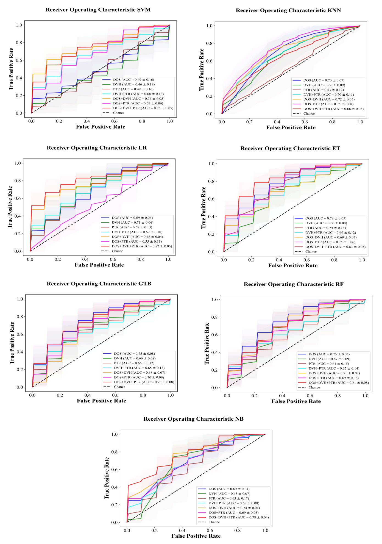 Supplementary Fig 1. Comparing Model Performance in Testing Cohorts via ROC Curves. The blue, green, brown, cyan, orange, pink, and red lines represent the results of DOS, DVH, PTR, DVH+PTR, DOS+DVH, DOS+PTR and, DOS+DVH+PTR ML models.
Supplementary File 1. The hyper-parameters for the seven classifiers

# Define the random search parameters for each model
params = {
'Support Vector Machine': {'C' : np.logspace(-5,10,1500, base=2),
'gamma': np.logspace(-15,3,180, base=2)},
'k-Nearest Neighbors': {'n_neighbors' : [1,2,3,4,5,6,7,8,9,10,11,12,13,14,15],
'p': [1,2]},
'Logistic Regression': {'penalty' : ['l1', 'l2', 'elasticnet', 'none'],
'l1_ratio': [0,1], 'C' : np.logspace(-5,10,100, base=2),
'solver' : ['lbfgs','newton-cg','liblinear','sag','saga'],
'max_iter' : [100, 1000,2500, 5000] },
'Extra-Trees': {'n_estimators' : [90, 230],
'criterion': ["gini", "entropy"],
'max_features' :np.arange(0.05,1.05,0.05),
'min_samples_split': np.arange(2,21,1),
'min_samples_leaf': np.arange(1,21,1)},
'Gradient Tree Boosting':{'n_estimators' : [200, 2000],
'learning_rate' : np.logspace(-7,-1,60, base=2),
'max_depth': np.arange(1,7,1),
'subsample': np.arange(0.6,1.05,0.05)},
'Random Forest':{'bootstrap': [True, False],
'max_depth': [ 5, 10, 20, 30, 40, 50, 60, 70, 80, 90, 100, None],
'max_features': ['auto', 'sqrt', None],
'min_samples_leaf': [1, 2, 4],
'min_samples_split': [2, 5, 10],
'n_estimators': np.arange(5,205,5),
'max_leaf_nodes': [3, 6, 9,None ]},
'Naive Bayes':{'alpha': [0.1, 0.5, 1.0, 1.5, 2.0],
'binarize': [0.0, 0.1, 0.2, 0.3, 0.4, None]}
}

