supplementary material

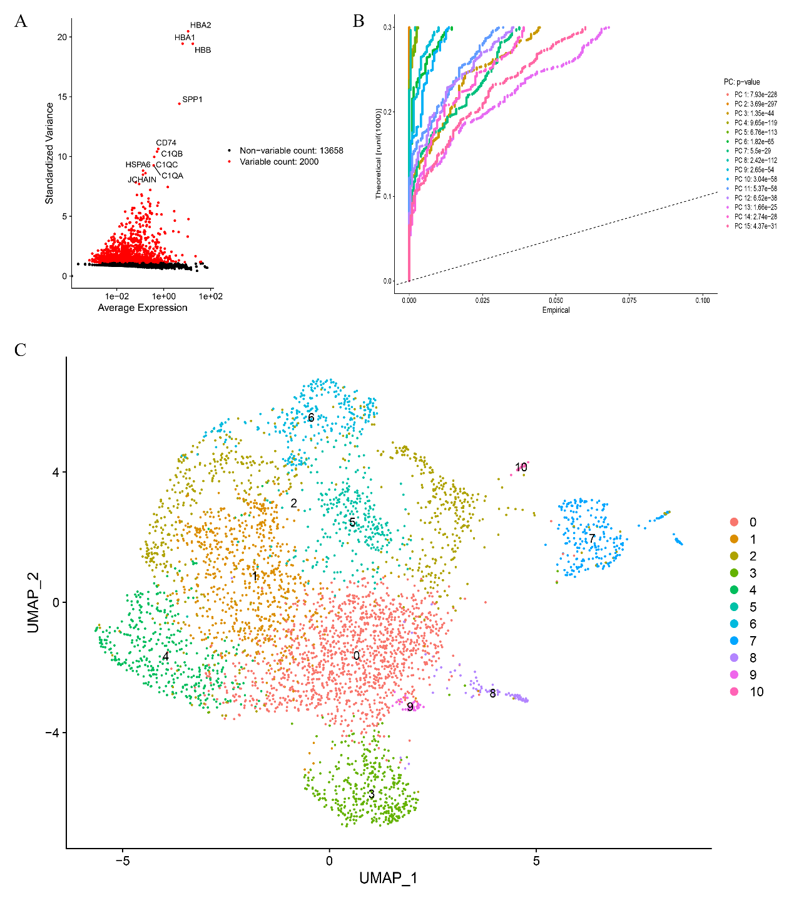
Supplementary figure 1. Quality control of CYB561 single-cell analysis data.A. Screening of top 2000 variable genes based on GSE199515 dataset.B. The top 15 principal components were selected for further analysis.C. Reduced-dimensional class clustering of cells using UMAP.

Supplementary figure 2. CYB561-related differential gene analysis.A. Based on the TCGA database, differential genes between high and low expression groups of CYB561 were analyzed.B. Based on gene chips, relevant differential genes were analyzed between the scr-shRNA group and the CYB561-shRNA group.

