Supplemental Figures
Figure S1 Risk of bias summary.
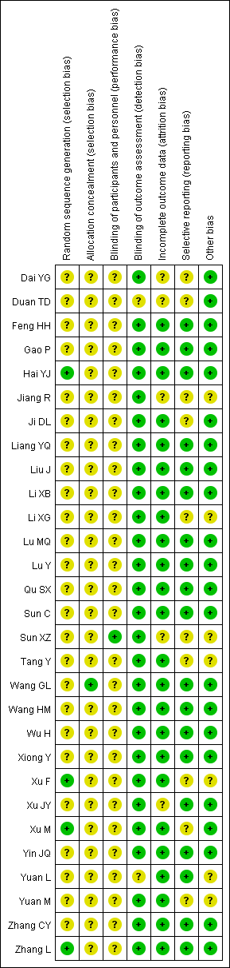
Figure S2. Forest plots showing MD with 95% CI of T-lymphocytes CD8⁺ percentage for huaier combined conventional treatment versus conventional treatment alone.
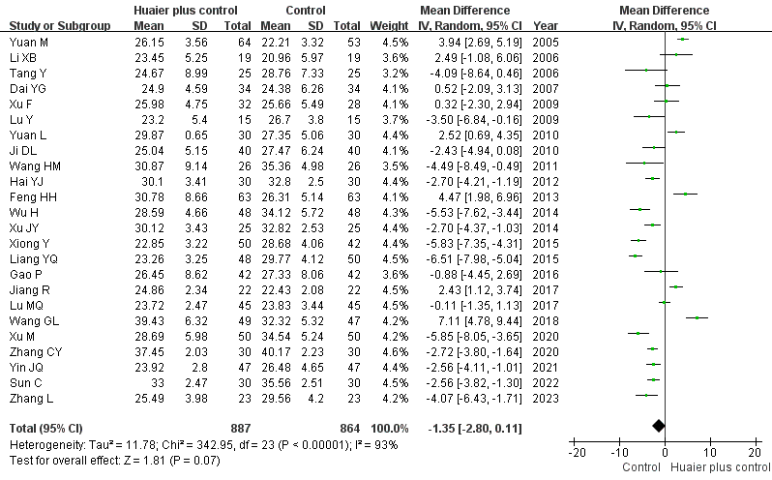

Figure S3 Forest plots showing SMD with 95% CI of IgA level for huaier combined conventional treatment versus conventional treatment alone.
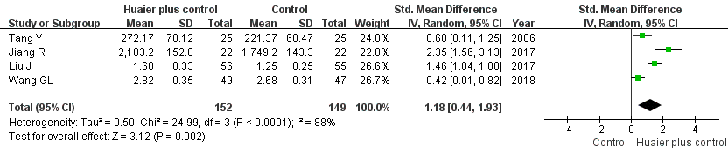

Figure S4 Forest plots showing SMD with 95% CI of IgG level for huaier combined conventional treatment versus conventional treatment alone.
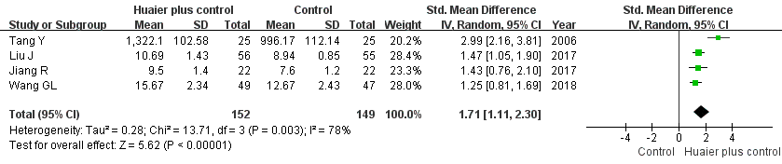

Figure S5 Forest plots showing SMD with 95% CI of IgM level for huaier combined conventional treatment versus conventional treatment alone.
