Comparative Efficacy of GLP-1 RAs and SGLT-2 Inhibitors in Reducing Cardiovascular Events in Type 2 Diabetes: A Meta-analysis of Randomized Controlled Trials

SUPPLEMENTAL MATERIAL

Contents

Supplemental Methods 2
Figure S1.Follow-up time for experiment 4
Figure S2.Cardiovascular disease funnel diagram of type 2 diabetes in experiment 5
Figure S3. MACE funnel diagram of type 2 diabetes in experiment 6
Figure S4.Biased evaluation of included articles 7
Figure S5. The results of GRADEpro assessment 8

Supplemental Methods

Screening terms: We included various brand names for "SGLT-2 inhibitors", "dapagliflozin", "empagliflozin", "canagliflozin", "ertugliflozin", "forxiga", "jardiance", "invokana", "steglatro", "GLP-1 Ras", "glucagon-like peptide-1 receptor agonist", "GLP-1 receptor agonist", "GLP1 receptor agonist", "albiglutide", "liraglutide", "exenatide", "dulaglutide", "exendin", "benaglutide", "loxenatide", "lixisenatide", "semaglutide", "diabetes", "mellitus", "diabetes mellitus", "DM" alone or combined with "randomized controlled trial", "randomized controlled trials as topic", "randomized controlled trials", "randomised controlled trials", "RCT", or "RCTs". Yuxin Zhang and Zhaoji Li conducted comprehensive searches independently. We searched English articles that were published before August, 2022 on Pubmed, Cochrane, Web of Science and Embase. The search strategy for Pubmed is described as follows:

#1 ("sglt 2 inhibitors"[Title/Abstract] OR "sglt2 inhibitors"[Title/Abstract] OR "dapagliflozin"[Title/Abstract] OR "Forxiga"[Title/Abstract] OR "empagliflozin"[Title/Abstract] OR "Jardiance"[Title/Abstract] OR "canaglifozin"[Title/Abstract] OR "Invokana"[Title/Abstract] OR "ertuglifozin"[Title/Abstract] OR "Steglatro"[Title/Abstract]) AND (randomizedcontrolledtrial[Filter]) AND (1000:2022/8/28[pdat])

#2 ("glp 1 ras"[Title/Abstract] OR "glucagon like peptide 1 receptor agonist"[Title/Abstract] OR "glp 1 receptor agonist"[Title/Abstract] OR "glp1 receptor agonist"[Title/Abstract] OR "albiglutide"[Title/Abstract] OR "liraglutide"[Title/Abstract] OR "exenatide"[Title/Abstract] OR "dulaglutide"[Title/Abstract] OR "exendin"[Title/Abstract] OR "benaglutide"[Title/Abstract] OR "loxenatide"[Title/Abstract] OR "lixisenatide"[Title/Abstract] OR "semaglutide"[Title/Abstract]) AND (randomizedcontrolledtrial[Filter]) AND (1000:2022/8/28[pdat])

#3 #1 OR #2

#4 ("diabetes"[Title/Abstract] OR "mellitus"[Title/Abstract] OR "diabetes mellitus"[Title/Abstract] OR "DM"[Title/Abstract]) AND (randomizedcontrolledtrial[Filter]) AND (1000:2022/8/28[pdat])

#5 #3 AND #4

The Cochrane, Web of Science and Embase used similiar search formulae.

Figure S1.Follow-up time for experiment
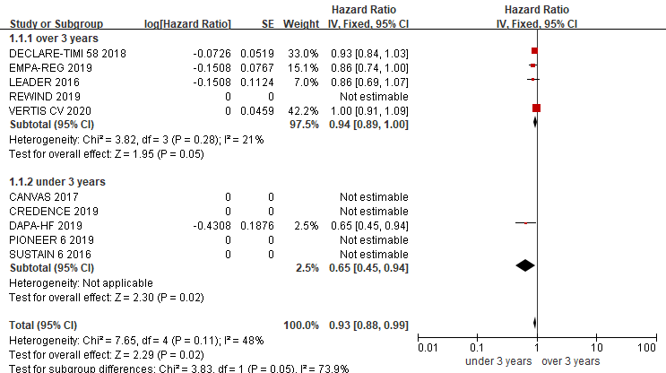
Legends: LEADER, REWIND,PIONEER 6,SUSTAIN 6: trials comparing glucagon-like peptide-1 receptor agonists (GLP-1RA) with placebo; EMPA-REG, CANVAS, CREDENCE,DECLARE-TIMI 58, VERTIS CV: trials comparing sodium-glucose cotransporter-2 inhibitors (SGLT2i) with placebo

Figure S2.Cardiovascular disease funnel diagram of type 2 diabetes in experiment

Figure S3. MACE funnel diagram of type 2 diabetes in experiment

Figure S4.Biased evaluation of included articles
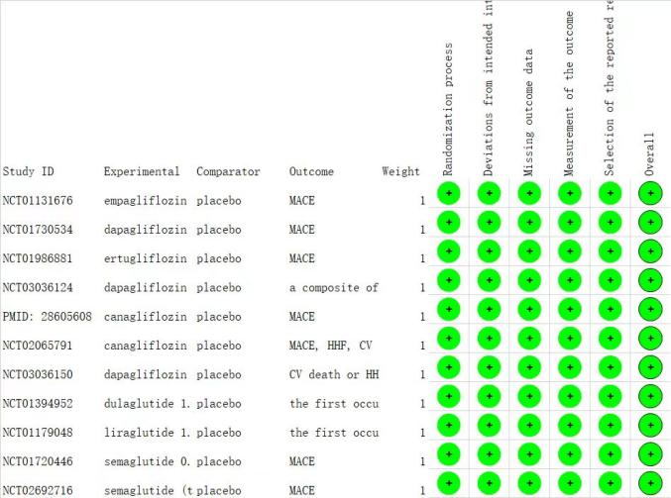
MACE, major adverse cardiovascular events；HHF, hospitalized for heart failure；CV，cardiovascular disease.

Figure S5. The results of GRADEpro assessment

