Additional file 1: Confusion matrix for diagnostic performance of FFM<17

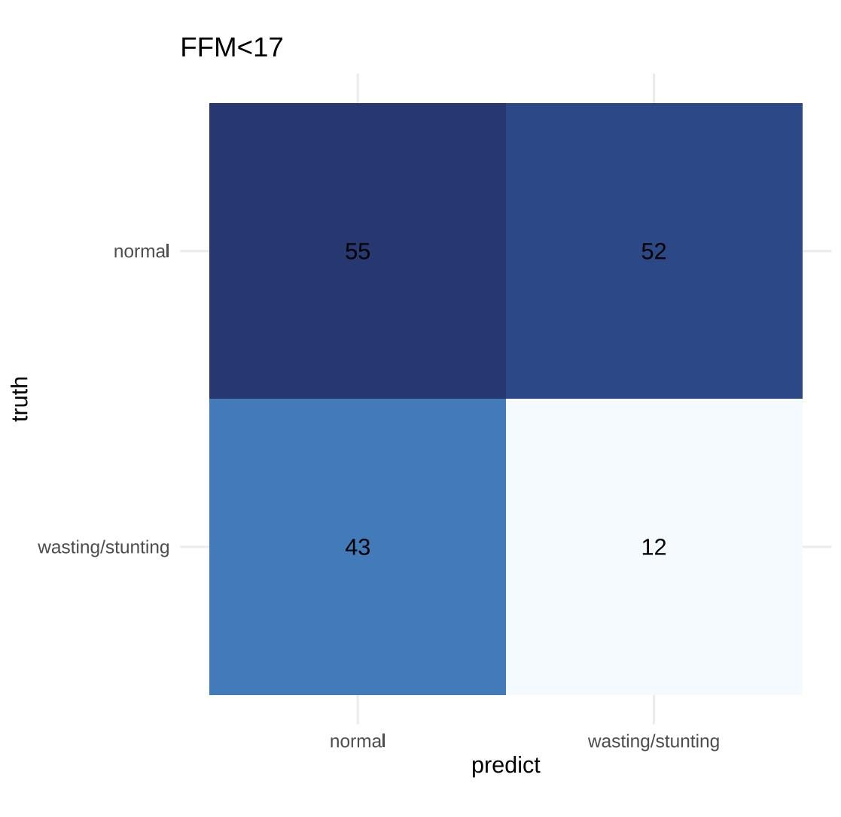

Additional file 2: Confusion matrix for diagnostic performance of FFM-change < 4
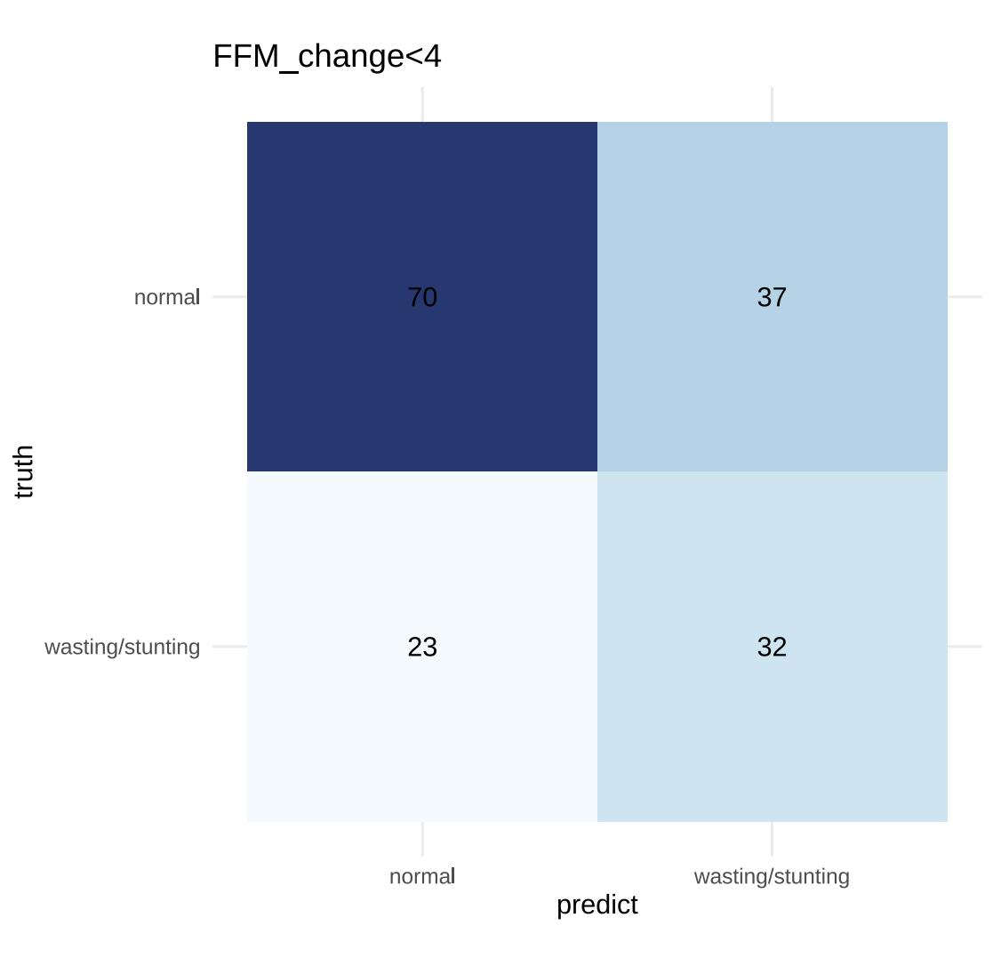

Additional file 3: Confusion matrix for diagnostic performance of SLM<18
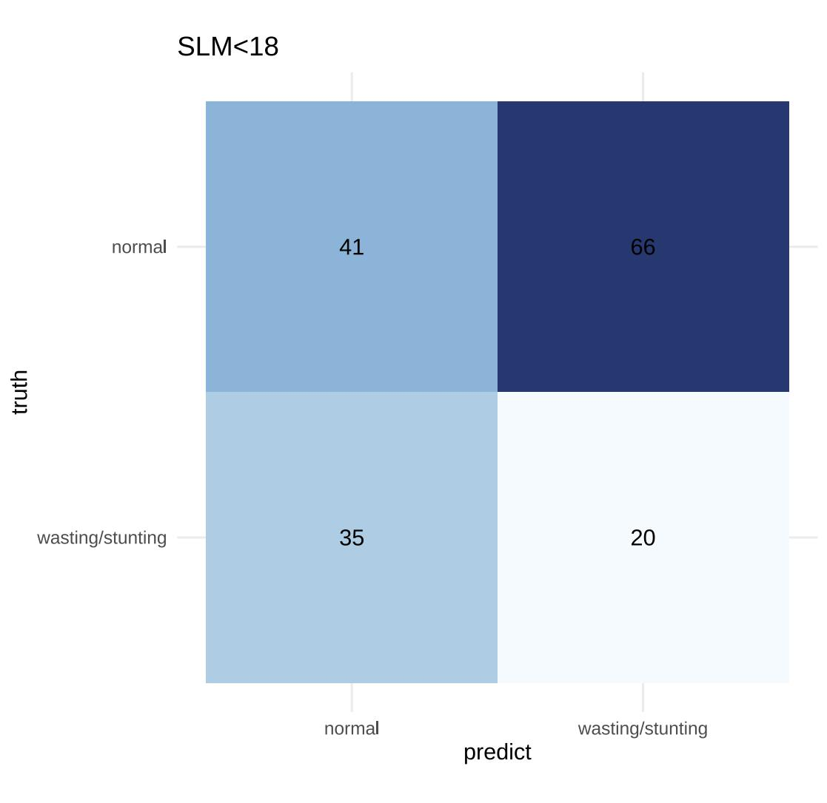

Additional file 4: Confusion matrix for diagnostic performance of SLM-change < 6
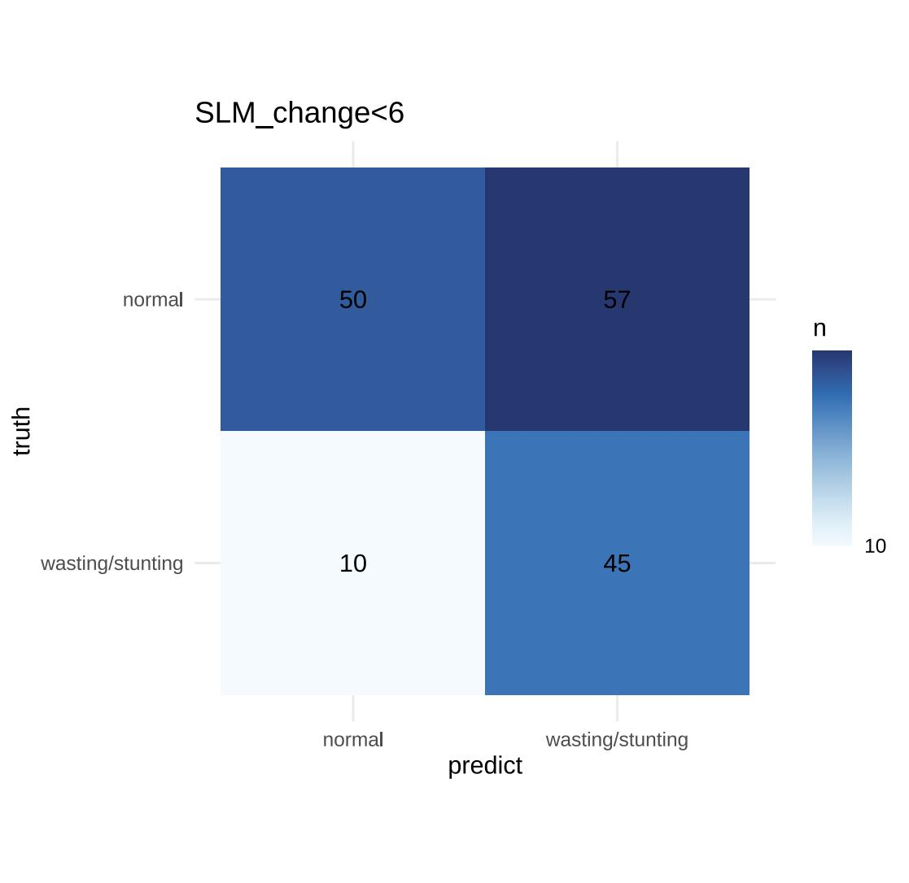

Additional file 5: Confusion matrix for diagnostic performanc of SMM<9

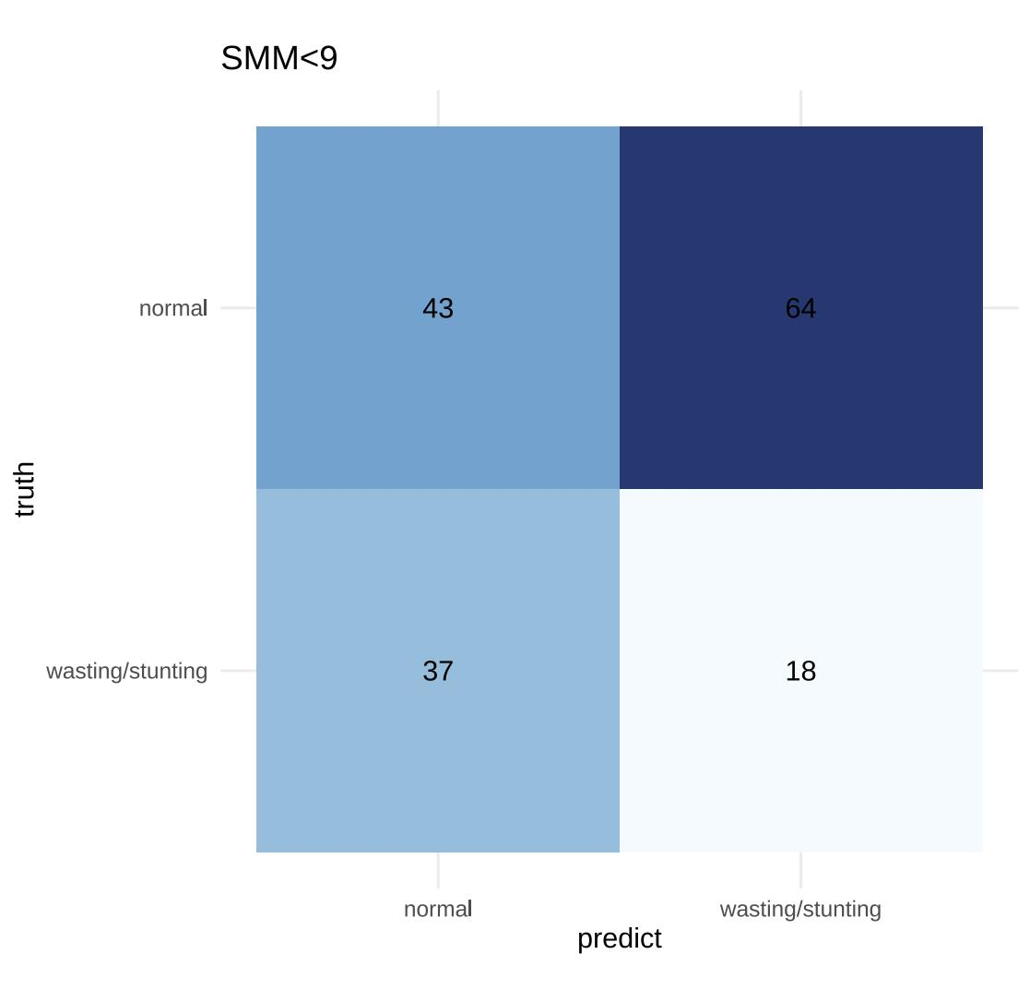

Additional file 6: Confusion matrix for diagnostic performanc of SMM-change < 3

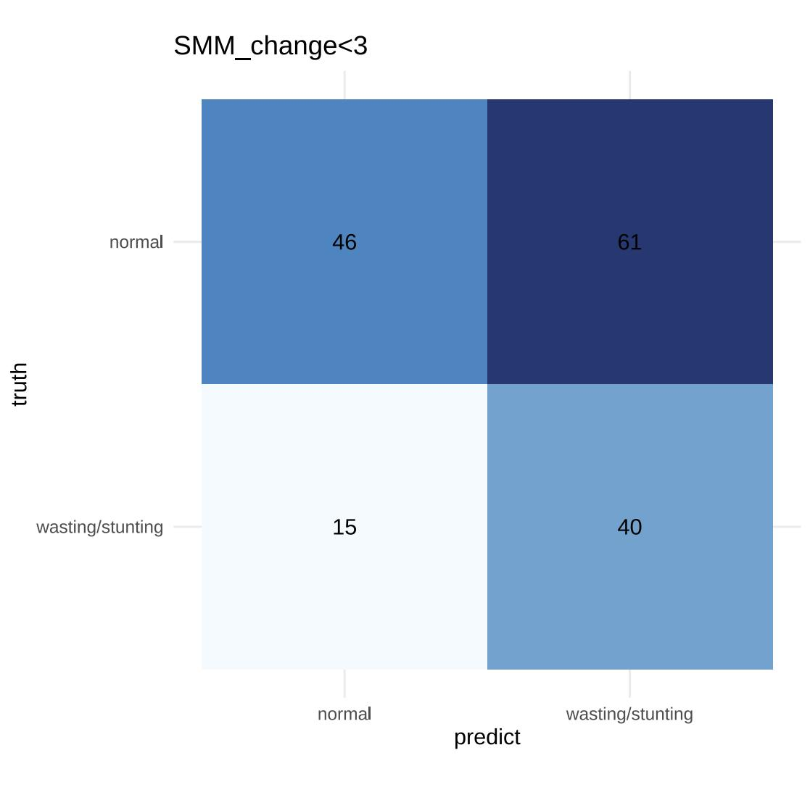

Additional file 7: Youden index analysis for FFM cutoff value determination
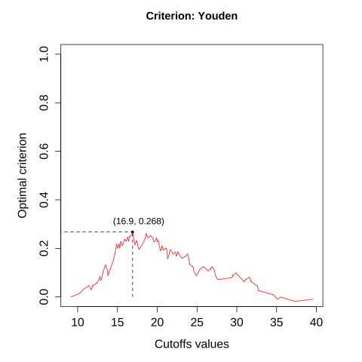

Additional file 8: Youden index analysis for FFM-change cutoff value determination
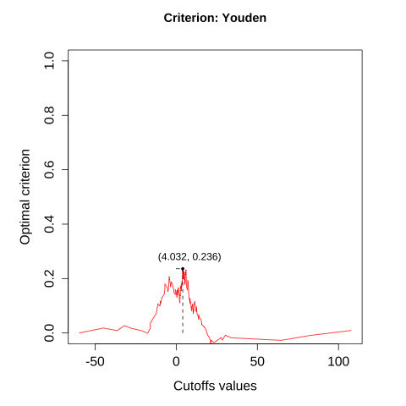

Additional file 9: Youden index analysis for SLM cutoff value determination
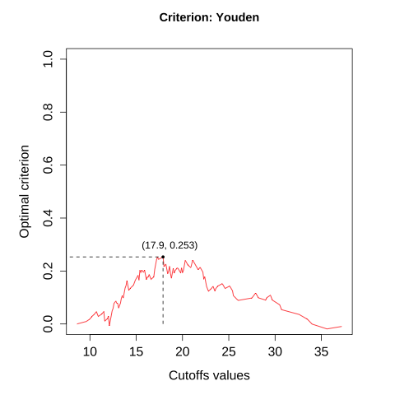

Additional file 10: Youden index analysis for SLM-chang cutoff value determination
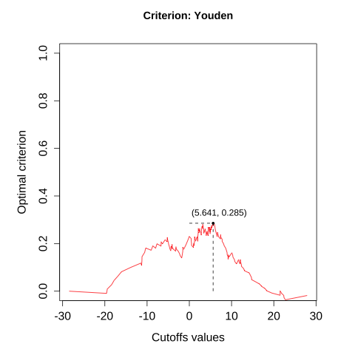

Additional file 11: Youden index analysis for SMM cutoff value determination
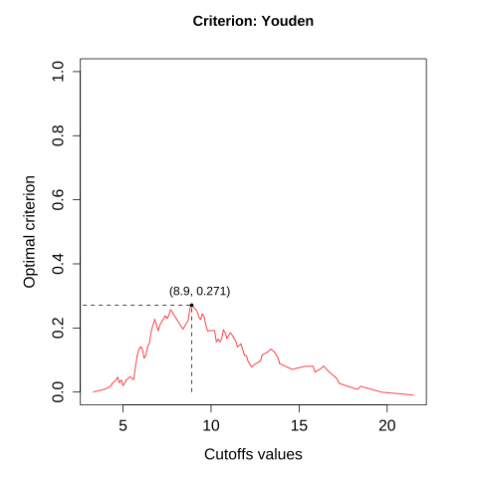

Additional file 12: Youden index analysis for SMM-change cutoff value determination
