Title: Associations between sepsis occurrence, hemoglobin level and mortality in patients with non-trauma hemorrhagic brain injuries: trajectory based analysis

Supporting Information
Figure S1. Flowchart of patient selection
Table S1. Selection process of hemoglobin-based trajectory models in HBI and HBI-with-sepsis cohorts
Figure S2. Hemoglobin-based trajectories in patients without vasopressor-use
Table S2. Comparison between Hemoglobin-based trajectories patients without sepsis
Table S3. Comparison between Hemoglobin-based trajectories patients with sepsis
Table S4. Associations between hemoglobin trajectories and 28-day mortality in multivariable logistic regression models
Figure S3. The 28-day survival probability curve of patients without Sepsis
Figure S4. The 28-day survival probability curve of patients with Sepsis
Table S5. Interaction effect between hemoglobin trajectories and RBC Transfusion
Table S6. Associations between hemoglobin trajectories and 28-day mortality in patients without vasopressor-use
Table S7. Associations between hemoglobin trajectories and 28-day mortality in multivariable COX regression models
Figure S1 flowchart of patient selection
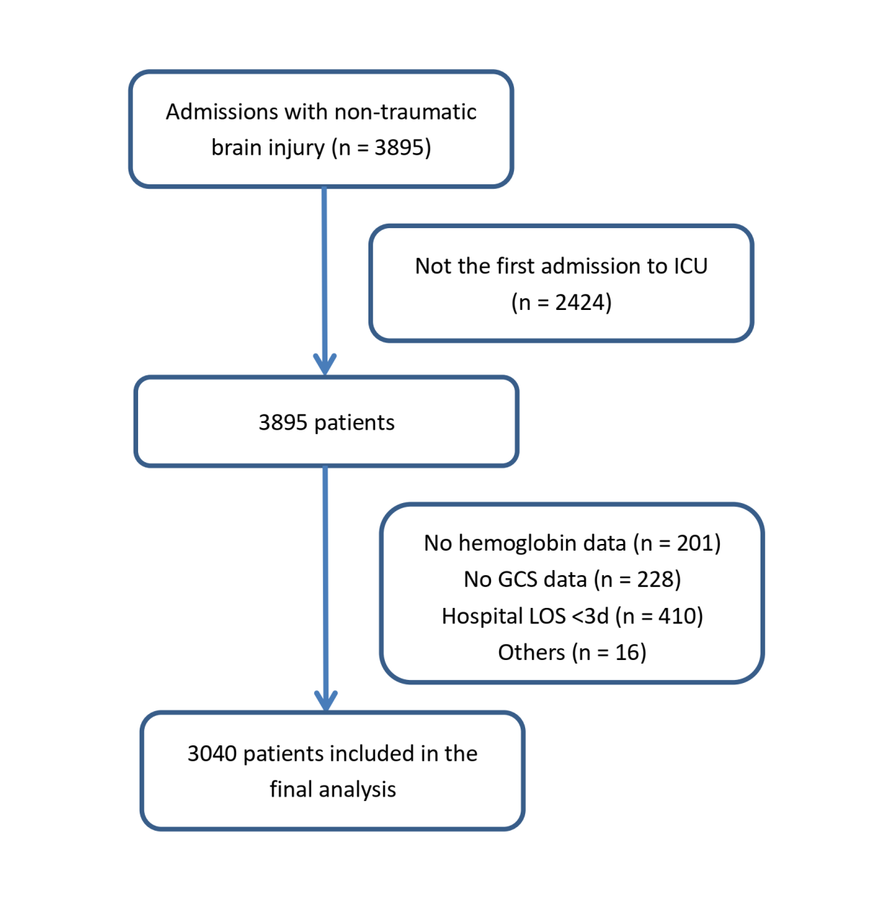

Table S1 Selection process of hemoglobin-based trajectory models in HBI and HBI-with-sepsis cohorts
HBI without sepsis cohort
HGB-based trajectory model | BIC | AvePP
HGB-based trajectory model | BIC | Traj-1 | Traj-2 | Traj-3 | Traj-4
One trajectory | -13715 | 1.00 ± 0.00 (n = 1978)
Two trajectories | -12158 | 0.93 ± 0.13 (n = 673) | 0.95 ± 0.10 (n = 1305)
Three trajectories | -11212 | 0.95 ± 0.10 (n = 297) | 0.92 ± 0.13 (n = 1025) | 0.93 ± 0.12 (n = 656)
Four trajectories | -10777 | 0.95 ± 0.11 (n = 215) | 0.91 ± 0.13 (n = 697) | 0.91 ± 0.12 (n = 783) | 0.90 ± 0.14 (n = 283)
Five trajectories | NS. | - | - | - | -
HBI with sepsis cohort
HGB-based trajectory model | BIC | AvePP
HGB-based trajectory model | BIC | Traj-1 | Traj-2 | Traj-3 | Traj-4
One trajectory | -10179 | 1.00 ± 0.00 (n = 1062)
Two trajectories | -8774 | 0.94 ± 0.12 (n = 379) | 0.97 ± 0.09 (n = 683)
Three trajectories | -8170 | 0.96 ± 0.09 (n = 240) | 0.93 ± 0.12 (n = 523) | 0.93 ± 0.12 (n = 299)
Four trajectories | -7904 | 0.94 ± 0.11 (n = 102) | 0.89 ± 0.14 (n = 276) | 0.92 ± 0.13 (n = 464) | 0.94 ± 0.12 (n = 220)
Five trajectories | NS. | - | - | - | -
Note: the trajectory models remained significant until the fifth trajectory was added in the model. Therefore, four HGB trajectories were kept in the final model.
Abbreviations: HGB hemoglobin; BIC Bayesian information criterion; AvePP average posterior probability; NS the fifth trajectory was not significant.
Table S2. Comparison between Hemoglobin-based trajectories patients without sepsis

Demographics | Traj 1  (n = 215) | Traj 2  (n = 697) | Traj 3  (n = 783) | Traj 4  (n = 283) | p
Age (years) | 70.94 ± 15.00 | 69.36 ± 16.05 | 65.64 ± 15.47 | 62.76 ± 15.69 | <0.001
Weight (kg) | 72.42 (18.57 | 73.33 (18.28 | 81.53 (21.29 | 90.44 (21.97 | <0.001
Male [n (%)] | 120 (55.81) | 354 (50.79) | 555 (70.88) | 252 (89.05) | <0.001
Comorbidities
Hypertension [n (%)] | 103 (47.91) | 410 (58.82) | 493 (62.96) | 178 (62.90) | 0.001
Diabetes mellitus [n (%)] | 64 (29.77) | 136 (19.51) | 146 (18.65) | 59 (20.85) | 0.004
Coronary diseases [n (%)] | 41 (19.07) | 96 (13.77) | 99 (12.64) | 30 (10.60) | 0.04
Subarachnoid hemorrhage[n (%)] | 44 (20.47) | 206 (29.56) | 190 (24.27) | 49 (17.31) | <0.001
Cirrhosis (%) | 13 (6.05) | 9 (1.29) | 4 (0.51) | 3 (1.06) | <0.001
Laboratory indexes
Initial white blood cell count (10^9/L) | 10.09 ± 4.22 | 9.88 ± 3.66 | 10.13 ± 3.47 | 10.44 ± 3.58 | 0.174
Initial hemoglobin level (g/dl) | 9.07 ± 1.25 | 11.43 ± 0.92 | 13.09 ± 0.88 | 14.87 ± 1.01 | <0.001
Initial platelet count (10^9/L) | 224.92 ± 120.38 | 223.44 ± 73.11 | 219.62 ± 64.47 | 220.46 ± 67.78 | 0.702
Initial serum creatinine (mg/dl) | 1.40 ± 1.51 | 0.94 ± 0.87 | 0.87 ± 0.31 | 0.91 ± 0.26 | <0.001
Treatment
Vasopressor-use [n (%)] | 9 (4.19) | 11 (1.58) | 6 (0.77) | 3 (1.06) | 0.003
RBC Transfussion[n (%)] | 33 (15.35) | 11 (1.58) | 3 (0.38) | 1 (0.35) | <0.001
Clinical evaluation
GCS at ICU admission [median (IQR)] | 14.00 [12.00, 15.00] | 14.00 [13.00, 15.00] | 15.00 [14.00, 15.00] | 15.00 [14.00, 15.00] | <0.001
GCS at ICU discharge [median (IQR)] | 14.00 [11.00, 15.00] | 15.00 [14.00, 15.00] | 15.00 [14.00, 15.00] | 15.00 [14.00, 15.00] | <0.001
Maximum GCS [median (IQR)] | 15.00 [14.00, 15.00] | 15.00 [14.00, 15.00] | 15.00 [15.00, 15.00] | 15.00 [15.00, 15.00] | <0.001
SAPS II at ICU admission [median (IQR)] | 38.00 [30.00, 45.00] | 31.00 [25.00, 38.00] | 27.00 [22.00, 33.00] | 24.00 [20.00, 31.00] | <0.001
Maximum SOFA [median (IQR)] | 4.00 [2.00, 5.00] | 3.00 [2.00, 4.00] | 2.00 [1.00, 3.00] | 2.00 [1.00, 3.00] | <0.001
ICU LOS (days) | 3.01 [1.69, 6.53] | 3.60 [1.87, 6.96] | 3.16 [1.75, 5.90] | 3.28 [1.70, 5.86] | 0.101
Hospital LOS (days) | 10.46 [5.90, 16.96] | 8.75 [5.71, 13.83] | 7.67 [4.96, 11.71] | 6.92 [4.73, 10.92] | <0.001
Poor neurologic outcome [n (%)] | 42 (19.53) | 60 (8.61) | 35 (4.47) | 12 (4.24) | <0.001
28-day mortality [n (%)] | 33 (15.35) | 47 (6.74) | 29 (3.70) | 9 (3.18) | <0.001
90-day mortality [n (%)] | 35 (16.28) | 47 (6.74) | 30 (3.83) | 9 (3.18) | <0.001

Table S3. Comparison between Hemoglobin-based trajectories patients with sepsis
Demographics | Traj 1  (n = 102) | Traj 2  (n = 276) | Traj 3  (n = 464) | Traj 4  (n = 220) | p
Age (years) | 64.63 (17.96) | 69.33 (15.37) | 65.87 (14.70) | 64.10 (15.13) | 0.004
Weight (kg) | 75.13 (20.42) | 73.65 (21.65) | 80.57 (19.82) | 86.56 (21.68) | <0.001
Male [n (%)] | 58 (56.86) | 132 (47.83) | 302 (65.09) | 191 (86.82) | <0.001
Comorbidities
Hypertension [n (%)] | 40 (39.22) | 141 (51.09) | 283 (60.99) | 149 (67.73) | <0.001
Diabetes mellitus [n (%)] | 33 (32.35) | 74 (26.81) | 109 (23.49) | 47 (21.36) | 0.136
Coronary diseases [n (%)] | 17 (16.67) | 45 (16.30) | 49 (10.56) | 26 (11.82) | 0.085
Subarachnoid hemorrhage[n (%)] | 20 (19.61) | 87 (31.52) | 146 (31.47) | 59 (26.82) | 0.073
Cirrhosis (%) | 12 (11.76) | 13 (4.71) | 11 (2.37) | 7 (3.18) | <0.001
Laboratory indexes
Initial white blood cell count (10^9/L) | 11.43 (6.57) | 11.68 (4.65) | 11.85 (4.60) | 12.35 (4.72) | 0.337
Initial hemoglobin level (g/dl) | 8.28 (1.15) | 10.52 (1.12) | 12.41 (0.99) | 14.32 (1.18) | <0.001
Initial platelet count (10^9/L) | 191.73 (126.11) | 222.76 (109.47) | 210.12 (74.77) | 218.73 (76.06) | 0.018
Initial serum creatinine (mg/dl) | 1.19 (0.84) | 1.19 (1.29) | 0.99 (0.67) | 0.99 (0.33) | 0.004
Treatment
Vasopressor-use [n (%)] | 21 (20.59) | 34 (12.32) | 36 (7.76) | 13 (5.91) | <0.001
RBC Transfussion[n (%)] | 47 (46.08) | 33 (11.96) | 8 (1.72) | 2 (0.91) | <0.001
Clinical evaluation
GCS at ICU admission [median (IQR)] | 12.00 [8.25, 15.00] | 12.00 [8.00, 14.00] | 12.00 [8.00, 14.00] | 12.00 [9.00, 14.00] | 0.72
GCS at ICU discharge [median (IQR)] | 13.00 [3.00, 15.00] | 13.00 [7.00, 15.00] | 14.00 [10.00, 15.00] | 14.00 [10.00, 15.00] | 0.671
Maximum GCS [median (IQR)] | 15.00 [14.00, 15.00] | 15.00 [14.00, 15.00] | 15.00 [14.00, 15.00] | 15.00 [13.00, 15.00] | 0.297
SAPS II at ICU admission [median (IQR)] | 37.00 [32.00, 47.75] | 38.50 [31.00, 48.00] | 35.00 [28.00, 42.00] | 32.00 [25.00, 41.00] | <0.001
Maximum SOFA [median (IQR)] | 5.00 [4.00, 8.00] | 5.00 [3.00, 6.00] | 4.00 [3.00, 6.00] | 4.00 [3.00, 6.00] | <0.001
ICU LOS (days) | 7.15 [3.81, 13.12] | 7.74 [3.96, 15.00] | 9.09 [4.57, 15.48] | 8.41 [4.13, 16.59] | 0.176
Hospital LOS (days) | 15.56 [8.59, 25.98] | 15.92 [8.70, 23.70] | 14.85 [9.00, 23.05] | 15.23 [8.03, 26.18] | 0.912
Poor neurologic outcome [n (%)] | 31 (30.39) | 77 (27.90) | 104 (22.41) | 46 (20.91) | 0.099
28-day mortality [n (%)] | 24 (23.53) | 57 (20.65) | 72 (15.52) | 32 (14.55) | 0.069
90-day mortality [n (%)] | 25 (24.51) | 58 (21.01) | 74 (15.95) | 32 (14.55) | 0.051

Table S4 Associations between hemoglobin trajectories and 28-day mortality in multivariable logistic regression models

HBI without sepsis cohort (n = 1978) |  |  | HBI with sepsis cohort (n = 1062)
Variables | Adjusted OR (95% CI) | p | Variables | Adjusted OR(95% CI) | p
Traj-1 | Ref. | - | Traj-1 | Ref. | -
Traj-2 | 0.56 (0.33 – 0.96) | 0.035 | Traj-2 | 1.06 (0.59 – 1.90) | 0.855
Traj-3 | 0.33 (0.18 – 0.59) | <0.001 | Traj-3 | 0.82 (0.47 – 1.45) | 0.504
Traj-4 | 0.26 (0.11 – 0.59) | 0.001 | Traj-4 | 0.78 (0.41 – 1.47) | 0.437
Cirrhosis | 2.62 (0.96 – 7.11) | 0.059 | Cirrhosis | 3.39 (1.18 – 4.87) | 0.016
Hypertension | 1.74 (1.12 – 2.70) | 0.013 | Hypertension | 1.18 (0.83 – 1.68) | 0.351
SOFA score on admission | 1.21 (1.05 – 1.38) | 0.006 | SOFA score on admission | 1.01 (0.91 – 1.12) | 0.845
Initial WBC count | 1.13 (1.07 – 1.18) | < 0.001 | Initial WBC count | 1.06 (1.02– 1.09) | 0.001
Initial creatinine level | 1.27 (1.08 – 1.49) | 0.004 | Initial creatinine level | 1.43 (1.20 – 1.70) | < 0.001
Initial platelet count | 0.994 (0.991 – 0.997) | < 0.001 | Initial platelet count | 0.996 (0.994 – 0.998) | 0.001
Vasoactive agents usage | 4.22 (1.62 – 11.03) | 0.003 | Vasoactive agents usage | 2.13 (1.29 – 3.50) | 0.003
Note: Associations between HGB trajectories and 28-day mortality were investigated in HBI cohort and HBI-with-sepsis cohorts. Compared to the OR of Traj-1, there was a stepwise increasing trend of OR from Traj-2 to Traj-4 in HBI cohort, while this trend was not significant in HBI-with-sepsis cohort. The VIF was 3.38 and 3.16 in these two models, respectively.
Abbreviations: HGB hemoglobin; HBI intracranial hemorrhage; SOFA sequential organ failure assessment; WBC white blood cell; VIF variance inflation factor; OR odds ratio; CI confidence interval.

Table S5 Interaction between hemoglobin trajectories and RBC Transfusion

Sepsis | Subgroup | Group | Count | Adjusted OR (95% CI) | p for interaction
Without sepsis | RBC Transfusion |  | 47 |  | 0.779
 |  | Traj-1 | 33 | Ref.
 |  | Traj-2 | 11
 |  | Traj-3 | 3
 |  | Traj-4 | 1
 | No RBC Transfusion |  | 1930
 |  | Traj-1 | 182 | Ref.
 |  | Traj-2 | 686 | 0.53 (0.30 – 0.94)
 |  | Traj-3 | 780 | 0.31 (0.17 – 0.59)
 |  | Traj-4 | 282 | 0.26 (0.11 – 0.59)
With sepsis | RBC Transfusion |  | 90 |  | 0.665
 |  | Traj-1 | 47 | Ref.
 |  | Traj-2 | 33
 |  | Traj-3 | 8
 |  | Traj-4 | 2
 | No RBC Transfusion |  | 972
 |  | Traj-1 | 55 | Ref.
 |  | Traj-2 | 243 | 1.15 (0.52 – 2.56)
 |  | Traj-3 | 456 | 0.89 (0.41 – 1.94)
 |  | Traj-4 | 218 | 0.82 (0.36 – 1.90)
Note: In the multivariate logistic model, confounders including initial white blood cell count, creatinine level, platelet , SOFA on ICU admission, Hypertension, Cirrhosis and vasopressor-usage in first 3 days were included in the HGB trajectory assignment model.
Abbreviations: HGB hemoglobin; HBI, hemorrhagic brain injury; RBC, Red Blood Cell; CI 95% confidence interval; OR, Odds Ratio.

Figure S2 Hemoglobin-based trajectories in patients without vasopressor-use

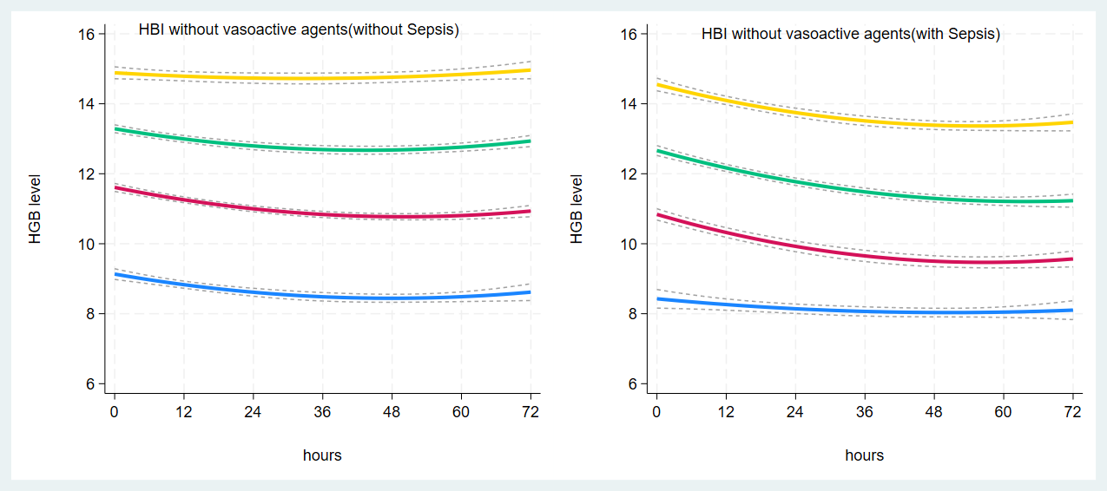Abbreviations: HGB, hemoglobin; HBI intracranial hemorrhage.

Table S6 Associations between hemoglobin trajectories and 28-day mortality in patients without vasopressor-use

HBI without sepsis cohort (n = 1949) |  |  | HBI-with-sepsis (n = 958)
Variables | Adjusted OR (95% CI) | p | Variables | Adjusted OR (95% CI) | p
Traj-1 | Ref. | - | Traj-1 | Ref. | -
Traj-2 | 0.61 (0.35 – 1.05) | 0.075 | Traj-2 | 1.10 (0.59 – 2.04) | 0.775
Traj-3 | 0.35 (0.19 – 0.64) | 0.001 | Traj-3 | 0.86 (0.47 – 1.55) | 0.607
Traj-4 | 0.22(0.09 – 0.54) | 0.001 | Traj-4 | 0.83 (0.42 – 1.61) | 0.574
Cirrhosis | 2.70 (0.98 – 7.45) | 0.054 | Cirrhosis | 3.03 (1.43 – 6.41) | 0.004
Hypertension | 1.75 (1.12 – 2.75) | 0.014 | Hypertension | 1.12 (0.77 – 1.63) | 0.567
SOFA score on admission | 1.23 (1.07 – 1.42) | 0.006 | SOFA score on admission | 0.98 (0.86 – 1.12) | 0.820
Initial WBC count | 1.13 (1.07 – 1.18) | < 0.001 | Initial WBC count | 1.06 (1.02 – 1.10) | 0.004
Initial creatinine level | 1.25 (1.06 – 1.48) | 0.009 | Initial creatinine level | 1.36 (1.13 – 1.64) | 0.001
Initial platelet count | 0.994 (0.992 – 0.998) | 0.001 | Initial platelet count | 0.997 (0.995 – 0.999) | 0.014
Note: Sensitivity analysis was performed in patients without vasopressor use. In HBI cohort, there was a stepwise increasing trend of OR from Traj-2 to Traj-4, compared to the OR of Traj-1. In HBI-with-sepsis cohort, this association was non-significant.
Abbreviations: HGB hemoglobin; HBI intracranial hemorrhage; SOFA sequential organ failure assessment; WBC white blood cell; OR odds ratio; CI confidence interval.

Table S7 Associations between hemoglobin trajectories and 28-day mortality in multivariable COX regression models

HBI without sepsis cohort (n = 1978) |  |  | HBI with sepsis cohort (n = 1062)
Variables | Adjusted HR (95% CI) | p | Variables | Adjusted HR(95% CI) | p
Traj-1 | Ref. | - | Traj-1 | Ref. | -
Traj-2 | 0.56 (0.35 – 0.89) | 0.014 | Traj-2 | 1.12 (0.68 – 1.83) | 0.664
Traj-3 | 0.34 (0.20 – 0.58) | <0.001 | Traj-3 | 0.95 (0.58 – 1.55) | 0.837
Traj-4 | 0.29 (0.13 – 0.63) | 0.002 | Traj-4 | 0.89 (0.51 – 1.56) | 0.678
Cirrhosis | 1.64 (0.69 – 3.84) | 0.265 | Cirrhosis | 3.39 (1.18 – 4.87) | 0.016
Hypertension | 1.63 (1.09 – 2.44) | 0.017 | Hypertension | 1.17 (0.85 – 1.60) | 0.340
SOFA score on admission | 1.19 (1.05 – 1.14) | 0.006 | SOFA score on admission | 1.04 (0.96 – 1.13) | 0.343
Initial WBC count | 1.10 (1.05 – 1.14) | < 0.001 | Initial WBC count | 1.05 (1.02– 1.08) | 0.001
Initial creatinine level | 1.18 (1.04 – 1.35) | 0.013 | Initial creatinine level | 1.33 (1.19 – 1.49) | < 0.001
Initial platelet count | 0.995 (0.992 – 0.997) | < 0.001 | Initial platelet count | 0.996 (0.994 – 0.998) | 0.001
Vasoactive agents usage | 3.09 (1.39 – 6.86) | 0.006 | Vasoactive agents usage | 1.85 (1.23 – 2.79) | 0.003
Note: Associations between HGB trajectories and 28-day mortality were investigated in HBI cohort and HBI-with-sepsis cohorts. Compared to the OR of Traj-1, there was a stepwise increasing trend of OR from Traj-2 to Traj-4 in HBI cohort, while this trend was not significant in HBI-with-sepsis cohort. The VIF was 3.38 and 3.16 in these two models, respectively.
Abbreviations: HGB hemoglobin; HBI intracranial hemorrhage; SOFA sequential organ failure assessment; WBC white blood cell; VIF variance inflation factor; OR odds ratio; CI confidence interval.

Figure S3 The 28-day survival probability curve of patients without Sepsis
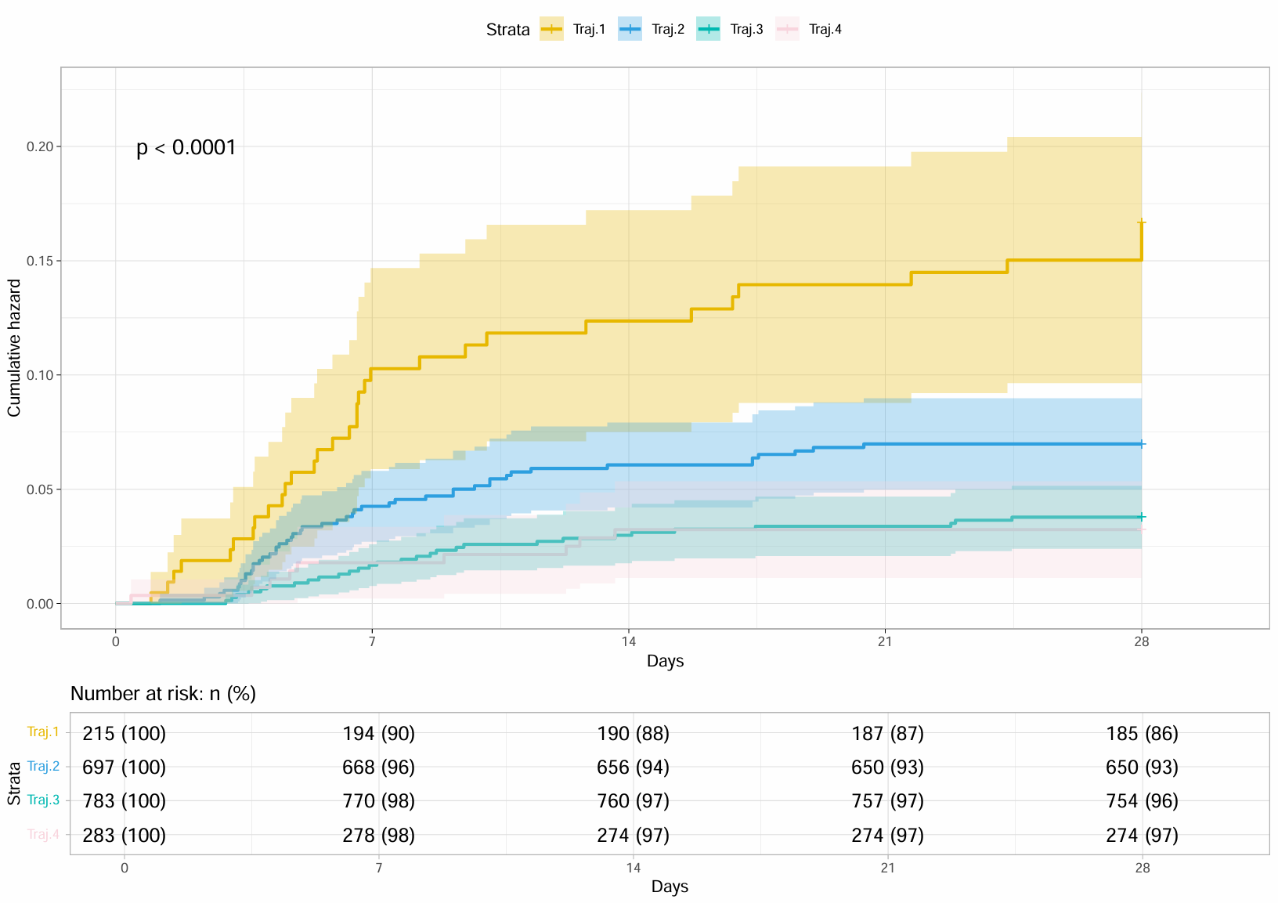
Figure S4 The 28-day survival probability curve of patients with Sepsis
