Supplementary Material
Supplementary Figure S1: Risk of bias for the studies included in this network meta-analysis.
Supplementary Figure S2. Funnel plots, Egger’s publication bias plot of different endpoints. A: Funnel plots and Egger’s publication of overall survival. B：Funnel plots and Egger’s publication of recurrence-free survival. C: Funnel plots and Egger’s publication of complete remission. D: Funnel plots and Egger’s publication of complete remission with incomplete blood count recovery. E: Funnel plots and Egger’s publication of overall response rate.
Supplementary Table S1 Brief table of the various medication included in RCTs
Supplementary Table S2 Search strategies.
Supplementary Table S3 Quality assessment for cohort studies.

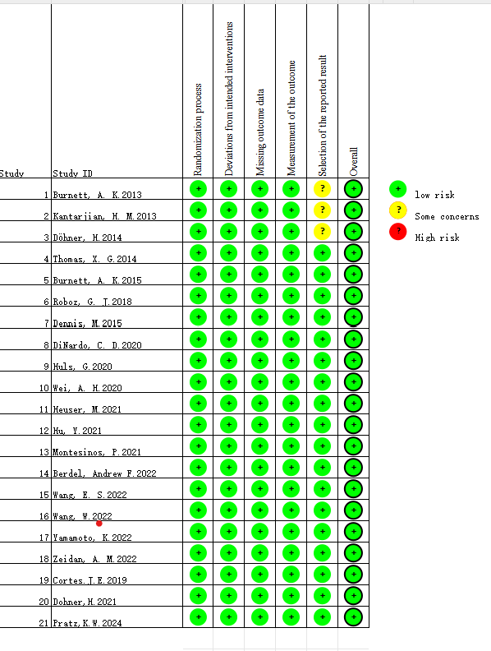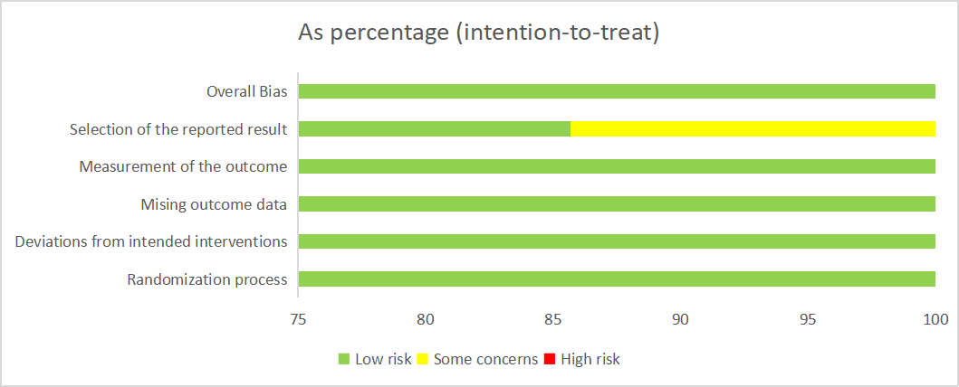
Supplementary Figure S1: Risk of bias for the studies included in this network meta-analysis.

(A)
(B)
(C)
(D)
(E)
Supplementary Figure 2. Funnel plots, Egger’s publication bias plot of different endpoints. A: Funnel plots and Egger’s publication of overall survival. B：Funnel plots and Egger’s publication of recurrence-free survival. C: Funnel plots and Egger’s publication of complete remission. D: Funnel plots and Egger’s publication of complete remission with incomplete blood count recovery. E: Funnel plots and Egger’s publication of overall response rate.

Supplementary Tables
Supplementary Table S1 Brief table of the various medication included in RCTs.
Name | Brief description of action
Gemtuzumab Ozogamicin | An antibody-drug conjugate targeting CD33, delivering a cytotoxic agent (calicheamicin) to induce DNA strand breaks and apoptosis in CD33-positive leukemic cells.
Barasertib | An Aurora B kinase inhibitor that disrupts mitosis, leading to apoptosis in proliferating cancer cells.
Volasertib | A Polo-like kinase inhibitor that induces mitotic arrest and apoptosis in cancer cells.
Sapacitabine | An oral nucleoside analog that causes DNA single-strand breaks, leading to apoptosis in cancer cells.
Vosaroxin | A quinolone derivative that intercalates DNA and inhibits topoisomerase II, leading to DNA damage and apoptosis.
Bortezomib | A proteasome inhibitor that disrupts protein degradation pathways, leading to apoptosis in cancer cells.
Glasdegib | A Hedgehog pathway inhibitor that disrupts cancer stem cell maintenance and survival.
Venetoclax | A BCL-2 inhibitor that restores apoptosis in cancer cells by inhibiting the anti-apoptotic protein BCL-2.
Ibrutinib | A Bruton’s tyrosine kinase inhibitor that impairs B-cell receptor signaling, leading to apoptosis in malignant B cells.
Talacotuzumab | An anti-CD123 monoclonal antibody that targets leukemic stem cells for immune-mediated destruction.
Nintedanib | A tyrosine kinase inhibitor targeting multiple receptors, including VEGFR, FGFR, and PDGFR, leading to inhibition of angiogenesis and tumor growth.
Gilteritinib | A FLT3 and AXL kinase inhibitor that targets mutations driving proliferation in AML cells.
Durvalumab | An anti-PD-L1 monoclonal antibody that enhances T-cell-mediated immune responses against tumor cells.
Azacitidine | A hypomethylating agent that incorporates into DNA and RNA, leading to gene reactivation and inhibition of tumor cell proliferation.
Decitabine | A hypomethylating agent that incorporates into DNA, leading to hypomethylation and apoptosis of cancer cells.
Low-dose Cytarabine | A nucleoside analog that inhibits DNA synthesis, leading to apoptosis in rapidly dividing cells.

Supplementary Table S2 Search strategies.
Search number | Query
1 | "Leukemia, Myeloid, Acute"
2 | "ANLL"ti,ab. OR "Acute Myeloblastic Leukemia"ti,ab. OR "Acute Myelocytic Leukemia"ti,ab.OR "Acute Nonlymphoblastic Leukemia"ti,ab. OR "Acute Nonlymphocytic Leukemia"ti,ab. OR "Acute Myelogenous Leukemia"ti,ab. OR "Acute Myeloid Leukemia"ti,ab. OR "acute granulocytic leukaemia"ti,ab. OR "acute granulocytic leukemia"ti,ab. OR "acute myeloblastic leukaemia"ti,ab. OR "acute myelocytic leukaemia"ti,ab. OR "acute myelogenous leukaemia"ti,ab. OR "acute myeloid leukaemia"ti,ab. OR "acute nonlymphoblastic leukaemia"ti,ab. OR "acute nonlymphocytic leukaemia"ti,ab.
3 | "Leukemia, Myeloid, Acute" OR "ANLL"ti,ab. OR "Acute Myeloblastic Leukemia"ti,ab. OR "Acute Myelocytic Leukemia"ti,ab. OR "Acute Nonlymphoblastic Leukemia"ti,ab. OR "Acute Nonlymphocytic Leukemia"ti,ab. OR "Acute Myelogenous Leukemia"ti,ab. OR "Acute Myeloid Leukemia"ti,ab. OR "acute granulocytic leukaemia"ti,ab. OR "acute granulocytic leukemia"ti,ab. OR "acute myeloblastic leukaemia"ti,ab. OR "acute myelocytic leukaemia"ti,ab. OR "acute myelogenous leukaemia"ti,ab. OR "acute myeloid leukaemia"ti,ab. OR "acute nonlymphoblastic leukaemia"ti,ab. OR "acute nonlymphocytic leukaemia"ti,ab.
4 | "Aged"
5 | "Aged"ti,ab. OR "Elderly"ti,ab. OR "Old people"ti,ab. OR "Old person"ti,ab. OR "Older"ti,ab. OR "Over 65"ti,ab. OR "senior citizen"ti,ab. OR "Senium"ti,ab. OR "advanced years"ti,ab. OR "aged patient"ti,ab. OR "aged people"ti,ab. OR "aged person"ti,ab. OR "aged subject"ti,ab. OR "elderly patient"ti,ab. OR "elderly people"ti,ab. OR "elderly person"ti,ab. OR "elderly subject"ti,ab. OR "senior citizen"ti,ab.
6 | "Aged" OR "Aged"ti,ab. OR "Elderly"ti,ab. OR "Old people"ti,ab. OR "Old person"ti,ab. OR "Older"ti,ab.OR "Over 65"ti,ab. OR "senior citizen"ti,ab. OR "Senium"ti,ab. OR "advanced years"ti,ab. OR "aged patient"ti,ab. OR "aged people"ti,ab. OR "aged person"ti,ab. OR "aged subject"ti,ab. OR "elderly patient"ti,ab. OR "elderly people"ti,ab. OR "elderly person"ti,ab. OR "elderly subject"ti,ab. OR "senior citizen"ti,ab.
7 | "Randomized controlled trial"ti,ab. OR "Random"ti,ab. OR "controlled trial"ti,ab. OR "randomised controlled study"ti,ab. OR "randomised controlled trial"ti,ab. OR "randomized controlled study"ti,ab. OR "RCT"ti,ab.
8 | "Cohort Studies"
9 | "Cohort analysis"ti,ab. OR "cohort fertility"ti,ab. OR "cohort life cycle"ti,ab. OR "cohort study"ti,ab. OR "Concurrent Study"ti,ab. OR "Closed Cohort Study"ti,ab. OR "Cohort Analyses"ti,ab. OR "Historical Cohort Study"ti,ab. OR "Incidence Study"ti,ab. OR "longitudinal studies"ti,ab. OR "follow-up studies"ti,ab. OR "prospective studies"ti,ab. OR "retrospective studies"ti,ab.
10 | "Cohort Studies" OR "Cohort analysis"ti,ab. OR "cohort fertility"ti,ab. OR "cohort life cycle"ti,ab. OR "cohort study"ti,ab. OR "Concurrent Study"ti,ab. OR "Closed Cohort Study"ti,ab. OR "Cohort Analyses"ti,ab. OR "Historical Cohort Study"ti,ab. OR "Incidence Study"ti,ab. OR "longitudinal studies"ti,ab. OR "follow-up studies"ti,ab. OR "prospective studies"ti,ab. OR "retrospective studies"ti,ab.
11 | "Case-Control Studies"
12 | "matched case control"ti,ab. OR "matched case control study"ti,ab. OR "Case Comparison Study"ti,ab. OR "Case-Compeer Study"ti,ab. OR "Case Referrent Study"ti,ab. OR "Case Referent Study"ti,ab. OR "Case Base Study"ti,ab. OR "Case Control Study"ti,ab. OR "Nested Case Control Study"ti,ab. OR "Matched Case Control Study"ti,ab. OR "Control Groups"ti,ab. OR "Matched-Pair Analysis"ti,ab.
13 | Case-Control Studies" OR "matched case control"ti,ab. OR "matched case control study"ti,ab. OR "Case Comparison Study"ti,ab. OR "Case-Compeer Study"ti,ab. OR "Case Referrent Study"ti,ab. OR "Case Referent Study"ti,ab. OR "Case Base Study"ti,ab. OR "Case Control Study"ti,ab. OR "Nested Case Control Study"ti,ab. OR "Matched Case Control Study"ti,ab. OR "Control Groups"ti,ab. OR "Matched-Pair Analysis"ti,ab.
14 | "Case-Control Studies" OR "matched case control"ti,ab. OR "matched case control study"ti,ab. OR "Case Comparison Study"ti,ab. OR "Case-Compeer Study"ti,ab. OR "Case Referrent Study"ti,ab. OR "Case Referent Study"ti,ab. OR "Case Base Study"ti,ab. OR "Case Control Study"ti,ab. OR "Nested Case Control Study"ti,ab. OR "Matched Case Control Study"ti,ab. OR "Control Groupsti,ab. OR "Matched-Pair Analysis"ti,ab. OR "Cohort Studies" OR "Cohort analysis"ti,ab. OR "cohort fertility"ti,ab. OR "cohort life cycle"ti,ab. OR "cohort study"ti,ab. OR "Concurrent Study"ti,ab. OR "Closed Cohort Study"ti,ab. OR "Cohort Analyses"ti,ab. OR "Historical Cohort Study"ti,ab. OR "Incidence Study"ti,ab. OR "longitudinal studies"ti,ab. OR "follow-up studies"ti,ab. OR "prospective studies"ti,ab. OR "retrospective studies"ti,ab. OR "Randomized controlled trial"ti,ab. OR "Random"ti,ab. OR "controlled trial"ti,ab. OR "randomised controlled study"ti,ab. OR "randomised controlled trial"ti,ab. OR "randomized controlled study"ti,ab. OR "RCT"ti,ab.
15 | "Case-Control Studies" OR "matched case control"ti,ab. OR "matched case control study"ti,ab. OR "Case Comparison Study"ti,ab. OR "Case-Compeer Study"ti,ab. OR "Case Referrent Study"ti,ab. OR "Case Referent Study"ti,ab. OR "Case Base Study"ti,ab. OR "Case Control Study"ti,ab. OR "Nested Case Control Study"ti,ab. OR "Matched Case Control Study"ti,ab. OR "Control Groups"ti,ab. OR "Matched-Pair Analysis"ti,ab. OR "Cohort Studies" OR "Cohort analysis"ti,ab. OR "cohort fertility"ti,ab. OR "cohort life cycle"ti,ab. OR "cohort study"ti,ab. OR "Concurrent Study"ti,ab. OR "Closed Cohort Study"ti,ab. OR "Cohort Analyses"ti,ab. OR "Historical Cohort Study"ti,ab. OR "Incidence Study"ti,ab. OR "longitudinal studies"ti,ab. OR "follow-up studies"ti,ab. OR "prospective studies"ti,ab. OR "retrospective studies"ti,ab. OR "Randomized controlled trial"ti,ab. OR "Random"ti,ab. OR "controlled trial"ti,ab. OR "randomised controlled study"ti,ab. OR "randomised controlled trial"ti,ab. OR "randomized controlled study"ti,ab. OR "RCT"ti,ab. AND "Aged" OR "Aged"ti,ab. OR "Elderly"ti,ab. OR "Old people"ti,ab. OR "Old person"ti,ab. OR "Older"ti,ab. OR "Over 65"ti,ab. OR "senior citizen"ti,ab. OR "Senium"ti,ab. OR "advanced years"ti,ab. OR "aged patient"ti,ab. OR "aged people"ti,ab. OR "aged person"ti,ab. OR "aged subject"ti,ab. OR "elderly patient"ti,ab. OR "elderly people"ti,ab. OR "elderly person"ti,ab. OR "elderly subject"ti,ab. OR "senior citizen"ti,ab. AND "Leukemia, Myeloid, Acute" OR "ANLL"ti,ab. OR "Acute Myeloblastic Leukemia"ti,ab. OR "Acute Myelocytic Leukemia"ti,ab. OR "Acute Nonlymphoblastic Leukemia"ti,ab. OR "Acute Nonlymphocytic Leukemia"ti,ab. OR "Acute Myelogenous Leukemia"ti,ab. OR "Acute Myeloid Leukemia"ti,ab. OR "acute granulocytic leukaemia"ti,ab. OR "acute granulocytic leukemia"ti,ab. OR "acute myeloblastic leukaemia"ti,ab. OR "acute myelocytic leukaemia"ti,ab. OR "acute myelogenous leukaemia"ti,ab. OR "acute myeloid leukaemia"ti,ab. OR "acute nonlymphoblastic leukaemia"ti,ab. OR "acute nonlymphocytic leukaemia"ti,ab.

Supplementary Table S3 Quality assessment for cohort studies.
Study | Year | Selection |  |  |  | Comparability | Outcome | Was follow-up long enough | Adequacy of follow up | Total score
Study | Year | Representativeness of exposed cohort | Representativeness of non-exposed cohort | Ascertainment of exposure | Demonstration that outcome of interest was not present at start of study | Comparability of exposed cohort and non-exposed cohort | Assessment of outcome | Was follow-up long enough | Adequacy of follow up | Total score
Jacob, L. A. | 2015 | 1 | 1 | 1 | 1 | 1 | 1 | 1 | 1 | 8
Pepe,S | 2020 | 1 | 1 | 1 | 1 | 1 | 1 | 1 | 1 | 8
Laloi,L | 2023 | 1 | 1 | 1 | 1 | 0 | 1 | 1 | 1 | 7
Petit,C | 2024 | 1 | 1 | 1 | 1 | 1 | 1 | 1 | 1 | 8
Baba,Y | 2024 | 1 | 1 | 1 | 1 | 1 | 1 | 1 | 1 | 8

