Table S1. Preoperative Baseline Data of Patients Grouped Between the Survivors and Outcomes in the training and internal test sets.
Variables | All patients (%)  171 cases | Missing data | No. of outcomes (%)  53 cases | No. of survivors (%)  118 cases | P value
Demographical data
Gender |  | 0 |  |  | 0.378
Female | 35 (20.47%) |  | 13 (24.53%) | 22 (18.64%)
Male | 136 (79.53%) |  | 40 (75.47%) | 96 (81.36%)
Age( years) | 48.82 ± 9.61 | 0 | 50.43 ± 9.38 | 48.09 ± 9.66 | 0.141
Risk factors
Smoking |  | 0 |  |  | 0.120
No | 69 (40.35%) |  | 26 (49.06 %) | 43 (36.44%)
Yes | 102 (59.65%) |  | 27 (50.94%) | 75 (63.56%)
BMI | 25.32 ± 3.65 | 19 (11.11%) | 25.66 ± 3.46 | 25.17 ± 3.74 | 0.420
HTN |  | 0 |  |  | 0.386
No | 53 (30.99%) |  | 14 (26.42%) | 39 (33.05%)
Yes | 118 (69.01%) |  | 39 (73.58%) | 79 (66.95%)
DM |  | 0 |  |  | 0.501
No | 170 (99.42%) |  | 53 (100%) | 117 (99.15%)
Yes | 1 (0.58%) |  | 0 (0%) | 1 (0.85%)
Previous CAD history |  | 0 |  |  | 0.887
No | 164 (95.91%) |  | 51 (96.23%) | 113 (95.76%)
Yes | 7 (4.09%) |  | 2 (3.77%) | 5 ( 4.24%)
Condition at admission
Phase |  | 0 |  |  | 0.022
Acute | 160 (93.57%) |  | 53 (100%) | 107 (90.68%)
Subacute | 11 (6.43%) |  | 0 (0%) | 11 (9.32%)
Chronic | 4 (2.29) |  | 1 (1.85%) | 3 (2.48%)
SBP (mmHg) | 140.37 ± 31.62 | 0 | 137.98 ± 34.51 | 141.45 ± 30.34 | 0.509
DBP (mmHg) | 80.06 ± 19.55 | 0 | 79.98 ± 22.67 | 80.54 ± 18.06 | 0.630
Shock |  | 0 |  |  | 0.016
No | 160 (93.57%) |  | 46 (86.79%) | 114 (96.61%)
Yes | 11 (6.43%) |  | 7 (13.21%) | 4 (3.39%)
MAP (mmHg) | 100.16 ± 21.97 | 0 | 98.65 ± 24.96 | 100.84 ± 20.57 | 0.547
PP (mmHg) | 60.32 ± 21.77 | 0 | 59.00 ± 22.90 | 60.91 ± 21.31 | 0.598
Heart rate (b.p.m.) | 83.37 ± 14.10 | 0 | 85.85 ± 14.49 | 82.26 ± 13.83 | 0.124
Chest pain |  | 0 |  |  | 0.292
No | 25 (14.62%) |  | 10 (18.87%) | 15 (12.71%)
Yes | 146(85.38%) |  | 43 (81.13%) | 103 (87.29%)
Back pain |  | 0 |  |  | 0.998
No | 71 (41.52%) |  | 22 (41.51%) | 49 (41.53%)
Yes | 100 (58.48%) |  | 31 (58.49%) | 69 (58.47%)
Abdominal pain |  | 0 |  |  | 0.009
No | 154 (90.06%) |  | 43 (81.13%) | 111 (94.07%)
Yes | 17 (9.94%) |  | 10 (18.87%) | 7 (5.93%)
Altered consciousness |  | 0 |  |  | 0.305
No | 165 (96.49%) |  | 50 (94.34%) | 115 (97.46%)
Yes | 6 (3.51%) |  | 3 (5.66%) | 3 (2.54%)
ST-segment deviation on ECG |  | 1 (0.58%) |  |  | 0.633
No | 115 (67.25%) |  | 37 (69.81%) | 78 (66.10%)
Yes | 56 (32.75%) |  | 16 (30.19%) | 40 (33.90%)
Pericardial effusion |  | 0 |  |  | 0.002
No | 98 (57.31%) |  | 21 (39.62%) | 77 (65.25%)
Yes | 73 (42.69%) |  | 32 (60.38%) | 41 (34.75%)
Pleural effusion |  | 0 |  |  | 0.182
No | 87 (50.88%) |  | 31 (58.49%) | 56 (47.46%)
Yes | 84 (49.12%) |  | 22 (41.51%) | 62 (52.54%)
Hospital stay
POHS (days) | 19.45 ± 14.47 | 0 | 10.25 ± 9.65 | 23.50 ± 14.41 | <0.001
ICUHS (days) | 11.90 ± 9.06 | 0 | 9.30 ± 9.05 | 13.07 ± 8.86 | 0.012
Preoperative laboratory results
WBC (×10ˆ9/L) | 12.35 ± 4.28 | 0 | 13.98 ± 4.67 | 11.62 ± 3.89 | <0.001
RBC (×10ˆ9/L) | 4.02 ± 1.18 | 0 | 3.90 ± 1.21 | 4.08 ± 1.16 | 0.361
ANC (×10ˆ9/L) | 10.59 ± 4.30 | 0 | 12.20 ± 4.66 | 9.87 ± 3.93 | <0.001
ALC(×10ˆ9/L) | 0.98 ± 0.52 | 0 | 0.94 ± 0.49 | 1.00 ± 0.53 | 0.479
HB (g/L) | 129.37 ± 22.71 | 0 | 128.04 ± 22.05 | 129.97 ± 22.63 | 0.609
PLT (×10ˆ9/L) | 167.87 ± 58.71 | 0 | 166.87 ± 56.51 | 168.31 ± 59.90 | 0.882
Total Protein (g/L) | 65.11 ± 7.02 | 0 | 65.62 ± 6.50 | 64.88 ± 7.25 | 0.525
ALB (g/L) | 33.71 ± 10.81 | 0 | 32.58 ± 10.87 | 34.22 ± 10.79 | 0.362
ALT (IU/L) | 46.04 ± 124.60 | 0 | 75.23 ± 219.35 | 32.92 ± 24.78 | 0.167
AST (IU/L) | 59.57 ± 171.30 | 0 | 105.26 ± 289.43 | 39.04 ± 63.52 | 0.105
Creatinine (μmol/L) | 98.50 ± 57.87 | 0 | 123.13 ± 84.61 | 87.43 ± 35.85 | 0.004
BUN (mmol/L), | 8.73 ± 15.91 | 0 | 9.53 ± 10.22 | 8.37 ± 17.92 | 0.594
LDH (U/L) | 668.63 ± 974.36 | 0 | 911.77 ± 1624.30 | 559.42 ± 409.9 | 0.028
D-dimer (μg/mL) | 10.28 ± 15.71 | 0 | 12.06 ± 17.38 | 9.48 ± 14.91 | 0.351
Fibrinogen (g/L) | 3.01 ± 1.69 | 0 | 3.00 ± 1.86 | 3.01 ± 1.62 | 0.566
FDP(mg/L) | 41.12 ± 87.77 | 5 (2.92%) | 46.3 ± 97.83 | 38.80 ± 83.2 | 0.629
Myoglobin (μg/L) | 225.72 ± 473.48 | 30 (17.54%) | 164.78 ± 209.76 | 253.09 ± 551.13 | 0.132
CK-MB (U/L) | 3.89 ± 7.01 | 19 (11.11%) | 3.53 ± 4.03 | 4.05 ± 8.00 | 0.578
BNP (pg/mL) | 1016.06 ± 1842.16 | 22 (12.87%) | 1120.77 ± 2255.99 | 969.03 ± 1631.44 | 0.661
cTnT (μg/L) | 0.22 ± 0.79 | 28 (16.37%) | 0.36 ± 1.16 | 0.15 ± 0.54 | 0.116
SII | 2714.73 ± 3554.34 | 0 | 3591.81 ± 5466.09 | 2320.78±2138.23 | 0.030
Intraoperative conditions
Operation time (min) | 557.08 ± 133.1 | 0 | 618.12 ± 166.56 | 530.18 ± 105.41 | <0.001
Intraoperative bleeding (ml) | 671.5 ± 650.17 | 0 | 911.03 ± 928.28 | 563.92 ± 439.97 | 0.012
Transfusion of SRBC (U) | 3.68 ± 2.98 | 0 | 4.52 ± 3.23 | 3.31 ± 2.79 | 0.020
Transfusion of Plasma (ml) | 832.88 ± 382.63 | 0 | 980.03 ± 431.25 | 766.78 ± 340.37 | <0.001
CPB time (min) | 273.97 ± 62.3 | 0 | 292.42 ± 64.12 | 265.69 ± 59.91 | 0.012
ACC time (min) | 161.73 ± 42.8 | 0 | 167.12 ± 29.51 | 159.31 ± 47.49 | 0.192
Abbreviations: POHS Postoperative Hospital Stay, ICUHS Intensive Care Unit Hospital Stay, SBP Systolic Blood Pressure, BMI Body Mass Index, HTN Hypertension, DM Diabetes Mellitus, b.p.m. beats per minute, MAP Mean Arterial Pressure, PP pulse pressure, ECG Electrocardiogram, CAD Coronary Artery Disease, WBC White Blood Cell, RBC Red Blood Cell, PLT Platelet, ANC Absolute Neutrophil Count, ALB Albumin, HB Hemoglobin, ALT Alanine Aminotransferase, AST Aspartate Aminotransferase, BUN Blood Urea Nitrogen, LDH Lactate Dehydrogenase, FDP Fibrin/Fibrinogen Degradation Products, CK-MB Creatine Kinase-Muscle/Brain, BNP B-Type Natriuretic Peptide, cTnT Cardiac Troponin T, SII Systemic Immune-Inflammation index, SRBC Suspended Red Blood Cells, CBP Cardiopulmonary Bypass time, ACC Aortic Cross Clamping time.
Notes: ‘outcome’ was defined as the presence of death under investigation.

Table S2. Preoperative Baseline Data of Patients Grouped Between the Training Set and Test Set.
Variables | Internal Test set  (34 cases) | External Test set (73 cases) | Training set  137 cases | P value
Demographical data
Gender |  |  |  | 0.149*/ 0.124 #
Female | 10(29.41%) | 20 (27.40%) | 25(18.25%)
Male | 24(70.59%) | 53 (72.60%) | 112(81.75%)
Age( years) | 48.35 ± 9.62 | 53.03±12.46 | 49.2±9.49 | 0.648* / 0.185 #
Risk factors
Smoking |  |  |  | 0.913* / 0.065#
No | 14 (41.18%) | 39 (53.42%) | 55 (40.15%)
Yes | 20 (58.82%) | 34 (46.58%) | 82 (59.85%)
BMI | 25.71 ± 4.54 | 24.49 ± 3.8 | 25.36 ± 3.62 | 0.639* / 0.109#
HTN |  |  |  | 0.308* / 0.626#
No | 13 (38.24%) | 19 (26.03%) | 40 (29.20%)
Yes | 21 (61.76%) | 54 (73.97%) | 97 (70.80%)
Condition at admission
Phase (Acute) |  |  |  | 0.055* / 0.188#
No | 0 | 4 (5.48%） | 15 (10.95%)
Yes | 34 (100%) | 69 (94.52%) | 122 (89.05%)
SBP (mmHg) | 152.76 ± 28.17 | 135.6±32.09 | 138.12 ± 31.20 | 0.062* / 0.594#
DBP (mmHg) | 85.62 ± 22.67 | 78.56 ± 21.3 | 79.49 ± 18.65 | 0.152* / 0.754#
Shock |  |  |  | 0.104* / 0.615#
No | 34 (100%) | 69 (94.52%) | 127 (92.70%)
Yes | 0 | 4 (5.48%) | 10 (7.30%)
MAP (mmHg) | 108.0 ± 22.9 | 97.59±22.75 | 99.03 ± 21.19 | 0.144* / 0.656#
PP (mmHg) | 67.15 ± 19.26 | 57.1 ± 24.01 | 58.63 ± 21.97 | 0.059* / 0.651#
Heart rate (b.p.m.) | 85.12 ± 12.26 | 77.99±18.66 | 83.26 ± 14.83 | 0.500* / 0.059#
Chest pain |  |  |  | 0.696* / 0.474#
No | 5 (14.71%) | 10 (13.70%) | 24 (17.52%)
Yes | 29 (85.29%) | 63 (86.30%) | 113 (82.48%)
Back pain |  |  |  | 0.731* / 0.347#
No | 15 (44.12%) | 25 (34.25%) | 56 (40.88%)
Yes | 19 (55.88%) | 48 (65.75%) | 81 (59.12%)
Abdominal pain |  |  |  | 0.179* / 0.868#
No | 33 (97.06%) | 65 (89.04%) | 123 (89.78%)
Yes | 1 (2.94%) | 8 (10.96%) | 14 (10.22%)
Altered consciousness |  |  |  | 0.214* / 0.927#
No | 34 (100%) | 70 (95.89%) | 131 (95.62%)
Yes | 0 (0%) | 3 (4.11%) | 6 (4.38%)
ST-segment deviation on ECG |  |  |  | 0.175* / 0.536#
No | 26 (76.47%) | 50 (68.49%) | 88 (64.23%)
Yes | 8 (25.53%) | 23 (31.51%) | 49 (35.77%)
Pericardial effusion |  |  |  | 0.153* / 0.881#
No | 16 (47.06%) | 45 (63.01%) | 83 (60.58%)
Yes | 18 (52.94%) | 28 (36.99%) | 54 (39.42%)
Pleural effusion |  |  |  | 0.731* / 0.114#
No | 17 (50.00%) | 31 (42.46%) | 73 (53.28%)
Yes | 17 (50.00%) | 43 (58.90%) | 64 (46.72%)
Hospital stay
POHS (days) | 16.53 ± 13.7 | 17.22 ± 10.72 | 19.88 ± 14.51 | 0.226* / 0.134#
ICUHS (days) | 10.35 ± 9.85 | 9.64 ± 6.7 | 12.26 ± 9.11 | 0.311* / 0.208#
Preoperative laboratory results
WBC (×10ˆ9/L) | 12.12 ± 3.87 | 13.49 ± 4.73 | 12.12 ± 4.50 | 0.913* / 0.956#
RBC (×10ˆ9/L) | 4.47 ± 0.86 | 4.15 ± 1.05 | 3.97 ± 1.18 | 0.115* / 0.274#
ANC (×10ˆ9/L) | 10.45 ± 3.9 | 11.55 ± 4.35 | 10.36 ± 4.48 | 0.906* / 0.064#
ALC(×10ˆ9/L) | 0.88 ± 0.53 | 1.25 ± 1.12 | 1.01 ± 0.52 | 0.218* / 0.087#
HB (g/L) | 132.88 ± 27.73 | 131.50 ± 25.00 | 128.09 ± 20.5 | 0.260* / 0.442#
PLT (×10ˆ9/L) | 154.35 ± 45.25 | 173.56 ± 68.31 | 170.98 ± 60.18 | 0.134* / 0.786#
Total Protein (g/L) | 66.62 ± 7.08 | 65.80 ± 7.20 | 64.96 ± 7.05 | 0.228* / 0.564#
ALB (g/L) | 37.15 ± 9.56 | 36.39 ± 3.76 | 33.53 ± 10.75 | 0.059* / 0.269#
ALT (IU/L) | 43.88 ± 77.81 | 41.60±27.82 | 46.54 ± 133.92 | 0.880* / 0.211#
AST (IU/L) | 58.35 ± 114.24 | 47.53 ± 63.62 | 59.52 ± 183.13 | 0.963* / 0.490#
Creatinine (μmol/L) | 119.88 ± 95.87 | 109.22 ± 72.47 | 93.03 ± 41.70 | 0.119* / 0.082#
BUN (mmol/L), | 7.92 ± 5.07 | 8.50 ± 10.00 | 8.96 ± 17.60 | 0.550* / 0.889#
LDH (U/L) | 596.5 ± 362.61 | 650.00±700.25 | 680.88 ± 1075.53 | 0.448* / 0.518#
D-dimer (μg/mL) | 8.14 ± 13.48 | 11.82±11.48 | 10.60 ± 16.27 | 0.365* / 0.740#
Fibrinogen (g/L) | 2.74 ± 1.18 | 2.5 ± 1.45 | 3.09 ± 1.79 | 0.272* / 0.115#
FDP(mg/L) | 27.84 ± 34.44 | 38.73±65.28 | 44.2 ± 96.45 | 0.332* / 0.101#
Myoglobin (μg/L) | 190.16 ± 320.67 | 213.39±412.86 | 234.44 ± 505.42 | 0.528* / 0.255#
CK-MB (U/L) | 4.07 ± 5.06 | 3.95 ± 6.25 | 3.87 ± 7.43 | 0.857* / 0.908#
BNP (pg/mL) | 1239.84 ± 2945.96 | 1098.62±2056.34 | 977.15 ± 1452.92 | 0.458* / 0.640#
cTnT (μg/L) | 0.39 ± 1.21 | 0.28 ± 0.93 | 0.17 ± 0.64 | 0.146* / 0.087#
SII | 2474.16±1957.16 | 2372.18 ± 1774.74 | 2715.71 ± 3855.29 | 0.609* / 0.379#
Intraoperative conditions
Operation time (min) | 559.59 ± 122.83 | 565.58 ± 113.63 | 551.85 ± 141.17 | 0.751* / 0.446#
Intraoperative bleeding (ml) | 726.07 ± 842.76 | 705.23±790.58 | 683.87 ± 743.44 | 0.790* / 0.475#
Transfusion of SRBC (U) | 4.1 ± 2.75 | 3.85±2.95 | 3.56 ± 3.13 | 0.331* / 0.167#
Transfusion of Plasma | 897.21 ± 352.63 | 616.4± 475.0 | 804.54 ± 398.32 | 0.187* / 0.244#
CPB time (min) | 274.91 ± 57.75 | 280.50±65.39 | 276.8 ± 73.20 | 0.873* /0.686#
ACC time (min) | 156.58 ± 29.73 | 161.27±37.46 | 163.19 ± 46.72 | 0.433* / 0.564#

Abbreviations: POHS Postoperative Hospital Stay, ICUHS Intensive Care Unit Hospital Stay, SBP Systolic Blood Pressure, BMI Body Mass Index, HTN Hypertension, b.p.m. beats per minute, MAP Mean Arterial Pressure, PP pulse pressure, ECG Electrocardiogram, CAD Coronary Artery Disease, WBC White Blood Cell, RBC Red Blood Cell, PLT Platelet, ANC Absolute Neutrophil Count, ALB Albumin, HB Hemoglobin, ALT Alanine Aminotransferase, AST Aspartate Aminotransferase, BUN Blood Urea Nitrogen, LDH Lactate Dehydrogenase, FDP Fibrin/Fibrinogen Degradation Products, CK-MB Creatine Kinase-Muscle/Brain, BNP B-Type Natriuretic Peptide, cTnT Cardiac Troponin T, SRBC Suspended Red Blood Cells, CBP Cardiopulmonary Bypass time, ACC Aortic Cross Clamping time.
Notes: P* values indicate comparisons between the internal test set and the training set; P# values indicate comparisons between the external test set and the training set.

Figure S1. Comparison of SVM Model Performance Metrics (Training vs Test sets)
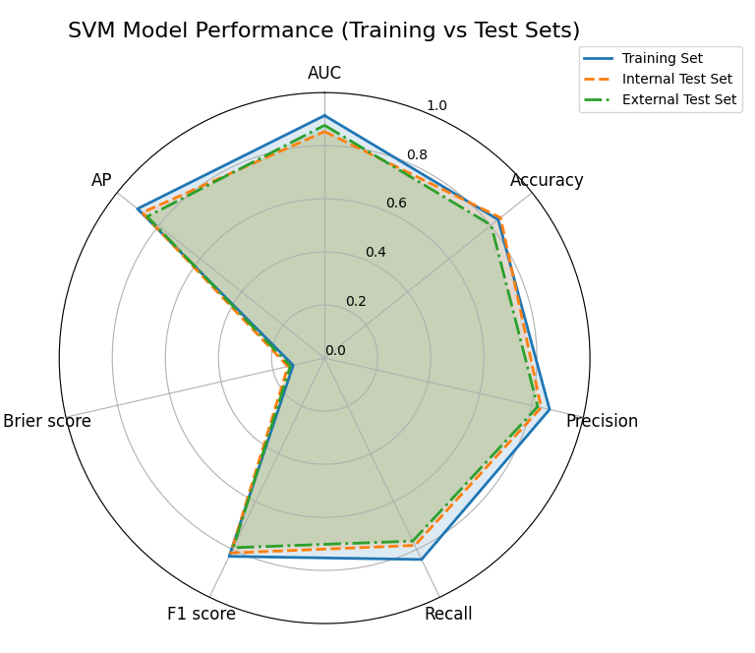
Abbreviations: AUC Area Under the Curve, AP Average Precision.

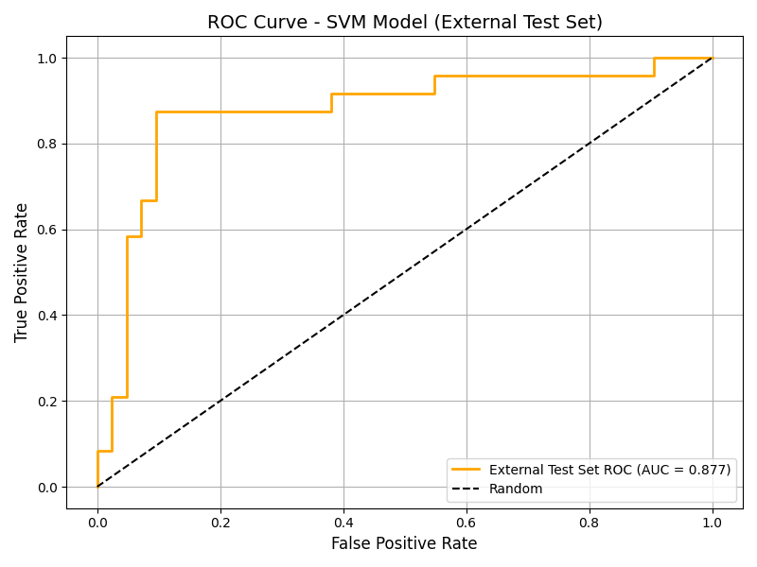

A
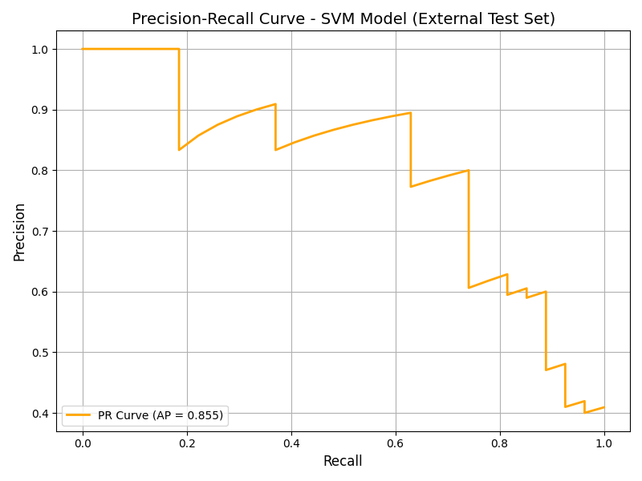
B
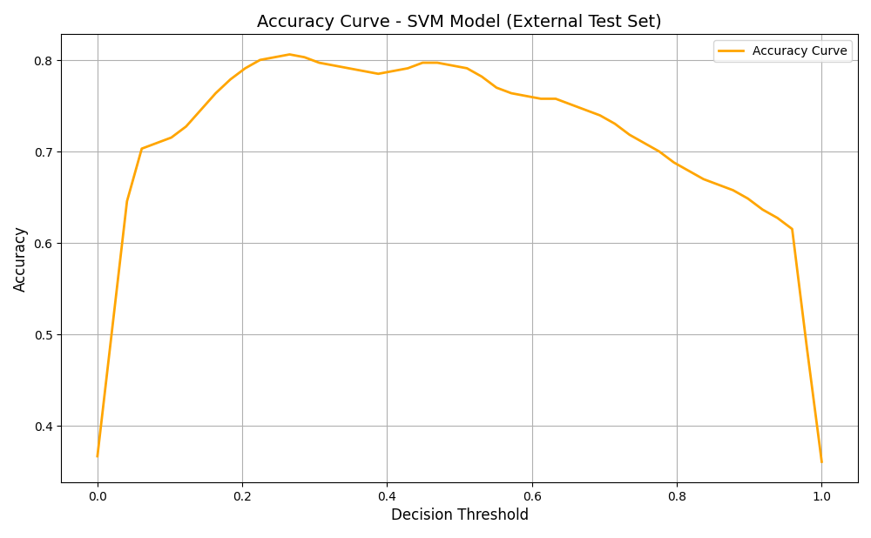
C
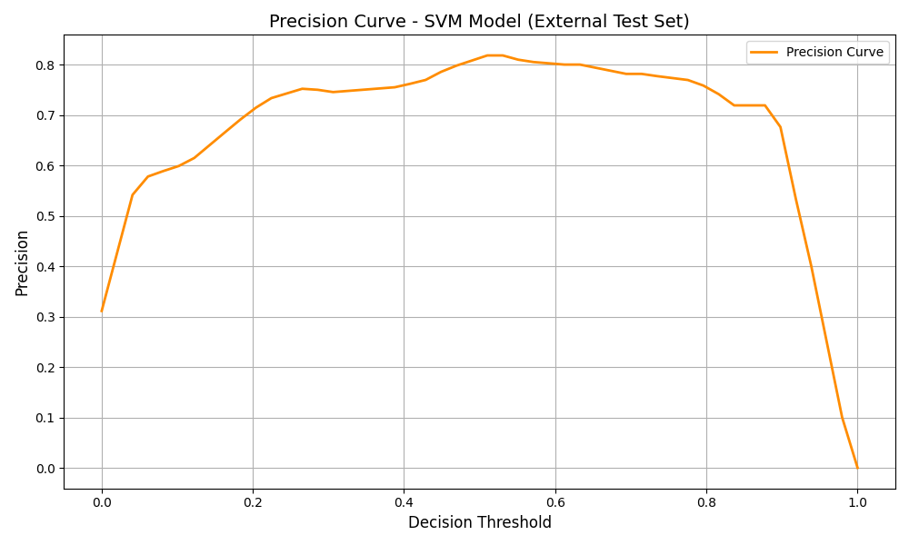
D

Figure S2. Comprehensive Performance Evaluation of the SVM Model.
- ROC curve with AUC values for the external test set; (B) PR curve with AP values for the external test set; (C) Accuracy curve illustrating the performance across different thresholds for the external test set; (D) Precision curve showing the precision at various thresholds for the external test set;

