Explainable machine learning model for prediction of 28-day all-cause mortality in immunocompromised patients in the intensive care unit: a retrospective cohort study based on mimic, iv database
Zhengqiu Yu, Lexin Fang, Yueping Ding
Supplementary material

1. ICD Codes for Immunosuppression Conditions
1. Antibody Deficiency
ICD-9 Codes: 27900, 27903, 27904, 27905, 27906
ICD-10 Codes: D800, D801, D802, D803, D804, D805, D830, D831, D832, D838, D839
2. Cellular Deficiency
ICD-9 Codes: 27911, 27912, 27913
ICD-10 Codes: D821, D820, D823
3. Combined Antibody and Cellular Immune Deficiency
ICD-9 Codes: 279, 2792, 2793
ICD-10 Codes: D810, D811, D812, D813, D815, D816, D817, D8189, D819
4. Phagocytic Defects
ICD-9 Codes: 2880, 2881, 2882
ICD-10 Codes: D700, D703, D71
5. Complement Defects
ICD-9 Codes: 2798, 2799
ICD-10 Codes: D841, D848, D849
6. Malignant Cancer
ICD-9 Codes: 208, 204, 140-172, 1740-1958, 200-208, 2386
ICD-10 Codes: C9200, C9201, C9210, C9211, C9590, C9110, C00-C26, C30-C34, C37-C41, C43, C45-C58, C60-C76, C81-C85, C88, C90-C97
7. Solid Tumors (especially if metastatic and/or under chemotherapy)
ICD-9 Codes: 199, 1985, 196, 197, 198
ICD-10 Codes: C800, C7951, C7952, C77, C78, C79, C80
8. Solid Organ Transplantation
ICD-9 Codes: V420, V421, V422, V427
ICD-10 Codes: Z940, Z941, Z942, Z944
9. Corticosteroids and Other Immunosuppressive Therapies
ICD-9 Codes: V5869, V5863
ICD-10 Codes: Z79899, Z7901
10. Hematopoietic Stem Cell Transplantation (HSCT)
ICD-9 Codes: V4281, V4282
ICD-10 Codes: Z9481, Z9482
11. HIV
ICD-9 Codes: 042, 79571, 043, 044
ICD-10 Codes: B20, R75, B21, B22, B24

2. Missing data rates
In this study, we remove features with >20% missing data to improve the effectiveness of the model, and the missing rate of the remaining features is shown in Supplementary Table 1.
Supplementary Table 1: Detailed information on missing data
Variable | Missing Count | Missing Percentage (%)
Methemoglobin | 8746 | 99.59
C-Reactive Protein | 8675 | 98.78
Direct Bilirubin | 8269 | 94.16
Troponin T | 7231 | 82.34
Fibrinogen | 7215 | 82.16
Creatine Kinase | 6796 | 77.39
Creatine Kinase-MB | 6717 | 76.49
Albumin | 6116 | 69.64
Ionized Calcium | 5984 | 68.14
Neutrophil | 5663 | 64.48
Lymphocyte | 5663 | 64.48
Fraction of Inspired Oxygen | 5023 | 57.2
Alkaline Phosphatase | 4736 | 53.93
Alanine Aminotransferase | 4714 | 53.68
Partial Pressure of Oxygen | 4710 | 53.63
Bilirubin | 4710 | 53.63
Aspartate Aminotransferase | 4692 | 53.43
Base Excess | 4311 | 49.09
Partial Pressure of Carbon Dioxide | 4308 | 49.05
Lactate | 4278 | 48.71
pH | 4055 | 46.17
Partial Thromboplastin Time | 1830 | 20.84
INR (Prothrombin Time) | 1733 | 19.73
Phosphorus | 515 | 5.86
Calcium | 512 | 5.83
Magnesium | 408 | 4.65
Mean Corpuscular Hemoglobin | 304 | 3.46
Mean Corpuscular Hemoglobin Concentration | 304 | 3.46
Mean Corpuscular Volume | 304 | 3.46
Hemoglobin | 302 | 3.44
White Blood Cell Count | 302 | 3.44
Platelet | 300 | 3.42
Creatinine | 253 | 2.88
Blood Urea Nitrogen | 249 | 2.84
Chloride | 249 | 2.84
Bicarbonate | 245 | 2.79
Sodium | 242 | 2.76
Glucose | 242 | 2.76
Potassium | 240 | 2.73
Weight | 178 | 2.03
Temperature | 111 | 1.26
Systolic Blood Pressure | 34 | 0.39
Diastolic Blood Pressure | 34 | 0.39
Respiratory Rate | 21 | 0.24
Mean Arterial Pressure | 13 | 0.15
Heart Rate | 10 | 0.11
Oxygen Saturation | 10 | 0.11
Glasgow Coma Scale | 10 | 0.11

3. Feature Selection Process and Detailed Information of Final Features
Our feature selection methodology followed a systematic and transparent approach to identify the most relevant predictors for 28-day mortality in immunocompromised ICU patients. We began with 128 potential predictor variables extracted from the MIMIC-IV database, including demographic information, vital signs, laboratory values, comorbidities, and clinical scores. Each variable was individually assessed for its association with 28-day mortality using univariate logistic regression. Variables with p-values < 0.05 were retained, resulting in 83 significant features (71 numeric and 12 categorical variables). The significant features included demographic characteristics (age, weight, ethnicity), clinical severity scores (Charlson Comorbidity Index, Glasgow Coma Scale, SOFA score), vital signs (minimum, maximum, and mean values of heart rate, respiratory rate, temperature, blood pressure measurements, oxygen saturation), laboratory values (bicarbonate, blood urea nitrogen, calcium, chloride, creatinine, glucose, hemoglobin, international normalized ratio, electrolytes, and blood cell counts), urine output, comorbidities (myocardial infarction, heart failure, cerebrovascular disease, pulmonary disease, liver disease, renal disease, metastatic tumor, AIDS), and mechanical ventilation status.

To reduce multicollinearity, we analyzed correlations between these 83 significant features using Spearman correlation for numeric-numeric pairs, Cramer's V for categorical-categorical pairs, and correlation ratio for mixed pairs. For variable pairs with correlation coefficients exceeding 0.75, we retained only the variable with the stronger association with mortality (determined by lower p-value in univariate logistic regression). This process identified 52 high-correlation pairs, leading to the removal of 39 variables including mean calcium, mean bicarbonate, mean platelet count, minimum mean corpuscular volume, maximum calcium, minimum phosphate, maximum heart rate, maximum international normalized ratio, mean chloride, minimum potassium, maximum magnesium, maximum respiratory rate, maximum sodium, minimum heart rate, maximum blood urea nitrogen, mean phosphate, maximum mean corpuscular hemoglobin concentration, mean mean corpuscular volume, maximum chloride, maximum temperature, maximum hemoglobin, mean creatinine, minimum creatinine, maximum creatinine, mean potassium, minimum international normalized ratio, mean systolic blood pressure, mean mean arterial pressure, maximum systolic blood pressure, mean blood urea nitrogen, minimum magnesium, mean hemoglobin, maximum white blood cell count, maximum bicarbonate, mean sodium, mean diastolic blood pressure, mean white blood cell count, mean mean corpuscular hemoglobin concentration, and minimum diastolic blood pressure.

Our feature selection process ultimately resulted in 44 final features that were used consistently across all eight machine learning models. These features represent a comprehensive collection of clinically relevant variables that capture different aspects of patient status, allowing our machine learning models to make well-informed predictions about mortality risk. The final feature set includes demographic characteristics (admission age and weight), clinical severity scores (Charlson Comorbidity Index, Glasgow Coma Scale, and Sequential Organ Failure Assessment scores), which are established predictors of patient outcomes in critical care settings. We incorporated various vital sign measurements including mean heart rate, minimum and mean respiratory rate, minimum temperature, minimum systolic blood pressure, maximum and minimum mean arterial pressure, and minimum, maximum, and mean oxygen saturation to capture the physiological status of patients within the first 24 hours of ICU admission. Key laboratory parameters were selected including minimum bicarbonate, minimum blood urea nitrogen, minimum calcium, minimum chloride, minimum hemoglobin, mean international normalized ratio, minimum platelet count, and minimum white blood cell count, which reflect organ function, coagulation status, and potential infection or inflammation. Cumulative urine output within the first 24 hours was included as an important indicator of renal function and fluid status. Pre-existing conditions that significantly impact patient prognosis were incorporated as binary variables, including myocardial infarction, congestive heart failure, cerebrovascular disease, chronic pulmonary disease, liver disease (mild and severe), paraplegia, renal disease, metastatic solid tumor, and AIDS. Additionally, mechanical ventilation status was included as a binary variable indicating respiratory support requirements. Each of these features demonstrated significant association with 28-day mortality in univariate logistic regression analysis (P < 0.05) and was selected after eliminating highly correlated variables to reduce multicollinearity.

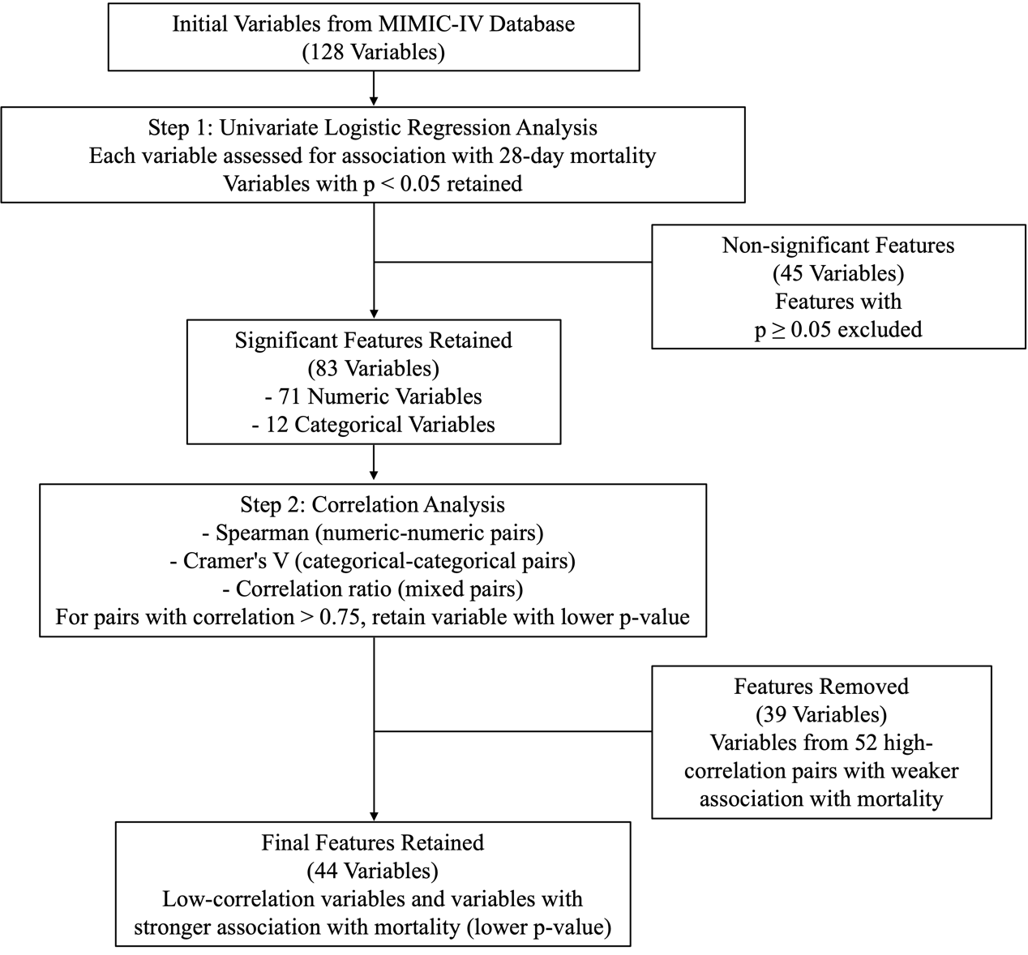
Supplementary Figure 1: Feature selection process flow diagram. Starting with 128 variables from the MIMIC-IV database, we employed a two-step approach: (1) univariate logistic regression analysis, which retained 83 significant variables (p < 0.05) and excluded 45 non-significant variables; and (2) correlation analysis, which identified 52 high-correlation pairs (r > 0.75) and retained only the variable with the stronger association with mortality from each pair, resulting in 44 final features. These 44 features were used consistently across all eight machine learning models.

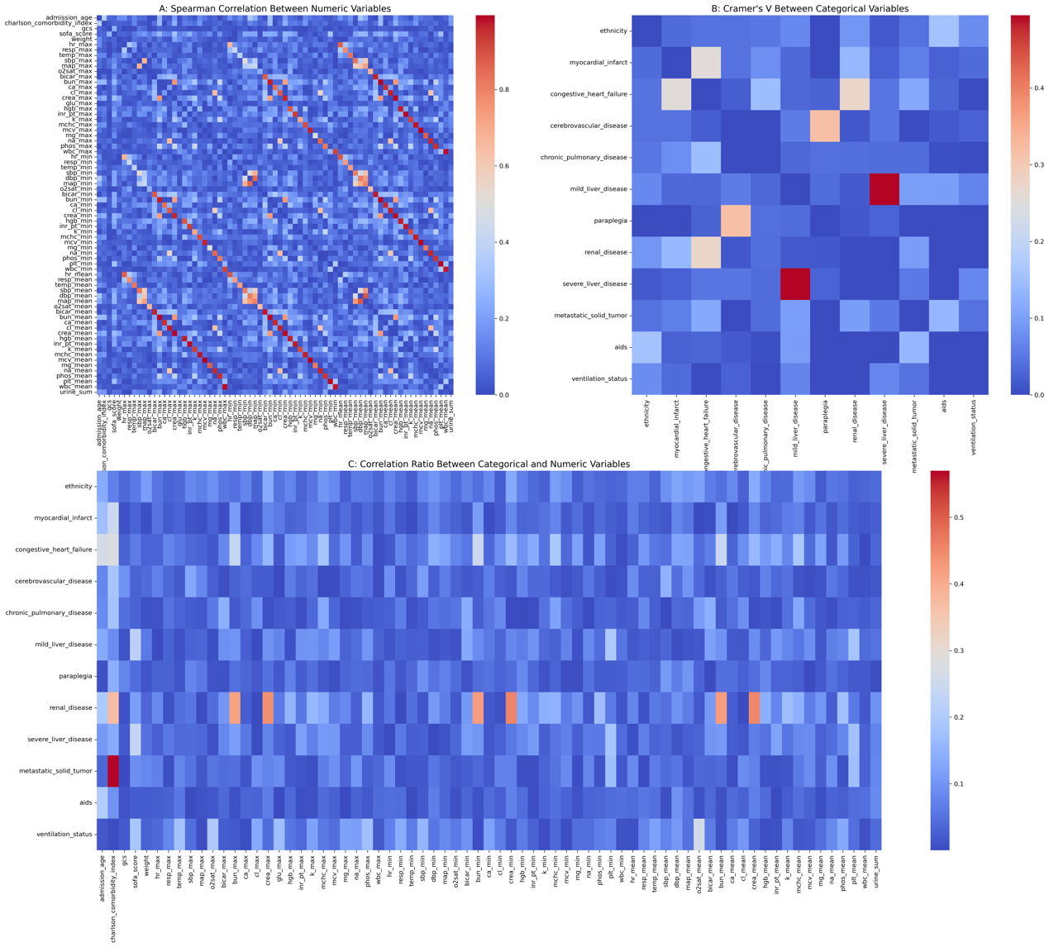
Supplementary Figure 2: Correlation heatmap of the 83 significant features identified after univariate analysis, highlighting the 52 high-correlation pairs.
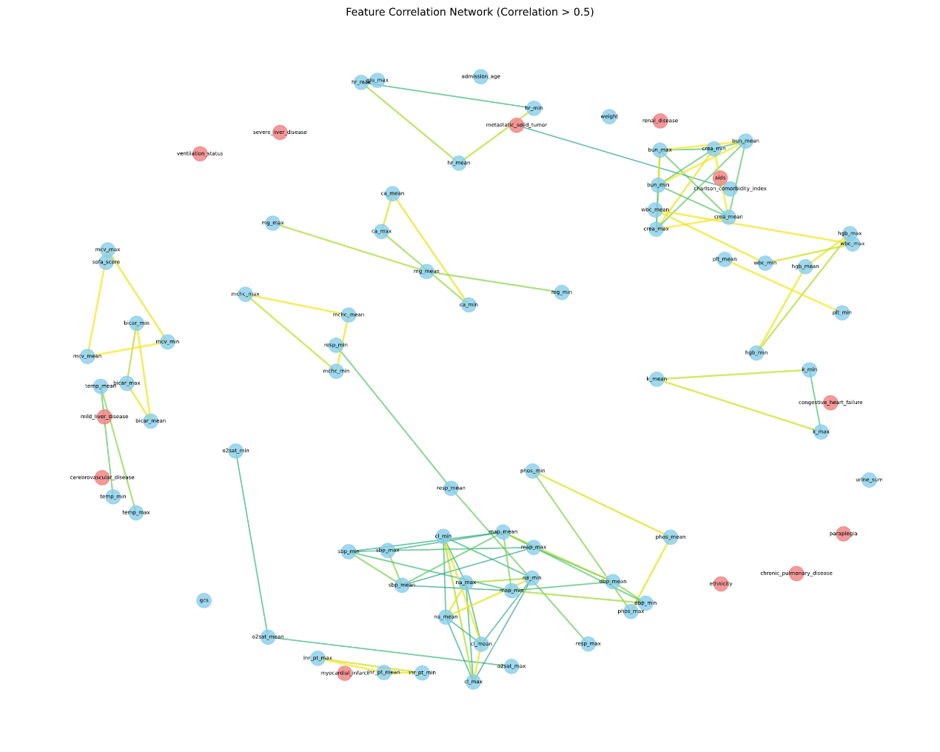
Supplementary Figure 3: Correlation network visualization of the final 44 features, demonstrating reduced multicollinearity.

4. Cox Proportional Hazards Regression
To account for the time-dependent nature of survival outcomes, we performed Cox proportional hazards regression analysis. Variables showing significant associations (p < 0.05) in univariable analysis were included in the multivariable model. The hazard ratios (HRs) and corresponding 95% confidence intervals (CIs) are presented in Supplementary Table 2.

Supplementary Table 2. Univariable and Multivariable Cox Regression Analysis for 28-day Mortality
Variables | Univariable analysis |  | Multivariate analysis
 | HR (95% CI) | p-value | HR (95% CI) | p-value
Age | 1.333 (1.264-1.405) | <0.001 | 1.035 (1.013-1.057) | 0.002
Weight | 0.764 (0.718-0.813) | <0.001 | 0.964 (0.943-0.985) | 0.001
GCS | 0.840 (0.811-0.871) | <0.001 | 0.960 (0.940-0.980) | <0.001
SOFA score | 1.402 (1.348-1.460) | <0.001 | 1.053 (1.031-1.075) | <0.001
Ethnicity
White | 0.835 (0.751-0.928) | 0.001 | 0.971 (0.926-1.018) | 0.221
Asian | 1.103 (0.872-1.396) | 0.412 | / | /
Hispanic-American | 0.920 (0.672-1.260) | 0.604 | / | /
Other | 1.378 (1.197-1.588) | <0.001 | 1.062 (0.993-1.136) | 0.08
Bicarbonate min | 0.641 (0.610-0.673) | <0.001 | 0.945 (0.925-0.966) | <0.001
BUN min | 1.393 (1.349-1.438) | <0.001 | 1.066 (1.044-1.088) | <0.001
WBC min | 1.088 (1.059-1.118) | <0.001 | 1.024 (1.003-1.045) | 0.026
Calcium min | 0.816 (0.775-0.858) | <0.001 | 0.978 (0.957-0.999) | 0.041
Glucose max | 1.080 (1.032-1.130) | 0.001 | 1.006 (0.985-1.028) | 0.559
HGB min | 0.744 (0.706-0.784) | <0.001 | 0.968 (0.948-0.989) | 0.003
HR mean | 1.541 (1.468-1.618) | <0.001 | 1.074 (1.051-1.097) | <0.001
INR mean | 1.199 (1.173-1.225) | <0.001 | 1.056 (1.035-1.078) | <0.001
Potassium max | 1.243 (1.193-1.295) | <0.001 | 1.026 (1.005-1.048) | 0.017
MCHC min | 0.727 (0.693-0.763) | <0.001 | 0.959 (0.939-0.979) | <0.001
MCV max | 1.233 (1.174-1.294) | <0.001 | 1.030 (1.008-1.052) | 0.006
Magnesium mean | 1.155 (1.103-1.209) | <0.001 | 1.016 (0.995-1.037) | 0.146
Sodium min | 0.816 (0.779-0.854) | <0.001 | 0.976 (0.955-0.997) | 0.023
Chloride min | 0.778 (0.742-0.816) | <0.001 | 0.965 (0.944-0.985) | 0.001
Phosphate max | 1.342 (1.300-1.385) | <0.001 | 1.043 (1.021-1.065) | <0.001
PLT min | 0.917 (0.870-0.967) | 0.001 | 0.990 (0.969-1.011) | 0.354
RR mean | 1.499 (1.434-1.567) | <0.001 | 1.066 (1.043-1.089) | <0.001
RR min | 1.316 (1.248-1.387) | <0.001 | 1.033 (1.011-1.055) | 0.003
SBP min | 0.647 (0.613-0.684) | <0.001 | 0.951 (0.931-0.972) | <0.001
MAP max | 0.854 (0.809-0.903) | <0.001 | 0.986 (0.965-1.007) | 0.179
MAP min | 0.729 (0.695-0.764) | <0.001 | 0.961 (0.940-0.982) | <0.001
SpO2 max | 0.852 (0.813-0.893) | <0.001 | 0.974 (0.953-0.995) | 0.015
SpO2 mean | 0.695 (0.664-0.728) | <0.001 | 0.946 (0.926-0.967) | <0.001
SpO2 min | 0.687 (0.665-0.710) | <0.001 | 0.929 (0.910-0.949) | <0.001
Temperature mean | 0.808 (0.767-0.852) | <0.001 | 0.972 (0.952-0.993) | 0.011
Temperature min | 0.826 (0.791-0.863) | <0.001 | 0.972 (0.951-0.993) | 0.008
Urine sum | 0.516 (0.482-0.553) | <0.001 | 0.931 (0.912-0.952) | <0.001
Ventilation status | 1.400 (1.255-1.562) | <0.001 | 1.067 (1.014-1.122) | 0.012
CCI | 1.627 (1.551-1.706) | <0.001 | 1.071 (1.048-1.094) | <0.001
Comorbidities
AIDS | 0.447 (0.303-0.659) | <0.001 | 0.895 (0.796-1.007) | 0.065
Cerebrovascular disease | 1.417 (1.227-1.636) | <0.001 | 1.080 (1.007-1.157) | 0.03
Congestive heart failure | 1.322 (1.181-1.479) | <0.001 | 1.012 (0.961-1.065) | 0.65
Chronic pulmonary disease | 1.120 (1.004-1.249) | 0.041 | 1.006 (0.959-1.055) | 0.819
Metastatic solid tumor | 2.164 (1.960-2.389) | <0.001 | 1.146 (1.097-1.198) | <0.001
Mild liver disease | 1.447 (1.270-1.650) | <0.001 | 1.051 (0.987-1.119) | 0.118
Myocardial infarct | 1.238 (1.074-1.426) | 0.003 | 1.014 (0.951-1.082) | 0.665
Paraplegia | 1.480 (1.196-1.831) | <0.001 | 1.105 (0.993-1.230) | 0.068
Renal disease | 1.250 (1.112-1.405) | <0.001 | 0.994 (0.942-1.048) | 0.811
Severe liver disease | 1.986 (1.682-2.345) | <0.001 | 1.127 (1.029-1.234) | 0.01
Note: GCS: Glasgow Coma Scale; SOFA: Sequential Organ Failure Assessment; BUN: Blood Urea Nitrogen; WBC: White Blood Cell; HGB: Hemoglobin; HR: Heart Rate; INR: International Normalized Ratio; MCHC: Mean Corpuscular Hemoglobin Concentration; MCV: Mean Corpuscular Volume; PLT: Platelet; RR: Respiratory Rate; SBP: Systolic Blood Pressure; MAP: Mean Arterial Pressure; SpO2: Peripheral Oxygen Saturation; CCI: Charlson Comorbidity Index; AIDS: Acquired Immune Deficiency Syndrome.

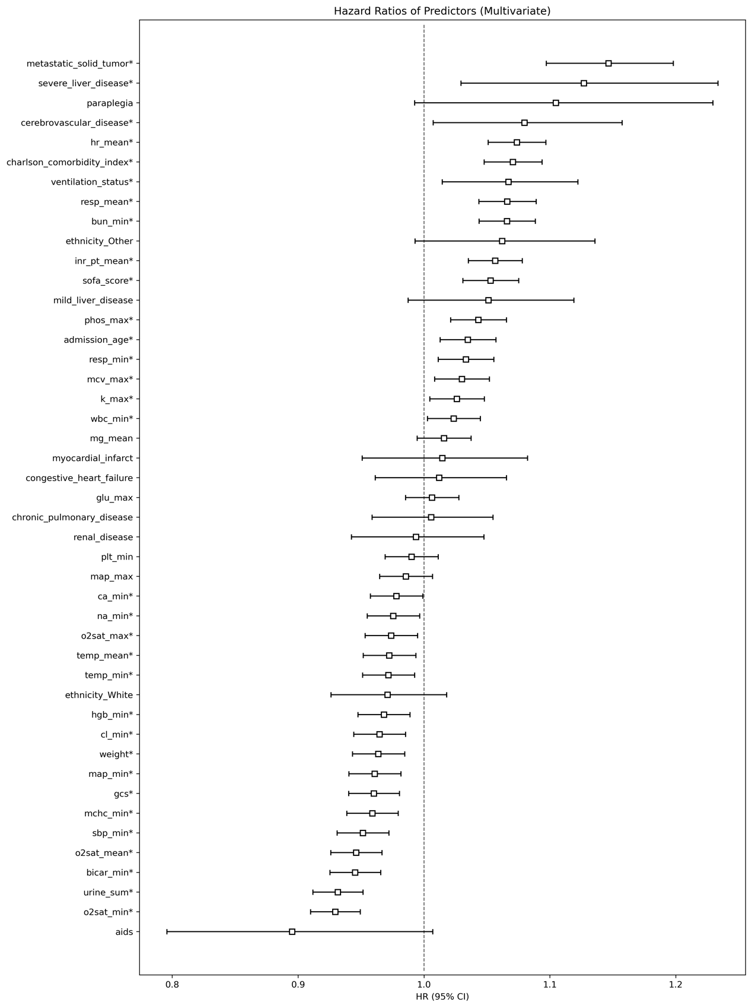
Supplementary Figure 4. Forest Plot of Hazard Ratios from Multivariable Cox Regression
Note: GCS: Glasgow Coma Scale; SOFA: Sequential Organ Failure Assessment; BUN: Blood Urea Nitrogen; WBC: White Blood Cell; HGB: Hemoglobin; HR: Heart Rate; INR: International Normalized Ratio; MCHC: Mean Corpuscular Hemoglobin Concentration; MCV: Mean Corpuscular Volume; PLT: Platelet; RR: Respiratory Rate; SBP: Systolic Blood Pressure; MAP: Mean Arterial Pressure; SpO2: Peripheral Oxygen Saturation; CCI: Charlson Comorbidity Index; AIDS: Acquired Immune Deficiency Syndrome.
Forest plot showing hazard ratios (squares) with 95% confidence intervals (horizontal lines) for variables in the multivariable Cox regression model. The vertical dashed line represents a hazard ratio of 1.0. Values greater than 1.0 indicate increased risk of mortality, while values less than 1.0 indicate decreased risk.

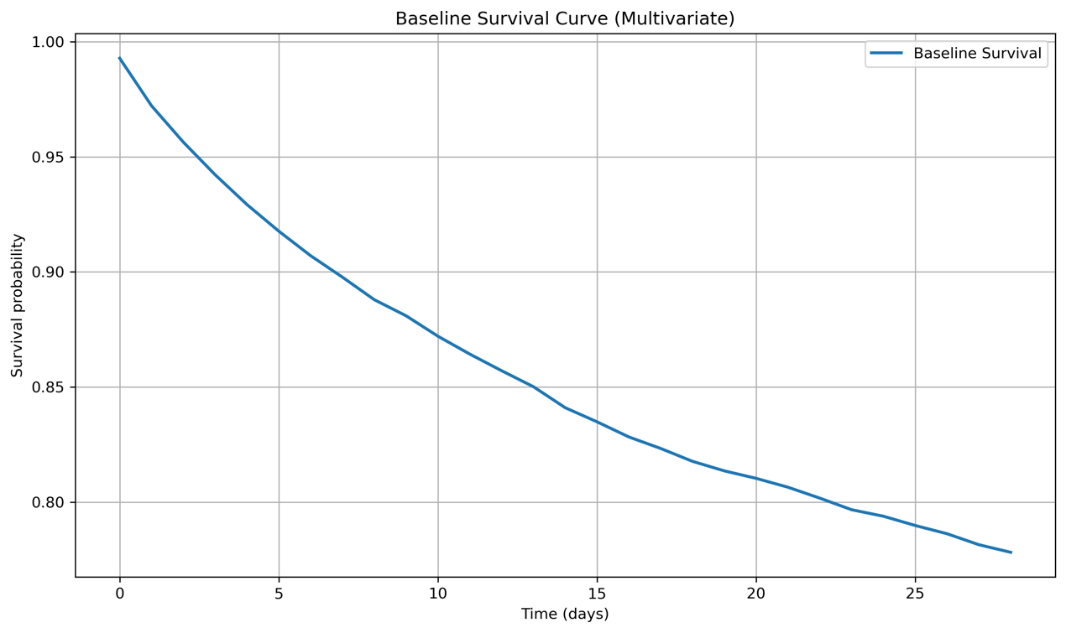
Supplementary Figure 5. Baseline Survival Curve from Multivariable Cox Regression
Note: Kaplan-Meier curve showing the estimated baseline survival probability over the 28-day follow-up period, adjusted for all covariates in the multivariable model.

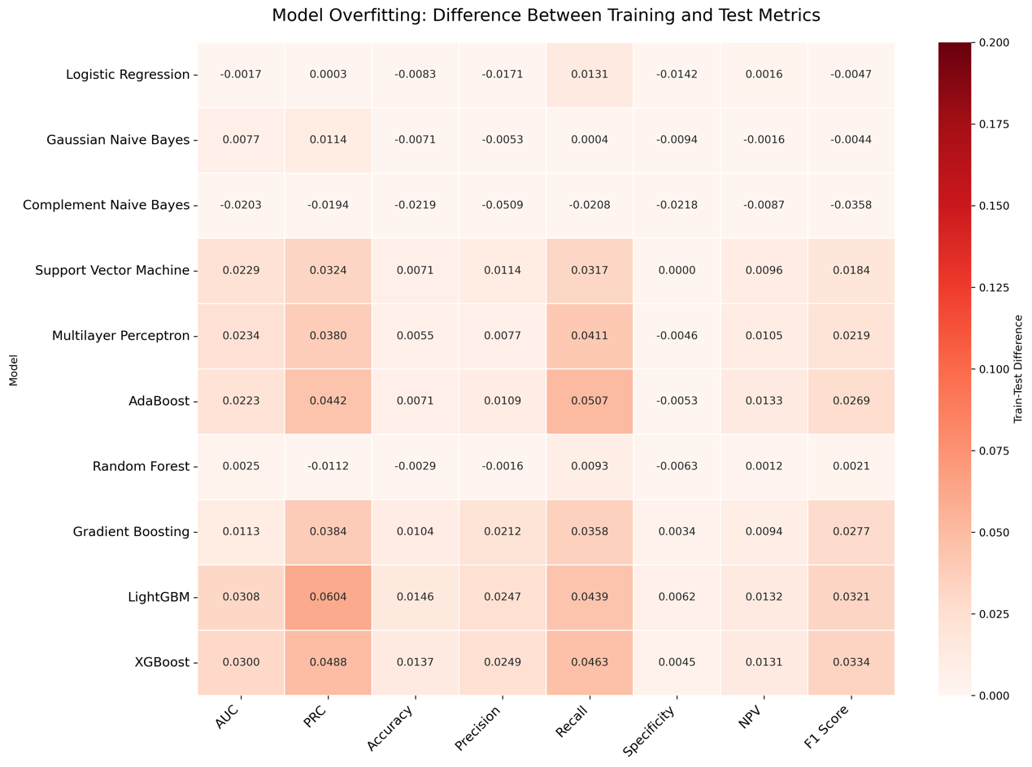
Supplementary Figure 6. Heatmap visualization of model overfitting. The heatmap shows the difference between training and test set performance (Train - Test) across multiple metrics for all models. Lower values (lighter colors) indicate less overfitting. Negative values (white) indicate metrics where test performance exceeded training performance. Most models show acceptable differences between training and test performance, with naive Bayes and logistic regression exhibiting minimal overfitting tendencies.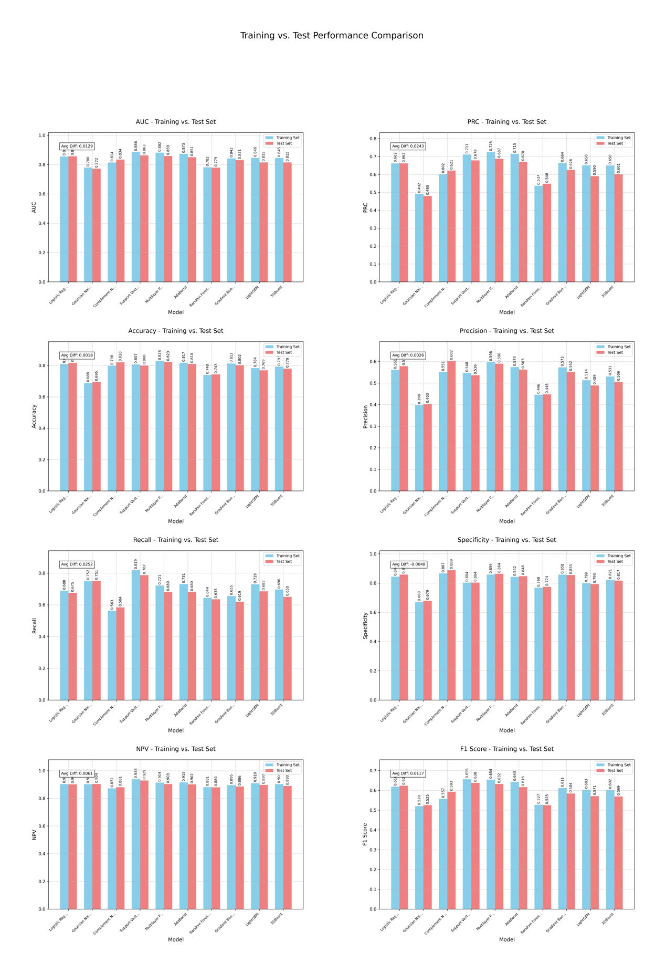
Supplementary Figure 7. Direct comparison of training vs. test performance for key metrics. Bar charts compare training (blue) and test (red) performance for AUC, PRC, Accuracy, and Precision across all models. Average differences are shown in the top left of each plot. While some performance gap exists, particularly in PRC metrics for tree-based models, the overall pattern indicates reasonable generalization to the test set with limited overfitting.

