Estimated Glucose Disposal Rate and the Risk of Major Adverse Cardio-cerebrovascular Outcomes and Mortality in Patients Undergoing Percutaneous Coronary Intervention: A Retrospective Cohort Study
Supplementary materials
Supplementary Table 1. Comparison of included and excluded cohorts in DM subgroup
Variable | DM Included | DM Excluded | P-value
Number | 1735 | 4135
Mean age (SD) | 64.3 (9.9) | 63.5 (10.4) | 0.004
Gender male% | 57.9% | 65.03% | <0.001
Mean BMI (SD) | 28.9 (4.6) | 28.78 (4.6) | 0.139
Mean WC (SD) | 102.3 (11.1) | 101.37 (10.5) | 0.002
Family history% | 17.75% | 18.40% | 0.556
Dyslipidemia% | 74.93% | 70.18% | <0.001
HTN% | 65.30% | 61.71% | 0.010
Current smoker% | 39.0% | 50.64% | <0.001
Body mass index (BMI), waist circumference (WC), hypertension (HTN)

Supplementary Table 2. Comparison of included and excluded cohorts in non-DM subgroup
Variable | Non-DM Included | Non-DM Excluded | P-value
Number | 173 | 4334
Mean age (SD) | 61.6 (11.2) | 61.42 (11.6) | 0.803
Gender male% | 80.3% | 82.00% | 0.579
Mean BMI (SD) | 27.8 (4.1) | 27.47 (4.2) | 0.347
Mean WC (SD) | 97.9 (10.1) | 98.31 (10.2) | 0.654
Family history% | 21.96% | 20.05% | 0.538
Dyslipidemia% | 54.91% | 49.65% | 0.175
HTN% | 48.55% | 44.09% | 0.247
Current smoker% | 59.5% | 64.84% | 0.345
Body mass index (BMI), waist circumference (WC), hypertension (HTN)

Supplementary Table 3. Comparison of included and excluded cohorts in pre-DM subgroup
Variable | Pre-DM Included | Pre-DM Excluded | P-value
Number | 236 | 3069
Mean age (SD) | 65.1 (10.4) | 62.23 (11.2) | <0.001
Gender male% | 72% | 77.45% | 0.056
Mean BMI (SD) | 28.8 (4.7) | 28.34 (4.5) | 0.083
Mean WC (SD) | 101.6 (10.5) | 100.46 (10.4) | 0.107
Family history% | 21.18% | 21.21% | 0.993
Dyslipidemia% (n) | 57.62% | 56.63% | 0.766
HTN% (n) | 53.81% | 49.62% | 0.215
Current smoker% (n) | 52.1% | 59.37% | 0.138
Body mass index (BMI), waist circumference (WC), hypertension (HTN)

Supplementary Figure 1. Restricted cubic spline analysis for eGDR-prognosis for MACE outcome in DM subgroup

Supplementary Figure 2. Restricted cubic spline analysis for eGDR-prognosis for all cause mortality outcome in DM subgroup

Supplementary Figure 3. Restricted cubic spline analysis for eGDR-prognosis for hospitalization outcome in DM subgroup

Supplementary Figure 4. Restricted cubic spline analysis for eGDR-prognosis for non fatal MI outcome in DM subgroup

Supplementary Figure 5. Restricted cubic spline analysis for eGDR-prognosis for repeated PCI outcome in DM subgroup
Supplementary Figure 6. Restricted cubic spline analysis for eGDR-prognosis for CABG outcome in DM subgroup

Supplementary Figure 7. Restricted cubic spline analysis for eGDR-prognosis for composite 1 outcome in DM subgroup

Supplementary Figure 8. Restricted cubic spline analysis for eGDR-prognosis for composite 2 outcome in DM subgroup

Supplementary Figure 9. Restricted cubic spline analysis for eGDR-prognosis for composite 3 outcome in DM subgroup

Supplementary Figure 10. Restricted cubic spline analysis for eGDR-prognosis for MACE outcome in non-DM subgroup

Supplementary Figure 11. Restricted cubic spline analysis for eGDR-prognosis for hospitalization outcome in non-DM subgroup

Supplementary Figure 12. Restricted cubic spline analysis for eGDR-prognosis for repeated PCI outcome in non-DM subgroup

Supplementary Figure 13. Restricted cubic spline analysis for eGDR-prognosis for composite 1 outcome in non-DM subgroup

Supplementary Figure 14. Restricted cubic spline analysis for eGDR-prognosis for composite 3 outcome in non-DM subgroup

Supplementary Figure 15. Restricted cubic spline analysis for eGDR-prognosis for MACE outcome in pre-DM subgroup

Supplementary Figure 16. Restricted cubic spline analysis for eGDR-prognosis for all-cause mortality outcome in pre-DM subgroup

Supplementary Figure 17. Restricted cubic spline analysis for eGDR-prognosis for hospitalization outcome in pre-DM subgroup

Supplementary Figure 18. Restricted cubic spline analysis for eGDR-prognosis for repeated PCI outcome in pre-DM subgroup

Supplementary Figure 19. Restricted cubic spline analysis for eGDR-prognosis for composite 1 outcome in pre-DM subgroup

Supplementary Figure 20. Restricted cubic spline analysis for eGDR-prognosis for composite 3 outcome in pre-DM subgroup

Supplementary Figure 21. Nonfatal myocardial infarction outcome
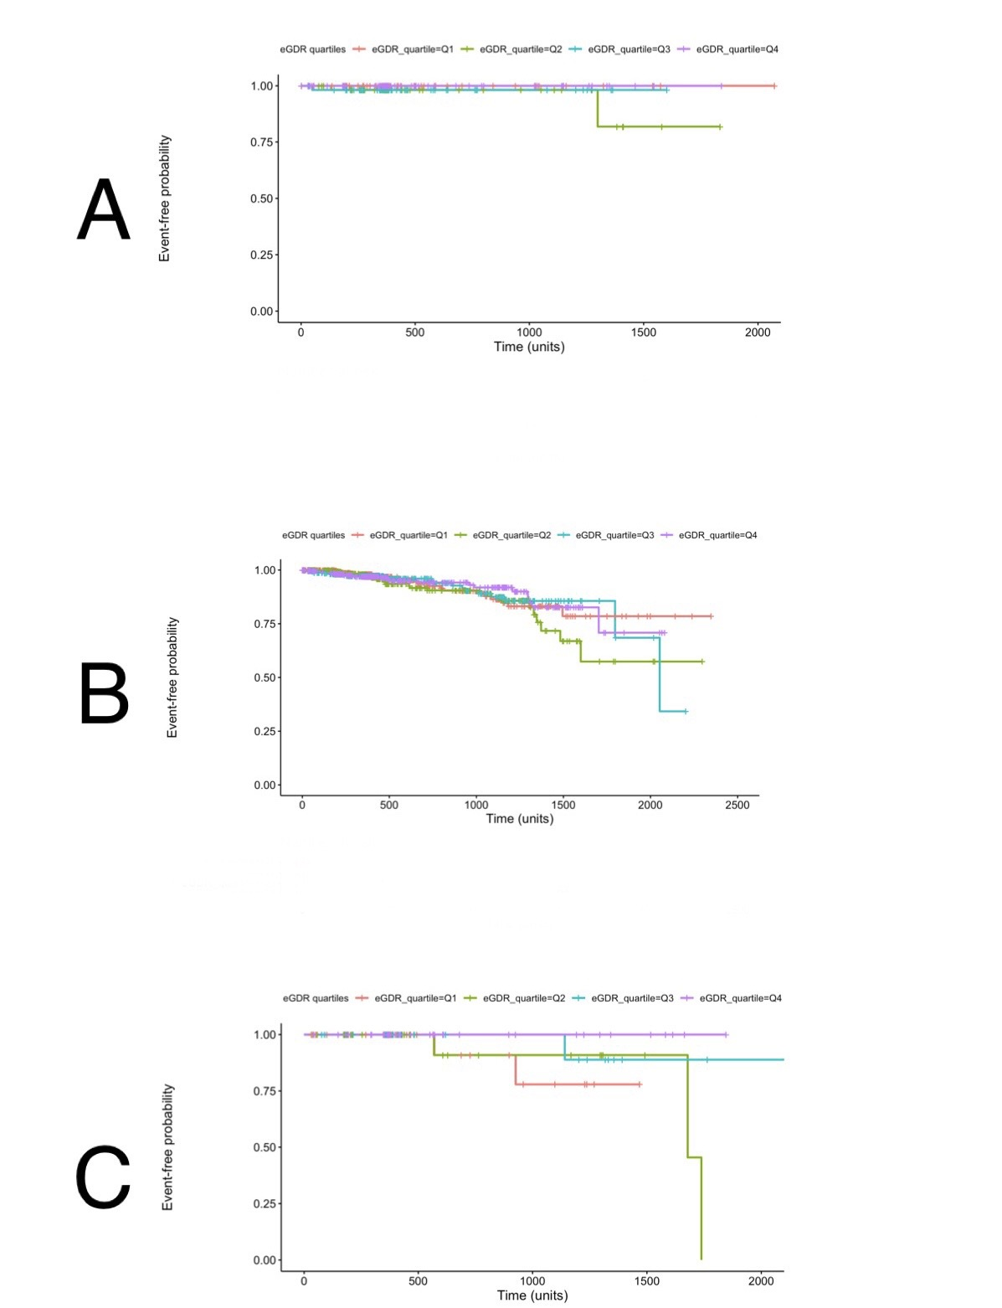
Kaplan-Meier figure for (A) Prediabetes group (B) Diabetes group (C) Non-diabetes group

Supplementary Figure 22. Repeated PCI outcome
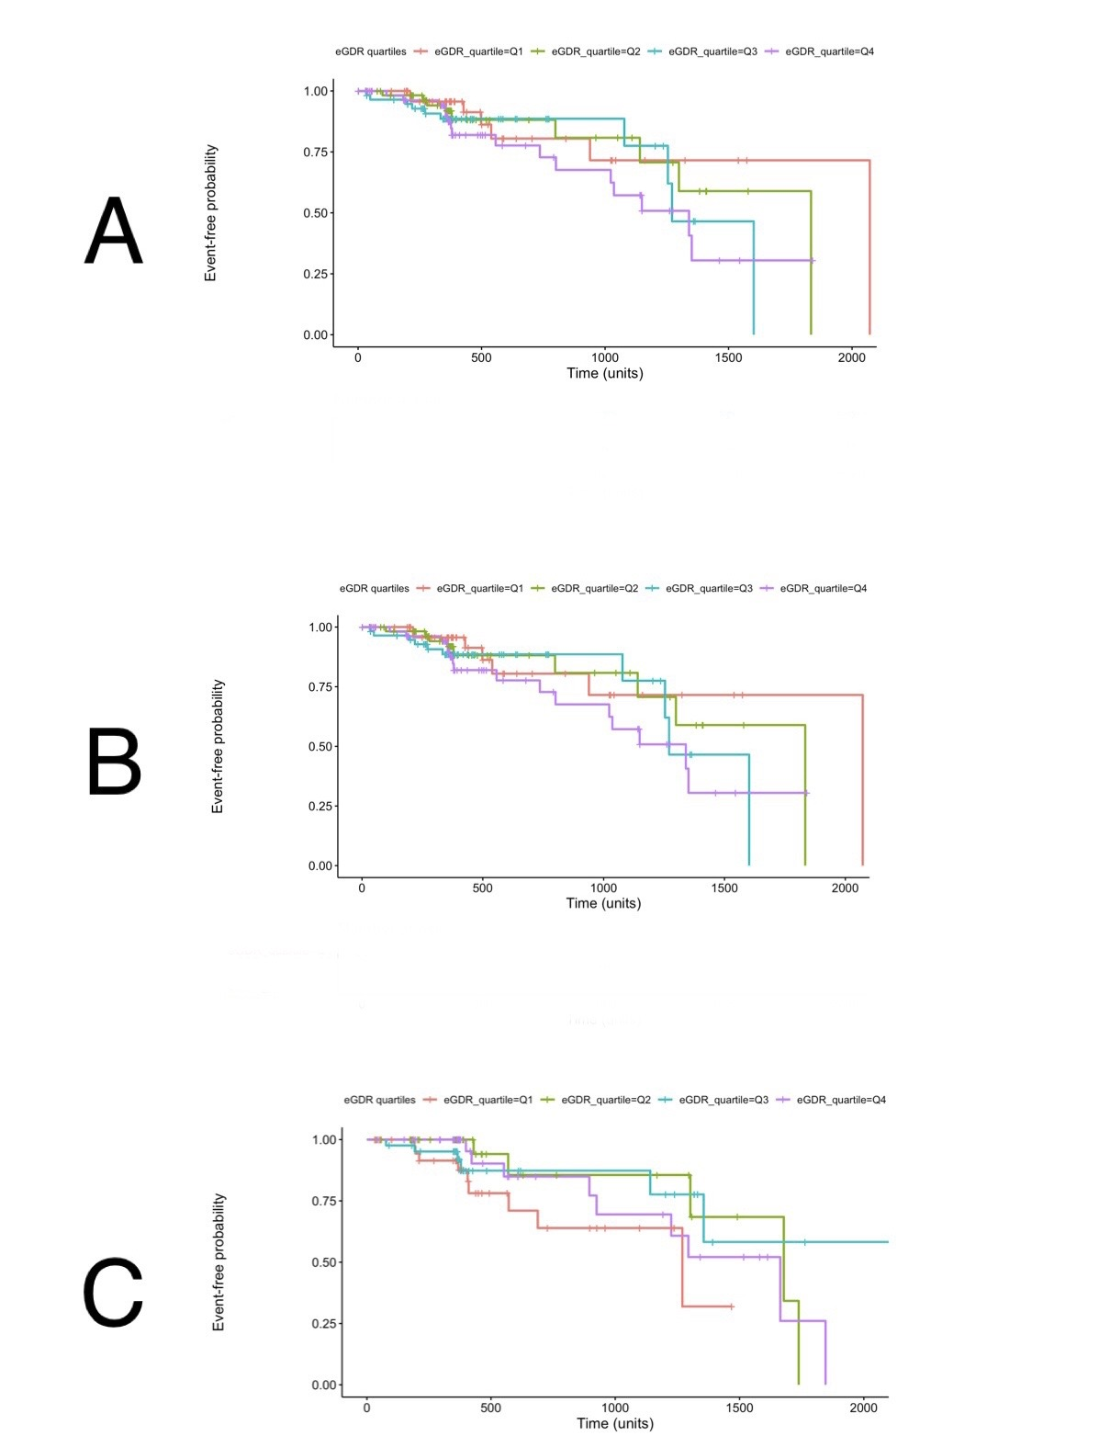
Kaplan-Meier figure for (A) Prediabetes group (B) Diabetes group (C) Non-diabetes group
Supplementary Figure 23. CABG outcome
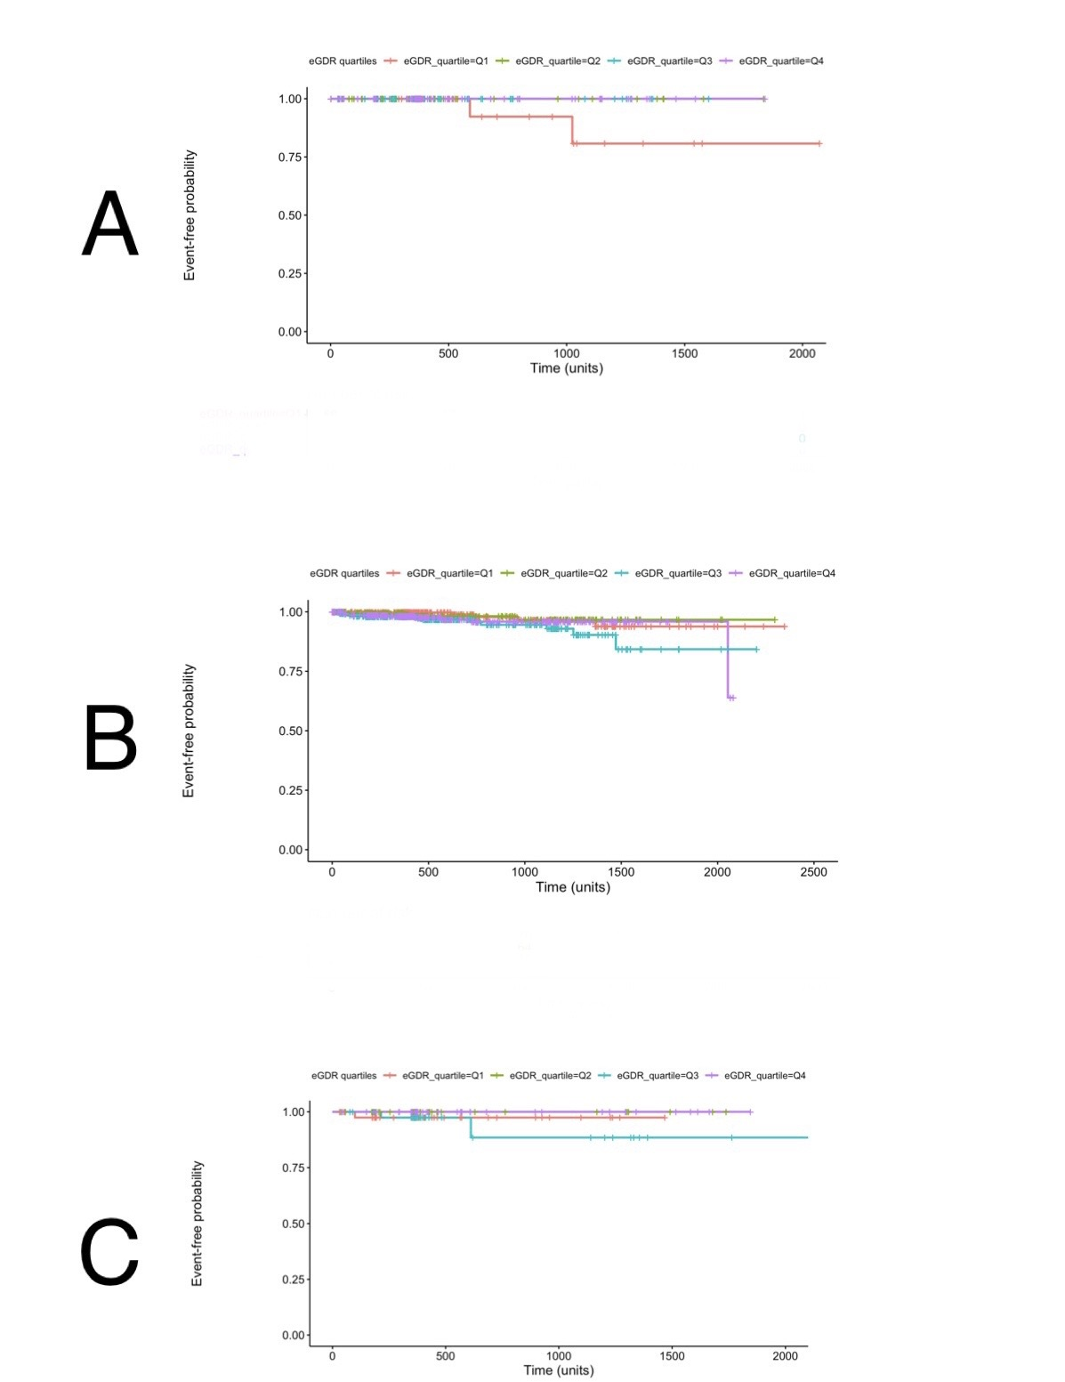
Kaplan-Meier figure for (A) Prediabetes group (B) Diabetes group (C) Non-diabetes group

Supplementary Figure 24. Stroke outcome
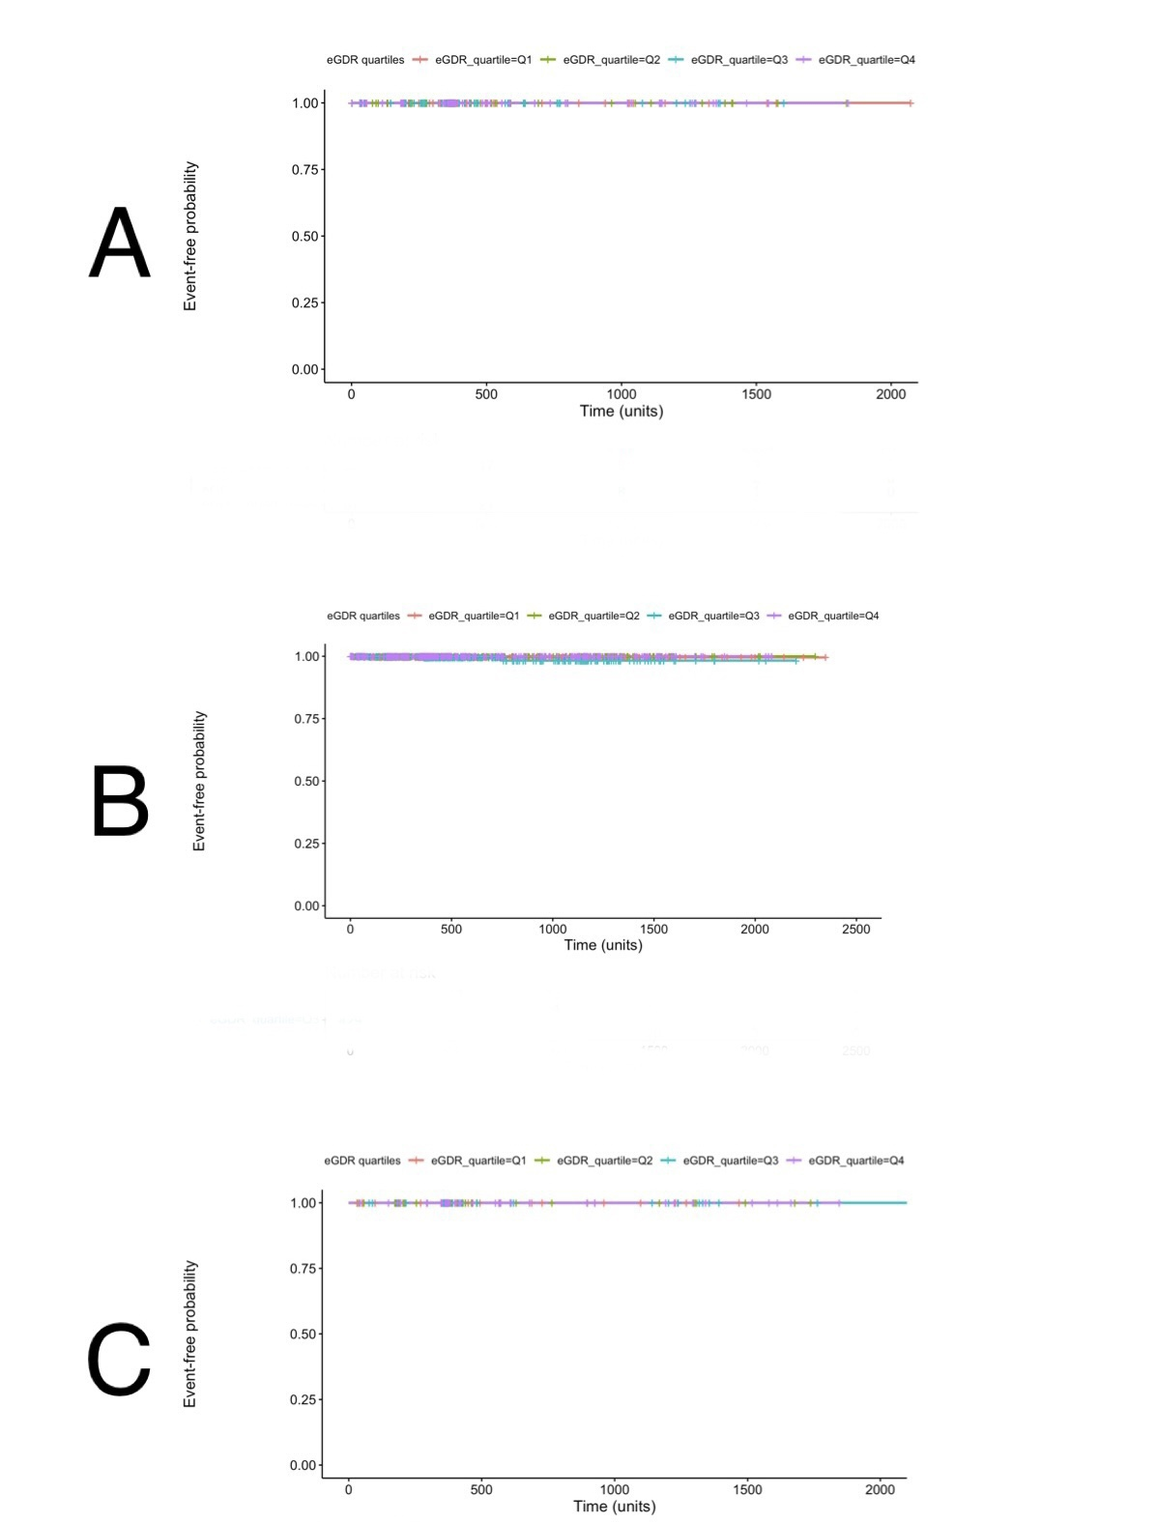
Kaplan-Meier figure for (A) Prediabetes group (B) Diabetes group (C) Non-diabetes group

