Supplementary Fig. 1 Sensitivity analysis
Age and any complications
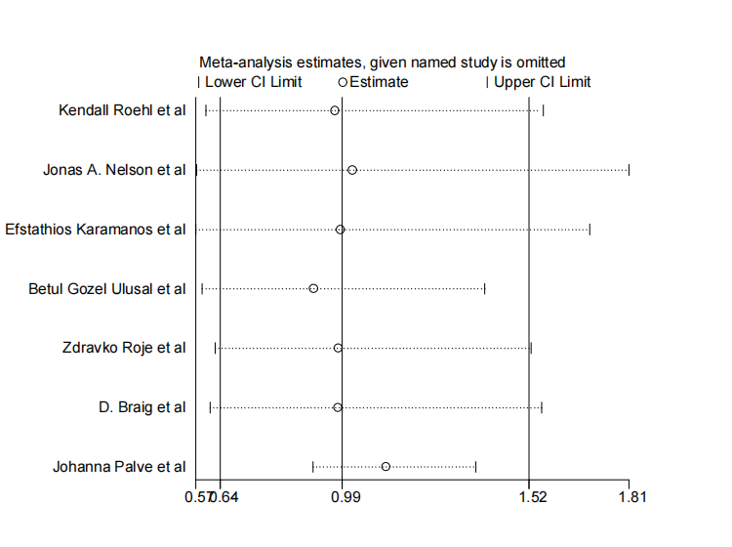
BMI and any complications
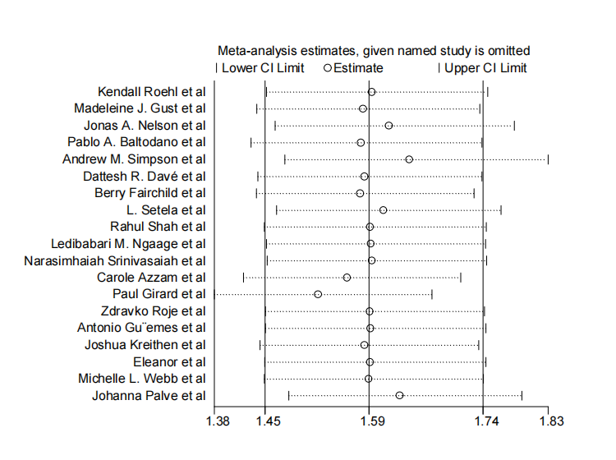
BMI and wound dehiscence
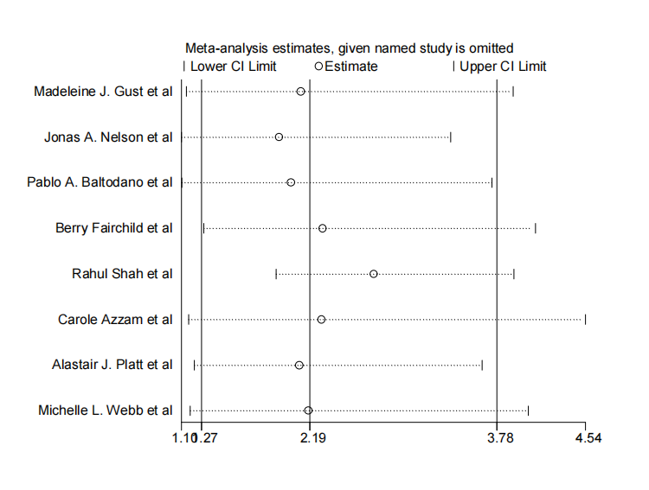
BMI and wound infection
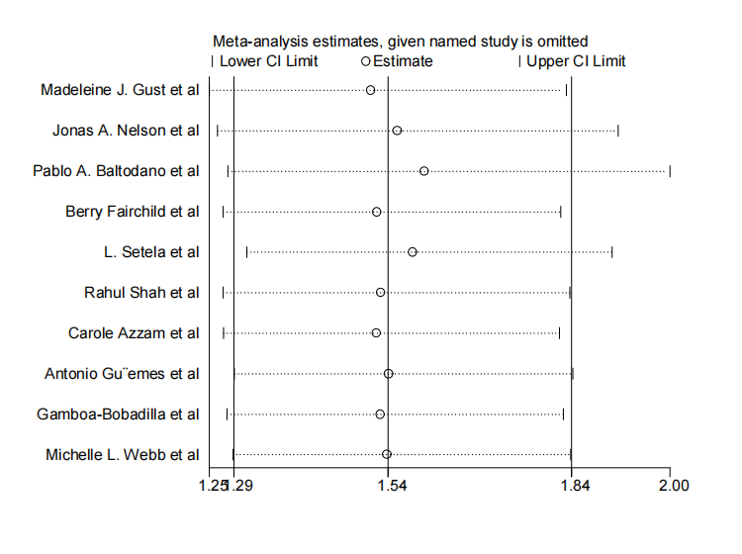
Diabetes and any complications
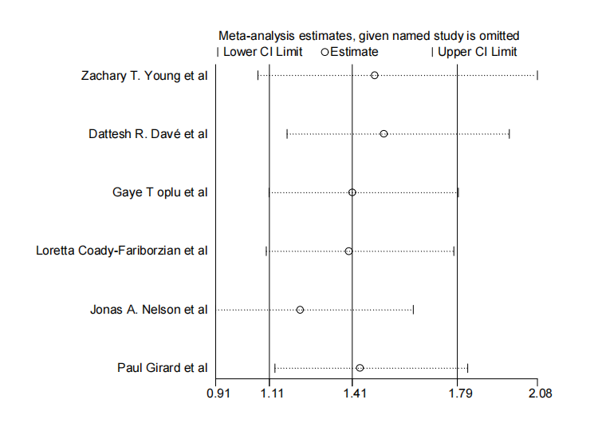
PRT and any complications
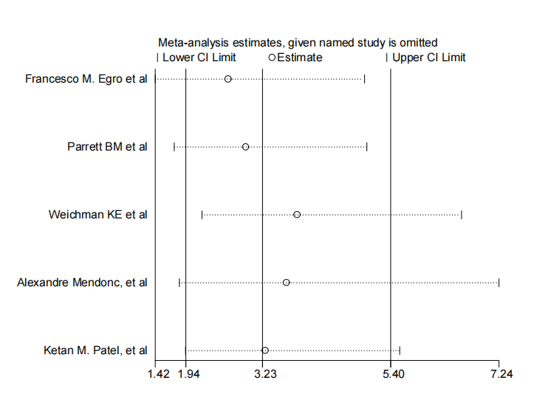
Smoking and any complications
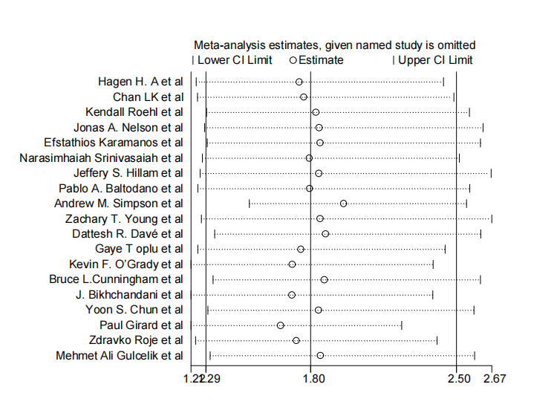
Smoking and hematoma
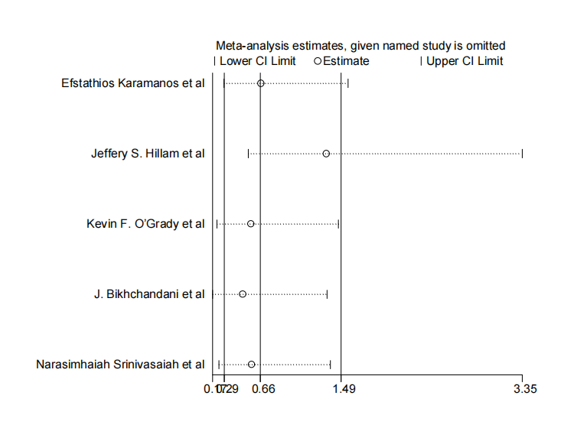
Smoking and wound dehiscence
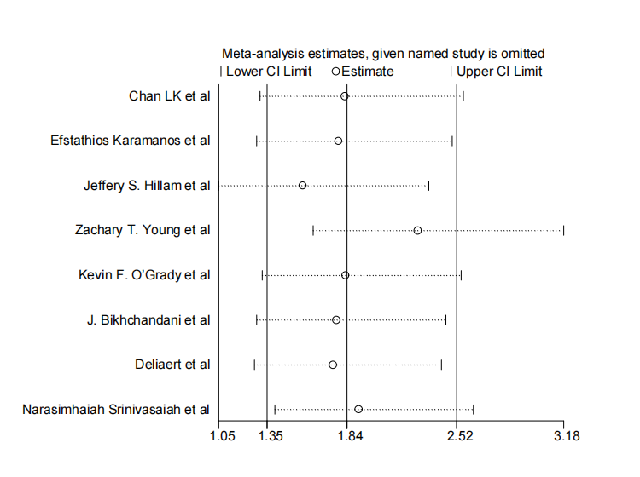
Smoking and wound infection
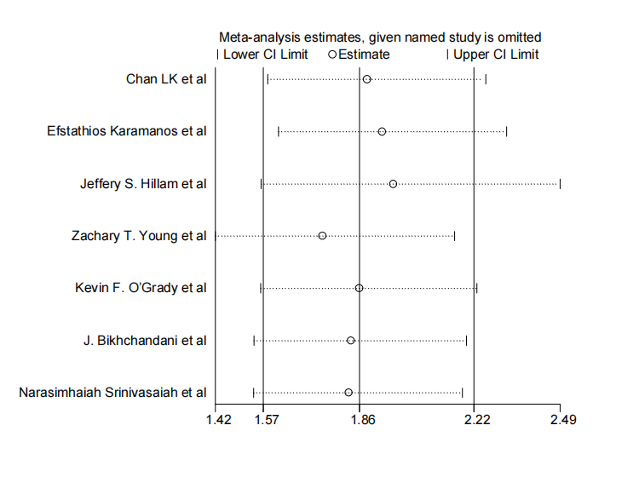
TRW and any complications
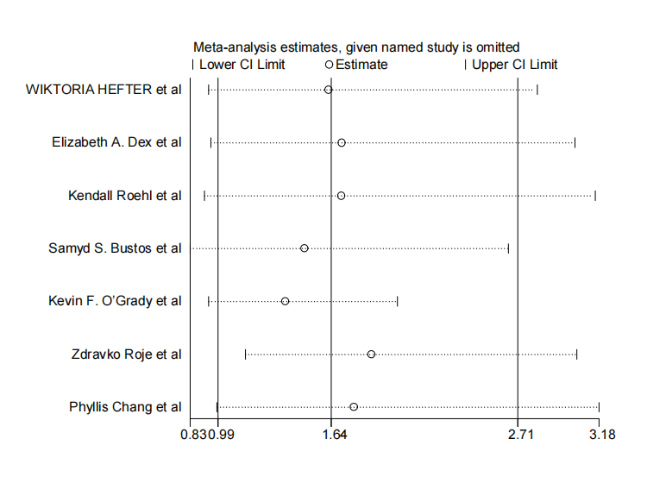
Surgical technique and any complications (IP and SMP)
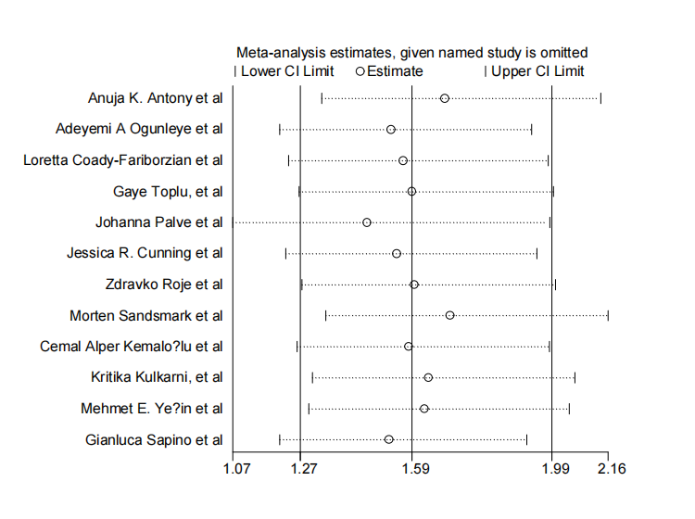
Surgical technique and fat necrosis (IP and SMP)
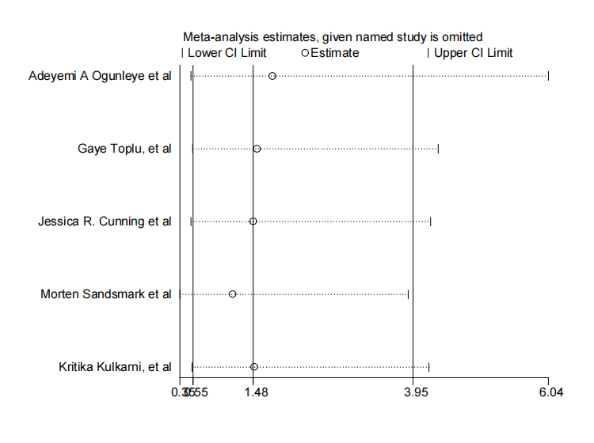
Surgical technique and hematoma (IP and SMP)
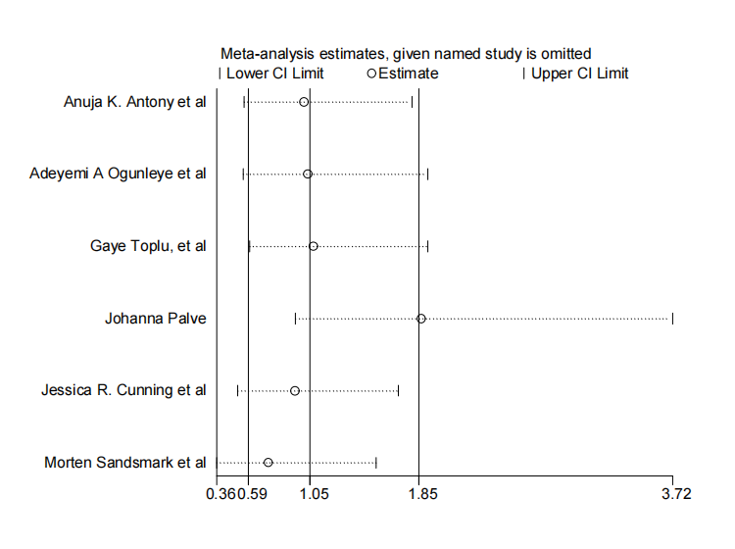
Surgical technique and NAC (IP and SMP)
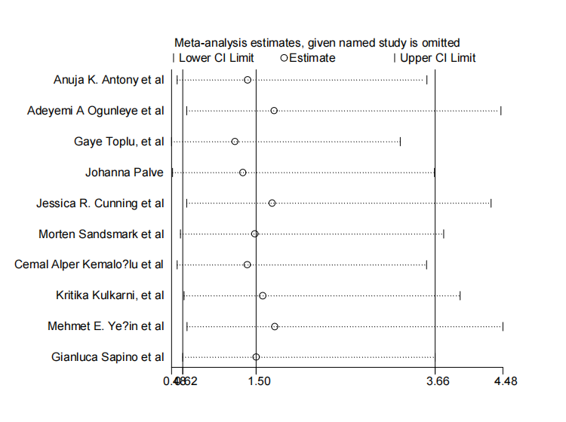
Surgical technique and wound dehiscence (IP and SMP)
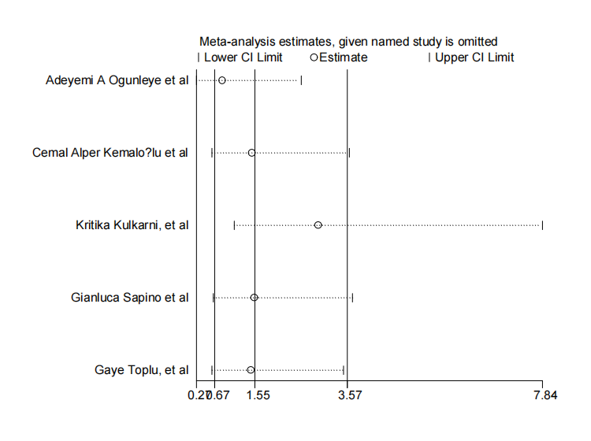
Surgical technique and wound infection (IP and SMP)
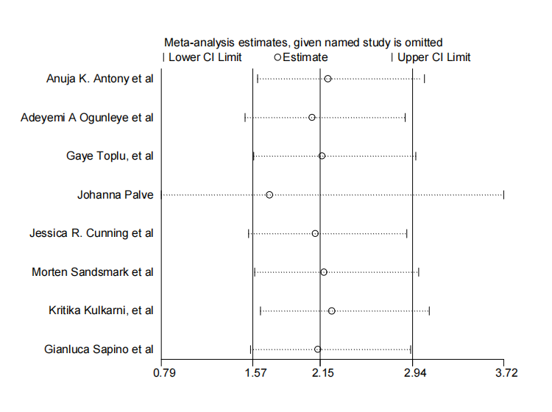
Surgical technique and any complications (IP and SP)
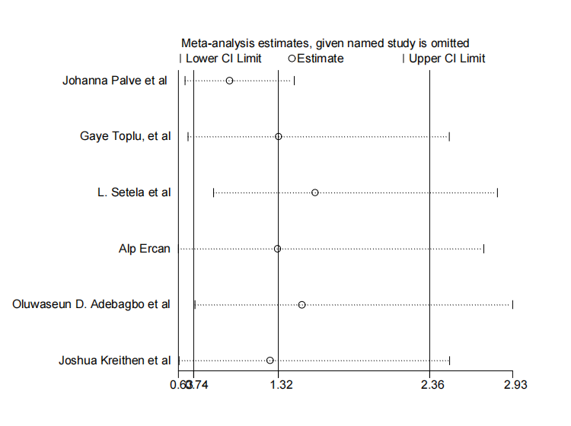
Surgical technique and wound infection (IP and SP)

