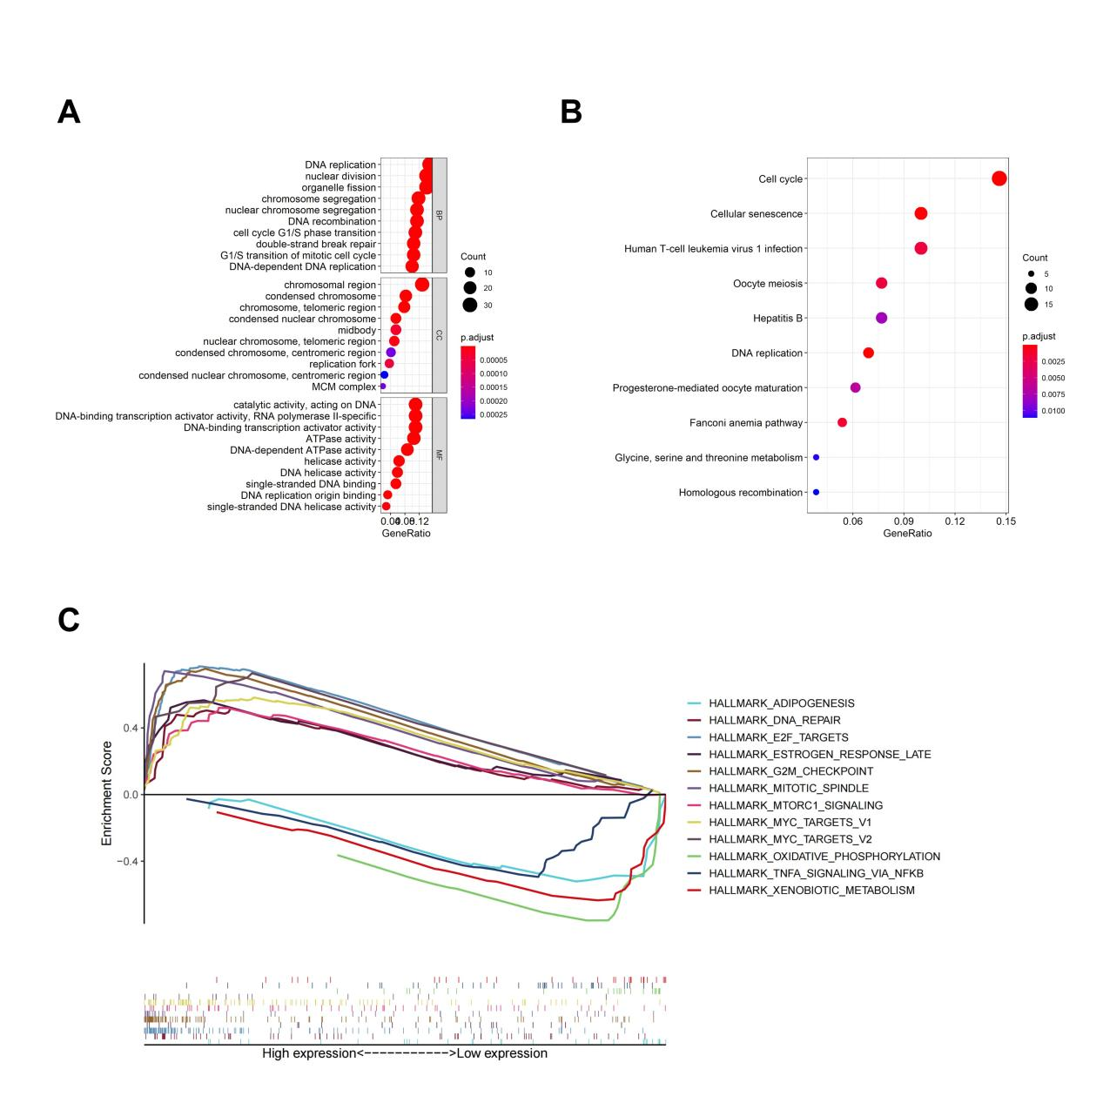
Supplementary Figure 1. Functional analysis of TM-related genes. (A) The top 10 most significant BP, CC, and MF terms in GO analysis. BP: biological process; CC: cellular component; MF: molecular function. (B) The top 10 most significant KEGG pathways. (C) GSEA analysis revealed significant enrichment in the cell cycle and cellular senescence pathways in the high-risk group.

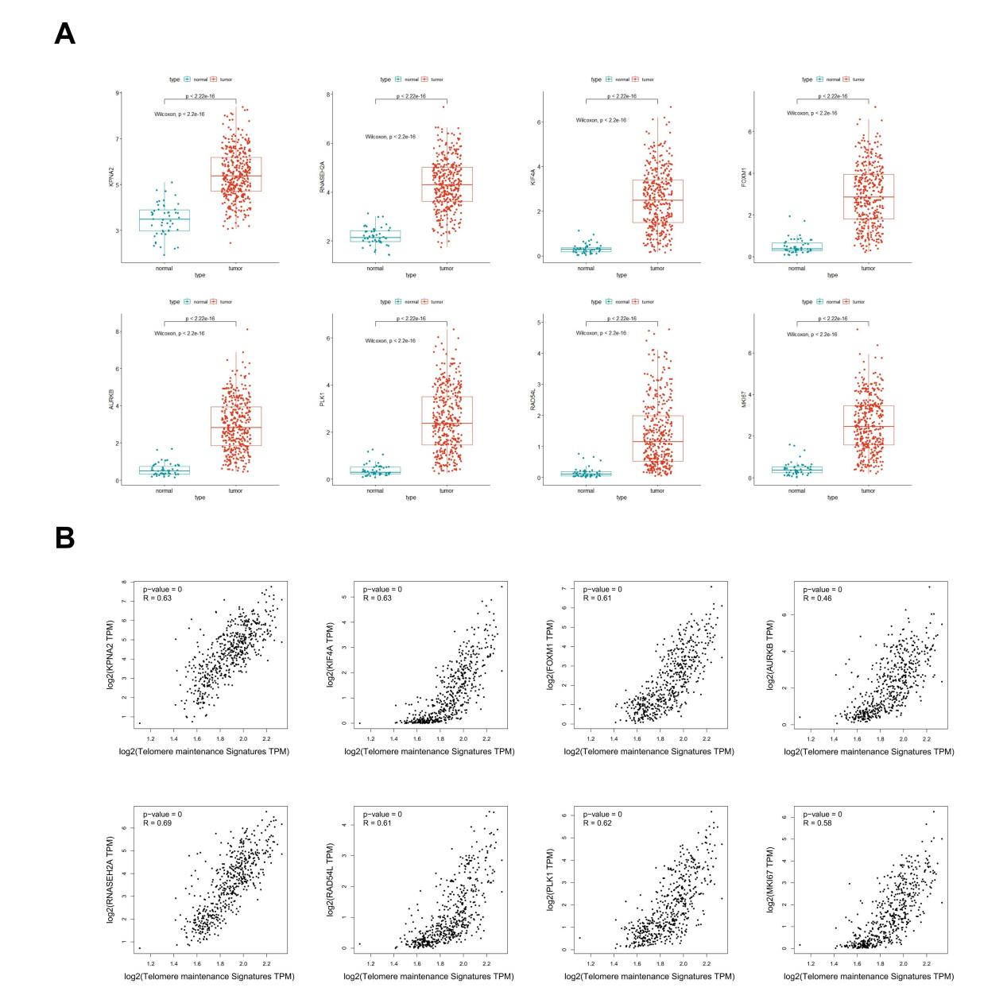
Supplementary Figure 2. Differential expression and correlation analysis of eight hub TM-related genes. (A) The mRNA expression levels of the eight genes in the TCGA database. (B) The relationship between eight genes and telomerase-related signature.

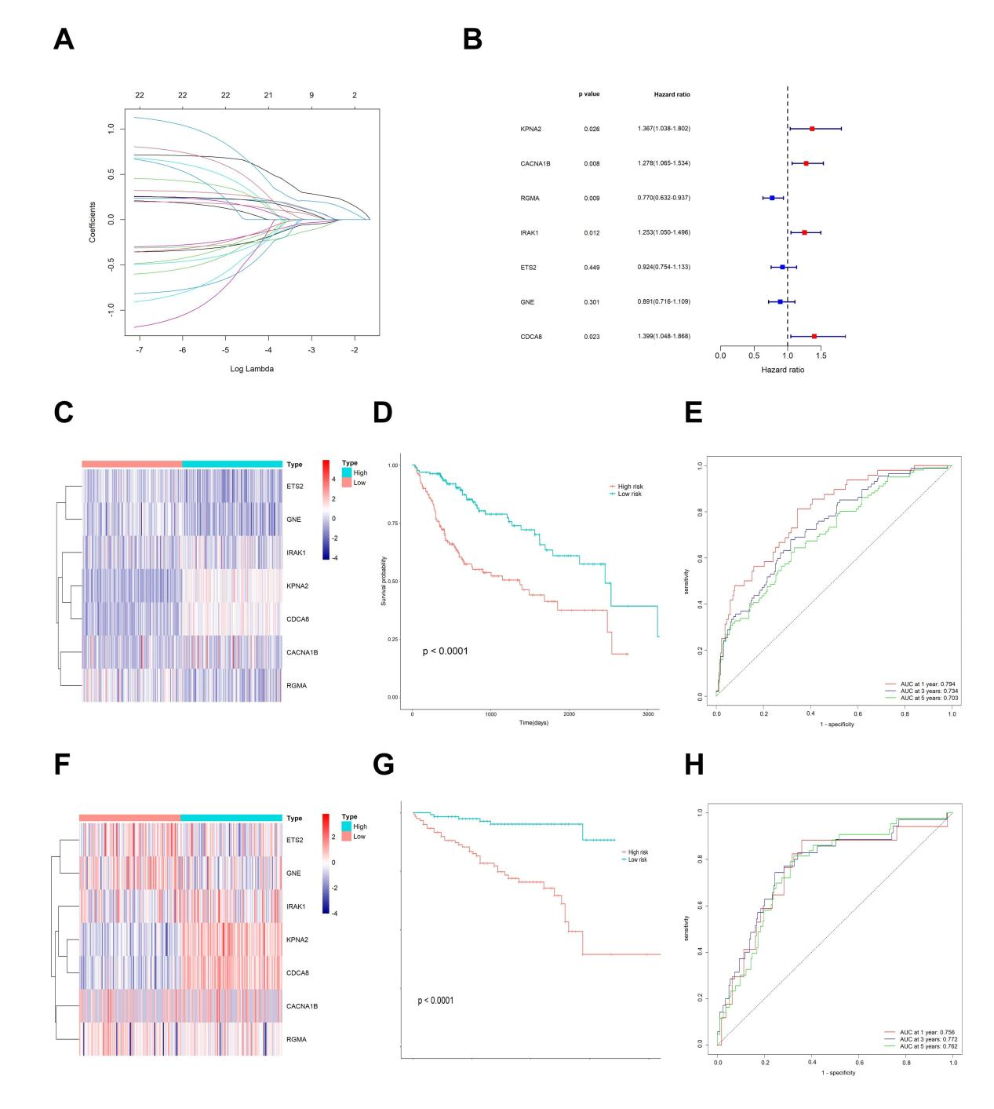
Supplementary Figure 3. Construction and validation of the prognostic TM-related gene signature. (A) The process of screening λ through 10-fold cross-validation in the LASSO model. (B) Univariate cox regression analyses of the 7 prognostic markers. (C) The expression patterns of the 7 prognostic markers within the TCGA cohort are illustrated in the heatmap. (D) Survival analysis of patients in the high-risk group and low-risk group in the TCGA cohort. (E) Time-dependent ROC curve verification of the prognostic signature at 1, 3, 5 years of overall survival (OS) in the TCGA cohort. (F-H) The heatmap, survival analysis and ROC curve of the prognostic signature in the ICGC cohort.

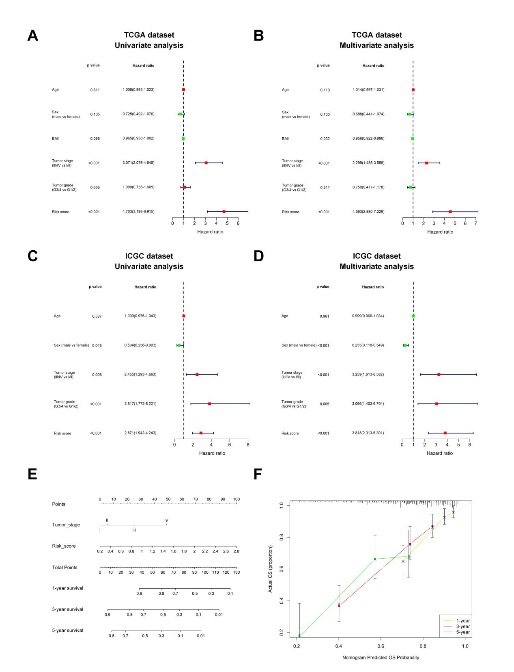
Supplementary Figure 4. Evaluating the independent role of the prognostic signature. (A, B) Univariate and multivariate cox regression analyses of the prognostic signature in the TCGA cohort. (C, D) Univariate and multivariate cox regression analyses of the prognostic signature in the ICGC cohort. (E) A nomogram to predict the survival probability at 1-, 3-, and 5-year. (F) The calibration plot for the nomogram predicting 1-, 3-, and 5-year overall survival.

