Meta-regression
Outcome | Standard error | 95%confidence interval (CI) | P value
Mean age
mRS 0-1 | 0.001 | (-0.0008–0.0032) | 0.25
mRS 0-2 | 0.0083 | (-0.01–0.012) | 0.75
MNI | 0.002 | (-0.0012–0.006) | 0.2
Death | 0.005 | (-0.02–0.003) | 0.2
sICH | 0.006 | (-0.01–0.01) | 0.7
Mean NIHSS score
mRS 0-1 | 0.001 | (-0.0031–0.0008) | 0.2
mRS 0-2 | 0.01 | (0.092–0.04) | 0.025*
MNI | 0.002 | (-0.006–0.003) | 0.2
Death | 0.006 | (-0.003–0.02) | 0.2
sICH | 0.007 | (-0.01–0.01) | 0.8
Male percentage
mRS 0-1 | 0.0046 | (-0.0057–0.023) | 0.48
mRS 0-2 | 0.0048 | (-0.018–0.0009) | 0.08
MNI | 0.007 | (-0.01–0.02) | 0.8
Death | 0.02 | (-0.03–0.05) | 0.7
sICH | 0.02 | (-0.04–0.04) | 0.96
Hypertension percentage
mRS 0-1 | 0.0027 | (-0.0035–0.0072) | 0.5
MNI | 0.06 | (-0.01–0.012) | 0.85
Death | 0.01 | (-0.04–0.02) | 0.4
sICH | 0.02 | (-0.02–0.03) | 0.7
mRS 0-1: Excellent functional outcome
mRS 0-2: Favorable functional outcome
MNI: Major neurological improvement
sICH: Symptomatic intracranial hemorrhage

Mean Age
mRS 0-1 (SE 0.001 95%CI (-0.0008–0.0032) P value 0.25)
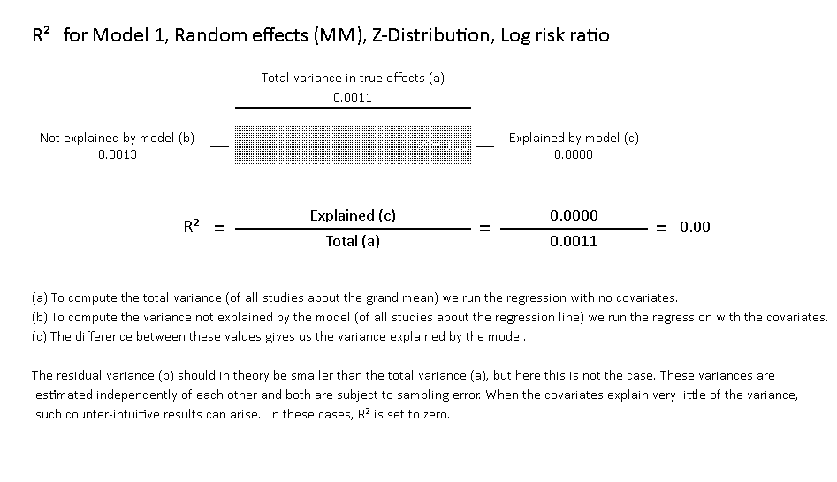
mRS 0-2 (SE 0.0083 95%CI (-0.01–0.012) P value 0.75)
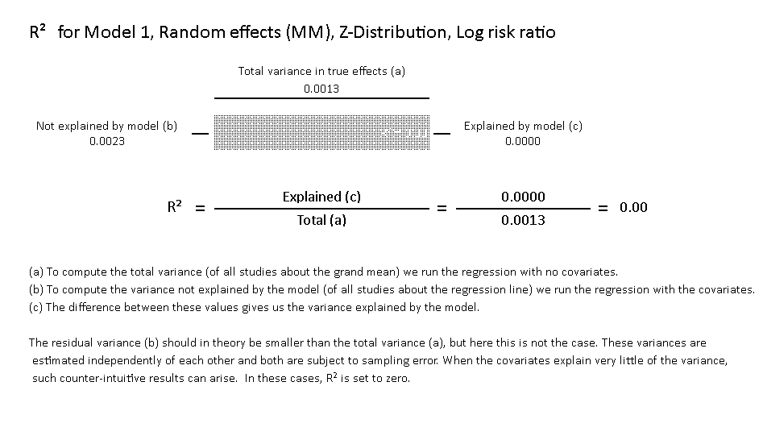

Major neurological improvement MNI (SE 0.002 95%CI (-0.0012–0.006) P value 0.2)
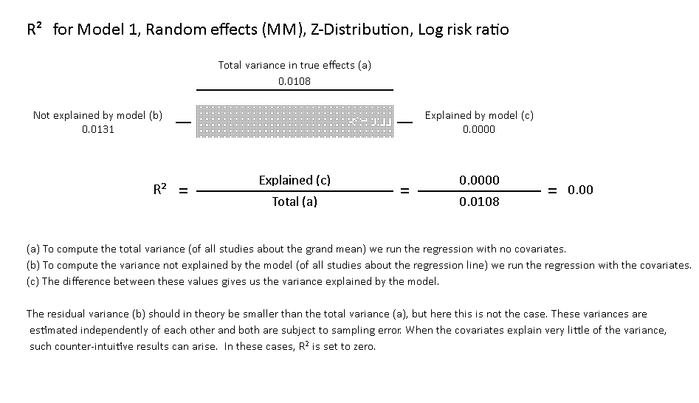
Death (SE 0.005 95%CI (-0.02–0.003) P value 0.2)
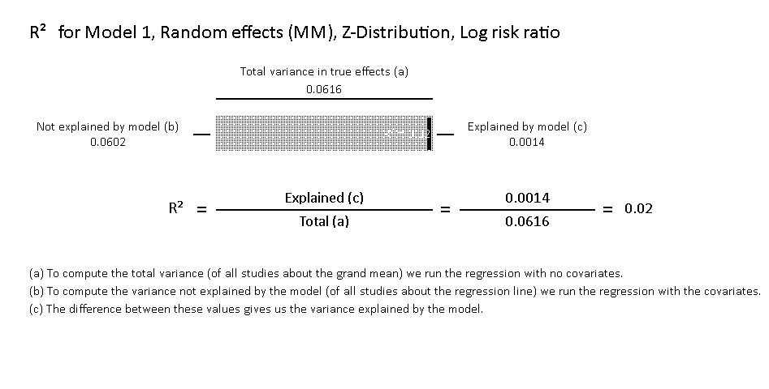
Symptomatic intracranial hemorrhage sICH (SE 0.006 95%CI (-0.01–0.01) P value 0.7)

Mean NIHSS score
mRS 0-1 (SE 0.001 95%CI (-0.0031–0.0008) P value 0.2)
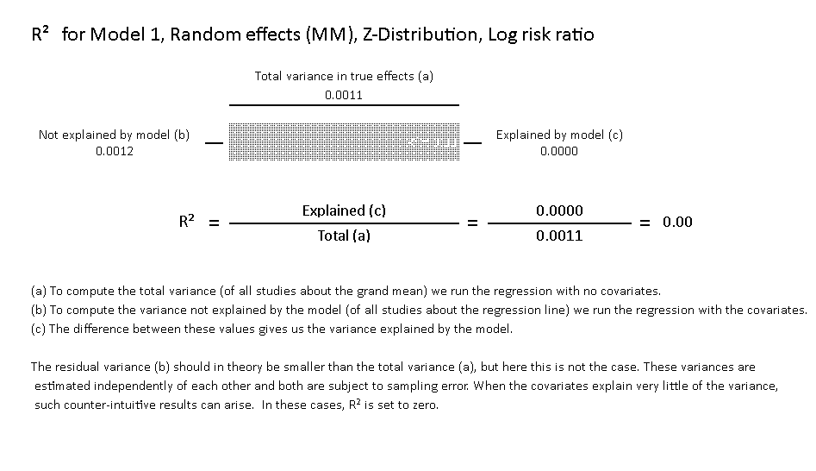

mRS 0-2 (SE 0.01 95%CI (0.092–0.04) P value 0.025)
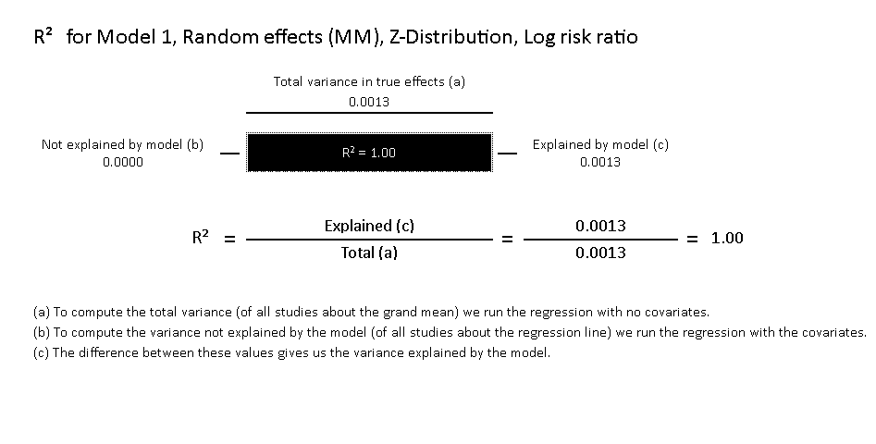

Major neurological improvement MNI (SE 0.002 95% CI (-0.006–0.003) P value 0.2)

Death (SE 0.006 95% CI (-0.003–0.02) P value 0.2)
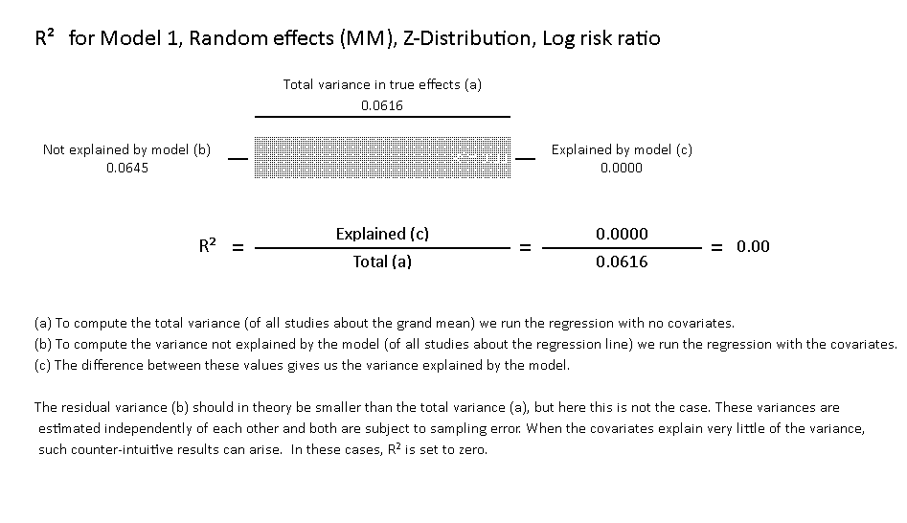
Symptomatic intracranial hemorrhage sICH (SE 0.007 95% CI (-0.01–0.01) P value 0.8)

Male percentage
mRS 0-1 (SE 0.0046 95%CI (-0.0057–0.023 P value 0.48)
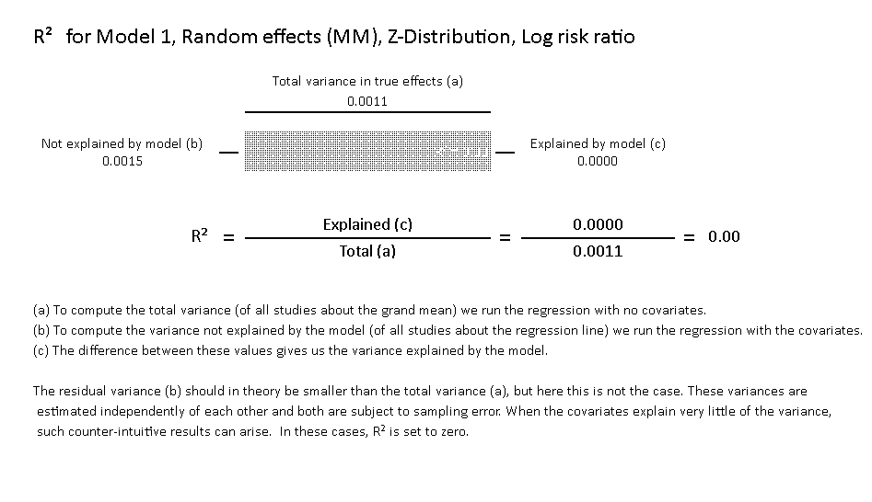
mRS 0-2 at 90 days (SE 0.0048 95%CI (-0.018–0.0009 P value 0.08)
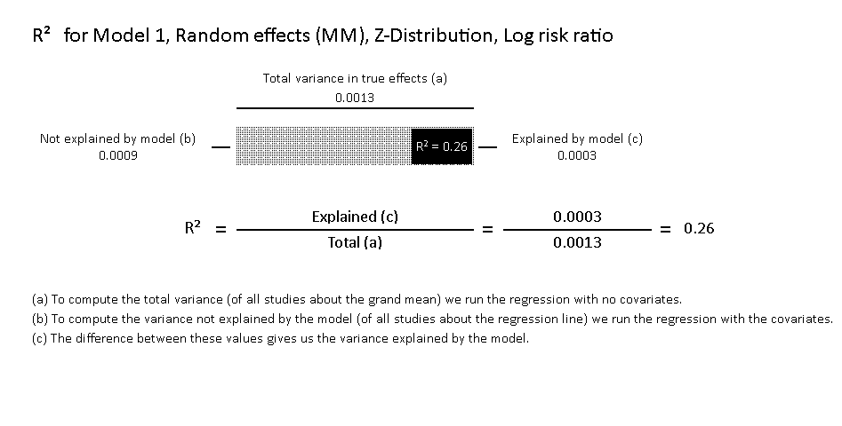

Major neurological improvement (SE 0.007 95%CI (-0.01–0.02 P value 0.8)
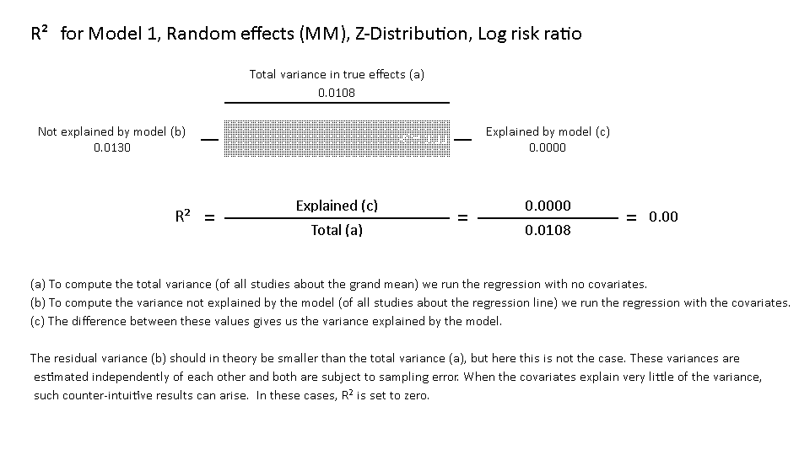
Death (SE 0.02 95%CI (-0.03–0.05 P value 0.7)
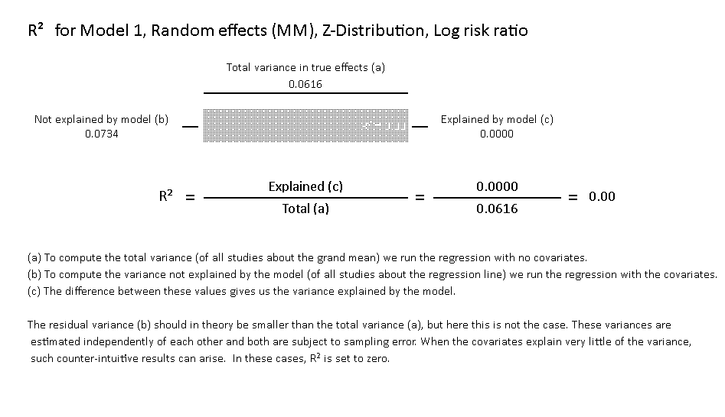
Symptomatic intracranial hemorrhage sICH (SE 0.02 95%CI (-0.04–0.04 P value 0.96)

hypertension percentage
mRS 0-1 (SE 0.0027 95%CI (-0.0035–0.0072 P value 0.5)
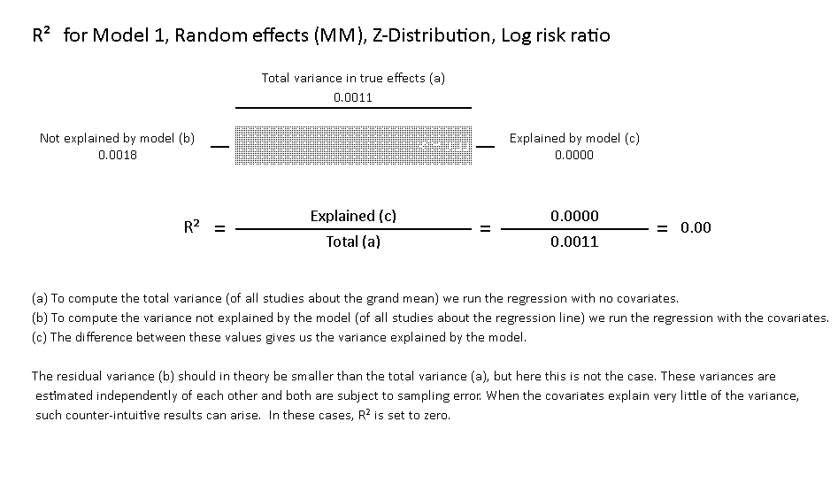
Major neurological improvement (SE 0.06 95%CI (-0.01–0.012 P value 0.85)
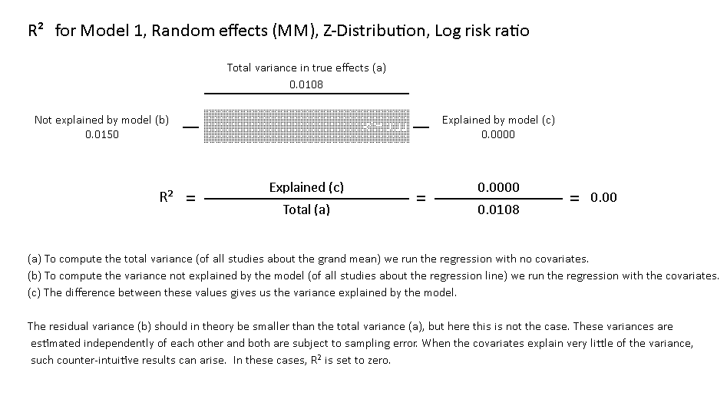
Death (SE 0.01 95%CI (-0.04–0.02 P value 0.4)
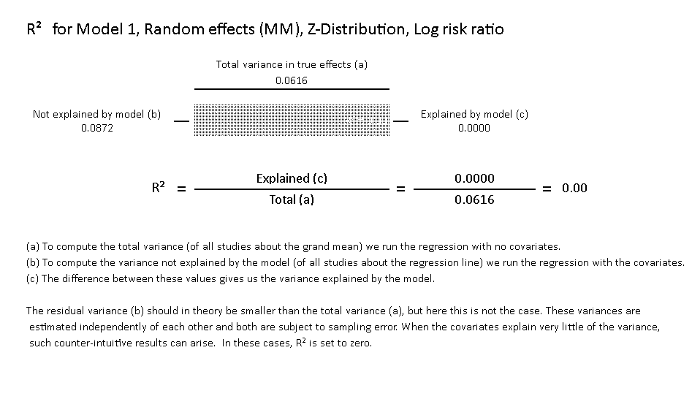
Symptomatic intracranial hemorrhage sICH (SE 0.02 95%CI (-0.02–0.03) P value 0.7)

