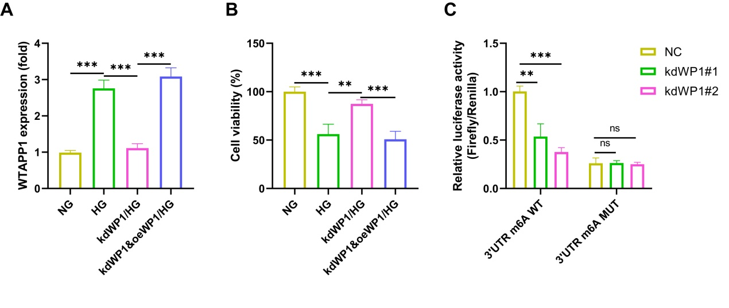
Fig.S1 A-B, In cells transfected with the knockdown WTAPP1 vector, the WTAPP1 overexpression vector was transfected, and after induction with high glucose, WTAPP1 expression was analyzed using RT-qPCR, while cell viability was assessed using the CCK-8 assay. C, The dual-luciferase reporter gene system was used to analyze the co-transfection of wild-type and mutant 3'-UTR m6A motif reporter vectors with two knockdown WTAPP1 vectors into cells. N=3 independent experiments. ^{ns}P>0.05, **P＜0.01, and *** P＜0.001.

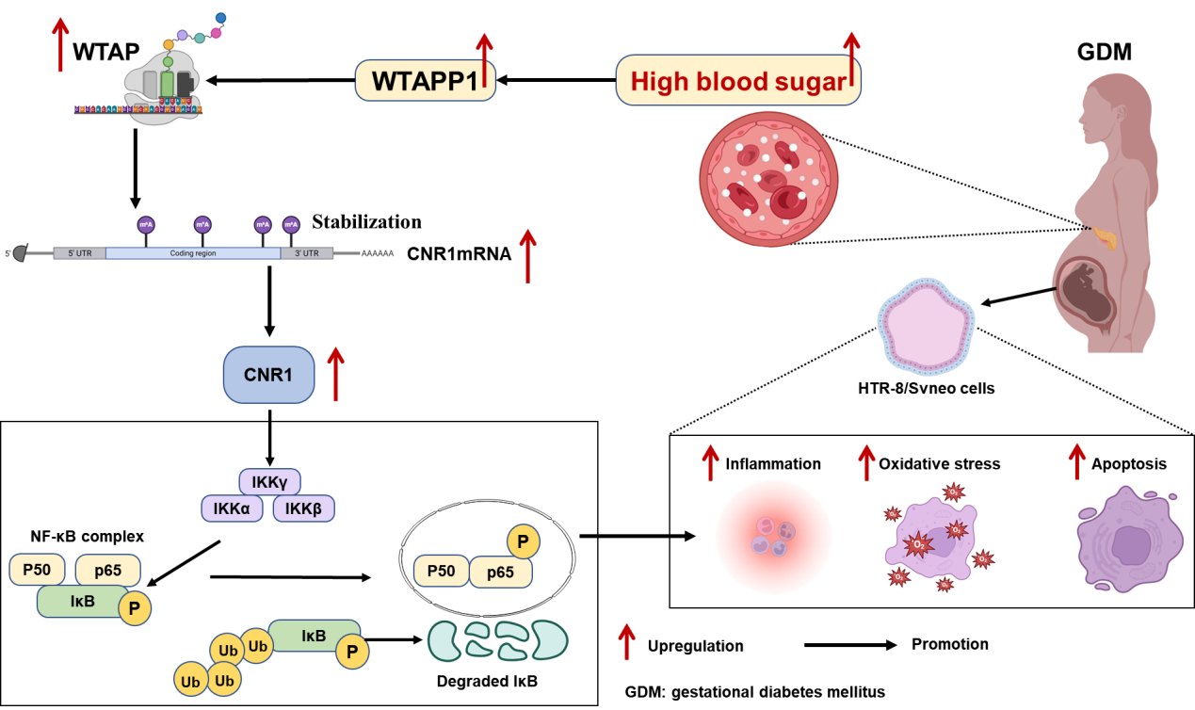
Fig.S2 Graphical abstract. In GDM placentas, hyperglycemia upregulates the pseudogene WTAPP1, which in turn enhances WTAP-mediated m6A methylation on CNR1 transcripts. This epigenetic modification stabilizes CNR1 mRNA, leading to increased CNR1 protein expression and subsequent activation of the NF-κB pathway. Consequently, this cascade promotes inflammation, oxidative stress, and apoptosis while impairing trophoblast cell viability in HTR-8/Svneo models.

