Supplementary File 1. Quantitative positional anatomy of the lumbar spine – individual‐study dataset supporting the meta‑analysis.

Contents
- Rationale and compilation methods
- Complete comparison‑level table
- Notes on data harmonisation and units
- Abbreviation list

1. Rationale and compilation methods
We extracted the raw means ± standard deviations (SD) reported in all nine eligible studies (41 independent comparisons, 1 248 participants). Extraction was performed in duplicate (A.D., S.S.) using a piloted spreadsheet (Microsoft Excel 365). When results were plotted graphically, values were digitised with WebPlotDigitizer v4.6. Disagreements > 0.5 mm or 0.5° were resolved by consensus.

2. Comparison‑level table has been provided on the next page.

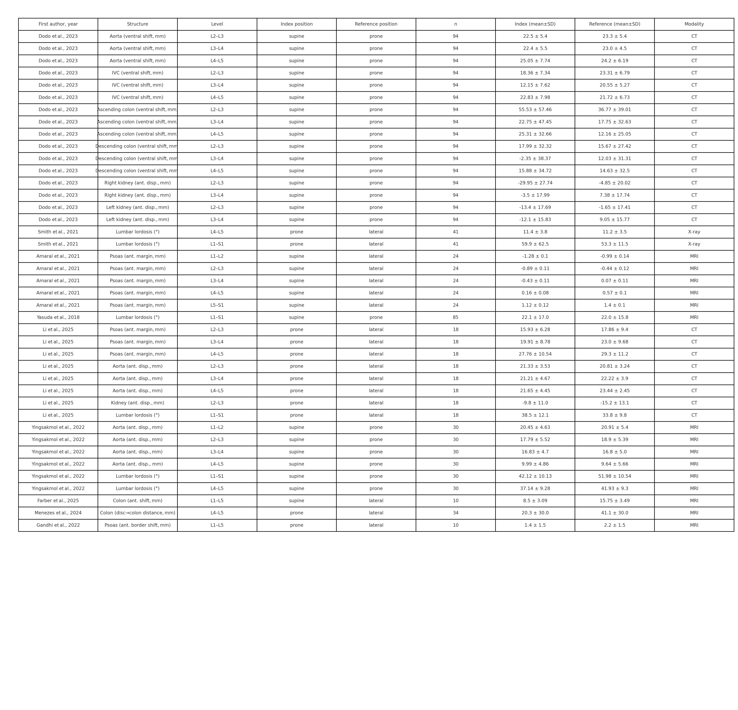
4 Data harmonisation
Units – All studies reported millimetres or degrees; no conversions were necessary.
Segmental lordosis – When only Cobb angles at adjacent endplates were given, the authors’ means and SDs were used directly; no back‑calculation was required.
Multiple levels within a study – Treated as separate comparisons but clustered under the same study identifier; variance–covariance was modelled using the robust (cluster) option in metafor.
Missing SDs – None; all nine studies provided measures of spread.

