A)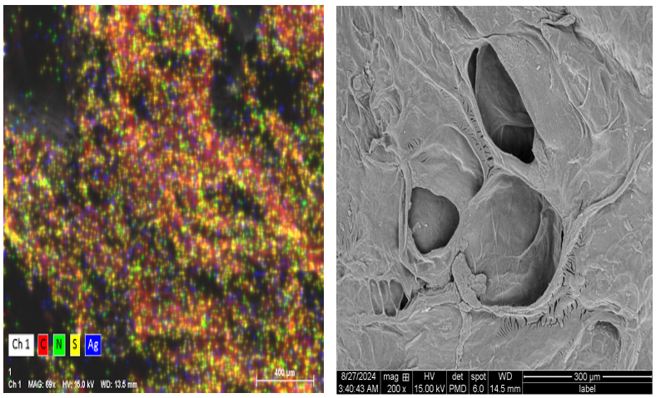
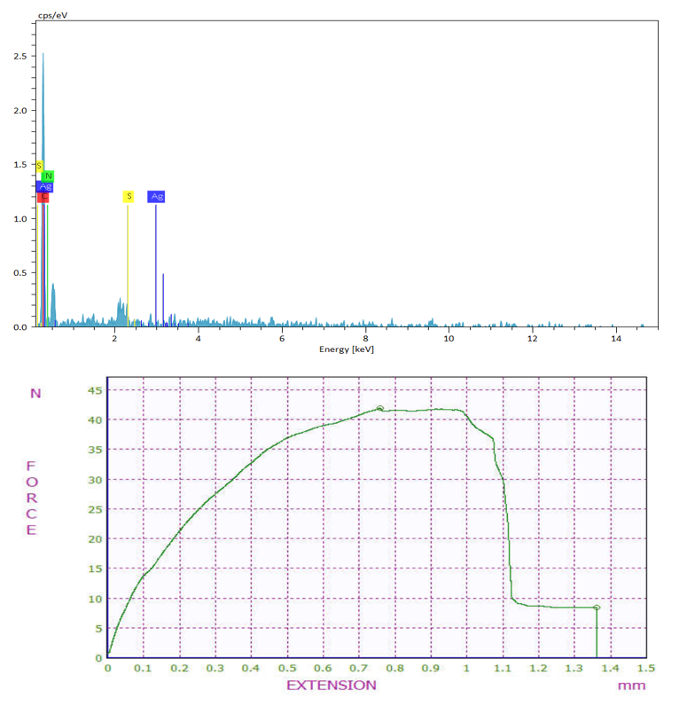

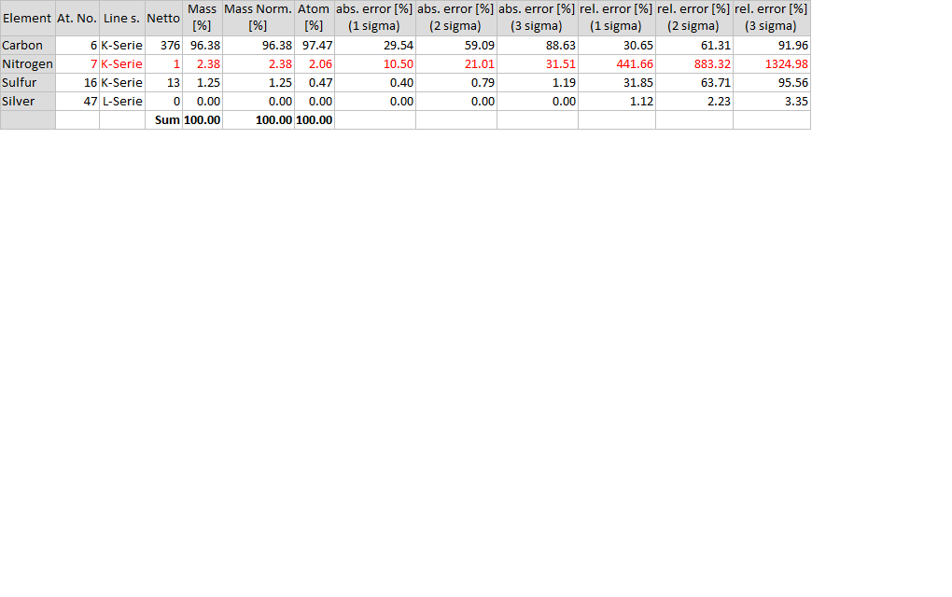

B)
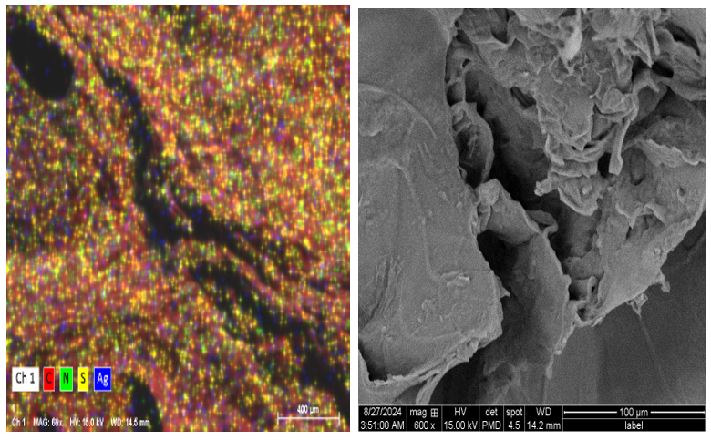
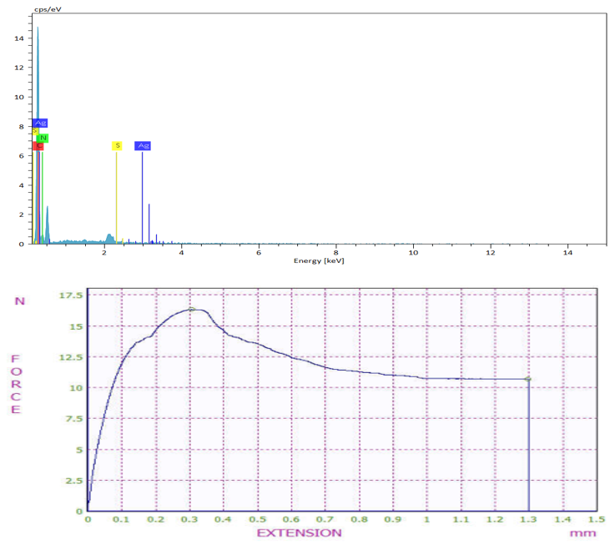
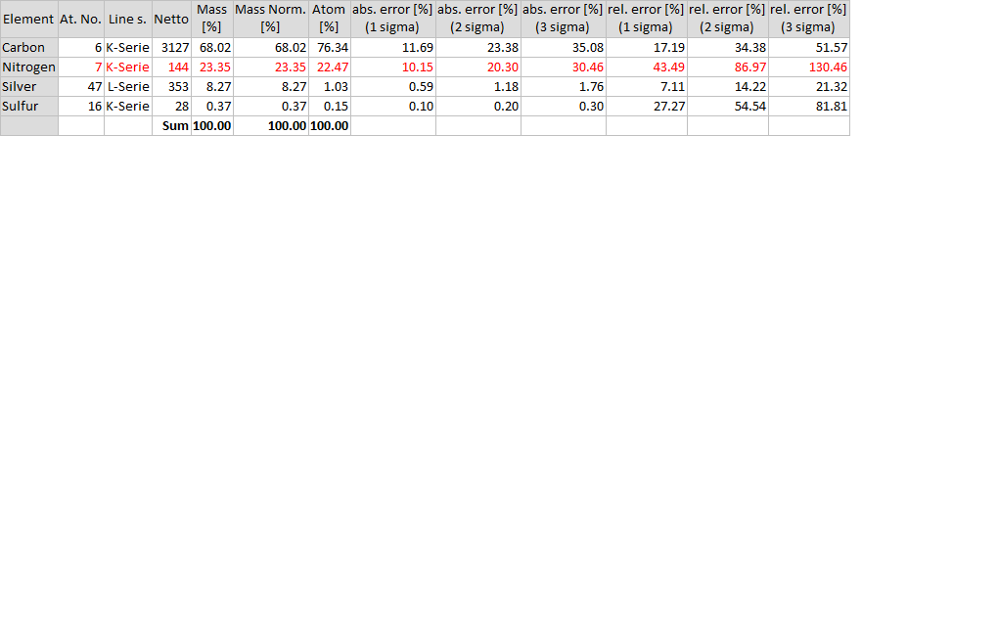
C)
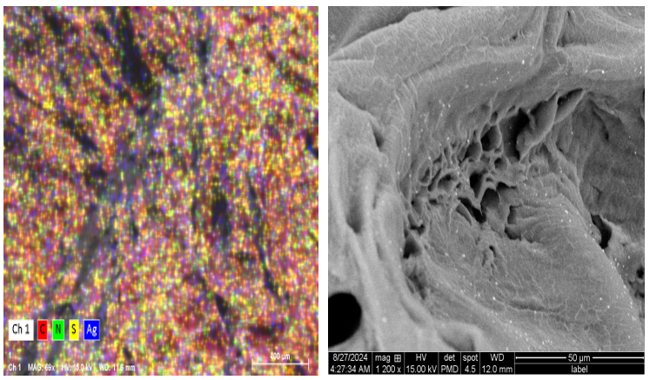
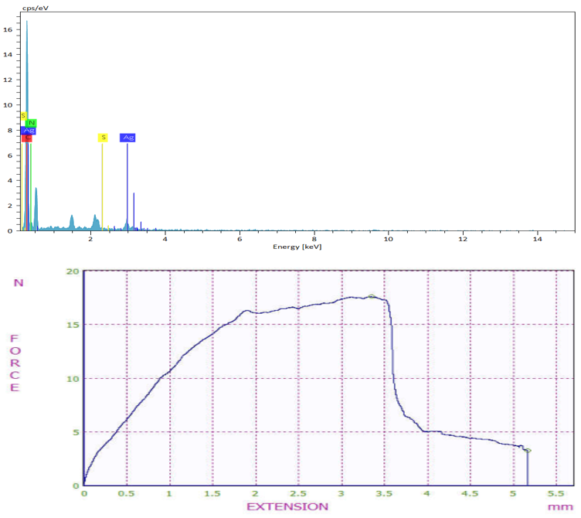
Figure S1. (A) SEM micrograph, EDS, and tensile of the fabricated pure hydrogel (B) drug-loaded hydrogel and AgNPs (C) drug-loaded hydrogel. Scale bar: 300 µm.

Table S1. Characteristics of strains isolated from patients.
Isolate  (n=10) | Bacteria | Biofilm formation
A1 | MSSA | Strong
A2 | VRSA | Strong
A3 | MRSA | Strong
A4 | MSSA | Moderate
A5 | MRSA | Strong
A6 | MSSA | Weak -biofilm forming
A7 | MRSA | Strong
P1 | Cipro-S | Strong
P2 | Cipro-S | Weak -biofilm forming
P3 | Cipro-S | Strong
MRSA: methicillin-resistant Staphylococcus aureus; MSSA: methicillin-sensitive Staphylococcus aureus. VRSA: vancomycin-resistant Staphylococcus aureus; Cipro-S: Ciprofloxacin-sensitive

Table S2. Antibiogram results of isolates.
Strains (n = 10) | P. aeruginosa  (n=3) | MRSA  (n=3) | MSSA  (n=3)
Ciprofloxacin | S | - | -
Levofloxacin | I | - | -
Imipenem | S | - | -
Ceftazidime | S | - | -
Piperacillin | S | - | -
Tobramycin | S | - | -
Cefoxitin | - | R | S
Gentamycin | - | S | S
Clindamycin | - | R | S
Mupirocin | - | S | S
Amoxicillin | - | R | S
Trimethoprim/sulfamethoxazole | - | R | S
Erythromycin | - | R | R
MRSA: methicillin-resistant Staphylococcus aureus; MSSA: methicillin-sensitive Staphylococcus aureus. VRSA: vancomycin-resistant Staphylococcus aureus

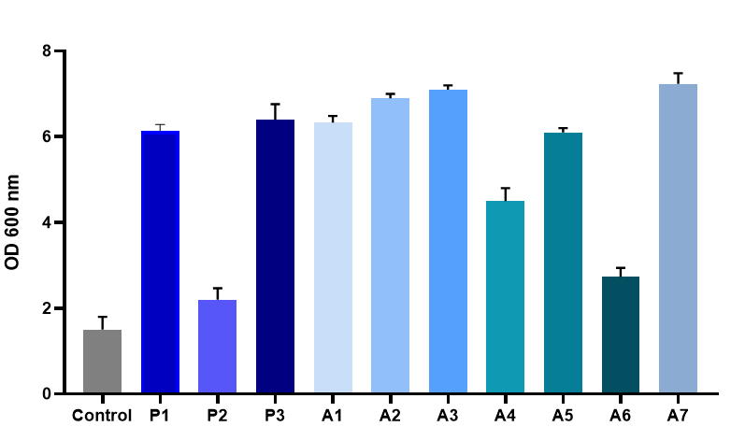
Figure S2. the biofilm production of bacterial isolates.

Table S3. 16S rDNA gene-targeted specific primers and TaqMan probes for isolation of bacteria.
Target Bacteria | Primer/probe* | Oligonucleotide sequence
Staphylococcus aureus | Primer F  Primer R  Probe | AAGTCGAGCGAACGGACGAG  CTCTCAGGTCGGCTATGCATCG  ACCTTACCAACTAGCTAATGCAGCGCGGAT
Pseudomonas aeruginosa | Primer F  Primer R  Probe | GTGGTTCAGCAAGTTGGATGTG  CCACGCTTTCGCACCTCAG  CGCCTTCGCCACTGGTGTTCCTTCCTATA
*Primers F (forward), R (reverse) and probes targeting the 16S rDNA gene

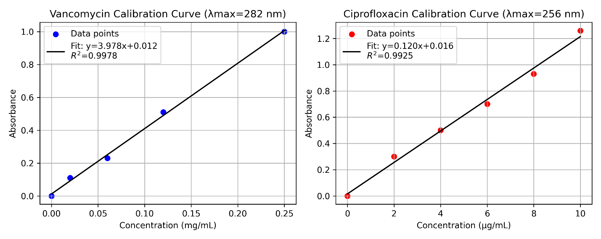

Figure S3. Standard carve of Ciprofloxacin and Vancomycin.

