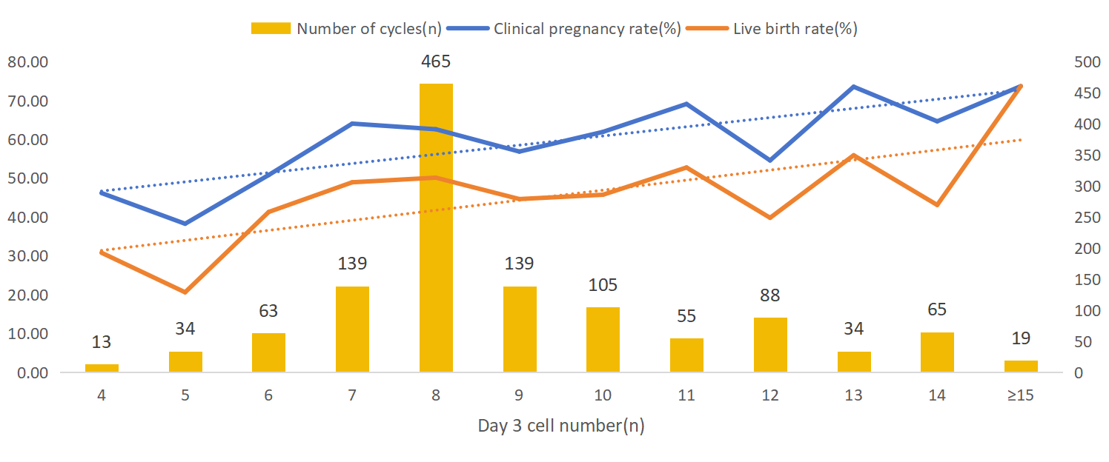
Supplementary Figure 1. Distribution of day 3 cell number and pregnancy outcomes by cell number after blastocyst transfer
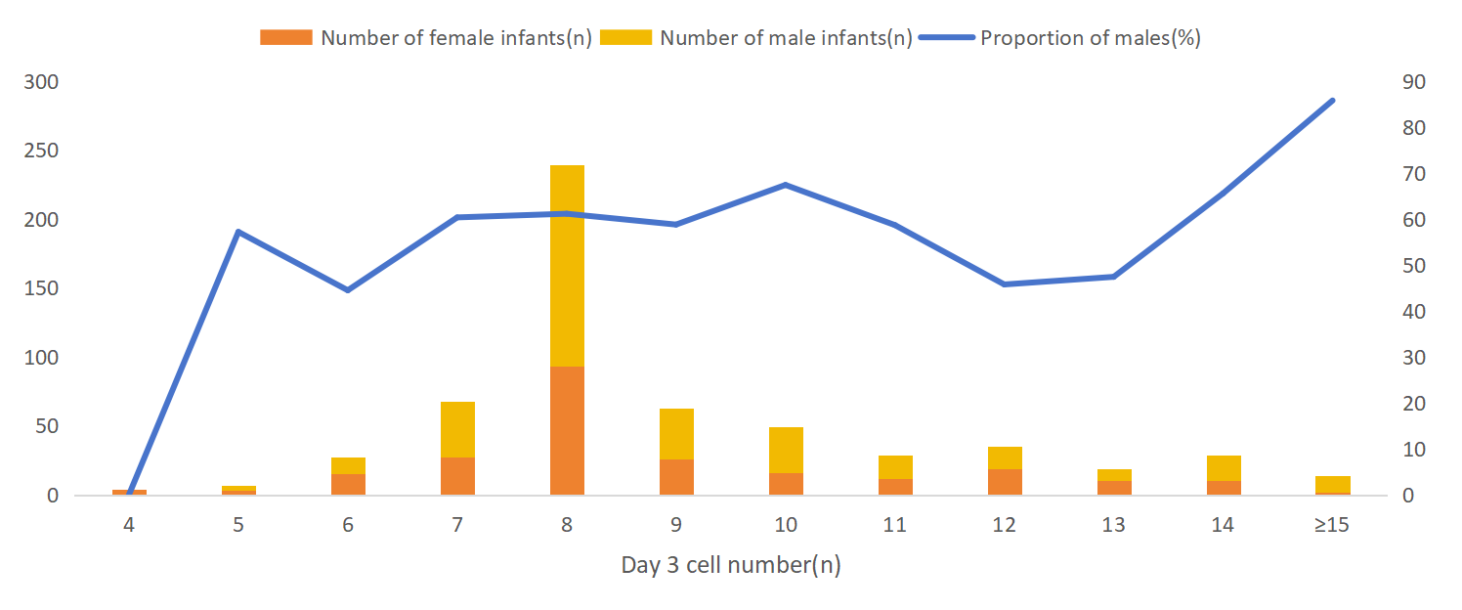
Supplementary Figure 2. Proportion of male infants by day 3 cell number after blastocyst transfer

Supplementary Table I Clinical and neonatal outcomes in subgroup analyses by age, blastocyst grade and embryonic development days
 |  | < 7-cell | 7-9-cell | 10-13-cell | > 13-cell | P-value
Ages(years)
< 35 | Number of cycles | 85 | 610 | 247 | 76
< 35 | Clinical Pregnancy rate (%) | 45.88(39/85) | 62.95(384/610)ª | 64.37(159/247)ª | 67.11(51/76)ª | 0.011
< 35 | Live birth rate (%) | 35.29(30/85) | 50.33(307/610) | 47.77(118/247) | 50.00(38/76) | 0.076
< 35 | Proportion of males (%) | 43.33(13/30) | 62.62(196/313) | 54.62(65/119) | 74.36(29/39) | 0.027
≥ 35 | Number of cycles | 25 | 133 | 35 | 8
≥ 35 | Clinical Pregnancy rate (%) | 48.00(12/25) | 56.39(75/133) | 48.57(17/35) | 62.5(5/8) | 0.726
≥ 35 | Live birth rate (%) | 28.00(7/25) | 42.11(56/133) | 37.14(13/35) | 50.00(4/8) | 0.532
≥ 35 | Proportion of males (%) | 37.5(3/8) | 49.12(28/57) | 76.92(10/13) | 50.00(2/4) | 0.251
Blastocyst grade
High-quality | Number of cycles | 73 | 641 | 265 | 82
 | Clinical Pregnancy rate (%) | 43.84(32/73) | 64.74(415/641)ª | 63.77(169/265)ª | 67.07(55/82)ª | 0.005
 | Live birth rate (%) | 30.14(22/73) | 51.33(329/641)ª | 47.17(125/265) | 51.22(42/82)ª | 0.006
 | Proportion of males (%) | 45.45(10/22) | 61.61(207/336) | 58.73(74/126) | 72.09(31/43) | 0.188
Low-quality | Number of cycles | 37 | 102 | 11 | 2
 | Clinical Pregnancy rate (%) | 51.35(19/37) | 43.14(44/102) | 63.64(7/11) | 50.00(1/2) | 0.833
 | Live birth rate (%) | 39.47(15/38) | 33.33(34/102) | 54.55(6/11) | 0.00(0/2) | 0.636
 | Proportion of males (%) | 40.00(6/15) | 50.00(17/34) | 16.67(1/6) | / | /
embryonic development days
Day 5 | Number of cycles | 47 | 582 | 258 | 83
Day 5 | Clinical Pregnancy rate (%) | 57.45(27/47) | 64.78(377/582) | 63.95(165/258) | 67.47(56/83) | 1.708
Day 5 | Live birth rate (%) | 42.55(20/47) | 52.06(303/582) | 48.45(125/258) | 50.60(42/83) | 0.437
Day 5 | Proportion of males (%) | 55.00(11/20) | 60.19(186/309) | 55.56(70/126) | 72.09(31/43) | 0.277
Day 6 | Number of cycles | 163 | 161 | 24 | 1
Day 6 | Clinical Pregnancy rate (%) | 38.10(24/63) | 50.93(82/161) | 45.83(11/24) | 0.00(0/1) | 0.534
Day 6 | Live birth rate (%) | 26.98(17/63) | 37.27(60/161) | 25.00(6/24) | 0.00(0/1) | 0.319
Day 6 | Proportion of males (%) | 29.41(5/18) | 61.67(38/61) | 83.33(5/6) | / | /
Note: 1. P value indicates differences among the four groups. P < 0.05 indicates statistically significant difference in results
2. “a” indicates a significant difference compared to < 7-cell group. According to Bonferroni correction for multiple comparisons, the difference was statistically significant at P < 0.008 (0.05/6)

Supplementary Table 2 Comparison of pregnancy outcomes after high-quality blastocyst transfer in patients < 35 years
 | < 7-cell | 7-9-cell | 10-13-cell | > 13-cell | χ² | P-value
Number of cycles | 61 | 540 | 232 | 74
Clinical Pregnancy rate (%) | 42.62(26/61) | 65.19(352/540)ª | 65.52(152/232)ª | 67.57(50/74)ª | 13.06 | 0.005
Live birth rate (%) | 32.79(20/61) | 52.78(285/540)ª | 48.28(112/232) | 51.35(38/74) | 9.22 | 0.027
Proportion of males | 45.00(9/20) | 62.72(180/287) | 56.25(63/112) | 76.32(29/38) | 7.31 | 0.063
Note: 1. P value indicates differences among the four groups. P < 0.05 indicates statistically significant difference in results
- “a” indicates a significant difference compared to < 7-cell group. According to Bonferroni correction for multiple comparisons, the difference was statistically significant at P < 0.008 (0.05/6)

