Effect of Different Types of Internal Fixation on the Incidence of Femoral Head Necrosis in Adult Femoral Neck Fractures: A Single-Arm Rate and Network Meta-Analysis

Table legends
eTable 1: Search strategy.
eTable 2a: The ROBINS-I scale of included studies.
eTable 2b: Risk of bias assessment of the included randomized controlled trial studies according to the revised Cochrane risk of bias assessment tool.
eTable 3. Supplementary Table of Basic Characteristics of Included Studies
Figure legends
eFigure 1. sensitivity analysis (CCS).
eFigure 2. Forest plot of diagnostic modality(CCS fixation)
eFigure 3. Forest plot of study design(CCS fixation)
eFigure 4. Forest plot of Sex (CCS fixation).
eFigure 5. Forest plot of retention or removal of internal fixation (CCS fixation).
eFigure 6. Forest plot of external force of injury (CCS fixation).
eFigure 7. Forest plot of methods of fracture reduction (CCS fixation).
eFigure 8. Forest plot of quality of reduction (CCS fixation).
eFigure 9. Forest plot of Garden classification (CCS fixation).
eFigure 10. Forest plot of Pauwels classification (CCS fixation).
eFigure 11. Forest plot of screw configuration (CCS fixation).
eFigure 12. The node splitting method for analysis and assessed the potential inconsistency.
eFigure 13. The convergence results.
eFigure 14. Forest plot of pairwise comparison results.
eFigure 15. The cumulative probability bar Chart.
eFigure 16. Heterogeneity of the network meta-analysis.
eFigure 17. Funnel plot of single group rate meta-analysis.

eTable 1. Search strategy
Databases | Search strategy | Result
PubMed | ((((("Femoral Neck Fractures"[Mesh]) OR (Femoral Neck Fracture[Title/Abstract])) OR (Femur Neck Fractures[Title/Abstract])) OR (Femur Neck Fracture[Title/Abstract])) AND ((((((((((("Femur Head Necrosis"[Mesh]) OR (Femur Head Necroses[Title/Abstract])) OR (Head Necrosis, Femur[Title/Abstract])) OR (Necrosis, Femur Head[Title/Abstract])) OR (Necrosis, Avascular, of Femur Head[Title/Abstract])) OR (Avascular Necrosis Of Femoral Head, Primary[Title/Abstract])) OR (Avascular Necrosis of Femur Head[Title/Abstract])) OR (Femoral Head, Avascular Necrosis Of[Title/Abstract])) OR (Ischemic Necrosis Of Femoral Head[Title/Abstract])) OR (Aseptic Necrosis of Femur Head[Title/Abstract])) OR (Necrosis, Aseptic, of Femur Head[Title/Abstract]))) AND (((((((((((("Fracture Fixation"[Mesh]) OR (Fixation, Fracture[Title/Abstract])) OR (Fixations, Fracture[Title/Abstract])) OR (Fracture Fixations[Title/Abstract])) OR (Fracture Reduction[Title/Abstract])) OR (Fracture Reductions[Title/Abstract])) OR (Reduction, Fracture[Title/Abstract])) OR (Reductions, Fracture[Title/Abstract])) OR (Skeletal Fixation[Title/Abstract])) OR (Fixation, Skeletal[Title/Abstract])) OR (Fixations, Skeletal[Title/Abstract])) OR (Skeletal Fixations[Title/Abstract])) | 372
Embase | #4. #1 AND #2 AND #3 354 2 Sep 2024  #3. 'fracture fixation'/exp OR 'fracture fixation' OR 122,662 2 Sep 2024  'fixation, fracture' OR 'fixations, fracture' OR  'fracture fixations' OR 'fracture reduction'/exp  OR 'fracture reduction' OR 'fracture reductions'  OR 'reduction, fracture'/exp OR 'reduction,  fracture' OR 'reductions, fracture' OR 'skeletal  fixation' OR 'fixation, skeletal' OR 'fixations,  skeletal' OR 'skeletal fixations'  #2. 'postoperative femoral head necrosis' OR 8,205 2 Sep 2024  'postoperative osteonecrosis of the femoral head'  OR 'femur head necrosis'/exp OR 'femur head  necrosis' OR 'femur head necroses' OR 'head  necrosis, femur' OR 'necrosis, femur head'/exp OR  'necrosis, femur head' OR 'necrosis, avascular,  of femur head' OR 'avascular necrosis of femoral  head, primary' OR 'avascular necrosis of femur  head' OR 'femoral head, avascular necrosis of' OR  'ischemic necrosis of femoral head' OR 'aseptic  necrosis of femur head' OR 'necrosis, aseptic, of  femur head'  #1. 'femoral neck fractures'/exp OR 'femoral neck 16,724 2 Sep 2024  fractures' OR 'femoral neck fracture'/exp OR  'femoral neck fracture' OR 'femur neck  fractures'/exp OR 'femur neck fractures' OR  'femur neck fracture'/exp OR 'femur neck  fracture' | 354
Cochrane Library | #1 Femoral Neck Fractures 2158  #2 Femoral Neck Fracture 2541  #3 Femur Neck Fractures 932  #4 Femur Neck Fracture 1175  #5 #1 or #2 or #3 or #4 3295  #6 postoperative femoral head necrosis 192  #7 postoperative osteonecrosis of the femoral head 73  #8 Femur Head Necrosis 339  #9 Femur Head Necroses 1  #10 Head Necrosis, Femur 339  #11 Necrosis, Femur Head 339  #12 Necrosis, Avascular, of Femur Head 117  #13 Avascular Necrosis Of Femoral Head, Primary 134  #14 Avascular Necrosis of Femur Head 117  #15 Femoral Head, Avascular Necrosis Of 227  #16 Ischemic Necrosis Of Femoral Head 31  #17 Aseptic Necrosis of Femur Head 23  #18 Necrosis, Aseptic, of Femur Head 23  #19 #6 or #7 or #8 or #9 or #10 or #11 or #12 or #13 or #14 or #15 or #16 or #17 or #18 561  #20 Fracture Fixation 5833  #21 Fixation, Fracture 5833  #22 Fixations, Fracture 77  #23 Fracture Fixations 77  #24 Fracture Reduction 5647  #25 Fracture Reductions 612  #26 Reduction, Fracture 5647  #27 Reductions, Fracture 612  #28 Skeletal Fixation 288  #29 Fixation, Skeletal 288  #30 Fixations, Skeletal 11  #31 Skeletal Fixations 11  #32 #20 or #21 or #22 or #23 or #24 or #25 or #26 or #27 or #28 or #29 or #30 or #31 9509  #33 #5 and #19 and #32 72 | 72

eTable 2a. The ROBINS-I scale of included studies
Study | Year | Bias due to confounding | Bias in selection of participants into the study | Bias in classification of interventions | Bias due to deviations from intended interventions | Bias due to missing data | Bias in measurement of outcomes | Bias in selection of the reported result | Overall risk of Bias
X. Zhou | 2024 | LOW | LOW | LOW | LOW | LOW | MODERATE | LOW | MODERATE
J. Zhang | 2024 | LOW | LOW | LOW | LOW | LOW | MODERATE | LOW | MODERATE
L. Yang | 2023 | LOW | LOW | LOW | LOW | LOW | MODERATE | LOW | MODERATE
J. Liu | 2023 | LOW | LOW | LOW | LOW | LOW | MODERATE | LOW | MODERATE
S. De Franco | 2023 | LOW | LOW | LOW | LOW | LOW | MODERATE | LOW | MODERATE
W. J. Cheng | 2022 | LOW | LOW | LOW | LOW | LOW | MODERATE | LOW | MODERATE
F. X. Ju | 2020 | LOW | LOW | LOW | LOW | LOW | MODERATE | LOW | MODERATE
K. Huang | 2020 | LOW | LOW | LOW | LOW | LOW | MODERATE | LOW | MODERATE
C. D. Novoa-Parra | 2019 | LOW | LOW | LOW | LOW | LOW | MODERATE | LOW | MODERATE
P. Campenfeldt | 2018 | LOW | LOW | LOW | LOW | LOW | MODERATE | LOW | MODERATE
J. W. Kim | 2017 | LOW | LOW | LOW | LOW | LOW | MODERATE | LOW | MODERATE
W. Fan | 2017 | LOW | LOW | LOW | LOW | LOW | MODERATE | LOW | MODERATE
H. K. Song | 2016 | LOW | LOW | LOW | LOW | LOW | MODERATE | LOW | MODERATE
O. Riaz | 2016 | LOW | LOW | LOW | LOW | LOW | MODERATE | LOW | MODERATE
J. S. Kang | 2016 | LOW | LOW | LOW | LOW | LOW | MODERATE | LOW | MODERATE
H. T. Hou | 2016 | LOW | LOW | LOW | LOW | LOW | MODERATE | LOW | MODERATE
H. F. Yuan | 2015 | LOW | LOW | LOW | LOW | LOW | MODERATE | LOW | MODERATE
C. Wang | 2015 | LOW | LOW | LOW | LOW | LOW | MODERATE | LOW | MODERATE
T. Wang | 2014 | LOW | LOW | LOW | LOW | LOW | MODERATE | LOW | MODERATE
Z. S. Ai | 2013 | LOW | LOW | LOW | LOW | LOW | MODERATE | LOW | MODERATE
J. C. Han | 2007 | LOW | LOW | LOW | LOW | LOW | MODERATE | LOW | MODERATE
Y. J. Mao | 2005 | LOW | LOW | LOW | LOW | LOW | MODERATE | LOW | MODERATE
O. Karaeminogullari | 2004 | LOW | LOW | LOW | LOW | LOW | MODERATE | LOW | MODERATE
K. E. Nikolopoulos | 2003 | LOW | LOW | LOW | LOW | LOW | MODERATE | LOW | MODERATE
F. Pei, R | 2020 | LOW | LOW | LOW | LOW | LOW | MODERATE | LOW | MODERATE
D. Schweitzer | 2013 | LOW | LOW | LOW | LOW | LOW | MODERATE | LOW | MODERATE
L. Nanty | 2019 | LOW | LOW | LOW | LOW | LOW | MODERATE | LOW | MODERATE
F. Y. Liu | 2015 | LOW | LOW | LOW | LOW | LOW | MODERATE | LOW | MODERATE
D. Jiang | 2021 | LOW | LOW | LOW | LOW | LOW | MODERATE | LOW | MODERATE
M. J. Parker | 1991 | LOW | LOW | LOW | LOW | LOW | MODERATE | LOW | MODERATE
Y. Liu | 2024 | LOW | LOW | LOW | LOW | LOW | MODERATE | LOW | MODERATE
C. Guo | 2024 | LOW | LOW | LOW | LOW | LOW | MODERATE | LOW | MODERATE
Y. Zhang | 2023 | LOW | LOW | LOW | LOW | LOW | MODERATE | LOW | MODERATE
J. Ji, H | 2023 | LOW | LOW | LOW | LOW | LOW | MODERATE | LOW | MODERATE
D. P. Dargan | 2016 | LOW | LOW | LOW | LOW | LOW | MODERATE | LOW | MODERATE
L. Cai | 2024 | LOW | LOW | LOW | LOW | LOW | MODERATE | LOW | MODERATE
Y. L. Zhang | 2016 | LOW | LOW | LOW | LOW | LOW | MODERATE | LOW | MODERATE
F. Razik | 2012 | LOW | LOW | LOW | LOW | LOW | MODERATE | LOW | MODERATE
M. Jakob | 1999 | LOW | LOW | LOW | LOW | LOW | MODERATE | LOW | MODERATE
S. C. Yeoh | 2024 | LOW | LOW | LOW | LOW | LOW | MODERATE | LOW | MODERATE
F. Zhang | 2023 | LOW | LOW | LOW | LOW | LOW | MODERATE | LOW | MODERATE
S. G. Yan | 2023 | LOW | LOW | LOW | LOW | LOW | MODERATE | LOW | MODERATE
M. Su | 2023 | LOW | LOW | LOW | LOW | LOW | MODERATE | LOW | MODERATE
H. Lin | 2023 | LOW | LOW | LOW | LOW | LOW | MODERATE | LOW | MODERATE
S. Ge | 2023 | LOW | LOW | LOW | LOW | LOW | MODERATE | LOW | MODERATE
X. Q. Zhou | 2021 | LOW | LOW | LOW | LOW | LOW | MODERATE | LOW | MODERATE
eTable 2b. Risk of bias assessment of the included randomized controlled trial studies according to the revised Cochrane risk of bias assessment tool.
Study | Year | Randomization process | Deviations from intended interventions | Missing outcome data | Measurement of the outcome | Selection of the reported result | Overall Bias
A. Upadhyay | 2004 | Low | Low | Low | Low | Low | Low
Q. Dong | 2019 | Low | Low | Low | Low | Low | Low
B. H. Yin | 2024 | Low | Some concerns | Low | Low | Low | Some concerns
H. Hong | 2024 | Low | Low | Low | Low | Low | Low
H. Xiao | 2023 | Low | Low | Low | Low | Low | Low
B. Siavashi | 2015 | Low | Low | Low | Low | Low | Low

eTable 3. Supplementary Table of Basic Characteristics of Included Studies
Study-Year | Diagnose | Diagnostic Methods for ONFH | Earliest Time for Partial Weight-Bearing in the Lower Limbs | Detailed Description of Weight-Bearing Protocol | Follow-up Period | Time to ONFH Onset
X. Zhou-2024 | Osteonecrosis of the femoral head (ONFH) is characterized by subchondral osteolysis, cystic changes, sclerosis, and segmental collapse on postoperative radiographs. Patients experience persistent hip pain and inability to bear weight. | X-ray examination is performed in the first postoperative month, followed by routine X-ray examinations (anteroposterior and lateral views) at each subsequent follow-up. | 12 weeks | Weight-bearing on the affected limb should be avoided for the first 3 months postoperatively. Partial weight-bearing is initiated following bone union, with a gradual transition to full weight-bearing at 6 months post-surgery. | 56.3 ± 13.38 months | 27.75 ± 10.24 months
J. Zhang-2024 | ONFH is diagnosed based on femoral head collapse or subchondral cysts observed in annual follow-up imaging data. | X-ray examination is conducted immediately postoperatively, followed by another X-ray examination (anteroposterior view) 2 years later. | NA | NA | 24.5 months | Diagnosed within 2-year follow-up imaging
L. Yang-2023 | ONFH evaluation involves measuring femoral neck shortening using orthogonal hip radiographs and exposed screw measurement. Hip function is assessed via the Harris Hip Score during follow-up. Diagnosis is confirmed if femoral head collapse or subchondral cysts are observed. | Monthly X-ray examinations are performed until fracture healing, then every 6 months post-healing. | 12 weeks | After a 3-month period of non-weight-bearing on the affected limb, progressive weight-bearing functional exercises are initiated based on radiographic evaluation of fracture healing. | All patients were followed up for at least 12 months | All complications (including ONFH) were assessed during follow-up (≥12 months postoperatively)
J. Liu-2023 | NA | Regular X-ray plain film examinations (anteroposterior and lateral views) are performed during postoperative follow-up. | 12 weeks | Lower limb functional exercises (e.g., seated activities) may begin on the second postoperative day. Complete weight-bearing on the affected limb is prohibited for 3 months, followed by gradual use of walking aids for partial weight-bearing based on fracture healing progress, ultimately transitioning to full weight-bearing. | Mean 14.8 months | NA
S. De Franco-2023 | Special attention is given to symptoms or imaging findings potentially caused by avascular necrosis. | Regular X-ray plain film examinations are performed during postoperative follow-up. | 4 weeks | Gradual and progressive weight-bearing is permitted starting from the first postoperative day, with full weight-bearing achieved within one month. | 58.3 months | 3–50 months postoperatively
W. J. Cheng-2022 | ONFH diagnosis relies on postoperative radiographic review, incorporating imaging signs of femoral head collapse or necrosis and clinical symptoms (e.g., pain, restricted mobility). | X-ray plain film examinations are performed on postoperative day 1, week 1, and at 1, 3, 6, 12, and 24 months. | NA | Patients are instructed to progressively increase weight-bearing on the affected limb based on clinical assessment until full weight-bearing is achieved. | 15–31 months | NA
F. X. Ju-2020 | Diagnosis of ischemic ONFH requires comprehensive evaluation of symptoms, physical signs, and imaging findings. | Postoperative follow-up includes medical history review, questionnaires, and outpatient visits. | NA | Protected weight-bearing exercises are initiated once the fracture line becomes indistinct or disappears on imaging. | 13–128 months (mean 61 months) | 1.5–5 years postoperatively: 4 cases at 1.5–2 years, 2 cases at 2 years, 1 case at 5 years
K. Huang-2020 | NA | Regular X-ray plain film examinations are performed postoperatively. | 8 weeks | Non-weight-bearing ambulation with crutches begins on the seventh postoperative day. Partial weight-bearing exercises start at 8 weeks, and routine weight-bearing activities are initiated by 12 weeks post-surgery. | Mean 22.5 ± 11.3 months (range 11–34) | NA
C. D. Novoa-Parra-2019 | Ischemic femoral head necrosis (NACF) is diagnosed via plain radiographs, defined as any necrotic signs on imaging. | Standardized assessments (including X-ray plain films) are conducted at 1, 3, 6, and 12 months postoperatively, followed by annual follow-ups for at least 2 years. | 6 weeks | Weight-bearing is permitted after 6 weeks postoperatively, contingent upon confirmation of healing via imaging. | ONFH group: 76.2 ± 31.6 months; Control group: 52.6 ± 25.1 months | Mean 19.7 months postoperatively (range 1.1–57.7 months): 2 cases (16.6%) within 1 year, 8 cases (66.6%) within 2 years, 2 cases (16.6%) ≥3 years
P. Campenfeldt-2018 | Diagnosis is confirmed by orthopedic surgeons through combined radiographic (X-ray) and clinical assessments. | X-ray plain films and clinical examinations are performed at 4, 12, and 24 months postoperatively. | NA | NA | 2-year follow-up (time points: 4, 12, and 24 months postoperatively) | NA
J. W. Kim-2017 | Suspected cases of osteonecrosis of the femoral head (OFH) are identified by patchy sclerosis, cystic changes, subchondral collapse, and/or femoral head flattening on radiographs. Diagnosis is confirmed by MRI findings of a characteristic band-like pattern (double-line sign) and subchondral collapse. | X-ray plain film examinations (anteroposterior and axial views) are performed at 6 weeks, 3, 6, 9, 12, 18 months, and 2 years postoperatively. | 6 weeks | Tolerable weight-bearing with walking aids (e.g., crutches) begins on the second postoperative day. Full weight-bearing with contralateral crutch assistance starts at 6 weeks, followed by unassisted full weight-bearing by 12 weeks. | Minimum 24 months (average 34 months) | Mean 19.1 months postoperatively (range 2–44 months): 5 cases at 20, 22, 26, 34, and 44 months
W. Fan-2017 | ONFH diagnosis is based on magnetic resonance imaging (MRI), the standard imaging modality for this condition. | Early and late bone SPECT imaging is performed at 2 weeks and 3 months postoperatively. | NA | NA | 2 years | NA
H. K. Song-2016 | Treatment failure (FIT) is defined as avascular necrosis (AVN) confirmed by computed tomography (CT) and bone scans. | Postoperative MRI and SPECT/CT examinations are performed. | 3 days | Standing and ambulation with walking aids are typically permitted within the first 3 postoperative days. | Mean 21.4 months (range 12–64 months) | NA
O. Riaz-2016 | Failure due to AVN is defined by subchondral sclerosis. | X-ray plain film examinations (anteroposterior and axial views) are performed at 6 weeks, 3, 6, 9, 12, 18 months, and 2 years postoperatively. | NA | NA | The study did not explicitly report a specific follow-up duration for all patients. Given the study period (2009-2015) and the inclusion of late-stage complications (e.g., avascular necrosis), it can be reasonably inferred that the follow-up was at least 1 year to capture endpoint failure events. | NA
J. S. Kang-2016 | AVN diagnosis is based on persistent hip pain reported during follow-up, along with subchondral sclerosis or segmental collapse on plain radiographs. | Postoperative X-ray examinations are performed (specific protocol unspecified). | 6 weeks | All patients must avoid any weight-bearing activities during the first 6 weeks postoperatively. | Mean 36.8 months (range 24–148 months) | NA
H. T. Hou-2016 | Osteonecrosis presents as heterogeneous density within the femoral head on radiographs, with radiolucent areas and sclerotic bands. | Regular X-ray plain film examinations (anteroposterior and lateral views) are combined with clinical symptom assessment during follow-up. | NA | After the fracture line becomes indistinct, patients perform walking exercises with bilateral crutches at one-third body weight loading. The load is incrementally increased by one-third every 2 months. Partial weight-bearing on the affected limb is maintained for 1 year following fracture union. | 2–10 years (mean 6.3 years) | Earliest diagnosis: 1 year postoperatively (typical cases)
H. F. Yuan-2015 | MRI is considered the "gold standard" for diagnosing potential ONFH. | X-ray plain films are performed every 2 months within the first year post-discharge, every 3–6 months after fracture healing, and biannually or annually after 2 years. | NA | NA | Minimum 2 years | NA
C. Wang-2015 | ONFH diagnosis is based on clinical symptoms and imaging features from X-rays, CT, MRI, or postoperative pathological reports. | X-ray plain films are performed immediately postoperatively, at 3 months, 1 year, and 2 years; MRI is performed if complications arise after 2 years. | NA | The time to weight-bearing was <3 months in 53 cases and >3 months in 97 cases. | Mean 37.4 ± 5.2 months (range 34–41 months) | Mean 1.4 ± 0.7 years postoperatively
T. Wang-2014 | ONFH diagnosis is established using radiographs and MRI. | X-ray plain films are performed immediately postoperatively, at 3 months, 1 year, and 2 years; MRI is performed if complications arise after 2 years. | NA | NA | Mean 52 months (range 6–90 months) | Mean 18 months (range 12–56 months)
Z. S. Ai-2013 | ONFH diagnosis is based on radiographs and MRI. | X-ray and MRI examinations are performed at 3 months, 6 months, and 1 year postoperatively, followed by annual follow-ups. | NA | For the postoperative interval to full weight bearing, it was between 3 months and 6 months in 20 patients (21.2 %) and over 6 months in 79 (79.8 %). | Mean 34.5 months (range 28–60 months) | 18–50 months postoperatively (highest frequency: 18–30 months)
J. C. Han-2007 | Postoperative functional assessment after femoral neck fracture fixation combines radiographic evaluation of fracture resorption/displacement with clinical assessment of pain and joint mobility. | X-ray plain films are performed at 3 months, 6 months, and 1 year postoperatively, followed by annual follow-ups. | NA | Non-weight-bearing quadriceps exercises are initiated early postoperatively. The timing of weight-bearing is determined at 6 months based on fracture healing progress. | 9–42 months | NA
Y. J. Mao-2005 | Ischemic femoral head necrosis: Postoperative radiographs show altered femoral head density, including sclerosis, cystic changes, and heterogeneity. | Regular X-ray plain film examinations are performed postoperatively. | NA | NA | 12–101 months (mean 32.7 months) | Most cases (95.7%) diagnosed within 3 years post-injury: 15 cases within 1 year, 26 cases at 1–2 years, 16 cases at 2–3 years, 2 cases at 3–5 years, 1 case >5 years, 10 cases with unclear timing
O. Karaeminogullari-2004 | NA | Review original medical records, X-ray films, and postoperative follow-up documentation. | 1 day | For all patients except those with bilateral fractures, partial weight-bearing with crutch assistance begins on the second postoperative day. Full weight-bearing is permitted after confirmed bone union. | At least 2 years | 1 case at 5 months; 3 cases at 2 years postoperatively
K. E. Nikolopoulos-2003 | Avascular necrosis is evaluated using the Ficat and Arlet radiographic criteria. Nonunion is defined as the absence of fracture healing within months post-injury. | Clinical and imaging follow-ups are conducted at 6 weeks, 3, 6, 12, 18, and 24 months postoperatively. | NA | NA | Mean 4.7 years (range 2–8 years) | NA
F. Pei, R-2020 | Staging of osteonecrosis follows the Ficat classification criteria. | X-ray plain films are performed preoperatively, immediately postoperatively, and at the final follow-up. | NA | NA | 1–15 years (mean 7.5 years) | 1–7 years postoperatively (mean 3.8 years)
D. Schweitzer-2013 | Routine follow-up with radiographs, supplemented by CT scans when necessary, is used to assess fracture healing and AVN presence. | Monthly X-ray plain films are performed post-discharge until fracture healing or femoral head necrosis occurs, followed by annual examinations. | NA | NA | Median 28 months (range 24–144 months) | NA
A. Upadhyay-2004 | AVN is defined by the presence of subchondral sclerosis or segmental collapse. | Monthly X-ray examinations are performed in the early postoperative period, then every 6 months post-healing; CT scans are added if necessary. | NA | Touch-down weight-bearing (toe-touch) begins at 6 weeks, partial weight-bearing at 12 weeks, and full weight-bearing is initiated after clinical and radiographic confirmation of fracture healing. | At least 2 years | NA
L. Nanty-2019 | AVN detection involves evaluating femoral head diameter and sphericity. | Follow-up for at least 2 years postoperatively with biannual re-examinations (specific method unspecified). | NA | Weight-bearing may begin immediately postoperatively or no later than 6 weeks post-surgery. | Follow-up radiographs at 3 and 12 months postoperatively | NA
F. Y. Liu-2015 | Osteonecrosis is assessed via magnetic resonance imaging (MRI). | MRI was performed 6-12 months later | NA | NA | ≥1 year | NA
Q. Dong-2019 | Osteonecrosis is radiographically evaluated using the Ficat criteria. | X-ray and MRI examinations are performed 6 to 12 months postoperatively. | 6 weeks | Touch-down weight-bearing (light ground contact without full loading) is maintained for the first 6 weeks, followed by a 6-week gradual transition to partial weight-bearing. | TCLS group: 13.4 ± 1.6 months; OCS group: 13.7 ± 0.9 months (all followed up to 12 months) | NA
B. H. Yin-2024 | ONFH is assessed via X-ray using Ficat criteria. CT or MRI is performed if needed to confirm nonunion or ONFH. | X-ray plain films and CT examinations are performed at 3 months, 6 months, and 2 years postoperatively. | 8 weeks | Patients maintain non-weight-bearing for at least 8 weeks postoperatively. Transition to partial weight-bearing begins with toe-touch loading once radiographic and clinical signs indicate progressive healing, followed by adjustments over the subsequent 6 weeks based on tolerance. | Follow-up at 1, 3, 6, 9, 12, and 24 months | NA
D. Jiang-2021 | AVN is defined by the Ficat classification and routinely evaluated using AP and lateral radiographs. | X-ray plain films are performed at 1, 3, 6, 9, 12, and 24 months postoperatively. | NA | All weight-bearing activities are avoided during the first 3 postoperative months. Partial weight-bearing is gradually initiated thereafter based on radiographic assessment of bone healing. | At least 2 years (time points: 6 weeks, 3 months, 1 year postoperatively, then annually) | NA
M. J. Parker-1991 | Diagnosis is made using imaging modalities such as X-rays. | Follow-up examinations (unspecified protocol) are performed at 6 weeks, 3 months, and 1 year postoperatively, then annually. | NA | NA | At least 2 years | NA
Y. Liu-2024 | ONFH is diagnosed via postoperative imaging (e.g., radiographs), primarily based on the extent of bone necrosis and articular surface collapse. | Patients require at least 2 years of postoperative follow-up (specific method unspecified). | NA | The transition from partial to full weight-bearing is guided by radiographic evaluation of fracture healing. | Mean 36.0 months (range 21–52 months) | NA
C. Guo-2024 | ONFH is evaluated radiographically and classified using the Ficat criteria. | X-ray plain films are performed at 3 days, 6 weeks, 3 months, 6 months, 12 months postoperatively, and annually thereafter. | 12 weeks | Partial weight-bearing exercises are recommended starting at 3 months postoperatively, with full weight-bearing achieved at an average of 6.5 months (range: 5–8 months). | Mean 22.8 months (range 16–30 months) | NA
Y. Zhang-2023 | Diagnosis integrates postoperative complication records with imaging (X-ray/CT) and clinical evaluations (Harris Hip Score). | Systematic follow-up assessments (including X-ray plain films) are performed at 1, 3, 6, 12 months postoperatively and annually thereafter. | 6 weeks | CT scans at 6 weeks postoperatively may reveal callus formation at the fracture site. Patients are permitted to sit or stand using the unaffected limb only (i.e., non-weight-bearing on the affected limb). | Retrospective study with ≥12 months follow-up | NA
J. Ji, H.-2023 | ONFH is diagnosed comprehensively via X-rays, MRI, and CT. | Regular X-ray and CT examinations are performed postoperatively. | NA | Regular postoperative radiographic evaluations are performed to adjust rehabilitation protocols and weight-bearing timelines based on fracture healing progress. | 20–34 months (mean 26.5 months) | 30 cases at 9–30 months postoperatively (mean 19.0 months)
D. P. Dargan-2016 | Specific diagnostic methods are not explicitly stated, but radiographs are used to identify imaging outcomes. | Regular X-ray, CT, and MRI examinations are performed postoperatively. | 1 day | Supervised weight-bearing is encouraged as early as the first postoperative day. | Mean 2.9 years (range 0–6.6 years) | NA
H. Hong-2024 | NA | X-ray plain films are performed at 3 months and 12 months postoperatively. | 4 weeks | Partial weight-bearing with crutch assistance begins at 1 month postoperatively, with gradual load increases tailored to individual healing rates. Full weight-bearing is determined by specific healing milestones. | ≥6 months | NA
L. Cai-2024 | Diagnosis is based on regular postoperative imaging (X-ray/CT) follow-up documenting complications. | Monthly follow-ups (unspecified method) are conducted in the first 3 months post-discharge. For satisfactory healing, follow-up intervals are adjusted to 3 months. | 1 day | Partial weight-bearing is initiated postoperatively and progressively adjusted based on each patient’s injury profile. | >12 months | NA
H. Xiao-2023 | Diagnosis is made through comprehensive evaluation of postoperative imaging (X-ray/CT) and clinical symptoms. | X-ray or CT examinations are performed at 6 weeks, 3, 6, and 12 months postoperatively. | 4 weeks | Partial weight-bearing with crutch assistance begins at 1 month postoperatively, with gradual load increases tailored to individual healing rates. Full weight-bearing is determined by specific healing milestones. | ≥6 months | NA
Y. L. Zhang-2016 | ONFH and its stages are determined using the Ficat-Arlet criteria. | Monthly follow-ups in the first 3 months postoperatively, then adjusted based on healing status; X-ray and CT examinations are performed. | 8-12 weeks | Weight-bearing is prohibited between 8 and 12 weeks postoperatively to mitigate adverse effects of shear forces. | Mean 21.6 ± 6.0 months (range 12–36 months) | NA
B. Siavashi-2015 | NA | X-ray examinations are performed at 1, 6, and 12 months postoperatively; 3D-CT is added if nonunion is suspected. | 6 weeks | Patients perform touch-down weight-bearing with axillary crutches for 6 weeks postoperatively, followed by an additional 6 weeks of partial weight-bearing. | 12–36 months | NA
F. Razik-2012 | AVN is diagnosed by complete or segmental femoral head collapse on imaging. | Follow-ups every 3 months for at least 1 year postoperatively, with X-ray examinations. | NA | NA | Mean 2 years | NA
M. Jakob-1999 | Diagnosis is based on integrated assessment of postoperative radiographs and clinical symptoms. | Regular clinical and radiological follow-ups are performed postoperatively. | 12 weeks | Patients are allowed to bear weight for 3–6 months postoperatively, with full weight-bearing permitted only after radiographic confirmation of complete fracture union. | Mean 116 months (range 74–177 months) | >3 years post-injury (4–10 years)
S. C. Yeoh2024 | ONFH diagnosis relies on postoperative imaging (X-ray, CT, or MRI) and clinical symptoms (e.g., hip pain, limited mobility). | Routine clinical and imaging follow-ups at 1 year postoperatively, with additional follow-ups after at least 5 years. | 3-7 days | Partial weight-bearing exercises with walking aids begin between 3–7 days postoperatively. Full weight-bearing exercises are initiated at 3–6 months based on recovery status. | Up to 18 months | NA
F. Zhang-2023 | ONFH diagnosis is based on imaging (X-ray, CT, or MRI) and clinical symptoms (e.g., hip pain, limited mobility) during postoperative follow-up, requiring radiographic confirmation of blood supply loss or structural collapse. | Imaging examinations (e.g., X-ray, CT, or MRI) are performed at 1, 2, 3, 6, 9, 12, and 18 months postoperatively. | 4 weeks | Isometric quadriceps exercises for both lower limbs are initiated on the first postoperative day. On the second postoperative day, patients are encouraged to begin non-weight-bearing ambulation with bilateral crutches. Partial weight-bearing under the protection of crutches is introduced at 4–6 weeks postoperatively. Full weight-bearing timing is determined between 3–6 months based on radiographic evidence of fracture healing. | 6–32 months | NA
S. G. Yan-2023 | ONFH is diagnosed using radiographic criteria (e.g., collapse or sclerosis) and clinical symptoms. | X-ray examinations are performed at 1, 3, 6, 12 months postoperatively and every 6 months thereafter. | 6 weeks | Weight-bearing should be avoided for the first 6 weeks postoperatively. Partial weight-bearing is permitted after 6 weeks, and full weight-bearing can be initiated depending on the progression of fracture healing. | FNS group: 21.26 ± 5.54 months; CCS group: 24.29 ± 5.72 months | NA
M. Su-2023 | ONFH is assessed using criteria proposed by Slobogean et al., observing segmental collapse or subchondral lucency on radiographs. | X-ray examination within 3 days postoperatively, followed by monthly examinations until healing, then every 3–6 months after 1 year. | NA | Partial weight-bearing exercises are adjusted based on the recovery progress of the affected limb, and full weight-bearing walking is permitted for 3–6 months following bone union. | ≥1 year (ONFH required ≥2 years) | NA
H. Lin-2023 | NA | X-ray | NA | NA | ≥12 months | Within the follow-up period (at least 12 months), 1 case was found in the FNS group and 2 cases in the control group.
S. Ge-2023 | NA | Monthly X-ray and CT examinations postoperatively for at least 1 year. | NA | When the X-ray shows blurred fracture lines (indicating healing), the limb can initiate partial weight-bearing activities. Patients may gradually discontinue crutch use two months post-surgery. | ≥1 year | NA
X. Q. Zhou-2021 | NA | Follow-ups are performed at 1, 3, 6, 9, and 12 months postoperatively. | 6 weeks | Encourage partial weight-bearing exercises at 6 weeks post-surgery, gradually resume normal activities based on the patient's condition, and transition to walking without crutches thereafter. | 10–22 months | NA
NA Not Available, ONFH Osteonecrosis of the Femoral Head, CCS Cannulated Compression Screw, FNS Femoral Neck System,

eFigure 1. sensitivity analysis (CCS)
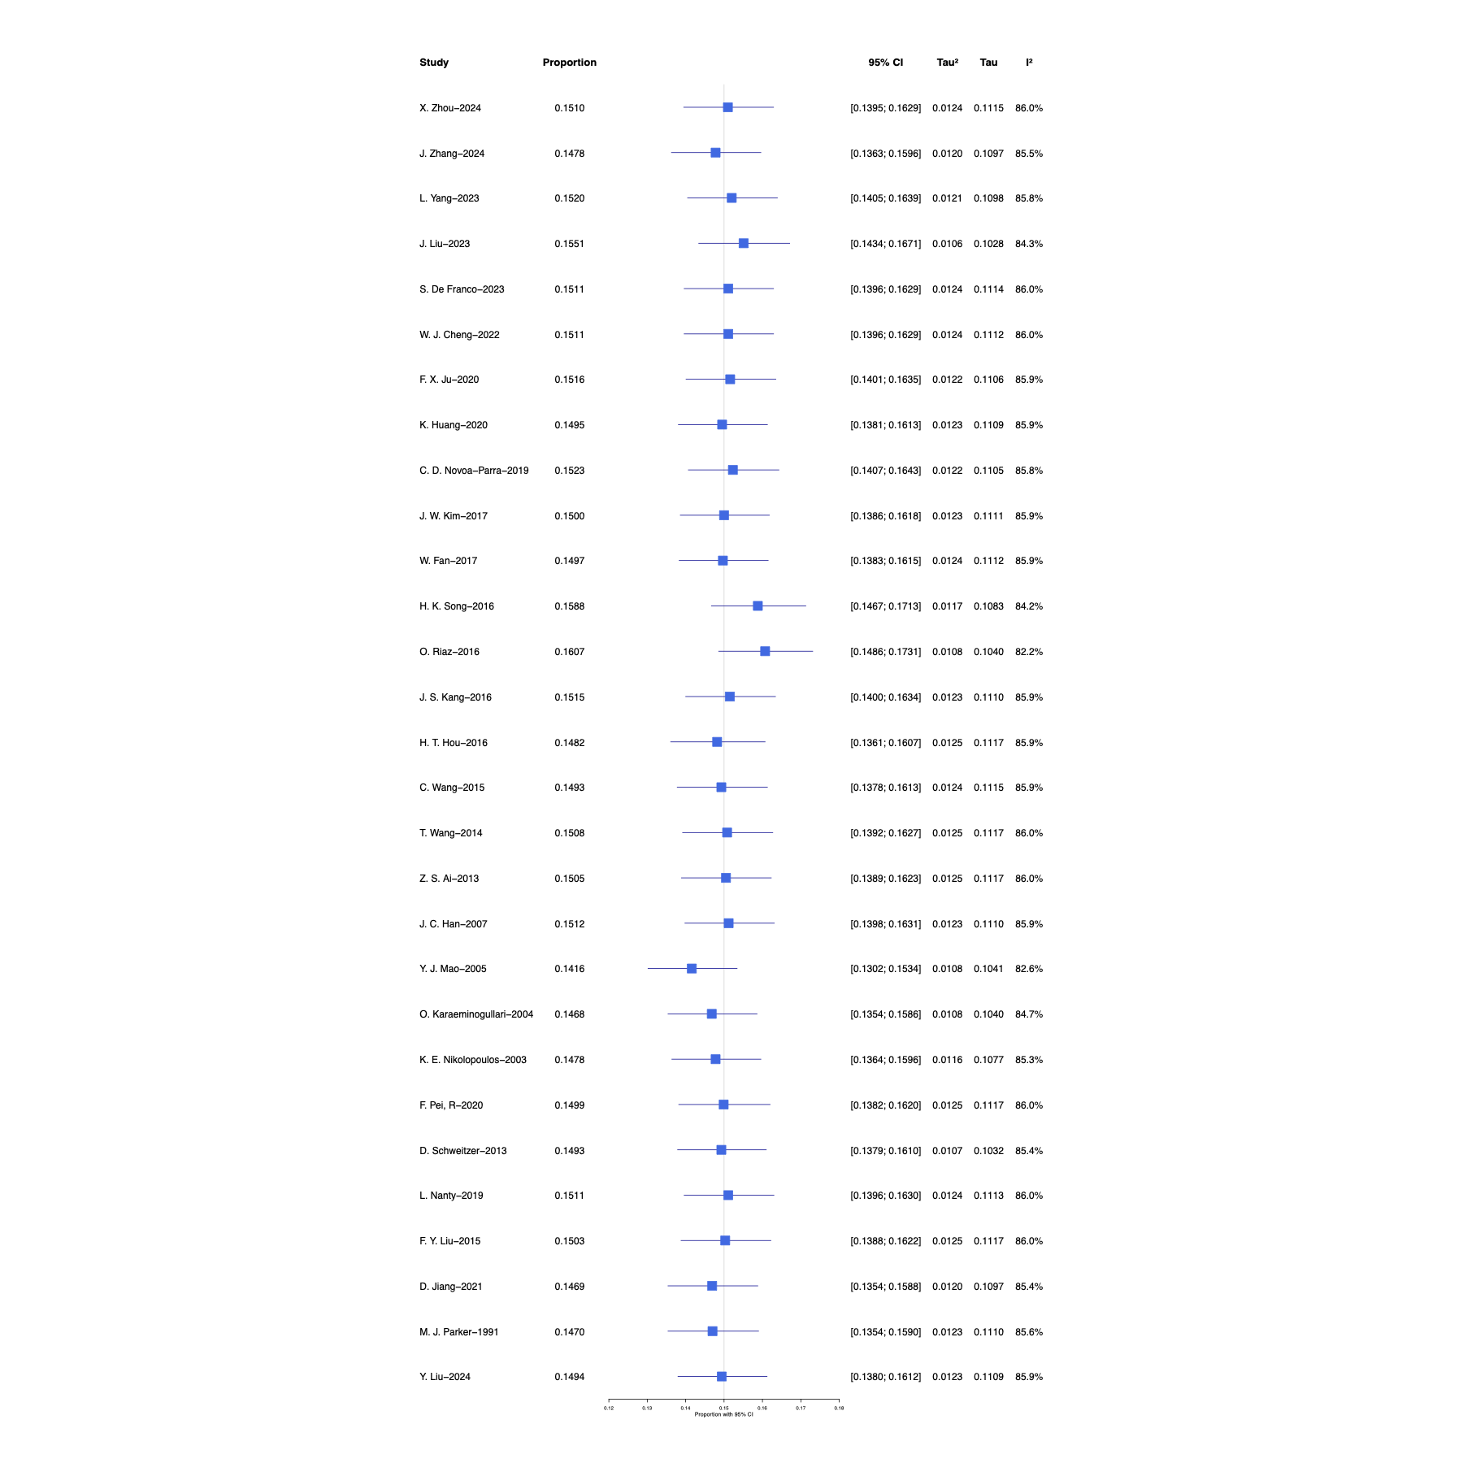
eFigure 2. Forest plot of diagnostic modality(CCS fixation)
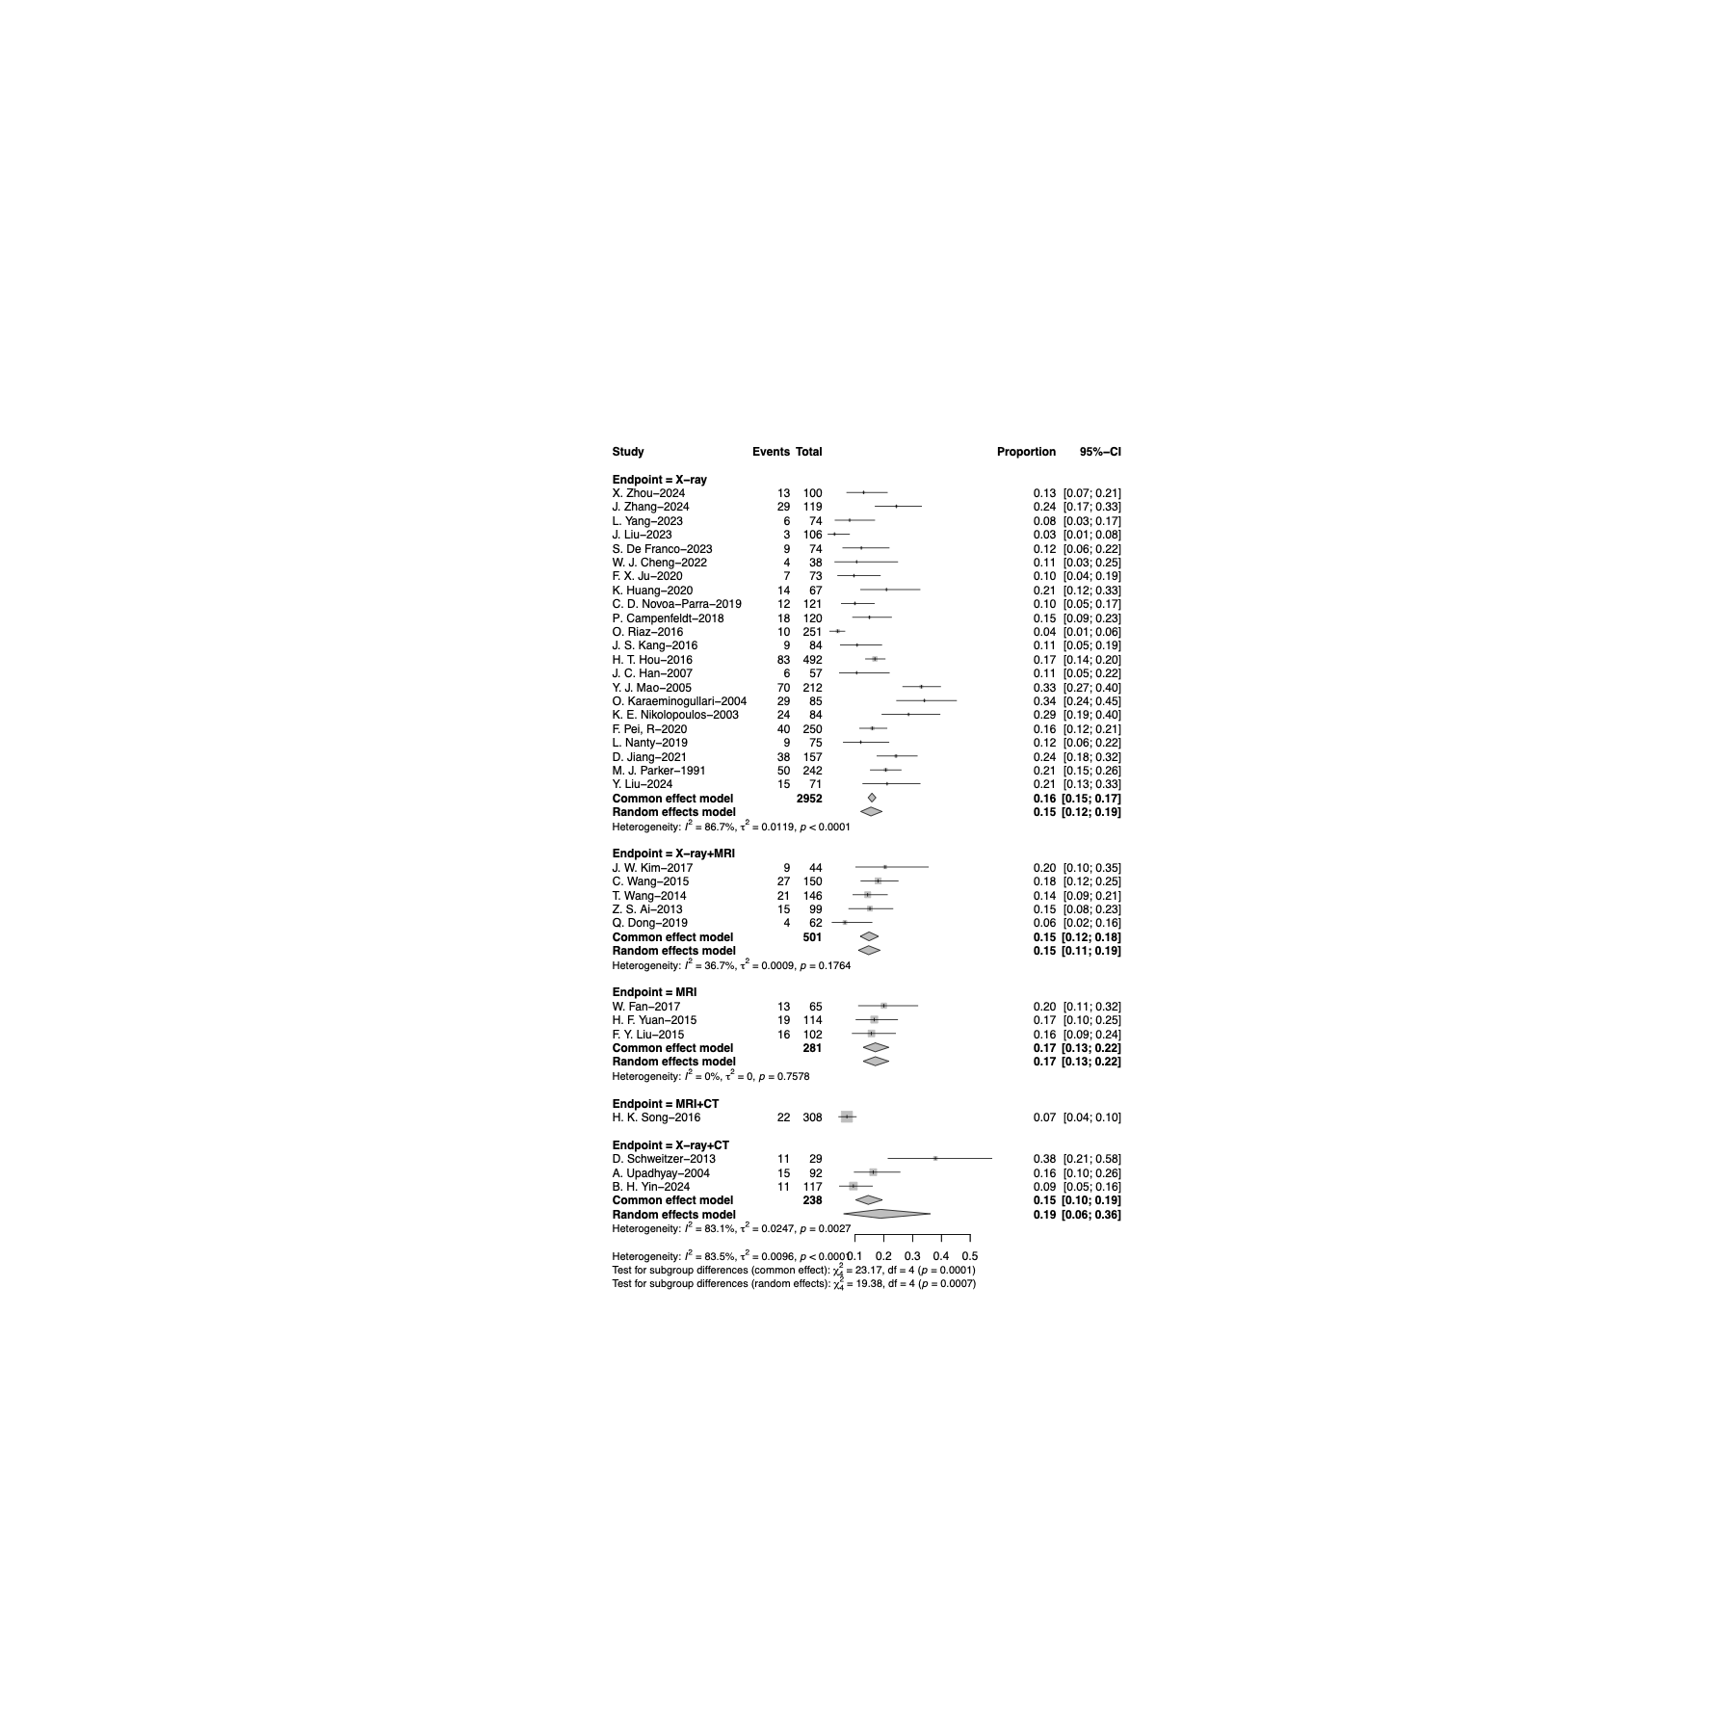
eFigure 3. Forest plot of study design(CCS fixation)
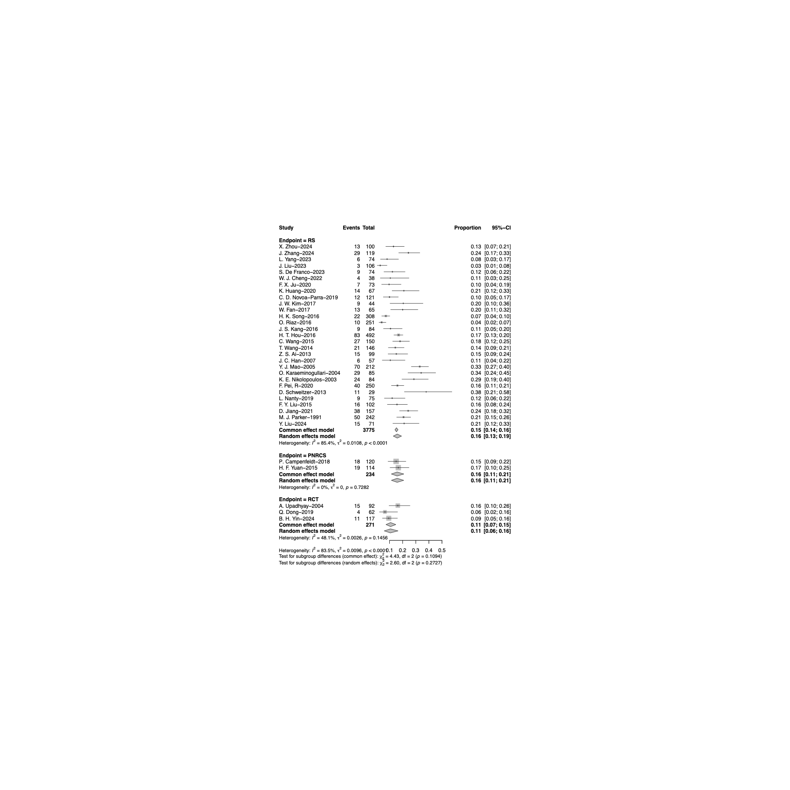
eFigure 4. Forest plot of Sex (CCS fixation)
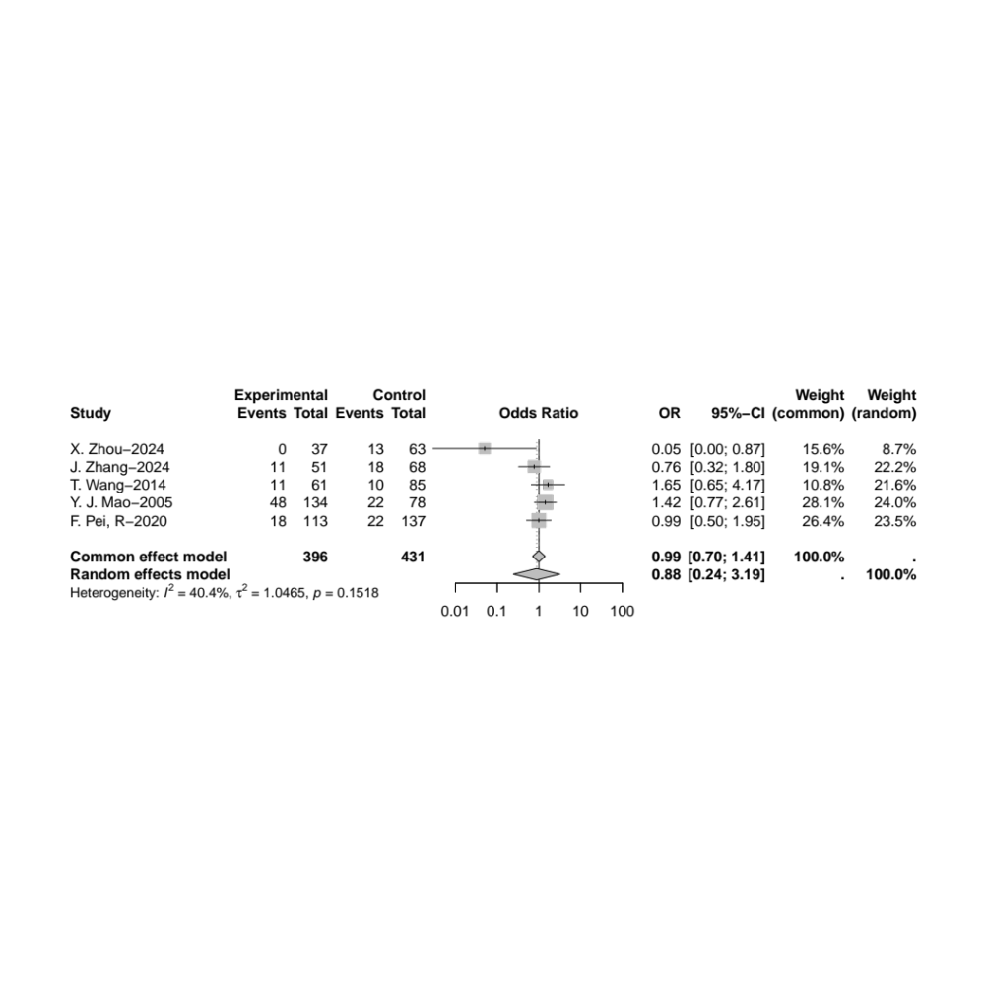
Given low heterogeneity (I² = 40.4%), the common-effect model was implemented.

eFigure 5. Forest plot of retention or removal of internal fixation (CCS fixation)
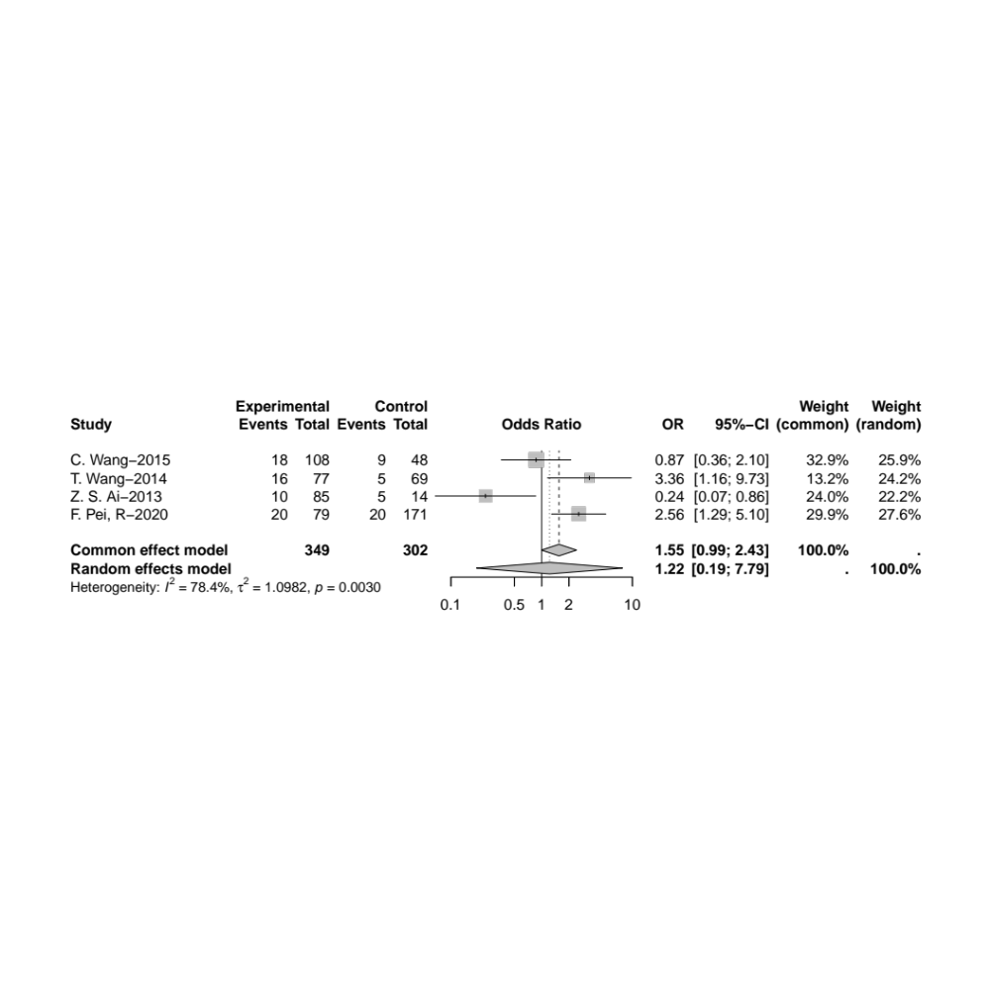
Given substantial heterogeneity (I² = 78.4%), the random-effects model was applied.

eFigure 6. Forest plot of external force of injury (CCS fixation)
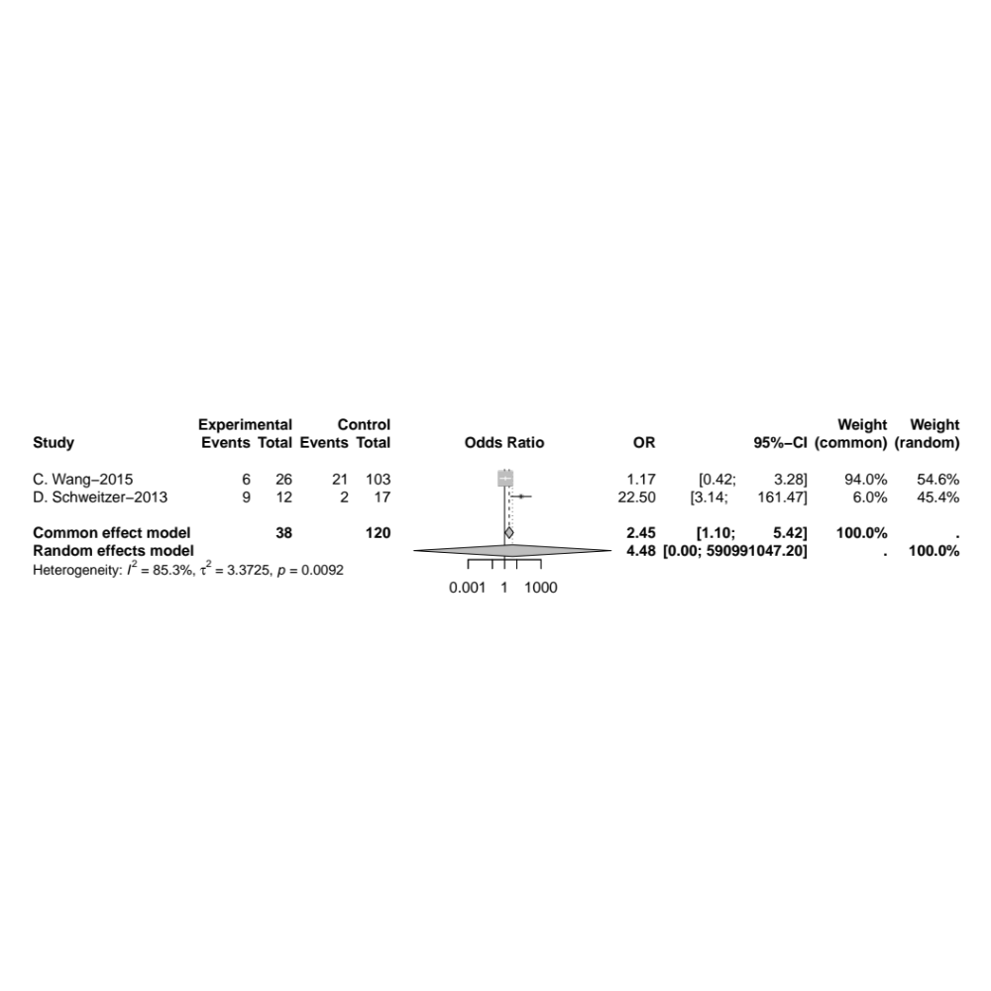
Given substantial heterogeneity (I² = 85.3%), the random-effects model was applied.

eFigure 7. Forest plot of methods of fracture reduction (CCS fixation)
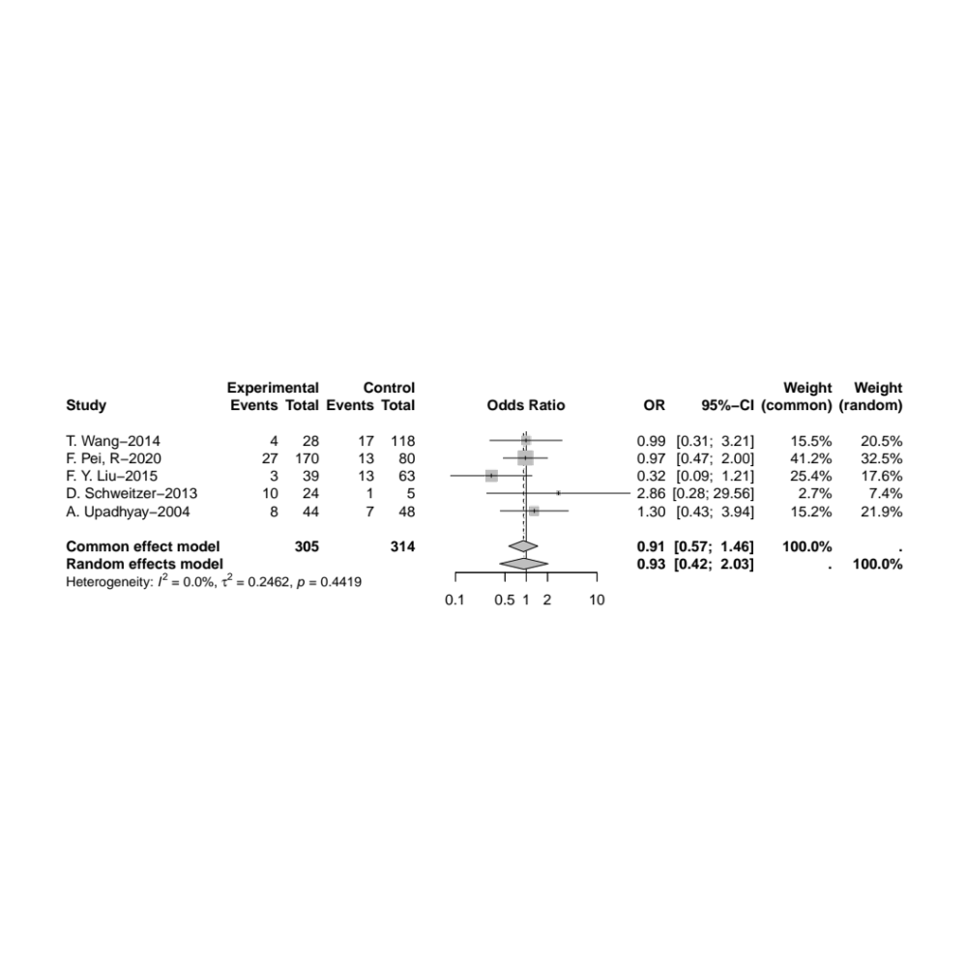
Given low heterogeneity (I² = 0.0%), the common-effect model was implemented.

eFigure 8. Forest plot of quality of reduction (CCS fixation)
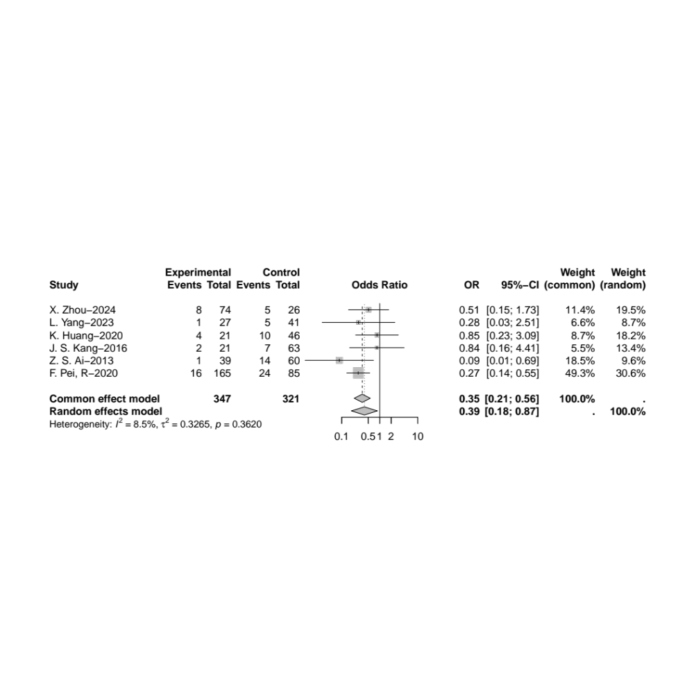
Given low heterogeneity (I² = 8.5%), the common-effect model was implemented.

eFigure 9. Forest plot of Garden classification (CCS fixation)
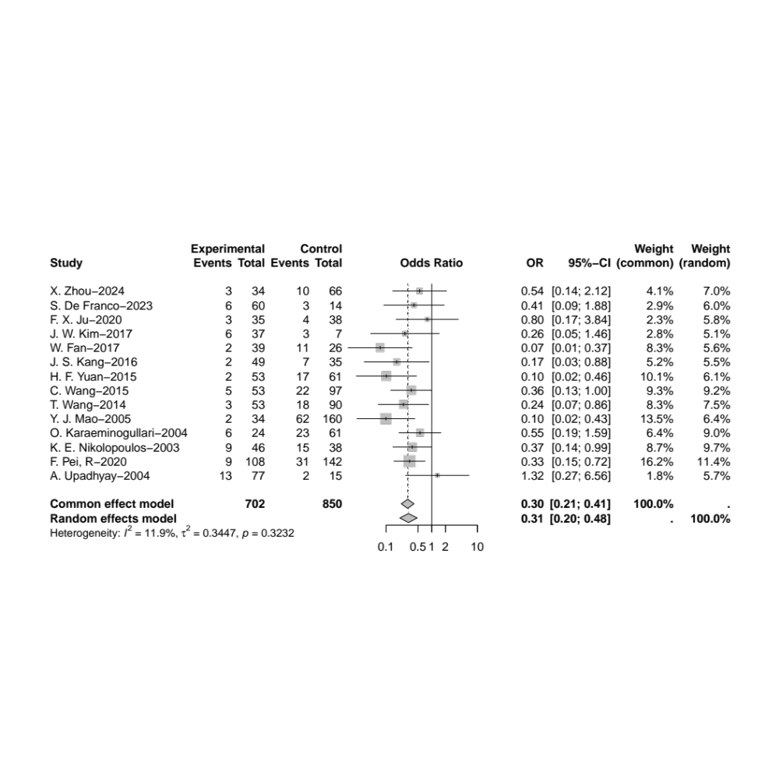
Given low heterogeneity (I² = 11.9%), the common-effect model was implemented.

eFigure 10. Forest plot of Pauwels classification (CCS fixation)
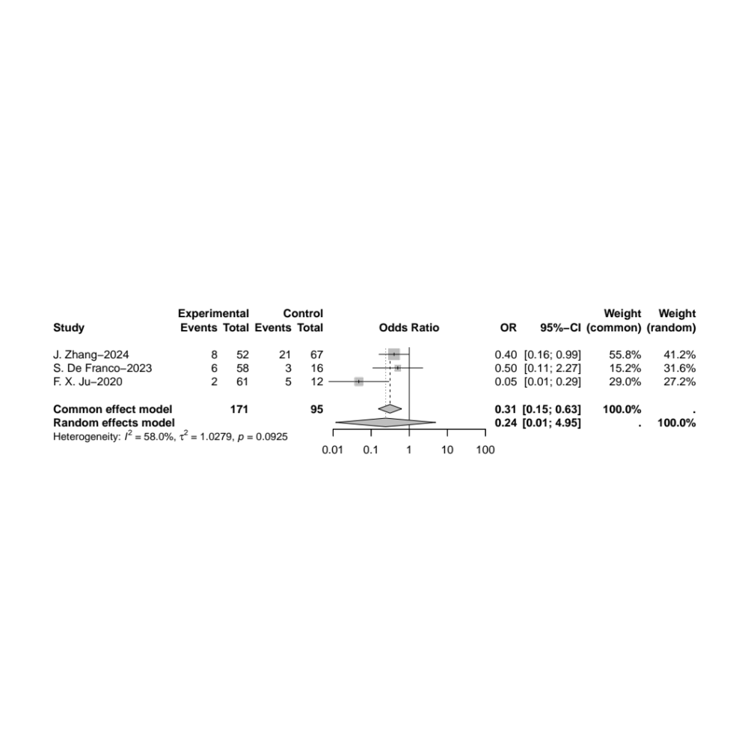
Given substantial heterogeneity (I² = 58.0%), the random-effects model was applied.

eFigure 11. Forest plot of screw configuration (CCS fixation)
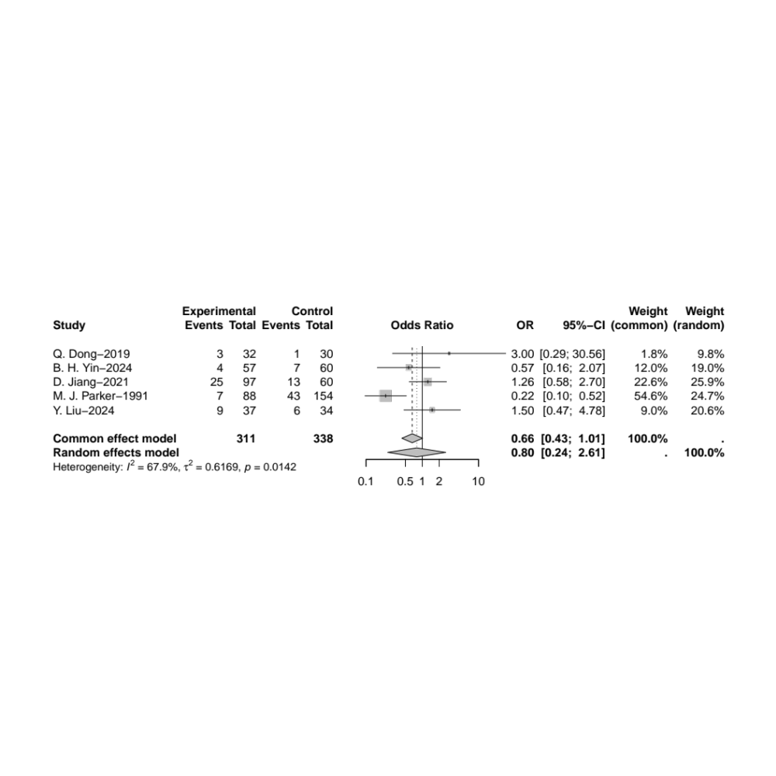
Given substantial heterogeneity (I² = 67.9%), the random-effects model was applied.

eFigure 12. The node splitting method for analysis and assessed the potential inconsistency
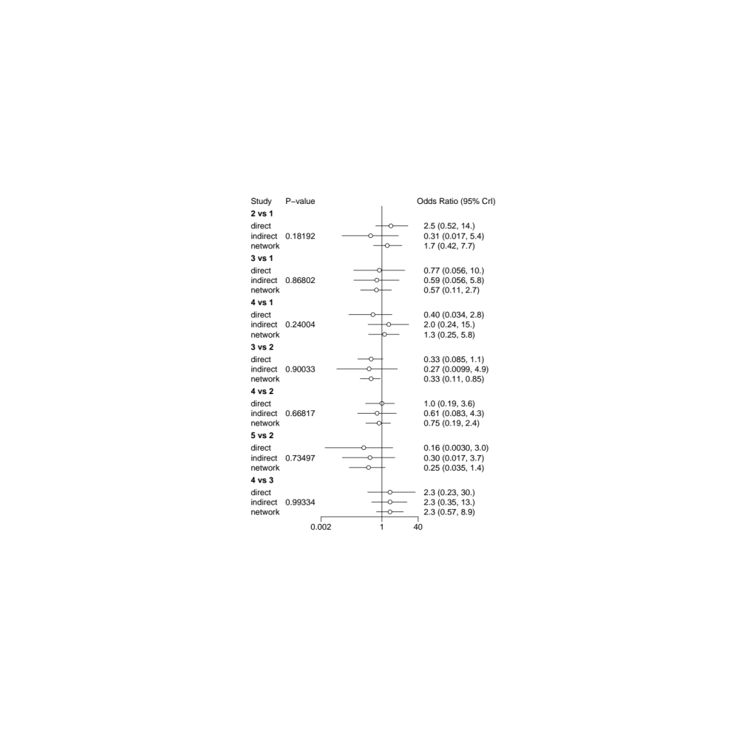
1 DHS, 2 CCS, 3 FNS, 4 DHS+CCS, 5 FNS+CCS

eFigure 13. The convergence results
1 DHS, 2 CCS, 3 FNS, 4 DHS+CCS, 5 FNS+CCS

eFigure 14. Forest plot of pairwise comparison results
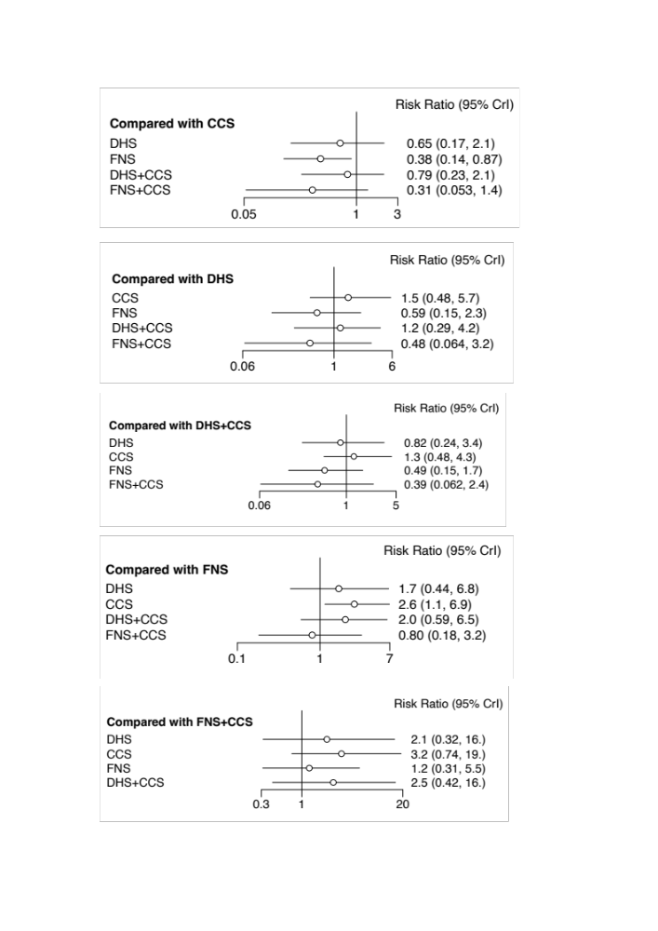

eFigure 15. The cumulative probability bar Chart
1 DHS, 2 CCS, 3 FNS, 4 DHS+CCS, 5 FNS+CCS

eFigure 16. Heterogeneity of the network meta-analysis
1 DHS, 2 CCS, 3 FNS, 4 DHS+CCS, 5 FNS+CCS

eFigure 17. Funnel plot of single group rate meta-analysis
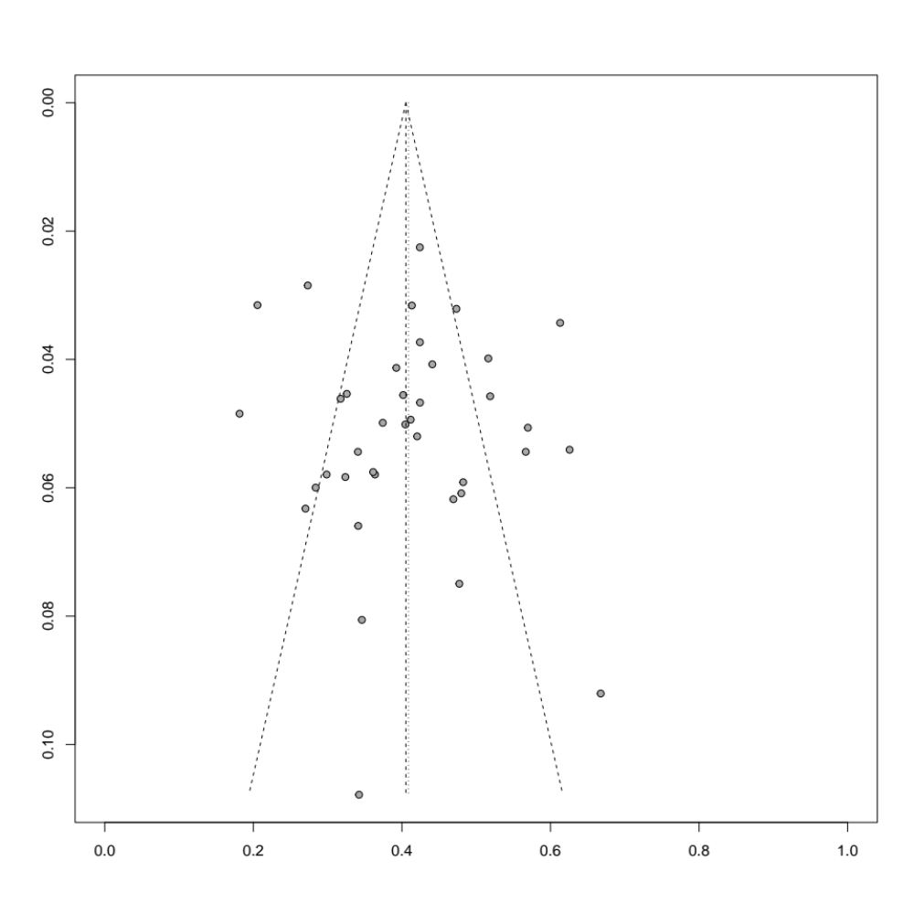
The funnel plot demonstrates symmetrical study distribution, supported by Egger’s test (P = 0.32), indicating no significant publication bias.

