Statin Use is Associated with Reduced Delirium and Improved Short-Term Outcomes in Critically Ill Patients with Chronic Kidney Disease
Yuanhao Chen^{1#}, Tongtong Li^{1#}, Zhikui Huo², Yuzhen Zhong¹, Xiu Wen¹, Liangmei Chen^{1*}, Fanna Liu^{1*}
- Department of Nephrology, The First Affiliated Hospital of Jinan University, Jinan University, Guangzhou, Guangdong, China
- Department of General Surgery, The second hospital of Jilin University, Changchun, Jilin, China

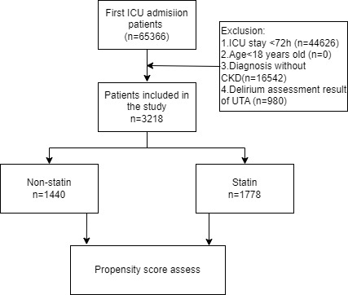

Fig. 1. Flowchart of cohort selection.
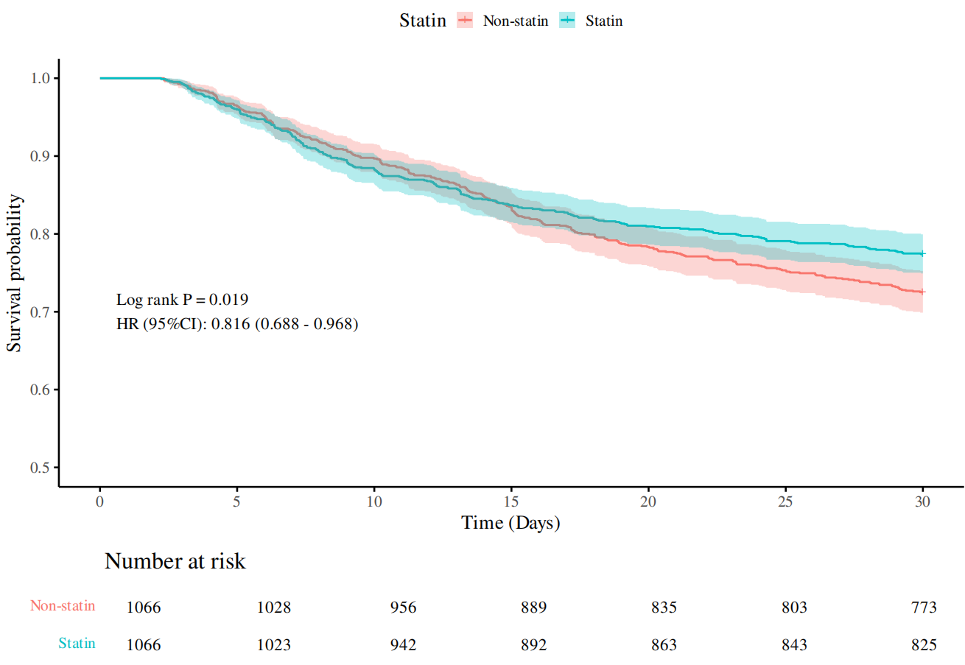
Fig. 2. KM survival curves of 30-day mortality within the ICU for patients in statin-exposure and Non-statin after PSM.

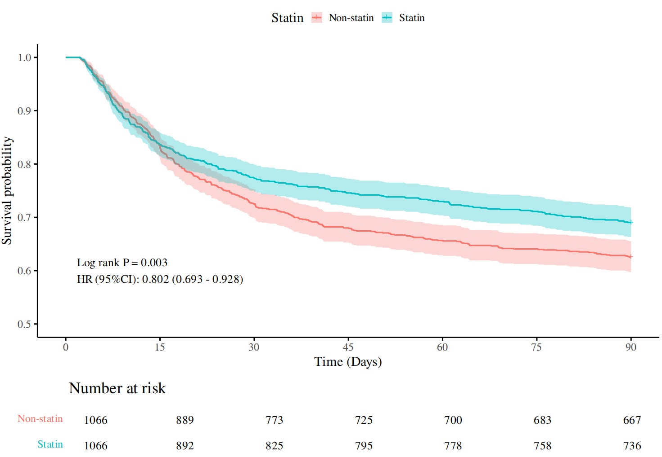Fig.3. KM survival curves of 90-day mortality within the ICU for patients in statin-exposure and Non-statin after PSM.

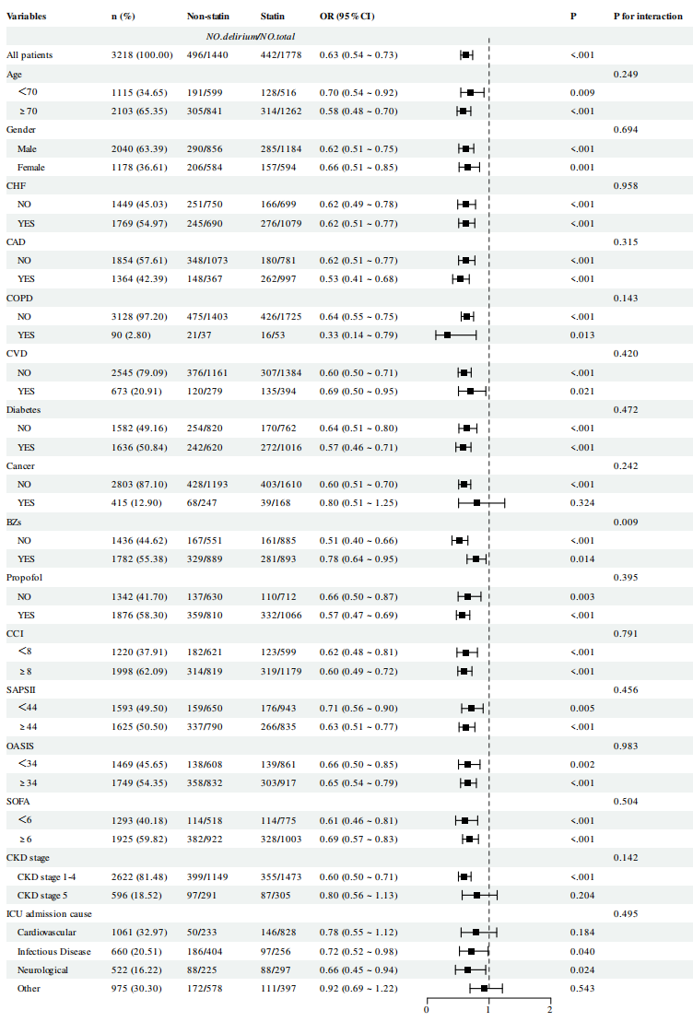
Fig. 4. Forest plot of the subgroup analysis of the association between statin and the incidence of delirium.
CHF, congestive heart failure; CAD: coronary artery disease; CVD, cerebrovascular disease; COPD: chronic obstructive pulmonary disease; BZs, benzodiazepines; CCI, Charlson Comorbidity index; SAPS II, Simplified Acute Physiology Score Index; OASIS, Oxford acute severity of illness score, SOFA, Sequential Organ Failure Assessment.

Table1. Baseline clinical characteristics before and after PSM.
 | Before PSM |  |  |  |  |  | After PSM
 | Total (n = 3218) | Nonstatin (n = 1440) | Statin (n = 1778) | P | SMD |  | Total (n = 2132) | Nonstatin (n = 1066) | Statin (n = 1066) | P | SMD
Age (year) | 74.8 (65.5, 82.8) | 73.0 (61.8, 82.1) | 76.1 (68.2, 83.2) | <0.001 | 0.369 |  | 75.7 (66.9, 83.1) | 75.4 (66.5, 83.6) | 75.8 (67.4, 82.8) | 0.813 | 0.010
Gender (male %) | 2040 (63.4) | 856 (59.4) | 1184 (66.6) | <0.001 | 0.152 |  | 1333 (62.5) | 659 (61.8) | 674 (63.2) | 0.502 | 0.029
Vital sign
HR (beats/min) | 83.8 ± 16.0 | 86.0 ± 17.2 | 82.0 ± 14.7 | <0.001 | 0.276 |  | 83.5 ± 16.0 | 83.8 ± 16.7 | 83.3 ± 15.3 | 0.538 | 0.028
RR (beats/min) | 19.6 ± 3.8 | 20.0 ± 4.0 | 19.3 ± 3.5 | <0.001 | 0.208 |  | 19.6 ± 3.8 | 19.6 ± 3.8 | 19.6 ± 3.7 | 0.907 | 0.005
MBP (mmHg) | 75.1 (69.6, 82.7) | 75.5 (69.8, 83.2) | 74.8 (69.4, 82.4) | 0.092 | 0.043 |  | 75.5 (69.8, 83.3) | 75.7 (69.9, 83.6) | 75.3 (69.6, 82.8) | 0.358 | 0.013
Comorbidity, n (%)
CHF | 1769 (55.0) | 690 (47.9) | 1079 (60.7) | <0.001 | 0.261 |  | 1171 (54.9) | 579 (54.3) | 592 (55.5) | 0.571 | 0.025
CAD | 1364 (42.4) | 367 (25.5) | 997 (56.1) | <0.001 | 0.616 |  | 765 (35.9) | 364 (34.2) | 401 (37.6) | 0.095 | 0.072
COPD | 90 (2.8) | 37 (2.6) | 53 (3.0) | 0.482 | 0.024 |  | 68 (3.2) | 33 (3.1) | 35 (3.3) | 0.805 | 0.011
CVD | 673 (20.9) | 279 (19.4) | 394 (22.2) | 0.053 | 0.067 |  | 476 (22.3) | 223 (20.9) | 253 (23.7) | 0.119 | 0.066
Diabetes | 1636 (50.8) | 620 (43.1) | 1016 (57.1) | <0.001 | 0.285 |  | 1055 (49.5) | 519 (48.7) | 536 (50.3) | 0.461 | 0.032
Cancer | 415 (13.0) | 247 (17.2) | 168 (9.5) | <0.001 | 0.263 |  | 285 (13.4) | 152 (14.3) | 133 (12.5) | 0.227 | 0.054
CKD stage | 596 (18.5) | 291 (20.2) | 305 (17.2) | 0.027 | 0.081 |  | 379 (17.8) | 191 (17.9) | 188 (17.6) | 0.865 | 0.007
Lab events
HCT (10⁹/L) | 31.1 ± 6.3 | 31.0 ± 6.6 | 31.2 ± 5.9 | 0.275 | 0.041 |  | 31.5 ± 6.3 | 31.5 ± 6.5 | 31.5 ± 6.1 | 0.900 | 0.006
HGB (g/dL) | 10.0 ± 2.1 | 10.0 ± 2.2 | 10.1 ± 2.0 | 0.263 | 0.042 |  | 10.1 ± 2.1 | 10.1 ± 2.1 | 10.2 ± 2.0 | 0.872 | 0.007
PLT (10⁹/L) | 175.0 (128.0, 234.5) | 170.0 (118.0, 235.6) | 178.0 (135.0, 233.4) | <0.001 | 0.087 |  | 179.5 (133.5, 238.0) | 176.5 (128.5, 236.9) | 182.0 (137.6, 240.0) | 0.045 | 0.097
WBC (10⁹/L) | 11.6 (8.5, 15.3) | 11.8 (8.2, 15.9) | 11.5 (8.7, 15.0) | 0.597 | 0.161 |  | 11.5 (8.3, 15.2) | 11.6 (8.1, 15.4) | 11.5 (8.5, 15.1) | 0.593 | 0.020
Aniongap (mmol/L) | 15.5 (13.0, 18.5) | 16.0 (13.5, 19.0) | 15.0 (12.5, 18.0) | <0.001 | 0.277 |  | 15.5 (13.0, 18.5) | 15.5 (13.0, 18.5) | 15.0 (13.0, 18.5) | 0.466 | 0.022
Bicarbonate (mmol/L) | 21.7 ± 4.4 | 21.3 ± 4.8 | 22.0 ± 4.1 | <0.001 | 0.183 |  | 21.9 ± 4.5 | 21.9 ± 4.7 | 21.9 ± 4.2 | 0.746 | 0.015
Chloride (mmol/L) | 102.4 ± 7.0 | 102.0 ± 7.5 | 102.7 ± 6.4 | 0.006 | 0.107 |  | 102.5 ± 7.0 | 102.5 ± 7.3 | 102.5 ± 6.7 | 0.961 | 0.002
Potassium (mmol/L) | 4.5 ± 0.7 | 4.5 ± 0.7 | 4.5 ± 0.6 | 0.504 | 0.025 |  | 4.5 ± 0.7 | 4.5 ± 0.7 | 4.5 ± 0.7 | 0.359 | 0.041
Sodium (mmol/L) | 138.0 (135.0, 141.0) | 138.0 (134.5, 141.0) | 138.0 (135.5, 140.5) | 0.276 | 0.024 |  | 138.0 (135.4, 141.0) | 138.0 (135.0, 141.5) | 138.0 (135.5, 140.5) | 0.239 | 0.063
BUN (mmol/L) | 36.0 (24.1, 56.5) | 38.5 (26.0, 62.0) | 34.0 (23.0, 52.4) | <0.001 | 0.230 |  | 36.5 (24.0, 57.0) | 37.5 (24.0, 58.0) | 35.5 (23.0, 56.0) | 0.246 | 0.024
Calcium (mmol/L) | 8.5 (8.0, 8.9) | 8.4 (7.94, 8.9) | 8.5 (8.1, 8.9) | 0.006 | 0.085 |  | 8.5 (8.0, 9.0) | 8.5 (8.0, 9.0) | 8.5 (8.1, 9.0) | 0.137 | 0.036
Creatinine (mg/dL) | 1.9 (1.4, 3.3) | 2.1 (1.4, 3.6) | 1.8 (1.4, 3.0) | <0.001 | 0.157 |  | 1.9 (1.4, 3.3) | 1.9 (1.4, 3.3) | 1.9 (1.4, 3.2) | 0.432 | 0.032
Glucose (mg/dL) | 136.5 (112.0, 178.5) | 136.5 (112.0, 179.0) | 136.3 (112.0, 177.5) | 0.999 | 0.013 |  | 137.0 (112.0, 179.5) | 138.0 (112.5, 178.0) | 136.0 (112.0, 181.4) | 0.952 | 0.017
Treatment, n (%)
BZs | 1782 (55.4) | 889 (61.7) | 893 (50.2) | <0.001 | 0.230 |  | 1186 (55.6) | 596 (55.9) | 590 (55.4) | 0.794 | 0.011
Propofol | 1876 (58.3) | 810 (56.3) | 1066 (60.0) | 0.034 | 0.076 |  | 1188 (55.7) | 577 (54.1) | 611 (57.3) | 0.138 | 0.064
Vasopressor | 775 (24.1) | 383 (26.6) | 392 (22.1) | 0.003 | 0.110 |  | 509 (23.9) | 248 (23.3) | 261 (24.5) | 0.509 | 0.028
Cortisone | 191 (6.0) | 101 (7.0) | 90 (5.1) | 0.020 | 0.089 |  | 137 (6.4) | 75 (7.0) | 62 (5.8) | 0.251 | 0.052
RRT | 804 (25.0) | 407 (28.3) | 397 (22.3) | <0.001 | 0.143 |  | 500 (23.5) | 252 (23.6) | 248 (23.3) | 0.838 | 0.009
VEN | 2012 (62.5) | 894 (62.1) | 1118 (62.9) | 0.643 | 0.016 |  | 1303 (61.1) | 642 (60.2) | 661 (62.0) | 0.399 | 0.037
Disease severity scores
CCI | 8.0 (7.0, 10.0) | 8.0 (6.0, 9.0) | 8.0 (7.0, 10.0) | <0.001 | 0.190 |  | 8.0 (7.0, 10.0) | 8.0 (7.0, 10.0) | 8.0 (7.0, 10.0) | 0.528 | 0.031
SAPSII | 44.0 (36.0, 53.0) | 45.0 (37.0, 56.0) | 42.0 (36.0, 52.0) | <0.001 | 0.165 |  | 43.5 (36.0, 53.0) | 44.0 (36.0, 54.0) | 43.0 (36.0, 53.0) | 0.583 | 0.001
OASIS | 34.0 (29.0, 40.0) | 35.0 (29.0, 42.0) | 34.0 (28.0, 39.0) | <0.001 | 0.178 |  | 34.0 (29.0, 40.0) | 34.5 (29.0, 41.0) | 34.0 (29.0, 40.0) | 0.431 | 0.027
SOFA | 6.0 (4.0, 9.0) | 7.0 (4.0, 10.0) | 6.0 (4.0, 9.0) | <0.001 | 0.294 |  | 6.0 (4.0, 9.0) | 6.0 (4.0, 9.0) | 6.0 (4.0, 9.0) | 0.734 | 0.011
Events
Delirium, n(%) | 938 (29.2) | 496 (34.4) | 442 (25.0) | <0.001 | - |  | 641 (30.0) | 366 (34.3) | 275 (25.8) | <0.001 | -
30-day Mortality, n( %) | 776 (24.1) | 413 (28.7) | 363 (20.4) | <0.001 | - |  | 534 (25.1) | 293 (27.5) | 241 (22.6) | 0.009 | -
90-day Mortality, n(%) | 1066 (33.1) | 567 (39.4) | 499 (28.1) | <0.001 | - |  | 729 (34.2) | 399 (37.4) | 330 (31.0) | 0.002 | -

Data are presented as mean±sd, medians (interquartile ranges), or numbers (percentages).
HR, heart rate; MBP, mean blood pressure; RR, respiratory rate; CHF, congestive heart failure; CAD: coronary artery disease; CVD, cerebrovascular disease; COPD: chronic obstructive pulmonary disease; HCT, hematocrit; HGB, hemoglobin; PLT, platelets; WBC, white blood cell count; BUN, blood urea nitrogen; BZs, benzodiazepines; RRT, renal replacement treatment; VEN, mechanical ventilation; CCI, Charlson Comorbidity index; SAPS II, Simplified Acute Physiology Score Index; OASIS, Oxford acute severity of illness score, SOFA, Sequential Organ Failure Assessment. SMD:Standardized Mean Difference.

Table 2. Relationship between statin and the incidence of delirium in different models before and after propensity score matching.
Non-statin vs.Statin | Before PSM |  | After PSM
 | OR, 95% CI | P | OR, 95% CI | P
Crude model | 0.63 (0.54 - 0.73) | <0.001 | 0.66 (0.55 - 0.80) | <0.001
Model 1 | 0.62 (0.53 - 0.73) | <0.001 | 0.67 (0.55 - 0.80) | <0.001
Model 2 | 0.54 (0.46 - 0.64) | <0.001 | 0.66 (0.55 - 0.80) | <0.001
Model 3 | 0.63 (0.52 - 0.76) | <0.001 | 0.60 (0.49 - 0.74) | <0.001
Model 1: adjusted for age and gender; Model 2: adjusted for age, gender and comorbidity; Model 3: adjusted for age, gender, vital sign, comorbidity, lab events, treatment and disease severity scores.

Table 3. Logistic analysis of the relationship between statin properties and delirium before and after PSM.
 | Before PSM |  | After PSM
 | OR, 95% CI | P | OR, 95% CI | P
Non-statin vs. Hydrophilic statins | 0.69 (0.53 - 0.91) | 0.008 | 0.83 (0.58 - 1.20) | 0.271
Non-statin vs. Lipophilic statins | 0.62 (0.52 - 0.72) | <0.001 | 0.55 (0.44 - 0.69) | <0.001
Adjusted for age, gender, vital sign, comorbidity, lab events, treatment and disease severity scores.
Table 4. Logistic analysis of the relationship between statin dose and delirium before and after PSM.
 | Before PSM |  | After PSM
 | OR, 95% CI | P | OR, 95% CI | P
Non-statin vs. Low-dose | 0.62 (0.48 - 0.80) | <0.001 | 0.65 (0.48 - 0.89) | 0.006
Non-statin vs. High-dose | 0.66 (0.53 - 0.82) | <0.001 | 0.62 (0.49 - 0.80) | <0.001
Adjusted for age, gender, vital sign, comorbidity, lab events, treatment and disease severity scores.

Table 5. Univariate and multivariable cox regression analysis before and after propensity score matching.
Non-statin vs.Statin | Before PSM |  | After PSM
 | HR, 95% CI | P | HR, 95% CI | P
30-day mortality
Univariate Cox logistic analysis | 0.69 (0.60 - 0.80) | <0.001 | 0.82 (0.69 - 0.97) | 0.019
Multivariate Cox logistic analysis | 0.85 (0.73 - 0.99) | 0.035 | 0.84 (0.71 - 1.00) | 0.053
90-day mortality
Univariate Cox logistic analysis | 0.67 (0.59 - 0.76) | <0.001 | 0.80 (0.69 - 0.93) | 0.003
Multivariate Cox logistic analysis¹ | 0.80 (0.70 - 0.91) | <0.001 | 0.81 (0.70 - 0.94) | 0.006
Multivariate Cox logistic analysis are adjusted for age, gender, comorbidity, vital sign, lab events, treatment and disease severity scores.

