Supplementary materials

Figure S1: Missing values in variables
Figure S2: Heatmap of Correlations among Continuous Variables
Figure S3: Variance Inflation Factor (VIF) for Selected Variables

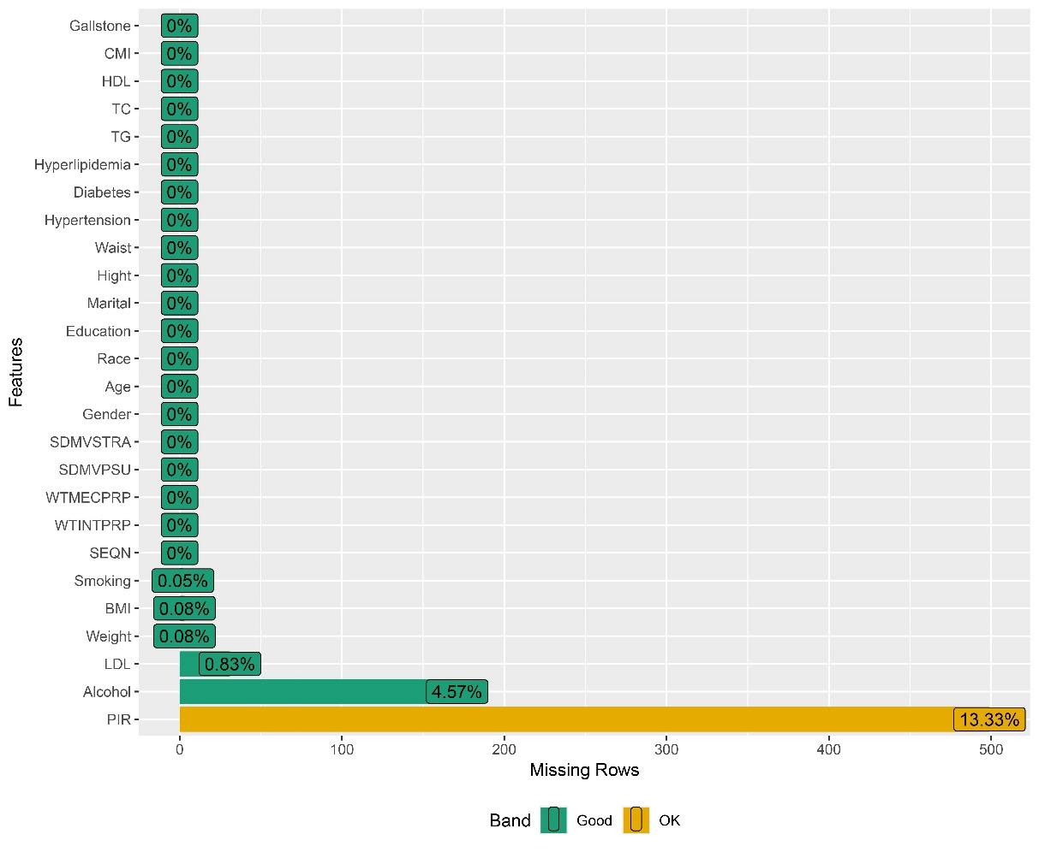
Figure S1: Missing values in variables

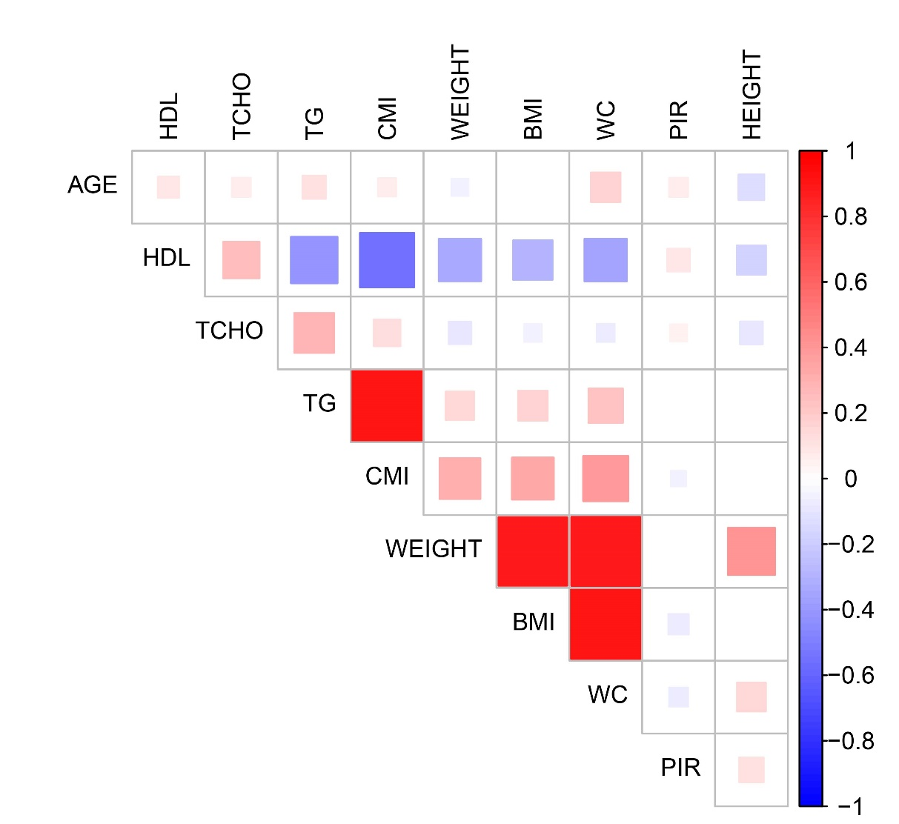
Figure S2: Heatmap of Correlations among Continuous Variables

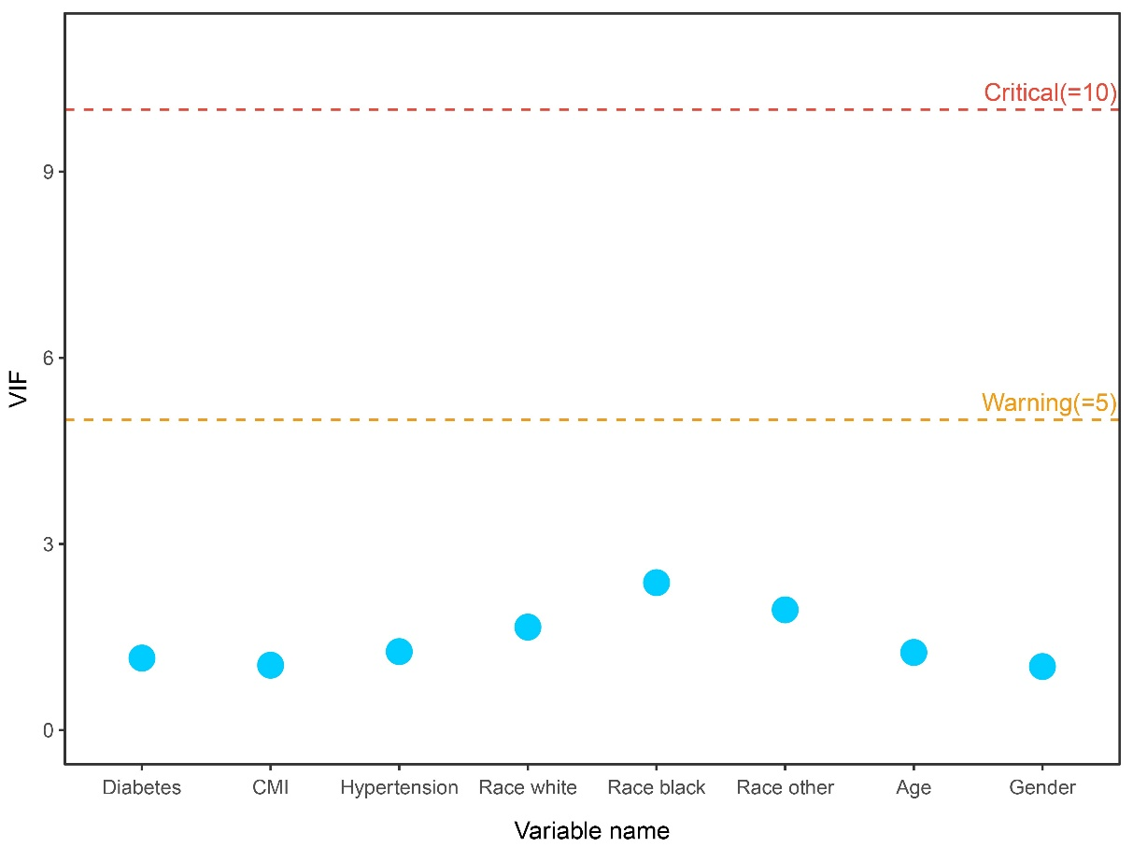
Figure S3 Variance Inflation Factor (VIF) for Selected Variables

