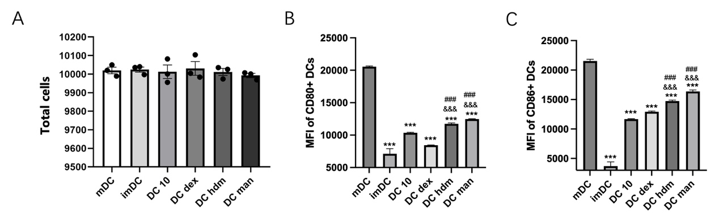
Fig 1 A. Total cell count under various induction conditions by flow cytometry. B. Mean Fluorescence Intensity of CD80⁺ DCs by flow cytometry. C. Mean Fluorescence Intensity of CD86⁺ DCs by flow cytometry. Data are presented as mean ± SD. Statistical significance was determined by one-way ANOVA with Tukey's post hoc test for multiple comparisons. (* vs. mDC; # vs. DC dex; & vs. DC 10; ***, ###, &&& p < 0.001)

