Table S1. ICD Codes for disease

Disease | ICD-9 | ICD-10
Traumatic brain injury | 800.0–801.9, 850.0–854.1, 950.1–950.3, 995.55, 959.01 | S02.0, S02.1, S02.8, S02.91, S04.02, S04.03, S04.04, S06, S07.1, T74.4

Table S2. Baseline characteristics of the original cohort derived from the MIMIC database.
 | Class 1  (N=702) | Class 2  (N=2481) | Class 3  (N=66) | p-value | SMD (Compare to class1, respectively) | Missing data (%)
Age | 55.00 [33.25, 73.00] | 70.00 [53.00, 82.00] | 56.50 [30.25, 69.00] | <0.001 | [0.567, 0.096] | 0.00
Gender (Female) | 201 (28.63%) | 935 (37.69%) | 19 (28.79%) | <0.001 | [0.193, 0.003] | 0.00
SOFA score | 4.00 [2.00, 5.00] | 3.00 [2.00, 4.00] | 7.00 [4.25, 10.00] | <0.001 | [0.273, 1.002] | 0.00
Charlson score | 2.00 [0.00, 4.00] | 4.00 [2.00, 6.00] | 2.00 [0.00, 4.00] | <0.001 | [0.438, 0.026] | 0.00
GCS score | 14.00 [10.00, 15.00] | 14.00 [13.00, 15.00] | 15.00 [11.25, 15.00] | <0.05 | [0.188, 0.041] | 0.00
Interventions (boolean for 1st 24 h)
Mechanical ventilation use (YES) | 508 (72.36%) | 778 (31.36%) | 60 (90.91%) | <0.001 | [0.900, 0.493] | 0.00
RRT use (YES) | 2 (0.28%) | 23 (0.93%) | 4 (6.06%) | <0.001 | [0.083, 0.334] | 0.00
Propofol use (YES) | 438 (62.39%) | 680 (27.41%) | 49 (74.24%) | <0.001 | [0.751, 0.257] | 0.00
Vasopressor use (YES) | 145 (20.66%) | 253 (10.20%) | 41 (62.12%) | <0.001 | [0.293, 0.928] | 0.00
Comorbidities (boolean)
Renal (YES) | 42 (5.98%) | 307 (12.37%) | 6 (9.09%) | <0.001 | [0.223, 0.118] | 0.00
COPD (YES) | 32 (4.56%) | 188 (7.58%) | 3 (4.55%) | <0.05 | [0.127, 0.001] | 0.00
CAD (YES) | 73 (10.40%) | 465 (18.74%) | 5 (7.58%) | <0.001 | [0.238, 0.099] | 0.00
Stroke (YES) | 71 (10.11%) | 179 (7.21%) | 3 (4.55%) | <0.05 | [0.103, 0.215] | 0.00
Sepsis (YES) | 449 (63.96%) | 916 (36.92%) | 49 (74.24%) | <0.001 | [0.562, 0.224] | 0.00
Vital signs (1st 24 h)
MAP | 86.00 [75.25, 100.00] | 88.00 [78.00, 99.00] | 81.50 [66.00, 104.75] | 0.15 | [0.020, 0.173] | 0.00
Heart rate | 93.00 [79.00, 107.00] | 82.00 [71.00, 95.00] | 87.00 [72.00, 106.00] | <0.001 | [0.473, 0.194] | 0.00
Temperature | 37.33 [36.89, 37.89] | 36.78 [36.50, 37.06] | 34.44 [33.40, 35.46] | <0.001 | [0.889, 2.160] | 0.00
Laboratory tests (1st 24 h)
WBC | 12.10 [9.40, 15.60] | 9.90 [7.43, 13.00] | 10.55 [6.90, 14.45] | <0.001 | [0.338, 0.249] | 0.12
Hemoglobin | 11.80 [10.40, 13.20] | 11.40 [9.90, 12.80] | 10.15 [8.70, 11.40] | <0.001 | [0.173, 0.576] | 0.12
Platelet | 205.00 [160.00, 256.00] | 195.00 [152.00, 250.00] | 137.00 [97.25, 211.00] | <0.001 | [0.092, 0.537] | 0.22
Sodium | 139.00 [137.00, 142.00] | 139.00 [136.00, 141.00] | 139.00 [135.25, 141.00] | 0.07 | [0.100, 0.197] | 0.06
Potassium | 4.00 [3.60, 4.30] | 4.00 [3.70, 4.40] | 3.90 [3.42, 4.38] | 0.22 | [0.019, 0.121] | 0.06
Bicarbonate | 23.00 [21.00, 25.00] | 24.00 [21.00, 26.00] | 20.00 [17.25, 22.00] | <0.001 | [0.117, 0.724] | 0.06
Chloride | 104.00 [101.00, 108.00] | 104.00 [101.00, 107.00] | 106.50 [103.00, 113.00] | <0.001 | [0.179, 0.379] | 0.06
BUN | 14.00 [10.00, 18.00] | 15.00 [11.00, 22.00] | 15.00 [12.00, 21.00] | <0.001 | [0.200, 0.195] | 0.22
pH | 7.39 [7.33, 7.44] | 7.38 [7.33, 7.43] | 7.27 [7.13, 7.33] | <0.001 | [0.044, 1.103] | 41.52
PO2 | 162.50 [103.75, 251.00] | 166.00 [98.00, 241.00] | 176.50 [98.00, 364.75] | 0.21 | [0.067, 0.241] | 58.97
PCO2 | 39.00 [34.00, 44.25] | 39.00 [34.00, 45.00] | 45.50 [38.75, 55.50] | <0.001 | [0.092, 0.775] | 60.05
Alkaline phosphatase | 73.00 [57.00, 99.00] | 77.00 [58.00, 103.00] | 55.00 [45.00, 80.00] | <0.001 | [0.088, 0.298] | 59.03
Outcomes (boolean)
ICU mortality (Death) | 77 (10.97%) | 125 (5.04%) | 27 (40.91%) | <0.001 | [0.220, 0.727] | 0.00
In-hospital mortality (Death) | 116 (16.52%) | 215 (8.67%) | 29 (43.94%) | <0.001 | [0.239, 0.625] | 0.00
Day28 mortality (Death) | 132 (18.80%) | 333 (13.42%) | 30 (45.45%) | <0.001 | [0.147, 0.595] | 0.00
Length of Stay (days)
ICU length of Stay | 4.49 [2.29, 9.41] | 2.68 [1.69, 4.93] | 5.00 [2.05, 16.48] | <0.001 | [0.442, 0.301] | 0.00
In-hospital length of Stay | 11.13 [5.90, 19.79] | 6.77 [4.03, 12.76] | 8.91 [3.77, 26.39] | <0.001 | [0.357, 0.128] | 0.00
Values are presented as mean (standard deviation) or median [Q1, Q3] for continuous variables and number (percentage) for categorical variables. Variables in bold have p-value < 0.05.

Table S3. Baseline characteristics of the original cohort derived from the eICU database.
 | class1  (N=712) | class2  (N=2473) | class3  (N=61) | p-value | SMD (Compare to class1, respectively) | Missing data (%)
Age | 52.50 [31.00, 70.00] | 68.00 [51.00, 81.00] | 63.00 [43.00, 78.00] | <0.001 | [0.593, 0.343] | 0.00
Gender (Female) | 205 (28.79%) | 1003 (40.56%) | 22 (36.07%) | <0.001 | [0.249, 0.155] | 0.12
SOFA score | 7.00 [5.00, 9.00] | 5.00 [3.00, 7.00] | 9.00 [6.00, 13.00] | <0.001 | [0.731, 0.607] | 0.00
Charlson score | 1.00 [0.00, 3.00] | 3.00 [1.00, 5.00] | 2.00 [0.00, 4.00] | <0.001 | [0.562, 0.333] | 0.00
GCS score | 1.00 [0.00, 3.00] | 3.00 [1.00, 5.00] | 2.00 [0.00, 4.00] | <0.001 | [0.562, 0.333] | 0.00
Interventions (boolean for 1st 24 h)
Mechanical ventilation use (YES) | 536 (75.28%) | 709 (28.67%) | 50 (81.97%) | <0.001 | [1.055, 0.164] | 0.00
RRT use (YES) | 3 (0.42%) | 21 (0.85%) | 0 (0.00%) | 0.4 | [0.054, 0.092] | 0.00
Propofol use (YES) | 328 (46.07%) | 381 (15.41%) | 18 (29.51%) | <0.001 | [0.705, 0.347] | 0.00
Vasopressor use (YES) | 101 (14.19%) | 143 (5.78%) | 29 (47.54%) | <0.001 | [0.283, 0.774] | 0.00
Comorbidities (boolean)
Renal (YES) | 31 (4.35%) | 209 (8.45%) | 4 (6.56%) | <0.01 | [0.168, 0.097] | 0.00
COPD (YES) | 31 (4.35%) | 211 (8.53%) | 4 (6.56%) | <0.001 | [0.171, 0.097] | 0.00
CAD (YES) | 75 (10.53%) | 455 (18.40%) | 9 (14.75%) | <0.001 | [0.225, 0.127] | 0.00
Stroke (YES) | 73 (10.25%) | 367 (14.84%) | 9 (14.75%) | <0.01 | [0.139, 0.136] | 0.00
Sepsis (YES) | 177 (24.86%) | 219 (8.86%) | 14 (22.95%) | <0.001 | [0.438, 0.045] | 0.00
Vital signs (1st 24 h)
MAP | 88.00 [76.00, 100.00] | 90.00 [79.00, 100.00] | 82.00 [65.00, 96.00] | <0.01 | [0.077, 0.273] | 0.03
Heart rate | 94.00 [79.00, 108.00] | 81.00 [70.00, 94.00] | 85.00 [67.00, 100.00] | <0.001 | [0.584, 0.435] | 0.00
Temperature | 37.39 [36.78, 37.90] | 36.72 [36.40, 37.00] | 34.22 [33.40, 35.30] | <0.001 | [0.605, 2.221] | 0.06
Laboratory tests (1st 24 h)
WBC | 12.50 [9.70, 16.13] | 9.80 [7.40, 12.80] | 10.22 [8.42, 16.75] | <0.001 | [0.450, 0.126] | 4.19
Hemoglobin | 11.80 [10.20, 13.30] | 11.90 [10.40, 13.40] | 10.95 [9.00, 13.00] | <0.01 | [0.071, 0.385] | 4.59
Platelet | 191.00 [148.00, 241.00] | 195.00 [153.00, 242.00] | 149.00 [106.50, 191.50] | <0.001 | [0.022, 0.574] | 4.22
Sodium | 140.00 [137.00, 142.00] | 139.00 [137.00, 141.00] | 141.00 [137.00, 144.50] | <0.001 | [0.142, 0.306] | 3.14
Potassium | 3.80 [3.60, 4.10] | 3.90 [3.60, 4.20] | 3.80 [3.45, 4.20] | <0.01 | [0.148, 0.006] | 3.05
Bicarbonate | 23.00 [20.85, 25.45] | 24.30 [22.00, 27.00] | 21.00 [16.35, 24.00] | <0.001 | [0.377, 0.564] | 4.68
Chloride | 106.00 [103.00, 110.00] | 105.00 [102.00, 108.00] | 110.00 [104.00, 114.00] | <0.001 | [0.230, 0.389] | 3.23
BUN | 13.00 [9.00, 18.00] | 15.00 [11.00, 21.00] | 17.00 [14.00, 24.50] | <0.001 | [0.244, 0.506] | 3.30
pH | 7.40 [7.34, 7.44] | 7.39 [7.34, 7.44] | 7.33 [7.26, 7.40] | <0.001 | [0.005, 0.644] | 64.97
PO2 | 144.50 [90.70, 209.00] | 137.50 [89.00, 217.00] | 143.00 [82.75, 242.95] | 0.85 | [0.015, 0.131] | 64.02
PCO2 | 37.00 [32.12, 41.00] | 38.00 [33.00, 43.00] | 38.85 [34.40, 44.25] | <0.01 | [0.195, 0.362] | 63.89
Alkaline phosphatase | 68.00 [55.00, 87.00] | 73.00 [58.00, 95.00] | 53.00 [45.50, 74.00] | <0.001 | [0.115, 0.265] | 46.70
Outcomes (boolean)
ICU mortality (Death) | 91 (12.78%) | 111 (4.49%) | 24 (39.34%) | <0.001 | [0.299, 0.635] | 0.00
In-hospital mortality (Death) | 129 (18.12%) | 196 (7.93%) | 35 (57.38%) | <0.001 | [0.307, 0.905] | 0.96
Day28 mortality (Death)
Length of Stay (days) | 4.94 [2.47, 10.53] | 2.48 [1.63, 4.44] | 2.59 [1.55, 7.90] | <0.001 | [0.28, 0.17] | 0.00
ICU length of Stay | 10.27 [5.07, 18.35] | 5.81 [3.45, 10.05] | 3.65 [2.18, 9.35] | <0.001 | [0.347, 0.393] | 0.00
Values are presented as mean (standard deviation) or median [Q1, Q3] for continuous variables and number (percentage) for categorical variables. Variables in bold have p-value < 0.05.

Table S4 Descriptive statistics for each identified temperature trajectory group.
Number of Classes | Log Likelihood | AIC | BIC | SABIC | Entropy | Class 1 (%) | Class 2 (%) | Class 3 (%) | Class 4 (%) | Class 5 (%)
1 | -27,803.42 | 55,614.84 | 55,639.19 | 55,626.48 | 1.00 | 100.00
2 | -25,487.99 | 50,991.98 | 51,040.67 | 51,015.25 | 0.80 | 74.18 | 25.82
3 | -23,758.02 | 47,540.04 | 47,613.07 | 47,574.94 | 0.90 | 21.61 | 76.36 | 2.03
4 | -23,027.33 | 46,086.67 | 46,184.04 | 46,133.20 | 0.91 | 21.67 | 72.79 | 3.88 | 1.66
5 | -22,488.04 | 45,016.08 | 45,137.80 | 45,074.25 | 0.90 | 4.00 | 0.68 | 71.19 | 18.44 | 5.69

Table S5 Mean of posterior probabilities in each class.
Number of Classes | probability 1 | probability 2 | probability 3
1 | 0.985 | 0.0000274 | 0.0153
2 | 0.00000350 | 0.987 | 0.0132
3 | 0.00660 | 0.139 | 0.854

Table S6 Performance of different predictive models in terms of discrimination and calibration
Model | AUC | 95% CI | Brier Score | Accuracy
XGBoost | 0.834 | 0.814–0.854 | 0.0625 | 0.923
SVM | 0.797 | 0.774–0.820 | 0.0601 | 0.926
KNN | 0.694 | 0.659–0.729 | 0.0611 | 0.932
Random Forest | 0.865 | 0.845–0.885 | 0.0547 | 0.930
OASIS | 0.824 | 0.803–0.844 | 0.0632 | 0.922
Logistic Regression | 0.850 | 0.828–0.872 | 0.0568 | 0.930
LightGBM | 0.860 | 0.839–0.880 | 0.0566 | 0.930
SAPSII | 0.835 | 0.808–0.862 | 0.0733 | 0.904

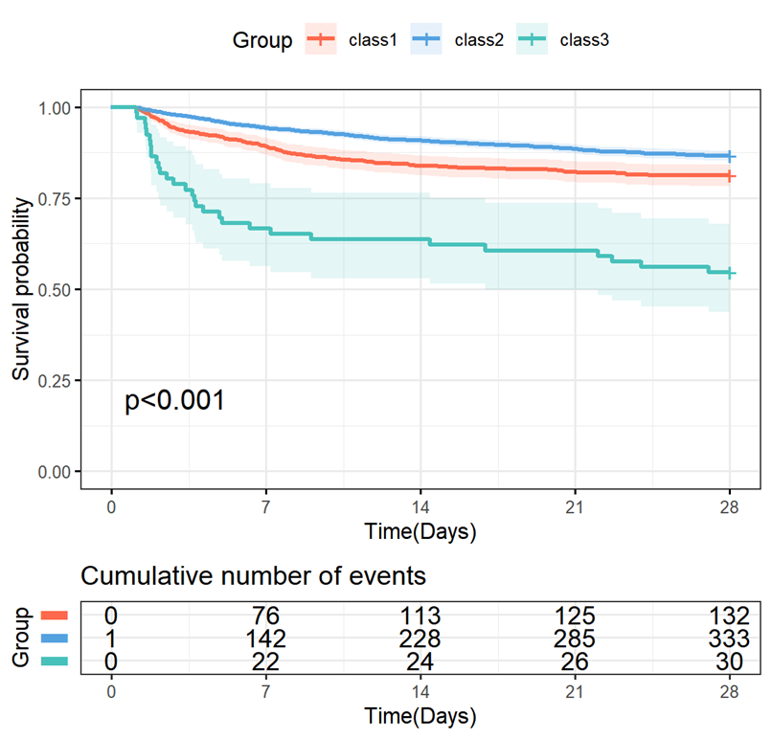
Figure S1 Kaplan-Meier analysis of 28-day mortality between groups in the MIMIC database.
Figure S2 Feature selection in eICU database using the Boruta algorithm.

Figure S3 Subgroup analysis of the association between temperature and 28-day mortality (A), ICU mortality (B), and in-hospital mortality (C) in the MIMIC database

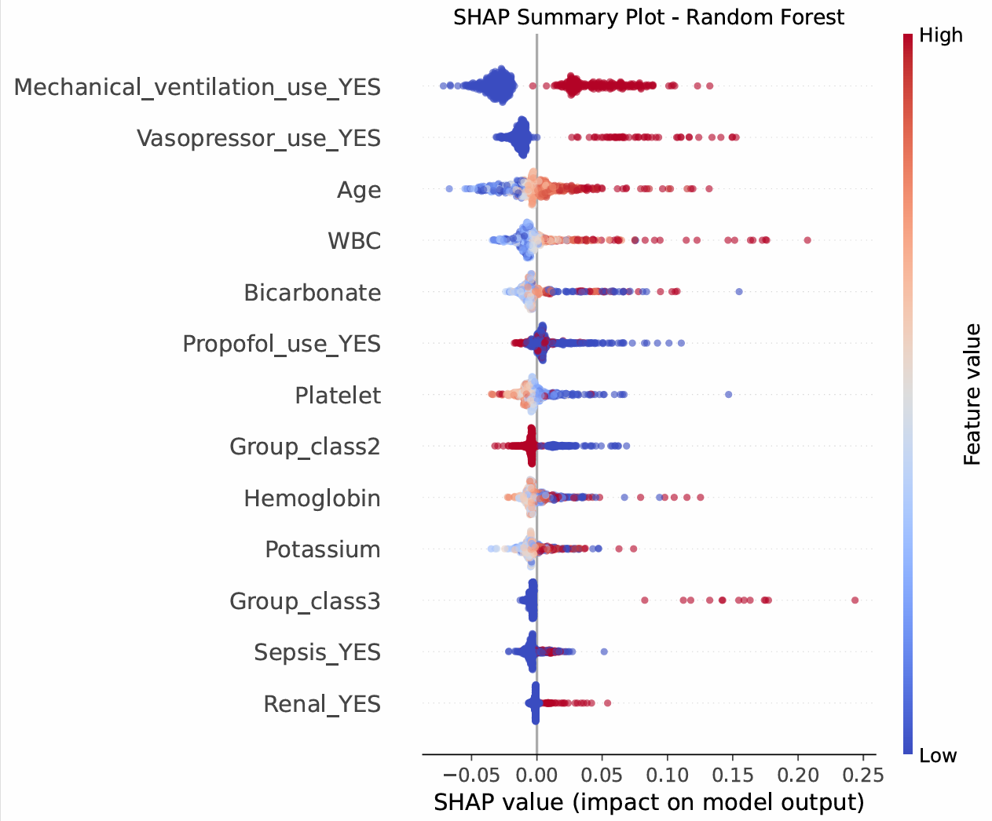
Figure S4 SHAP summary plot showing the impact of each feature on random forest model predictions.

