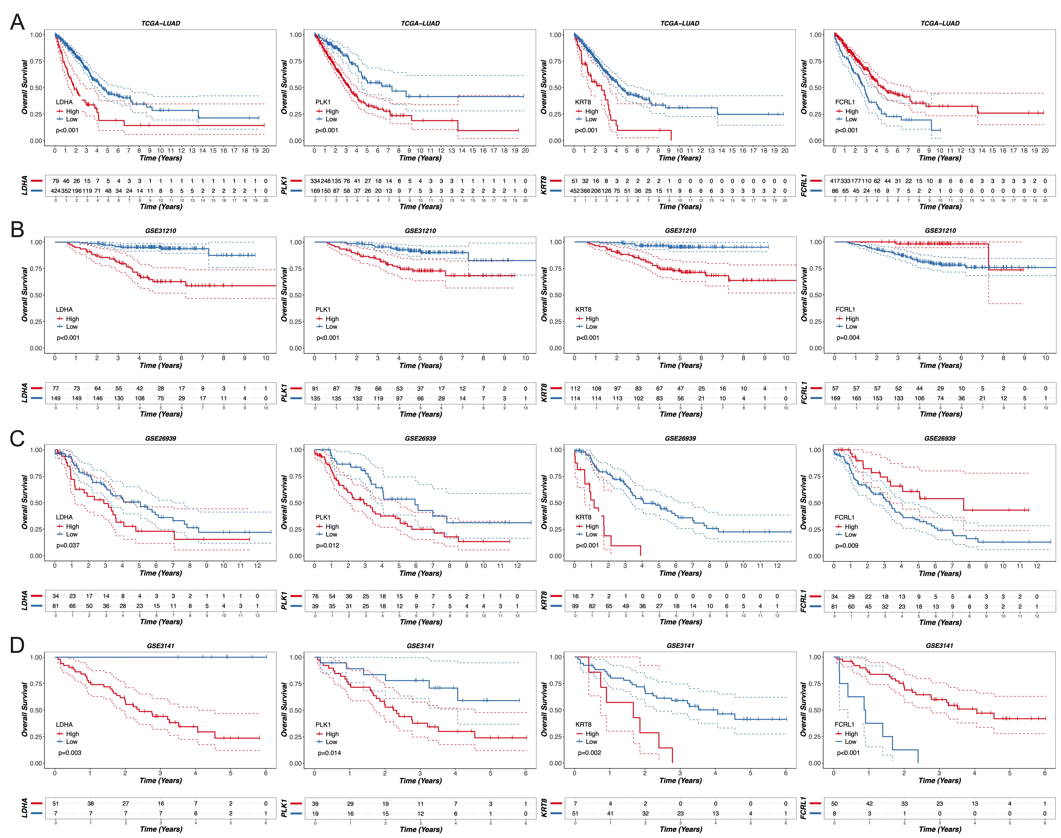
Figs. 1 Four-gene survival analysis. A-D KM survival curves for OS of four genes in the datasets TCGA-LUAD (A), GSE31210 (B), GSE26939 (C), and GSE3141 (D), respectively.
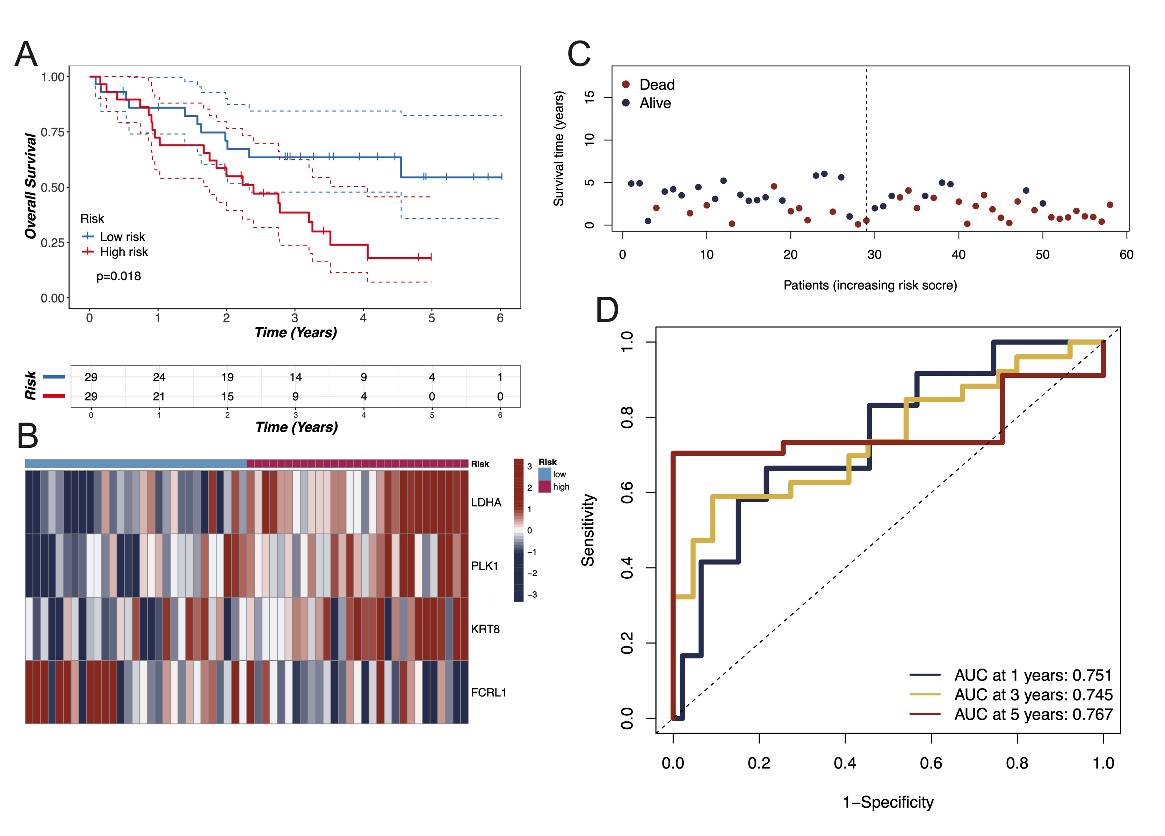
Figs. 2 Validation was performed in the external cohort GSE3141. A-D KM survival curves for OS (A), expression heatmap of model genes (B), risk score distribution plot (C), and ROC curves at 1-, 3-, and 5-year OS (D).
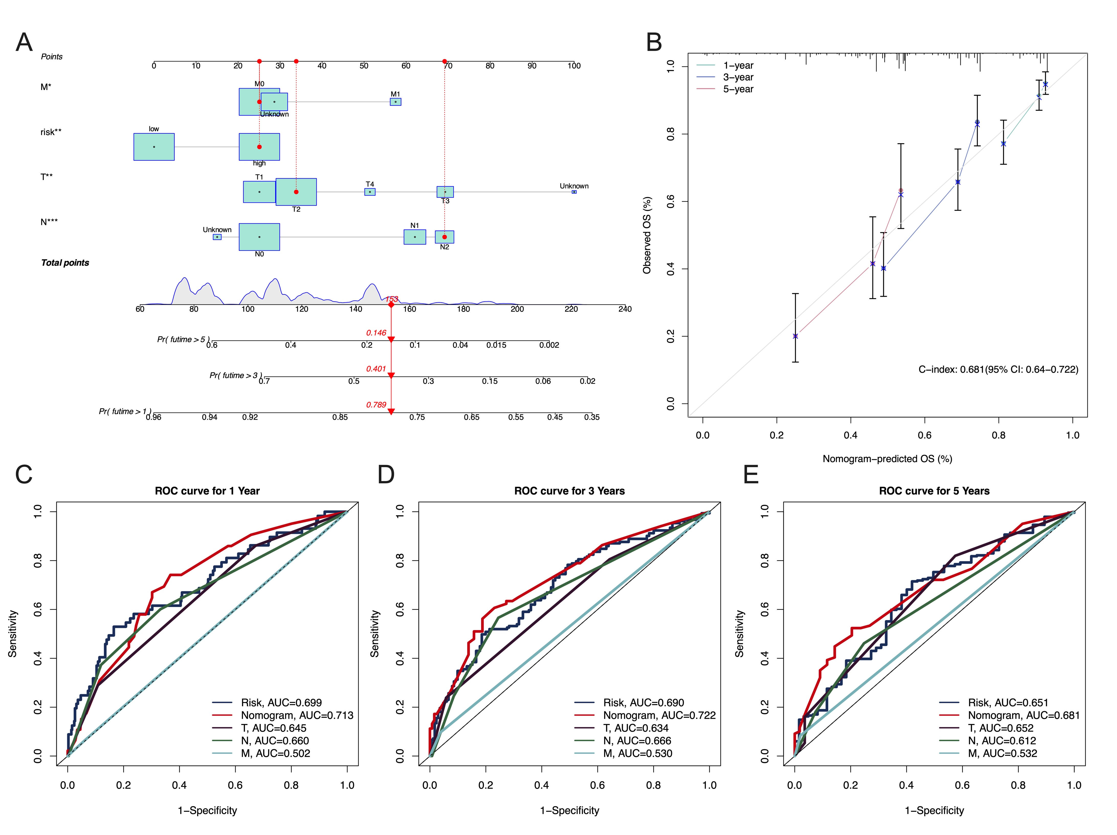
Figs. 3 A nomogram was constructed in the TCGA-LUAD dataset. A Nomogram predicting 1-, 3-, and 5-year OS in TCGA-LUAD. B Calibration curves evaluating the predictive accuracy of the nomogram for 1-, 3-, and 5-year OS. C-E ROC curves comparing predictive power of clinical factors and the nomogram at 1-, 3-, and 5-year OS. Statistical significance is indicated as follows: *, P < 0.05; **, P < 0.01; ***, P < 0.001.
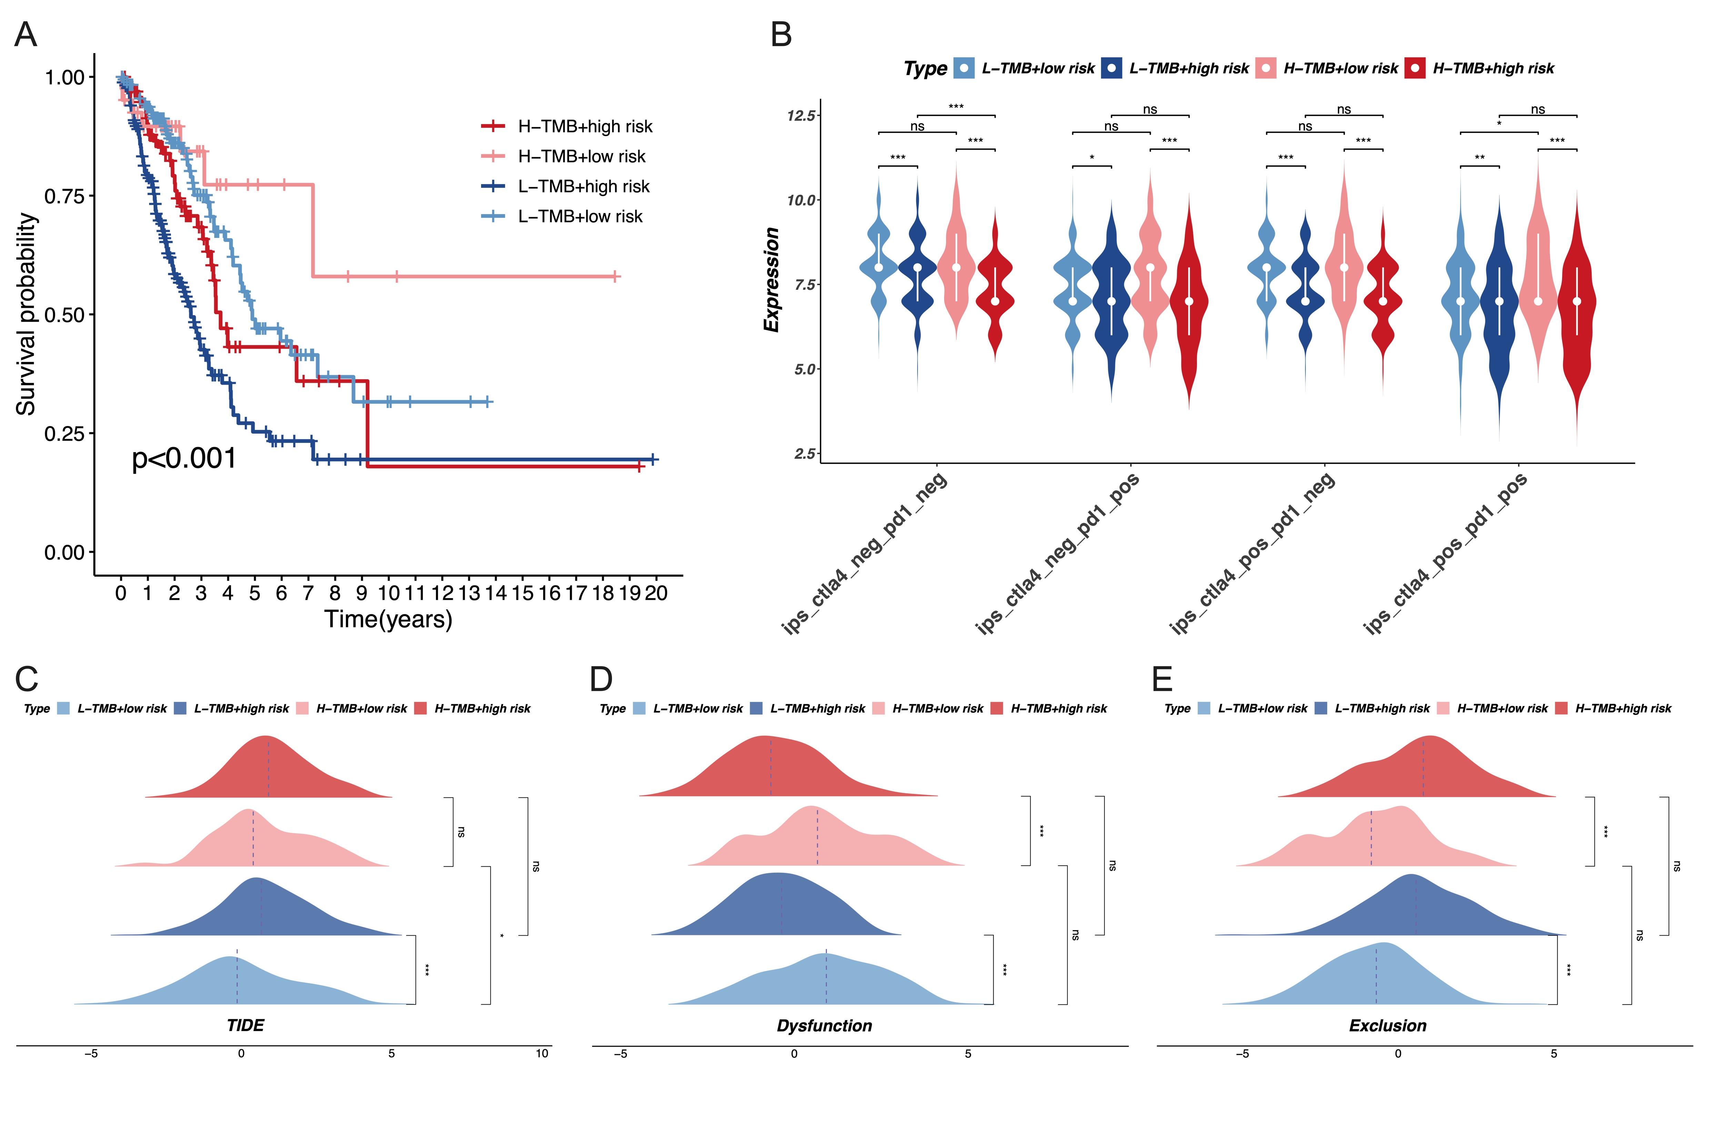
Figs. 4 Analysis of immunotherapy in relation to TMB. A KM survival curves linked to TMB and risk. B Evaluation of TMB efficacy in predicting immunotherapy success. C-D TIDE analysis assessing the influence of TMB on immunotherapy efficacy. Statistical analyses for group comparisons were performed using the Wilcoxon rank-sum test for bioinformatics data. Statistical significance is indicated as follows: *, P < 0.05; **, P < 0.01; ***, P < 0.001, ns, not significance.
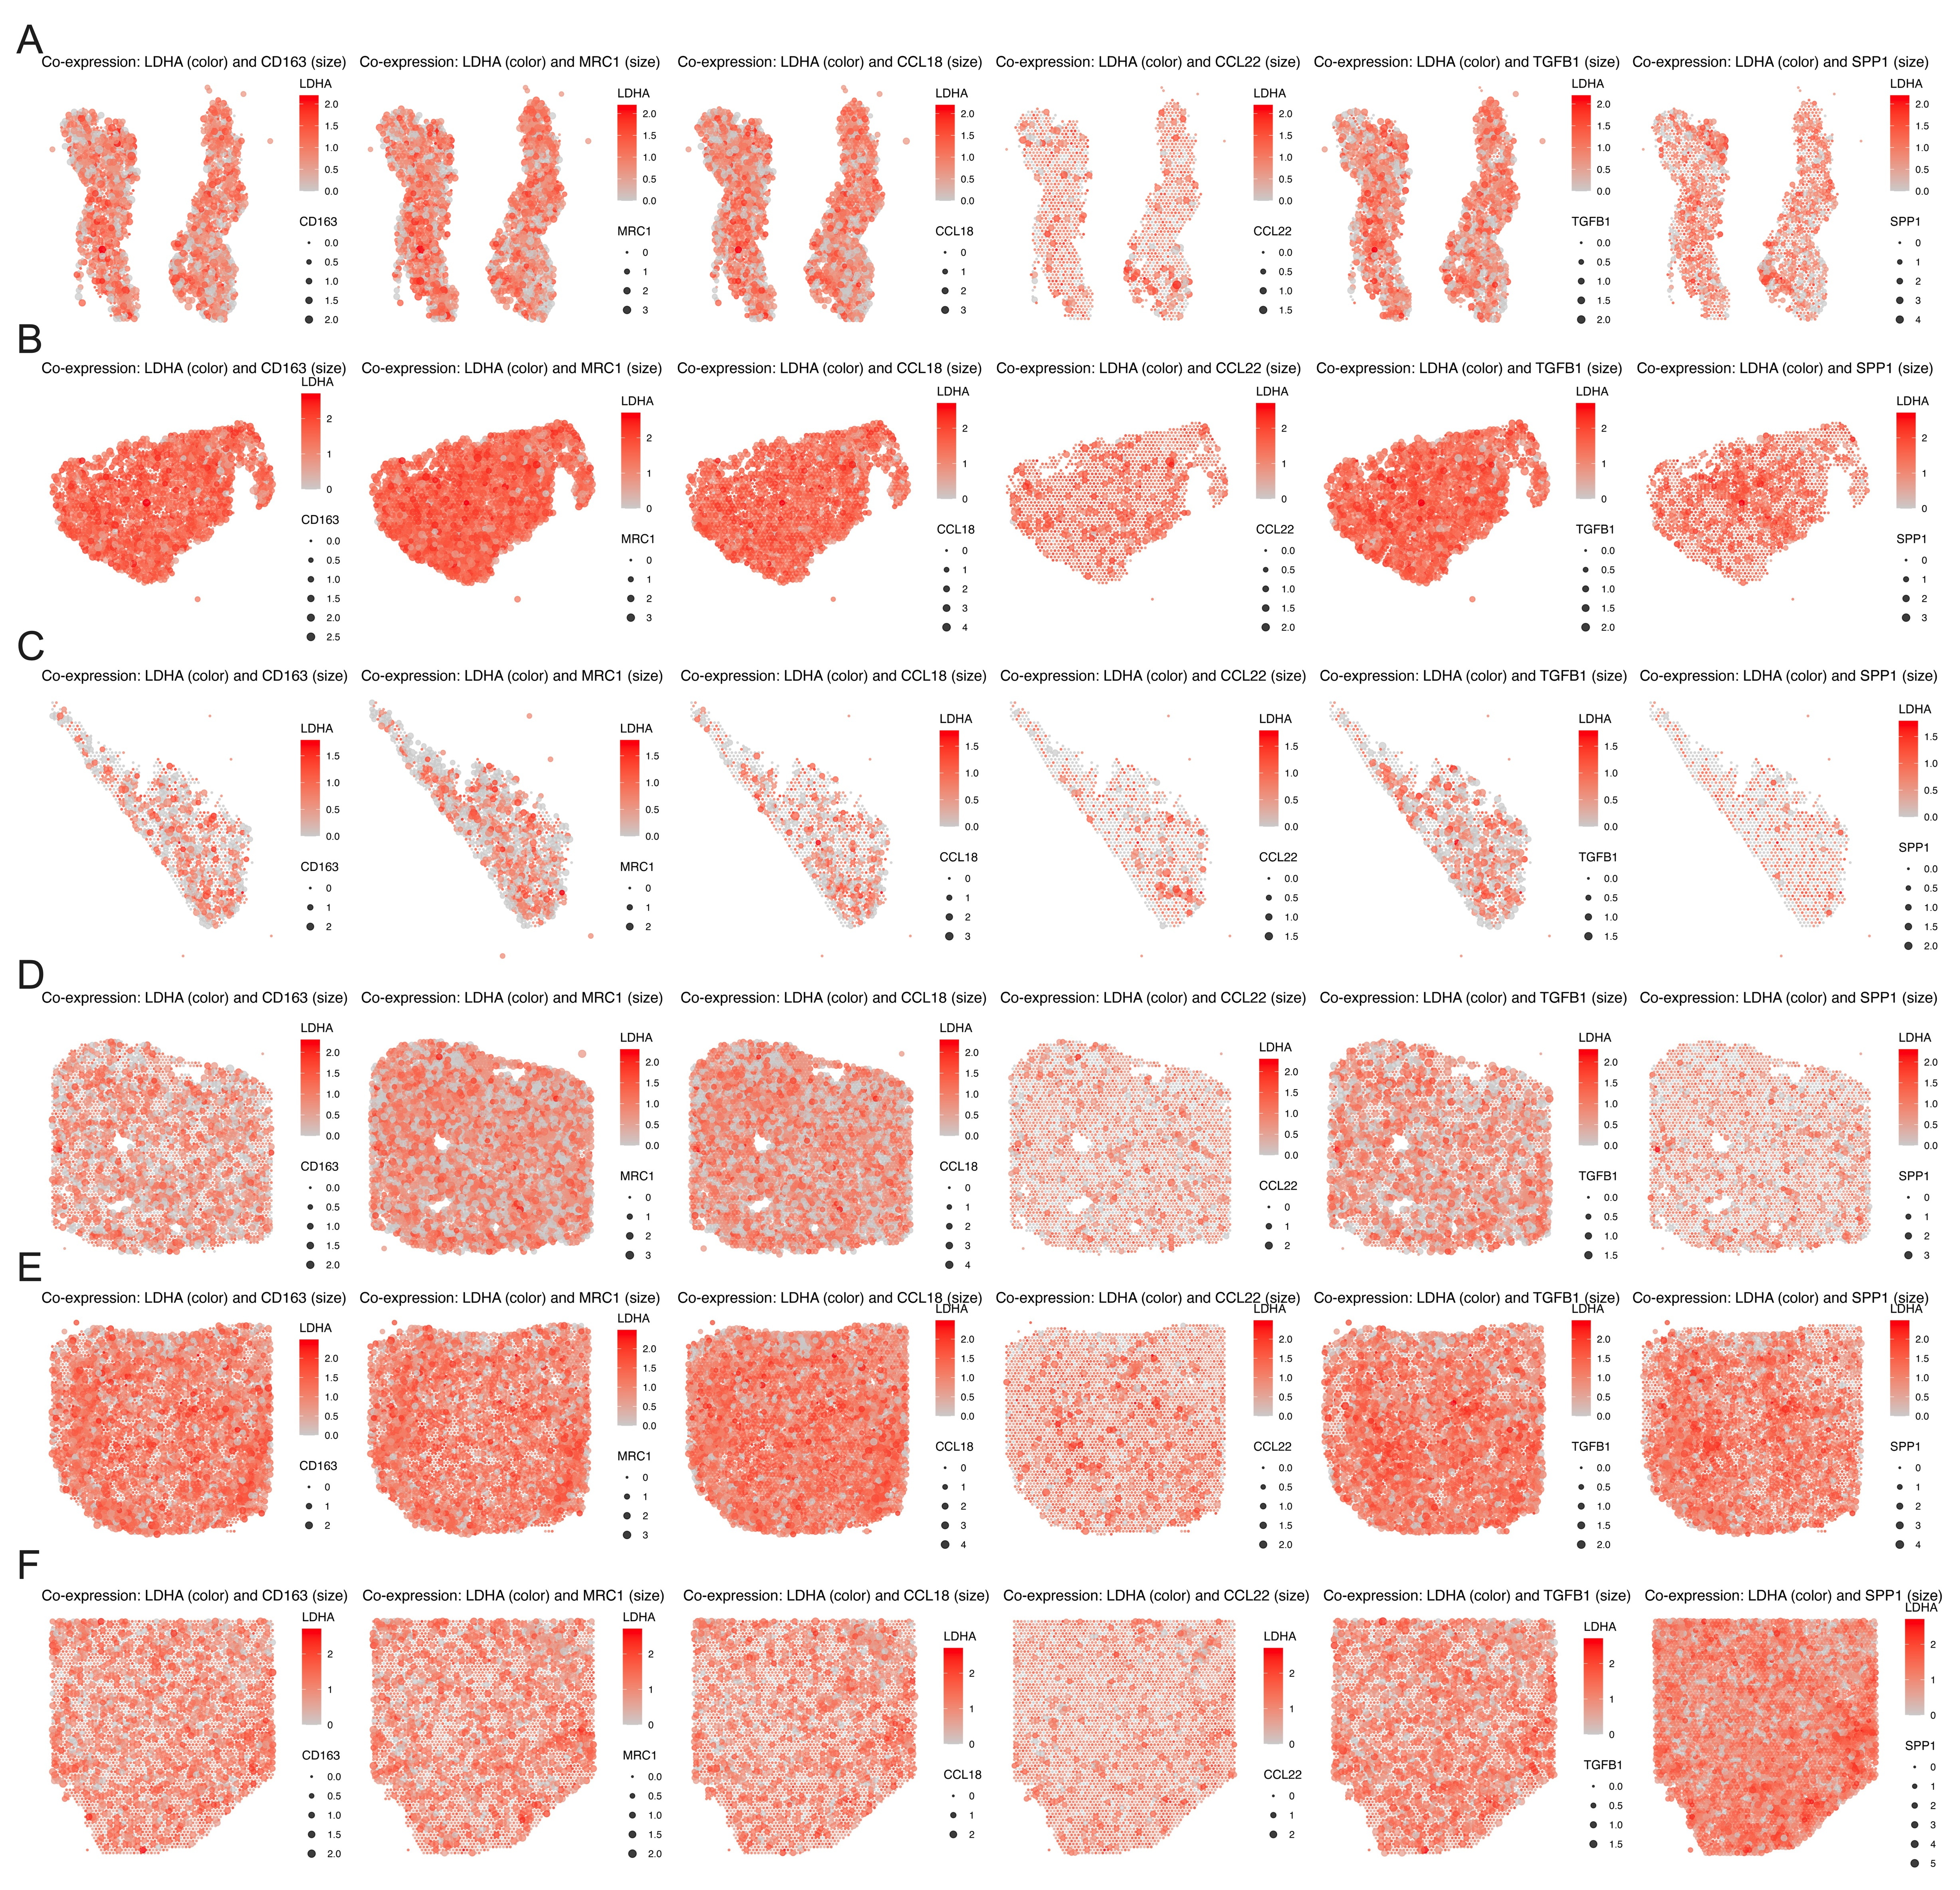
Figs. 5 Analysis of stRNA-seq. A-F Spatial co-expression patterns of LDHA in six LUAD samples with CD163, MRC1, CCL18, CCL22, TGFB1, and SPP1.
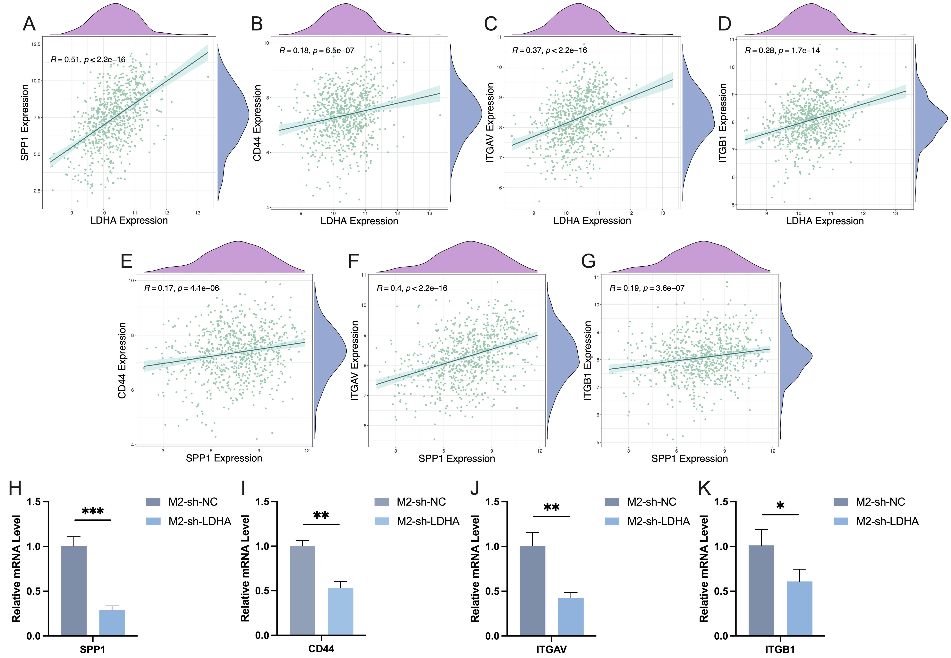
Figs. 6 Correlation analysis between LDHA and SPP1-CD44/ integrin. A-D Correlation Analysis Between LDHA and SPP1 (A), CD44 (B), ITGAV (C), ITGB1 (D), Respectively. E-F Correlation Analysis Between SPP1 and CD44 (E), ITGAV (F), ITGB1 (G), Respectively. H-K qRT-PCR analysis of SPP1 (H), CD44 (I), ITGAV (J), and ITGB1 (K) expression in M2 Macrophages following LDHA knockdown. Statistical analyses for group comparisons were performed using the Student's t-test for experimental data. Statistical significance is indicated as follows: *, P < 0.05; **, P < 0.01; ***, P < 0.001.

