Supplementary tables

Tables S1: Baseline clinical characteristics of 963 patients.
Table S2: Baseline clinical characteristics of 890 patients,
Table S3: Seven key clinical features selected by LASSO regression in 890 patients.
Table S4: Key clinical features in 797 NTIS patients to establish a mortality prediction model.
Table S5: Baseline characteristics of 890 patients in the occurrence prediction model.
Table S6: Baseline characteristics of 797 patients in the mortality prediction model.

Supplementary figures
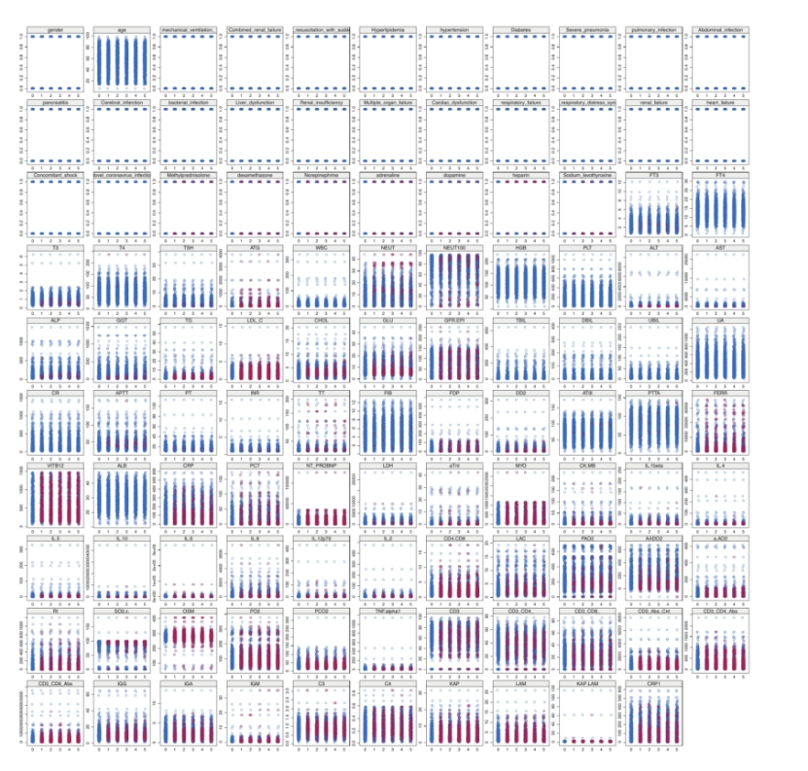
Figure S1 Strip graph showing the interpolation of missing values. The abscissa represents the interpolation number, and different features are plotted to illustrate how their values are adjusted through the interpolation process.

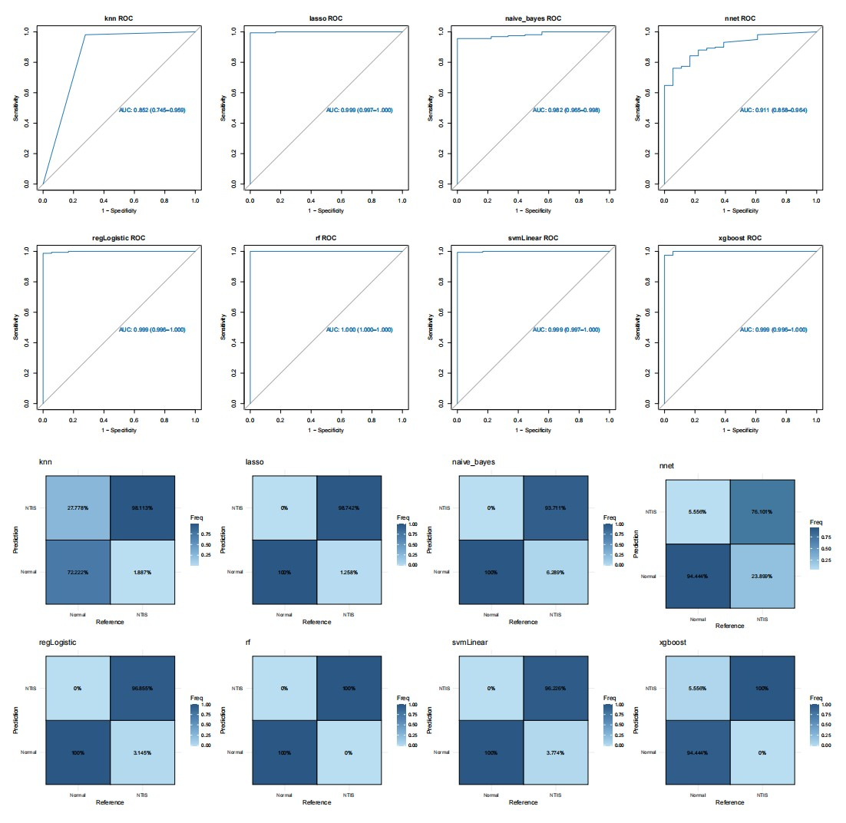Figure S2 ROC curves and the confusion matrices of the NTIS occurrence model in the validation cohort.
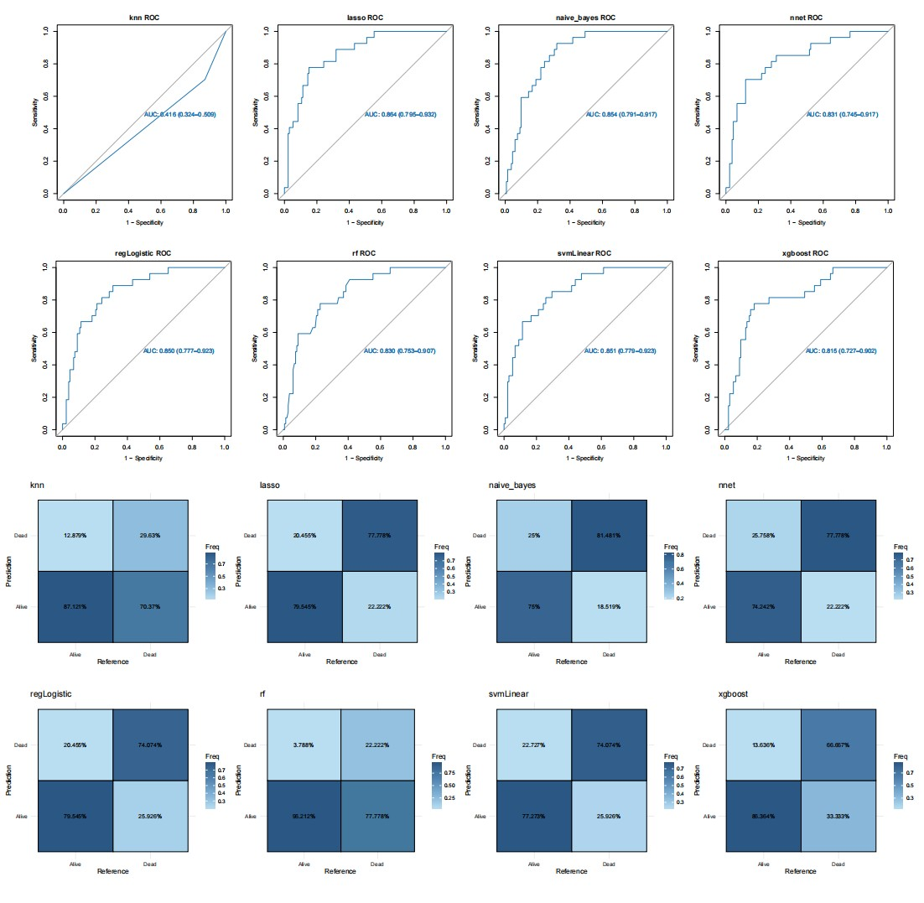
Figure S3 ROC curves and confusion matrices for the NTIS mortality model in the validation cohort.
Figure S4 Assessment of the proportional hazards (PHs) assumption in Cox models for NTIS prognosis. (a) Main Cox model (cox1) including all covariates. (b) Stratified Cox model (cox2) with Sex and PulmInf as stratification factors.

Figure S5 Restricted cubic spline (RCS) analysis of continuous covariates in the Cox model for NTIS prognosis.

