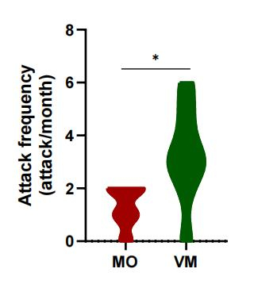
Figure S1. The monthly attack frequency graphs for the VM group and the MO group of patients.

